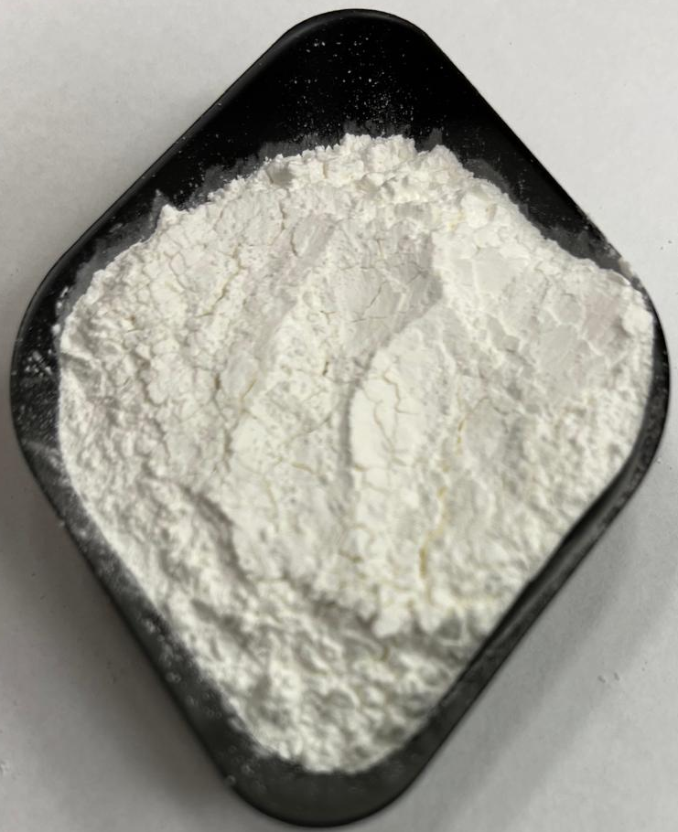 | 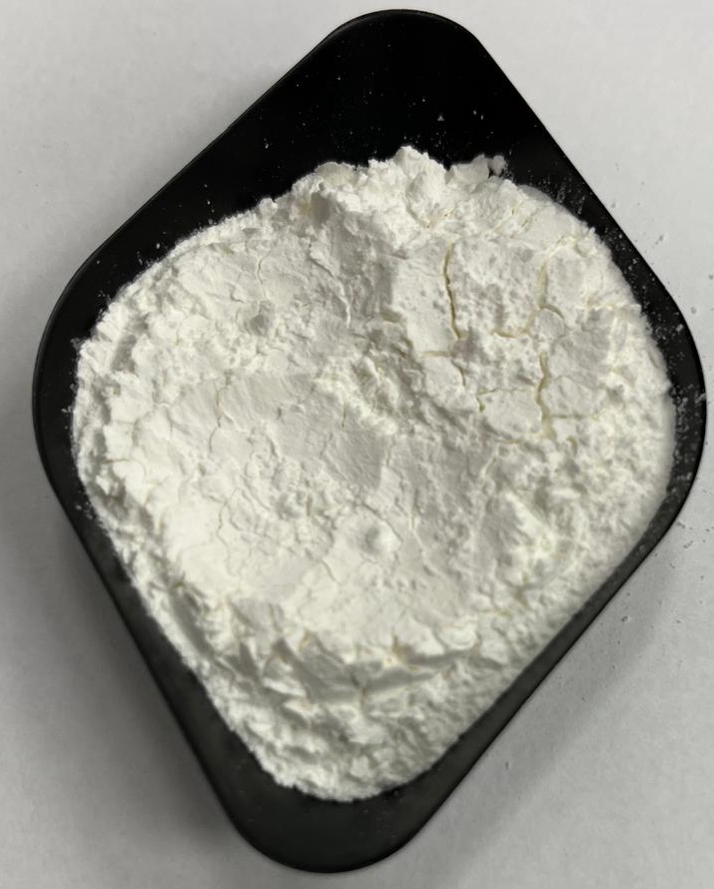 | 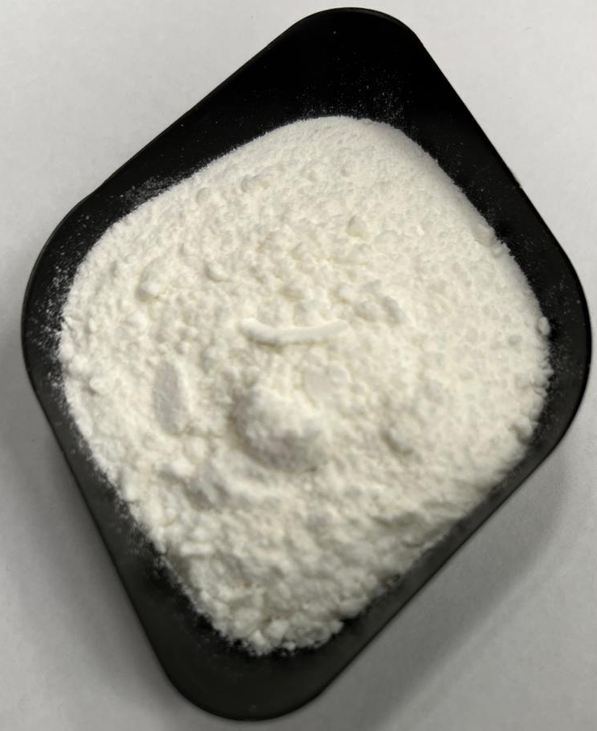
ESD | CSD | FD
Figure S1. Images of ESD, CSD and FD powder samples of low a_{w} WPI-Lac model system at pH 6.0 after production

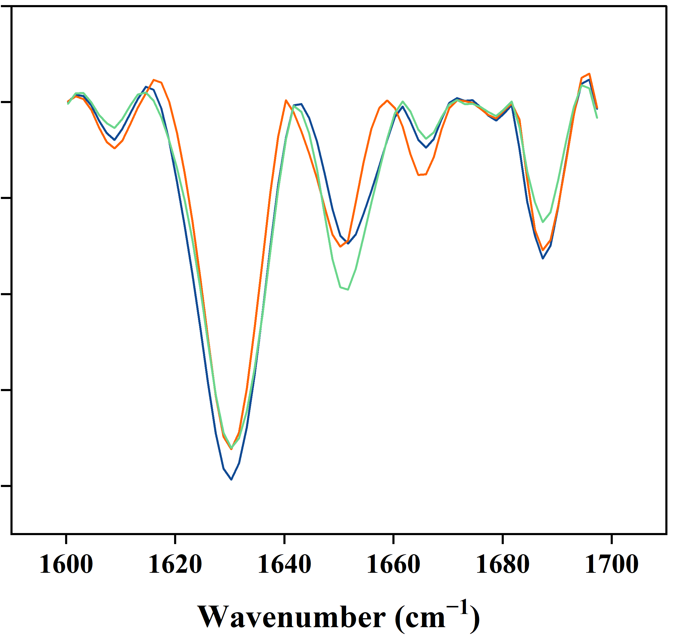
Figure S2. Second derivative FTIR spectra of the Amide I region of low a_{w} WPI-Lac model system at pH 6.0, dried by ESD (⎯⎯), CSD (⎯⎯) and FD (⎯⎯) immediately after production.

Table S1. Levels of free -NH₂ groups (in mmol/kg) in powdered WPI-Lac and WPI-Lac-Glu systems after production (t₀) and after storing at 20°C for 0, 7, 14, 21 and 28 days.
Sample ID | Model system | pH | Water activity category | t₀ | t₇ | t₁₄ | t₂₁ | t₂₈
ESD_1 | WPI-Lac | 6.0 | L | 222.1 ± 33.4^{aA} | 244.5 ± 27.6^{aA} | 251.2 ± 41.3^{aA} | 213.7 ± 9.3^{aA} | 210.6 ± 3.4^{aA}
ESD_2 | WPI-Lac | 6.0 | I | 242.6 ± 13.7^{aAB} | 228.7 ± 16.8^{aAB} | 256.6 ± 23.4^{aA} | 207.7 ± 9.6^{aB} | 211.4 ± 6.4^{bB}
ESD_3 | WPI-Lac | 8.0 | L | 211.4 ± 13.5^{aA} | 245.0 ± 22.0^{aA} | 233.4 ± 20.0^{aA} | 223.3 ± 18.6^{aA} | 220.3 ± 13.7^{aA}
ESD_4 | WPI-Lac | 8.0 | I | 224.6 ± 38.5^{aA} | 232.6 ± 14.9^{aA} | 213.3 ± 12.5^{aA} | 210.9 ± 27.3^{aA} | 187.3 ± 13.8^{bA}
ESD_5 | WPI-Lac-Glu | 6.0 | L | 198.2 ± 17.0^{aA} | 233.8 ± 6.7^{aA} | 256.1 ± 56.1^{aA} | 218.6 ± 10.3^{aA} | 213.8 ± 19.6^{aA}
ESD_6 | WPI-Lac-Glu | 6.0 | I | 220.0 ± 3.3^{aAB} | 222.8 ± 13.2^{aAB} | 261.2 ± 45.3^{aA} | 213.8 ± 16.5^{aAB} | 195.6 ± 4.5^{bB}
ESD_7 | WPI-Lac-Glu | 8.0 | L | 226.5 ± 13.2^{aA} | 234.6 ± 15.6^{aA} | 203.3 ± 7.6^{aA} | 203.4 ± 24.9^{aA} | 204.9 ± 16.4^{aA}
ESD_8 | WPI-Lac-Glu | 8.0 | I | 221.6 ± 19.3^{aA} | 210.7 ± 11.7^{aA} | 211.0 ± 35.4^{aA} | 217.7 ± 11.3^{aA} | 214.8 ± 12.1^{bA}
CSD_1 | WPI-Lac | 6.0 | L | 159.2 ± 19.1^{bA} | 159.7 ± 7.7^{cA} | 189.5 ± 12.7^{bA} | 165.9 ± 17.6^{bA} | 194.0 ± 13.3^{dA}
CSD_2 | WPI-Lac | 6.0 | I | 156.7 ± 30.6^{bA} | 176.6 ± 7.5^{cA} | 191.6 ± 6.6^{bA} | 185.7 ± 13.1^{bA} | 185.0 ± 7.8^{eA}
CSD_3 | WPI-Lac | 8.0 | L | 183.4 ± 20.1^{bAB} | 162.9 ± 7.6^{cB} | 211.7 ± 16.3^{bA} | 170.5 ± 17.0^{bB} | 195.5 ± 5.7^{dAB}
CSD_4 | WPI-Lac | 8.0 | I | 183.6 ± 10.3^{bA} | 166.2 ± 13.4^{cA} | 195.6 ± 23.5^{bA} | 197.3 ± 7.0^{bA} | 181.7 ± 2.0^{eA}
CSD_5 | WPI-Lac-Glu | 6.0 | L | 185.1 ± 24.9^{bA} | 184.5 ± 14.8^{cA} | 187.3 ± 6.7^{bA} | 199.8 ± 9.3^{bA} | 177.4 ± 6.7^{dA}
CSD_6 | WPI-Lac-Glu | 6.0 | I | 175.6 ± 14.4^{bAB} | 170.3 ± 21.0^{cB} | 226.0 ± 35.7^{bA} | 168.3 ± 19.4^{bB} | 175.9 ± 9.9^{eAB}
CSD_7 | WPI-Lac-Glu | 8.0 | L | 161.0 ± 12.1^{bA} | 158.0 ± 13.9^{cA} | 201.0 ± 10.5^{bA} | 187.5 ± 27.3^{bA} | 178.0 ± 16.7^{dA}
CSD_8 | WPI-Lac-Glu | 8.0 | I | 152.9 ± 6.8^{bA} | 174.9 ± 13.5^{cA} | 182.7 ± 5.5^{bA} | 173.0 ± 24.7^{bA} | 177.8 ± 12.3^{eA}
FD_1 | WPI-Lac | 6.0 | L | 214.2 ± 16.1^{aA} | 214.4 ± 19.6^{bA} | 215.1 ± 14.5^{bA} | 217.5 ± 8.0^{aA} | 198.5 ± 12.1^{cA}
FD_2 | WPI-Lac | 8.0 | L | 222.2 ± 5.4^{aA} | 195.2 ± 22.1^{bA} | 200.8 ± 13.0^{bA} | 216.6 ± 5.0^{aA} | 203.9 ± 11.3^{cA}
FD_3 | WPI-Lac-Glu | 6.0 | L | 254.7 ± 25.5^{aA} | 210.9 ± 16.2^{bAB} | 197.0 ± 15.9^{bB} | 219.7 ± 17.4^{aAB} | 199.4 ± 16.5^{cB}
FD_4 | WPI-Lac-Glu | 8.0 | L | 242.8 ± 36.3^{aA} | 230.3 ± 39.6^{bA} | 212.2 ± 8.2^{bA} | 220.0 ± 4.3^{aA} | 197.3 ± 8.6^{cA}
Values presented are the means of 2 replicates ± standard deviation; values within a row not sharing a common uppercase superscript letter differ signiﬁcantly; values within a column not sharing a common lowercase superscript letter differ signiﬁcantly, p < 0.05; ESD- electrostatic spray drying, CSD- conventional spray drying, FD- freeze drying; low a_{w} (L: 0.1-0.15) and intermediate a_{w} (I: 0.2-0.25)

Table S2. Levels of free -NH₂ groups (in mmol/kg) in powdered WPI-Lac and WPI-Lac-Glu systems after production (t₀) and after storing at 40°C for 0, 7, 14, 21 and 28 days.
Sample ID | Model system | pH | Water activity category | t₀ | t₇ | t₁₄ | t₂₁ | t₂₈
ESD_1 | WPI-Lac | 6.0 | L | 222.1 ± 33.4^{aAB} | 200.3 ± 26.0^{aBC} | 274.0 ± 39.0^{aA} | 152.8 ± 6.4^{abC} | 197.6 ± 6.9^{aBC}
ESD_2 | WPI-Lac | 6.0 | I | 242.6 ± 13.7^{aA} | 199.5 ± 16.0^{aB} | 235.0 ± 13.2^{aA} | 189.4 ± 11.6^{abB} | 189.4 ± 8.4^{aB}
ESD_3 | WPI-Lac | 8.0 | L | 211.4 ± 13.5^{aAB} | 223.4 ± 24.7^{aAB} | 243.3 ± 30.2^{aA} | 179.5 ± 17.4^{abB} | 194.9 ± 8.2^{aAB}
ESD_4 | WPI-Lac | 8.0 | I | 224.6 ± 38.5^{aAB} | 198.5 ± 14.2^{aAB} | 244.0 ± 20.9^{aA} | 179.7 ± 20.6^{abB} | 179.7 ± 19.3^{aB}
ESD_5 | WPI-Lac-Glu | 6.0 | L | 198.2 ± 17.0^{aA} | 220.2 ± 52.3^{abA} | 224.7 ± 12.5^{bcA} | 163.0 ± 17.0^{cdA} | 185.1 ± 23.5^{bA}
ESD_6 | WPI-Lac-Glu | 6.0 | I | 220.0 ± 3.3^{aA} | 146.9 ± 7.7^{abB} | 142.1 ± 11.7^{bcB} | 63.6 ± 6.7^{cdC} | 76.4 ± 6.5^{bC}
ESD_7 | WPI-Lac-Glu | 8.0 | L | 226.5 ± 13.2^{aA} | 187.1 ± 10.8^{abBC} | 222.7 ± 19.5^{bcAB} | 155.4 ± 17.2^{cdC} | 173.8 ± 6.0^{bC}
ESD_8 | WPI-Lac-Glu | 8.0 | I | 221.6 ± 19.3^{aA} | 156.1 ± 18.9^{abBC} | 208.6 ± 45.8^{bcAB} | 105.1 ± 17.1^{cdC} | 105.1 ± 14.5^{bC}
CSD_1 | WPI-Lac | 6.0 | L | 159.2 ± 19.1^{bC} | 207.9 ± 19.3^{aB} | 251.6 ± 10.2^{abA} | 177.7 ± 13.9^{abBC} | 192.3 ± 9.9^{aBC}
CSD_2 | WPI-Lac | 6.0 | I | 156.7 ± 30.6^{bB} | 221.4 ± 14.4^{aA} | 222.3 ± 15.1^{abA} | 175.8 ± 14.2^{abB} | 175.6 ± 7.3^{aB}
CSD_3 | WPI-Lac | 8.0 | L | 183.4 ± 20.1^{bB} | 222.6 ± 14.7^{aAB} | 240.0 ± 13.0^{abA} | 203.9 ± 5.7^{abAB} | 207.4 ± 22.2^{aAB}
CSD_4 | WPI-Lac | 8.0 | I | 183.6 ± 10.3^{bA} | 201.2 ± 10.9^{aA} | 216.1 ± 16.8^{abA} | 181.7 ± 15.8^{abA} | 180.7 ± 22.3^{aA}
CSD_5 | WPI-Lac-Glu | 6.0 | L | 185.1 ± 24.9^{bA} | 185.8 ± 18.3^{abA} | 213.7 ± 18.3^{bcA} | 164.9 ± 7.0^{bcA} | 190.2 ± 25.0^{abA}
CSD_6 | WPI-Lac-Glu | 6.0 | I | 175.6 ± 14.4^{bA} | 178.0 ± 11.3^{abA} | 173.6 ± 8.9^{bcA} | 152.2 ± 9.3^{bcA} | 150.1 ± 12.3^{abA}
CSD_7 | WPI-Lac-Glu | 8.0 | L | 161.0 ± 12.1^{bA} | 188.3 ± 12.4^{abA} | 210.6 ± 18.7^{bcA} | 162.7 ± 5.8^{bcA} | 162.4 ± 37.2^{abA}
CSD_8 | WPI-Lac-Glu | 8.0 | I | 152.9 ± 6.8^{bB} | 160.8 ± 19.3^{abAB} | 197.2 ± 19.8^{bcA} | 127.9 ± 12.4^{bcB} | 127.9 ± 10.6^{abB}
FD_1 | WPI-Lac | 6.0 | L | 214.2 ± 16.1^{aAB} | 202.5 ± 14.3^{aB} | 251.4 ± 17.3^{aA} | 215.9 ± 23.0^{aAB} | 182.2 ± 17.9^{abB}
FD_2 | WPI-Lac | 8.0 | L | 222.2 ± 5.4^{aA} | 208.6 ± 22.9^{aAB} | 245.6 ± 16.7^{aA} | 215.7 ± 9.3^{aA} | 174.7 ± 12.6^{abB}
FD_3 | WPI-Lac-Glu | 6.0 | L | 254.7 ± 25.5^{aA} | 167.3 ± 18.5^{bB} | 168.5 ± 10.3^{cB} | 116.5 ± 30.1^{dB} | 56.1 ± 20.4^{cC}
FD_4 | WPI-Lac-Glu | 8.0 | L | 242.8 ± 36.3^{aA} | 97.3 ± 11.8^{bB} | 141.0 ± 2.2^{cBC} | 72.1 ± 4.9^{dC} | 54.9 ± 22.2^{cC}
Values presented are the means of 2 replicates ± standard deviation; values within a row not sharing a common uppercase superscript letter differ signiﬁcantly; values within a column not sharing a common lowercase superscript letter differ signiﬁcantly, p < 0.05; ESD- electrostatic spray drying, CSD- conventional spray drying, FD- freeze drying; low a_{w} (L: 0.1-0.15) and intermediate a_{w} (I: 0.2-0.25)

Table S3. Total HMF concentrations (in g/kg) in powdered WPI-Lac and WPI-Lac-Glu systems after production (t₀) and after storing at 20°C for 0, 7, 14, 21 and 28 days.
Sample ID | Model system | pH | Water activity category | t₀ | t₇ | t₁₄ | t₂₁ | t₂₈
ESD_1 | WPI-Lac | 6.0 | L | 0.12 ± 0.02^{abA} | 0.12 ± 0.03^{bcA} | 0.11 ± 0.01^{cA} | 0.11 ± 0.01^{bA} | 0.14 ± 0.01^{bA}
ESD_2 | WPI-Lac | 6.0 | I | 0.15 ± 0.01^{abAB} | 0.16 ± 0.02^{bcA} | 0.14 ± 0.01^{cAB} | 0.14 ± 0.01^{bAB} | 0.13 ± 0.01^{bB}
ESD_3 | WPI-Lac | 8.0 | L | 0.14 ± 0.02^{abA} | 0.14 ± 0.01^{bcA} | 0.13 ± 0.00^{cA} | 0.15 ± 0.02^{bA} | 0.15 ± 0.01^{bA}
ESD_4 | WPI-Lac | 8.0 | I | 0.15 ± 0.03^{abA} | 0.15 ± 0.02^{bcA} | 0.16 ± 0.04^{cA} | 0.16 ± 0.02^{bA} | 0.15 ± 0.02^{bA}
ESD_5 | WPI-Lac-Glu | 6.0 | L | 0.16 ± 0.02^{abAB} | 0.16 ± 0.02^{abAB} | 0.15 ± 0.01^{abB} | 0.15 ± 0.02^{bAB} | 0.20 ± 0.02^{aA}
ESD_6 | WPI-Lac-Glu | 6.0 | I | 0.20 ± 0.02^{abA} | 0.19 ± 0.01^{abA} | 0.19 ± 0.01^{abAB} | 0.16 ± 0.01^{bBC} | 0.15 ± 0.00^{aC}
ESD_7 | WPI-Lac-Glu | 8.0 | L | 0.17 ± 0.00^{abA} | 0.17 ± 0.02^{abA} | 0.17 ± 0.02^{abA} | 0.17 ± 0.01^{bA} | 0.18 ± 0.01^{aA}
ESD_8 | WPI-Lac-Glu | 8.0 | I | 0.16 ± 0.02^{abA} | 0.16 ± 0.01^{abA} | 0.17 ± 0.03 ^{abA} | 0.17 ± 0.02^{bA} | 0.16 ± 0.02^{aA}
CSD_1 | WPI-Lac | 6.0 | L | 0.13 ± 0.01^{aA} | 0.14 ± 0.06^{bcA} | 0.14 ± 0.02^{bcA} | 0.15 ± 0.02^{bA} | 0.16 ± 0.04^{abA}
CSD_2 | WPI-Lac | 6.0 | I | 0.17 ± 0.02^{aA} | 0.17 ± 0.02^{bcA} | 0.17 ± 0.02^{bcA} | 0.18 ± 0.02^{bA} | 0.14 ± 0.02^{abA}
CSD_3 | WPI-Lac | 8.0 | L | 0.14 ± 0.03^{aA} | 0.14 ± 0.02^{bcA} | 0.15 ± 0.02^{bcA} | 0.16 ± 0.04^{bA} | 0.15 ± 0.04^{abA}
CSD_4 | WPI-Lac | 8.0 | I | 0.16 ± 0.03^{aA} | 0.16 ± 0.02^{bcA} | 0.17 ± 0.02^{bcA} | 0.15 ± 0.03^{bA} | 0.13 ± 0.01^{abA}
CSD_5 | WPI-Lac-Glu | 6.0 | L | 0.17 ± 0.03^{aA} | 0.17 ± 0.02^{aA} | 0.18 ± 0.02^{aA} | 0.17 ± 0.02^{aA} | 0.17 ± 0.02^{aA}
CSD_6 | WPI-Lac-Glu | 6.0 | I | 0.20 ± 0.02^{aA} | 0.22 ± 0.01^{aA} | 0.20 ± 0.04^{aA} | 0.20 ± 0.04^{aA} | 0.16 ± 0.02^{aA}
CSD_7 | WPI-Lac-Glu | 8.0 | L | 0.18 ± 0.02^{aA} | 0.18 ± 0.02^{aA} | 0.19 ± 0.04^{aA} | 0.20 ± 0.02^{aA} | 0.19 ± 0.04^{aA}
CSD_8 | WPI-Lac-Glu | 8.0 | I | 0.19 ± 0.00^{aA} | 0.20 ± 0.02^{aA} | 0.20 ± 0.03^{aA} | 0.21 ± 0.04^{aA} | 0.18 ± 0.03^{aA}
FD_1 | WPI-Lac | 6.0 | L | 0.11 ± 0.02^{bA} | 0.12 ± 0.04^{cA} | 0.12 ± 0.02^{cA} | 0.14 ± 0.01^{bA} | 0.15 ± 0.02^{abA}
FD_2 | WPI-Lac | 8.0 | L | 0.13 ± 0.03^{bA} | 0.13 ± 0.03^{cA} | 0.14 ± 0.03^{cA} | 0.14 ± 0.02^{bA} | 0.14 ± 0.02^{abA}
FD_3 | WPI-Lac-Glu | 6.0 | L | 0.15 ± 0.02^{bA} | 0.15 ± 0.04^{bcA} | 0.16 ± 0.02^{bcA} | 0.17 ± 0.01^{bA} | 0.16 ± 0.01^{aA}
FD_4 | WPI-Lac-Glu | 8.0 | L | 0.12 ± 0.01^{bB} | 0.13 ± 0.03^{bcB} | 0.13 ± 0.01^{bcB} | 0.15 ± 0.00^{bAB} | 0.19 ± 0.03^{aA}
Values presented are the means of 2 replicates ± standard deviation; values within a row not sharing a common uppercase superscript letter differ signiﬁcantly; values within a column not sharing a common lowercase superscript letter differ signiﬁcantly, p < 0.05; ESD- electrostatic spray drying, CSD- conventional spray drying, FD- freeze drying; low a_{w} (L: 0.1-0.15) and intermediate a_{w} (I: 0.2-0.25)

Table S4. Total HMF concentrations (in g/kg) in powdered WPI-Lac and WPI-Lac-Glu systems after production (t₀) and after storing at 40°C for 0, 7, 14, 21 and 28 days.
Sample ID | Model system | pH | Water activity category | t₀ | t₇ | t₁₄ | t₂₁ | t₂₈
ESD_1 | WPI-Lac | 6.0 | L | 0.12 ± 0.02^{abB} | 0.14 ± 0.05^{bAB} | 0.20 ± 0.03^{cdA} | 0.18 ± 0.01^{dAB} | 0.18 ± 0.04^{dAB}
ESD_2 | WPI-Lac | 6.0 | I | 0.15 ± 0.01^{abB} | 0.18 ± 0.02^{bB} | 0.26 ± 0.03^{cdA} | 0.18 ± 0.01^{dB} | 0.15 ± 0.01^{dB}
ESD_3 | WPI-Lac | 8.0 | L | 0.14 ± 0.02^{abB} | 0.17 ± 0.02^{bB} | 0.24 ± 0.02^{cdA} | 0.17 ± 0.01^{dB} | 0.17 ± 0.02^{dB}
ESD_4 | WPI-Lac | 8.0 | I | 0.15 ± 0.03^{abA} | 0.19 ± 0.03^{bA} | 0.23 ± 0.05^{cdA} | 0.22 ± 0.04^{dA} | 0.17 ± 0.02^{dA}
ESD_5 | WPI-Lac-Glu | 6.0 | L | 0.16 ± 0.02^{abC} | 0.18 ± 0.03^{bBC} | 0.22 ± 0.03 ^{bcBC} | 0.25 ± 0.03^{bcAB} | 0.32 ± 0.04^{bA}
ESD_6 | WPI-Lac-Glu | 6.0 | I | 0.20 ± 0.02^{abD} | 0.33 ± 0.05^{bC} | 0.40 ± 0.03^{bcBC} | 0.42 ± 0.01^{bcB} | 0.66 ± 0.05^{bA}
ESD_7 | WPI-Lac-Glu | 8.0 | L | 0.17 ± 0.00^{abC} | 0.19 ± 0.01^{bC} | 0.25 ± 0.03^{bcB} | 0.26 ± 0.02^{bcB} | 0.39 ± 0.04^{bA}
ESD_8 | WPI-Lac-Glu | 8.0 | I | 0.16 ± 0.02^{abD} | 0.25 ± 0.04^{bC} | 0.34 ± 0.03^{bcB} | 0.34 ± 0.01^{bcB} | 0.49 ± 0.02^{bA}
CSD_1 | WPI-Lac | 6.0 | L | 0.13 ± 0.01^{aA} | 0.20 ± 0.04^{bA} | 0.16 ± 0.02^{dA} | 0.20 ± 0.02^{dA} | 0.21 ± 0.05^{dA}
CSD_2 | WPI-Lac | 6.0 | I | 0.17 ± 0.02^{aA} | 0.20 ± 0.01^{bA} | 0.19 ± 0.02^{dA} | 0.20 ± 0.01^{dA} | 0.16 ± 0.02^{dA}
CSD_3 | WPI-Lac | 8.0 | L | 0.14 ± 0.03^{aB} | 0.16 ± 0.03^{bAB} | 0.19 ± 0.01^{dAB} | 0.21 ± 0.03^{dA} | 0.17 ± 0.02^{dAB}
CSD_4 | WPI-Lac | 8.0 | I | 0.16 ± 0.03^{aAB} | 0.20 ± 0.00^{bAB} | 0.15 ± 0.02^{dB} | 0.22 ± 0.02^{dA} | 0.15 ± 0.02^{dB}
CSD_5 | WPI-Lac-Glu | 6.0 | L | 0.17 ± 0.03^{aC} | 0.22 ± 0.01^{bBC} | 0.27 ± 0.04^{bAB} | 0.31 ± 0.01^{bA} | 0.26 ± 0.03^{cAB}
CSD_6 | WPI-Lac-Glu | 6.0 | I | 0.20 ± 0.02^{aB} | 0.29 ± 0.06^{bAB} | 0.35 ± 0.06^{bA} | 0.38 ± 0.08^{bA} | 0.31 ± 0.03^{cAB}
CSD_7 | WPI-Lac-Glu | 8.0 | L | 0.18 ± 0.02^{aC} | 0.24 ± 0.02^{bB} | 0.27 ± 0.01^{bB} | 0.33 ± 0.02^{bA} | 0.25 ± 0.02^{cB}
CSD_8 | WPI-Lac-Glu | 8.0 | I | 0.19 ± 0.00^{aC} | 0.28 ± 0.01^{bBC} | 0.36 ± 0.03^{bAB} | 0.37 ± 0.07^{bAB} | 0.37 ± 0.03^{cA}
FD_1 | WPI-Lac | 6.0 | L | 0.11 ± 0.02^{bB} | 0.13 ± 0.02^{abB} | 0.22 ± 0.02^{cdA} | 0.22 ± 0.01^{cdA} | 0.21 ± 0.02^{cdA}
FD_2 | WPI-Lac | 8.0 | L | 0.13 ± 0.03^{bB} | 0.20 ± 0.03^{abAB} | 0.22 ± 0.01^{cdA} | 0.24 ± 0.02^{cdA} | 0.26 ± 0.04^{cdA}
FD_3 | WPI-Lac-Glu | 6.0 | L | 0.15 ± 0.02^{bD} | 0.42 ± 0.04^{aC} | 0.45 ± 0.05^{aBC} | 0.51 ± 0.03^{aB} | 0.70 ± 0.00^{aA}
FD_4 | WPI-Lac-Glu | 8.0 | L | 0.12 ± 0.01^{bD} | 0.50 ± 0.03^{aC} | 0.58 ± 0.01^{aB} | 0.59 ± 0.02^{aB} | 0.67 ± 0.04^{aA}
Values presented are the means of 2 replicates ± standard deviation; values within a row not sharing a common uppercase superscript letter differ signiﬁcantly; values within a column not sharing a common lowercase superscript letter differ signiﬁcantly, p < 0.05; ESD- electrostatic spray drying, CSD- conventional spray drying, FD- freeze drying; low a_{w} (L: 0.1-0.15) and intermediate a_{w} (I: 0.2-0.25)

Table S5. Browning index of powdered WPI-Lac and WPI-Lac-Glu systems after production (t₀) and after storing at 20°C for 0, 7, 14, 21 and 28 days.
Sample ID | Model system | pH | Water activity category | t₀ | t₇ | t₁₄ | t₂₁ | t₂₈
ESD_1 | WPI-Lac | 6.0 | L | 3.1 ± 0.2^{cB} | 3.7 ± 0.2^{bA} | 3.5 ± 0.2^{bAB} | 3.3 ± 0.1^{bAB} | 3.4 ± 0.2^{bAB}
ESD_2 | WPI-Lac | 6.0 | I | 3.5 ± 0.2^{cA} | 3.7 ± 0.5^{bA} | 3.5 ± 0.2^{bA} | 3.5 ± 0.2^{bA} | 3.8 ± 0.3^{bA}
ESD_3 | WPI-Lac | 8.0 | L | 3.2 ± 0.1^{cA} | 3.6 ± 0.5^{bA} | 3.3 ± 0.1^{bA} | 3.4 ± 0.0^{bA} | 3.3 ± 0.1^{bA}
ESD_4 | WPI-Lac | 8.0 | I | 3.3 ± 0.2^{cA} | 3.4 ± 0.2^{bA} | 3.3 ± 0.1^{bA} | 3.5 ± 0.0^{bA} | 3.5 ± 0.1^{bA}
ESD_5 | WPI-Lac-Glu | 6.0 | L | 3.0 ± 0.2^{cA} | 3.1 ± 0.5^{bA} | 3.0 ± 0.2^{bA} | 3.1 ± 0.1^{bA} | 3.6 ± 0.3^{bA}
ESD_6 | WPI-Lac-Glu | 6.0 | I | 3.0 ± 0.1^{cA} | 3.1 ± 0.3^{bA} | 3.2 ± 0.1^{bA} | 3.2 ± 0.1^{bA} | 3.2 ± 0.2^{bA}
ESD_7 | WPI-Lac-Glu | 8.0 | L | 3.0 ± 0.2^{cA} | 3.1 ± 0.2^{bA} | 2.9 ± 0.1^{bA} | 3.1 ± 0.1^{bA} | 3.1 ± 0.2^{bA}
ESD_8 | WPI-Lac-Glu | 8.0 | I | 3.7 ± 0.1^{cB} | 4.0 ± 0.1^{bA} | 3.8 ± 0.1^{bAB} | 3.8 ± 0.1^{bAB} | 3.6 ± 0.1^{bB}
CSD_1 | WPI-Lac | 6.0 | L | 4.0 ± 0.6^{bA} | 3.7 ± 0.1^{bA} | 3.8 ± 0.2^{bA} | 3.9 ± 0.1^{bA} | 3.9 ± 0.3^{bA}
CSD_2 | WPI-Lac | 6.0 | I | 4.4 ± 0.1^{bA} | 3.9 ± 0.1^{bB} | 4.0 ± 0.1^{bB} | 4.1 ± 0.2^{bB} | 4.1 ± 0.0^{bAB}
CSD_3 | WPI-Lac | 8.0 | L | 3.9 ± 0.2^{bA} | 4.0 ± 0.2^{bA} | 3.8 ± 0.1^{bA} | 4.1 ± 0.1^{bA} | 3.8 ± 0.1^{bA}
CSD_4 | WPI-Lac | 8.0 | I | 4.2 ± 0.0^{bA} | 4.1 ± 0.2^{bA} | 4.0 ± 0.1^{bA} | 4.2 ± 0.1^{bA} | 4.4 ± 0.2^{bA}
CSD_5 | WPI-Lac-Glu | 6.0 | L | 3.6 ± 0.1^{bAB} | 3.3 ± 0.1^{bB} | 3.6 ± 0.1^{bAB} | 3.7 ± 0.2^{bA} | 3.7 ± 0.0^{bA}
CSD_6 | WPI-Lac-Glu | 6.0 | I | 4.0 ± 0.3^{bA} | 3.7 ± 0.1^{bA} | 3.6 ± 0.1^{bA} | 3.8 ± 0.1^{bA} | 3.9 ± 0.1^{bA}
CSD_7 | WPI-Lac-Glu | 8.0 | L | 3.8 ± 0.2^{bA} | 3.2 ± 0.1^{bB} | 3.6 ± 0.1^{bA} | 3.7 ± 0.1^{bA} | 3.6 ± 0.2^{bA}
CSD_8 | WPI-Lac-Glu | 8.0 | I | 4.7 ± 0.4^{bA} | 4.1 ± 0.2^{bA} | 4.3 ± 0.4^{bA} | 4.6 ± 0.2^{bA} | 4.6 ± 0.2^{bA}
FD_1 | WPI-Lac | 6.0 | L | 7.8 ± 0.4^{aA} | 8.5 ± 0.7^{aA} | 7.5 ± 0.3^{aA} | 7.8 ± 0.5^{aA} | 7.7 ± 0.6^{aA}
FD_2 | WPI-Lac | 8.0 | L | 8.2 ± 0.4^{aAB} | 8.7 ± 0.1^{aA} | 7.8 ± 0.2^{aB} | 8.0 ± 0.1^{aB} | 8.0 ± 0.1^{aB}
FD_3 | WPI-Lac-Glu | 6.0 | L | 7.2 ± 1.1^{aA} | 8.0 ± 1.3^{aA} | 7.0 ± 1.2^{aA} | 7.4 ± 1.2^{aA} | 7.0 ± 0.9^{aA}
FD_4 | WPI-Lac-Glu | 8.0 | L | 8.8 ± 1.2^{aA} | 9.4 ± 1.7^{aA} | 8.1 ± 1.2^{aA} | 8.5 ± 1.4^{aA} | 8.3 ± 1.2^{aA}
Values presented are the means of 2 replicates ± standard deviation; values within a row not sharing a common uppercase superscript letter differ signiﬁcantly; values within a column not sharing a common lowercase superscript letter differ signiﬁcantly, p < 0.05; ESD- electrostatic spray drying, CSD- conventional spray drying, FD- freeze drying; low a_{w} (L: 0.1-0.15) and intermediate a_{w} (I: 0.2-0.25)

Table S6. Browning index of powdered WPI-Lac and WPI-Lac-Glu systems after production (t₀) and after storing at 40°C for 0, 7, 14, 21 and 28 days.
Sample ID | Model system | pH | Water activity category | t₀ | t₇ | t₁₄ | t₂₁ | t₂₈
ESD_1 | WPI-Lac | 6.0 | L | 3.1 ± 0.1^{cB} | 3.6 ± 0.3^{bA} | 3.4 ± 0.1^{cAB} | 3.6 ± 0.2^{cAB} | 3.6 ± 0.1^{bAB}
ESD_2 | WPI-Lac | 6.0 | I | 3.5 ± 0.0^{cA} | 3.6 ± 0.2^{bA} | 3.7 ± 0.2^{cA} | 3.8 ± 0.2^{cA} | 3.8 ± 0.2^{bA}
ESD_3 | WPI-Lac | 8.0 | L | 3.2 ± 0.0^{cB} | 3.5 ± 0.3^{bAB} | 3.3 ± 0.1^{cAB} | 4.1 ± 0.5^{cA} | 3.9 ± 0.2^{bAB}
ESD_4 | WPI-Lac | 8.0 | I | 3.3 ± 0.2^{cB} | 3.6 ± 0.2^{bAB} | 3.6 ± 0.1^{cAB} | 3.6 ± 0.1^{cAB} | 3.7 ± 0.1^{bA}
ESD_5 | WPI-Lac-Glu | 6.0 | L | 3.0 ± 0.2^{cBC} | 2.4 ± 0.4^{bC} | 3.2 ± 0.2^{cAB} | 3.5 ± 0.0^{cAB} | 3.6 ± 0.2^{bA}
ESD_6 | WPI-Lac-Glu | 6.0 | I | 3.0 ± 0.0^{cC} | 3.4 ± 0.6^{bBC} | 3.8 ± 0.1^{cB} | 5.3 ± 0.2^{cA} | 5.2 ± 0.1^{bA}
ESD_7 | WPI-Lac-Glu | 8.0 | L | 3.0 ± 0.2^{cB} | 3.2 ± 0.2^{bAB} | 3.3 ± 0.2^{cAB} | 3.4 ± 0.1^{cAB} | 3.7 ± 0.1^{bA}
ESD_8 | WPI-Lac-Glu | 8.0 | I | 3.7 ± 0.1^{cB} | 3.9 ± 0.2^{bB} | 4.1 ± 0.1^{cB} | 4.6 ± 0.3^{cA} | 4.7 ± 0.1^{bA}
CSD_1 | WPI-Lac | 6.0 | L | 4.0 ± 0.4^{bA} | 3.6 ± 0.2^{bA} | 3.8 ± 0.2^{cA} | 4.1 ± 0.2^{cA} | 4.0 ± 0.1^{bA}
CSD_2 | WPI-Lac | 6.0 | I | 4.4 ± 0.1^{bAB} | 4.2 ± 0.2^{bBC} | 4.1 ± 0.1^{cC} | 4.3 ± 0.0^{cABC} | 4.4 ± 0.2^{bA}
CSD_3 | WPI-Lac | 8.0 | L | 3.9 ± 0.1^{bB} | 3.9 ± 0.1^{bAB} | 4.0 ± 0.1^{cAB} | 4.0 ± 0.2^{cAB} | 4.3 ± 0.1^{bA}
CSD_4 | WPI-Lac | 8.0 | I | 4.2 ± 0.0^{bAB} | 4.0 ± 0.1^{bB} | 4.2 ± 0.2^{cAB} | 4.3 ± 0.1^{cA} | 4.3 ± 0.1^{bA}
CSD_5 | WPI-Lac-Glu | 6.0 | L | 3.6 ± 0.1^{bB} | 3.6 ± 0.2^{bB} | 3.8 ± 0.1^{cAB} | 4.1 ± 0.1^{cA} | 4.1 ± 0.2^{bA}
CSD_6 | WPI-Lac-Glu | 6.0 | I | 4.0 ± 0.2^{bA} | 4.0 ± 0.0^{bA} | 3.9 ± 0.1^{cA} | 4.1 ± 0.1^{cA} | 4.3 ± 0.1^{bA}
CSD_7 | WPI-Lac-Glu | 8.0 | L | 3.8 ± 0.1^{bBC} | 3.6 ± 0.0^{bC} | 3.9 ± 0.1^{cBC} | 4.1 ± 0.1^{cAB} | 4.4 ± 0.2^{bA}
CSD_8 | WPI-Lac-Glu | 8.0 | I | 4.7 ± 0.4^{bA} | 4.8 ± 0.3^{bA} | 4.7 ± 0.1^{cA} | 4.9 ± 0.3^{cA} | 6.0 ± 1.6^{bA}
FD_1 | WPI-Lac | 6.0 | L | 7.8 ± 0.4^{aA} | 6.4 ± 0.5^{aB} | 8.5 ± 0.3^{bA} | 8.5 ± 0.3^{bA} | 8.3 ± 0.2^{bA}
FD_2 | WPI-Lac | 8.0 | L | 8.2 ± 0.4^{aBC} | 7.6 ± 0.7^{aC} | 9.1 ± 0.1^{bAB} | 9.2 ± 0.1^{bA} | 9.1 ± 0.1^{bAB}
FD_3 | WPI-Lac-Glu | 6.0 | L | 7.2 ± 1.1^{aB} | 7.0 ± 1.8^{aB} | 11.6 ± 2.9^{aAB} | 11.7 ± 2.9^{aAB} | 21.4 ± 10.3^{aA}
FD_4 | WPI-Lac-Glu | 8.0 | L | 8.8 ± 1.0^{aB} | 10.4 ± 1.4^{aAB} | 17.2 ± 1.7^{aAB} | 16.4 ± 1.7^{aAB} | 20.0 ± 8.5^{aA}
Values presented are the means of 2 replicates ± standard deviation; values within a row not sharing a common uppercase superscript letter differ signiﬁcantly; values within a column not sharing a common lowercase superscript letter differ signiﬁcantly, p < 0.05; ESD- electrostatic spray drying, CSD- conventional spray drying, FD- freeze drying; low a_{w} (L: 0.1-0.15) and intermediate a_{w} (I: 0.2-0.25)

Table S7. Surface composition of powdered WPI-Lac and WPI-Lac-Glu systems after production (t₀), presented in percent coverage of surface by protein
Sample ID | Model system | pH | Water activity category | Protein %
ESD_1 | WPI-Lac | 6.0 | L | 55.9 ± 0.3ª
ESD_2 | WPI-Lac | 6.0 | I | 58.9 ± 0.8ª
ESD_3 | WPI-Lac | 8.0 | L | 54.1 ± 0.8ª
ESD_4 | WPI-Lac | 8.0 | I | 55.4 ± 0.0ª
ESD_5 | WPI-Lac-Glu | 6.0 | L | 55.3 ± 1.7ª
ESD_6 | WPI-Lac-Glu | 6.0 | I | 58.8 ± 0.3ª
ESD_7 | WPI-Lac-Glu | 8.0 | L | 55.1 ± 0.3ª
ESD_8 | WPI-Lac-Glu | 8.0 | I | 57.4 ± 0.6ª
CSD_1 | WPI-Lac | 6.0 | L | 56.9 ± 1.2ª
CSD_2 | WPI-Lac | 6.0 | I | 51.8 ± 2.2ª
CSD_3 | WPI-Lac | 8.0 | L | 54.3 ± 0.8ª
CSD_4 | WPI-Lac | 8.0 | I | 56.2 ± 0.8ª
CSD_5 | WPI-Lac-Glu | 6.0 | L | 52.2 ± 3.1ª
CSD_6 | WPI-Lac-Glu | 6.0 | I | 57.0 ± 1.0ª
CSD_7 | WPI-Lac-Glu | 8.0 | L | 52.5 ± 2.5ª
CSD_8 | WPI-Lac-Glu | 8.0 | I | 54.5 ± 1.7ª
FD_1 | WPI-Lac | 6.0 | L | 42.2 ± 0.4^{b}
FD_2 | WPI-Lac | 8.0 | L | 38.8 ± 1.7^{b}
FD_3 | WPI-Lac-Glu | 6.0 | L | 40.6 ± 1.1^{b}
FD_4 | WPI-Lac-Glu | 8.0 | L | 42.5 ± 4.3^{b}
Values presented are the means of 2 replicates ± standard deviation; values within a column not sharing a common superscript letter differ signiﬁcantly, p < 0.05; ESD- electrostatic spray drying, CSD- conventional spray drying, FD- freeze drying; low a_{w} (L: 0.1-0.15) and intermediate a_{w} (I: 0.2-0.25)

