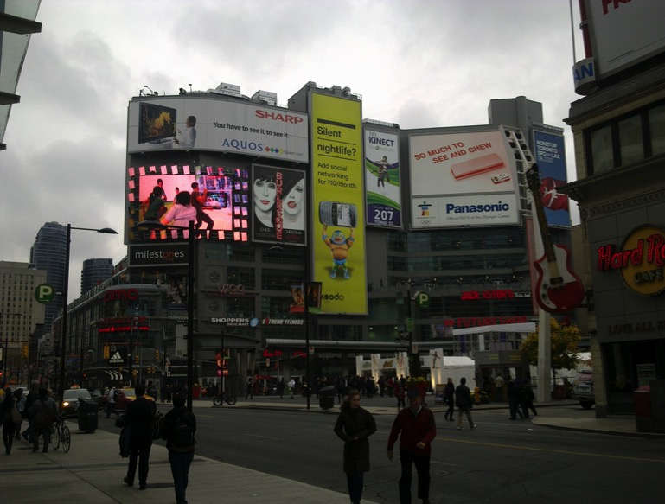
Christopher McElligott BA (Hons) MPlan
Thesis submitted for PhD programme in Social Sciences, Graduate Research Education Programme
National University of Ireland, Cork

Head of Department: Dr Niamh Hourigan
Supervisor: Dr Kieran Keohane

A genealogy of the neoliberal city, through four generations of shopping spaces in Toronto

Life in the City starts at the Centre

Table of Contents
List of Images 5
List of Figures 7
Declaration 7
Acknowledgements 8
Introduction 9
An archaeology of shopping spaces in the city 10
Literature on Neoliberal Urban Planning 13
Methodology 21
Why was Toronto chosen as the focus of the study? 24
Outline of thesis 27
Chapter Two: The City and the consolidation of consumer culture. 30
Yonge Street: the commercial heart of Toronto. 31
Toronto Arcade 33
The arcade – a world in miniature 38
The rise of the department store 42
Eaton’s Department Store 44
The Industrial Slum 48
Reshaping the Industrial City for Consumer Society 50
Municipal power in Toronto 1834 -1953 51
Housing in the Municipal City 54
Toronto Housing Company 54
Single Women in the City 57
Chapter Three: The Suburbs and the Mall 61
The Automobile Suburb 62
The emergence of Metropolitan Toronto 64
The Rise of Welfare Capitalism 68
Post-War Suburbia 69
Robert Moses – Re-imagining New York City for the Post-War Society 69
Don Mills – the model for Canadian Suburbia 71
The development of Suburban Shopping in Toronto 77
Shopping Spaces for the new suburbia 78
The Linda Vista Shopping Centre – welfare capitalism and military housing 79
Planning the Shopping Spaces of 194X 83
Victor Gruen – bringing Urban Vienna to Suburban America 85
Providing a focus for the ‘amorphous conglomeration’ 87
Tomorrow’s Main Street Today 90
The Materialisation of Mass Consumer Society 96
A shopping space for the ‘push button’ generation 99
The Malling of North America 106
Chapter Four: The downtown Shopping Centre 109
Focus shifts back to Yonge Street 111
Project Viking 114
Shaping the Shopping Quadrant 115
Facilitating Private Development 117
Extracting public benefit from private development 118
The Mayor’s Office 120
Nathan Phillips – Mayor of all People 120
A more fitting neighbour for New City Hall 122
The increasing power of the Metropolitan Council 123
Eaton’s proposal 124
Jewel in the Crown 125
The end of Old City Hall? 128
Friends of Old City Hall – Reclaiming the city 130
Negotiation and the politics of urban development 133
Eatons cancels the development 134
The Yonge Street Pedestrian Mall 136
The 1976 Central Area Plan 140
The Urban Crisis and the emergence of the Neo-liberal City 142
The Decline of Welfare Capitalism 144
The decline of Yonge Street 149
The impact of the neoliberal city 153
Re-casting the city: A response to the ‘Urban Crisis’ 155
Chapter Five: ‘Life in the City Starts at the centre’ The Eaton Centre 158
Toronto Eaton Centre: Creating the dreamworld 159
The Resurrection of the Toronto Eaton Centre 160
Opening up the Eaton Centre to the city 163
Public Access to Private Space 164
Selling the Centre 165
Connecting the centre to the city around it 166
Shifting the focus inwards 170
A multi-level shopping street 170
Life in the City starts at the centre 173
The Hyperreal City Street 177
Applying a veneer of urbanity 178
Flight Stop – Art in the City 181
The replacement of the public street 185
Chapter Six: The Suburb exteriorised in the City 192
Recession and the influence of Neoliberal policies on Toronto 192
Urban Planning to Urban Development Services 194
Public v Private – neoliberal urban planning 196
Planning framework and the emergence of Yonge Dundas Square 197
Timeline of the development of Yonge Dundas Square 201
What is public space? 203
Exteriorising the Mall – creating the ideal brandscape and shopping space. 205
Spaces with the appearance of Publicness 209
The privatised city 213
Revitalisation of the Eaton Centre 215
‘MORE THAN EVER In. To. You.’ 218
Maintaining the dream – preventing the ruin 219
The City of Late Capitalism 223
Creating the Secret – Being first in Canada 230
Chapter Seven: The ‘right type of people’ for the City 234
Smokers on the edge 238
Protest on the periphery 239
Inside the walls of the Toronto Eaton Centre 243
Shooting in the Food court 247
Idle No More protest 251
Virtual Communities: opting in. 252
Rules of the Toronto Eaton Centre Facebook page 255
Chapter Eight Discussion & Conclusion 265
How Neoliberal revitalization has recast the City 268
The Neoliberal City and public life 270
The impact of suburban individualism and the demise of universal Utopian Dreams 274
After Neoliberalism: The role of planning 276
Bibliography 279
Appendix 1: Archive of the evolution of the Toronto Eaton Centre Website 292
Appendix 2: Mall Map and tenant list from 2010 300

List of Images

Image 1 Entrance to Westfield Stratford City, taken December 2011. Many of the visitors to the 2012 London Olympics passed through the centre on the way to Olympic Park. Authors own 19
Image 2 Interior of Arcade By Unknown, Toronto Public Library code TEC 441B -Public Domain, https://commons.wikimedia.org/w/index.php?curid=49648432 35
Image 3: Advertisement, The Daily Mail, June 30, 1884. Via http://torontoist.com/2009/03/historicist_the_rise_and_fall_of_a/ 36
Image 4 Arcade Guide Cover Toronto Reference Library, Baldwin Collection 983-8-79 37
Image 5 Toronto Arcade Exterior, City of Toronto Archives 38
Image 6 Eaton's Catalogue Fall-Winter, 1884 [Reproduction of 1978] T. Eaton Co. fonds Reference Code: F 229-1-0-1 Archives of Ontario 45
Image 7Eatons College Street Store, now part of the College Park Development via City of Toronto Archives, Date unknown. 47
Image 8 Cottage Flats at Riverdale Courts ca. 1915 The Toronto Housing Company, Fonds 101 55
Image 9 Public Notice on Housing Shortage July 29, 1944 City of Toronto Archives Series 361, Subseries 1, File 56 65
Image 10 Canadian Mortgage and Housing Corporation Sketch Designs for Housing 1948 67
Image 11 Don Mills indicative site map illustrating key transport links and the Radburn style housing layout 72
Image 12 Don Mills brochure 73
Image 13 Map from the 1943 “Master Plan for the City of Toronto and Environs”, as reproduced in the Royal Architectural Institute of Canada, Journal, June 1944. The numbers in the yellow areas are residential population projections. (http://www.neptis.org/public) 75
Image 14 Carton from The Toronto Telegram, August 29 1957 76
Image 15 Linda Vista Community Development Corporation, 2014 http://www.lindavista.org/lvcdc/index.php/accomplishments.html 81
Image 16 Linda Vista Community Development Corporation, 2014 http://www.lindavista.org/lvcdc/index.php/accomplishments.html 81
Image 17 Linda Vista Shopping Centre aerial view. 82
Image 18 Garden Court, Southdale Mall Edina c. 1956 (Minnesota Archive) 91
Image 19 Aerial View of Southdale Center, Seventieth and France, Edina http://collections.mnhs.org/cms/largerimage.php?irn=10070510&catirn=10671105 93
Image 20 Aerial View of Southdale Center, Seventieth and France, Edina http://collections.mnhs.org/cms/largerimage.php?irn=10070510&catirn=10671105 95
Image 21 Mall Plan of Yorkdale Mall http://www.blogto.com/city/2016/05/what_yorkdale_mall_looked_like_in_the_1960s_and_70s/ 96
Image 22 Still taken from In the Suburbs (Redbook, 1957, Prelinger Archive) 101
Image 23 Still taken from In the Suburbs (Rebook, 1957, Prelinger Archive) 101
Image 24 Still From In The Suburbs of Hillsdale in California (10.00 – 10.25) 102
Image 25 Image from Eatons 1958 Catalogue http://richardlpaquette.ca/1958Eaton'scatalogue.htm 104
Image 26 Image from Eatons 1958 Catalogue http://richardlpaquette.ca/1958Eaton'scatalogue.htm 105
Image 27 Yonge Street, Eatons Store. 113
Image 28 Looking North, Nathan Philips Square is in the foreground, and was undergoing repaving at the time of visit, and The New City Hall in the Background. 122
Image 29 Overhead view of Model of Eaton Centre Development as envisioned Toronto Telegram, 1966 126
Image 30 Replacement building on site of Old City Hall 127
Image 31 In the presentation to the Metro Council, these Illustrations showed the proposed scale of Eaton Centre plans for new centre 129
Image 32 Shot taken of diners outside a restaurant on Yonge Street Pedestrian Mall 137
Image 33 Shot taken of diners outside a restaurant on Yonge Street Pedestrian Mall 138
Image 34 Shot taken on Yonge Street Pedestrian Mall 138
Image 35 Shot taken of pedestrians on Yonge Street Pedestrian Mall 139
Image 36 Cover Page of The Toronto Star from August 2nd 1977 151
Image 37 Taken from Flickr user Islandersa1 (https://www.flickr.com/photos/58226389@N07/5353499368/in/photolist-9a55Rf-9fqYBL-9fqYRE-9fqYKm/) 154
Image 38 November 2010. Looking South East, Nathan Philips Square can be seen in the foreground and the Old City hall and its Clock Tower can be seen in the left background. Behind this, we can see the Cadillac Fairview tower, which is part of the Eaton Centre. 156
Image 39 The Church of the Holy Trinity now located in Trinity Square, (November 2010) 162
Image 40 Indicative Map of Eaton Centre in relation to transport links and other key downtown attractions from Centre Brochure. 167
Image 41 Site Plan of the Proposed Eaton Centre, which shows the location of the key anchors and footfall drivers and the layout of the multi-level Galleria 168
Image 42 Cadillac Fairview, Lettings Brochure, date unknown. View southward with the Yonge and Dundas entrance in the foreground, and the Old City hall in the centre of the photograph 172
Image 43 Life in the City Advert 1983 via Retro Ontario 173
Image 44 At 0.04 the female shopper browses the Jewellery selection, behind the plate glass windows reminiscent of Benjamin’s Arcade 174
Image 45 0.24 secs View of Eaton Centre with Helium Balloon floating upwards. 176
Image 46 North East Corner of the centre, the entrance from Yonge and Dundas. 181
Image 47 Author’s own image taken 03/11/2010 182
Image 48 City of Toronto Archives Fonds 1257, Series 1057, Item 56. In this image, we can see three department stores on Yonge Street. On the left side of image (west side of street), Simpsons (Now The Bay) is in foreground, Woolworths is in middle ground and Eaton's is in background. (Public Domain) 189
Image 49 : Post 1977 image of the Eaton Centre, The Former Woolworths store can be seen in the left of the image. City of Toronto Archives 189
Image 50 This image from the City of Toronto Archives is undated but appears to have been taken in the early 1990’s before the alterations were made to the Yonge Street façade and the removal of the external walkways and entrances. The blank 1970’s façade of the Woolworth store has been replaced with a postmodern blend of the original Nineteenth Century building with late twentieth century addition. 190
Image 51 taken from Google Streetview 2012 shows how the Yonge Street Façade has changed over the period. Woolworths closed in the 1980’s and a number of different tenants have occupied the space since. 190
Image 52 Yonge Dundas Square looking North. The building frontages facing the square were emblazoned with supersized advertising billboards and large L.E.D. video screens. The site is a simulation of other famous city centre spaces such as Times Square. 205
Image 53 Yonge Dundas Square looking West, the Eaton Centre is in the centre left. 212
Image 54 Bollards and signage to indicate you are entering Private Property in Spitalfields, London (Authors own, taken December 2011) 214
Image 55 6th Jun 2010 Revitalisation Overview 217
Image 56 Eaton Centre Homepage 8th Feb 2011 217
Image 57 Urban Eatery Launches September 1st, 2011 218
Image 58 Homepage 2nd Sept 2011 218
Image 59 Taken on Level 4 of the hoarding which was placed to hide the building work. 220
Image 60 Revitalisation poster 221
Image 61 View of Eaton Centre scaffolding 222
Image 62 ‘Sorry for the Disruption’ Freestanding sign outside The Gap clothing store which was under refurbishment. 225
Image 63 Interior view of Eaton Centre looking south illustrating the scaffolding encasing the centre. 227
Image 64 Interior view of the Eaton Centre looking North towards Sears (Eaton’s). 227
Image 65 Hoarding with retailer imagery – Aéropostale Image 66 Hoarding with retailer imagery- Nike 228
Image 67 Hoarding with retailer imagery - TNA 228
Image 68 Lowered Hoarding in front of Arizla women’s clothing store. 229
Image 69 The Suit Exchange, closing due to lease expiry 230
Image 70 Frontage of the Victoria’s Secret Store is blank besides for two posters. The imagery has the aura of sexuality but does not expose any intimate aspects. 231
Image 71 Screencap of www.torontoeatoncentre.com from 4th Jan 2006 – Advertising the first in Canadian branch of Hollister Co. – an American Youth casual fashion brand. 232
Image 72 Yonge Dundas Square Looking East 235
Image 73 Narrow strip of pavement outside North East Corner of Toronto Eaton Centre on Yonge Street. 240
Image 74 Protest outside Eaton Centre, with Yonge Dundas Square in the background. 240
Image 75 Front and back of a Leaflet being handed out at the Entrances to Sears from Yonge Street 241
Image 76 Sears workers protest the implementation of new contract terms. 242
Image 77 Break-dancers perform at the Yonge and Dundas corner of the Eaton Centre. 243
Image 78 Shot of interior of the centre. 245
Image 79 First Tweet from @CFtoeatonCentre [https://discover.twitter.com/first-tweet#CFtoeatonCentre] 253
Image 80 Facebook Interactions 254
Image 81 Twitter Interactions 255
Image 82 Facebook page #MothersDay promotion 258
Image 83 Homepage of Toronto Eaton Centre 23 Sept 2014 262
Image 84 #TOTHECITY promotional material 263
Image 85 Open streets TO 272
Image 86 The role of the City Planning in the 21st Century should be as a marshal between competing interests 277

List of Figures

Figure 1 Three subsystems and their relationship’ Offe (1993) 146
Figure 2 Adapted from J.C. Williams Group Appendix D p.4-5 202
Figure 3 `Demographics of visitors to Eaton Centre and Yonge Dundas Square 206
Figure 4 Twitter number of references by month to #ToTheCity 259
Figure 5 Number of references by Hashtag 260
Figure 6 Volume of connections #ToTheCity 261
Figure 7 The shift balance between Public V Private since the nineteenth century shows that the city is a site of contested interests and perspectives 269

Declaration

This thesis is my own work and has not been submitted for another degree, either at University College Cork or elsewhere.
Signature________________________ Date: _____________________________

Acknowledgements

It is a privilege to be afforded the opportunity to pursue PhD study. I am very grateful to live in a society which makes it possible to do so. I am also thankful for all those who helped me during my studies. Firstly, I would like to express my gratitude to my advisor Dr Kieran Keohane for his guidance and encouragement that led me to pursue my research interests by taking up the PhD study. I also owe a debt of gratitude to Prof Cathal O’Connell and the rest of the staff from the Graduate Research Education Programme for their support and guidance throughout.

For their insightful comments and encouragement, I would also like to thank Dr Clare Edwards and Dr Marie Leane. I am grateful for the help that Ms Aine Flynn, Ms Michelle Nelson, and the staff of the Graduate Studies Office provided in helping me reach the submission stage of this thesis. I also would like to thank Dr Niamh Hourigan and Dr Mervyn Horgan for taking the time to examine the thesis and allowing me the opportunity to defend my work during the viva voce.

To my biggest cheerleader and greatest advocate, my mother Anna Marie, thank you for the encouragement and support throughout my 29 years of formal education! My siblings Barry, Grace and Tom, thank you for your support and encouragement throughout the PhD journey.

To my late grandmother Anna who never did make it to my graduation ceremony; your thirst for knowledge and drive for self-actualisation will be carried by your children and grandchildren to be passed on to future generations.

Also absent from future celebrations, my aunt and godmother Rose, and late grandfather Sam, who along with the rest of my extended family had a role throughout my formative years in shaping the person I have become. Thank you!

Thank you to my friends Conor, David, Gavin, Geraldine, Kiera, Karen, and Jan who have provided counsel and laughter throughout the PhD Study. And finally, to my colleagues in the IT Services Department, thank you for your support and encouragement especially in the finally stages of the study.

Introduction

In constructing a genealogy of the neoliberal city, this study seeks to uncover a historical archaeology of shopping spaces in the city of Toronto. This will reveal traces of the influence that the exercise of power has had on the way in which the city has come to be managed. This study is not a search for its origins, or the outline of a strictly linear development. Instead it highlights the emergence of specific interventions in urban life which made the city more hospitable to consumer culture and highlighting the practices of thought and action that officials, reformers, and shoppers developed to deal with problematic situations, we can uncover how the city came to be dominated by consumption practices.

Foucault (1972) outlined how genealogy is in part a struggle against the coercive effects of hierarchized formal scientific discourse. The formal institutions of knowledge are so encompassing that "genealogists" must constantly be shift their ground and their concepts to avoid capture by the intellectual establishments. Foucault's ideas of genealogy were greatly influenced by the work that Nietzsche had done on the development of morals through power. In his essay “Nietzsche, Genealogy, History" Foucault (1971) outlines how Nietzsche developed a method of philosophy which focuses on history and engaging with it as a process which has never come to an end and will never end. Foucault (ibid.,) describes genealogy as an investigation into those elements which "we tend to feel [are] without history". By conducting an archaeology of a phenomenon, 'the genealogist needs history to dispel the chimeras of the origin, somewhat in the manner of the pious philosopher who needs a doctor to exorcise the shadow of his soul'.

The genealogical method which Foucault advocates, is most explicitly outlined in the thesis of Discipline and Punish (Foucault, 1991). He outlines the links between the emergence of the human sciences to a shift in strategies of power which occurs at the end of the eighteenth century and he argues that this shift most dramatically manifested in a change in the economy of punishment. With his analysis of the prison system, especially Bentham’s panopticon, where the prisoner is constantly faced with the possibility of surveillance, Foucault ‘problematized’, the practices we generally accept as given. This has the effect of questioning our intellectual and institutional habits as historical products. This genealogy of power-knowledge is an emphatic rejection of the totalizing discourse of Marxism or psychoanalysis. It is an argument to rally against disciplinary power. What bothers Foucault about the aspiration of Marxism and psychoanalysis to scientific status and the privileges of a "theoretical avant-garde" is the implicit grasp for a certain kind of power. This puts the hands of defining the problem in the hands of those who have already been bestowed the power to define through disciplinary power.

To understand the connection between retail development and the role that consumption plays in the neoliberal city, a genealogy will be used as a mode of analysis that sheds light on the historical construction of theories and institutions to focus our attention on basic habits of thought and action. This study analyses how the advent of, and transformations in these retail spaces, has contributed to the emergence of neoliberal urbanism. Four generations of retail development that have contributed to its emergence will be identified. The central argument is that the neoliberal city is dominated by consumption, and that dominant governance principles revolve around attracting forms of global capital that facilitate and bolster a globalised consumer culture.

An archaeology of shopping spaces in the city

The first iteration of retail development that will be identified is the enclosed arcade. It will be demonstrated how the principles of enclosure, sanitization and control characteristic of the arcade, have been replicated and re-applied to subsequent retail development. The development of the enclosed shopping arcade in the nineteenth century had the effect of creating a space which could reduce the city to what Benjamin (1999) described as ‘world in miniature’ within its walls. The development of the arcade demonstrates a tendency during this era to retreat from the urban realm into the privately controlled realm. In the arcade, commodity fetishism could take hold of the shoppers who visited an environment which was free of the poverty and squalor of the industrial city. The arcade was usurped by the department store which removed the plate glass barriers between the shopper and the goods and heralded the beginning of the era of mass consumption. The department stores spread out into the city, locating along major public streets. This growth of the phantasmagorical realm which had begun in the arcades, began to spread out beyond its walls and occupy the general urban realm.

The next generation of retail development arises with the growth of the suburbs from the early twentieth century. The rise of the suburbs which was greatly facilitated through private car ownership and urban policies prioritised home ownership over other forms of housing tenure. The result saw urban life sprawl further and further into a suburban realm. As the city spread out, new retailing centres were necessary. From the earliest shopping centres of the 1920s to the enclosed regional shopping malls that emerged in the 1950s, there is a process of reimagining of the ideas introduced in the Arcade to create a miniature commercial city in the suburbs. Surrounded by acres of parking and sealed from the elements, suburban shopping malls such as the Southdale Centre (1956) in Minnesota acted as a template for suburban centres across the world.

The city experienced vast spatial and structural changes in second half of the Twentieth Century. As industrial, residential, and commercial uses migrated from the city core, the city faced new competition for growth with the expanding suburbs. The legacy of redundant industrial landscapes and underutilised commercial centres and the resulting decline in municipal revenue became a significant issue for urban authorities. Because of this, there has been an increasing impetus for revitalisation of the city. As the city attempts to cope with the growth of suburbia, we see the development of enclosed shopping centres in downtown areas, which bring the elements of control and enclosure which were refined in the suburban mall to the downtown realm. In a similar manner to the arcade, the downtown shopping mall is sealed off from the surrounding streets and creates a space in the city which is focused on consumption.

The next stage occurs when the elements of control and surveillance in the suburban and city centre enclosed malls are applied to open-air city spaces. The privatisation of public streets and the rise of non-governmental and semi-public forms of power to control and manage these spaces, mark the retreat of municipal power from urban life. The shopping mall and the associated sensibilities it projects are no longer restricted to within the physical boundaries inside the walls of the mall. The shopping mall has been used as a template to reinvent the city to suit the consumer culture that it promotes. In this scenario, the city street no longer acts as a public place where all citizens can interact freely. Instead, city authorities relinquish control of these spaces, and it becomes a tightly managed and controlled space for the ‘right type of public’ to interact with the world of the globalised consumer culture.

We see the progression from the municipal city as the early provider of welfare to the inhabitants of the industrial city, to the post World War II welfare state which provided income guarantees and mass employment through the embracing of the ideals of Welfare Capitalism. In the 1970s, we see the decline of the welfare state as Keynesian economics fails to solve the economic crisis which emerged. This created a political and ideological vacuum which was filled by neoliberalism. We see the materialisation of the dominant economic ideology in the emergence of what could be termed the Neoliberal City. The neoliberal paradigm is an approach in which the city is repositioned to no longer function solely as a place to live and a centre of trade and culture, but as an attractive destination for mobile transnational private investment. In this narrative, the city must attract speculative ventures from global property funds and development companies and it must compete on an international level for this investment. The result is that the city is transformed into a space which must act as a shop window to the world; attracting visitors, migrants, and global capital.

A dominant model for planning the revitalised city has emerged in the past 40 years. With the rise of the neoliberal approach to city management from the mid-1970s onwards, there has been a vast volume of research on the impact that these policies have on the city. In the literature, there is a consensus that there has been a rise of urban spaces which are controlled by new forms of management outside of traditional municipal control (Minton, 2009; 2012, Harvey, 1989; 2000; 2003, and Sennett, 1977). This has resulted in spaces in the city which are managed and controlled by private entities such as property management companies or semi-public bodies created by municipal authorities. This model of urban development and revitalisation has been pursued by local authorities, property developers and urban planners, through an array of terminologies, theoretical conceptions, and urban policies

Literature on Neoliberal Urban Planning

Neoliberal approaches to the city revitalisation and redevelopment have had a significant impact on urban planning and local governance from 1970s onwards. Richard Sennett (1977) charts the emergence of the privatised enclaves of Battery Park in New York in his book The Fall of Public Man. In this he carries out case studies of the newly emerging privatised spaces which have the appearance of public access but are tightly controlled by private property owners Sennett (1977 p.14) talks about the impact of this internationalist style in terms of three developments in New York, Paris, and London. He criticizes the enclosed open spaces in the Lever Building in New York, the impact of the concourse of the Brunswick centre which serves as a barrier which separates ‘within’ the centre from ‘without’’, and the Defence area in Paris, with its large office blocks and small amount of shops as an area to be travelled through and not one to linger within. Sennett (1977 p. 16) argues that the signs of a ‘blatant signs of an unbalanced personal life and empty public life have been a long time in the making.

One of the more influential recent approaches emerges from the ideal of the Creative City. Landry and Bianchini (1995) outline what constitutes this city type using examples from the United Kingdom, United States and Germany amongst others, of cities that have embraced ‘diverse forms of innovation to deal with recession and post-industrial scars on urban centres. Landry (2000) elaborates this in his Toolkit for Urban Innovators through case studies including Glasgow and Helsinki. He uses these case studies to illustrate how innovation and creativity can be driver of city redevelopment and help the city to recover from de-industrialisation and economic stagnation. The Creative City became the de rigueur approach to revitalising the post-industrial city and it was spawned a significant output of literature and studies.
In the footsteps of the Creative City movement, The Rise of the Creative Class by Richard Florida (2002; 2005) became a popular go-to for urban planners as a possible model of city development that could help revitalise their cities. It proposes a model of the revitalised city as an attractive site for creative elites. This is led by the belief that by focusing on attracting these individuals, it will lead to the creation a successful city, and business and capital will follow. Florida’s thesis proposes that there is a relationship between the creative class and economic growth of a city. Florida’s ideas were broadly assimilated into the urban revitalisation policy across the United States. This was especially the case in slow-growth metropolitan areas, where it was hoped that a ‘‘creative city’’ development strategy might reverse decades of relative decline. Peck, (2005) argues that this creative city growth strategy worked primarily to repackage and strengthen the downtown-based property-led development paradigm. Zimmerman (2008) elaborates on the criticisms of the Creative City with a case study of Milwaukee’s redevelopment. It illustrates how cities that pursue the creative city development strategy are engaging with the forces of neoliberalism. Zimmerman concludes that the marriage of Florida’s ideas with municipal action served to reinforce difference in one of the most economically and racially polarized large cities in the United States.
As was the case in other cities experiencing economic distress, Milwaukee’s growth coalition became captivated by Richard Florida’s thesis about the relationship between sustainable economic growth and the creative class… The marriage of Florida’s ideas with municipal action in Milwaukee did support a celebrated resurgence in the comparatively tiny downtown area, but it did nothing to forestall the economic disintegration of the remainder of the city. It therefore ultimately brought into even sharper relief what was already one of the most economically and racially polarized large cities in the United States
(Zimmerman, 2008 pp. 240-241)

Zimmerman’s study of Milwaukee reinforces the assertions made by Peck (2005) in terms of identifying a property-led development paradigm. The creative city development strategy is broadly in line with the policy approaches first outlined by Harvey (1989) in terms of the entrepreneurial city. Milwaukee, like many other industrial cities experienced intensified inter-urban competition and the solution prescribed through place marketing and privately funded property-led development resulted in gentrification, and inequality. Desmond (2016) explores this in his ethnography of eight families who are tenants of low-income housing in Milwaukee. He identifies the inequality of housing provision in de-industrialised cities.

More recently, we have seen the ideal of the Smart City which is being spearheaded by technology companies such as IBM, CISCO, and Intel as the technological solution to managing the urban realm. This technological utopia is driven by a similar ideology that technology and private management can create the ideal city and it has been criticised widely for the impact it has on urban governance and the dystopian potential for mass surveillance through the vast amount of data that is being gathered on city residents. (Sennett 2012; Kitchin 2014). The Smart City paradigm is mainly driven by a corporate agenda in order to sell local authorities new technologies which will improve efficiency of city systems or eliminate human labour. There is a concern that this will result in the corporatisation of the city. This is especially possible in initiatives to build new smart cities in Songdo or Masdar City where technology companies have a major impact on the form these settlements are to take. As corporate IT giants attempt to convince local authorities to deploy their technology to make our cities smarter we see the active promotion of a neoliberal political economy. Public Services can be tendered out to the lowest bidders and traditional city functions are managed for private profit (Hollands, 2008). This is symptomatic of what a trend towards New Public Management (NPM) which can be first identified in Thatcher’ Britain of the 1980’s where new approaches to public administration emerge.

Hood (1991), is one of the first to use the term New Public Management to capture the scale of the changes that were transforming the administration of public services. We see the application of a corporate approach to managing public services as citizens come to be seen as consumers of public services. The logic of NPM has been to encourage policymakers to ‘depoliticize’ functions (Flinders, 2008) and the separation of work out into separate organisational units and organisations which can compete for work and whose outputs can be explicitly measured and compared (Dunleavy and Hood 1994). In terms of planning, the impact of NPM can be seen in the creation of decentralised units within planning departments to focus on encouraging development. One such organisation to emerge from this approach was the London Docklands Development Corporation. It was a quasi-autonomous non-governmental organisation (Quango) that was established by the then Secretary of State for the Environment, Michael Heseltine, under section 136 of the Local Government, Planning and Land Act 1980, to lead the regeneration of the Docklands area in the east of London. While the Corporation was seen as a success in leading the redevelopment, it encountered criticisms in terms of the relationship it had with local communities. There was a shift of power from elected representatives to non-elected managers in this type of organisation (Ferile et. Al. 1996) which resulted in criticism of the role that the local community could play in the regeneration measures that were implemented.

The rise of new forms of public management can also be seen in the way public spaces are owned and managed. With increasing privatization and public/private partnerships the division between the roles of public and private sectors in providing public services become intertwined. In 1961 in New York City, the authorities began to allow developments that have increased density in exchange for developers allotting open public spaces on their land. These Privately Owned Public Open Spaces (POPS) in Manhattan, New York which were prescribed in a zoning resolution by the New York Planning Authority from 1961 onwards. (Kayden, 2000). The development of POPS is the ultimate form of deregulation of the role of the urban municipal authority in managing life in the city. These spaces were designed and managed in part for the owner’s private interest in succinct and ambiguous ways (Mitchell 1995; Smithsimon 2008). As a result, many of these POPS were considered a failure and attempts were made to revise these resolutions to create spaces which serve the public (Yoon, and Srinivasan, 2014) but as we have seen there are still questions over the public nature of these spaces in recent years with the emergence of the Occupy Wall Street movement in Zuccotti Park, a POPS in the financial area of the city.

The trend towards the enclosure and privatisation of what was once ‘public space’ has been a focus of investigation for many years (Davis, 1998; Sorkin, 1992). Others have investigated what is referred to as a new management trend of quasi-public spaces, within which the public are expected to abide by the rules which are created to achieve private goals. Minton (2009) outlines the two key trends in terms of how the privatised city has emerged. The first is the privately-owned city. Minton uses Canary Wharf as the example of a vast city complex built to suit the needs of finance in the London Docklands. Minton argues that this site became a template for the redevelopment of town centres across the United Kingdom, such as Liverpool One which is owned by the Duke of Grosvenor. The second model of the privatised city which Minton identifies is the privately managed city. This is evident in the Business Improvement District (B.I.D.) model where control and governance of certain neighbourhoods has been devolved to city centre streets and commercial areas. Minton argues that the main aim of both of these models is to keep property prices high and to extract the greatest profit for the investors.

In the privatised city Architects and Planners are expected to help create an environment which fits with the requirements of private capital which mainly includes property owners and investors. The city becomes a product from which profit can be extracted. In a similar manner, the local authority wants to maximise the return to the exchequer by creating an environment which is attractive for inward investment. Keil (2002) explains how the vision for the reinvention of the city of Toronto with its ‘New City Plan’ and bid for the 2008 Olympics was driven by planner, architects and business lobbies who had links and access to transnational capital and government funding. This approach is one which employs ‘nominally progressive elements and a vocabulary of urban reform’ but it is actually about reshaping the city to suit neoliberal and entrepreneurial orientations to produce a gentrified simulation of the city which suits the needs of private property owners. The Toronto plan, though never implemented follows the same path as that implemented elsewhere such as London in 2012 in terms of pursuing a neoliberal approach to revitalising the city and making it more attractive to international investment.

In a similar vein to the Great Exhibitions of the nineteenth century, the staging of global sporting events such as the Olympics, have come to be regarded as opportunities to reposition cities on a global stage. Staging contemporary global events such as the Olympics, tends to involve significant public investment in buildings and facilities which in the case of Athens Olympic 2004 infrastructure lies empty and underused afterwards, or as in the case of London and Rio, is sold off to private developers who can extract profit from large scale Olympic investments. Miles (2012) refers to as the ‘Olympics effect’ where public investment is targeted into providing infrastructure for a high profile global event to revitalise an area of the city making it more attractive for global capital. As evidenced in the vast public investment in the Rio 2016 Olympics, this type of investment does not benefit all residents of the city equally. The vast public investment has been made with the aim of making the city more attractive for private investors. This is illustrated through the sale to Qatari Diar, the oil-rich state's investment arm, and UK property developer Delancey Estates of the athletes' village next to the London Olympic Park for £557m which resulted in a significant loss to the U.K. exchequer.

In 2012 Minton updated her 2009 book about fear in the contemporary city to take into account the London Olympic Park and the development of Westfield Stratford City. She argues that the Olympic developments were about maximising the return for the exchequer. The Olympic village was sold to the Royal Qatari Family, the shopping mall was developed by an Australian company and the remaining parkland became Queen Elizabeth II Park. What becomes clear is that the city is being re-shaped and redesigned for a global sports event but in reality, it is being redesigned as a consumption space.
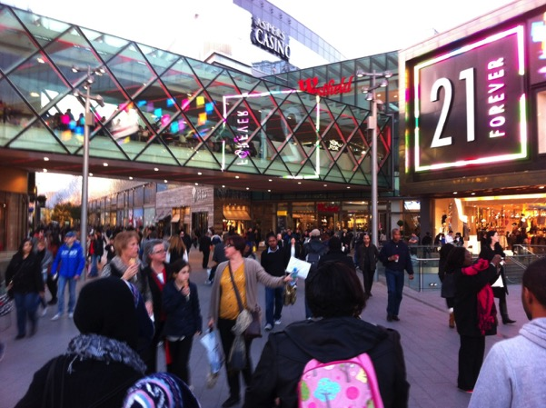
Image 1 Entrance to Westfield Stratford City, taken December 2011. Many of the visitors to the 2012 London Olympics passed through the centre on the way to Olympic Park. Authors own

Miles (2012) looks at the development of Westfield Stratford City in London as the central commercial core of Olympic Park for the 2012 Olympics. This is an example of how the city is being re-shaped for middle class consumption cultures. The re-generation of this former industrial wasteland in East London saw it re-cast and re-imagined becoming the centre of a new urban landscape. The Shopping Mall became home to international food, fashion, and leisure brands. However, Miles also proposes that the consumption this centre will bring to the area will give the opportunity for personal and social exploration.
It may be that not only will such a mall provide a boost to the local economy… but it may also intervene in people’s lives in such a way that they become readily and actively complicit in the freedoms to consume that such spaces provide. In this context, it could be argued that consumption potentially at least provides a particular kind of citizenship in which the consumer’s relationship with the city comes to the fore.
Miles (2012, p 221 - 222)
The advent of this type of commercial space in the East End of London allows the nearby residents that chance to claim citizenship in the agora of global consumer society. In this contemporary commercialized private agora, the consumer can experience global brands and dining experiences and mix with the masses. It is the illusion of freedom and the chance to experience the physical realm of the consumer capitalism

It has been discussed how neoliberal approaches to city planning has shaped and re-shaped the city by creating new spaces for consumption and new opportunities for the investment of surplus capital. There has been a change in how we manage, develop, and own the city. Whereas before the private commercialised sphere was limited to the arcade, the department store, or the shopping mall, in the contemporary city, the difference between public spaces and spaces which are privately owned or managed is less apparent. As the enclosed shopping mall arrives downtown and, the city street becomes enclosed and privatised, and in a sense sanitised to replicate the suburban mall. It is a recreation of the Arcade on a massive scale in the city centre. The relationship we have with this shopping space is deeper than the purely rational relationship we have with it as a site of consumption. It becomes a central part of urban everyday life. It imbues meanings and values in those who visit it. It encourages us to behave in a certain way. What we have seen is that consumerism and desire have been at the core of the materialisation of consumer society in the urban realm. The dominant narrative for how a city should develop has been shaped by the requirements of neoliberal capitalism. In a sense, the city itself is increasingly being privatised.

What unites the approaches outlined above, is that they embrace a vision of urban re-development in which the government or local authority is retreating from the provision of universal services and welfare towards a model which targets public investment into initiatives that make the city more attractive to private speculation. Cox (1993) refers to it as ‘new urban politics’ where the combination of globalisation and the resulting hypermobile nature of capital exert strong redistributive pressures on urban communities. Harvey (1989) conceptualised it as the shift towards the ‘entrepreneurial city’ when he describes the shift of urban planning towards facilitating private property interests. Harvey (2000) elaborates on the impact of this referring to it as 'feeding the downtown monster' which he coined to describe the investment of public funds into large downtown plans which did not serve the interest of the broad public. This thesis will explore the impact of this new urban politics on one particular city in the form of an extended case study which will illustrate the impact that the shift in dominant narratives on urban planning and governance have had on its downtown.

Based on the review of the literature, the key research question which will be considered is the connection between the advent of and transformations in retail spaces in the city of Toronto to the emergence of neoliberal urbanism. The literature points to the emergence of the Neo-liberal city as the dominant trend that drove the reinvention of city centres which experienced industrial and commercial decline. This study will assess the validity of this paradigm in relation to the selected site. The dominant perspective which emerges from the literature is that the balance has shifted between public and private space in the city. The central argument that emerges is that the neoliberal city is dominated by consumption, and that dominant governance principles revolve around attracting forms of global capital that facilitate and bolster globalised consumer culture. This assertion will be evaluated with the site chosen. The hypothesis that materializes from the literature is that the contemporary City has been recast by neoliberal urban policy as a site of profit accumulation, where the shape and structure constantly needs to be renewed to facilitate the capitalist appetite for growth and profit. This study will evaluate how this applies to Toronto and will identify instances where this dominant narrative is subverted and reimagined. This will allow the identification of the sites of resistance in the capitalist city. Having considered the sites of urban resistance retrospectively, the study seeks to signpost prospective developments and the impact that technology has on the ability for resistance to spread across geographic boundaries and nation borders.

Methodology

The argument outlined above guides the inquiry towards the use of research methods which go beyond measuring and recording specific phenomena to establish the links between the dominant economic and social paradigms in the city and the consumer society. The epistemology underpinning this research rejects the totalizing discourses of Marxism or psychoanalysis and is interdisciplinary in nature, combining Sociological, Geographical and Urban Planning. By taking this approach, it strives to avoid the rigidity of a singular disciplinary power. It puts the hands of defining the problem in the history that can be unearthed from the development of retail spaces in Toronto and the impact that this has had on the way in which the city has come to be governed. For this reason, the methodology is empiricist, realist and descriptive, based on an extended historical case study of the development of the Toronto Eaton Centre. Each of the generations of retail spaces that are identified illustrate a general pattern: from the 19th Century arcade, to the suburban mall, to the downtown mall, to the city re-made after the model of the mall; each of these iterations in turn correspond to historical political-economic formations, municipal capitalism; welfare capitalism; the crisis of the welfare state; and neoliberalism.

This study will engage with the canon of texts on urban planning in the neoliberal city and assess how they apply to a specific city downtown. This case study will outline how a city centre developed and outline how the dominant narrative which guided this development shifted over time. It will also identify the sites of resistance against the dominant planning orthodoxy of the time and how in time, many of these sites of resistance were co-opted into the mainstream approach to city development. The case study will act as the foundation on which to base observations and it will assess whether the general understanding of the neoliberal urbanism that has emerged in urban and sociological theory applies to a specific site.

The fieldwork data gathered for this research is centred upon fourteen days of participant observation in the Eaton Centre and surrounding downtown. Fieldwork was carried out at the Eaton Centre between November 04th and November 18th, 2010. This time was chosen to capture a holistic image of the reality that exists in the mall, outside of the Summer and Christmas season. Daily site visits were conducted over the two weeks, which were recorded through written accounts and photography. I visited the mall every day, arriving by different entrances, through different stores, and from different levels. The visits were carried out at various times of day, during and after business hours. Photographic evidence was gathered focusing on the structure of the mall, the physical features - the attempts to ‘mask’ the building during redevelopment work, to maintain the ideal shopping environment. Each floor and section of the mall was visited, and displays and promotional materials were observed. Over 200 photographs were taken and coded and categorised using the Social Sciences Qualitative research tool, nVivo.

Due to the remote nature of the site from where I am based, significant preparations where made before I embarked on the fieldwork. The initial preparation involved contacting the key interview targets for this project to arrange face-to-face interviews during the course of my visit. When I arrived, I met management from the centre and held an unstructured interview with Brian O’Hoski, who worked for Cadillac Fairview, the property management company who owns and manages the Toronto Eaton Centre as the relationship manager between tenants and the mall owners during the revitalization process. I had contacted what from my initial research I considered to be key actors, including members of the planning department and researchers in the local community, but due to the condensed nature of the fieldwork trip, and the availability of interview targets, it was not possible to conduct further interviews. The focus of the research took a step away from the accounts of the individual actors and shifted towards identifying the key texts in terms of planning policy and documents, property brochures and media accounts of the development process. During the fieldwork visit I had the opportunity to gather other sources from the Toronto Urban Affairs library, including key planning documents related to the development of the centre. This was to prove a rich source of primary data on how the Eaton Centre came to be. This historical evidence contributes to a spatial archaeology of the site. This historical account is combined with the contemporary observations which were collected on the physical space and the activity that was happening within it. The aim of this is to place the Eaton Centre within the canon of texts that exist about the neoliberal city.

Studying this site from a remote location, I was limited in terms of the access I could have to the site. Other methods of online research were employed to gain a deeper understanding of the site. The included gathering the promotional material which existed for the Mall. I had studied the website www.torontoeatoncentre.com before visiting the centre, and followed its social media streams on Facebook and Twitter after I returned home. A social listening tool was set up using the online monitoring system Google Alerts to notify me of internet postings in relation to the Eaton Centre. This was set up to email me in relation to key terms “Toronto Eaton Centre”. This method contributed to the data collection phase and also kept me informed of any mentions of the Eaton Centre on news websites, forums, or blogs. The Mall's online social media presence not only kept me informed of the progress of the revitalisation, but allowed me to keep up to date of any changes to the mall, which the developers wanted to promote. The commencement of the study coincided with the increasing spread of social media into the realm of community building for individuals and brands. The Toronto Eaton Centre launched social media presences early in the research phases of this study with their Facebook and Twitter pages going live in July 2010. It became apparent that this would offer a rich source of material which could be gathered with minimal intervention or mediation by the researcher. The data lay waiting to be collected and recorded in a manner which has minimal impact on the reality in which it can be observed.

With the combination of data collection methods, including fieldwork, desk-based and online research, the overall aim of the fieldwork in the Eaton Centre was to trace the ideals which are shared in what has become a key space of everyday life in downtown Toronto. The search for what Benjamin had referred to as the stillstellung or the freeze frame moments is an attempt to awaken understand the mythic forces which drive the consumer realm. The research is not a critique of consumption, it is an interpretation of how and why a city has developed.

Why was Toronto chosen as the focus of the study?

There have been several studies of retail spaces which have been focused on suburban regional shopping centres (such as Crawford, 1992; Goss 1999, Shields, 1989; Underhill, 2005). Attention has also been paid to downtown post-modern types of retail spaces such as Horton Plaza in downtown San Diego (Jameson, 2003) and the Toronto Eaton Centre (Jameson, 1991). This research follows a similar approach, but keeps the focus on one site over a longer period. The studies of shopping centres mentioned above focus on the immediate reality observed by the researcher. This study has similar elements to the study of shopping centres in Canada (West Edmonton Mall and Toronto Eaton Centre) carried out by Shields (1988) in which he constructs a spatial archaeology of these sites to uncover how they emerged. This aligns with the aim of the study to engage with the canon of texts on the neoliberal city and assesses whether these apply to a specific site. It accepts that cities have been a constant site of change and capitalist endeavour. It also accepts that spatial phenomena such as the enclosed shopping mall are but one of many types of spaces in the city which are designed to encourage consumption and which also includes the arcade, the department store, and the public city street.

In the early stages of this research, the focus was drawn to one site. Opened in 1977, the Toronto Eaton Centre was a pioneering type of downtown shopping mall. Located in the centre of downtown Toronto, it embraced elements of the nineteenth century arcade, the Gallerias of Milan, and the malls of Southdale Minnesota. The key factor which marks the site out is the fact that it was positioned and marketed as ‘the new centre of the city’. It was billed as a hermetically sealed replacement downtown. The centre brought the elements of the enclosed suburban shopping centre downtown and re-cast urban life in its shopper friendly image. The historical development of the centre and its subsequent redevelopment, along with the impact it had on the city streets around it provide a vast subject area for investigation. The Toronto Eaton Centre is an exemplar for the themes explored in this study and the ideal case study site to test the paradigms which were explored in relation to the neoliberal city in the literature review.

The Toronto Eaton Centre can be considered an archetype of the type of redevelopment that was happening in downtowns across the world. It was a harbinger of the emergence of the Neoliberal city. Sheilds, (1988) recognised this when he analyised the Toronto Eaton Centre in the 10 years after it’s opening. His approach was influenced by Benjamin in the attempt to create a spatial archaeology of the shopping arcade/shopping mall. Shields charts the development of the arcade in the 19th century up until the early 1980s when we saw the emergence of the super-regional malls in Canada. He focuses on the West Edmonton Mall, at the time the biggest mall in the world and the Toronto Eaton Centre an enclosed downtown shopping mall in Toronto. In the case of the Toronto Eaton Centre, it became a simulation of Toronto City Centre, fully enclosed and sanitised of the undesirable elements of city life. Sheilds refers to this as a spatial moment in which the physical environment influences the socially constructed reality. The shopping mall became the new downtown, positioning itself as the sanitised, shopper friendly alternative to the relative unpredictability of the main thoroughfare it borders; Yonge Street. This research will build on the spatial moments which Shields highlights by broadening the scope of investigation to the process of the creation of these spatial realities and how they manifest themselves in a physical manner in terms of our built environment beyond the walls of the mall.

Jameson also looked at the Toronto Eaton Centre along with other what he terms postmodern spaces such as the Bonaventure Hotel in Los Angles. He identifies these enclosed city enclaves as examples of postmodern spaces that began to emerge in the late 1970’s. Jameson explained how these types of spaces exemplify the conditions of post-modernity by fabricating a type of urban life which is disconnected from the city around it. Jameson argues that this type of realm is a fabricated simulation of city life which is mediated by private developers in commercialised private spaces. They are spaces which replicate traditional public spaces, yet are private and regulated. Whether it is in the highly secured Bonaventure Hotel, where there is a focus on private car based access over pedestrian, or the Eaton Centre with its private security mall police, the citizen’s right to the city is being usurped by a commercialised private realm. The Eaton Centre is one of the earliest large scale postmodern downtown malls in North America. Here in these new types of shopping spaces, the occupiers are encouraged to consume a simulacrum of reality which is more real that the reality that it represents. The shopping mall attempts to replace the city.

I was drawn to the site based on the texts which were uncovered during the literature review which studied the Toronto Eaton Centre. Along with this, I became aware at the that the centre was also about to undergo a major $120 Million revitalization project commencing in the latter half of 2010. The scale of the site and its location offered the potential to interrogate all aspects of the research questions in a site in the centre of a large North American City. I recognise that I approached the site with an agenda. I was looking for documents which would give an insight into how this space operates. Goss referred to this approach as a “privileged" semiotic reading.

‘The critic's task is not to rudely wake up the consumer to the reality outside of consumption, but to ourselves awaken to the potential of the dream inside of which we shop, and so to reveal the traces of ideals of collectively meaningful life that are so vulnerable to forgetting.’
(Goss, 1999 p. 49)

To achieve this semiotic reading, I sought to gather as broad a range of sources about the site as my resources would allow. The fact that the Toronto Eaton Centre was about to undergo a major revitalisation project at the hands of the owners Cadillac Fairview was to become the key factor in the selection of the site. The upheaval which I expected to occur during the reconstruction work would make it easier to cast a critical eye over the observed reality that would be encountered. It was during the fieldwork stage of the research, that it became clear, that the parameters for the study could not be limited just to the Toronto Eaton Centre. It became clear that there would need to be an engagement with the urban sphere that gave rise to the centre. The scope was widened to include the surrounding streets – mainly Yonge Street and the role that this area played in the formation of contemporary Toronto.

Outline of thesis

In the seven chapters that follow, the research is laid out in the form of an extended case study (Burawoy, 1998). This method is used to put the historical development of the study site into the broader political, sociological and economic contexts. Chapter Two will focus on the City and the Arcade and it will chart the development of Yonge Street and the growth of the strip between Dundas and Queen Street as the centre of commercial activity in Toronto. It will illustrate how this area became the centre of trade in the city and the impact that changes in consumption practices and new types of retailing space such as the Arcade and the department store had on the city. The advent of new types of retail space and the rise of middle class consumption culture changed not only Toronto but also cities across North America and Europe. There is an attempt city to rehabilitate the industrial city by improving housing to make it more suitable for middle class consumer cultures which is signified in the apartment boom in Toronto and the growth in availability of housing for newly affluent single women who worked in the new consumer industries such as Eaton’s department store. However, there is still room for dissent from consumer society. This can be seen through the expression of forms of religious and sectarian identity on the public streets of the city. Overall this chapter will show how the growth of the City of Toronto fits in with the political and economic theory that exists on the growth of the nineteenth century industrial city and the rise of municipal authorities in the urban realm.

Chapter three will chart the rise of the suburbs and the Shopping Mall. This chapter will highlight the growth of Suburban Toronto and focus on the growth of the suburban shopping mall and the impact that this had on the traditional urban core. Chapter Four will illustrate the impetus for the reinvention of downtown due to de-industrialisation and the shift of populations and commercial activity to the suburbs. This is characterised by the push to bring the enclosed suburban style shopping mall downtown, to create a mini-city within the city. This chapter will highlight the counter-narratives that emerged during the inception of the Toronto Eaton Centre project and the role that local politics and civil society groups played in shaping the form the development would take. It will also discuss the impact of the Urban Crisis of the late 1960s and early 1970s and the impact that this had on the emergence of neoliberal approaches to city redevelopment.

Chapter Five will chart the opening of the Toronto Eaton Centre and explore how it usurped Yonge Street as the centre of retailing in the city and positioned itself as the centre of ‘life in the city’. The Toronto Eaton Centre borrows from the principles of the Arcade to create a city within a city, yet on a much greater scale. Chapter Six will outline the growth of the neoliberal city and discuss the political and economic drivers of this new paradigm. This will lead to a discussion of the retreat of the political administrative authorities from the role they had assumed as the provider of universal municipal services to agencies which promote strategic economic investments to generate employment and encourage private investment. The development of Yonge Dundas Square, will be a key focus of this chapter. The question of who these neoliberal spaces are being created for and what constitutes the public is discussed in Chapter Seven. It is considered in terms of where the space for protest now lies, and what rom is there for dissent in this type of neoliberal domain. Finally, Chapter Eight will consist of a discussion and conclusion to the findings of the study and a revisit to the key research questions posed.

Chapter Two: The City and the consolidation of consumer culture.

The Nineteenth Century saw the City of Toronto grow at a frantic pace as it made the transformation from a trading and communications post on a key route to Upper Canada, to a vast industrialised city. The changes in the size and physical structure of the city reflect the changing nature of capitalism and the growth of the consumer economy in not only the province of Ontario, but across North America and Europe. Over the course of 25 years between 1876 and 1901, the population of Toronto had tripled growing from 68,000 to 208,000 (Solomon, 2007 p.17). As Toronto expands, Yonge Street becomes the focus for the emerging consumer society. Developments such as the Toronto Arcade, Eaton’s Department store, and Simpsons neighbouring store had a significant impact on where and how Torontonians shopped. This chapter will explore the transformations in the retail spaces of the nineteenth century Toronto, and how the city was shaped the urban form becomes increasingly dominated by consumption.

To begin, the newly emerging privately-owned consumption spaces, namely the Arcade and the department store will be discussed. The shifts in capitalism that have driven the emergence of consumer culture in Toronto will be highlighted. After this, the focus will shift to changes in how Toronto is managed with the rise of the municipal government. Toronto followed a similar path to expanding industrial cities such as London and Paris, as there was a growing impetus to develop a response to poverty and housing pressures. In Toronto, there is an attempt to reinvent the city to sanitise the city by improving housing to make it more suitable for middle class consumer cultures. However, there is still room for dissent from consumer society. This can be seen through the expression of forms of religious and sectarian identity on the public streets of the city. The consumption culture that is permeating urban life has not yet subsumed the space for political and religious expression on the street. Finally, the rise in the availability of housing for newly affluent single women working in the new consumer focused industries such as Eaton’s Department store will be discussed as evidence for the consolidation of consumer culture in Toronto. Overall this chapter will outline the connection between the emergence of consumer culture, shifts in capitalism and the specific iteration in the Toronto context.

Yonge Street: the commercial heart of Toronto.

To understand why Yonge Street became an important site in the development of a consumer culture in the city, and how in turn the Eaton Centre would become a significant space in downtown Toronto, one must consider how the street developed in the Nineteenth Century. The early history of Yonge Street is characterized by its dual role as a major transportation route and a commercial main street. Ontario's first Lieutenant Governor, John Graves Simcoe was instrumental in the development of the street as a transportation route between the Town of York (on March 6, 1834, York was officially incorporated as Toronto) and Lake Simcoe in 1796. First surveyed in 1794 by Augustus Jones, Yonge Street has been the primary north-south axis for development in the Toronto area for over two centuries. From its earliest conception, it was a route to help with the settlement and communication with Upper Canada. At the time, the focus was not only on opening up trade, it was also rooted in military necessity under the threat of an American invasion. The task of clearing the route was overseen by Simcoe and he tasked the Queen’s Rangers to cut the route northward. For this route to be a success, Simcoe’s aim was to build a route which would open up the territory and encouraged to settle along it. He was aware that settlers would need to be attracted to the route and encouraged to build along it to ensure that the settlement attempts would succeed against the threat of American conquest of the territory (Berchem 1996, p 28-29).

By the early 1800s Yonge Street reached the edge of Lake Ontario and it became the main thoroughfare for traders, farmers, militia and stage coach passengers entering and leaving the city.
During the War of 1812, Yonge Street undoubtedly continued to be used as a route to and from the Town of York for private citizens and for farmers on their way to market as a key ‘safe’ route for shipping goods. During the War, Yonge Street was also used for the movement of the local militia from North York and the outlying townships in York County, and for the transportation of the militia stores and equipment.
(City of Toronto, 2016 p. 115)

In 1816, the Yonge Street route became passable to Lake Simcoe, and soon after this it extends to Georgian Bay as a military trail. As one of the main routes from Toronto to the interior of the province, Yonge Street quickly developed the character of a main street. For traders and travellers coming into the city from the North, Yonge Street was the main entry point into Toronto and their first impression of the city. This street became a focus for trade and followed a similar development path to that which had occurred in cities across North America and Europe. As the shift from the consumption of goods and services based on need to that based on desire induced wants, New types of retail spaces were developed to cater for the emergence of the new consumer culture. As shopping shifted in the nineteenth century from that based on satisfying basic needs to an activity based on consuming social imbued wants and desires, the city became a highly refined centre of capitalism.

The nineteenth century saw increasing urbanisation and great changes in terms of the space outside the home or the public realm. In Industrial cities, a rich individuality could emerge where the focus begins to shift from natural needs to historically produced need. In these cities, a growing entrepreneurial class provided a market for luxury goods and a growing middle class aspired to mirror their conspicuous consumption (Miles and Miles, 2004 p. 87). As the speed of technological development increased, along with growing urbanisation, life in the nineteenth century came to be increasingly dominated by man-made items instead of naturally occurring ones. In this type of society, the buyers and sellers perceive each other through the commodities that they buy and sell. The use value was removed or hidden from the products of labour, replaced with values generated from the social relationship between different members of society. Capitalism was no longer focused on the traditional exchange of goods in the local market; instead new technologies begin to emerge to shape the increasingly commodity focused character of the period. Marx (1857) explores this in The Grundrisse when he describes the replacement of natural needs such as food and shelter with historically produced needs. He argues that capital is productive and serves to shape the society it exists within.

Capital's ceaseless striving towards the general form of wealth drives labour beyond the limits of its natural paltriness, and thus creates the material elements for the development of the rich individuality which is as all-sided in its production as in its consumption, and whose labour also therefore appears no longer as labour, but as the full development of activity itself, in which natural necessity in its direct form has disappeared; because natural need has been replaced by historically produced need.

The historically produced need is what Marx regards as the driver of consumption. This is the idea that society is shaped by the economic activity it engages in. This is the concept of historical materialism. Marx argues that changes in human society, such as the shift from ancient society to feudalism to capitalism are brought about by changes in the means by which humans collectively produce the necessities of life. To facilitate the newly emerging consumer society, new types of consumption spaces such as the arcade and department store are built which employ principles of enclosure, sanitation and control to create spaces which focus solely on encouraging consumer activity.

Toronto Arcade

To facilitate the growth of capitalism, cities needed to create spaces where shoppers are not only comfortable engaging in shopping but also willing to engage with the dream images and commodity fetish being pedalled to them. The enclosed Arcade, which emerges in Europe in the late 1810’s is the first example of the trend towards the development of purpose built spaces to for the urban consumer society in the industrial era. These techniques were refined in the European Arcades where the exterior of the city was excluded and the focus placed on what Benjamin (1999) described as ‘a world in miniature’ focused on the commodity fetish. Toronto’s first arcade opened much later in the century (1884) yet its design emulated the European Arcades which preceded it such as the Galeria Vittorio Emmanuelle II in Milan (1865-67).

In the year 1881 the Directors of the Ontario Industrial Loan and Investment Company, conceived the idea of establishing an Arcade. They hoped that this development would be of great commercial value to their shareholders and ‘be a lasting credit to the metropolis of Western Canada’ (Ontario Industrial Loan and Investment Company, 1884 p. 7).The developers of the arcade describe it as ‘a style of building of which there is no other in Canada and but few in the United States; a style, though, which has become deservedly popular in the great cities of the old world, notably Milan, Paris, London, Edinburgh, Birmingham, etc.’ (ibid.,1884 p70). The arcade is described as

267 feet long, by 90 feet wide, is of Ohio cut stone and brick, and in design is of the modern Greek style, treated in a rather bold, free manner, not too much loaded with elaborate detail. The general plan comprises a central and two end buildings, all connected with each other, the later building being four stories in height; the central building is of three stores, covered by a glass roof 35 feet span by 130 feet in length… On the ground floor there are thirty-two stores, four at each end, fronting on Yonge and Victoria Streets respectively, and twenty-four in the centre building… On the first floor of the centre building there are twenty stores, somewhat similar to those below, approached from a gallery 6 feet wide over this again, on the second floor, there are twenty rooms suitable for office or private apartments.
(ibid., 1884pp 9-11)

The arcade consisted of a wide passageway lined by shops over two floors, and a mixture of offices on the upper floors. The ground floor contained 32 stores, 24 in the covered pedestrian walkway between Yonge and Victoria and 4 on each end facing out on the street, with 20 more were located on the first floor. The units were "compact little places" at just 12 feet wide and 29 feet deep, though the street-level shops had full basements. In a similar manner to the arcades of Paris, the Toronto arcade was to provide a covered and enclosed space where consumption could take place. It was built with the materials of the industrial revolution and bathed in natural light under a glass roof of ‘35feet span by 130 feet in length’ over a three-story atrium. The arcade was to be a modern space, where Torontonians could engage with the commodity fetish in an enclosed realm free from the vagaries of the weather and the mayhem of the Nineteenth Century Street.
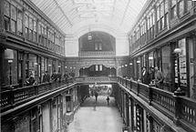
Image 2 Interior of Arcade By Unknown, Toronto Public Library code TEC 441B -Public Domain, https://commons.wikimedia.org/w/index.php?curid=49648432

The Arcade created a private passageway from Yonge to Victoria Street containing an eclectic mix of stores. It was not just a space for shopping, it was to be a multifunctional space with a variety of uses. Businesses as diverse as a dentist, Business College, and a cattle dealer had a storefront in the building that would be a landmark on Yonge Street for more than 70 years (Bateman, 2013 blogto.com). The Arcade was pitched as a city in miniature with a mixture of stores and offices. This was apparent from advertisements placed by the developers before the arcade was opened to attract tenants. A call is put out to ‘Stationers, Druggists, Tobacconists, Dealers in Gents Furnishings, and all kinds of light fancy goods’ to take up space in this new development. Along with this, ‘Lawyers, Artists, Dentists and everyone requiring convenient office room’ is encouraged to secure office space in the arcade before it is ‘too late’

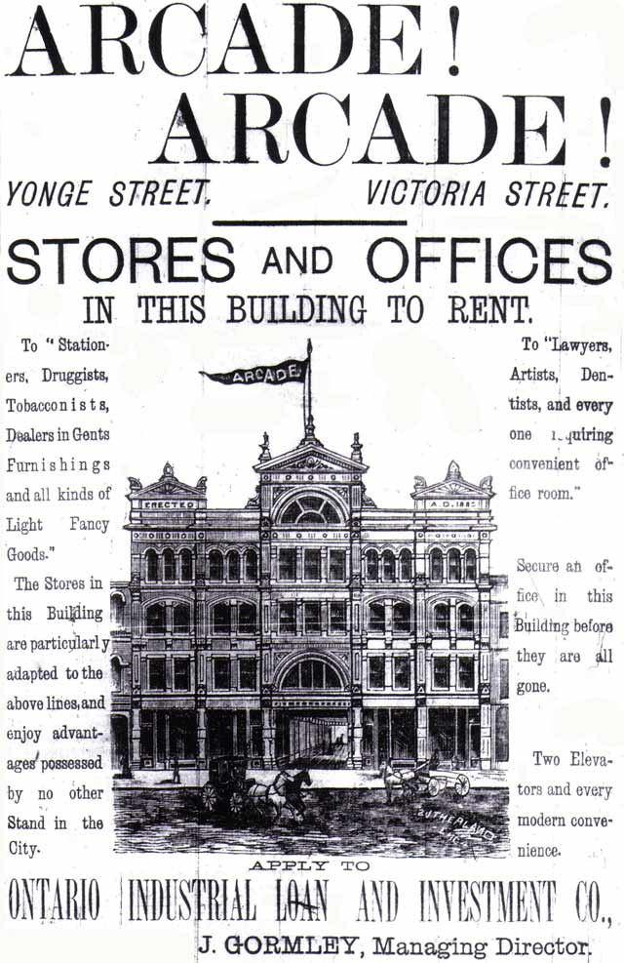
Image 3: Advertisement, The Daily Mail, June 30, 1884. Via http://torontoist.com/2009/03/historicist_the_rise_and_fall_of_a/
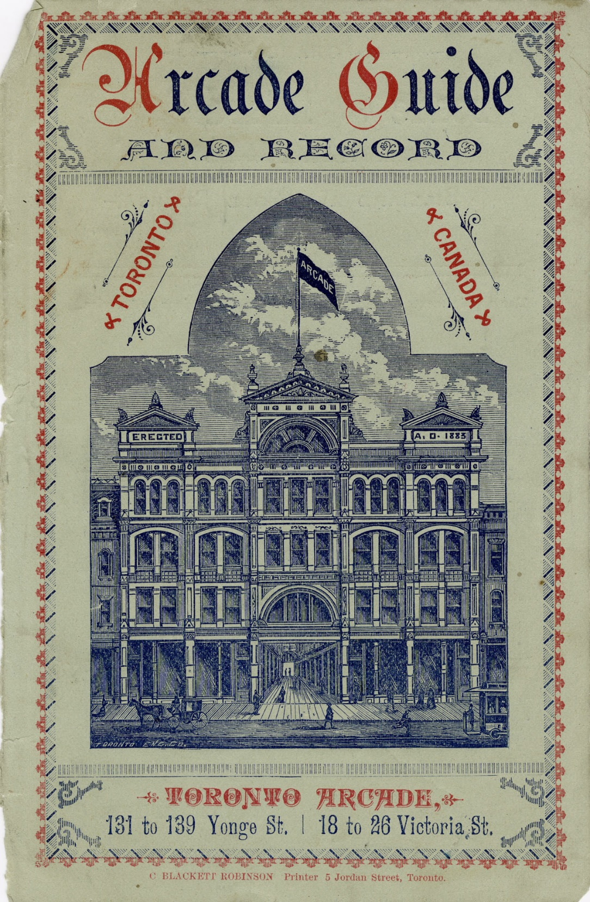
Image 4 Arcade Guide Cover Toronto Reference Library, Baldwin Collection 983-8-79

The third floor of the Arcade was occupied local British American Business College. Which can be seen in the top right foreground of the image above.

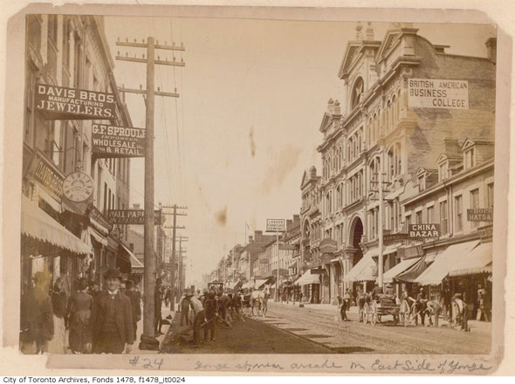
Image 5 Toronto Arcade Exterior, City of Toronto Archives

The arcade – a world in miniature

The Arcade, as one of the first purpose built spaces for the emerging consumer society of the nineteenth century, is an important moment in the spatial organisation of the city. It is a space which emerges from the building materials of the industrial revolution. A rational space roofed in glass, the passageways ‘lined with glass plate windows and the eye is guided towards parallel lines of window displays (which reflect back the image of the person gazing) in a glass roofed space set apart from the rest of the city’ (Miles and Miles 2004 p.87). The key element in this space is a utopian possibility of plenty, close at hand almost within reach. The shopper is free to embrace the phantasmagorical elements of the products on display. The Toronto Arcade, much like its European antecedents excludes the vagaries of the weather and stresses of urban life. The focus in this space is on the world in miniature. The consumer can shop the world in a compact glass plated realm. The Arcades Project gives us a collage of commodity fetish in the passageways of the arcades of Paris of the first half of the nineteenth century. During the analysis in the Arcades Project, Benjamin provides illustrations to uncover the real meaning behind the spaces and the images within them. It is not just a descriptive account that emerges but a theoretical approach which attempts to capture the fickle nature of the dream of consumerism and the commodity fetish. Through the descriptions of city streets, fashions, and shop windows, along with company records, advertisements, and industry publications Benjamin helps us to uncover the roots of modern consumer culture.
In speaking of the inner boulevards says the Illustrated Guide to Paris, a complete picture of the city on the Seine and its environs from the year 1852, “we have made mention again and again of the arcades which open onto them. These arcades, a recent invention of industrial luxury, are glass-roofed, marble-panelled corridors extending through whole blocks of buildings, whose owners have joined together for such enterprises. Lining both sides of these corridors, which get their light from above, are the most elegant shops, so that the arcade is a city, a world in miniature, in which customers will find everything they need.
(Benjamin, 1999 p.873)

Benjamin (1999) documented the phantasmagoria and industrial luxury of the fabricated panorama and the fancy goods on display in the arcades of Paris. The goods displayed behind glass encourage the shopper to fantasize about their relationship with the items in a realm of what Benjamin describes as industrial luxury. As a space, the arcades were different from previous consumption sites in the city such as the market or the bazaar. It was a space which was separate and enclosed from the rest of the city built with the modern materials of the industrial revolution. The arcades brought the individualized practice of shopping for luxury goods to the expanding middle class with the industrial innovation of the nineteenth century. Before the arcade, there were examples of commercial spaces and piazzas such as Covent Garden in London, but the arcade was different because it was sealed off from the city around it and inside there was a new focus on the commodity fetish. As they appeared in Paris and other major European cities in the early nineteenth century, the arcade constituted a new architectural space designed for consumption. Across Europe many of these spaces were built. They were speculative developments opening up, joining and creating new opportunities for the urban dweller to roam.

The motivations driving the development of the earliest of these arcades, gives an important insight into why these spaces were built. In London, the Burlington Arcade was built between Burlington House and Bond Street. It was opened in 1819 by the owner Lord George Cavendish and it was designed by Samuel More and was one of the world’s earliest arcades (Jackson, 1996 p.111). Ware's report of May 1815 (1963) described the proposed development of the Burlington Arcade as 'a Piazza for all Hardware, Wearing Apparel and Articles not Offensive in appearance nor smell'. It describes the plans for a ‘double-sided arcade divided into four sections by three spaces called 'inter-shops' where the promenade would be wider and shops would be replaced (as at the entrances also) by 'stands' or 'stalls' which were to be 'after the principle of those in Exeter Change'. There were to be 38 shops and 20 stalls’. The Burlington Arcade was designed as a rational shopping space in that it served a clearly defined purpose and there is evidence that the design of the arcade is an attempt to control the reality within the space by creating a space removed from the chaos of the Industrial city.

Activities which offended this reality, such as a product which had a bad smell or which did not fit in with the aesthetic of the arcade were to be excluded. This is evident in The Gentleman's Magazine in September 1817 where the proposed Burlington Arcade is described as a space 'for the sale of jewellery and other fancy articles' and to be intended 'for the gratification of the publick [sic], and to give employment to industrious females'. Here we see that the focus is for conspicuous consumption which gives pleasure to the purchaser. This is a place separate from the city around it, which is devoted to pleasure and gratification. By doing this, it recognises that it will create economic activity and employment. On a micro level, it is the physical manifestation of the capitalist society, providing profit, employment and pleasure in an enclosed realm. However, this piece also offers an insight to what may have been a key motivation for the development of the arcade. It is the solution to the problems presented by neighbouring residents. In a sense, it was envisaged as a way of eliminating the nuisance of the city outside.
What first gave birth to the idea was the great annoyance to which the garden [of Burlington House] is subject from the inhabitants of a neighbouring street throwing oyster-shells etc. over the walls'. The adjacent properties overlooking the garden had certainly given trouble, and in 1870 a former pupil of Ware's, Henry Baker, stated that the arcade' was designed solely with the object of shutting out the hundreds of windows in Old Bond street.
Gentleman’s Magazine September 1817, In Survey of London (1963)

Here we see the practical motivations which Lord Cavendish may have had to build the arcade. It created a space which was separate from the ‘troublesome neighbours’. Any activity which could cause annoyance to ‘gratification of the publick’ would be kept outside the confines of the arcade. There was to be no longer a risk of a shopper being hit on the head by a discarded Oyster-shell. Poverty could also be kept beyond the walls of the arcade and allow the shoppers to focus on the commodity fetish of ‘jewellery and other fancy articles’ which would be on offer in the arcade. The arcade was built to deal with the problems of the Nineteenth Century City, creating a space which was removed from poverty and squalor. It was sealed off from the city in the manner of a medieval walled town, but on a smaller scale.

Daylight is the only element of the city outside which can permeate the arcade and this was made possible by the new building technologies such as plate glass and iron frame construction. These building materials allow for the enclosure of the arcade in a light filled realm. Benjamin (1999 p. 539) proposes that it is ‘Actually, in the arcades it is not a matter of illuminating the interior space, as in other forms of iron construction, but of damping the exterior space’. The effect is to focus the attention on the interior while damping or blocking out the exterior. The spaces served to transport the shopper from the city street to a world away from their everyday lives. They were transported to an artificial world of consumerism. The shops, with their glass windows, marble surrounds and polished wood were technologies to display and complement the consumer items on display.
The wide variety of retailers in the arcade may seem similar to that of modern covered shopping malls; however, the public nature of the arcade was tempered by its exclusivity. The arcade emphasized fashion and genteel display under its arches. Customers and would-be customer were aware of this emphasis... Shopping arcades brought the older, aristocratic individualized shopping for luxury goods into an innovative nineteenth-century form.
(Whitlock 2005, pp. 25 -26)

By creating a space which was removed from poverty and squalor, the arcades created a realm of exclusivity, a miniature version of the city where there was a focus on the commodity fetish. The arcade emerges across Europe as a new type of space for urban consumption. The Toronto Arcade stood on this site for over 70 years before being demolished. In the 1950s, as the old building began to show its age, two fires damaged the upper floors and it was fully demolished in 1954. The building was replaced with the 10 storey Arcade Building which opened in 1960. The legacy of the arcade did not endure in Toronto. It was the department stores which lined Yonge Street which were to have the most significant impact on shaping how Torontonians shopped and the way commercial activity in the city was to develop. Along with Simpsons on Yonge Street, Eaton’s Department Store became the focus of retailing in downtown for Toronto from the late nineteenth century onwards.

The rise of the department store

The arcade was usurped by the department store which removed the plate glass barriers between the shopper and the goods and heralded the beginning of the era of mass consumption. In cities across the Western World, department stores spread out into the city, locating along major public streets. This growth of the phantasmagorical realm which had begun in the arcades, began to spread out beyond its walls and occupy the general urban realm. Before the cities could be given over to the commodity fetish and consumer activities, they would need to be re-invented to make them more hospitable to this type of activity. The Grand City Exhibition which emerges in the middle of the nineteenth century is the precursor towards a large-scale reinvention of the city as a space for consumption.

The motivations behind the exhibitions of this era was to boost their respective cities and cementing their position in the increasingly global economy. The exhibitions were displays of the aspirations of the city and important statements of power that the city held. The spaces of the Great Exhibition in 1851 in London which saw the construction of a vast exhibition space, The Crystal Palace in London, designed by Joseph Paxton and spanning over 92,000 square metres expanded the principles of the arcade on a vast scale. It was a statement about the power of the city of London and a signifier of the intentions that it held for the future of life in the city.

The exhibitions also acted as vast three-dimensional demonstrations of the emerging urban consumer culture.The Palais de l'Industrie was constructed for the Paris Exposition Universelle in 1855. It was on a similar scale to the Crystal Palace.
Then go to the Palais de l’Industrie, built for the Universal Exposition of 1855 and see a cavernous space that goes far beyond Baltard. Now compare these new spaces with the arcades that had been so important in the early 1800s. The form and the materials are the same, but there has been an extraordinary change of scale (something that, incidentally, Walter Benjamin fails to register in his Arcades project in spite of his intense interest in the spatial forms of the city.
(Harvey 2003 p13)
The scale is vastly different. The Passage des Panoramas pales in comparison to the scale of the Palais de l'Industrie. Whereas the Arcade created a miniature version of the city, the exhibition aimed to interiorize the whole global capitalist system in the process of re-imagining the dreamworld. Harvey (2010 p. 168) explains that the changes in the urban structure of Paris which began around this era saw the evolution of a new urban way of life and a new urban persona. ‘Paris became the “city of light”, the great centre of consumption, tourism and pleasure. The cafes, the department stores, the fashion industry, the grand expositions, the opera, and the spectacle of court life all played their part in creating new profit opportunities through consumerism.

The principles of the Great Exhibition where they had acted as showcases of the consumer goods of industrial capitalism where applied to new types of spaces in the city in the form of the Department Store. No longer would the shopper have to travel from store to store to get what they want; now they could get it all under the one roof in vast retail emporiums such as La Bon Marche opening in 1852, or Selfridges in London which opened in 1909. What we see in this era is that the private shopping enclave created in the Arcade was spreading out to line the major streets of the city and in turn change the whole city. The department store served as a focus for the new consumption focused culture that was permeating industrial societies. To understand the impact that the department store made on the commercial activity on Yonge Street will now consider the history of the Eaton’s Department Store.

Eaton’s Department Store

In December 1869, Irish immigrant Timothy Eaton, opened his first store on Yonge Street, south of the Queen Street intersection in the centre of Toronto. He later moved north of the Queen Street intersection, where he took a position directly opposite the rival department store - Simpsons. In this new location, the store expanded to an expansive collection of buildings that eventually encompassed the city block bordered by Yonge Street to the east, Queen Street to the south, and Albert and James Street to the west. Over time Eaton’s store would come to dominate this section of downtown and it was from this site, that Timothy Eaton would build his retailing business into a force that would shape the way Canadians shopped for over 130 years.

In 1883 Eaton's opened a new four-storey store on this site with elevators, electric lighting and ladies' restrooms. The store was close to the centre of public life with City Hall to the west and the Queen Street to the south, and the main thoroughfare - Yonge Street to the east. The success of Eaton’s reflected Timothy Eaton's innovative business practices. Such practices are clear in his first advertisement, which read: "We propose to sell our goods for CASH ONLY In selling goods, to have only one price." (Satisfaction Guaranteed CBC, 2003). At a time when haggling over prices was the norm, the concept of fair, affordable shopping attracted customers. Another retailing innovation came from the surrounding streets, in a cluster of factories to the north of the store. Here Eaton’s pioneered production of own-brand goods under the brand name Viking which allowed them to control prices and quality (Dendy and Kilbourn 1986, p291), which was to prove a major hit. In addition to these innovations, Eaton developed a catalogue mail-order business that served all corners of the country. The catalogue was published twice a year from 1884 to 1976 (Dendy and Killbourn, 1986 p. 291) and allowed Eaton to bring the array of goods and services he offered to the farthest reaches of the country.

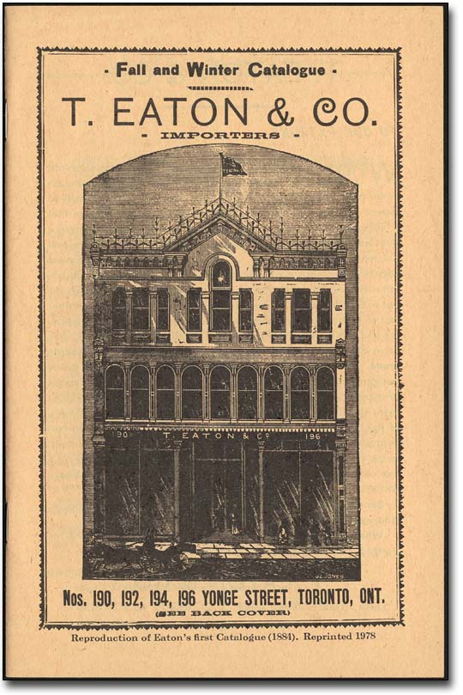
Image 6 Eaton's Catalogue Fall-Winter, 1884 [Reproduction of 1978] T. Eaton Co. fonds Reference Code: F 229-1-0-1 Archives of Ontario

The catalogue was a portable window display which shoppers could browse in the comfort of the home. It gave customers the freedom to consume or dream about consuming on their own terms and at their own schedule and distance. Innovations such as these helped Eaton’s become a Canadian retailing institution that affected the lives of shoppers from coast to coast. It had become a key force in creating and supporting the dream of consumer capitalism across Canada. By the time Timothy Eaton died in 1907, Eaton's had two major stores, a mail-order business and an army of shoppers spread across the country.

Along with their increasing national footprint, Eaton’s continued to drive their expansion in downtown Toronto. In the 1928 Eaton’s proposed plans for a large development of a new store and office tower on Yonge and College, north of the existing store. Eaton's College Street was envisioned to be a monumental complex which would cover a full city block and include a 38-storey office tower. It was envisioned that Eaton’s would close their Yonge and Queen Street store and move northwards to the new state of the art store. Osbaldeston (2008) explains how it was proposed to feature 5,000,000 square feet (465,000 square metres) of retail and office space and was to be the largest retail and office complex in the world. However, the Great Depression was to scupper the ambitious plans for the site. The first phase of the project, a seven-story department store of 600,000 square feet (56,000 square metres), was the only part of the complex that was built. Eaton’s College Street store opened its doors on October 30, 1930. The Depression and the subsequent World War meant that the plan was only partially completed (Dendy and Killbourn, 1986 p 291). The existing store remained open and for close to 50 years, Eaton’s operated two stores on Yonge Street, never fully implementing their ambitious plans for the College Street site.
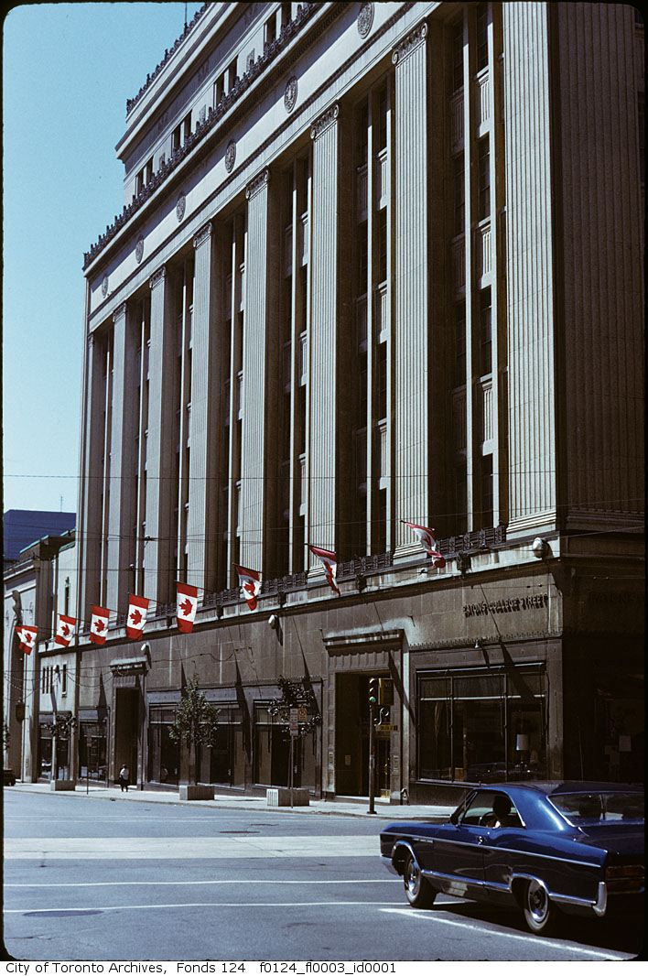
Image 7Eatons College Street Store, now part of the College Park Development via City of Toronto Archives, Date unknown.
Not only did the industrial revolution change how consumption occurs in the city, it also had a major impact on where and how city inhabitants lived. The tremendous population growth prompted an impetus for major changes in how cities were governed and organised across the world. There was an increasing recognition of the power that the growing industrial city had in terms of its surrounding hinterland but also the impact it was having on the lives of those who lived in it. There was a shift away from liberal ideals of capitalism under which the individual was responsible for their own welfare towards a collective approach to improving life in the city. There was also the push to make the city more suitable for consumer culture and make the streets an attractive destination to wander.

The Industrial Slum

The Industrial Revolution had a massive impact on the organization and character of urban areas. It is during this era we see the emergence of the industrial slum. Factories sprung up in midst of towns and cities and people moved to these areas in search of employment in the new industries. This is illustrated in the novels of Charles Dickens such as Oliver Twist (1837), A Christmas Carol (1843) and Hard Times (1854) where he outlines the horrors of urban life for the working class of a capitalist industrial city. Engels (1844) highlights in The Condition of the Working Class in England the difficulties of life in the backstreet sections of Manchester and other Mill towns. These densely packed settlements lacked proper sanitary facilities and the populations were at great risk of disease from contaminated water supplies. There was persistent dampness and the people who lived here were at great risk of developing health issues. Later in the nineteenth century the literary genre ‘Slum Fiction’ portrays the urban slum as an uncontrollable nightmare. It re-enforces the image of the city being inhabited by a mass unruly urban crowd which is difficult to control and manage. The slum dwellers are to be feared and viewed as the unruly ‘other’ which are incapable of saving themselves from the nightmare of life in the slums.

In response to the ‘horrors of the Industrial City’ we see the emergence of the Municipal City where local authorities try to respond to the negative aspects of life in the Industrial City and in turn improve life for all those who live there. These measures involved interventions in terms of improving public health and well-being and increasing the quality of life of urban dweller through infrastructural investments. It is during this era that we see measures such as slum clearance and the provision of social services such as public baths, libraries, and education. This reforming impetus which up until this point only shown by philanthropic organisations such as the church, moved into the hands of local authorities

In what was the United Kingdom of Great Britain and Ireland, municipal Corporations, became powerful organizations and had a significant impact on urban development in the Nineteenth Century. These local corporations aimed to promote the economic, social, and environmental well-being of their municipality. They were also involved in the promotion, organization, funding, building and management of everything from housing to water supplies and the provision or other public utilities. With the growth of city services and welfare provisions the idea of equality began to become embedded in urban societies. It was ‘elaborated in terms of entitlement to public services in the form of social security, education, health care and housing.’ (O’Connell 2011, p.231). This is where we see the shift begin to occur from the liberal ideals of capitalism which the individual handled their own welfare towards the earliest roots of the welfare state and universal citizenship and equality for all. The growth of the Industrial City also corresponds with key revolutionary movements advocating a shift to democratic ideals and universal rights.

The ideals of liberal democracy and the democratic republic had become entrenched with the revolutions of the late eighteenth century including the American Revolution (1776), the French Revolution (1789 -1799) and the Irish Rebellion (1798). The ideal of the modern liberal democratic republic which was to emerge was premised on the principle of the equality of all citizens through political and civil rights. These democratic ideals were refined and redefined with the subsequent development of the nation state through the nineteenth and twentieth centuries. Key to this was ‘the extension of theses ideals and that status of citizenship was expanded from the original ‘man of property’ to include all men and women, rich and poor.’ (ibid., pp. 230 -231).

This leads to the growth in the power of municipal authorities who were tasked with providing for the welfare of the citizens and improving life for city dwellers. Public investment was made in the interests of improving the life of all city residents. It was not just limited to the wealthy. Investments in water sanitation and other public utilities made the city a better place for everybody. By investing in this infrastructure, municipal authorities were investing in a public good and by maintaining ownership of this infrastructure, they could ensure that access was granted universally. All citizens, rich and poor would benefit from the investment by the municipality. There were also other areas in which the municipal authority began to funnel investment such as public buildings and the public realm. One of the most influential examples of this shift occurred in Paris form 1850 onwards.

Reshaping the Industrial City for Consumer Society

Haussmann was involved in redesign of the City of Paris and he not only re-imagined the scale on which the city should be cast but he also rebuilt it as an entity, comprising of complex systems of parks, sewers, suburbs and he changed the scale on which the city was thought of. Under Haussmann’s leadership, Paris between 1850 and 1870, underwent a major transformation in terms of its physical layout and the spaces in the city where the individual could engage in a public life.
Haussmann worked at all these levels simultaneously. The new boulevards created their own forms of spectacle, through the hustle and bustle of carts and the public conveyances over newly macadamized surfaces (which some radicals through were designed to prevent them from converting cobblestones into barricades).
The arrival of the new department stores and cafes, both of which spilled out onto the sidewalks of the new boulevards, made the boundary between public and private spaces porous
Harvey (2003 p 212)
What happened in Paris in this era is the further specialisation of space within the city. Social activity is regulated based on what type of activities are acceptable within certain spaces in the city. The boundary between the private shopping spaces of the arcade and the public street becomes porous. The boulevard becomes a space for engaging in the commodity fetish. Harvey (2003 p.3) captures the changes which had occurred in Paris between the emergence of the arcade and the Haussmann’s reconstruction of Paris in the second half of the Nineteenth Century.
‘Before there were Romantic poets and novelists (Lamartine, Hugo, Musset, and George Sand); and after came the taut, sparse and fine-honed prose and poetry of Flaubert and Baudelaire. Before there were dispersed manufacturing industries organized along artisanal lines; much of that then gave way to machinery and modern industry. Before, there were small stores along narrow, winding streets or in the arcades; and after came the vast sprawling department stores that spilled out onto the boulevards. Before, there was utopianism and romanticism; and after there was hard-headed managerialism and scientific socialism. Before, water carrier was a major occupation; but by 1870 it had almost disappeared as piped water became available. In all of these respects - and more- 1848 seemed to be a decisive moment in which much that was new crystallized out of the old.’
The transformation that occurs during the Humanisation of Paris is evidence of the turn towards a grander scale of re-shaping and reconstructing of urban life led by the increasingly powerful city authorities and political figures. The re-invention of Paris by Hausmann is representative of the increasing power of the Municipal city where the local urban authorities engage in massive programmes of public works to improve urban life. By dealing with the problems of the industrial revolution, they could make the city more suitable for consumption.

Municipal power in Toronto 1834 -1953

In 1834 the Township of York was incorporated and succeeded by the City of Toronto. Toronto’s first by-law, described as “an Act for the preventing & extinguishing of Fires”, was passed on May 10, 1834. By passing this first bylaw, the elected council was employing municipal power to reduce the risk of fire in a city largely constructed of wood. The by-law specified building requirements, regulated or prohibited hazardous activities such as the disposal of combustible materials, and defined the responsibilities of fire inspectors and wardens, fire companies, and citizens in preventing and fighting fires. The local government/council would take a direct role in what had previously been taken by national government, philanthropist, or reformer. The idea that the needs of citizens could be taken care of and a safety net put in place to protect those vulnerable gained increasing traction.

Urban politics and administration in Toronto became an instrument for maintaining and re-enforcing sectarian divides which had been brought to the city by immigrants. Religion became the factor with which Torontonians were defined. This contrasted with other North American cities such as New York where ethnicity and nationality became the key aspect of divide amongst immigrants. The emergence of the municipality in Toronto was shaped by unique sectarian divides which led to a set of dominant and counter narratives that became expressed on the public streets of the city. What we see in Toronto up until the Second World War was is the emergence of a city municipality which was segregated along sectarian lines, controlled by one group and the subjugation of the minority population. This manifests itself most clearly in the Orange Parade and the loyalty expressed to the crown.

Migration has shaped the City of Toronto for centuries. The influence of large migration from the Britain and Ireland and the sectarian divides amongst these migrants had a significant impact on society in the city. These divides were exacerbated after the 1798 Irish rebellion which increased the chasm between Catholic and Protestants. This divide manifested itself in the political structures of the city. For a period of ninety years beginning with the election of F.H. Medcalf, which Smyth (2015 p. 34) describes as 'Toronto's first avowedly Orange mayor', administrative power lay firmly in the hands of members of the Orange Order. This period is characterised by strong links between Belfast and Toronto as migration from the latter saw the recreation of similar sectarian divides.

Transference from Belfast was embedded in Toronto's history, culture, image, and personality. The specifics of geography and the accidents of history helped create a distinctive civic culture in the Canadian city and, although it was never a replica of Belfast, it did sustain over many generations a resemblance that was always more complex than simply being a site for the re-enactment of immigrant Irish quarrels. Sectarian violence was part of Toronto's past, but its identity as the "Belfast of Canada" extended well beyond that to include a distinctive manifestation of municipal governance - one wherein the political machinery of Orangeism was able to develop a remarkable grip on power and patronage within the city. To some extent there were similarities with the system operated by ward bosses and their political machines in contemporary American cities, but in Toronto it was religion, not ethnicity, that provided the unifying bonds for the dominant group. (Smyth, 2015 p.3)

There was a strong grip held on municipal governance by the dominant protestant groups which is illustrated in the fact that each Mayor of the city between 1840 and 1953 had been a member of the Orange Order. The impact of this grip on power manifested itself through the municipal authority.

It was well known in the city that Protestants were at a significant advantage when seeking public employment, but, despite generations of protest by Catholics, little change was registered before the 1950s. Until the mid-twentieth century, City Hall maintained a tradition of granting leave with pay to employees wishing to participate in the annual Twelfth of July parade, and municipal business was traditionally suspended for the day. Belfast was the only other city in the world where commemoration of the 1690 Battle of the Boyne received such official acclaim (Smyth, 2015 p.62)

The political and municipal structure of the city help reinforce the expression a cultural identity and privilege this over other religious and cultural identities. The space for the counter narrative to emerge was in the city street in the form of violence at flashpoints over religious and cultural identity. The manifestation of sectarian power divide was demonstrated in the regular parades commemorating the Battle of the Boyne. Here religious and political affiliations took over the public realm in the form of the Orange parade.

Indeed, in both Belfast and Toronto there were occasions when the inter-group suspicions escalated into religious animosities that spilled over into street riots and neighbourhood violence... (Smyth 2015, p.4)

Tensions that spilled over into riots or street violence were not merely short-term responses to long-term demographic shifts. They were violent episodic expressions of ingrained attitudes and endemic mutual distrust. The major incidents of street violence in Toronto and Belfast... [and] many smaller incidents occurred regularly in both places – eliciting, because of their apparent routine commonality, only passing comment in police and newspaper reports. (Smyth, 2015 p.48)

Goheen (1994) explains that Public Space in the City Street played a significant role in nineteenth-century Canadian urban life. It acted as a symbol of protest, dissent and public freedom which was valued by city residents. Goheen explores this by examining the process of negotiation by contending interests in Toronto to secure their rights use the public street to express these freedoms. In the ongoing disputation over control and appropriate uses of the street, the most important public space during the middle decades of the nineteenth century, the social significance of public space. Yonge Street was the venue where the dominant political narrative could be expressed and reinforced but it was also the site where counter-narratives could take hold in the form of protest, violence and resistance.

Housing in the Municipal City

At the beginning of the twentieth century, Toronto was already expanding at a frantic pace. Between 1901 and 1921 it had doubled from 208,000 to 522,000 (Solomon, 2007 p.17). Yonge Street had emerged as the main street of a booming industrial city. Along its main thoroughfares, were important municipal and commercial buildings. The expanding streetcar network linked it north and opening up links to the new suburbs to the north of the city. For Toronto’s growing middle class, Yonge Street was the natural place to go to take part in the burgeoning consumer economy and central to this was the major department stores of Eaton’s and Simpson’s. Toronto experienced the same pressures which many other industrial cities of the nineteenth century struggled to deal with due to high levels of immigration and the associated issues of overcrowding. These astounding rates of growth, sustained over decades, had never been seen in Canada. Because the population increase was unprecedented, the government initially had few rules in place to control the development that accompanied it. Toronto grew organically and there were few commercial and residential zoning regulations, and few restrictions on the uses (Solomon, 2007 p.17.).

Toronto Housing Company

As in other growing municipalities, urban reformers in Toronto advocated slum clearances to eradicate what was perceived to be a moral rot. This marks the City of Toronto’s first significant attempt at social reform. The return of veterans and the increase in immigration following World War I presented serious pressures on housing in the city. Overcrowding and deteriorating housing conditions emerged as a serious problem.

As a result, the City made its first great foray into social reform, extending public controls over formerly sacred private property rights. Between 1913 and 1918, 1,600 substandard houses were demolished at the call of the City's health officials. An increasing demand for subsidized housing also emerged at this time, leading to the formation of the Toronto Housing Company, viewed by many as a regrettable but necessary intrusion into the free market.
(Solomon, 2007 p.31).

The Toronto Housing Company arose in 1912 from a municipal committee seeking solutions to the housing crisis. The formation of a municipal company to deal with these issues was a sign of the increasing power of the municipal authorities in shaping the lives of Torontonians.

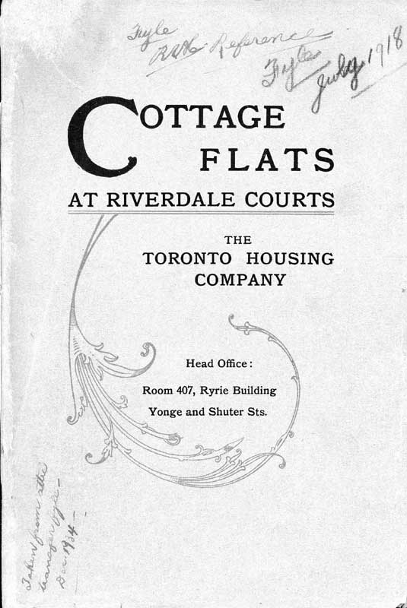

Image 8 Cottage Flats at Riverdale Courts ca. 1915 The Toronto Housing Company, Fonds 101

The Toronto Housing Company had 85% of its bonds guaranteed by the city and it was organised like a public utility (Weaver, 1977 p.29). The first schemes were envisioned as a ‘model garden suburb’ with one hundred and eighteen connected units with a central heating plant which was built in 1913. It was heavily influenced by the Garden City Movement in the United Kingdom, with the ideal that architecture and courtyard landscaping created a healthier, more natural setting than the tenements or slum row houses of the city. In the brochure for the Cottage Flats development (Toronto Housing Company 1915) the dwellings were described in detail and in the excerpt from the brochure below we see the idealistic design motivations that were behind the development:

A cottage flat is a modern apartment with its own front door to the street. The Bain Avenue buildings of the Toronto Housing Company are arranged around three grass courts. There the small children will have ample room to play, where their parents can see them, and away from the dangers and the dust of the street. Each building consists of from two to nine houses; each house contains two cottage flats, one downstairs and one upstairs, that is, one on the ground floor, one on the first and second floors. The entire development is to be heated by steam from a central plant and the same plant will furnish hot water to every flat the year round. There are no dark or poorly ventilated rooms, because the buildings have a wide frontage, and are only two rooms deep, so that every room opens to the air and sunlight. Each flat has its separate bathroom, separate balcony or veranda and separate basement. Gas stoves, electric fixtures and window blinds are installed by the Company. In every kitchen there is an enamelled combination sink and laundry tub.

Model housing such as this would be built to inculcate family values and create a new way of urban living for city dwellers. Pinder (2005 p. 31) describes the emergence of utopian approaches to cities around this period a response to the fears of the late nineteenth and early twentieth centuries. The common characteristic of these approaches was the importance of creating urban spaces which aim to shape a different and better future. Pinder referrers to these approaches as ‘restorative utopias’.

Single Women in the City

As the population of Toronto grew, it became increasingly diverse. The availability of well paid jobs for women led to increasing demand for suitable housing for single women. Dennis (2006) analyses the presence of independent working women and their residence in purpose-built apartments and other kinds of housing in the first third of the twentieth century. He highlights the impact that Eaton’s department store had on providing employment for female workers.

The principal single source of employment for apartment tenants in 1930, but probably also for women in all kinds of housing situations, was Eaton’s… [A]bout 50–60 per cent of Eaton’s workers were female; but of an estimated female workforce of about 5,000 in 1915, only 85 were traced as liable to tax in the assessment roll, mostly clerks and salesladies.
(Dennis, 2006 p. 46)
The department store provided new types of jobs beyond the factories and domestic service.
Young women began to enter the labour market in positions other than as domestic servants from the 1880s onwards. Carolyn Strange (1995) argued that the nature of Toronto’s ‘girl problem’ (single women living in the city) began to shift. In the nineteenth century, the single working girl living apart from parents was perceived as a moral problem, vulnerable to sexual exploitation and in danger of moral corruption. This is encapsulated in the figure of the ‘Sphinx in the city’.
In the cities of modernity and postmodernity, it is the Sphinx, half woman, half animal, that has represented what is feared and desired at the heart of the maze. She may take the shape of the genius of Metropolis, or of the slatternly fishwife of the slums… Urban civilisation has come, in fact to mean an authoritarian control of the wayward spontaneity of all human desires and aspirations. Women without men in the city symbolise the menace of disorder in all spheres once rigid patriarchal control is weakened.
(Wilson 1991 p. 157)
By the 1920s this figure of the single woman was stereotyped as a self-aware, resourceful, occasionally even predatory ‘good-time girl’. This is explored in Garner’s (1950; 1968) novel Cabbagetown which covers the experience of growing up in Toronto in the 1920s and 1930s. One of the protagonists Myrla Patson loses her job as a hosiery factory worker early in the Depression. The 17-year-old escapes the poverty of a slum cottage in Cabbagetown in Toronto’s east end by finding employment as a live-in maid in a house in North Toronto. But after losing this job she becomes a waitress in the Union Jack Grill on Queen Street West. She lives first in a rooming house, then just north of the restaurant in a small two-room apartment, provided by her employer in return for sexual favours eventually turning towards prostitution full-time. This novel captures the experience of coming of age during the Depression in Canada. During this era, reformers sought to inculcate “a discipline of work and pleasure”, something for which women’s clubs such as the YWCA who provided boarding houses for working women, attempted to cater. (Dennis, 2006 p. 46). However, only a small proportion of working women could be accommodated in this way

In Toronto in 1912, about 15,000 of Toronto’s 40,000 single working women lived away from home (37.5 per cent). In the 1920s, estimates suggested that 20–30 per cent of ‘working girls’ (presumably a more restricted, younger group than all working women) lived apart from their families
(Dennis, 2006 p.36)
By the 1930s, it was taken for granted that single women from all social backgrounds would find full-time paid employment when they finished their formal education. This was not only down to changing social and economic consequences but also due the availability of affordable accommodation.

While the Toronto Housing Corporation had initially been set up to build homes for the families of working men, the number of homes which were headed by a female resident increased significantly over time. In the period between 1914 and 1916, 42 per cent of its homes were rented by manual workers, this had fallen to 17 per cent by 1923. At the same time the percentage of single working women, many sharing with other women, who were renting the companies properties increased to 15-20 percent of householders (Dennis, 2006 p. 200). The rents were below market rates but still beyond the reach of most working families. The housing crisis persisted throughout the early half of the twentieth century. This marked a shift away from solely providing homes for working class families towards providing homes for the clerks and retail workers of the city.

There had been major booms in apartment-house construction in the early 1910s and late 1920s. The city put a restriction on apartment construction between 1914 and 1918 due to the First World War which would result in housing shortage. The report of the City’s Housing Commission 1918 observed that “there are numbers of business women who would be very glad to obtain small apartments, suitable for groups of three or four, and thus avoid the regrettable rooming system.” (Dennis, 2006 p.27). City Controller O’Neill advocated relaxing the regulations which prohibited new apartment housing to allow the construction of, or conversion of existing dwellings into, three-flat apartment houses which he thought would provide ideal accommodation for groups of female sharers But what was most striking was the growth of apartment-households headed by single women. In 1914, 37 per cent of female-headed apartment households were headed by unmarried women, and 59 per cent by widows. In 1930, the proportions were almost exactly reversed: 37 per cent of female heads were widowed, and 57 per cent were single (ibid., 2006 p. 44) We can see the impact that consumer society was having on remaking the city by providing well paid employment for women in the city. The principal single source of employment for apartment tenants in 1930 was Eaton’s (ibid., p46). The availability of housing for newly affluent single women occurs in tandem with the emergence and consolidation of consumer culture in Toronto.

In 1934, a report on housing conditions in Toronto pointed out that, despite the gains made through the demolition of slum structures in the 1910s, poverty, overcrowding, and deteriorating conditions had begun to take over. This was especially true in the downtown core where many large residential structures were being converted from single-family dwellings to multi-family units. The City responded with its pioneering Standard of Housing By-law, which led to federal home improvement loans legislation making it easier for owners to repair or rebuild. By 1939, more than 9,000 homes had been inspected, with over half subsequently renovated or replaced.

There was an increasing trend to the urbanization of land outside Toronto’s boundaries. Toronto’s reluctance to incorporate these areas into the city caused great difficulty. Since these developments were outside of the city, they were without the services and improvements available to city taxpayers, relying instead on the inadequate services provided by the rural townships. Development activity increased along the suburban fringes of the city during this period, as speculators banked on the economic benefits to be gained from further annexations. However, the development of retail services for the newly expanding suburban areas was not to occur on a large scale until after the Second World War Yonge Street remained the centre of consumer culture in downtown Toronto. It was the venue where the dominant political narrative could be expressed and reinforced but it was also the site where counter-narratives could take hold in the form of protest, violence and resistance. The pre-eminence of Yonge Street would be threatened in the second half of the twentieth century as the city spreads out into the suburbs and new types of spaces such as the suburban shopping mall compete with Yonge street as spaces where urban life would occur.

Chapter Three: The Suburbs and the Mall

The growth and subsequent sprawl of suburban Toronto mirrors trends in the development of the urban centres across North America during the Twentieth Century. This process of suburbanisation had already begun in the nineteenth century with the growth of commuter rail transport which opened up new areas outside of cities for development. Initially new suburban development was focused along suburban rail lines. Around the stations on these lines new centres begin to develop. Local services such as shops, churches, and community buildings are built to serve these new centres. The size of residential areas was iinfluenced by the walking distance from the station. Such subcenters are still clearly recognizable in the Greater London Area (Gruen and Smith 1960 p. 19). In Toronto, suburban growth was also focused along railway lines as developers focused their house building efforts on these new suburban rail linked outposts. The Toronto Belt Line Railway was constructed in the 1890s as a commuter railway line to service and promote new suburban neighbourhoods north of the city. Few developers built housing in outlying areas that weren’t served by public transit systems, and there was a recognition of the importance of nationally owned transport systems. (Solomon, 2007 p. 9)

In spite of the re- appropriation of Howard’s utopian ideals, the Garden City Movement was to have a major impact on twentieth century urbanism. It stood in stark opposition to La Corbusier’s Radiant city of skyscrapers. While both approaches gained traction in terms of dealing with the overcrowded Industrial city, it was the growth of suburbia which was to have the greatest impact on changing how and where the city dweller would live in North America. However, the biggest factor which would influence twentieth century urban development and drive development across the continent was the rise in car ownership. Mass private car ownership was to give a new level of personal mobility to city dwellers to move beyond the city limits, railway lines and streetcar stops further and further from the city core. This turbo-charged the growth of suburbs.

The Automobile Suburb

The private automobile was to have a dramatic effect on the manner in which the suburbs would grow. No longer would they be focused on the suburban railway lines stretching out from growing industrial cities. The automobile opens the countryside to the newly mobile suburbanite. Henry Ford had revolutionised the production line and the dawn of the era of mass private automobile ownership arrived. The automobile opened the countryside to ex-urbanite. The impact of the Garden City movement had begun to be felt across the world. Frank Lloyd Wright (1932) proposed a design for Broadacre City in his book The Disappearing City which advocated the reconstruction of the city on a large scale. Each family would live on a site of one acre and transportation would be based mainly on the automobile.

As had occurred in the rail based suburbs of the city, services had to be provided for the suburban car owner. We see the emergence of strip development with commercial and leisure businesses beginning to locate along the key radial routes. One of the first attempts to regulate the unplanned development of suburban shopping space can be traced back to a Chicago suburb called Lake Forest in 1916. A shopping centre called Market Square was developed as part of the Lake Forest Improvement Plan. The centre was designed to remodel Lake Forest’s business district and replace buildings and empty back lots which had become an eye-sore and had created slum conditions. The new centre comprised of ‘twenty-five stores, 12 offices, and 28 apartments… designed with rows or arcades in the eastern corners. Two Tyrolean towers and an Italian Renaissance central building, across the west side, were all coordinated in cultivated taste and enduring beauty, making it one of the most attractive business centres in the country.’ (Arpee, 1963 pp. 179-180). The suburb was given a new pedestrian friendly centre that was a simulation of European Urban life which still stands today. Lake Forest was built next to a railway station. It acts as a point of arrival into the community and creates a sense of place. Unlike later shopping centres, the focus was on proximity to the rail link and there was a focus on pedestrian access. As car ownership continued to rise, later shopping centre developments would need to cater for shopper in a different way.

In the period after World War I up until the Depression, retail development increasingly began to move away from the urban city centre to cater for the new suburban markets. In Kansas City Missouri, the Country Club Plaza development was opened in 1922, and was a pioneering development of a new emerging urban form of car based retailing. Country Club Plaza Shopping Center, was designed by Architect E. W. Tanner and signalled the beginning of an ordered approach to retailing in the car based suburbs. This pace-setting development located shopping facilities away from the busy highway, provided offsite parting, architectural unity, and sign control (Gruen and Smith 1960 p.12). Retailers begin to follow their market to the suburbs. In the United States, Major department stores began to develop branches outside of city centres to capture growing suburban markets in New York and Chicago. We see iconic city centre department stores such as Marshall Field’s open branch stores in the suburbs of Chicago (1928). We also begin to see the emergence of self-service retailers. The Woolworths chain expanded throughout the United States, Britain, Ireland and further afield offering an array for consumer goods for a fixed price

The emergence of Metropolitan Toronto

In the period after World War 1, Toronto's suburbs continued to crop up on the edges of the city, block by block, with little central planning. In the 1920s and '30s, there were early attempts at a planned approach to development in areas such as Leaside, the Kingsway and Lawrence Park. These areas were laid out in a planned manner but they were of a small scale to what was to come next. During this era, the growth of the retail industry and speculative housing developments was hampered by the stock market crash of 1928 and the subsequent Depression. It was not until the 1940’s when large scale residential development restarted in the suburbs that we begin to see further innovation in terms of suburban shopping centres in the United States.

The province’s creation of Metropolitan Toronto accomplished its goals. Through this partial amalgamation mechanism, the suburbs were financed and methodically filled in.
But partial amalgamation was not the province’s only financing mechanism in the years following the Second World War. The province also spawned suburban expansion through infrastructure projects that would mesh Toronto with its immediate suburbs and beyond. These flowed from far-reaching plans begun by pre-war planning bodies.
As the end of the war neared, political leaders established planning agencies to provide for the betterment of the people.
(Solomon, 2007 p.65)

The strengthening and expansion of municipal power into the growing suburban areas cemented the power of local authorities. The City Planning Board, created as Toronto’s first official planning board was to have a significant impact on shaping the future development of the metropolitan area. This was the first step towards municipal powers taking control over how and where Torontonians would live. Strategic Local targets were set in terms of housing the project growth in populations. New policies to deal with the tremendous growth that the city was experiencing began to be complemented on a national level across Canada

The Municipality faced a serious crisis due to the lack of housing during the Second World War. The crisis resulted in a campaign to discourage further people from migrating to the city in search of jobs associated with the War effort. The City of Toronto was overwhelmed and as can be seen in an example of one of the public notices posted in the newspaper press, it was absolving itself of any responsibility for housing the flows of families flocking to the city.

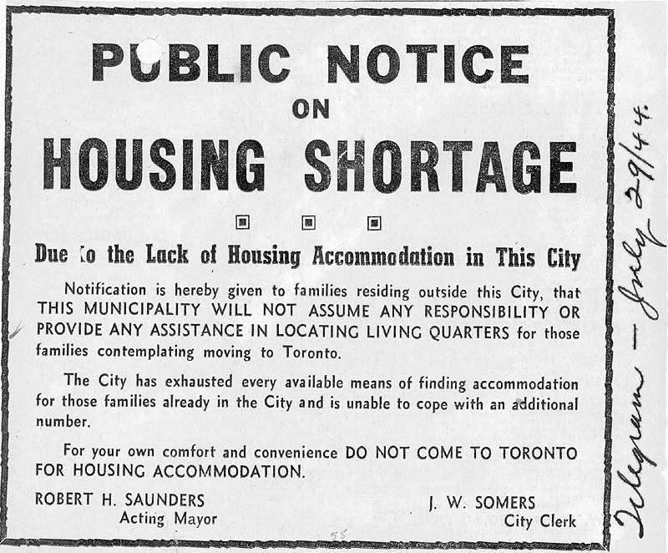
Image 9 Public Notice on Housing Shortage July 29, 1944 City of Toronto Archives Series 361, Subseries 1, File 56
The housing shortage which the War Effort had brought into sharp focus, put pressure on local and national authorities to act. There was significant pressure on the supply of housing as workers flocked to the city to work in munitions factories and other industries geared towards the war effort. Not only was there the need to house munitions workers, there was also the need to house returning veterans. Toward the end of the 1940s, the federal government embarked on a program of much-needed social and rental housing, creating a federal-provincial public housing program for low-income families, with costs and subsidies shared 75% by the federal government and 25% by the province. The suburbs are the result of the pursuit of welfare capitalism and the elevation of private home ownership to the most desired form of tenure. It was the federal government that intervened to become the major player in providing housing by constructing large tracts of housing in the townships around Toronto. The Veterans Land Act

In 1944, the federal government approved the National Housing Act (NHA) which was described as ‘An Act to promote the construction of new houses and the repair and maintenance of existing houses and improvement of housing and living…. The Act served to consolidate all housing legislation which had existed up until that point and it gave the federal government a leading role in housing programs. The Central Mortgage and Housing Corporation was formed on January 1, 1946 to stimulate housing supply in the private market and in turn help war veterans returning from conflict purchase their own home. The CMHC was tasked with managing and the Home Improvement Loans Guarantee Act, and provide discounting facilities for loan and mortgage companies.

In addition to creating the Veterans Land Act, the federal government created the Central Mortgage and Housing Corporation, a permanent civilian agency, to provide housing after the war. ‘We were going to call it the Central Mortgage Corporation with no reference to housing at all,’ recalled David B. Mansur, its first president. ‘But later, in a meeting with Finance Minister J.L. Ilsley, Dr. McIntosh proposed a change. “I think it should be called Central Mortgage and Housing Corporation,” he said, “because they’re going to be in the housing business and no fooling.” Of course, he was right.’
(Solomon, 2007 p.50)

The CMHC embraced their housing role and commissioned designs for cheap suburban homes which would provide modern facilities in a ‘simple, but attractive design’. It was providing citizens with the chance to purchase their own home with their own front door and garden in a semi-rural setting reminiscent of the Garden City. In the image below we can see an indicative floor plan and illustration of the home that could be built. It is a declaration of intent for how the CMHC sees the future of Canadian Suburban life.

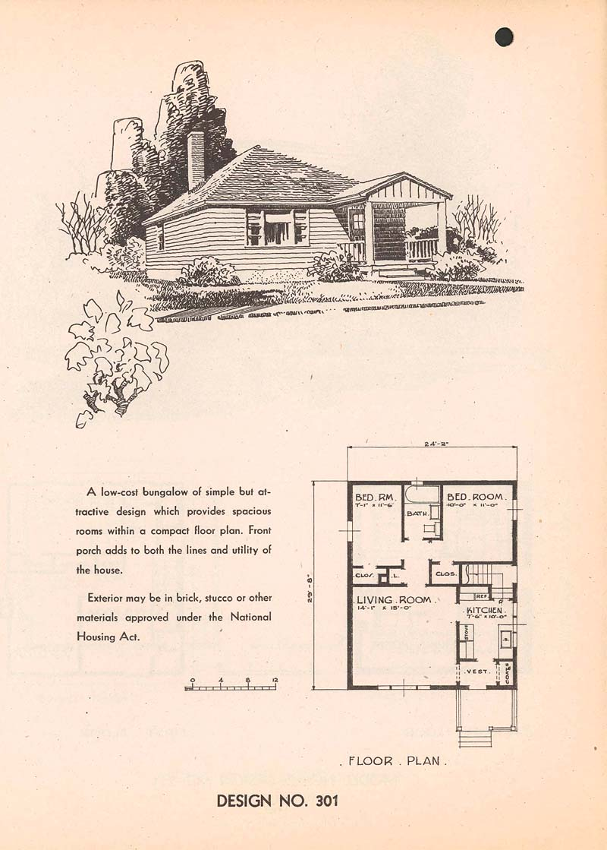
Image 10 Canadian Mortgage and Housing Corporation Sketch Designs for Housing 1948

Post-war immigration combined with the "baby boom" to dramatically increase Metropolitan Toronto's population, creating a demand for new housing. The CMHC helped Canadians to purchase affordable new homes in the expanding suburban realm. The increase in automobile use allowed for the construction of new housing further and further afield in the suburban reaches of Metropolitan Toronto. Not since the era before World War I had building activity in the suburbs been so rampant, as the private sector subdivided and developed them at a prodigious rate. In the post-war period, the federal government scaled down its housebuilding effort and began to withdraw from its housing programs. This left the provision of housing to the private sector. However, Federal legislation made it easier for developers to build houses and for home-owners to buy them by creating the centralised Mortgage and Housing Corporation

The Rise of Welfare Capitalism

The Post-War era of the mid Twentieth Century marks the peak of the influence welfare state and the era of full employment in developed industrial economies. It was the era of Welfare capitalism and the rise of universal rights and benefits which the state should bestow on its citizens. The emergence of the term Welfare Capitalism can be linked to initiatives by individual business owners who provided improved conditions and welfare services and good quality living accommodation to their employees. Examples include Robert Owen and the New Lanark mills in Scotland, Cadbury’s Bournville in England and Port Sunlight built by the Lever Brothers, also in England. These ideals began to be embraced by Nation states in the late nineteenth and early twentieth century. However, it is the period after World War II went the growth of Welfare Capitalism is at its peak.

T.H. Marshall in his essay, Citizenship and the Social Class (1949), outlines the concept of Social Citizenship which outlines the social responsibilities the state has towards its citizens or as Marshall explains that the role of the state came to be to protect the most vulnerable from inequality and social exclusion by putting into place welfare policies which resulted in the redistribution of wealth through taxation. This the era when the functions of the municipal city begin to be subsumed into the roles and responsibilities of national governments. Health and welfare measures taken for the betterment of citizens of cities were expanded in the form of national healthcare systems and universal health care and universal social insurance. This is the peak of welfare capitalism and the peak of Keynesian economics when living standards and individual rates of consumption grow at a rate never seen before. To illustrate the impact of this shift towards Welfare Capitalism it is useful to look at the impact this had on the North American city in the mid-twentieth century. This era saw the vast growth of the suburbs in North America as the state created the economic conditions for it to thrive. The resulting suburbanisation and growth of new consumer spaces such as the suburban shopping mall. One particular example which illustrates this impact is in the area of the provision of military housing.

Post-War Suburbia

Even before the Second World War had ended, there is an identifiable shift towards a vision of the post war modern city as being suburban and car focused. Two of the most influential figures in progressing the vision of the post war North American City were Robert Moses and Victor Gruen. Between 1942 and 1943 both had influential visions of urban life published in the influential architectural journal – Architectural Forum. Both provide visions of a rebuilt city in which a prosperous post war society could live and enjoy the freedom of private car based transport. A dominant narrative begins to emerge in which the focus shifts from the city core to the periphery through the growth of automobile dependent residential developments and suburban shopping malls. Government policy in the United States such as the Federal Highways Act placed a focus on road building to facilitate the growth in car ownership helped to reinforce this. The growth of the suburbs was at the expense of the city, as it sucked the roles and functions once held by the urban centres to the edge of the city.

Robert Moses – Re-imagining New York City for the Post-War Society

In 1942 an article from Architectural Forum by Robert Moses was a harbinger of a new dominant narrative to the development of the city and suburbs. The article was entitled What Happened to Haussmann? (Architectural forum, July 1942; vol. 77:1, p. 57-66;). It analysed Hausmann’s reconstruction of Paris after 1850. In this piece Moses has great praise for the impact Hausmann had on Paris. He attempted an analysis of his mistakes made by Hausmann but also attempted to recast Haussmann’s as one of the greatest urbanists of all time. Moses put forward the idea that for the post-war society to thrive and prosper, it was needed to engage in a vast reconstruction of city life on a scale not seen since Hausmann. The impact of Moses’ ideological homage to Hausmann was to play out in the impact he was to have on the re-invention of one of America’s greatest metropolis. After World War II, Moses served as New York City Construction Coordinator, where he oversaw hundreds of millions of dollars of investment in reshaping the city. These projects included parks, public beaches, housing, and bridges and highways. Moses was involved in completely re-shaping the New York region. This is the era in which we see the massive growth of the suburbs. The whole region was re-engineered in Moses vision for the city, which earned him the reputation as Master Builder of New York. He favoured highways and bridges over the expansion of public transport and drove through major projects such as the Cross-Bronx Expressway which had a permanent effect on the physical and social makeup of the Bronx area.

In The Right to the City Harvey (2008), explains that the process of urbanisation is driven by the necessity to absorb surplus capital. According to Harvey, a crisis emerges when capitalism cannot find a place to invest the surplus it produces. This is a constantly re-occurring crisis of capitalism. Harvey argues that the transformation of urban life is completely linked to the absorption of capital surplus. Credit institutions rid the barrier to consumption by providing loans for people to invest in property. Harvey compares the changes in settlement patterns which occurred in the twentieth century with the shift to the suburbs to the large-scale city reconstruction projects of the nineteenth century Paris. Harvey highlights the similarities between the reconstructions of urban Paris with the urbanisation process which occurred during the mid to late Twentieth Century in the United States. Harvey (2008) argues that there was a similar glut of surplus capital and labour in the United States in 1942, to that of Paris in 1850. For a while the problem was eliminated by the war effort for World War II when capital and labour were absorbed. Harvey (2008, p.5) explains that ‘Moses changed the scale of thinking about the urban process and through the system of (debt-financed) highways and infrastructural transformations, through suburbanization and through the total re-engineering, not just of the city but of the whole metropolitan region, he absorbed the surplus product and thereby helped resolve the capital surplus absorption problem’. This approach to city development could not happen without political influence. To help the residents of the newly minted suburban realm, financial institutions and tax arrangements needed to be structured so that credit could be liberated to finance the urban expansion through debt.

The impact which Robert Moses had on the reshaping of the New York metropolitan area was significant. The aim was to provide the physical and financial infrastructure necessary for the construction of a suburban realm of privately owned homes and automobiles financed by subsidies and freely available mortgages. This is the era when mass consumption begins to change the way the city is laid out. A complete restructuring of the urban system was to occur. The process of speculation saw the development of land in the suburbs which was cheaper than the core. In many ways, the development of suburban Toronto was to embrace these ideals as the city struggled to cope with the influx of residents to work in the war industries during the second world war and the baby boom afterwards.

Don Mills – the model for Canadian Suburbia

Sewell (1993 p.81) identifies Don Mills as the most influential development in Canada during the twentieth century. E.P. Taylor of Argus Corporation originally bought the land for a brewing plant, but decided to make the site the focal point of the 2,100 acre (8.35 km²) planned community. Within a few years of being built, it was to become the model for suburban development across Canada. Taylor had limited previous experience in the property development business, but had built a project named the Wrentham Estates in York Mills. Seeing the profit to be made with such projects, Taylor abandoned the brewery idea and decided to simply build a new town on the 2,000 acres (8.1 km²) he had acquired. The promotional map in Image 10 below outlines the planned layout for the new suburban community. It highlights the road links to rest of Toronto. and the proposed Don Valley parkway. We can see evidence of a quadrant design with small access roads connecting housing to main roadways. Don Mills was billed as ‘Canada’s most modern integrated community…’ in the brochure illustrated in Image 11.

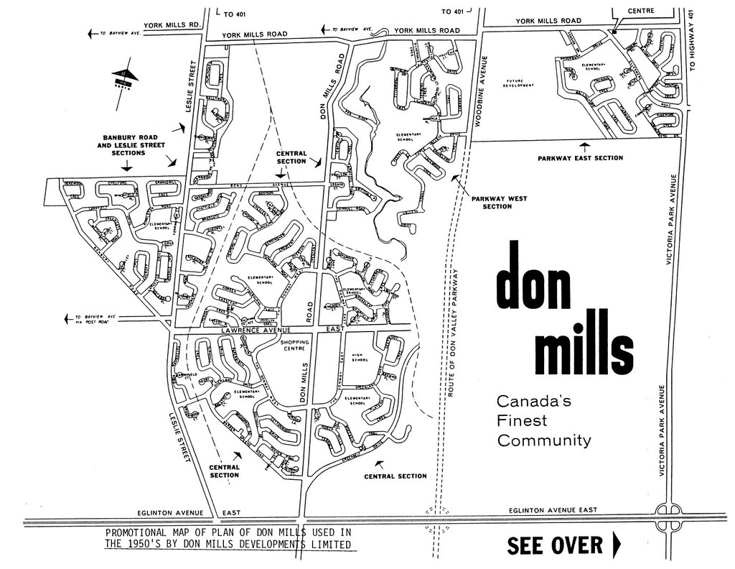

Image 11 Don Mills indicative site map illustrating key transport links and the Radburn style housing layout
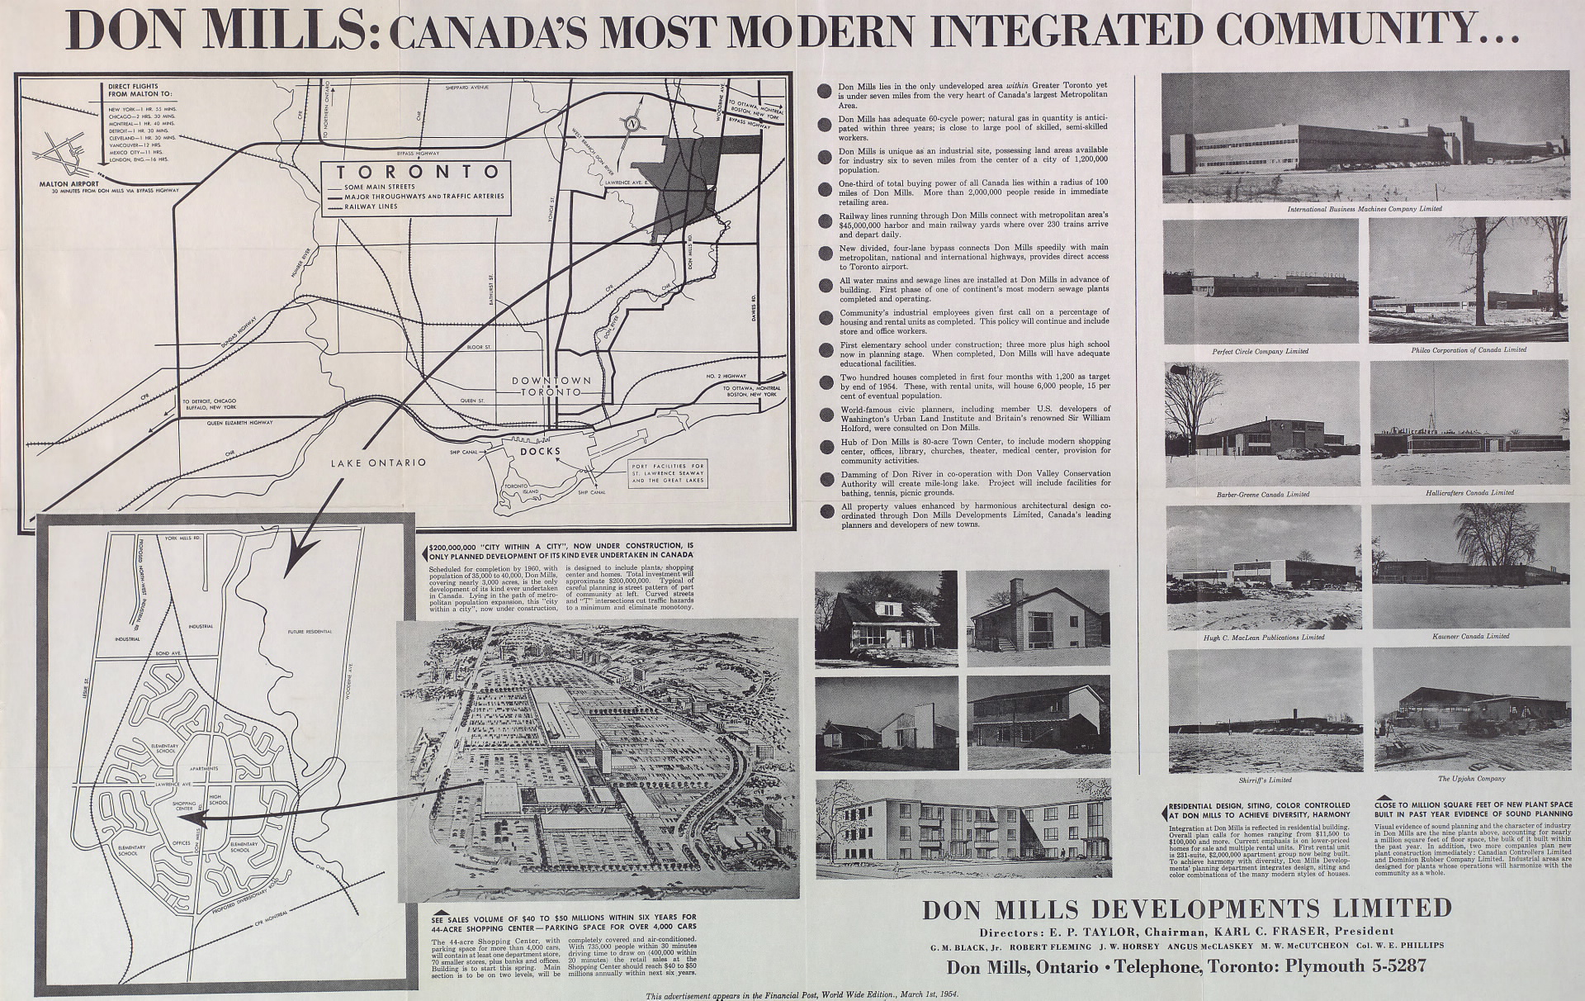
Image 12 Don Mills brochure
In 1951 he began planning the Yorktown community (as it was first known), and it was announced on March 11, 1953. The community was to be built on about 8.35 km² (3.22 sq mi) of farmland centred at the intersection of Don Mills Road and Lawrence Avenue East, with an expected cost of $200 million. Development was headed by the Taylor-owned Don Mills Development Company, (known as O'Keefe Realty in the days of the brewery development). The design of Don Mills reflects the ideals of Ebenezer Howard's Garden City, and it also employed the principles of two American town planners, Clarence Steinand Henry Wright, who developed the garden city community of Radburn, New Jersey.

The design was based on the neighbourhood principle. This broke down the community into four neighbourhood quadrants, all surrounding a regional shopping centre, at the southwest corner of Don Mills and Lawrence. Each quadrant was to contain a school, a church, and a park. In the Image 11 above, the Radburn style housing layout can be seen. This was to be a car based development linked to downtown with the Don Valley Parkway.

'The most telling statistic about Don Mills, however, and the one with the biggest impact on Toronto's future development, was that a mere 5 percent of people who live in the suburb worked close by. Without access to the subway, the majority were partaking in what became the aggravating suburban commute. And in the fifties, Toronto's roadways were not adequate for this increased traffic.'
(Levine, 2014)

As early as 1943, the City of Toronto’s Master Plan called for a new express route along the lakeshore, shown on a map as simply “Superhighway A. The promotional material from Image 12 outline the road connectivity with both the Airport and downtown with the ‘new divided four lane bypass connects Don Mills speedily with metropolitan, national, and international highways, provides direct access to Toronto Airport’. The individual who drove the development of the highway was Metro chairman, Frederick Gardiner. He developed a reputation for pursuing large scale investment in roads and infrastructure in a similar manner to his contemporary Robert Moses.

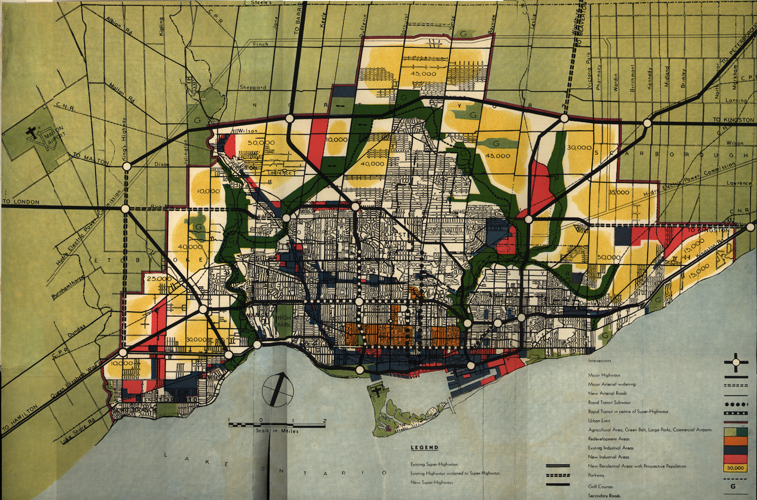
Image 13 Map from the 1943 “Master Plan for the City of Toronto and Environs”, as reproduced in the Royal Architectural Institute of Canada, Journal, June 1944. The numbers in the yellow areas are residential population projections. (http://www.neptis.org/public)

In 1953, Premier Leslie Frost named Gardiner chairman of the newly formed Metropolitan Toronto. In this position for the next 8 years, Gardiner turned all his powers toward building the large-scale infrastructure of a major metropolis. This included roads, bridges, subways, sewers, schools, parks and highways. Gardiner had a similar impact on the development of metropolitan Toronto as Moses had over the New York area.. Gardiner won approval for an eight-mile lakeshore highway in 1953 by cajoling hesitating councilors into starting construction in 1955. His biographer, Timothy Colton, called him a tyrant and a charmer, “big in size, big in ambition, big in appetites and big in rhetoric.” His nickname was “Big Daddy.” borrowed from Tennesse William's play Cat on a Hot Tin Roof, from Toronto alderman Philip Givens. Editorial cartoonists depicted him as an ermine clad emperor or, in one famous rendering by the Toronto Star’s Duncan Macpherson, the “Maharajah of Metrostan.”.

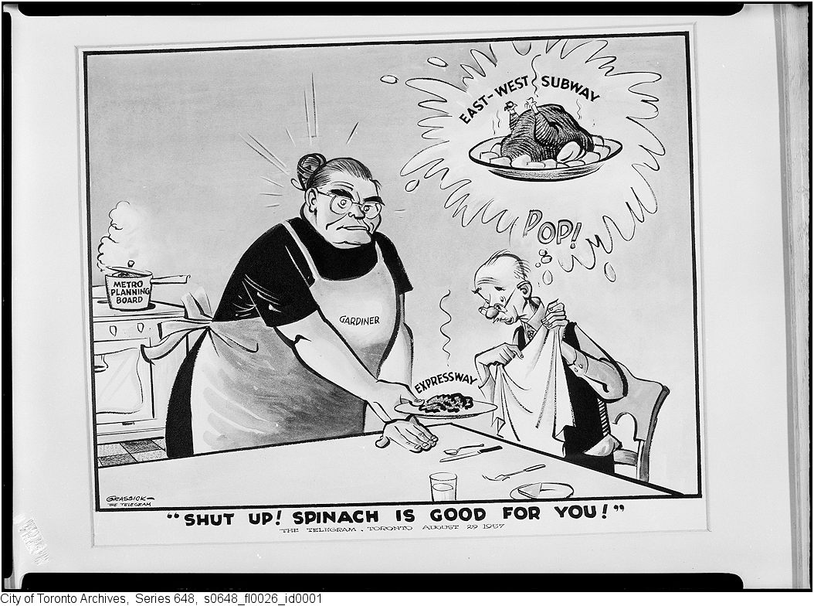
Image 14 Carton from The Toronto Telegram, August 29 1957

When politicians wrangled over the route of one section, Mr. Gardiner threatened to halt all construction until they had a deal. When conservationists complained that the proposed expressway would be routed straight through the historic Fort York, Gardiner said he would simply move the thing to the waterfront, “brick by brick.”. However, he eventually agreed to reroute the roadway around the fort. The expressway began construction in 1955 and was fully opened in 1958. Gardiner was not loved for long. Even as the Gardiner was being finished, community activists were protesting a plan to cut a swath through the neighbourhoods of central Toronto to build the Spadina Expressway. Leading the charge was Jane Jacobs, the American author who moved to Toronto after helping block Moses New York’s Lower Manhattan Expressway.

The development of Suburban Shopping in Toronto

The development of Post-World War II Toronto was reflective of the patterns emerging in cities across North America. The result was the creation of new suburban centres which were in competition with the downtown core. In 1951 Taylor had built one of Canada’s earliest shopping plaza the York mills plaza at York mills and bay view (Sewell 1993 p 112 – 113). The plaza at Eglinton was built around the same time, and this was followed by the Don Mills plaza. Initial construction of the Don Mills Centre began in 1954. In 1955, a strip plaza opened with a Dominion Supermarket, Kofflers Drug Store (the first Shoppers Drug Mart), Brewers Retail and a dozen other retailers. As the commercial focus shifted from the traditional main street to the shopping mall these centres emulated and simulated the functions of urban life in a whole new manner. However, they did this in a location remote to the city centre surrounded by an ocean of parking spaces, and cut off from the surrounding neighbourhood. It is important to understand the genesis of this dominant approach by first illustrating the ideals espoused by Moses and Gruen and identify how these narratives on how the post-modern city developed, manifested themselves in Toronto

The emerging suburbs recast the city in a new decentralized manner and led to the requirement for new types of shopping spaces. Don Mills Centre was primarily intended to serve the local community, centrally located within walking distance of many rental units built around the core of the community. The entrances turned away from the cars and towards an internal sheltered and landscaped walkways Don Mills and Rockland Shopping Centres, in the town of Mount Royal, Qué (Martin and Prus, 1958) were two examples of this type of centre in Canada. A shift had already occurred in terms of shopping centre designed. With the opening of Southdale Centre in Edina, walkways were later enclosed entirely to create a climate-controlled space. The centre modelled in part on European pedestrian arcades, such as the Galleria Vittoria Emanuele in Milan. One of the early Canadian examples of an enclosed, all-weather facility was Yorkdale Shopping Centre, North York, Ontario (John B. Parkin and Associates, 1960-64) When it opened it was the largest shopping mall to that date in Canada (119 000 m², with 2 department stores, a supermarket, and 90 shops). As in the case of Southdale Mall, it was an early regional centre, located at the intersection of two highways.

Shopping Spaces for the new suburbia

One of the key phenomena that emerged from this era was been the spread of new types of spaces which have the appearance of being public yet are privately owned. The enclosed shopping mall is the prime contemporary example of this type of space. In 1956 Southdale, Minnesota became home to the World’s first fully enclosed shopping centre and was to become a model for the next 25 years of retail development in the United States, and beyond. It is the one of most significant cultural and economic factors and the most significant spatial phenomenon of the late 20th century. The original Southdale Mall, which the architect Victor Gruen designed as something akin to an oasis of urbanity in suburban America was created to combat the post-war sprawl he saw drastically altering the urban structure of America. Instead, the shopping mall morphed into a highly controlled and regulated consumption space worsening the sprawl it was designed to combat. It has been discussed how this type of space spread throughout the world and became a dominant everyday space in modern life.

It has been discussed that a dominant narrative about the future form that the city would take began to emerge in North American urban planning in the 1940’s. There was an emerging discourse about how the urban realm should be developed after the war had ended and there was an increasing recognition of the pressure to provide quality affordable housing. There was also an increasing recognition of the opportunity for growth that could arise once war ended and the soldiers and other defence workers return home. Mass federal led developments such as Linda Vista in San Diego were a pioneering approach to housing the defence workers who were flocking to cities to work in the war industries and those who would return when the war had ended. The interventions made by the Canadian Federal government through the Veteran’s Land Act and the Central Mortgage and Housing Corporation were evidence of a shift from interventions made at a local municipal level to a national level intervention in urban development. This reflected increasing steps towards the nationalisation of welfare provisionand the declining role that municipal authorities would have on shaping urban lifeThese programmes encouraged mass home ownership facilitated by the massive growth of suburban housing. This was to have a dramatic impact on the commercial and social life of the North American City and heralded the era of rise of the suburban shopping mall. However, this shift to suburban shopping centres was not an overnight event. The first automobile-oriented shopping centre, the Country Club Plaza in Kansas City had opened in 1923. The impact of the Great Depression had stunted the growth of suburban shopping centres and as late as 1946 there were only eight shopping centres in the United States.

The Linda Vista Shopping Centre – welfare capitalism and military housing

The growth of the military during the run up to United States involvement with World War II necessitated large increases in construction to house the swaths of new defence workers. The U.S. Congress passed the National Housing for Defence Act of 1940 (also known as the Lanham Act) on October 14, 1940. This provided $140,000,000 for defence housing construction (Federal Works Agency, 2nd Annual Report, 1941 p. 29) and there was an impetus to provide housing for defence workers as quickly as possible. The Linda Vista development was the result of this national policy and to support the build-up of the military during World War II. The contractor’s slogan for Linda Vista was "3000 houses in 300 days" and it became America's largest defence housing project. This development is a signifier of the shift from municipal investment in the urban realm towards investment on a national scale by a national authority. As the development was being completed, San Diego became America's fastest growing city and with this growth, problems quickly emerged.

The Linda Vista development lacked basic shopping facilities and residents had to travel outside of the development for basic necessities. The Linda Vista Shopping Centre was designed to provide a retail and community centre for the people of Linda Vista. Considering the growth of automobile ownership, the centre was laid out with car parking and landscaped open spaces. Shoppers could park their cars at the edge of the centre and shop in a pedestrian only realm. The centre was designed to act as a focus of the Linda Vista community, not just a retail node (Taschner, 1982). The retail functions were located next door to a tenant activity building for residents to hold meetings and events. Ultimately it was to be the centre of the community for the residents of the large suburb.

The Linda Vista Shopping Centre was one of the earliest types of shopping spaces designed for the car owning suburban dweller and it was an important keystone in the development of a new suburban realm which would transgress the entire country. The importance of the site is evident in the fact that the opening of the Shopping Centre was dedicated in 1942 by the United States First Lady at the time, Mrs. Eleanor Roosevelt. This development is an important moment in the shift of urban life from the realms of the centrally focused Municipal city to the dispersed and mobile Welfare Capitalist State. Linda Vista is a pioneering prototype for the shopping centres which were to follow and the prototype of what suburban life would look like after the war had ended.
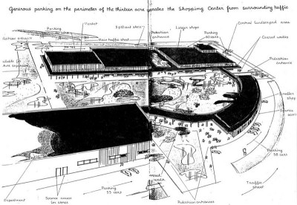
Image 15 Linda Vista Community Development Corporation, 2014 http://www.lindavista.org/lvcdc/index.php/accomplishments.html

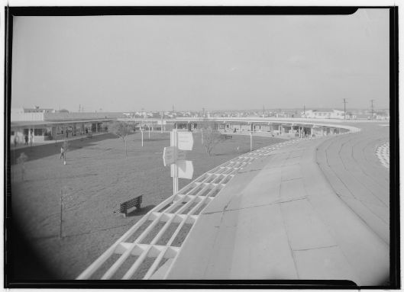
Image 16 Linda Vista Community Development Corporation, 2014 http://www.lindavista.org/lvcdc/index.php/accomplishments.html
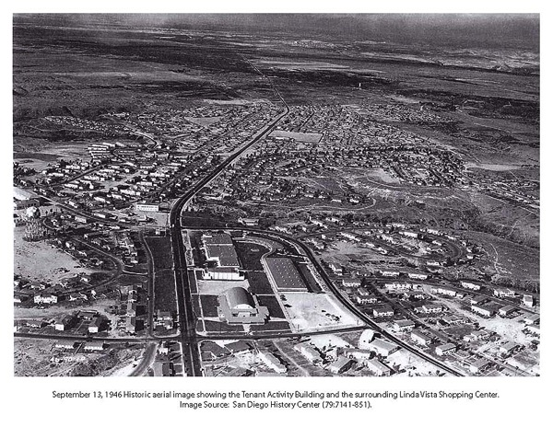
Image 17 Linda Vista Shopping Centre aerial view.

The images above show how Linda Vista Shopping Centre surrounded by car parking. Shoppers could park their car on the edge and enjoy the pedestrianized realm surrounded by rows of shops. The second image shows the open green area and the sense of space which the centre evoked. The third image shows how the Linda Vista Shopping Centre was designed as a focus for the new dispersed low-density community. Linda Vista marks the beginning of the era when city authorities, planners, developers, and federal government begin to focus their attention on what life in the American city will be like after World War II had ended. In Linda Vista, the task of providing the municipal services is no longer driven solely by the local authority. National government policy is directing the development of this suburban way of life. Public money is being directed from national government to provide a local neighbourhood.

It was not until the mid-1950s when we see the post-war home building effort in full swing that we see the later growth of suburban shopping centres. There is one centre which is the genesis of the suburban shopping mall form: The Southdale Mall (1956) in Edina, Minnesota (Crawford 1992, 2004; Gladwell, 2004; Gillette, 1985; Shields, 1989). The form it took became a template for shopping centre development that spread across the world and changed the urban landscape permanently. The Southdale Mall (1956), was the first enclosed and hermetically sealed regional suburban shopping centre in North America. It was conceived of as an oasis of urbanity in suburban America. The designer, Victor Gruen saw it as a space that could combat the post-war sprawl he saw drastically altering the urban structure of America. His original ideas for the American city of 194X were firmly based on transplanting the model of European city centres to the suburbs. Gruen believed that they would not only serve as shopping centres but also give a focus to what he saw as an isolated suburbia. The mix of commercial and social spaces would strengthen social ties.

Planning the Shopping Spaces of 194X

Architectural Forum published an issue in May 1943 entitled ‘New Buildings for 194X’ in which it commissioned 23 architectural firms to design hypothetical buildings for a “hypothetical town of 70,000” modelled on the urban fabric and local economy of Syracuse, New York. With the ‘New Buildings for 194X’ commission Architectural Forum was to provide a major outlet for new ways of thinking about how the city and their suburbs would be reshaped after the war. The brief given in ‘New Buildings for 194X’ was to design components for the future of an ideal mid-size American city. What was to emerge in this issue is an emphasis on developing a planned approach to managing the economy after the war. One of the designs for this commission was submitted by Victor Gruen and his wife at the time Elsie Krummeck. In the proposal, they proposed a series of small neighbourhood shopping centres with food stores and local services, and a “larger centre” which would cater for higher order retail and serve the region. In 1943, the idea of a large regional shopping centre which would serve the car owning shopper may have seemed fantastic and futuristic but the proposal was building on ideas already pioneered in Country Club Plaza and Linda Vista. What was novel about this plan was the idea of expanding the scale to serve a larger catchment area. Gruen and Krummeck believed that people would drive longer distances to enjoy the facilities a regional centre could provide. The proposal is the most realistic prediction of the entire 194X city issue. ‘The American metropolis’s form and feeling would be more profoundly shaped by the construction of giant shopping centre than by all Architectural Forum’s other 194X proposals combined’ (Hardwick 2004 p.89). The design which Gruen and Krummeck proposed did not have an immediate impact, it was over a decade later that they were to wait to get the chance to implement their ideas for a larger scale suburban shopping centre.

In the 1950’s the modern version of the suburban shopping centre began to emerge at key points on the newly emerging national highway network. The Federal Highways Act 1956 provided funding for the vast expansion of the United States national road network. New regional shopping centres were developed at the convergence of major new highways. The process of suburban decentralisation which had begun decades earlier saw the growth of communities which lacked a centre and where development had sprung up along main roads and lacked a focus. On April 21, 1950, the Northgate Shopping Mall in Seattle, which was planned by developers Rex Allison and Ben B. Ehrlichman and designed by John Graham. In his evolution of retail spaces Koolhaas’ (1998, p.34) describes Northgate as the first open-air mall. Coleman (2007 p.42) explains that Northgate shopping mall proved the idea of shops being arranged either side of a long linear pedestrianized walkway which became the model for the other suburban malls. Crawford (2002, p.23) states that, the major explosion of shopping malls after World War II was marked by the development of ‘dumbbell plan’ which was department store ‘anchors’ connected by an outdoor pedestrian mall. The earliest of this type was Shoppers’ World, designed by Morris Ketchum, in 1951 in Massachusetts (Koolhaas 1998, p.34). The Shoppers’ World’s safe and protected pedestrian malls and courts also housed ‘tot-lots, chapels, community rooms, and a host of temporary activities including art exhibits, dances, and fashion shows’. Additionally, it was also the first shopping centre to have a musical water fountain show. The concept of a centre for the suburbs was continuously redefined and redefined by these spaces in the early1950’s. However, it was Victor Gruen Associates and the department store chain such as Dayton’s which were to prove the most influential in bringing about the genesis of the modern enclosed suburban shopping mall.

Victor Gruen – bringing Urban Vienna to Suburban America

The Vienna which Gruen grew up in was a thriving hub of political action, art and commercial life. Like other European metropolitan cores, such as Paris, Berlin and London it was the centre of public and social life. Gruen (1972, p. 1) noted that, "European cities have been held by a tight urban tissue. In Paris, the Sorbonne is located in close integration with living quarters, stores, cafes, restaurants, cinemas and theatres; in Copenhagen, the Royal Academy of Arts is right in the heart of the city; in Vienna, the Technical University is located a few steps from the famous Ringstrasse, in the midst of the intensely developed urban core." The urban core of the Vienna of Gruen's youth was the centre of Viennese public life. It was in many ways quite different from the dispersed suburban metropolis that which he would come to know in the United States. One of the most significant characteristics of urban life in Vienna was the "Ringstrasse", a road which circled the inner core of the city. In this core, there was a mix of activities including residential, industrial, cultural, and recreational sites. Even though they were clustered together they did not interfere with each other. The Ringstrasse had a strong influence in Gruen's approach to city life and this can be seen in his plans for pedestrian friendly shopping centres for the dispersed American Metropolis.

Between 1918-1925, Gruen attended Vienna Technical Institute and Academy of Fine Arts, and from 1923-1932 he worked as a Designer with Melcher & Steiner, Architects, Vienna, Austria. Following this, Gruen worked as an independent designer in Vienna between 1932 and 1938. During this time, he received much acclaim for his work on creating modern shopfronts with large plate glass windows for retailers such as Singer. Gruen designed vast shop windows and dramatic glass fronts which turned small shops into vast display canvases before fleeing Nazi oppression in Austria for the United States. In 1939, he worked on the General Motors Corporation Highways and Byways of the Future exhibit for the 1939 New York World's Fair. During this period, he worked with other designers and architects including Elsie Krummeck (who he was to marry in 1941). Gruen founded Gruen & Krummeck Partnership, New York, in 1939. They worked on buildings, storefronts, and store interiors and one of their first large projects was to design, in association with architect Morris Ketchum, a new store for the Lederer Company in New York City in 1939. They designed a store for Fifth Avenue for Lederer de Paris which had a recessed arcade which was dedicated to displaying the array of goods on sale in the store. It was akin to a consumer trap etched into the flush facades of Fifth Avenue to trap the consumer in a three-dimensional box for the display of the phantasmagoria. Gruen brought the techniques he had developed in Vienna to one of the most expensive shopping areas in the world and he was to get the chance to express this in a more complete form over the following decades.

In 1941 Gruen & Krummeck moved its main office to Los Angeles, and after the dissolution of his marriage to Krummeck in 1951. Gruen founded Victor Gruen Associates (later Gruen Associates) which was a collaborative team of architects, planners, and engineers with main offices in Los Angeles and New York and project offices in Detroit, Chicago, Miami, Rochester, Minneapolis, Honolulu, San Francisco, Washington, D.C. and Tehran. The firm soon became one of the busiest in the United States, providing master plans and shopping centers for municipalities, department store owners, and property developers across the country. Gruen had arrived to the United States as an outsider uprooted by war from his homeland. This position gave him a different perspective which could help him understand the impact which suburbanisation had on his new homeland. The impact of his approach to creating centres for suburbia began to be felt from 1954 onwards as his designs began to pop up across the United States. Along with his implemented designs, it is the book Shoppingtowns USA (1960) which he wrote with economist Larry Smith which offers the best insight into the guiding ideals which Gruen had on how to reshape and reimagine modern suburbia.

Providing a focus for the ‘amorphous conglomeration’

To accommodate the flood of humans seeking escape from the intolerable conditions of the city, mass housing builders tore up the ground, chopped down the trees, and removed swiftly and clinically every vestige of what the people had come to find. Modern suburbia was born, in which there were neither the values of a rural community nor those of an urban environment.
(Gruen and Smith 1960 p. 19)

Modern suburbia is portrayed by Gruen and Smith as a place which had been stripped of value and meaning. All that had made it rural had been cleared away by the mass housing builders and any vestiges of rural community were wiped away. What replaced it was a space which displayed neither the values of rural communities nor those of the city. Gruen and Smith propose that the decentralised nature of modern suburbia was created by the lack of a defined centre as had been seen in the railway suburbs which were centred around stations on commuter lines. For a sense of community to emerge in the suburbs, a centre would need to be created where services such as retailing and other community activities could occur.
Since suburbia is undoubtedly having a serious effect on the personality of our entire urban life, it is natural that its influence should be felt by the segment of human activity that is of primary concern to us here: the marketing of goods for the gratification of human needs and desires. In this amorphous conglomeration—suburbia—the merchant has had difficulty in finding a logical way to integrate his activities with the local scene. Stores, which followed their customers into the suburbs, were no longer provided with obvious predetermined locations such as near railway stations. For the customer no longer emerged at defined points; he and his automobile were everywhere. Under these circumstances the best bet seemed to be store locations on highways over which shoppers would have to travel on their way back and forth to the city
(Gruen and Smith 1960 p.22)

Gruen had grown up in Freud’s Vienna and takes a psychoanalytical approach to the impact of the suburbs on the personality of urban life where human activity is driven by the urge for gratification of human needs and desires. The newly mobile suburban dweller was not confined to travel to places only on public transport. The automobile created opportunities to be ‘everywhere’. The ‘amorphous conglomeration’ lacked a centre. Gruen and Smith argue that centres need to be defined in a similar manner to that of the railway suburb. Customers need to know where to go to satisfy their needs and desires and retailers need to know where their customers gather. What is being advocated is the creation of defined points in suburbia to focus retail development.

Shoppingtowns USA was published after Gruen and his company had the opportunity to design many of the pioneering shopping centres throughout the 1950’s and in many ways, acts as a toolkit to shopping centre developers on how to recreate the elements Gruen had perfected in their own centres. Gruen and Smith are speaking from a position of authority. The company developed the pioneering concepts for regional shopping centers, beginning with Northland Center (1954) near Detroit. Smith and Gruen explain how many department stores have embarked on suburban expansion programs to regain customers that have been lost to suburban commercial developments. In Northland, Gruen worked with a chain of department stores, J.L. Hudsons, with a plan to ring the central business district with branch locations in suburban areas. The key aim of this was to ensure adequate representation throughout the metropolitan area to recapture customers lost to suburban retail developments. In a sense Gruen was encouraging the department store to go to where it’s customers were living and to create new centres which were easily accessible and would provide a focus for shopping in the suburbs.

For the J. L. Hudson Company in Detroit, for example, a master plan has been developed which has spotted locations approximately ten to eleven miles distant from the downtown business district in various segments of the metropolitan area. In accordance with the locations indicated on the master plan, sites were or are being acquired. Two centers, namely Northland and Eastland, are already in operation. The method chosen by the Company is to erect branch stores of considerable size (between 400,000 and 500,000 square feet) within regional shopping centers which, together with the department store, contain approximately 1,000,000 square feet of rental space.
(Gruen and Smith 1960 p. 37)

The impact which the Department Store was having on focusing development within the suburbs was clear. Gruen convinced the J. L. Hudson company to plan for a network of four centres circling downtown Detroit at a relative equal distance of 10-11 miles. There are similarities here to Howard’s Garden Cities in terms of the network of ring centres. It is a rational approach to organising life in the suburbs to combine the best aspects of rural and urban life. These centres would provide a focus in the decentralised mass of suburbia. They would act in a similar manner to commercial and community centres along the railway lines of nineteenth century suburbia but their catchment area would be occupied by a highly mobile population of car owners who are spread out far beyond the previous limits of walking distance. Building on the design for a regional centre advocated in New Buildings for 194X each of these four centres would serve as regional centres providing a larger range of shopping and services in a planned and well-designed setting which would encourage the shopper to travel a further distance for the better shopping experience.

Northland was an attempt to bring the best aspects of an urban environment to the suburbs. It provided a centre in the suburbs without the drawbacks of driving downtown. Unlike so many of the fully enclosed malls that came after, the two-million square foot centre included outdoor space, auditoriums, a bank, a post office, local retailers and a self-service supermarket. Gruen created a space in the suburbs where the citizen could experience life outside the home in a privatised realm which had the appearance of being public. The utopian ideals of the project were outlined in the Gruen’s visions of the role the space could play as a focus for the life of the community. It is in one of his subsequent projects which he was to explore this to a fuller extent.

Tomorrow’s Main Street Today
Southdale Mall Advertisement, 1956 Wrigley and Lowe, 2002: p 218

The genesis of the enclosed suburban shopping mall is Southdale Mall in Minnesota, which opened its doors in 1956. The Southdale Mall was born of the utopian idea that a better life could be provided for suburban dwellers in the hermetically sealed shopping centre. It was to provide a centre for retailing in the suburbs as an antidote to strip based commercial development. The Southdale Mall was designed by Gruen to provide a European Style pedestrian centre for the suburbanite which was fully sealed from the elements. In a similar manner to Northland, he re-created a spatial form inspired by the town centres of Europe where pedestrian activity was key. The advertisements for the Southdale centre when it first opened promised a utopian experience ‘A whole new shopping world ’ (Wrigley and Lowe, 2002: p 218), where customers could come and experience ‘Tomorrow’s Main Street Today’. The Southdale Mall built on the ideas Gruen developed in Northland but the major development was the creation of enclosed streets with a central courtyard and fountain. The Southdale Mall was the recreation of the nineteenth century arcade on a larger scale. It also expanded on a massive scale the elements of retail display he had explored in the shopfronts he designed in Vienna for the Singer store and on Fifth Avenue for Lederer, amongst others.

The plate glass and modern steel and concrete construction of Southdale allowed the creation of a pedestrianized town centre with wide malls and a central courtyard laid out as a Garden court. Hermetically sealed from the Minnesota climate, air conditioned and climate controlled, it was regarded as the ideal shopping environment. The Mall had been commissioned by the head of Dayton’s, a Minneapolis based chain of department stores. The developers quoted the US Department of Commerce Climatological Survey in promotional literature for the Mall which stated that it had calculated that there were only ‘126 ideal weather shopping days per annum’ in Minneapolis. Dayton wanted Gruen to design the ideal shopping environment to satisfy the shopper all year round. In original brochures advertising the Southdale Mall this key data was cited to explain why the centre would be different. Shoppers of Minnesota would no longer be limited to an average of 126 ideal shopping days per annum. In the Southdale Centre everyday would have the ideal shopping weather and in the Garden Court at the heart of the centre, the community could gather all year round.

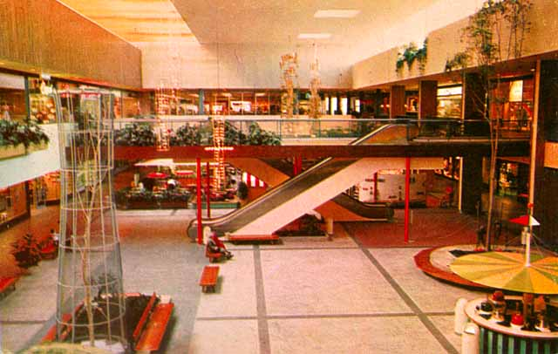
Image 18 Garden Court, Southdale Mall Edina c. 1956 (Minnesota Archive)

This hermetically sealed, climate controlled space was to be the centre of a brand new community which would include playgrounds, nurseries, residential units and recreational facilities. Here in the suburbs of Minnesota, a modern privatised space emerges for the twentieth century suburbanite. It was a direct response to the car based strip mall development which had characterised shopping in the suburbs up until this point. The Southdale Mall was to be a true centre for public life in the suburbs. The car was relegated to the exterior and inside the pedestrian was free to roam a city in miniature. It was the recreation and re-imagination of Main Street for the suburban lifestyle where the individual can walk the passageways and experience a version of urban life.

In 1960 Shoppingtowns USA he outlines the list of mall activities to which people flock to the shopping mall even when the mall is closed. However, in the context of an increasingly consumption focused and speculation-driven economy Gruen’s shopping center became an enormous selling machine and this had a formative impact on the development of cities all around the world. Gruen and Smith (1960 p.22-24) the role which Gruen believes that shopping centres can play in expressing community life is outlined.
The basic need of the suburban shopper is for a conveniently accessible, amply stocked shopping area with plentiful and free parking. This is the purely practical need for which the shopping center was originally conceived and which many centers most adequately fulfill. Good planning, however, will create additional attractions for shoppers by meeting other needs which are inherent in the psychological climate peculiar to suburbia. By affording opportunities for social life and recreation in a protected pedestrian environment, by incorporating civic and educational facilities, shopping centers can fill an existing void. Thev can provide the needed place and opportunity for participation in modern community life that the ancient Greek Agora, the Medieval Market Place and our own Town Squares provided in the past.
(Gruen and Smith 1960 p. 23 -24)

Creating spaces which allowed ‘opportunities for social life and recreation in a protected pedestrian environment… incorporate civic and educational facilities’ would allow these centres to fill a ‘void’ in the suburbs. Gruen believed that shopping centre developments such as Southdale and his earlier Northland Centre in Detroit, could provide an identifiable commercial and civic centre for the sprawling suburbs. This would provide a focus for social life in the same manner that the agora acted as site in which the citizen could participate in public life.
That the shopping center can fulfil this perhaps subconscious but nonetheless urgent need of suburbanites for the amenities of urban living, is convincingly proved in a large number of centers. In such centers, pedestrian areas are filled with teeming life not only during normal shopping hours, but on Sundays and holidays when people windowshop, promenade, relax in the garden courts, view exhibits and patronize the restaurants.

All age groups are provided for. Auditoriums are booked to capacity. Meeting rooms are busy with civic and cultural affairs. Dance schools, music schools, and ice skating rinks attract teen-agers; amusement centers are popular with children.

Such a planning concept also results in an upgrading of the residential area surrounding the center. It not only protects surrounding communities from blight but actually raises their desirability and consequently their property values.

If the shopping center becomes a place that not only provides suburbanites with their physical living requirements, but simultaneously serves their civic, cultural and social community needs, it will make a most significant contribution to the enrichment of our lives.
(Gruen and Smith 1960 p. 24)
Gruen has a utopian ideal of providing the ultimate centre which will bring community life to the suburbs. However, in providing a life for the community which was separate from the city and which was in private ownership, it created space in which the primary focus was on shopping. In a similar fashion to the arcades of the nineteenth century, the enclosed shopping centre interiorised the city and created the ideal realm for engagement with the capitalist realm of the commodity fetish. The suburban dweller could claim citizenship not of public life but of a commodity focused privatised pedestrian shopping centre.

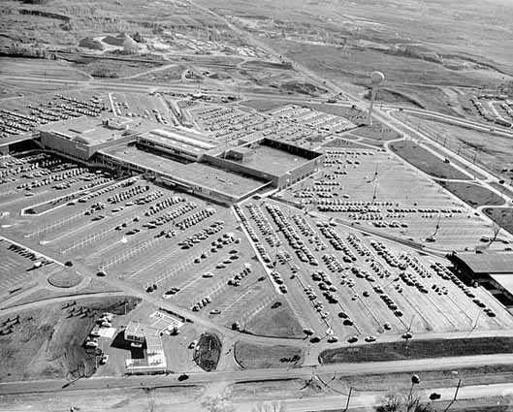
Image 19 Aerial View of Southdale Center, Seventieth and France, Edina http://collections.mnhs.org/cms/largerimage.php?irn=10070510&catirn=10671105
Gruen wanted to improve life in the suburbs and believed that architecture could help to provide a space which could combine the convenience of suburbia with the ‘pleasures and advantages of urban life’ It was a utopian ideal reminiscent of the idealistic exhibitions of the 1939 World Fair, where modern building technology and private car ownership would reshape the city into a suburban utopia with pedestrianized shopping towns surrounded by large parking lots.
The shopping center is one of the few new building types which represent a response to the emergence of the automobile as a means of mass transportation. It is a grouping of buildings and related spaces, establishing a new environment in 20th Century life, not only for shopping but for many other activities as well. Its building group and related spaces are not strung along existing roads but constitute a new planning pattern of their own. This new environment is dedicated to the pedestrian. (Gruen and Smith, 1960 p.140)

The Southdale model of an enclosed controlled retail environment would serve the car dependent populations of the newly built suburbs. It would provide a pedestrian realm where the suburban dweller could experience city life (Gruen and Smith 1960 p.147)

We must try to remember the important and vibrant role our town squares have played in the life of our communities. We must sensitively observe the colorful, stimulating, and commercially busy urban scenes in the market squares in Central European cities in order to understand the contribution to community life the open spaces in our new shopping towns can make.

(Gruen and Smith 1960 p.147)

The Southdale Mall did not invent the concept of a shopping centre; there have been retail centres which bear some resemblance to the Southdale Center, such as Trajan’s Market in Ancient Rome, and the great souks of Aleppo, Istanbul and Damascus. These spaces were also purpose-built shopping centres. What is different about the Southdale Mall is that it is fully enclosed and inward-looking. The enclosed shopping mall was designed to be reached in a car for a decentralised suburban population. In spite of the idealism that Gruen demonstrated in the design of the Southdale Mall, what emerged in the centres which were built in its image was a massive privately-owned realm which replicated the shopping elements of urban public spaces and neglected the other aspects of public life. However, the Southdale mall spawned a series of what Victor Gruen termed ‘bastard developments’ which neglected his ideals of creating an oasis of urbanity. Instead they exacerbate sprawl and provide a standard fit for retail development across the world. The result of this is that the city becomes more like everywhere else, a shopping mall with a veneer of local images and metaphors. As time went by, Gruen disassociated himself from the ‘run-of-the-mill’ shopping malls which had sprung up across America of which the Southdale Mall was seen as the genesis.

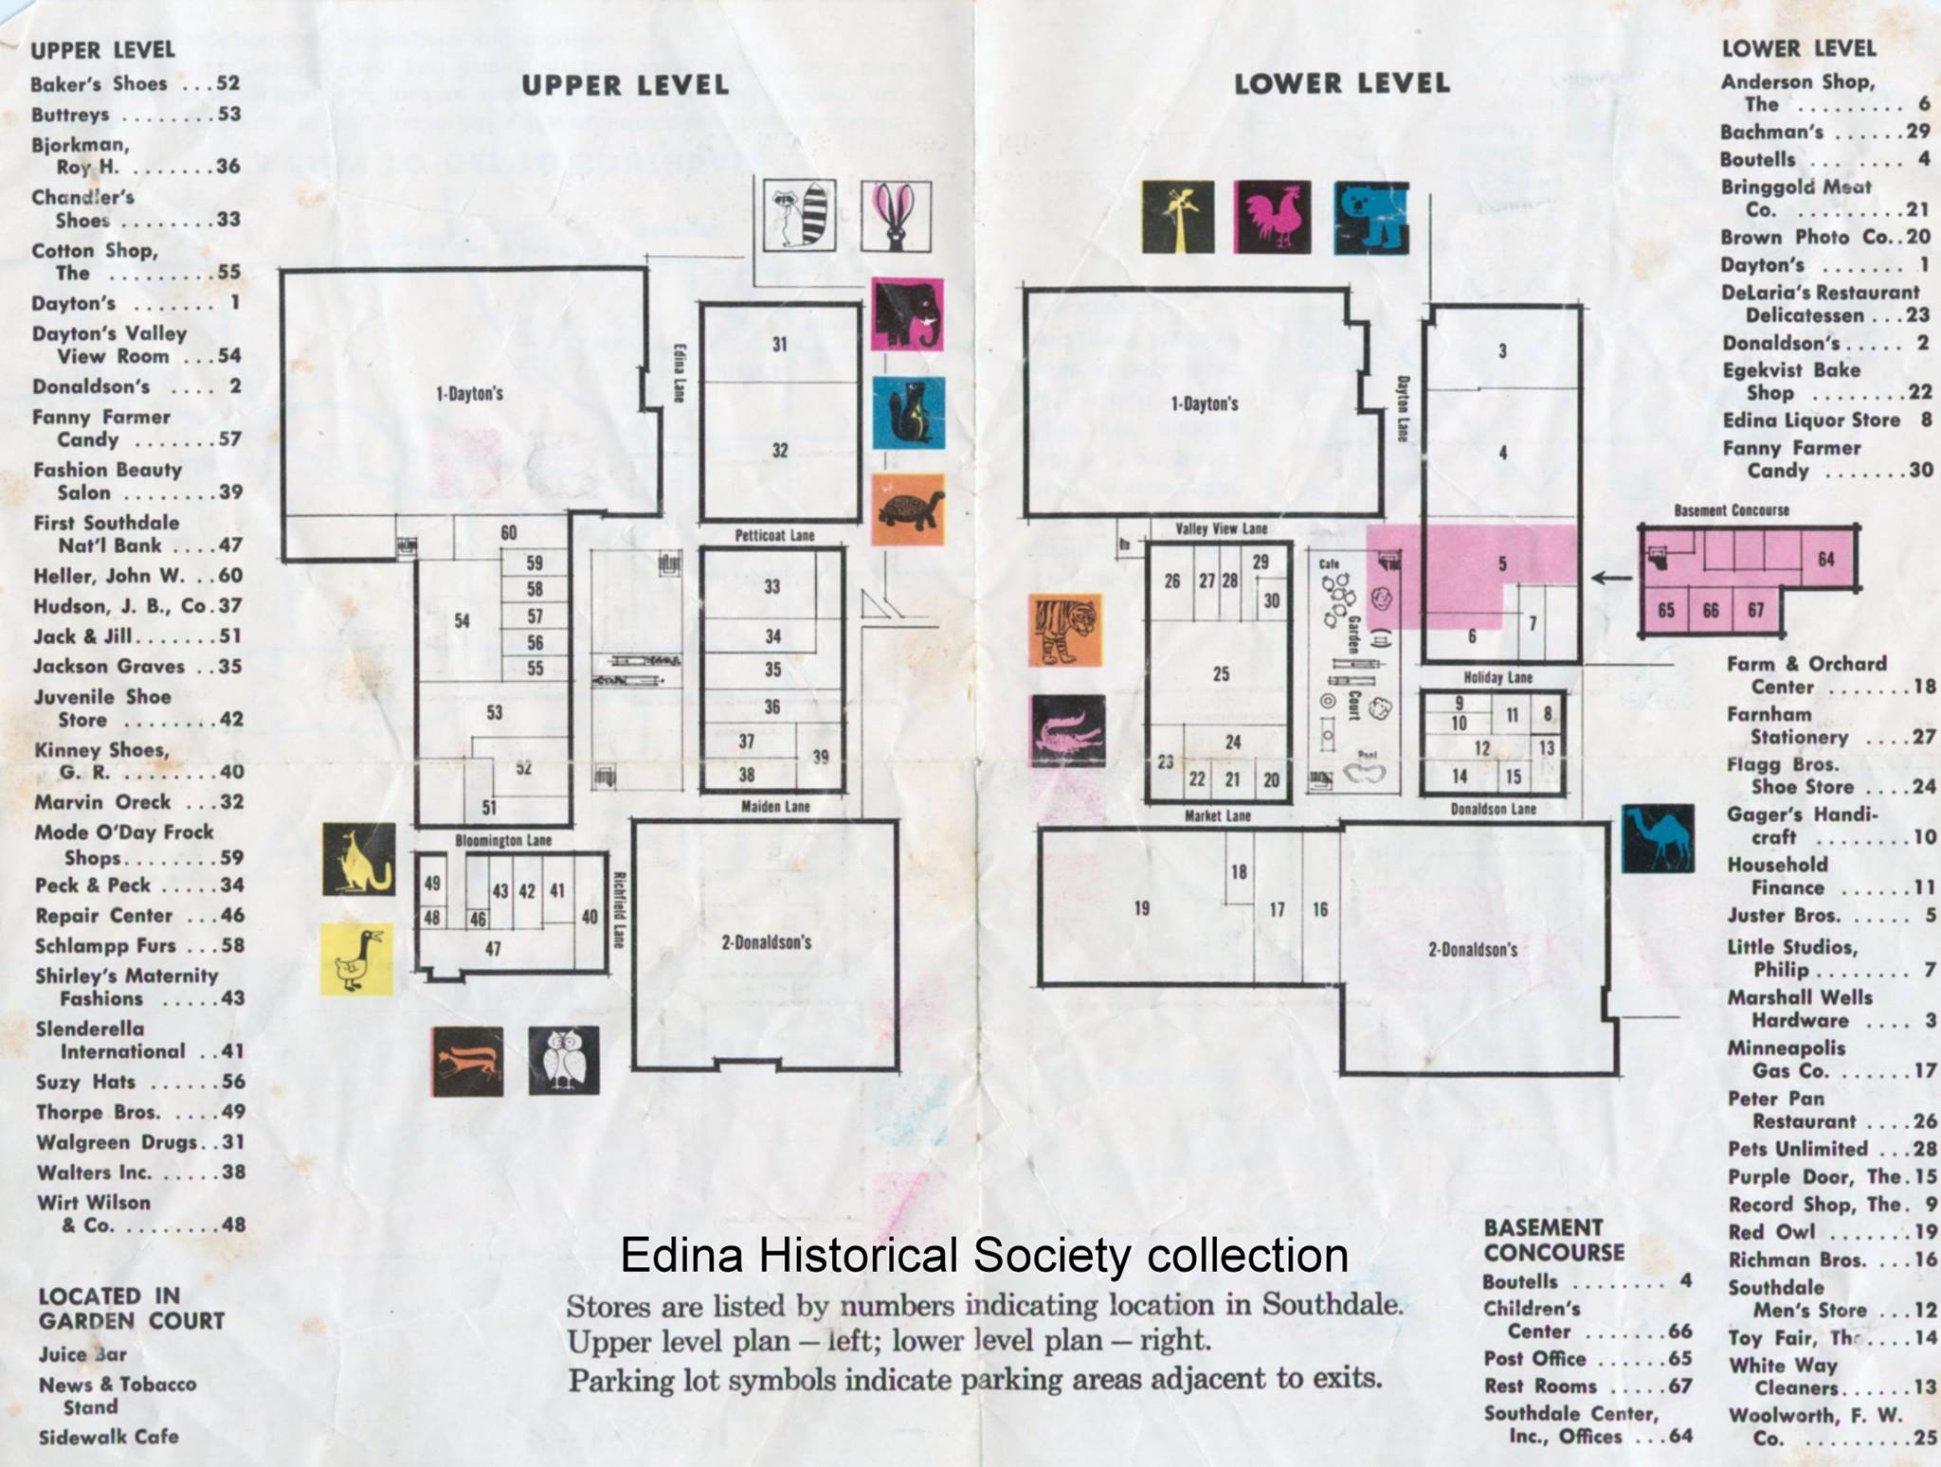
Image 20 Aerial View of Southdale Center, Seventieth and France, Edina http://collections.mnhs.org/cms/largerimage.php?irn=10070510&catirn=10671105

Yorkdale, which opened in 1964 was became a harbinger of what form suburban shopping would take across Canada. It could be said that Yorkdale revolutionized shopping in Ontario, setting the trend for many malls that followed, including the Toronto Eaton Centre and Fairview Mall. Like the Southdale Mall, it brought two department stores under the one roof linked by an enclosed mall, which was lined by smaller retail units. It centralized the shopping experience bringing together, under one roof Eaton’s and Simpson’s department stores.

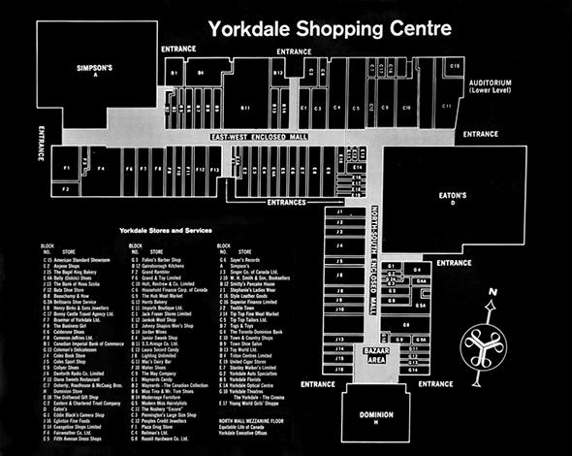
Image 21 Mall Plan of Yorkdale Mall http://www.blogto.com/city/2016/05/what_yorkdale_mall_looked_like_in_the_1960s_and_70s/

The Materialisation of Mass Consumer Society

With the growth of the Welfare state, we see the emergence of the Consumer state. The pursuit of universal rights to welfare and housing saw a vast increase in quality of life and expansion in personal spending power. This lead to a democratisation of conspicuous consumption. As the department stores revolutionised nineteenth century consumption, the suburban shopping mall also reshaped consumption patterns. The spread of the mall across the United States, Europe and the rest of the world is not solely based on changing settlement patterns due to increasing car ownership. It can also be linked to materialisation of the commodity fetish and conspicuous consumption in our everyday lives. The 1940’s marked the period when the formulation of the conditions necessary for daily life for the suburban lifestyle were planned and designed. In the 1950’s there was a concerted effort by mall makers, retailers and advertisers to shape the modern city into a suburban utopia where happiness could be purchased in the mall. Harvey (2010) highlights that there was a significant effort put into shaping the dreamworld to ensure a potential market for the vast array of consumer goods which were coming on the market.
An immense amount of effort, including the formation of a vast advertising industry, has been put into influencing and manipulating the wants, needs and desires of human populations to ensure a potential market. But something more than just advertising is involved here. What is required is formation of conditions of daily life that necessitate the absorption of a certain bundle of commodities and services in order to sustain it. Consider, for example, the development of the wants, needs and desires associated with the rise of a suburban lifestyle in the United States after the Second World War. Not only are we talking about the need for cars, gasoline, highways, suburban tract houses and shopping malls, but also lawn mowers, refrigerators, air-conditioners, drapes, furniture (interior and exterior), interior entertainment equipment (the TV) and a whole mass of maintenance systems to keep this daily life going.
Harvey (2010 p. 106)
The suburban lifestyle focused on creating a daily life which was focused on pleasure and comfort. This shift towards a society occupied by individuals who constantly seek out pleasure can be traced back to the early half of the twentieth century. Freud’s theories of desire and the pleasure principle gave us an image of society in which the individual is constantly striving to satisfy their desires and avoid pain. The phantasmagorical spaces of consumer society served as spaces to engage in the sublimation of our desires into the commodity fetish. Edward Bernays, the nephew of Freud, employed his Uncle’s theory of psychoanalysis to create the template for how to understand the individual consumer and in turn manipulate them to behave or think in a certain manner. Bernays (1928) described society as chaotic and in need of order and believed:
The conscious and intelligent manipulation of the organized habits and opinions of the masses is an important element in democratic society. Those who manipulate this unseen mechanism of society constitute an invisible government which is the true ruling power of our country.
Bernays, 1928 p. 11
Bernays perspective on intelligent manipulation was part of a general trend of emerging mass ideologies which aimed to change the way people thought about the world around them. The Propagandists and the Public Relations People (of which Edward Bernays is seen as the founder of the discipline) brought the Social Sciences into new directions in an attempt to exert a greater control over public opinion and perspectives. Bernays is credited with bringing Freud’s ideas to the United States. His book, Propaganda (1928) was widely received after it was first published for the insights it gave on persuasion and the idea of Public Relations. The concept of Propaganda, in terms of manipulating public opinion gained negative connotations after Nazi Propagandists employed the ideas to produce anti-Semitic films aiming to influence German public opinion and develop a systematic stereotype of the Jewish Community.

Bernays most renowned act involved sending a group of young models to march in the New York City Easter Parade in 1929. Before they arrived, he told the press that a group of women's rights marchers would light ‘Torches of Freedom’. On his signal, the models lit Lucky Strike cigarettes in front of the photographers. The New York Times (1 April 1929) printed a story with the headline ‘Group of Girls Puff at Cigarettes as a Gesture of 'Freedom’. This helped break the taboo against women smoking in public and opened up a vast market of willing female consumers for the American Tobacco Company.

Bernays elaborates on his ideas for the conscious manipulation of the mass in later texts. Bernays (1947, p 116) elaborates on this further in his essay The Engineering of Consent in which he explains how modern communications technology can be used to engineer consent. In this piece he speaks of the discipline of public relations as ‘an instrument for achieving adjustment if any maladjustment in relationships exists’ with the public.

Leaders may be the spokesmen for many different points of view. They may direct the activities of major organized groups such as industry, labor, or units of government. They may compete with one another in battles for public good will; or they may, representing divisions within the larger units, compete among themselves. Such leaders, with the aid of technicians in the field who have specialized in utilizing the channels of communication, have been able to accomplish purposefully and scientifically what we have termed "the engineering of consent.
Bernays, 1947 p 116

Bernays believed that individuals can be manipulated to consume by tapping into their unconscious desire seeking/pain avoiding tendencies. Bernays was given permission by his clients to employ the services of a Psychoanalyst to uncover the hidden meanings and desires associated with smoking. Ultimately, he was to produce a public relations campaign which consciously manipulated the habits and opinions of the masses in a democratic society. This was to become a powerful tool used by corporate and political leaders to implement what Bernays referred to as an ‘invisible government’ which he saw as the true ruling power of society. It became clear that the desires and wishes of the general population could be harnessed and manipulated to exert an invisible control over them.

A shopping space for the ‘push button’ generation

There was recognition of the impact of the on-going engineering of consent in American Society. Vance Packard, a sociologist criticised the power of the advertising companies in shaping the behaviours and shopping patterns of ordinary consumers. He claims in his 1957 book The Hidden Persuaders that Americans had become ‘the most manipulated people outside the Iron Curtain’. Packard was critical of Bernays and his attempts to tap into the unconscious desires of the consumer but he was also critical of another influential marketing expert called Ernest Dichter. Both Dichter and Bernays had worked with tobacco companies but Dichter built on Bernays traditional psychoanalytical approach to what he called Motivational Research. Dichter wanted to find out what the shoppers really wanted through the process of psychoanalysis by observing their behaviours in new forums such as ‘focus groups’. According to Packard (1957) Dichter’s approach was considered so successful that he was even accused of threatening America's national well-being. This approach to the individual as a pleasure seeking, pain avoiding ‘happiness machine’ inspired new types of advertising and new attempts to reach customers.

This new approach to advertising can be seen in a 1957 film produced by American magazine Redbook, entitled In the Suburbs which created an image of their readers for the benefit of perspective advertisers. This film was produced to create an image of suburban America for the benefit of advertisers. It identified and characterized the spending habits of a new group of possible consumers – Young adults. In this film, it is explained who this group is and how companies could target them. ‘these young couples discover Redbook around the time they apply for their marriage license’. The target market of the magazine is categorized for the advertiser. They go on to build a full image of the readers of the magazine. This generation of Young Adults is portrayed as suburban car owners and lovers of convenience. The Redbook film illustrates not only how these consumers live but the many spending opportunities they encounter. The still, shown below, shows a man unloading an array of consumer goods from his station wagon to fill his suburban home. The images evoke a sense of plenty and abundance. The Young Adults of the suburbs are free to create their very own consumer dream world in their own home. The Redbook Magazine presents their readers as a new group of affluent consumers ready to be educated about new consumption possibilities by advertisers.


Image 22 Still taken from In the Suburbs (Redbook, 1957, Prelinger Archive)
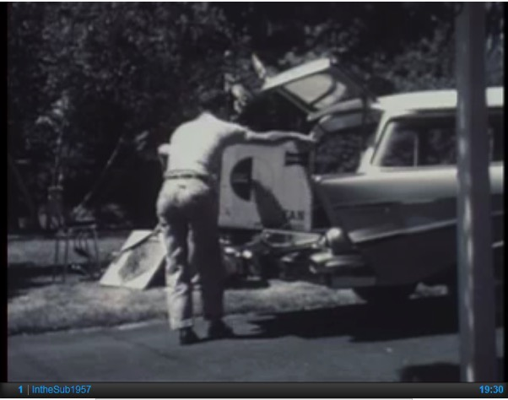
Image 23 Still taken from In the Suburbs (Rebook, 1957, Prelinger Archive)

(c.7mins 45sec – 8 mins 16sec)
It takes a while for a young couple to realize all they are in for when they buy a house, or when they have a baby… and when they buy a house and have a baby… so hardly realizing it they come into their purchasing stage and they are off on a wild non-stop ride…
(8.30 –8.55)
it’s a happy go spending world, reflected in the windows of the suburban shopping centres where they go to buy… Redbook has been studying shopping centres because the people who created the suburbs are young adults and the shopping centers are built in their image

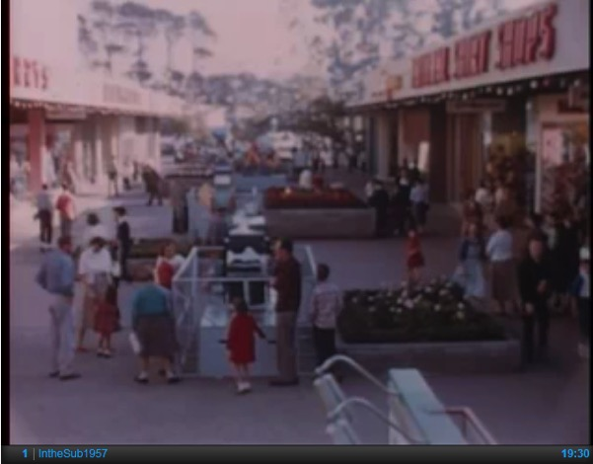
Image 24 Still From In The Suburbs of Hillsdale in California (10.00 – 10.25)

Carts rolling down the malls at Southdale, at Northland, at Gulfgate, Sunrise, and Eastpoint, at Hillsdale in California
These young adults shopping with the same determination that led them to the suburbs in the first places are the goinest-part of a nation on wheels… living by the automobile - the first young adults in the age of the push button
In the Suburbs: Redbook Magazine (1957)
Prelinger Archive

Here, advertisers are presented with the idealized representation of the consumer who buys the Redbook Magazine and who their adverts will reach if they choose to purchase advertising space. The young affluent consumer who is engaged in household formation is in a key buying stage of their life. These target consumers spend more as they come into their ‘purchasing stage’ on to a wild ‘non-stop ride’. Once the shopper has entered this stage, it is a ‘happy go spending world’ where the convenience of the automobile is combined with the push button simplicity. The suburb is being shaped in the image of these young consumers who are taking off on a ride through the consumer utopia that was presented to them. This provides an insight in the way advertising and marketing companies were finding new ways to approach the newly emerging suburban populations. The ease of this ‘happy go spending world’ is reinforced with the images of consumer plenty used in the film to portray the idealized suburban life style. There is no scarcity or strife in this image, it is one of plenty and possibility.

The role of Eaton’s department store in reshaping how Canadians shopped can be seen in the pages of its catalogue. In the same era of the birth of the ‘push button happy-go-spending consumer in the United States, we can see the goods that are being targeted at the ‘average Canadian family’. A motorboat is described as a ‘Family runabout with motor’ and in the product description it is pitched as ‘especially suited to the average Canadian family, Boat is exceptionally sturdy and stable – versatile too!’ and can be paired with an Eaton branded Viking outboard motor to make it suitable for “fun afloat” all season long. This is a aspirational instruction on how to live the good life in post war Canadian suburbia. The modern nuclear family could live the ultimate suburban life by purchasing all the accoutrements necessary at Eaton’s.

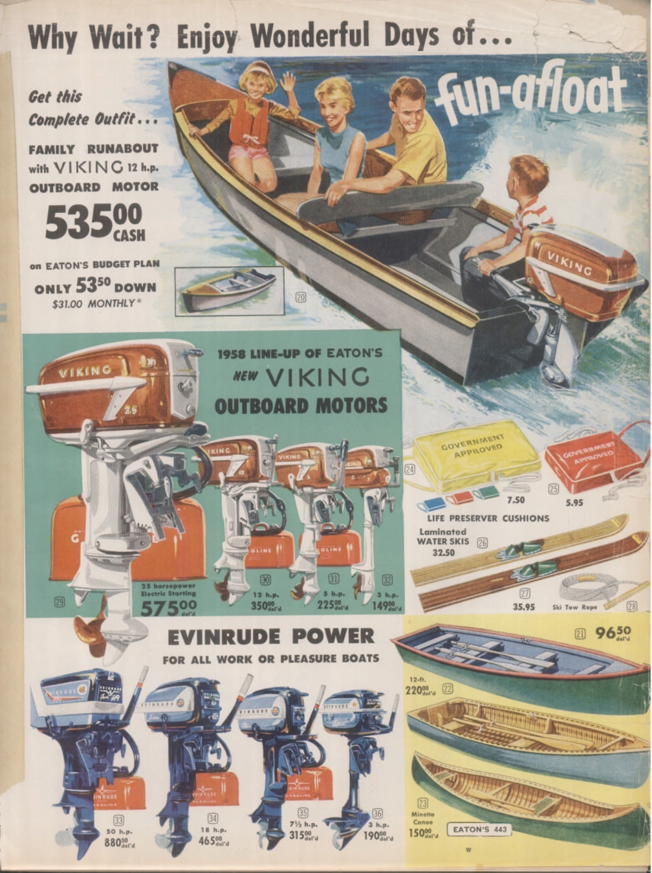
Image 25 Image from Eatons 1958 Catalogue http://richardlpaquette.ca/1958Eaton'scatalogue.htm

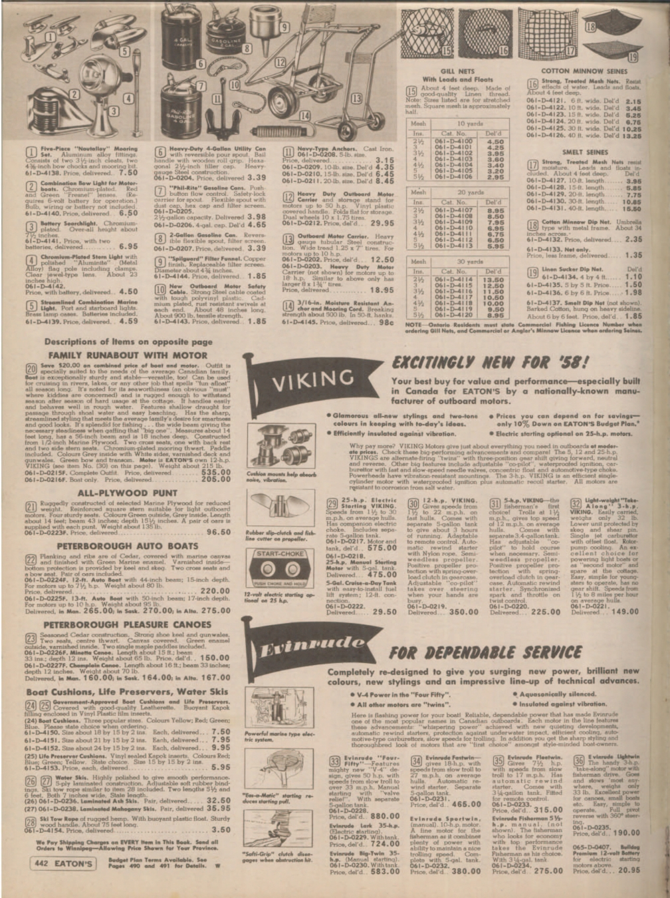
Image 26 Image from Eatons 1958 Catalogue http://richardlpaquette.ca/1958Eaton'scatalogue.htm

The Malling of North America

The manmade environment the shopping mall gave us has made us more and more detached from the natural environment. What becomes clear is that the shopping mall is a highly controlled space in many respects. Whether it is in the intricate design features, arranged to accommodate the car borne shopper; the flat traffic free surfaces to ensure “carts rolling down the malls” will not be hindered in any way. The private security force and closed-circuit surveillance system providing a sense of panoptic reassurance. Harvey (2000 p.168) explains
The shopping mall was conceived of as a fantasy world in which the commodity reigned supreme. And if homeless old folks started to regard it as a warm place to rest, youths found it a great place to socialise, and political agitators took to passing out their pamphlets, then the apparatus of surveillance and control (with hidden cameras and security agents) made sure nothing untoward happened.

The shopping mall morphed into a space where the focus remained on the commodity. Anything which would interfere with the fantasy world would be removed by the apparatus of surveillance and control. Southdale Mall and its spawn became a technological force of panoptic spaces that helped to reinforce the capitalist way of life. Mennel (2004, p.132) cites an article in the Minneapolis Sunday Tribune (October 7, 1956) Southdale was wired with ‘a giant $100,000 electronics network which probes every corner with its inconspicuous glass eyes, hidden alarms and safety devices’. Security in the Southdale Mall was visible and acted as a reassuring gesture towards the shoppers. The happiness machines who flocked to this space could relax in the knowledge that somebody else was watching over them ready to intervene at the slightest hint of disturbance to the dreamworld.

Margaret Crawford (1992) refers to the period after the opening of Southdale Mall up until the late 1970’s as the golden era of the ‘Malling of America’. Thousands of similar malls were built, off the major roadways of cities across the world; sealed from the elements, and surrounded by acres of car parking spaces. The regional shopping centre was followed by the emergence of super-regional centres from the late 1970s onwards. This era also saw the opening of large scale malls super-regional malls the Mall of America in Minnesota and the West Edmonton Mall in Canada. These centres such as the West Edmonton Mall and the Mall of America were on an even vaster scale and could compete with city centres in terms of the range of shops and services on offer. These super-regional malls provided a huge mix of leisure and shopping opportunities. Examples of such developments include the Galleria in Houston, Tyson’s Corner in Fairfax County, and Virginia, Roosevelt Field in Long Island. These super regional malls were created to not only provide a centre for suburban dwellers but also to replace the traditional Central Business District (Jackson, 2011 p.71).

Around this time, we see the emergence of Real Estate Investment Trusts (REIT) who sought to invest in standardised real estate which the market demanded and on which a return could be calculated. This led to the replication of the enclosed suburban shopping mall throughout North America. Crawford (1992) believes that during this period the model of the basic regional mall was perfected and systematically replicated across the country. It is another mall which Gruen designed for James Rouse and his company Rouse Corp. which demonstrates the impact of the standardised approach to shopping mall development. The Cherry Hill Mall opened in New Jersey in 1961 Rouse Corp was one of the first ‘fully integrated operations in the shopping centre field’ (Bloom, 2005 p.111). Rouse Corp. became one of the top ‘mall makers’ producing shopping spaces across the United States which were tenanted mainly by national chains because the rents were too expensive for most local or independent retailers.

Gruen saw shopping centres as the chance to bring community life to the suburbs and to prevent strip development. However, his ethos was abandoned. The community facilities weren’t built or where sold off or converted into extra mall space. In Northdale the outdoor spaces were enclosed in 1974 and the spaces inside were converted to extra retail space. Gruen would later grow disenchanted with the malls he helped start with Northland. The architect, who also designed suburban Detroit's Eastland Center, Chicago's Randhurst and South Jersey's Cherry Hill Mall, pronounced himself disillusioned with the ugliness and fast-buck approach of many projects. Concerned that the economically irresistible progeny of his own utopian plans would also cross the Atlantic and contaminate Europe, Gruen flat out disclaimed responsibility for the now prevalent run-of-the-mill shopping malls, declaring: “I refuse to pay alimony for those bastard developments” (Gruen, quoted in Mennel 2004, p. 142 Time Magazine).

It is useful to show how Utopian ideals are appropriated for the capitalist system of speculation and what Harvey (2008) would call capital absorption. David Harvey highlights the difficulties with implementing social reform while trying to protect the agency of capital accumulation, and the state. Jacobs was to be highly critical of this movement and what it had become. She uses a composite term ‘the Radiant Garden City Beautiful’ (Jacobs, 1961) to characterise the influence of Le Corbusier, Howard and the City Beautiful Movement. The aim which Gruen had set out to create a space to which would produce a better form of social life was mainly abandoned. The Utopian ideals that Gruen had espoused had been hijacked and he had lost control over what he had created. Gruen saw the shopping mall as a space that could combat the post-war sprawl he saw drastically altering the urban structure of America. He was deeply concerned at how his initial vision of bringing European city life to the heart of suburban America has been hijacked. Gruen would disassociate himself from the run of the mill shopping malls which spread across the country.

Chapter Four: The downtown Shopping Centre

The next generation of shopping spaces begins to emerge when the shopping mall arrives downtown. Here, the work of Jacobs, Sennett, Harvey and Jameson will provide insights into the changes which occur. Decades of decentralization and suburbanization, the ‘Urban Crisis’ of the 1960’s and 1970’s left large sections of Downtown areas across North America in ruin and ripe for redevelopment. The shift of population to the suburbs resulted in the hollowing out of cities. The focus began to switch back to the city and the brownfield sites which were left behind after suburbanisation, containerisation and de-industrialisation. The elements of the shopping mall refined in the suburbs from the 1950’s onwards is brought downtown to create an enclosed city centre free of the negative aspects of urban life. We see the opening of the first enclosed downtown shopping centre with the Midtown Plaza (1962) which was designed by Southdale Mall creator, Victor Gruen. The city in trying to compete with the mall, becomes more and more like it. These developments had significant impacts on their city centres, and how the individual experiences the city. We see that the mall was no longer a development on the edge of the city, it had become the city.

We will then consider how the development of what would become the Toronto Eaton Centre became a site of contestations between different interest groups. This will also allow the identification of the key stakeholders and demonstrate how their interests and values became embedded in plans for the site. The key interest groups that will be discussed include property owners, politicians, planners and city officials, the media, and newly emerging civil society groups. It will become clear that both individual and common interests guided the debate on the form that downtown Toronto would take. By analysing the plans, visions, and ideals that were proposed by the most vocal interest groups during this era it is possible to uncover the common interests that they shared and the disagreements that prompted action. In turn, this will demonstrate the process of negotiation, renegotiation and mediation which were involved in bringing a large downtown site like the Eaton Centre to fruition.

This chapter is an exploration of the key debates and disagreements that emerged in the City of Toronto during the period 1953 – 1977 about the future development of the Eaton's Department Store and the surrounding area. As the future of the site was debated and reimagined a number of times, this era also marks a period major changes in how the City was administered and governed. These changes stretch from the founding of the Metropolitan Council in 1953, of which the City of Toronto became part of a greater metropolitan authority covering the city and suburbs, up until the opening of the Eaton Centre in 1977. This era provides worthy material for a case study of how the political tendencies of the era played out in urban centres across the world. The development of Toronto during this period was not a straightforward linear progression. It was a progress of negotiation and re-negotiation between competing and complementary interest groups.

The politics of urban development in downtown Toronto from the mid twentieth century up until the late 1970s had a significant impact on the shape of the contemporary city. As Toronto spread out into the suburbs, the focus of retail spread beyond its lengthy main thoroughfares; Yonge Street, Bloor Street, Queen Street, and King Street, to new suburban centres. The 1960’s saw the opening of significant shopping space in suburban Toronto. The focus of retailing was no longer solely on the core downtown area. Eaton’s Department Stores opened a suburban outlet at Don Mills Shopping centre in 1961. Yorkdale Shopping Centre opened in 1964 offering over 93,000 square metres of enclosed suburban shopping space. This pattern of decentralisation and suburbanisation reflected the general trend across North America spurred on by the growth of car ownership and the development of affordable tract suburban housing. This was a period of significant change in the city both in terms of the built environment and the political realm. This period was also marked by a lengthy period of negotiation between city authorities, property owners, and civic groups on how the city should evolve to compete with the suburban competition.

As the focus of development shifts away from the urban core, there was an increasing recognition amongst many key stakeholders that the centre of downtown Toronto would need to evolve to compete with the new suburban centres. To compete with the suburban competition, downtown Toronto had to replicate the best aspects of the suburban shopping centre which had been introduced in Yorkdale and Don Mills. It had to recreate the sanitised, consumer friendly shopping space downtown where shoppers could experience mall life with an aura of urbanity. Not only had it to create a space which would attract customers, but it also had to create a space which replicated the successful elements of the suburban enclosed mall which retailers were demanding. The impetus was to create a space which would stimulate and direct the desires of those who visited. The Eaton Centre was one of the products of this process. This site was to have a transformative effect on Toronto, adding vast quantities of modern retail space to the centre of the city.

Focus shifts back to Yonge Street

With the Queen Street store remaining open, Eaton’s retained ownership most of the land situated between Yonge, Queen, Bay and Dundas (CBC, 2003). By the 1950’s the way this land was used began to change. The warehousing and factory buildings that had previously taken up a portion of the site began to migrate to suburban locations. This freed up space downtown, which opened up the possibility of redevelopment and expansion of retailing in the city centre. The Eaton’s land bank encompassed a vast section of prime downtown space positioned on the main thoroughfare of Yonge Street and near the newly emerging commercial sector south of Queen Street which saw the development of large office complexes such as Mies Van der Rohe’s Toronto Dominion Centre, which commenced construction in 1964 and opened in 1969. The only two sites which were not included in Eaton’s parcel of land, were the Old City Hall, the Salvation Army Building and the Church of the Holy Trinity.

The growth of suburban Toronto in the 1950s was accelerated with the 1954 Toronto Transit Commission subway completion and in the 1960s regional highway completion into the Downtown Toronto improved the road connections between the city and the suburbs. This facilitated the employment growth that was beginning to take place because of the major shift of the Canadian financial sector from Montreal to Toronto due to the actions of the Front de Libération du Québec paramilitary organisation in support of the Quebec sovereignty Movement. In addition to these security concerns, language became a major issue in the 1970s. In 1977, the provincial government of Quebec passed the Charter of the French Language. Under this charter, the language of work in Quebec would be the French language. With the majority of Canadian domestic and international business being carried out in the English language, this law can be seen as a key factor which drove some major companies to trade stock at the Toronto Stock Exchange, where business could be done in English.

The de-industrialization due to the migration of industrial activities to cheaper locations outside the city left behind it a vast array of brownfield sites which could be redeveloped to become the focus for employment to banking and law in the Downtown. This influx of employment and infrastructural investment led to the first steps towards a redevelopment of this large downtown site which was largely in single ownership of Eaton’s. There are several interest groups who see this large brownfield site as an opportunity to revitalise and re-invent the centre of Toronto and help it to compete with suburban competition. This occurs around the same time that the newly emerging suburban retailing centres such as Yorkdale and Don Mills were coming to fruition. It was not only private interest such as those of the landowner – Eaton’s which began to be expressed, but public interest in how this site should be developed emerged surfaced in the political corridors of the city and the desks of the planners of the city authorities. This large site began to be seen as an important location for the revitalisation of the city centre in light of suburban competition and the plans that emerged were to shape the development of the centre of downtown Toronto for the next half century.

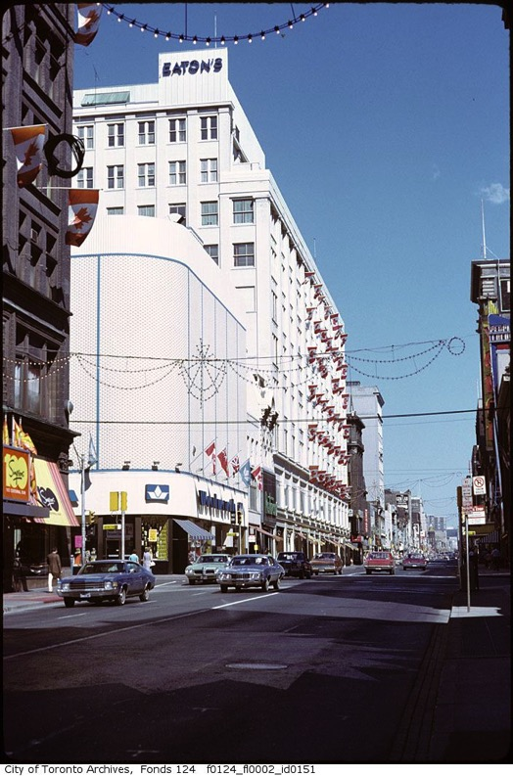
Image 27 Yonge Street, Eatons Store.

This undated image from The City of Toronto archives appears to have been taken in the late 1960’s/early 1970’s. We can see the original Eaton’s store in the centre of the image, on the Western side of Yonge Street. The Simpsons Department store can be seen in the left foreground and the Woolworth’s building can be seen in the centre left.

Project Viking

In 1958, local government and the City Planners produced a memorandum on the redevelopment of property owned by T.Eaton Co. Ltd in the centre of Toronto. This memo also referred to as Project Viking set out clear objectives for the future development of a large area of downtown Toronto, with a specific focus on the area surrounding Eaton’s Queen Street store. Eaton’s large land holdings between Yonge and Bay Streets were the target of this strategy. The proposal envisions the development of a ‘more fitting neighbour for the proposed new city hall and square’ (Osbaldeston, 2008. p. 30). In this memorandum, the Planning Board outlined floorspace and land use targets and included models, drawings and illustrations of the envisioned development. The aim of the project was to ensure ‘full advantage is taken of the site a large-scale development of great importance will be created in the very heart of the City’ (City of Toronto Planning Board (CTPB), 1958 p. 1).

In the proposal, there is an explicit recognition that the T.Eaton Co. Ltd. site is a strategic opportunity to expand the retail core of downtown, ‘adjoining the main shopping centre, the largest business concentration, and the new Civic Square’ which it describes as the most ‘important development in downtown Toronto’. Throughout the document there is a recognition that there would be a re-organisation of land uses on this site as factory and warehouse uses migrated to the suburbs. This migration would create an opportunity for redevelopment. This memorandum firmly places the planned civic square and the T. Eaton Co. Ltd. site as the centre of the city.
North of Queen Street the new Civic Square will be an attractive development of the greatest significance. Around it will be the best possible sites for prestige buildings in Toronto. The Square and its surroundings should remain the established centre and the focus of attention.
(CTPB, 1958 p.2)

The civic square was predicted to be a key focus of urban life in Toronto and this memorandum was a firm statement of intent to focus and cement a centre for the sprawling metropolitan area. The proposal also reinforces the role that this space would play in the future development of the city. It recognises that for the civic square to become a significant site, it needed to be adjacent to a mixture of commercial and retail uses. It highlights the growth of the financial centre to the south on Bay and King Streets with the growth of new office buildings, and the opportunities that exist with the redevelopment of Eaton’s store and the surrounding buildings. This site would be a statement of what Toronto aspired to be, where the gaze of citizens and visitors would be drawn and which would help portray the identity of a modern Toronto.

Shaping the Shopping Quadrant

The memorandum divides the downtown area into four quadrants bounded by King, University, Dundas and Yonge Streets which are intersected by Queen and Bay Streets. Of these quadrants, the North East Quadrant, of which the T.Eaton and Co. site occupies a large proportion, the CTPB proclaims that there is the greatest opportunity for redevelopment.
The northeast quadrant will be ripe for major redevelopment within the next few years. On Queen and Yonge Streets it contains the Old City Hall and a major shopping concentration. Between this concentration and Bay and Dundas lies a considerable area of land owned or controlled by the T. Eaton Co. Ltd. The buildings, and the activities which they house, are becoming generally inappropriate for the very heart of the city. Furthermore, a considerable expansion of the Eaton’s main store is contemplated by the Company and it can only be northwards.
(CTPB, 1958 p.3)

There is explicit evidence that the Planners worked with Eaton’s to help them fulfil their intentions of increasing the retail space and maximising the use of their landholding. It is stated (CTPB, 1958 p.5) that the first requirement of redevelopment would be ‘to provide for expanding business in the main store’. The Planning Board, explains that it is acting on advice given to them by ‘officers from Eaton’s’. This advice is detailed extensively in the memorandum. Eaton’s have been given the chance to outline their assumptions for the future development of the site and the CTPB has incorporated them into the objectives set out for the development of the site. These objectives are outlined as follows:

- The total retail spaces should be expanded to 1,500,000 square feet;
- The present main store should eventually be rebuilt; the retailing being kept in operation while rebuilding is taking place;
- The new department store should not be more than six storeys in height;
- Offices should be provided adjacent to the main store;
- Shipping and other services to the main store should be provided in the project area, and truck access to the store should be underground;
- Other operations of the T. Eaton Co. Ltd. may be moved from the project area as part of company reorganisation and provided a suitable site can be found for the mail order department;
- Provision should be made for customer parking
The development proposal for this quarter had been explicitly shaped by the main property owners. The Planning Board is fully embracing Eaton’s plans for the site and the interests of the private developer are at the heart of the vision for the site redevelopment. In many ways, this approach to site development is characteristic of the era. The development would be mainly single use zoning, with some provision made for offices. There is a clear demarcation between the public spaces of the street and the planned civic square adjacent to the site. This would be a site which would provide commercial activity in a separate but adjacent space to the City Hall. It would maximise the potential of the site by removing the uses which did not fit in, such as warehousing and production and make provision for them outside the city. The site would be served by a network of underground service tunnels, creating the maximum above ground space for commercial activity.

The objectives for this site and surrounding area demonstrate an attempt to create an efficient and competitive shopping quadrant in the city of Toronto. It was a strategy to reshape the downtown area into a rational, modern and efficient shopping centre which could compete with the suburban centres which were being planned at the time. By dividing the city into quadrants, each with a specific function, the planners are creating and reinforcing rigidly defined land use patterns in the city. This was reflective of the pattern of zoning which was creating vast swathes of suburban residential neighbourhood across North America. It is in stark contrast to traditional urban mixture of land uses which emerged organically over time. What is clear from the objectives outlined is that the planners and developers agreed that for the city to continue to retain its role as the centre of Toronto, it would have to replicate the rational approach to development employed in the suburbs which focused on single use land-zoning which facilities car driving urban dwellers, to the detriment of the traditional mixed-use patterns of urban development which had characterised urban life for millennia.

Facilitating Private Development

In the memorandum, not only is there evidence that Eaton’s plans for the site shaped the objectives outlined by the planning board, there is specific declarations made that the local authority would intervene to help streamline the site assembly process. There is also a recognition that issues may arise surrounding site assembly for the development and a tacit acceptance that the development Eaton’s planned could be hindered by the non-cooperation of property owners in the sections of the site that were not in Eaton’s ownership. The planning board (ibid., p. 8) makes two key suggestions on how to prevent this:
(F) In order to achieve the desirable fully comprehensive scheme, certain properties should be acquired either by the Company or the City. If they were acquired either by the former there might be little publicity, if by the latter there might be protracted argument. It could, however, be shown that some properties were required for the widening of Bay and Dundas Streets.

(g) It is suggested that the acquisition of property required for the comprehensive project should take place immediately, as acquisition would be more difficult once the plan of development was known and new building commenced.

These two suggestions illustrate the political dynamics of property ownership in the Twentieth Century Capitalist city. The rights of the private property owner are protected within the legal system, but it is during this century that we see the increasing growth of the field of Planning. With the growth of the profession, we see the increasing power those working in the Planning offices of local authorities gain in terms of limiting or enhancing the rights of property owners. Here the Planning Authority is offering to help facilitate the rights of a property owner to enhance the value of their property by subjugating the rights of smaller property owners who may stand in their way. The Planning Board is suggesting that if Eaton’s is unable to purchase the smaller sites that they need to complete their development site, that they will use the power they have to compulsory purchase the sites under the guise of street widening. The planning authority is stating that ‘it could be shown that some properties were required for the widening of Bay and Dundas Streets’. By stating that it is willing to demonstrate that properties not in ownership of Eaton’s could be required for a planned widening of Bay and Dundas Streets it is making a clear statement about how it is willing to use the powers invested in it for enhancing the public good for the benefit of a private developer. This is a pro-development intent and demonstrates the willingness of the local authority to use the power it has in protecting the interests of the public good, to suit the needs of private companies. It has been shown that there is a clear impetus to ensure that this site is developed and that any obstacles, which may arise, can be mitigated for the developers.

Extracting public benefit from private development

Although there is clear evidence of the intention to facilitate private development, there is also evidence of an attempt to extract a perceived benefit for the public. The Project Viking memorandum is evidence of an attempt to balance the interests of private property owners and the common good. There are other clear measures such as the provision of subway connections to the Dundas and Queen stations that are evidence of efforts to leverage this development to help improve transport and pedestrian links for those who visit downtown. In the accompanying models and sketches for the proposal, the Planning Board includes indicative locations for parking, deliveries, new office buildings and the extension of the Eaton’s store. It also outlines the impetus to create strong links to the subway stations at Dundas and Queen. This is where there is evidence of attempts to extract a public benefit from the proposed development. The CTPB proposes that the extension to Eaton’s store should be placed equidistant from the subway stops at Dundas and Queen to spread out the flow of shoppers arriving downtown at the congested Dundas station. This is a rational objective in terms of making the city more efficient for the people who travel downtown from the suburbs each day for work and shopping.

The objective set by the Planning Board in relation to subway connections is a step towards mandating private developers to contribute to the creation of the city realm. It is putting it to a developer to develop their property in a manner which contributes to the functioning of the city. While they are not signalling their intent to hand over full responsibility to the private developers for the development of city infrastructure, it is signalling that the privately-owned spaces in the city centre such as shopping malls and department stores exist as an extension of the greater public realm of the city. It is also an attempt to control a private street before it has been built. By controlling the location and links it has to the public transport system, the authority is exerting control over how the space will be used and the manner in which it will connect to the rest of the city around it.

The Eaton’s site is seen as the chance to create a more fitting neighbour for the proposed civic square. The planners recognise that for the New City Hall and square to become the focus for city life, it needed to be adjacent to the centre of retail and commercial life of the city. The investment made by the City in this new civic building and public space would set the tone for the future development of the city. The initial investment by the City was expected to be followed by significant private investment. New City Hall would create a focus for city life which would be at the heart of the modern city centre. The City will facilitate private investment which fits in with this goal. In many ways, this public investment is the model or showpiece for the aspirations of the Local Authority. Commercial development should centre on this location and contribute to the recreation of the city in the high-rise image of the New City Hall.

The overwhelming impetus that can be detected from this document is that of the intention to see the development of the area in the most pragmatic way possible. This would be done by facilitating the needs of the private property owner to bring the site to construction, while also extracting a dividend for the public good. This shows the pragmatic approach that planners were beginning to embrace around this era, to encourage the redevelopment of brownfield sites which are in private ownership. Faced with the growth of the suburbs and the migration of industrial and commercial activity out of the centre, cities were faced with large underused downtown sites which had become redundant. With the growth of the suburbs, and the new retailing centres to serve them, there is new competition for capital investment from the city core. There was an increasing recognition that in order to attract investment, cities would need to make their cities more attractive for development. This marks a shift away from the municipal city towards the city as a political body which directs investment in a manner which extract the maximum amount of investment in the city. In the context of the Eaton’s site and Project Viking, there is evidence of the need to balance the intentions of the property owner to extract the maximum value from their site, with extracting the most benefit for the surrounding area and for the public who will use this space. However, the Planning Board are not operating in a political vacuum. There is an element beyond the private developer and the public which also needs to be considered. It important to consider the political context in terms of local government at the time.

The Mayor’s Office

In 1953, the federated municipality known as Metropolitan Toronto was formed. In this era, power became decentralised from the urban core of the City of Toronto, to be spread out across the Metropolitan area. This regional authority was to encompass the City of Toronto and 12 other municipalities; which were subsequently amalgamated into 6 municipalities in 1967 . Each municipality had its own mayor and council. Up until 1997, the most senior political figure in the Metropolitan Toronto government was the Chairman of the Municipality of Metropolitan Toronto. Members of the Metropolitan Council voted on the candidate who would take this role. However, the first holder of this office was Chairman William Allen, who as the initial holder of the role, was an unelected provincial government appointee. Despite the decentralisation of power to the metropolitan area, the office of Mayor of the City of Toronto still had a significant role in pushing forward the development of the city. Officeholders have taken the opportunity to push this in ways that fit in with their own political persuasions.

Nathan Phillips – Mayor of all People

The period between 1954 and the opening of the Eaton Centre in 1977, saw five different Mayors hold office. Mayor Nathan Philips could be considered to have sown the seeds of redevelopment of this section of downtown Toronto. Phillips was the first non-protestant Mayor of Toronto in the twentieth century and he gave a powerful victory speech on December 6, 1954, in which he expressed his sense of pride that most Torontonians had rejected his incumbent Saunders’s ideology. For Phillips, this was demonstrating the city’s gradual acceptance of its increasing cultural diversity.
Every person should be proud of his ancestry, and I am proud of the blood that flows in my vein. I am sure that every other citizen is proud of the blood that flows in his veins. I shall represent all the people, and I mean all the people in the broadest sense, fairly and without discrimination. I shall cut intolerance, I will try and be you, all the people of Toronto, and reflect your aims, ideals, aspirations and ambitions.

Phillips came to be seen as the ‘Mayor of all people’ and just a few months after his election (Sewell, 1993 p. 139) he began to push for the plans for a major re-shaping of downtown Toronto. The first step he became involved with was triumphing the construction of the New City hall on a site to the west of the Eaton’s landholding. When the New City Hall had been built, Philips hoped that the Old City Hall would be replaced with something “larger and more modern, more fitting to the new Toronto”. He hoped to fund this new city hall by selling the old hall as a development site (ibid., p139). The New City Hall was constructed on a site adjacent to the Old City and instead of selling the site off for re-development, Phillips sold the Old City Hall to the newly formed Metropolitan Council for $4.5 million. He championed an international design competition for the New City Hall after taking office and the result of this was to be the commencement of the building of New City Hall in 1961 and its opening in 1965.

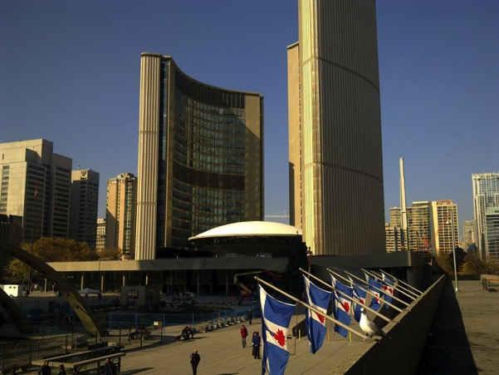
Image 28 Looking North, Nathan Philips Square is in the foreground, and was undergoing repaving at the time of visit, and The New City Hall in the Background.

A more fitting neighbour for New City Hall

Philips drive to see the commencement of the New City Hall was accompanied with a push to redevelop the neighbouring Eaton’s site on Yonge Street. The department store had grown of the previous century to encompass a selection of buildings, and surrounding factories and warehouses which had become redundant with increasing suburbanisation. Pressure was put on Eaton’s to progress plans for the redevelopment of their large city centre site. With the commencement of construction of New City Hall, Eaton’s began to make public their plans to redevelop their large adjacent landholdings. The first murmurings of Eaton’s development proposal came to light at the end of Mayor Philips term in 1962. Eaton’s worked with Webb and Knapp to design a ‘superblock’ proposal which would cover Yonge, Bay, Queen and Dundas. For financial reasons, Webb and Knapp withdrew from the project in 1962 and were replaced by E. P. Taylor who had developed the suburban retail site in Toronto, Don Mills. This was to change again, when Eaton’s decided to develop the site on their own (Osbaldeston, 2008., p 30).

In 1965 Eaton’s unveiled their new proposal that they planned to develop on their own and which would encompass an increased area. This proposal would include a new Eaton’s store, additional retail space, and large floorplate office. A key aspect of this revised plan was a proposal put to the Metro Council to purchase the Old City Hall site. The building, which had been sold to Metro Council by the City Council to raise funds for the construction of the New City Hall, was to become a significant part of the proposed development and would allow Eaton’s to build a large store facing their rival – Simpsons on the opposite side of Queen Street. Four years after the site had been sold to the Metro Council for $4.5 million, Eaton’s were prepared to offer €8 million for the site. According to Sewell (p.139) the Metro Council expected to have the building remain at the main city courthouse but were surprised when Eaton Company offered $8 million to buy the site of Old City Hall. In spite of this, the amount offered by Eaton’s was far in excess of what that the Metro Council had paid the City of Toronto for the site. The Metro Council would stand to double their investment in terms of the funds they used to purchase the Old City Hall from the City of Toronto.

The increasing power of the Metropolitan Council

Donald Summerville who took office in January 1963 was to take a different approach to the development of the site in what was to be the beginning of a contentious era in city politics. Community opposition to Eaton’s plans for the site began to emerge in parallel with campaigns against other major redevelopment projects in the city. Civil society groups began to mount campaigns against the destruction of the historic fabric of the city of Toronto. The campaign against the Spadina Expressway – which was a key priority of the Metropolitan Council had been gaining momentum from the early 1960s. Mayor Summerville strongly opposed Eaton’s plans for the site that this stance had a populist appeal (Sewell, 1993, p 140). This pitted the office of Mayor of the City of Toronto against the office of the Chairman of the Metro Council. Both offices had significantly different views on the future development of the City of Toronto.

A major shift in the dynamics of power was to occur when Summerville died suddenly at hockey match on 19th November of that 1963. Philip Givens was appointed temporary Mayor of the City of Toronto because of Summerville’s premature death. Givens was appointed officially to the office of Mayor of the City of Toronto on November 23rd of the same year and he served until 1966. Givens was in favour of the demolition of Old City Hall and this view was in line with that of the government appointed Metro Chairman William Allen. Within a space of a year these two political figures had gained control over the future development of the Eaton site. Their pro-demolition view towards Old City Hall was to prove divisive.

Eaton’s proposal

At an Executive Committee of the Metropolitan Council in October 1965, Eaton’s issued the formal proposal to purchase the Old City Hall for $8 Million (Sewell, p.139). The Old City Hall site was declared by Eaton’s as an integral part of the proposed development. It became clear at this point that the development which Eaton’s planned would dramatically alter the urban fabric of this area. The frontage on Yonge and Queen Streets would see major changes in terms of the street scape and the built environment. By agreeing to sell the site to Eaton’s, the Metro Council was giving a strong sign of support for Eaton’s plans for the development of the site. With this action, it can be interpreted that they would support the demolition of Old City Hall as part of the redevelopment of the site.

In March 1966, before, the proposal to sell the site of Old City Hall was put to a vote of the Metro Council, Eaton's presented the complete concept of the project to the public. The proposal was for a massive superblock type development which would see the demolition of the Eaton’s Department Store, the Old City hall and numerous lanes and downtown streets (Albert Street, Louisa Street, Terauley Street, James Street, Albert Lane, Downey's Lane and Trinity Square). Eaton’s wanted to build a massive new flagship store facing its rival Simpsons store on Queen Street. It is important to look at this proposal in greater detail in order to understand the impact that it was to have in terms of mobilising and motivating key stakeholders into action.

Jewel in the Crown

The 1966 Eaton’s proposal was covered widely by the press and media at the time. Important aspects of the reception that this proposal received are documented in ‘Jewel in the crown’, a radio documentary first broadcast on the Canadian Broadcasting Corporation (CBC) in February 1977, the year in which the first section of the Eaton Centre was to open. The documentary includes excerpts from recordings of the presentation to the Metro Council on March 1 1966 where representatives of Eaton’s and their architects pitched their vision of how the site should be presented. In their proposal, the Old Trinity Church was to be retained, along with the Old City Hall Clock Tower and Cenotaph, the building was to be incorporated into the development. The Managing Director of Eaton’s, David Owen (CBC, 1977) describes the project as a “logical opportunity for expansion of central business core”. At the time, the Eaton’s site was proposed as an opportunity to extend the growing commercial core of Toronto south of Queen Street. The presentation was an attempt to pitch the developer’s vision to the media, politicians and the general public. A variety of scale models and artist’s renditions were presented to portray the scale of the proposed development. The development was to include a large new store for Eaton’s and a few Office towers, a hotel and parking facilities. These buildings were to be surrounded by large open-air plazas which would provide vast open space in the heart of downtown.

David Owen (ibid.), managing director of Eaton Centre Ltd. Outlines the rational approach that would be taken to the site. He offers further justifications for the site proposal ‘the whole economics which one has to assess, as well as the planning and urban design principles when putting a plan together, require the amount of space that you see here to justify the land value so we do need this amount of building’. As the managing director of Eaton Centre Ltd., Owen is outlining how the key focus would be to maximise the potential of the site to ensure as much profit can be extracted from the proposed investment. This aim is echoed by the architect but it justified in terms of design and style characteristics. During the presentation, architect Douglas Haldenby explains “these tall office buildings compliment new city hall and the great square in front of it and certainly the development of open spaces which is the necessity of good urban design”. The concept was focused on creating space in a congested city core. It was about building high-rise structure with a smaller footprint, which could free up open space at ground level. The neighbouring New City Hall and Nathan Philips Square were cited as the inspiration.
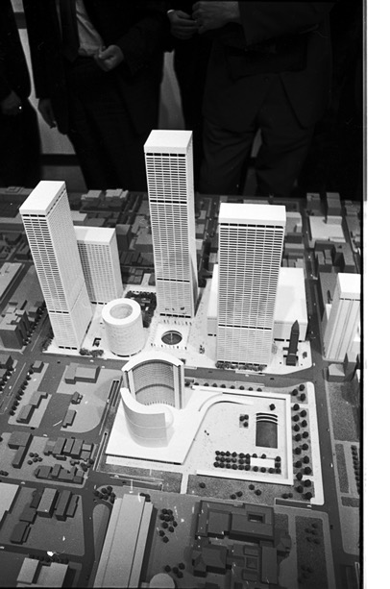
Image 29 Overhead view of Model of Eaton Centre Development as envisioned Toronto Telegram, 1966
1966-03-01 York Reference URI: http://hdl.handle.net/10315/5917

Nathan Philips Square can be seen in the foreground with the Eaton site in the background. The Clock tower, in the Centre right of the image, is the only remnant of Old City Hall which would have been maintained in this site. In Image 28 the proposed Building which Eaton’s proposed would replace the Old City Hall from the initial proposal of March 1966. The Clock tower of Old City Hall is retained.
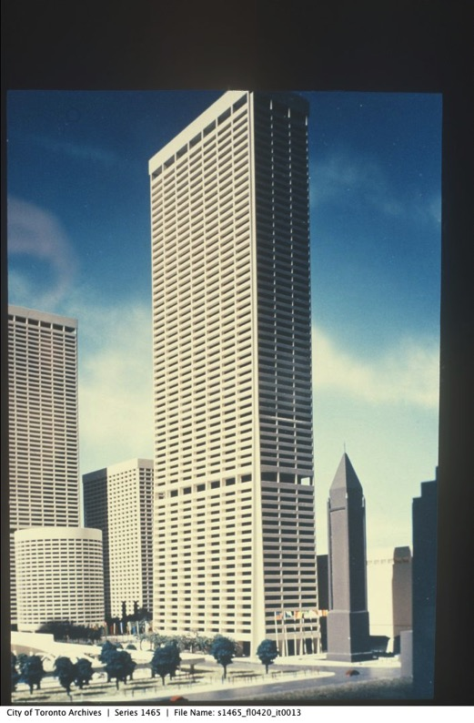
Image 30 Replacement building on site of Old City Hall

The end of Old City Hall?

As the presentation continues, Haldenby attempts to harness the dreams and aspirations that the residents of Toronto have and re-appropriate them into the reality that would be created if the Eaton Centre was built. He continues to explain to the council and other observers:
At present Toronto has no true centre, except for city hall, and city hall itself is the element which is going to allow all the land around it to redevelop because of the encouragement by its own visual image. Toronto itself is a city which has aspects not unlike Los Angeles; it has been scattering since the war. It’s refocusing now, it’s coming into play because city hall has made a very important statement and because there is large landownership around it that we have spoken of already. The Eaton Centre, the Simpson block, the block south of… Square will create not only a city within a city but actually be the city of Toronto in the future! This is the image of the new city; the city of Toronto; the city people will see on Postcards across the world, the city which brings identity in an urban sense, and an image which is different from any other…

This passage from the presentation captures the essence of the project for the backers and designers. The goal was to recast and recreate the downtown of Toronto to compete with the other large North American cities. It was to create a strong visual image of the centre of the city which would become what Kevin Lynch (1960) would refer to as the ‘vivid holdable image’ of Toronto which will be festooned on postcards and tourist guides for the city. Key to this plan was to demolish the Old City Hall, a major civic space at what was considered the centre of Toronto and replace it with a private development. Here we see key insights into the symbolism that this proposed development espoused and aimed to replace.

During the presentation, it becomes clear, that what had traditionally been a centre of civic life in the city, the Old City Hall was to be demolished to make way for tall office buildings and private open spaces. The symbols of what Toronto stood for in the past were to be swept away and replaced with a logical expansion of the city core retail and office space. In doing so the aim was to create a space which would maximise the value of this large landholding at the centre of Toronto. The vestiges of the old city centre, namely the Old City Hall were having lost their purpose and an attempt was made to reshape the city with a privatised public space. This was to spark fierce debate between conservationists who aimed to protect Toronto’s built heritage and progressives who wanted to replace the Victorian and Edwardian heart of the city with a modern city centre in the image of Nathan Philips square.

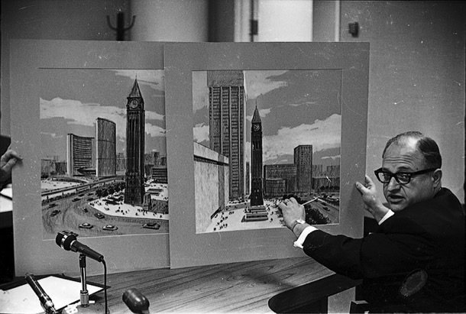
Image 31 In the presentation to the Metro Council, these Illustrations showed the proposed scale of Eaton Centre plans for new centre

In the presentation to the Metro Council, Illustrations were presented to show the proposed scale of Eaton Centre plans for new centre Toronto Telegram, (1966 URI: http://hdl.handle.net/10315/5898 York). A key section of the Jewel in the Crown documentary signals the roots of public opinion that started to emerge at the time. Drew Davis, is quoted in the show talking about the demolition of the Old Trinity Church and mentioned that “there are people who believe in God but there is nobody who believes in the history of Toronto”. He raises concerns over the planned demolition of the aspects of the urban framework, such as the Old City Hall. Reporting on the presentation Ed McGiven, for Toronto File, CBC declared that the reaction was mostly favourable, but a ‘few shed a tear’ for the Old City hall’. However, this era marks the beginning of the mobilisation of opposition to Eaton’s proposal.

Friends of Old City Hall – Reclaiming the city

Toronto's Old City Hall was home to the Toronto city council from 1899 until 1966 with the opening of the New City Hall. The building is located at the corner of Queen and Bay Streets and it a widely recognised landmark of downtown Toronto. The building has a distinctive clock tower which acts as a terminating vista from Front Street to Queen Street. After Eatons released their 1966 plans for the Eaton Centre which would involve the demolition of Old City Hall, a group emerged which called themselves ‘Friends of the Old City Hall’. This group consisted of architects, conservationists and others interested in civic affairs. They joined together to oppose any plan which would involve the demolition. According to Sewell (1992 p. 140) ‘the group represented the ‘solid middle-class professional and knew all the tricks about reading reports, writing to politicians, ferreting out backroom information, and generally making it clear that its members would not permit Old City Hall to be demolished without a fight’. This group rallied against the pure rational approach to the development of the city of Toronto being proposed by the developers and which was espoused in the presentation given to the Metro Council in March 1966. The emergence of the ‘Friends of Old City Hall’ was an attempt to prevent the demolition of what had been the centre of civic life in downtown Toronto and its replacement with a private commercial space.

In the immediate Post War era, there was a seemingly unstoppable pattern of urban development in North American cities which saw Urban centres were being hollowed out by increasing suburbanisation. The dominant literature in Urban Planning at the time was focused on how to deal with ‘the urban crisis’. This impetus to deal with the city became manifested in the hands of influential people such as Robert Moses who was influential in laying out plan for the restructuring of New York City through major infrastructural projects such as The Cross-Bronx Expressway. These large infrastructural investments were funded as "slum clearance" by Title I of the Housing Act of 1949. It was his vision for a Lower Manhattan Expressway through the Washington Park area of Manhattan, which was to draw the most intense opposition. Jacobs (1958) took on influential figures such as Robert Moses for what she described as the ‘creative destruction’ of the city. "Downtown Is for People", appeared in a 1958 issue of Fortune, and marked her first public criticism of Moses approach to the city. While living in New York’s Greenwich Jacobs confronted Moses at a Board of Estimate hearing in 1958 that squashed his plan to build a ten-lane expressway through Downtown Manhattan that would have razed the cast-iron district of Soho and much of Chinatown and Little Italy through a "slum-clearance" initiative Jacobs was highly critical of the egoistic buildings which had begun to pop up downtown in cities such as New York, Chicago and Toronto. She explains that the ‘architects, planners – and businessmen as fascinated with scale models and bird’s eye views’ to the neglect of the impact of the building on the city. Jacobs is advocating a shift in focus from skyscraper super-block developments. She was highly critical of what had become the standard approach to city planning which oversimplified urban life and ignored the complexity it had.

Harvey (2008) outlines how urban based campaigns to protect the fabric of the city began to emerge across the world during the 1960’s. He mentions the campaign to stop the Left Bank Expressway and the destruction of traditional neighbourhoods ‘by the invading ‘high-rise giants’ such as the Place d’Italie and Tour Montparnasse’ which he explained contributed to the vitality of the 1968 uprisings. New social movements aimed at protecting the fabric of the city were emerging in cities such as Toronto. Here local organisations such as ‘Friends of Old City Hall’ and campaigners/writers such as Jane Jacobs voiced strong opposition to the destruction of old city neighbourhoods.
Monopolistic shopping centers and monumental cultural centers cloak, under the public relations hoohaw, the subtraction of commerce, and of culture too, from the intimate and casual life of cities. (Jacobs, 1961 p. 4)

In cities across North America, there had been segregation of the city into large enclosed blocks which broke up the traditional organic street structure. Jacobs criticises the overly prescriptive approach to space which planners, designers and city officials were taking at the time which had implanted mono-functional spaces in the heart of downtown and destroyed organic patterns of street life which had built up over generations. Jacobs speaks of the benefits of the ‘chance encounter’ and the ’sidewalk ballet’ where mixing with the stranger could occur. She is espousing an organic approach to city life which is not overly planned. This unplanned mixing is what Jacobs sees as key to a vibrant city. This had been overlooked or forgotten by the modernist use of the internationalist style of ahistorical architecture in the city. Jacobs argues that the modern superblock developments taking over the centre of cities across North America created spaces in which there was no chance to experience the intimate casual life of the traditional city street. This critical approach to the monopolist shopping centres and monumental cultural centres manifests itself clearly in the City of Toronto. The Friends of Old City Hall campaign to retain the built cultural heritage that the Old City Hall represents. They rally against the bulldozing of the building, and subsequent replacement with a modern superblock development. They are campaigning to maintain the remnants of the Cities history.

In June 1966, the proposal to sell Old City Hall to Eaton’s was put before the Metro council. Despite lobbying efforts from civil society groups such as Friends of Old City Hall, the vote was 16:5 in favour of selling the site to Eaton’s. After the vote, it emerged that even more of the site was to be demolished. According to Osbaldeston (2008, p. 37) council concerns over the height of the proposal next to Nathan Phillips square led to demands to cut the height of the building which would replace Old City Hall to the East of Nathan Phillips Square. In response Eaton’s offered to cut 14 stories off the proposed tower on Bay near Queen Street. This however would require a bigger building footprint which would require now require not only the demolition of the Old City Hall, but also its clock tower which it had been planned to retain. Any remnants of the Old City Hall would be obliterated with this new proposal. This mobilised the Friends of Old City Hall into Action during the Mayoral election in December 1966.

The Friends of Old City Hall citizens group believed strongly in maintaining the built heritage of Toronto and mobilised themselves into political action to influence the course of the election for city mayor by working to prevent Givens from taking a second term in office. The group campaigned to support the mayoral candidate William Dennison who agreed with the need to conserve Old City Hall. Here we see the struggle between local interest groups, politicians and unelected officials erupt. Dennison was elected to office and the balance of political power shifted against the demolition of Old City Hall. Dennison stood firmly in the way of immediate approval of the development

Negotiation and the politics of urban development

In 1966, the plan was supported in general by city planners and council officials and the city’s three daily newspapers all supporting the development (Osbaldeston, 2008 p37). However, small disagreements begin to emerge over the next few months in terms over how the development should proceed. Firstly, there was concern that this development would have a similar fate as that of Eaton’s plans for a large development of a new Store on Yonge and College in the 1920’s. Eaton’s College Street store was built between 1928 and 1930 but the Depression meant that the plan was only partially completed (Dendy and Killbourn, 1986 p 291). It was for this reason that the council resolved to ensure that a bond or other guarantee of development would be put in place before the Old City hall was sold to Eaton’s. The city also voted to lease the land rather than sell it outright to retain the ownership of the site (Osbaldeston, 2008 p 37). Secondly disagreement began to emerge of the site of the Cenotaph memorial site. According to Osbaldeston, the Council felt that it should be part of the deal ‘Council wanted the flexibility to move the memorial since veteran’s groups were rather reasonably, not wild about its being stranded in the front yard of a department store’. (ibid., p37). However, Eaton’s did not want to pay for this and this became another factor to negotiated on. Negotiations continued over the next year on matters such as compensation for the closed streets.

In February 1967, the project appeared to be close to progressing to the build stage. The Toronto Star (22 February 1967) reported that the planning struggle had come to an end and reported on plans for the site which would include ‘four six-storey sections…ground level between the four sections will be an open pedestrian plaza and at the upper levels the four sections will be connected by glass-walled bridges’. Negotiations continued and the plan changed again. The Toronto Star reported (18 May 1967) ‘All streets in the 29-acre site would disappear, creating a “superblock”. Underneath it would be levels for car parking and pedestrian malls with small shops”. However, another stumbling block was soon to arise.

Eatons cancels the development

Toronto’s World image for big-time real estate gone with Eaton Centre.
The Toronto Star 19th May 1967

Eaton’s cancelled the project in late May 1967 citing the ‘municipalities uneconomical planning and financial demands’ (Osbaldeston 2008; Sewell, 1992). The newspapers reacted to the cancelation of the project with despair. The Toronto Telegram (20 May 1967) also expressed disappointment that this had ‘set Toronto back years’. The Globe and Mail (20 May 1967) reporter, Alden Baker reports that ‘Eaton’s refuses to revive $260 million development’. The cancellation struck a bitter cord amongst the media and the three major daily newspapers were quick to voice the criticisms voiced by Eaton’s on the impact that the municipalities ‘uneconomical planning and financial demands’ which they blamed for the demise of the project. Criticism was firmly directed at the City Authorities for the cancellation.

Considering the criticism that emerged after Eaton’s cancelled the project in 1967, Aldermen struck committees to revive the development but these were unsuccessful (Sewell, 1993 p.144). There was pressure on elected members and city authorities not to see the project completely derailed. Sewell (2015, p. 72-73) outlined his role in arguing for a revised plan which would involve the retaining of Old City hall. Once he secured his position on the council in the 1969 election, he argued for ‘a revised plan that kept both historic structures and asked that the development have a better design’. Tony Coombes, was the city Planner assigned to the case echoed Sewell’s position and strongly argued that the development would need to vastly improve over what had been proposed.

The momentum in terms of public opinion and political power had begun to shift away from the demolition of Old City hall. There was less and less appetite for the destruction of Old structures such as City Hall and old neighbourhoods such as those in the Trafann Court area of Eastern Toronto. The Friends of Old City Hall had convinced the politicians to preserve this important landmark and this signalled the emergence of a more general political and municipal movement towards protecting the existing built heritage. The impact made by the Friends of the Old City Hall resonated through future development projects in Toronto. It signified the emergence of an urban preservation movement which had been inspired by citizen activism. The activists involved in this group were also involved in opposing new road building projects, such as the Spadina Expressway where they worked to protect old neighbourhoods from demolition and in turn preserve the urban fabric of the city. What emerged were the foundations for the establishment of a new development approval procedure which was far more sympathetic to the role of the traditional urban fabric (Dendy and Kilbourn, 1986 p291). The preservation of Old City Hall gave an upper hand to the urban preservation movement over the new developments which proposed demolition of large sections of downtown. The battle which played out is that between conservatism and modernism. In turn, this preservation movement was followed by national initiatives.

Under the Historic Sites and Monuments Act (1985) there was a clear definition put in place of what constitutes a historical site or monument. In the Act, ‘a historic place is defined as 'a site, building or other place of national historic interest or significance, and includes buildings or structures that are of national interest due to age or architectural design'. The work of community groups such as Friends of Old City Hall marked the beginning of a shift in the way historic sites and buildings were viewed in Canada. Old City Hall was eventually declared a National Historic Site by the Historic Sites and Monuments Board of Canada in 1989.

The Yonge Street Pedestrian Mall

The Eaton Centre proposal was not the only proposal for revitalising downtown Toronto during this period. There were also other less development focused approaches to making the city more attractive to citizens and to help it compete with the new suburban competition in Don Mills and Yorkdale. One of the major interventions in downtown Toronto before the opening of the Toronto Eaton Centre was the creation of a temporary Yonge Street Pedestrian Mall. Beginning in the summer of 1971, the City of Toronto conducted what was termed a ‘public spacing experiment’. This involved the closure of Yonge Street to vehicle traffic, giving the space over to pedestrians, open-air cafés, street musician performances, and independent vendors.

David Crombie was elected to Toronto's city council in 1970, and became Mayor of Toronto in 1972. He was inspired by thinkers such as Jane Jacobs and the successes of groups such as Friends of Old City hall and is associated with the heralding of a new era of what could be considered socially inclusive urban development in the city. Crombie was a lecturer in politics and urban affairs at Ryerson in the 1960s when he became involved in Toronto's urban reform movement. Crombie’s views were in contrast to the dominant pro-demolition views of the council which had persisted throughout the 1950s and 1960s Crombie, along with John Sewell and other urban reformers, had initially become leaders in a grassroots movement that favoured curtailing development in favour of improving social services and prioritizing community interests and had achieved success with the Spadina Expressway project, the prevention of demolition of old housing in the East of the city, and in the campaign against the demolition of old city hall. Under Mayor Crombie’s municipal government, City Council expressed concern with the lack of "open spaces" inside the "Core," or central business district. One of the first major initiatives during Crombie’s term was to the temporary pedestrianizing of Yonge Street during summer months to create a vast open-air mall in the heart of Toronto.

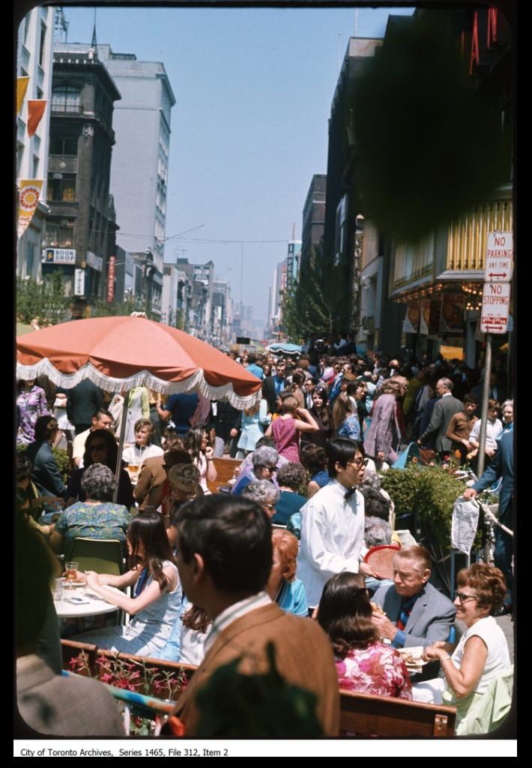

Image 32 Shot taken of diners outside a restaurant on Yonge Street Pedestrian Mall

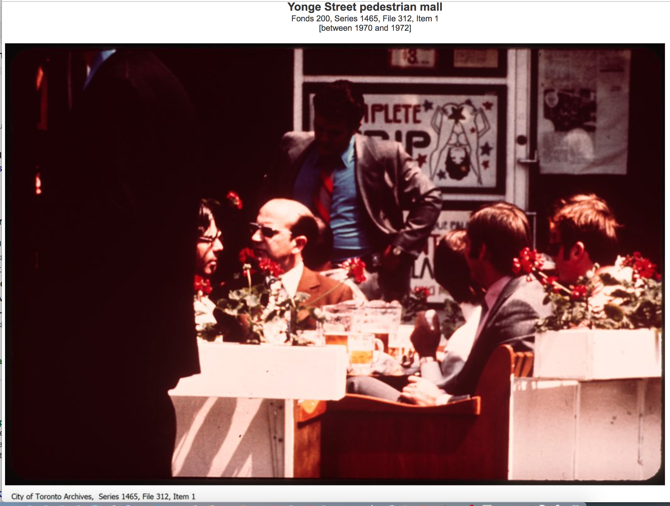

Image 33 Shot taken of diners outside a restaurant on Yonge Street Pedestrian Mall
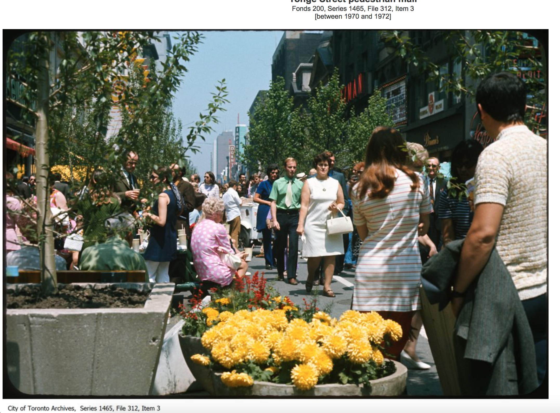

Image 34 Shot taken on Yonge Street Pedestrian Mall

The mall was a summer-only space: it lasted for two weeks in 1971. It was expanded to eleven weeks in 1972 & 1973; and eight weeks in 1974. It provided a pedestrian friendly realm in the heart of the city which was open to all.

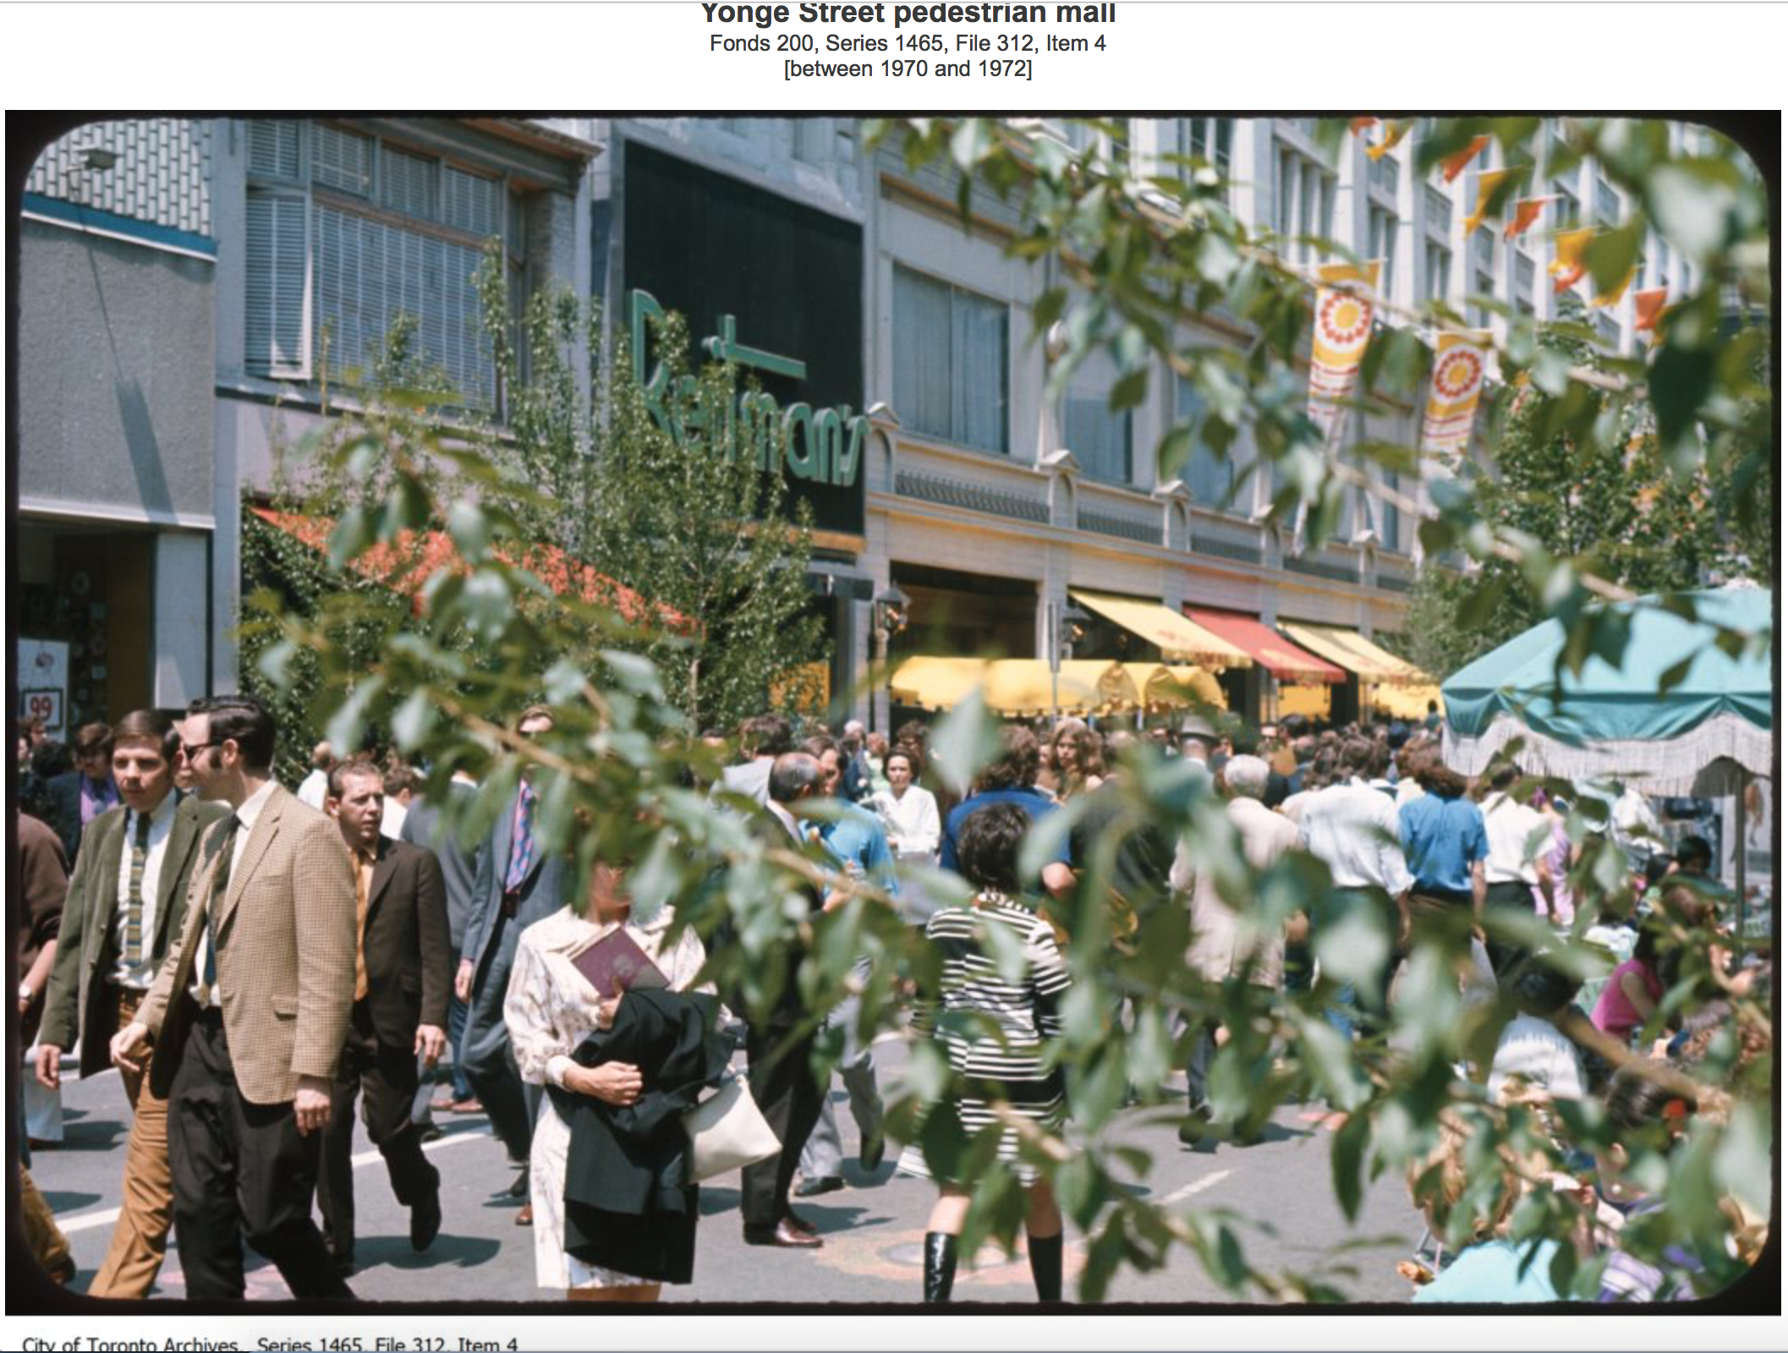

Image 35 Shot taken of pedestrians on Yonge Street Pedestrian Mall

In the photos above from the City of Toronto Archives, we see the vibrancy of the pedestrian mall on Yonge Street. Here we can see the vision of what could have been of Yonge Street as a vast public city street where citizens can share life in the city. This activity would later be captured by the newly built Toronto Eaton centre which would run parallel to the street and the expanding PATH underground network. In these photos that all is at play in terms of the future form that life in the city will take. The initiative was a short-term victory for the pedestrian over the automobile. Pressure began to mount from many corners and the pedestrian mall was discontinued in 1975. Yonge Street was no longer to be given over to the pedestrians of the city each summer. This period marks the beginning of a new era in the history of Yonge Street.

The Yonge St. mall was temporary and improvised at first, but a tremendous success both with citizens and almost all the merchants whose stores fronted on the closed-off street. But it died four years later when the provincial government, bowing to big-money interests about to launch the Eaton Centre, refused to grant the minor permissions needed to make it permanent.
BARBER Sun., April 20, 2014 The Toronto Star

With the impending opening of the Toronto Eaton Centre, we see the contrasting approaches which had been entertained in the centre of Toronto. In the end, it was the large private investment which was to win out in terms of longevity. With the opening of the enclosed shopping mall in 1977, the late 1970s mark the beginning of the migration of street life indoors, off Yonge Street to within the confines of the Toronto Eaton Centre and the increasing underground PATH system of underground shopping malls. These two different projects show contrasting approaches to city revitalisation that were emerging during this era. We have to think about the impact of changing approaches to political administration and the changing role that local authorities began to play in the life of citizens during this era.

The 1976 Central Area Plan

Leading up to the 1970s and before the implementation of the Central Area Plan, Toronto was similar to many other North American Downtowns. It faced the dual phenomenon of de-industrialization and population loss was a threat to the cities pre-eminence in the growing metropolitan area. Prior to the 1976 Central Area Plan, interior retail malls primarily in the lower level of the newly constructed major office towers became the dominant type of retail development in Downtown. The residential developments in Downtown seldom usual included retail in the base. The Colonnade was one of the first mixed-use developments. The retail planning history in Toronto since 1976 shows a move for an alternative to the pure market system whereby retailers and developers can build what they want and where they want. Similarly, retail development cannot be completely fixated on the look and feel of the street and have little regard for how retail needs to function. ‘The goal is the balance of these two major objectives to achieve viable and functional retail spaces that also create exciting and animated streets’ (J.C. Williams Group, 2015 p. 3). There was a new focus on finding a balance between economic and social goals to create a vibrant and successful central area.

The 1976 Central Area Plan changed that way of thinking. This was the earliest efforts in the emergence of a Legacy of Mixed-use Retail Planning and Main Streets in the Downtown area.
It was unique in North America. There was an expressed desire to create greater linkages between residential and retail opportunities. Retail along the street fronts was preferred. Density incentives for interior malls on the lower levels were removed and incentives for retail at grade were implemented. With this new focus on bring retail into more mixed-use type developments, the aim was to provide the modern larger floor plates that retailers required, and to enhance the role of main streets

It would not be until the 1980s and into the 1990s that the value of Toronto’s retail main streets (retail strips) became recognised and mentioned in planning documents. The City began to determine where large format retail could be allowed, and where it needed to be discouraged in Downtown from the 1990s onwards. There was a change in policy related to enhancing main streets. In addition, the City designated Priority Retail Streets in Downtown's zoning code. It was also during this time that the pre-eminence of Downtown Toronto for retail was included in the Official Plan. Programs and catalyst projects such as urban entertainment centres were developed, reinforcing the attraction of Downtown. There was investment in sporting facilities in Downtown that shifted and coalesced sporting and entertainment attendees into a central area.

While Toronto was undergoing many what may be considered progressive reforms as the political reigns were handed to Mayor Crombie in the 1970s, the events unfolding in the cities across the United States were on a more drastic scale. The 1970s could be considered the era when what would be referred to as the ‘Urban Crisis’ reached its pinnacle and nowhere was this documented and analysed as much as in the City of New York.

The Urban Crisis and the emergence of the Neo-liberal City

The Neoliberal City is one which is focused on creating an individualised utopia as opposed to a mass utopia. During this ‘Urban Fiscal Crisis’ of the 1970s, cities such as New York were faced with a large-scale funding crisis. Harvey (2008) focuses on New York to illustrate the impact that this shift in perspective was to have. He explains the financial crisis which New York faced in the mid-1970s led to huge international concern that the whole financial industry would collapse if the city was not bailed out. Budgetary power was taken away from the city. All the tax income due to NYC was used to pay off the debt to the investment bankers and the leftovers were used to pay for municipal services. The impact of the turning off the tap of federal government funding and access to borrowing markets caused great difficulties for city authorities. Bailey (1984) outlines the stark reality that was faced by the City of New York in autumn of 1974.
The ever-mounting need of the city for more and more short-term credit flew in the face of a contracting market, higher interest rates, and more intense competition for available credit. The problem went to the heart of city operations. This $13 billion a year municipal corporation needed credit to keep operating. The dependence on credit went far beyond deficit financing. It was required by the nature and structure of New York’s primary sources of revenue: its own taxes and intergovernmental aid. The need was twofold: first, to keep afloat approximately $3 billion in accumulated budget deficits, and second, to sustain a reliable cash flow so New York could meet its payroll, service its debts, repay its suppliers and contract for services. In short, so it could govern. (Bailey, 1984 p. 16)

The City Authorities were faced with the task of implementing austerity policies to reduce public spending to solve the cash flow crisis and pay off financial obligations. However, the traditional institutions of the city were not those which were tasked with the implementation of these austerity policies. A new institutional framework was established through an interactive process between creditors and city officials. This framework was developed between the city and its financiers in what was referred to as the Financial Community Liaison Group (FCLG). This was followed by the creation of the Municipal Assistance Corporation (MAC) by the State of New York. The clearest declaration of the fiscal crisis was the declaration through State Legislature of a ‘financial emergency’ on September 9th, 1975. The state instituted the Emergency Financial Control Board for New York City (EFCB) which assumed significant political and enforcement control over the implementation of a three-year financial plan which would involve large scale cuts to public spending. A new role was also set up through state legislature 0f the Office of Special Deputy (State) Comptroller (OSDC) ‘which was tasked with providing support staff and financial analysis for the MAC and EFCB’ (Bailey, 1984 p.17).

The actions taken by the FCLG and the MAC represented a significant retrenchment of municipal power in the lives of New Yorkers. The formal municipal institutions of power were being usurped by a framework of power which would implement fiscal policy which would satisfy the banks and financial institutions. This reflects what Offe (1993, p.150) explained about how the burden of economic crisis was spread upon the rest of society to keep the system working.
'To be sure, no one would deny that there are causes of declining growth rates and capitalists' failure to invest which have nothing to do with the impact of the welfare state upon business, but which are rather to be looked for in inherent crisis tendencies of the capitalist economy such as over accumulation, the business cycle, or uncontrolled technical change. But even if so, it still might make sense to alleviate the hardship imposed upon capital - and therefore, by definition, upon the rest of society, within the confines of a capitalist society - by dropping some of the burdens and constraints of the welfare state.'

The result was huge cuts to public services including fire protection, health, housing, education, and other social services. This approach has been repeated in response to fiscal crisis across the world in terms of austerity policies to deal with public funding problems. Harvey proposes that this is the key element which has guided politics over the following 40 years; the wellbeing of the financial institution is more important than the wellbeing of the people.

The Decline of Welfare Capitalism

The end of this period of growth of welfare capitalism occurs in the 1970s where the universal guarantees of the welfare state begin to be eroded. This is the birth of the Neoliberal city as the impetus emerges to deal with the scarred remains of the Industrial City which had been gouged apart by suburbanisation, deindustrialisation and decline led to increasing concern over the demise of public space and the ‘right to the city’. Offe (1993) interprets the decline in municipal power as the breakdown of the post-war settlement that produced the welfare capitalist state. He refers to it as a 'crisis of crisis management' because welfare capitalist states are no longer capable of fully dealing with the socio-political problems that emerge in late capitalist societies. Offe discusses this specifically within the context 'of the New Right, corporatist, and democratic socialist proposals for their restructuring' (Offe,1993 p. 147)
'The welfare state has served as the major peace formula of advanced capitalist democracies for the period following the Second World War. This peace formula basically consists, first in the explicit obligation of the state apparatus to provide assistance and support (either in money or in kind) to those citizens who suffer from specific needs and risks which are characteristic of the market society; such assistance is provided as a matter of legal claims granted to the citizens. Second the welfare state is based on the recognition of the formal role of labour unions both in collective bargaining and the formation of public policy. Both of these structural components of the welfare state are considered to limit and mitigate class conflict, to balance the asymmetrical power relation of labour and capital, and thus to overcome the condition of disruptive struggle and contradictions that was the most prominent feature of pre-welfare state, or liberal capitalism. In sum, the welfare state has been celebrated throughout the post-war period as the political solution to societal contradictions.'

Offe recognises that this view had tended to be the emerging dominant view amongst political elites in countries where the 'welfare state is fully developed (for example, Great Britain, Sweden) and in Countries where it is not completely realised such as the USA where it has caused political conflict. Offe explains that despite the different levels of implementation of the Welfare State, the view until the mid-1970s was that it would provide the peace formula or political solution for capitalist societies. (Offe 1993 p. 148)

The point to start with is the observation that the almost universally accepted model of creating a measure of social peace and harmony in European post-war societies has itself become the source of new contradictions and political division in the 1970s'

Offe observes that it was the sharp economic recession of the mid 1970s that gave rise to a powerful neo-laissez-faire intellectually and politically powerful monetarist economic doctrine. These doctrines mounted fundamental critiques of the welfare state.

The key argument that arises is that 'the welfare state imposes a burden of taxation and regulation upon capital which amounts to a disincentive to investment. Second, at the same time, the welfare state grants claims, entitlements and collective power positions to workers and unions which amount to a disincentive to work, or at least to work as hard and productively as they would be forced to under the reign of unfettered market forces. Taken together, these two effects lead into a dynamic of declining growth and increasing expectations, of economic 'demand overload' (known as inflation) as well as political demand overload (un-governability'), which can be satisfied less and less by the available output. (p. 149)

Applying Offe’s model of how the state attempts to balance contradictory imperatives gives us an insight into how City governments attempt to deal with the Urban Crisis. In this model, the economic system needs the state to continuously intervene to eliminate internal malfunctions. In turn the state submits to transfers- such as taxation, of portions of the value it produces to the political administrative system. In turn, the political-administrative system has a set of demands, claims and expectations placed on it which it uses the welfare state and other organisational services to breed loyalty. Offe describes this as ‘functional legitimation processes (which) are determined by the political system itself, namely, by its welfare state, ideological and repressive functions, as well as by autonomous, “pre-political” changes in the system of norms, ideologies and class consciousness.

Organisational disjunction
Welfare State Services
Regulatory Services

Normative (legitimation) system
Political Administrative System
Economic System

Mass Loyalty
Fiscal Inputs

Figure 1 Three subsystems and their relationship’ Offe (1993)

In Figure 1, the ‘Three subsystems and their relationship’ are illustrated, in which Offe, (1993, p.52) outlines the role of the Capitalist state. It is conceptualised as consisting of as three subsystems: the economic system, the political-administrative system, and the normative (legitimation) system. The increasing influence of Neoliberal economics was signified by the retreat of the Political Administrative system from many aspects of its role in regulatory services and provision of welfare. Mason (2011, pp 124 -125) outlines the linage of Neoliberal economics and traces its origins back to the departure of Friedrick Von Hayek from the London School of Economics for the University of Chicago in 1950. It was here that he could promote a doctrine of free market thinking to a small group which Milton Friedman was part of. Milton Friedman published Capitalism and Freedom in 1962 which reinforced the doctrine that private property and the free market are essential conditions for freedom. Mason explains that this perspective remained in the wilderness until the 1970s when many key events occurred. The first was the abandonment of the Gold Standard by Nixon in 1971. Faced with rising inflation and declining economic growth, Nixon imposed wage controls and abandoned the dollar’s convertibility to gold which had been in place since the Bretton Woods agreement in 1944 (ibid., p.124). Mason describes this as ‘the end of the currency framework that made Keynesianism possible’.

The second factor that contributed to increasing influence of Neoliberal doctrine was the Oil Crisis of 1973. Mason argues that this is what had a significant impact on the influence of Keynesian economics which had advocated that the public sector should intervene to rectify inefficient macroeconomic outcomes based on private sector decisions. This was mainly in the form of monetary policy interventions by the central bank and through fiscal policy actions by the government to stabilize output over the business cycle. Keynesian measures in response to the oil crisis did not work and Western governments were faced with increasing inflation and stagflation. As they began to run up massive budget deficits, Western Governments were faced with raising taxes or cutting welfare. Where a state retreats from this role and neglects the most disadvantaged in society it can pose a threat to the legitimacy of the state and its institutions as evidenced by O’Connell (2011 pp230-245) in relation to social exclusion and disadvantage in communities in Limerick, Ireland.

The architects and planners of the welfare state sought to create a healthy city for all social classes and they attempted to “monumentalise” this condition of urban equality in the form of full employment, social security, health, education and social housing. However, the equality project faltered with the demise of the industrial economy on which the welfare settlement was founded. Secure employment in manufacturing industries was replaced by large-scale, long-term unemployment, as the transition to the post-industrial economy impacted disproportionately on the poorly educated and low-skilled workforce, poor immigrants and ethnic minorities. They were cut off from the new economy and the opportunities it presented due to a lack of skills and educational credentials and became heavily reliant on a retrenched welfare system where the emphasis had shifted from care to control. (O’Connell, 2011 p. 239)

The end of era of full employment and universal welfare provision also heralds the retreat of the City from its role of caring for its citizens to that of controlling its citizens. De-industrialisation of the City and the loss of secure employment in manufacturing lead to long-term unemployment and welfare dependency for the most vulnerable in society. There is a move away from universal provision of social services to the provision of services only for those who need them. Welfare becomes associated with marginalised members of society.

Offe charts the breakdown of the post-war settlement that produced the welfare capitalist state. He refers to it as a 'crisis of crisis management' because welfare capitalist states are no longer capable of fully dealing with the socio-political problems that emerge in late capitalist societies. Offe discusses this specifically within the context 'of the New Right, corporatist, and democratic socialist proposals for their restructuring' Offe (ibid., p 149) observes that is was the sharp economic recession of the mid 1970s that gave rise to a powerful neo-laissez-faire intellectually and politically powerful monetarist economic doctrine. These doctrines mounted fundamental critiques of the welfare state.

During this era, we also see the emergence of privatised enclaves within the city. Harvey and Sennett will help us to understand the impact which the privatisation of parts of the city began to have. In the 1960s New York saw significant de-industrialisation to either the suburbs or the cheaper locations in the American South. Industrial employment was replaced with public employment e.g. education, healthcare, municipal services. In 1973, the United States Federal Government faced economic pressures on several fronts including the first Oil crisis and the exorbitant cost of funding the conflict in Vietnam. Along with these also the government was also funding anti-poverty programmes to help combat the issues which de-industrialisation and suburban migration had caused.

President Richard Nixon in a radio address to the United States (Radio Address on Urban Affairs. November 1, 1972) refuses to describe the state or urban America as the "urban crisis." He claimed that he would ‘prefer to think of it, however, as the "urban opportunity." Harvey (2008) argues that this was a signal being firmly raised that the federal government would be unwilling to continue funding investment in public services in urban areas that were perceived to in decline and facing fiscal funding crises. Nixon was heralding a new era of government intervention when the money that would be invested would be more focused and less universal in nature. The subsequent global crash in property markets that was to follow had a significant impact on the credit system, especially on the banks which were heavily invested in cities such as New York. This pause or shock to the process of reinvestment of surplus capital, caused a crisis. New York City faced the reality of dealing with less and less income from taxes on property development, the impact of which was compounded by a decrease in the availability of federal money following cutbacks by the Nixon government.

In 1975, there was what Harvey (2008) refers to as a ‘financial coup’ against the local government in New York. Investment banks decided that they would not underwrite any more money to support the city government. This led to the financial crisis within the credit institutions that, through debt-financing, had powered the property boom in the preceding decades. New York was forced to appeal to the Federal Government for assistance. In the aftermath of the Watergate scandal, Nixon was no longer President. On Oct. 29, 1975, President Ford gave a speech denying federal assistance to spare New York from bankruptcy. The front page of The Daily News (New York) on Oct. 30, 1975 read: “FORD TO CITY: DROP DEAD.” William Tabb (1982) refers to this era in his book, The Long Default: New York City and the Urban Fiscal Crisis, and he explained that the way that this crisis was responded to has led to the emergence of the neoliberal city in an era when the role of the municipality in providing for the universal welfare of its citizens became usurped with the impetus to direct dwindling resources at specific initiatives to make the city more attractive for private investment.

The decline of Yonge Street

While 1970’s Toronto did not experience the same decline as the City of New York, there was a perceived decline of Yonge Street with the increase in lower value uses on the street. The fear of crime and the impression that the street was an unsafe space also came into question and there was a focus on the types of activities that were occurring on the street. Moore Milroy (2009 p. 45) outlines the impact that the changing tenants and uses had on the way the street was perceived. She explains how the history of lower Yonge Street and the Yonge-Dundas intersection is characterised by the shifts in the sense of importance, or lack thereof, over the years.

The street-related enterprises in the area in question gradually changed from sober butchers, haberdashers, milliners, and house painters to clothing retailers, taverns, tea rooms, restaurants, and cinemas to fast-food outlets, game arcades, massage parlours, electronics retailers, and souvenir stores. Much of what was happening to the retail and commercial segment of the street was tied to the large-scale influences that came with post–Second World War growth: the city’s form shifted from being monocentric (centralized transit and pedestrian shopping) to being polycentric (decentralized, car-oriented shopping).

The changes that Moore Milroy outlines was happening all over Canada and the United States. The opening of the Toronto Eaton Centre would have a significant impact on acceleration of the migration of higher order land uses off the street and into the enclosed mall. One key event which brought these changes into sharp focus was the murder of Emanuel Jacques (See Image 35: Front page of the Toronto Star on August 2, 1977). The murder scandalized Toronto and brought the differences between Yonge Street the enclosed and sanitised passageways of the Toronto Eaton Centre which had only opened 6 months beforehand, into sharp focus.

The shopping mall had been protected from the realities of urban life by the private security force that protected its domain from the city around it. However, to claim that the shooting of Emanuel Jacques drove people indoors is to ignore the other political and economic realities that led to the decline of the street. Violence has not been solely confined to the public street. On December 26, 2005, on the Western side of the newly opened Yonge Dundas Square, 15-year-old student Jane Creba was shot in the crossfire of a gang related shooting. The Toronto Eaton Centre was also the site of gun violence in 2012. A shooting incident occurred on June 2nd when Christopher Husbands entered the Toronto Eaton Centre food court and fired 14 shots which killed two men and injured 5 others. The perception of the centre as a place immune to the dangers of gun violence was shattered in this incident. Gun violence was not the main factor in the decline of Yonge Street, however it did serve to tarnish the reputation as a key shopping street and increase the perception it had developed in the 1960s as venue for as the ‘sex strip’ of downtown Toronto.

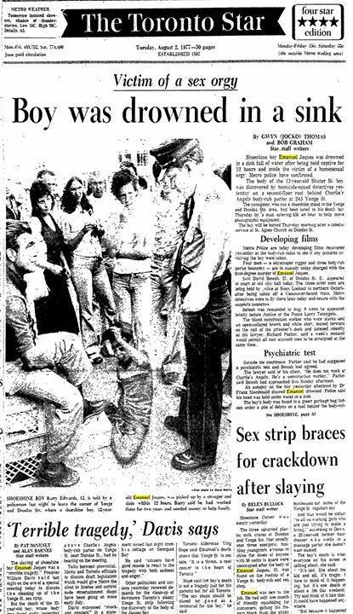

Image 36 Cover Page of The Toronto Star from August 2nd 1977
The impact of this murder still resonates with Torontonians. Toronto Star readers, shopkeepers and residents were asked to share their memories of Yonge Street in An Oral History of Yonge Street’ created by the Toronto Star (https://www.facebook.com/YongeStreetHistory/) Extracting the posts made to this page, there were three specific reference is made to this event and the impact it had on the street:

Yonge St. degenerated badly in the aftermath, its nadir coming three years later with the murder of shoeshine boy Emanuel Jaques. The swelling flood of pedestrians that inspired council to create the mall in the first place diverted into the privately owned, weather-protected Eaton Centre, which quickly became the world’s most successful and most imitated urban shopping mall. The once-famous Yonge St. Strip was left to its own dubious devices.

Not so good memory: in 1977, 12-year-old Emanuel Jaques is abducted, sexually assaulted, strangled and drowned above the Charlie Angels body parlour after agreeing to help two strangers move some equipment. Two men were convicted of first degree murder, one was convicted of second degree murder, and a fourth, who held the door open allowing for Emanuel to be carried inside, was acquitted. The aftermath of this tragic incident was the "clean up" of Yonge Street. Gone were the adult stores, body parlours and shoe shine stands. Yonge Street became a more people-oriented street. The negative backlash against the gay community was regrettable, but Toronto and Canada recovered and became one of the first of the western industrialized nations to legalize gay marriage." - Manuela Da Rocha

I remember this like it was yesterday. I was 13 and my mother was devastated that such a thing could happen. death of a shoe shine kid.

The murder had an impact on how the street was perceived not only by shoppers, it also changed the way the local authority viewed the street. It was around this time that Ken Greenberg, architect in Toronto, was invited to join the staff of Toronto’s Department of Planning and Development to set up an urban design program. Greenberg outlines the scale of the task the he felt he faced in terms of dealing with the perceived decline of the street.

By the mid-1970s downtown portions of Yonge Street were out of control. The popular clothing stores and other retailers that had once lined the thoroughfare had given way to a drug scene and a proliferation of body rub parlors and trinket shops. At first, a series of temporary pedestrian malls, which closed portions of the street to traffic for several weeks at a time in the summer months, had mixed success in bringing visitors back, but in the end, they only amplified the problems of prostitution, panhandling and drugs and created an uneasy atmosphere. Yonge Street’s deteriorating condition came to a head with a tragic event in 1977 that galvanised the attention of the public. A twelve-year-old shoeshine boy named Emanuel Jacques, the son of Portuguese immigrants, was lured into an apartment above a body rub parlor with the promise of work. He was brutally assaulted and murdered. A crime of this nature was considered unthinkable at the time in Toronto. Numerous protests and marches demanded that the city clean up “the strip” and provided the catalyst for shutting down the number of “adult” stores and body rub parlors… it was felt that if Yonge Street could be made more attractive to a greater variety of people and to better- quality business, this would deter further physical and social decay
(Greenberg 2011 pp 125 -126)

What Greenberg is outlining is that for Yonge Street to be considered ‘attractive to a greater variety of people’ there would need to be a change in the type of activities that occurred there. For this to occur a new type of approach would need to be embrace where there was stricter control taken over the types of activities which could occur, which was beyond the financial resources of many North American urban authorities. Again, it is in the City of New York that we see the implementation of new approaches to urban planning to deal with fiscal austerity which involved the retreat of the political administrative system from public life.

The impact of the neoliberal city

In the City of New York, we see a similar pattern emerging to that of Paris after the revolution of 1848. Power shifted to a new institutional framework which was shaped by the bankers and city financiers. They wanted to rebuild the city as one which was fiscally prudent and open to capital accumulation and had a vibrant base. The impact of the fiscal retrenchment by the municipal authority was widely felt amongst city employees and the general public. Harvey (2008) explains that the unions of the fire and police were instrumental in instituting a counter narrative to this approach with a ‘fear city’ campaign. You could be mugged on the subway - stay off the street, stay in a lower floor of the hotel. A pamphlet campaign was initiated by an organisation named the Council for Public Safety which portrayed New York City as a crime ridden dystopia where you were certain to become a victim of crime. In the pamphlet, which was subtitled as a survival guide for visitors to New York, nine steps were outlined to stay safe in the city.
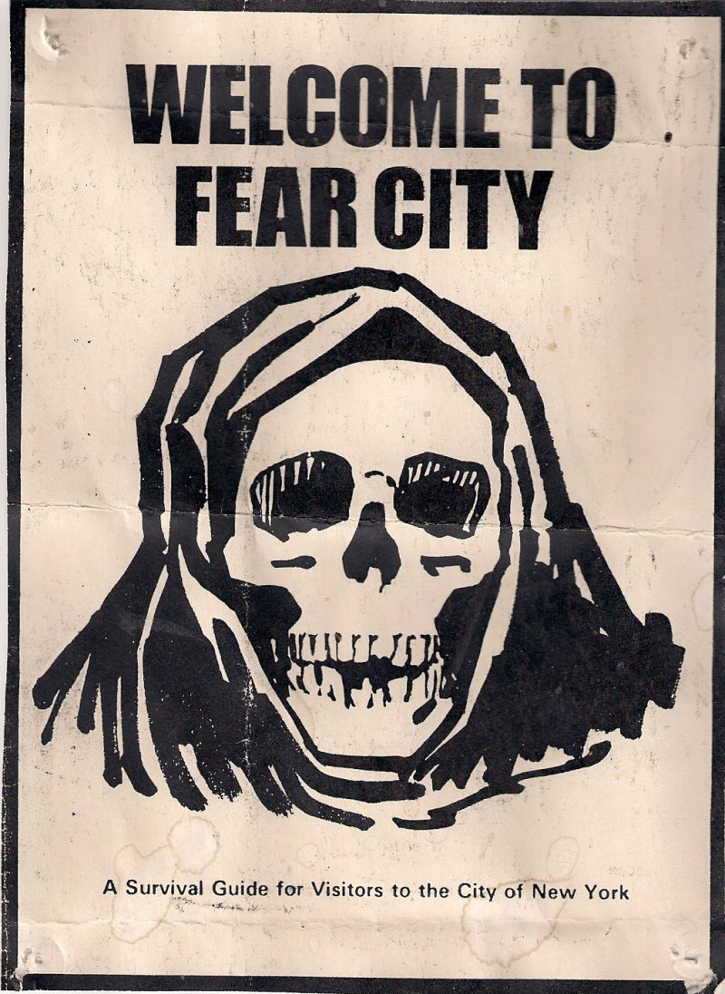
Image 37 Taken from Flickr user Islandersa1 (https://www.flickr.com/photos/58226389@N07/5353499368/in/photolist-9a55Rf-9fqYBL-9fqYRE-9fqYKm/)

In the pamphlet, advise to visitors including urging them to stay off the street after 6pm, avoid public transportation, and to stay in ‘fireproof’ hotels in a room close to the fire escape. This was a direct attempt to target the city’s tourism and conference industry. The real motivation is made clear in the second paragraph of the pamphlet.
Now, to "solve" his budget problems, Mayor Beame is going to discharge substantial numbers of firefighters and law enforcement officer of all kinds. By the time you read this, the number of public safety personnel available to protect residents and visitors may have already been still further reduced.

This campaign was an attempt by certain factions of city workers to combat the efforts of the FCLG, the MAC, the OSDC, along with the Mayor Abraham Beame to institute the policies of fiscal austerity. It was a reaction to the proposed large-scale layoffs and wage cut to public workers throughout the city. The Fear City campaign was not universally supported by the public unions. Concessions were made by public workers and this helped the city to narrowly avoid bankruptcy in October 1975.

Re-casting the city: A response to the ‘Urban Crisis’

The city of New York which teetered from crisis to crisis during the 1970s and had developed a reputation as a dangerous place needed to be rebranded as an attractive place to visit. The neoliberal principles were a new way absorb the excess capital in the city. A consensus begun to emerge was that Manhattan should be recast as the centre of tourism, culture, and shopping in the City. For this to happen adequate city services would need to be focused on this area ensure that the city was a safe and attractive place to visit. The best example of this re-branding exercise to occur during this period was the slogan ‘I love NY’. This became the brand which was to be used to market the city to the world. The revitalisation of Times Square is also heralded as another key moment in the reinvention of New York City as a safe, consumer focused tourist destination. A mini state within the city began to emerge, which was privileged above the other areas - a fragmented city with islands of privilege in a sea of decay. This is crucial to the politics of neo-liberalism.

The Eaton Centre was envisioned as a counter point to the newly developing retail centres on the edge of the city such as Don Mills or Yorkdale. It was not only an attempt to build a modern new store for Eaton’s, but it became an effort to recreate and re-establish the centre of Toronto. The period discussed in this chapter covers key events in the progression of the site from vision to development. In the historical case study of the key events and documents which occurred during the period defined, we see that the key theme which emerges is that of the contestation of meanings about how the future of downtown Toronto should develop. Each of stakeholders involved had developed a set of meanings of what the site was, and what the site could be and how the site should be developed. What becomes clear is that the planning stages of the Eaton Centre were a process of negotiation and renegotiation between private property owners, and public bodies on the future of downtown Toronto. Evidence was presented in the form of the Project Viking Memorandum that there was an impetus by City Authorities and the Planning Board to facilitate private development and in turn extract some benefit for the public.

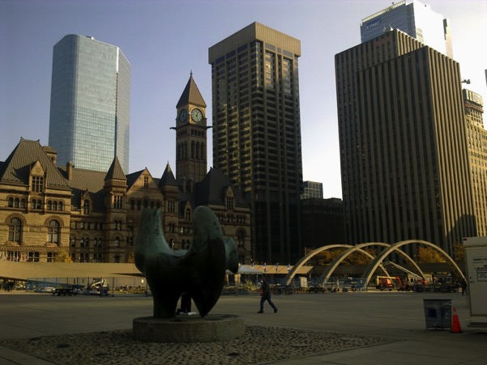
Image 38 November 2010. Looking South East, Nathan Philips Square can be seen in the foreground and the Old City hall and its Clock Tower can be seen in the left background. Behind this, we can see the Cadillac Fairview tower, which is part of the Eaton Centre.

The dominant political and development perspective in the 1950s that persevered was that development was good and that this was what the city of Toronto needed to remain the heart of the Metropolitan region. However, counter-narratives emerge which challenge this dominant view. The key factor that allows these counter narratives to emerge is the time that it took for the development to come to completion. The protracted process of negotiation and renegotiation saw the evolution of the form that this site would take.

What makes the Eaton Centre an important case study site are the following events which occurred during this process
- The memorandum of development – the Planning Board sets out the strategy to facilitate the development of a large privately-owned site in the heart of Toronto, which is neighbouring a publicly owned site
- Emergence of counter narratives to the dominant forms of post ware urban development and the role they played in shaping political power and in turn changing the form that the development would take. There is also the clash between the newly emergent conservation movement and the architectural modernism that had comes to characterise post -war development in downtown Toronto through the Mies Van Der Rohe’s Toronto Dominion centre and the brutalism of New City Hall.

Overall what we can see is that the development of the Eaton Centre was a contested process. The various interest groups mentioned such as the property developers and local interest groups such as Friends of Old City hall clashed. The challenge faced by city authorities was to balance the needs of capitalism, mainly the interests of the developer and retailers with the interests of the public. It was a considered and negotiated journey towards the submission to a privatised public realm at the heart of Toronto. To compete with the suburban competition, Toronto had to reinvent its city core. It had to recreate the idealised suburban shopping space downtown. In many ways, the Council and planners exerted relatively positive influence over the developer. The key historical buildings were kept. The subway stations were linked. The New City Hall had a modern and fitting neighbour which modernised the retail heart of Toronto and kept this area as the focus of the social and commercial life downtown. They also managed to maintain public access and maintain active frontages on Yonge Street. In the next chapter, we will consider the impact that the centre had after opening and consider how this privatised space in the heart of the city, shifts the experience of life in the city.

Chapter Five: ‘Life in the City Starts at the centre’ The Eaton Centre

As shopping malls begin to be constructed downtown in the 1960’s and 1970’s they aim to recreate the city in miniature separated from the negative aspects of the city such as crime and homelessness. We begin to see the emergence of privately managed public spaces. In cities across the world there has been an attempt to enclose public space and sanitize it or domesticate it to make it more conducive to commodity fetishism. We see the emergence of the open-air shopping district, which is privately managed and is presented as a space which integrates seamlessly with the surrounding city. Examples include Midtown Plaza (1962), in Rochester New York, (also designed by Victor Gruen) and the Toronto Eaton Centre (1977). The emergence of the downtown shopping mall leads to the growth of fabricated spaces which create a simulation of urban life which is more suitable for commodity fetishism. The key elements of the shopping mall begin to be applied to downtown areas and we see the emergence of privately managed public spaces. In cities across the world there has been an attempt to enclose public space and sanitize it or domesticate it to make it more conducive to commodity fetishism. When publicly owned spaces are privately managed there is an impact on what you can and cannot do in the space.

This chapter will explore the way a reimagined vision for the Toronto Eaton Centre was positioned by the developers as the centre of modern downtown Toronto. It will be shown how this was achieved through the physical layout of the development and the branding of the centre. Key texts and design features of the centre which will be analysed to illustrate the efforts that were made brand the space. The impetus of this approach is to illustrate how this postmodern enclosed city centre was crafted in terms of (a) the physical reality inside the mall, mainly in terms the physical structure of the mall, and (b) the collective image of the centre which was gestated through advertising and publicity campaigns. The aim of this section is twofold. Firstly, it will uncover and interpret the manner in which this space was shaped for the collective dreamworld of the residents and visitors to Toronto and in turn how they were encouraged to adopt the centre as the essence of city life through shopping and consuming. Secondly, it will consider the impact that the opening of the centre had on the surrounding city by analysing attempts to revitalise the surrounding streets, in particular Yonge street through local authority initiative.

Toronto Eaton Centre: Creating the dreamworld

As discussed in the previous chapter, the Toronto Eaton Centre development had evolved from the initial proposal to build an enclosed shopping mall transplanted downtown to a development which created a light filled enclosed city street which had the appearance of publicness. It was a site to which the public would have access to 24 hours a day because of planning conditions imposed on the development which state that access must be maintained for the public between Yonge and Trinity Square. The Toronto Eaton Centre is a development which shifted the focus of the city streets it neighboured inwards. The centre is an important case study site to explore the increasing tendency towards enclosed, privately managed urban spaces which began to increasingly emerge around this era. The Toronto Eaton Centre, much like the Houston Galleria, and Bonaventure Centre in Los Angeles created a large enclosed urban realm which served to create a branded city space, which was focused on consumption and leisure and which was managed privately. The Eaton Centre employed elements in its design to reflect the city streets around it, to evoke the spontaneity and chance of encounter with the stranger that the city offers, in a regulated, privately managed environment. It is important to understand how the Eaton Centre became an instrument of postmodern consumer society or what Jameson (1991) would refer to as a space of late capitalism. To achieve such an understanding, it is useful to look at the imagery which was used to create the sense of place in the centre before it opened and in the early days of operation. During the research, promotional material for the mall and early advertisements for the centre were uncovered. An analysis of these texts will now be used to illustrate the role that the Eaton Centre was portrayed as filling. We will begin with an analysis of the promotional brochure produced by the mall owners to entice retailers to locate here. This will consider the dream that was being sold to retailers and the positioning of the centre as the prime location in the centre of Toronto. Moving on from this, the commissioning of Advertisements as Art programme will be considered as an attempt to adorn the mall with the advertising imagery of a commercial downtown core. It was also an attempt to authenticate the urban experience in the Eaton Centre. After this we will consider one of a series of television adverts which were produced in the 1980’s for the Eaton centre. It will be shown how these advertisements position the centre as the heart of the city and a destination for food and fashion in the tagline ‘Life in the City, Starts at the centre’.

The Resurrection of the Toronto Eaton Centre

The Eaton Centre plans were revived in 1971 and they included the preservation of Old City Hall. However, the new plans took a different approach to the development of the site. In the new proposed development, they would work with a developer partner Fairview and the proposal would consider the public disquiet concerning the demolition of Old City Hall. In the new proposal, Eaton’s and their architects embraced key elements of the built environment to create a centre which would mix old and new in what was billed as a new improved city centre. The approach proposed several changes in terms of the physical form and layout which would completely reimagine the vision for the site.

The first significant change in this new proposal was that the new Eaton's store was to be shifted north to Dundas Street. The logic given was that the new store would be too large to be accommodated in its traditional location on Queen Street (opposite its rival Simpson's) due to the preservation of Old City Hall. This resulted in the mall being constructed with Eaton’s and Simpsons acting as anchors at either end of an enclosed mall. This is more in line with what had become the standard approach to enclosed suburban shopping mall development since the opening of the Southdale Mall in 1956. The location of a department store at either end was used in thousands of malls across North America to encourage shoppers to filter past the rows of the smaller shops lining the passageways between the anchor department stores.

The second significant change was the reduction in the size of the office component, so that the Eaton Centre project no longer represented an attempt to extend the City's financial district north of Queen Street, as the Eaton Family had originally contemplated in the 1960s. Finally, the bulk of the centre was shifted east to the Yonge Street frontage, and the complex was designed so that it no longer had any frontage along Bay Street. Old City Hall would be saved, as was the Salvation Army headquarters building by virtue of its location between the two other preserved buildings. Despite this, controversy erupted afresh when the congregation of the Church of the Holy Trinity exhibited an increased willingness to fight the demolition plans for its church. They refused to give up their church on Trinity Square. Several redesigned plans were presented before enough support could be achieved for the scheme to proceed around Old City Hall and Trinity Square which would save both Old City Hall and the Holy Trinity Church.

In 1972, the basic concept was approved by the City Council who at that stage were anxious to encourage downtown developments (Dendy and Kilbourn, 1986 p.291). However, the proposal was attacked by most aldermen elected to the 1973-74 City Council. In response to these criticisms, the City Council convinced Eaton’s partners in the development, Fairview, to make changes to the exterior facing Yonge Street. The council passed a holding by-law which enabled the city to compel the developer to make changes to the proposed development which would improve its character. This included making changes to the amount of sunlight which would enter Trinity Square (Dendy and Killbourn, 1986 p.293). However, a large section of nineteenth and early twentieth century buildings on the west side of Yonge Street were to be eliminated. Further revisions were made when Holy Trinity's parishioners successfully fought to ensure that the new complex would not block all sunlight to the church. Criticisms of the exterior of the development began to emerge, especially against the façade on Yonge Street. The key criticism was that the development displayed a disregard for the public street life on Yonge Street by confronting it with a bland and sterile exterior.
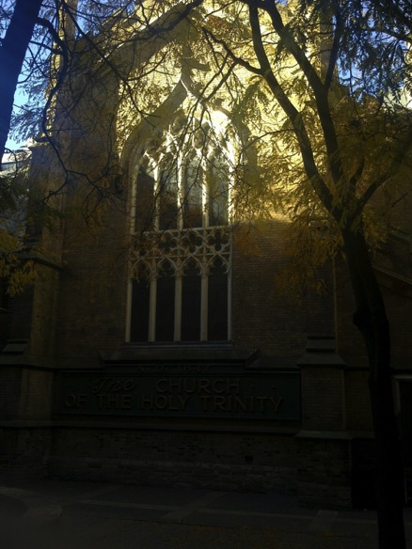
Image 39 The Church of the Holy Trinity now located in Trinity Square, (November 2010)

Opening up the Eaton Centre to the city

In response to the growing criticism that was being levelled at the proposed Eaton Centre design, the Zeidler Partnership were called into help improve the character of the development and help create a design that would satisfy the city council. Working with Bregman & Harmann, Zeidler’s proposals aimed to deal with many of the criticisms the design had gathered. Eberhard Zeidler, in his autobiography, outlines how he viewed the project when he was asked to join the design team.
A job that changed my career was the Eaton Centre in Toronto. The initial (terrible) idea had been to tear down Toronto’s magnificent Old City Hall and to build the project there. By the time we got involved, in 1969, the project had already been through many incarnations…
…I myself had fought it when they originally wanted to tear down the Old City Hall. That battle however had been won. The proposed site had been altered, leaving City Hall intact, and Bregman + Hamann had prepared a design that was most uninspiring. It looked like an enclosed suburban mall – something like Scarborough’s Fairview Mall – misplaced in the downtown core. Tony Coombes, the chief planner for central Toronto, was fighting this plan and demanded that somehow one face of the Eaton Centre open onto Queen Street’ (Zeidler pp.168 -169)

The design up until this point was akin to the transplantation of the suburban mall typology borrowed from the enclosed malls of Southdale, Yorkdale and Don Mills into a site downtown. The proposal was to develop an enclosed box surrounded by skyscrapers and lacking in any connection to the surrounding neighbourhood. Zeidler worked alongside Bregman and Harmann to create a development that was to become an exemplar for the contemporary urban shopping mall. During the redesign process, the architects kept coming back to one particular historical site: The Galleria Vittorio Emanuele II in Milan. They admired the role that the Galleria played in Milan and Zeidler (2013 p.168) explained that ‘It functioned like a lively outdoor street, yet was protected from the weather. This seemed the right thing to do in this location. It integrated all the shopping into one area and made it ‘the place to be’. The aim of the development was to make the Eaton Centre the centre of downtown much like the Galleria Vittorio Emanuelle II acts as a central draw in Milan. This was to manifest itself in the design which was proposed.

The new proposal for the Eaton Centre envisioned a vast downtown shopping space no longer just a site for an enlarged Eatons Store. Instead it was to become a large, enclosed shopping complex of shops and restaurants ‘with exposed and exaggerated structural detail and greenhouse glazing, created an airy high –roofed shopping street reminiscent of the Galleria (1865-7) in Milan’. (Dendy and Killbourn, 1986 p. 293). The scale of the Toronto Eaton Centre was intended to impress at 866 feet long, with 1,566700 square feet of space and at least 305 shops. The exterior of the centre facing Yonge Street was changed by Zeidler to place shops along the street.

It was necessary not only to create a wonderful pedestrian galleria inside but also to animate two streets outside: Yonge Street to the east and Bay Street to the west. The city has force us to give ten feet to the sidewalk on the Yonge Street side, but there was still enough space between the galleria and Yonge Street to develop another set of stores that could open toward Yonge Street. In the southerly section we changed that to some through-stores, such as restaurants and pharmacies that could afford to have doors both inside and outside. The required exit doors would have filled nearly half the length of Yonge Street elevation so we decided to create a second level and have half of these stores exit at that level to reduce the number of exits on Yonge Street.
(Zeidler 2013 p.177)

A system of ‘walkways and balconies built up from metal beams and railing animates the façade and supports an array of neon signs that add light and movement. This was not purely for aesthetic reasons, but was the result of a condition placed by the local authority for planning approval.

Public Access to Private Space

Another condition imposed on the developers was in relation to access. There were requirements put in place to maintain access to the centre in areas which originally had a public right of way. The mall was required to remain accessible to the public from the east side of the complex, just opposite Shuter Street on Yonge to the west side at Trinity Square Park. This condition required that the route remain open twenty-four hours a day. Zeidler (2013 p.176) explains that this required taking an innovative approach to maintaining this required public access.
Because we had to leave the Trinity-Shuter crossing open twenty-four hours a day, we studied all kinds of closing mechanisms that could separate the rest of the mall from this public crossing during times when the mall itself was closed. We had trouble finding the right solution before the Eaton Centre opened, and it opened without a mechanism for closing the mall. It turned out this was not necessary because the whole mall acted like a street after the shops closed. People walking through it didn’t cause any damage. The mall has always acted like a public street, even if it’s patrolled by security guards rather than police.

This is an innovative example of privately managed space with the appearance of publicness. There is the impression that anybody can access the centre at any time of the day as long as they obey the rules imposed by the private security force.

The political pressures exerted on the developers by municipal politicians had an impact on the form the development was to take. The design elements that were mandated aimed to strengthen the link between the Centre and the exterior along Yonge Street. Bernstein and Cawker (1982 p. 114) proposed that the Eaton Centre’s consortium client had been successful in gentrifying ‘a formerly sleazy strip of Yonge Street.’ They also highlight the impact of the design changes mandated by municipal politicians in exchange for permitting street closures as contributing to the success of the centre as an urban place. What was initially proposed as a project of the 1960s superblock era, a rational approach to land use, linked to the PATH system (an underground city of connected walkways, shops and foodcourts), downtown skyscrapers and the public transport system -a rationalised approach to the city, reconfigured itself to become a postmodern fully enclosed city centre. The Eaton Centre was to have a key role in the shaping the image of downtown Toronto. The lengthy planning and development process, allowed the developers (Cadillac Fairview Corporation, the T. Eaton Company Ltd., and the Toronto-Dominion Bank) to consolidate six hectares of downtown land into a single parcel and reshape the traditional retail core of downtown Toronto.

Selling the Centre

It was the late 1970’s when the Eaton Centre opened to the public. This happened in two stages: on February 10, 1977, the northern section opened its doors which included the new Eaton’s Department store. In August 8, 1979, the southern section, which stretched towards Queen Street, was completed. Before the centre opened to the public, the developers needed to sell the centre to the retailers and other businesses that they were hoping to attract to the centre. During the fieldwork visit, a promotional brochure was uncovered at the Toronto Urban Affairs Library, which had been produced by the mall developers Cadillac Fairview and was targeted at prospective tenants. Inter-spliced with artist impressions and illustrations, the Toronto Eaton Centre brochure is a freeze-frame or snapshot of how the Eaton Centre was pitched to prospective tenants before it opened. The brochure describes the Eaton Centre as one of the largest and most important downtown redevelopment projects under construction in Canada at the time. The brochure proclaims that the ‘Eaton Centre at completion will become the downtown focus for visitors, shoppers and business in Toronto... a major civic space for all to enjoy’ (Cadillac Fairview, date unknown p. 2). This document creates a holistic image of the centre before it had opened. The imagery and development descriptions serve to crystalize the reality which would exist in the space before it had been fully formed.

Connecting the centre to the city around it

The function of the brochure is to explain what type of space the centre will be and what type of experience the visitor will have. Photomontages were used to put the centre into the context of downtown Toronto and to show its relationship to the surrounding streets. Maps were also produced to emphasize the connectedness of the site and the central location it occupied. These maps act as an idiographic representation of the spatial synchronisation of the retail and leisure functions of the downtown area. In the map, 21 key landmarks are highlighted including the C.N. Tower, major hotels, and public institutions. The transportation routes are also highlighted to show the connectedness of the site. The aim of the map illustrated below is to place the development at the centre of Toronto and highlight the potential footfall. It is a map of key attractions downtown, from which people can be encouraged to visit the centre. It could be considered a map of potential target shoppers. Also, as a downtown location, without the acres of free surface parking, which by this stage had become associated with the shopping malls across North America, the centre had to show how the potential customers would get to the centre. The transportation options were clearly highlighted including Subway, Streetcar, Bus and Go-Transit lines. The key pedestrian routes were also highlighted along with the key intersections. For those who were to travel by car, the multi-story parking garage would be connected to the centre would provide them with easy access. The key transport links are highlighted and the key traffic drivers and footfall drivers nearby are highlighted. The centre was being portrayed as the focus of downtown Toronto and the centre of life in the city.

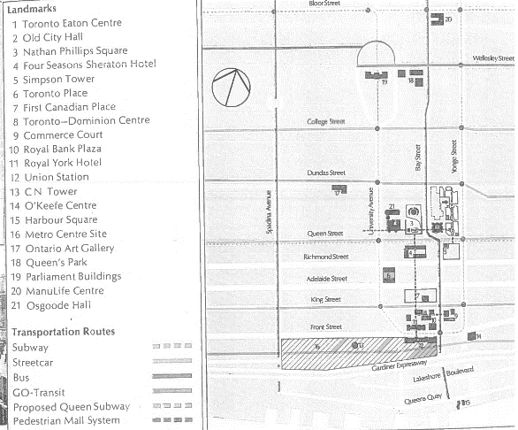
Image 40 Indicative Map of Eaton Centre in relation to transport links and other key downtown attractions from Centre Brochure.
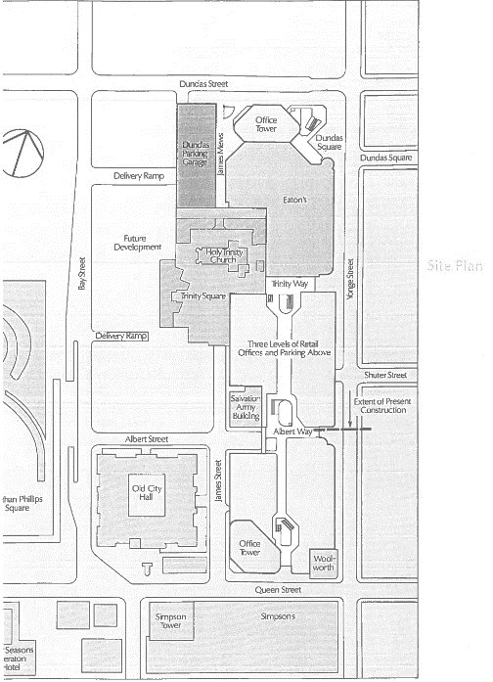
Image 41 Site Plan of the Proposed Eaton Centre, which shows the location of the key anchors and footfall drivers and the layout of the multi-level Galleria

The site plan above gives context to the proposed development. It uses the existing landmarks of the city such as the Old City Hall and Holy Trinity Church to help the viewer understand the space which the site will occupy. It illustrates key elements of the centre, such as the Dundas Parking Garage, and the street level entrances to the centre. This serves to make real the new shape of this downtown area. Absent are the names of the old streets which were going to be replaced. There is no reference to the buildings which once stood on this site. Instead the city centre has been repackaged and renamed to fit in with the image of the centre. This approach has been employed in many cities across the world. It is still used today where we see large scale development of towns and city centres. Liverpool One in the centre of Liverpool saw a large swathe of the city centre reimagined to form a coherent shopping and leisure destination. The Victoria Square development in Belfast, Northern Ireland also saw the redevelopment of a large city centre site and its semi enclosure with a glazed roof.

The site plan is not only used during the development stage to attract prospective tenants. It has now become a common feature of most shopping centres in the form of the mall map and directory. This is usually displayed within the centre, or posted on the centre website, or in the form of printed leaflets the mall plan has become a key instrument in navigating and instilling a sense of place in the visitors to the mall. During the fieldwork, at the busier periods, members of Eaton Centre staff were standing near the entrances handing out copies of the all map and directory. The image below is a copy of the map which was being handed out to mall visitors during the site visit. It is a diagrammatic representation of each of the five levels of the centre, and it appears that each floor is hanging in mid-air striped of walls and the other confines of the mall. It highlights the key pedestrian routes through the centre and illustrates the location of the escalators and lifts which allow the visitor to navigate between each floor. The list of tenants is relegated to the back of the page to a list organised in alphabetical order, and each tenant is assigned a number which relates to an area of the mall plan. The only tenant illustrated in the plan is Sears, which as the original Eaton’s store was designed, acts as the northern anchor of the development. The function of the mall plan or map is not only to help the shopper find what they are looking for, but also encourage efficient transit through the mall. It lays out the spatial reality as the mall owners would like the visitor to experience it. The passageways are the spaces which link the shopping or eating opportunities.

Shifting the focus inwards

Speaking about the retail mall, the developers proclaim that it ‘… was designed with the objective of encouraging retailers to use creativity in the planning of their shops. It is this expression of individuality that will blend a human scale with the grand interior space of the three-tiered street. Park-type benches are placed throughout the mall for shoppers to rest, to watch and to be seen, and many of these are places within the three major courts - the focal points of the retail mall’ (Cadillac Fairview, p 10). The developers are not only signalling the difference between this space and the surrounding city centre but they are positioning the centre as a new type of space. This is not the standardised suburban shopping development, but an attempt at post-modern place making. It is not just the rationalised shopping space, enclosed from the elements and reachable by car. This is an integrated city space, which connected to the public transport network which can be enjoyed for the sake of being there or just passing through. The focus of the space is not just said to be on shopping. The visitor to the space is encouraged to linger, rest, watch, and be seen. The new Eaton’s store, which the developers explain will replace the ‘world famous “Eaton’s Queen Street”, is described as the ‘finest and most complete shopping environment in North America’ (Cadillac Fairview, p 8). Here the developers are signalling the difference between the Eaton Centre and the traditional experience of urban shopping. It is the move from a streetscape to a ‘shopping environment’ where the shopper can experience the commercial life of the city without leaving the confines of the centre.

A multi-level shopping street

The multilevel nature of the centre is also highlighted and the attempts that will be made to link each level visually and in turn encourage the shopper to travel through the centre. ‘Trees are planted flush at floor-level. Street lights, awnings and patterned floor material will give added character to the shopping levels, and from a translucent arch high overhead, natural light will penetrate the courts and openings that relate the various mall levels to each other’ (Cadillac Fairview, p 10). This description of a key structural element of the mall contributes to the reinforcement of the image of the space as a holistic entity. It can be considered an enclosed unit where everything has been thought of to keep the attention of the occupier focused on the interior of the space and encouraging them to explore it to the maximum. This space was also to be an inclusive space which made allowances for the different types of users. ‘Specially designed handrails around the courts will ensure security. Consideration has been given to the handicapped so that they can move freely throughout Eaton Centre.’ (Cadillac Fairview, p 10). These key elements of the mall structure are highlighted to not only mark the centre out as a modern space which is easy to navigate for all, but also one which has been built in a rational manner to protect those who occupy it. The dangers of the street traffic have been removed in the pedestrian mall and every consideration has been paid to ensure the multiple levels can be transgressed in a safe manner without the shopper having to be distracted from their immersion in the dreamworld.
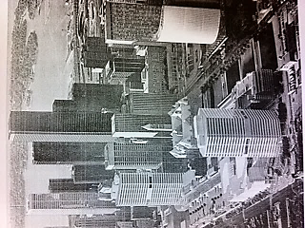
Image 42 Cadillac Fairview, Lettings Brochure, date unknown. View southward with the Yonge and Dundas entrance in the foreground, and the Old City hall in the centre of the photograph

Life in the City starts at the centre

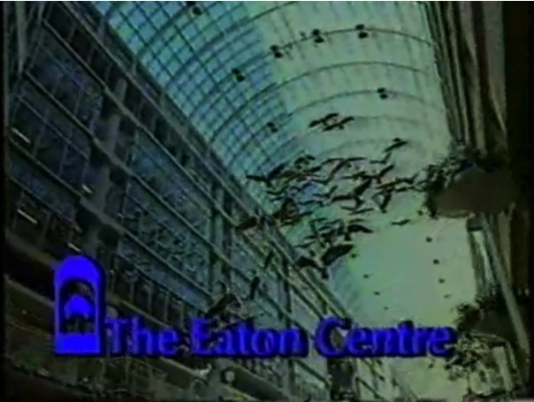
Image 43 Life in the City Advert 1983 via Retro Ontario

This section considers how the Toronto Eaton Centre was sold to customers as the centre of downtown life in Toronto. A series of television adverts which first ran in 1983 created an image of what life in the city can be like in the Toronto Eaton Centre. In these adverts, we are presented with a hyperreal image of the city. It is the simulation which exists before the reality of life in the centre is even experienced. Each advert is a simulated trip or a stylised shopping scenario. The Eaton centre is presented as a space in which one is free to enjoy the city, but there are cues and signals on how this can be done. It acts like a menu of leisure and shopping opportunities. The main themes in the adverts include the opportunity to buy the latest contemporary fashions, the chance to sample a variety of global cuisines, and the portrayal of the centre as the ideal location to meet with friends and just ‘hang out. The key elements of these adverts are that they present a highly sanitised version of city life filmed with the same production values as a 1980’s serialised television show. Amongst this series of adverts, one, encompasses all these elements. It focuses on all the shopping opportunities; not just the food, fashion or entertainment.

The essence of the mall that the owners want to create is encapsulated in a 30 second 1983 television advert with the slogan ‘Life in the City, Starts at the centre’. The advert opens with a woman in her twenties dressed in a fashionable clothing sporting a hat sipping a cup of coffee as she wanders through the ‘streets’ of the centre. This is the realm of the empowered female, who is free to shop whenever she wishes. The song opens with the following lines:

Wake up and meet a new day
Hear the song of the street

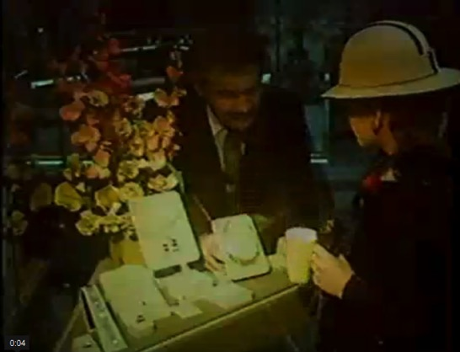
Image 44 At 0.04 the female shopper browses the Jewellery selection, behind the plate glass windows reminiscent of Benjamin’s Arcade
A female vocalist sings the first two lines of the song, before the tempo changes an upbeat tempo kicks in and a group sing the rest of the verse in a rousing style, with a key change brought in to enliven the finale two lines:

Life at the city
starts at the centre
Life in the city
starts in the Eaton centre
Life at the city
starts at the centre

At 0.07, the scene transitions with a clothes rack sliding across the screen to reveal a view of the internal mall of the Eaton Centre. The vast scale of the centre becomes apparent. This is not a traditional cluttered arcade of the nineteenth century. It is a vast open space of late capitalism. Between 0.08 and 0.15 tracking shots of the interior of the Eaton centre are flashed on screen planting the imagery of the centre and cementing a sense of place. At 0.15, a couple appear in the walkway that joins Simpsons to the Eaton centre. The man hands the woman a yellow rose, a sign of friendship, or maybe more as the woman smiles a knowing smile.

At 0.17, the woman from the start of the advert appears again in a different outfit, this time smelling some perfume before looking up at the flock of geese in the Flight Stop sculpture. At 0.20, we see another couple taking a seat at a restaurant table in the mall. At 0.21 we see a child release a helium balloon to the air. At 0.23 it flies past the face of the woman who was just smelling perfume and looking at the geese. As she leans over the railing of the upper level, her glasses fall off and land on the face of a man reading a novel on the level below. For a moment, the man thinks his eyes have stopped working so turns his book upside down, before realising he is now wearing a pair of glasses which have fallen from the sky. What is encapsulated in this section is the multi-level nature of the site. The shopper is given the freedom to transgress the street level and ascend to the upper levels. They are free to float upwards like a balloon, and here they can take in the vista, but must be careful not to become too engrossed and lose their eyeglasses over the edge.
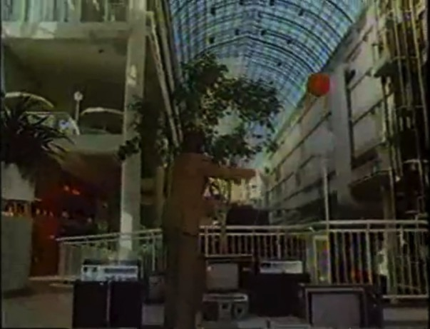
Image 45 0.24 secs View of Eaton Centre with Helium Balloon floating upwards.

At 0.24 a conductor appears and seems to be conducting the balloon in the sky, and cut to a child smiling. The ad closes with the image of the Eaton centre and the logo appearing in a graphical overlay.

Of all the adverts which were uncovered for the centre from this era, this is the one which focused on the actual physical layout of the mall. The mall became the stage for the story of life in the new centre of Toronto to be told. The multi-level nature of the centre is used as a prop in the advert. It is animated with the attempt at a humorous set-piece. This is the ultimate image of the postmodern city centre. The song of the centre sings to those who want to shop and browse and dream about what they will shop for when they finish working to pay for the items that they last dreamt of and paid for on their credit cards.

The marketing scheme was devised to attract retailers and it pitched the scheme in a manner to different types of retailers. Moderate priced store and chains were located on the lower levels and speciality shops above had been transformed into a series of identifiable spaces.

The Hyperreal City Street

The Toronto Eaton Centre which is being portrayed in this advert is similar in many ways to one of the pioneering spaces in creating a similution of an idealised version of urban life Main Street U.S.A. in Disneyworld Orlando, is a clear example of the simulacrum. A utopian simulation of small town America is encapsulated in Main Street U.S.A.. Whether it is in California, Florida, Hong Kong, or Paris, the recreation of an American Main Street is recreating something that did not exist before. Baudrillard refers to this state as hyperreality. Baudrillard explains how the universality of the simulacrum is becoming the expansive ‘alternative reality’. We have become assimulated into this reality in which Soja (1997, p 244) sumarizes as simulations that take on the:
…appearances and effect of material things and increasingly influence our everyday thoughts and actions: who we vote for, where we choose to live, how we fulfil our desires and needs.

Soja has captured the important factor that emerges in Hyperreality. That is the increasing influence of the appearance or image, and the effect of commodity fetish on our thoughts and desires. He signals how the consumption of the appearances and effects of material things are becoming a major element of the reality that we occupy. Elements of public life which can be traced back to the Agora in Ancient Greece have ceased to exist within the space of the shopping mall. It has been replaced with a privately-owned realm where the chance to mix with the mass and engage with the stranger and society in general tends to occur in spaces where the prime focus is on consumption and the commodity fetish. The hollowness of public life which Sennett (1977) identifies is the dreamworld of consumer capitalism where the citizen shopper is offered the chance to fulfil their wishes and desires in a consumption focused hyperreality. In building the dreamworlds of consumer society, the perceived risks and uncertainties of city life are replaced by the falsehood of the shopping mall. It is the spatial separation and ghettoization of the commodity fetish into spaces which are separate from the city. However, elements of the shopping mall began to be recreated downtown to reshape the urban reality it had usurped in the first place

Applying a veneer of urbanity

As one of the earlier examples of downtown shopping centres which espoused the place making principles of late capitalism, the Toronto Eaton Centre stood out as a new way of arranging downtown shopping. Part of the Eaton Centre Project envisioned by the design team Bregman & Harmann and the Zeidler Partnership was the Toronto Eaton Centre Art/Advertising Programme. This project involved the commissioning of Canadian artists to create advertising signboards in their own style and medium for the inside of the mall and the exterior of the building facing Yonge Street. The vision for the project was a ‘street gallery of Canadian art which would contribute to the ‘life in the City’ theme of the centre (Parkin, 1982 p. 67). This was an attempt to bring the city inside the mall. It was an effort to combine consumer capitalism with the signs and images of visual art and commercial advertising in the city. It is an attempt to re-appropriate the images of urbanity and arrange them in a sanitised consumer friendly version inside the mall. Along with the attempt to evoke the historical image of the covered arcade with the mass of buyers and sellers thronging in busy confusion, this project is also an attempt to apply a veneer of authenticity through the advertising and commercial imagery which lined the upper levels of the Toronto Eaton Centre internal Galleria and the Yonge Street Façade.

The Art/Advertising Programme was not funded by the owners of the Eaton Centre, instead it was self-financed by the advertisers. The advertising agent Morley A. Arnason and the consulting firm Art Collection Canada were tasked by the centre’s architects to commission advertising executed by Canadian artists. (Lambton, 1994 p.94). The advertisers paid to rent the space for 5 years upfront. At the end of the five-year lease, the advertiser had the option to buy the sign for one dollar. (Parkin, 1982 p. 67). Despite difficulties convincing advertisers to engage with the project, 16 advertisers eventually commissioned artwork. Canadian household names such as Shoppers Drug Mart, Lipton Soup and Royal Worcester where joined by Fisher-Price, Uniroyal, Toronto Dominion Bank, Red Cross, Cadillac Fairview, Timex, Coca-Cola, Technics, McGregor, Bata, Orrefors, and Fiberglas Canada. This project was an attempt to commoditise the built environment of the city. Adverts were created as original pieces, which had a unique aura, specific to the Eaton centre. The programme was an attempt to give the Eaton Centre a sense of authenticity as the centre of commercial activity downtown. It is the ultimate commodification of art in the age of mechanical production when the images advertising mass produced products are crafted to evoke a unique impression on the visitors to the centre. This evokes well-known urban brandscapes like Times Square in New York or Piccadilly Circus in London.

As the Eaton Centre attempts to reproduce city life, evoking the commercial imagery of the city outside, or what a city is perceived to be, it can only ever create a simulacrum of the boisterous reality of city life on Yonge Street. Benjamin (1936 pp 214 -218) explains how 'Even the most perfect reproduction of a work of art is lacking in one element: its presence in time and space, its unique existence at the place where it happens to be.' Parkin (1982 p. 67) outlines that’s ‘Historically the Yonge Street strip has been the rambunctious visually turbulent lifeline of downtown Toronto, to which the architect wanted to relate the building’s façade’. Bregman & Harmann and Zeidler Partnership re-crafted the Yonge Street Façade into their version of what city life should be; they also curated what version of city life would permeate the centre. The world of advertising would be embraced and given a highly visible location in the mall. In effect, the multi-story galleria would become a massive blank canvas which could be used to advertise to the visitors to the mall. The messages which were to occupy this space could be seen as agenda setting, or the spreading of a grand narrative floating above the heads of the happiness machines, waiting to be consumed.

To understand what is happening, as the Eaton Centre attempts to reproduce city life inside its own walls, we should consider where Benjamin (1936) argues that the "sphere of authenticity is outside the technical". He explains that the original artwork is independent of the copy, yet through the act of reproduction something is taken from the original by changing its context. The Eaton Centre usurps the ‘rambunctious’ street life of Yonge Street by dragging the commercial activity inside its realm and attempts to recreate aspects of the commercial imagery inside. It could also be said that the simulation of city life which the Eaton Centre was to become had to exist to before the reality of the street life outside could be interpreted, reflecting Baudrillard’s view of hyperreality. However, Benjamin highlights the quality the original has which the reproduction does not have. He describes this as the "aura" of a work and explains it is absent in a reproduction. This is easy to apply to a painting where the brushstrokes of an original painting cannot be recreated exactly by another painter. With the world of photography and digital imagery, the technology of reproduction makes it harder and harder to identify the unique aura of the original piece. Yet, the aura remains constant in terms of the unique presence the original has in space and time. This is easier to see in terms of spaces such as landmarks, buildings or city streets. The scale of these original spaces is too big to create an exact copy and they cannot occupy the same space, unless the original is destroyed and replaced by the reproduction. If we apply Benjamin’s perspective on the aura strictly, the Eaton Centre will never be able to recreate the aura of the surrounding streets because it cannot occupy the actual space and become it in the truest sense.

During the site visit in November 2010, the Art/Advertising Programme has been superseded by what appears to be an Advertising programme. During the fieldwork, there was no evidence of the project. The interior galleria of the centre was draped with two dimensional billboards advertising clothing brands such as Liz Claiborne, upcoming programmes on the Discovery Channel or mall promotions for the festive session. The scale of the advertisements ranged from 3-4 stories in height. Some of the advertising was taken up by tenants of the mall. The image below for the Apple iPad dominated the Yonge Dundas entrance to the mall, hanging on the wall between the entrances to Sears and H&M during the field visit.
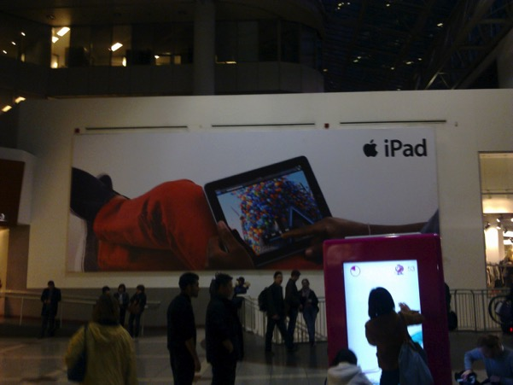
Image 46 North East Corner of the centre, the entrance from Yonge and Dundas.

What was an attempt to create recreate the visual imagery of the commercial core of a city has been replaced with high quality, high resolution, temporary or seasonal advertising for global brands? In the image above, a woman can be seen in the foreground interacting with a digital touch screen advertisement. The imagery of the advertising billboard blends into the background. However, during the fieldwork, there was the one aspect of the centre which was most photographed. It was the ‘interest point’ were visitors would ‘point and click’ their camera phones. The sculpture of the flock of Geese: Flight Stop, designed by artist Michael Snow

Flight Stop – Art in the City

This installation is comprised of 60 geese forming a sculpture known as "flight stop", epitomises all that the centre offered when it first opened and what it still espouses. The idea of space and freedom to roam, spread your wings and explore the city life as it is portrayed in the Eaton Centre. It has become the vivid holdable image (Lynch, 1960) associated with the centre for visitors to the centre and Torontonians alike.

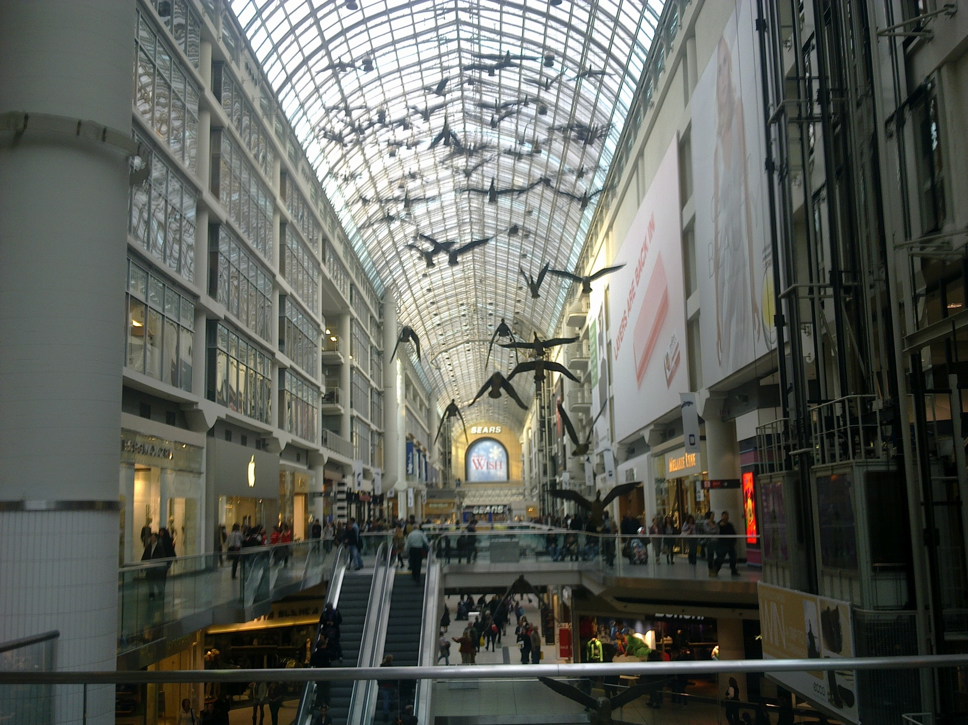
Image 47 Author’s own image taken 03/11/2010

Planning had begun to embrace the importance of the image in creating spaces which people wanted to come to from the 1960’s onwards. It was Kevin Lynch who offered the greatest insights at the time with his 1960 book The Image of the City. Lynch helps uncover the common mental pictures carried by large number of a city’s inhabitants which he refers to as ‘areas of agreement which might be expected to appear in the interaction of a single physical reality, a common culture, and a basic physiological nature.’ (Lynch, 1960 p.7). Kevin Lynch’s views on imageability in the city provide an insight into the way people understand and build ties to a space. Lynch defines this imageability as ‘that quality in a physical object which gives it a high probability of evoking a strong image in any given observer.’
‘Each individual creates and bears his own image, but there seems to be substantial agreement among members of the same group. It is these group images, exhibiting consensus among significant number, that interest city planners who aspire to model an environment that will be used by many people’ (Lynch, 1960 p. 7)

People flock to these spaces because there is agreement among many individuals that these are the type of spaces which it is worth spending time in. They evoke a sense of meaning in the lives of the happiness machines which travail their passageways. Lynch argues that the coherence of the image can emerge in several ways. ‘There may be little in the real object that is ordered or remarkable and yet its mental picture has gained identity and organization through long familiarity. One man may find objects easily on what seems to anyone else to be a totally disordered work table. Alternatively, an object seen for the first time may be identified and related not because it is individually familiar but because it conforms to a stereotype already constructed by the observer’ (Lynch 1960 p.6) It is this imageability which city authorities realise they need to embrace.

Flight Stop is visited daily by thousands of people. During the site visit, it was a vista that was continuously recorded by visitors with their cameras and smartphones. It is a sight which is synonymous with the centre. The installation is also associated with an important legal ruling on copyright in Canada. The artist, Michael Snow, initiated a civil suit in 1982 when the Eaton Centre’s Christmas decorators tied ribbons around what they thought of simply as the necks of the geese (Langford, 2014). Snow sued the Eaton Centre to have the ribbons removed from Flight Stop.

Snow won on the argument that his moral rights had been violated. The Ontario High Court of Justice (Snow v Eaton Centre Ltd 70 CPR (2d) 105, [1982] OJ No 3645) ruled that the decorations distorted or modified the work. The judge, J. O’Brien, agreed with Snow in his ruling on the 8th December 1982. He held that the sculpture's integrity was "distorted, mutilated or otherwise modified" which was "to the prejudice of the honour or reputation of the author" contrary to section 28.2 of the Copyright Act. In his ruling, Judge O’Brien said ‘I am satisfied the ribbons do distort or modify the plaintiff's work and the plaintiff's concern this will be prejudicial to his honour or reputation is reasonable under the circumstances’. The opinion was based both on the opinion of Snow as well as the testimony of experts in the art community. This was a precedent-setting case, settled some six years before formal recognition of moral rights in the 1988 amendment to the Copyright Act of Canada. The artist in this case was successful in resisting the attempts to distort his artwork to make it fit in with the consumer culture of the mall. In this case the autonomy of art was protected and re-enforced. It could not be co-opted by the mall owners to fit in with the festive shopping frenzy.

Attempts to brand the city, and the introduction of Business Improvement Districts (BIDs) or Business Improvement Areas in cities such as New York, Toronto, and Dublin, are examples of the way the city has tried to embrace elements of the shopping mall and apply them to a city, a neighbourhood, or a street. The work that has been done by private developers to encourage the shopper to visit the space, linger and spend money has been highly specialised. Private shopping spaces have become the life in the city where people go to spend their time outside work and home. From the inception, the project developers for the Eaton Centre wanted to recreate the image of downtown Toronto. They wanted to create a sanitised version of Yonge Street which would attract shoppers who had become used to the homogenised predictable experience of the enclosed suburban shopping mall.

We have reached the stage where the vivid holdable images of global brands have transcended geographical boundaries and cemented their place in a global consumer dreamworld What becomes clear is that there is a trend towards the conversion of our city centres into outposts or shop windows of a global capitalist system that are focused firmly on keeping people shopping, and ensuring that the economy continues growing. When people spend more and more of their time in these spaces, they may experience what Baudrillard described as ‘a lack’. This is the feeling of panic when the individual struggles to find authenticity amidst the placeless liminality of the contemporary privatised shopping agora. Global brands aim to recreate a uniform image to be consumed by shoppers all over the world. While elements of localisation may occur in terms of the language and cultural norms, generally the associations which the signs and images evoke tend to stay the same. The spread of privatised shopping agorae across the world had brought with it an imageability which encourages the people who visit these spaces to behave in a certain manner.

Expanding on the notions of Lynch, Jameson (1991, p.34) argues that the mental map of the city explored by Lynch can be extrapolated to that of the mental map of the social and global totality we carry around in our heads in ‘variously garbled forms’. In the spaces of Jameson’s ‘late capitalism’ or Baudrillard’s Hyperreality it appears that reality has been shaped to shape the desires of the ‘happiness machine’. Consumers may compensate for the chronic deficit of certainty in one way only: by pursuing the avenues laid out and made comprehensible by marketing and shopping (Bauman, 2001 p25). An image emerges of an ideal shopper who enjoys an ideal day and consumes the ideal goods in an ideal manner. It has become evident that the shopping mall is the key consumption space which can intervene in the construction of identity. It provides a regulated liminal experience. It is one, which is homogenized, consistent, predictable, and provides the ideal shopping environment in which to consume.

The replacement of the public street

The opening of the Toronto Eaton Centre was to have a drastic impact on Yonge Street. The impact it had on shifting retail off Yonge led to the increase in lower value uses along the street. The shift of activity which had occurred on the public street, inwards was symptomatic of a trend across North America in the growth of new types of private space. In the latter half of the twentieth century we see the massive growth of privatised spaces become more real and immersive than the reality they replaced. Gottdiener (1982) discusses this in his analysis of Disneyland as a utopian urban space. He explains how this themepark with its idealised representations of urban life can be seen as a spatial representation of a capitalist ideology. With a semiotic analysis of the site, Gottdiener proposes that it is a space which is at:
…the juncture of two separate semantic fields, one personal and the other specific to the social formation of late capitalism… this articulation is a mythical construct or hypostatization because space defined by capitalism is articulated by space as interpreted from the personalised referent of an idealised youth… Disneyland is overdetermined with meaning and mythical in form. No single interpretation can capture the symbolic experience of the park.

Here Gottdiener portrays Disneyland as the product of postmodern space building and the idealised notion of urban life possessed by the developer - Walt Disney. As a space, it is the personalised representation of a bourgeois ideology. What Disneyland offers is a private version of public life. Here the religious iconography of the Athenian Agora is replaced with the fairy-tale castle of Fantasyland and a cast of iconic characters such as Mickey Mouse. It creates a hyperreal version of America free of the problems of everyday life such as homelessness or traffic. Gottdiener (1986) discusses this further in The City and the Sign to explain that themepark is just one of the many spaces of late capitalism which emerge in the twentieth century where the focus shifts towards an overdetermined version of urban life.

Crawford (1992) describes the inauthentic nature of American urbanism and the spread of themed spaces throughout the country. As the number of regional malls reached saturation point in the 1980’s, Crawford identifies the emergence of the super-regional mall, which she describes ‘became catalysts for new suburban mini cities’ (Crawford, 1992: p 24). The West Edmonton Mall, which is in Edmonton, Alberta, Canada, opened in 1986 and in its present form contains over 850 stores and services and almost 12,000 parking spaces. Alberta, with its extreme winter temperatures needed a fully enclosed, climate controlled environment, which could offer the ideal conditions for shopping and leisure all year round. Jeffrey Hopkins has investigated this consumption space. He offers a description of the variety of attractions and facilities in this mall, which differentiate it from other shopping malls. It is the interior of this mall that makes it distinct.

While the exterior of WEM is a standard frame structure of brick with flat and galleria roof surrounded by four-lane roads and two-level parking garages, the interior is distinct. Mall attractions include a seven-acre waterpark, a National Hockey League-size skating rink, an 18-hole miniature golf course, a Fantasyland with triple-loop roller coaster, a four-acre sea aquarium with four Atlantic bottlenose dolphins, four fully operational submarines and a scaled replica of Christopher Columbus’s Santa Maria. There are also numerous exotic flora, fauna, and fountains, a ‘New Orleans’ themed streetscape, eight statues, 19 movie theatres and a Fantasyland Hotel with 360 rooms, 120 of which are modelled according to one of six-themes…
(Hopkins, 1990 in Wrigley and Lowe, 2002: p222).
For Hopkins, this mega mall is a prime example of the trend in North America towards specialized, self-contained built environments. The exterior is flat and indistinct. It could be on a highway on the approach to any major population centre in North America. It is the interior that is distinct. Inside is a hyperreal world in miniature. The visitor can have dinner in New Orleans before checking into the Fantasyland Hotel. No longer is the main focus to create a simulated climate in an air-conditioned fully enclosed mall, but it appears to be to create a simulation itself. This development is a step beyond the control of the weather.
The Mega-mall is ‘spectacle’ integrated into the everyday and open year-round… Built environments, which provide such specialised experiences’ go beyond two-dimensional illusion by providing three-dimensional theatre in which patrons are both spectators and actors (sightseers themselves are part of the show). WEM is neither merely disneyfied, nor Disneyland simply imagineered, both are part of a much larger set of processes, one of which is simulated elsewhereness
(Hopkins, 1990 in Wrigley and Lowe, 2002: p222).
It appears to be an attempt to control the realities that are created within the Mall. It is an attempt to make a suburban mall in Canada a simulated elsewhereness. The exterior or these spaces is not important, it is the reality that is created inside that is the key element of their success. The major difference between these ‘Mega-Malls’ and the other specialized built environments, such as the themepark and the world fair is that the mall is permanent and everyday yet, world fairs are temporary and amusement parks tend to be seasonal. These malls which evoke the sense of hyperreal ‘simulated elsewhereness’ focus on allowing the occupiers to retreat in the realm of pleasure principle. They help to propagate a consumer society in which a mass of consumers lives with the pressure to constantly generate new desires. The concept of ‘simulated elsewhereness’ highlights the importance of images and metaphors in contemporary society. Hyperreal spaces create something that did not exist before and they become more real than the reality that they represent. This is a useful insight into the construction of conceptual systems to which individuals attribute truths. It has been established how truths are always relative to a conceptual system (Lakoff and Johnson, 1980).
Architectural historian Margaret Crawford focuses on the growth of the shopping centre in Britain. In line with Baudrillard, Crawford expresses similar criticisms of this trend. She argues in Susan Marling’s (1993) book, American Affair: The Americanisation of Britain, that:
Shopping malls, Disneyland, television, are all examples of the new range of hyper-reality - the falseness that is better than the reality. Reality always has its detrimental aspects like crime, homeless people, and dirt.
(Crawford, In Marling, 1993 p. 27).
Both Crawford and Twitchwell (1999) have identified a space, which is private and controlling in both a physical sense, and a psychological sense. Twitchwell mentions ‘Eden’ suggesting that these spaces aim for a utopian goal, far removed from reality. The West Edmonton Mall (WEM) is a response to all these factors and more. It creates a Super-Regional Centre, which aims to create the ideal shopping experience in part of the world where the weather does not suit open air shopping all year round. The Toronto Eaton Centre was a response to these trends towards privately managed urban spaces. The centre created an enclosed, hermetically sealed version of the main shopping street, immediately adjacent to it. This ‘simulated elsewhereness’ with its multi-storey galleria, and redefined what ‘life in the City’ would be for Torontonians.
After the Eaton Centre opened, Yonge Street regained its pedestrian traffic, and there were more pedestrians along the west side of the street than there had been before. The problem was on the east side. While the east side of Yonge Street had had a number of nice stores and restaurants that were all eager to take advantage of the attraction that the Eaton Centre created, speculative developers bought the properties and didn’t renew the leases of the existing tenants. The developers needed second-rate tenants who were willing to vacate these spaces at the drop of a hat, as soon as their premises were needed for the construction of a new building. Unfortunately, there is no law in Canada that forces a building owner to maintain the street front in a pleasant way. Over the next thirty years, this resulted in the demise of the east side of Yonge Street north of Queen, and the Eaton Centre was blamed. (Zeidler 2013 p.178)

Although the exterior walks and balconies were designed for public use on the Yonge Street Facade, it was observed that ‘people tend to stay inside, so that some shop owners with doors on the mall and on Yonge prefer to keep the Yonge entrances closed’ (Dendy and Kilbourn, 1986 p. 293). The attempts made by the planning department and the architect Zeidler were soon redundant. The exterior walkways were removed and the Yonge Street façade slowly turned its back on the street.

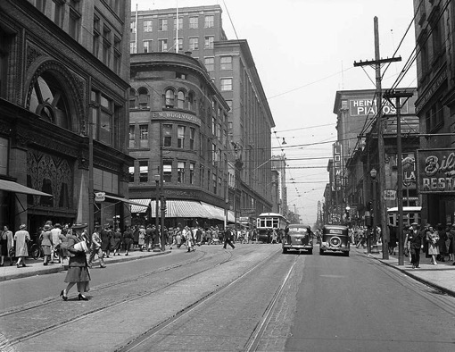
Image 48 City of Toronto Archives Fonds 1257, Series 1057, Item 56. In this image, we can see three department stores on Yonge Street. On the left side of image (west side of street), Simpsons (Now The Bay) is in foreground, Woolworths is in middle ground and Eaton's is in background. (Public Domain)
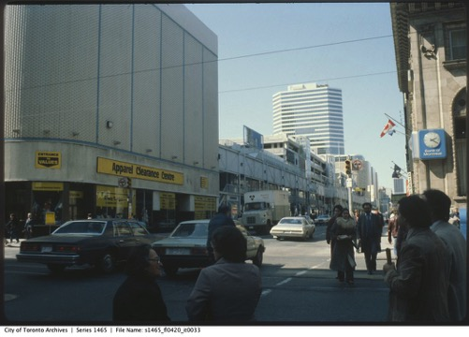
Image 49 : Post 1977 image of the Eaton Centre, The Former Woolworths store can be seen in the left of the image. City of Toronto Archives

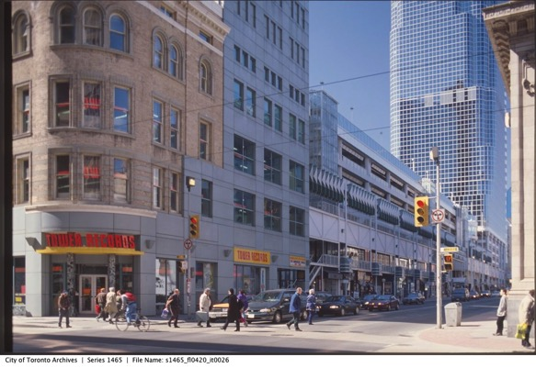
Image 50 This image from the City of Toronto Archives is undated but appears to have been taken in the early 1990’s before the alterations were made to the Yonge Street façade and the removal of the external walkways and entrances. The blank 1970’s façade of the Woolworth store has been replaced with a postmodern blend of the original Nineteenth Century building with late twentieth century addition.
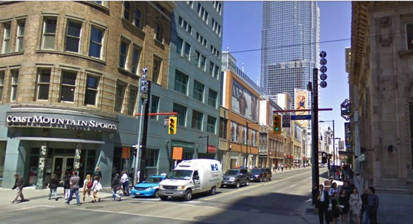
Image 51 taken from Google Streetview 2012 shows how the Yonge Street Façade has changed over the period. Woolworths closed in the 1980’s and a number of different tenants have occupied the space since.

In the images above we can see the evolution of the Yonge Street Façade over the twentieth century. The first image is undated, but appears to be taken in the 1930’s. In this photo, we can see the Eaton’s store in the centre background. The frontage is more varied and resembles other main thoroughfares of the era, with a mixture of uses and activities providing a vibrant streetscape. The second image shows the site post 1977; the exterior walkways and balconies can be seen in the centre of the photograph which were designed to maintain an active frontage on Yonge Street. The next two images show how subsequent developments and revisions to the centre saw the removal of this active frontage and its replacement with blank facades covered in pseudo windows and advertising signs.

These four images show the changes which have occurred on the Yonge Street Façade over the century. The changes which occur also demonstrate how the focus moves from the street into the Eaton Centre. In the initial designs and in the early years of the mall operation attempts were made to keep the frontage active with passageways and aerial walkways but these were eventually eliminated to provide a pseudo blank building façade which could be covered in advertising. The Eaton Centre Yonge Street facade went from a real building façade in the form of Eaton’s Store, to a contrived one, in the form of the open walkways of the early Eaton Centre, to a blank mass of what Koolhaus might refer to as Junkspace, with faint references to the traditional urban grain and a veneer of urban authenticity. The debates that emerged in the development of the Eaton Centre present themselves in similar developments across the world.

The malling of America drove the emergence of Neo-liberal city. The city had to become more like the mall to compete with it. In Toronto, the result was the transplantation of the suburban mall to downtown. This had an impact of the public street with the shift of activity into these enclosed, privately managed simulations of city life. The Toronto Eaton Centre became a Privately managed, publicly accessible space. This is a key factor in the site. It was to remain open 24 hours a day. Anyone could enter if they obey the rules of the private security force.

Chapter Six: The Suburb exteriorised in the City

The Neoliberal City is characterised by an ever-increasing impetus to re-invent, re-imagine, and re-position itself to attract private investment. This phenomenon can be identified in the revitalisation programmes instigated for public spaces such as the squares, plazas, and streets, but it can also be observed in the rebranding and refurbishment of privately owned spaces such as the shopping mall. This chapter will first consider how Yonge Street and the Yonge Dundas intersection, came to be in need of revitalisation. It will discuss the economic and political impetus that resulted in the creation of Yonge Dundas Square, a privately managed public space in the heart of downtown Toronto. As a space, it emulated many of the characteristics of its neighbour, The Toronto Eaton Centre and there is clear evidence that the Yonge Dundas development was an attempt to encourage patrons to venture beyond the mall and into the city. Following this a consideration will be paid to the changes that were made during a major revitalisation project that the owners of the Toronto Eaton Centre undertook 33 years after it had first opened. It will assess the motivations for the revitalisation and analysis the data gathered from the fieldwork which was carried out while the refurbishment works were in progress.

Recession and the influence of Neoliberal policies on Toronto

The decades between 1970 and 1990 mark a period of significant restructuring in the Toronto area and in the Canadian economy in general. Toronto had become a centre for global finance with a shift of banking and insurance jobs from Montreal in light of attacks on government and financial organisations attributed to the Front de libération du Québec, a paramilitary organisation in support of the Quebec sovereignty Movement. Along we this, we see the signing of the Canada-US Free Trade Agreement (FTA) in 1987 and the North American Free Trade Agreement (NAFTA) which came into force on January 1st, 1994. These transnational trading agreements opened the Canadian economy to cheaper imports. With increasing importation of goods from Mexico and the United States, there was a speed up of the transformation of the Canadian economy towards a post-industrial base. The processes of deindustrialisation, which Todd (1993) describes with specific reference to Toronto, involved ‘sectoral shifts in economic activity, rising unemployment, and speculative, finance-based forms of accumulation’. Economic events which centre around Black Monday in 1987 and the bursting of the Housing Bubble in 1989 led to a significant recession in the Canadian Economy. This recession was felt particularly hard in Toronto and Downtown Toronto. Office towers were left uncompleted and many retailers shrank in size or went bankrupt. (J.C. Williams Group, 2016 p.2). With the increasing de-industrialisation of the city of Toronto and falling levels of employment in the downtown area, the city development plan - Cityplan ’91 outlined a commitment to intensification of the urban landscape and this would require that the city be sanitised for middle class consumption cultures and made more attractive for private investment.

The City of Toronto was deeply affected by the economic restructuring that took place between 1989 and 1994. This is an era marked by the decline of the Municipal City as it retreated from the lives of Torontonians. Welfare rates were cut and there was an increased presence of pan-handlers and due to cutbacks in terms of mental health provision, there was a visibly noticeable increase in the number of people displaying symptoms of mental illness on the streets due to deinstitutionalization policies which were not matched by community care. (Moore Milroy 2009 p. 44). It was not only the strip joints and body rub parlours for which Yonge Street had become synonymous for since the 1970’s, but the rise in visible homelessness became undesirable to middle class eyes. In the 1990’s two youth shelters and a shelter for homeless men opened within two blocks of the Yonge Dundas intersection. Federal government funding for all social housing programs had been stopped and homelessness became an increasingly visible phenomenon and more panhandling and loitering than had likely been seen in Toronto since the 1930s

By the mid-1990s Yonge-Dundas became a microcosm of the impact that austerity was having on Toronto. The impact of austerity could be seen in this public space from cut backs in social protection. This presented an image of the city which did not fit in with middle-class consumer culture. Moore Milroy (2009 p. 44) in her study of the development of Yonge Dundas square outlines the dominant perspective which had emerged of the site by this period as ‘a picture of a rotting heart that could be, and indeed had to be, repaired to keep the city from collapse, from presenting a poor image to the world, and from unsustainability’ This notion of the site as the rotting heart of downtown became an allegory for the perceived deterioration of Toronto.

There was a perspective that redevelopment was not happening because the area was so ‘down-at-the-heel’ Moore Milroy (2009 p.45) and this was discouraging investment. Investors were put off by the reputation that the area had garnered for strip joints and sex stores. This image contrasted sharply with the sanitised, family friendly environment that existed inside the Toronto Eaton Centre. The Toronto Eaton Centre had drawn activity inwards, away from the street. For decades, since the Yonge Street Pedestrian Mall in the early 1970’s, there has been concern over the Yonge Street Strip. It had developed a reputation for being a space for the expression of youth cultures. This shaped how older adults perceived the street. ‘Older adults have worried about its influence on their children at least since hippie youths hung out there in the 1970s, followed by punk youths in the 1980s and hip-hop youths in the 1990s, always with a certain amount of drug use and trade happening.’ Moore Milroy (2009 p.45). Whichever narrative one is to embrace, the area suffered in comparison with the Toronto Eaton Centre. The physical realm was in poorer condition and it did not encourage shoppers to linger in the same way that the Toronto Eaton Centre did. This was one of the busiest street corners in the country in terms of pedestrian traffic yet it was suffering from an image problem. It was widely agreed that a planned solution was needed. Efforts made to fix up the area over more than two decades were judged to have had little effect. Yonge Street needed to be sanitised for middle class consumption cultures. During this era, there were also changes occurring in terms of how the city was governed and a shift in approaches in how the city was planning

Urban Planning to Urban Development Services

From the mid-1990s, the key trend that can be identified in terms of urban planning and municipal politics is a shift towards private management of the city. This manifested itself in a multitude of forms through Public Private partnerships, QUANGOs, and in the shift from Planning departments, towards a new model of Development Services departments. When Yonge Dundas Square was being developed a range of options were considered for its management (Moore Milroy, p. 194). Initially the planning department was not recommending public private management for the square. However, many political and structural changes would occur in terms of local government amalgamation and re-organisation of the planning authority, which had an impact on the outcome. In mid-1995 a newly elected provincial government led by Mike Harris, came to power which promised to fix Ontario’s economy via huge tax cuts, the reduction of social programs, and the introduction of workfare and law-and-order measures. During what was referred to by Harris and his proponents was a ‘common sense revolution’, the new government sought to reduce the number of local governments and their range of activities. This approach to New Public Management which has its roots in Thatcherite Britain was applied to both local governments in terms of amalgamation, and to the departments within the municipal structures within.

It is during this era that Toronto is consolidated into what Kipfer and Keil (2002) term the “competitive city.” They explain that this emerged because of the ‘impasse of post-war metropolitan planning in the early 1970s, the socio-spatial limitations of downtown urban reform politics in the 1970s and 1980s, and the neoliberal restructuring and rescaling of the local state in the 1990s.’. By 1996, the city of Toronto was facing legislation to force its own amalgamation with five adjacent cities. This would see the abolition of the metropolitan level of government, which had been in place for forty-five years. The metropolitan government had been credited with contributing to the Toronto region’s incorporation of rapid population growth while maintaining a healthy city core, unlike many US cities (Frisken 2008). In spite of opposition from the local governments, and elected representatives, amalgamation finally occurred in 1998. The regional municipality of Metropolitan Toronto and its six constituent municipalities – East York, Etobicoke, North York, Scarborough, York, and the City of Toronto (1834) were dissolved by an act of the Government of Ontario. A new single municipality called the City of Toronto was formed to take the place of all seven governments.

Public v Private – neoliberal urban planning

In line with the goals of the reform government of Ontario, the principles of New Public Management were applied to the Planning and Development Department of Toronto. It was renamed Urban Development Services in September 1996. The title is signalling a move away from the strategic element municipal influence of the planning department on the future of the city. Instead it is signalling a move towards the development services model, that the planning department should be there mainly to attract and facilitate private development. This renaming occurs during a shift in political strategy and perspectives in the city. This change in direction is common across the world as the influence of Entrepreneurial Planning which focuses on encouraging private investment by making the city as attractive as possible to private capital.

In Toronto, one of the clearest way this manifests itself is in the removal of oversight of the creation of Yonge Dundas Square from the Planning department to the Economic, Culture and Tourism Department. The result of this shift was an increased impetus to harness spaces like Yonge Dundas square for commercial use. A new governance model was to be applied to the square. The project site was turned over to private-sector redevelopment interests to make Toronto more competitive in comparison to other cities; processes were largely kept away from public scrutiny, and the so-called public square ended up promoting private consumption. An important role was played by Ron Soskolne, who had been involved with the revitalisation of Times Square in New York. He had longstanding connections to Toronto having been the City's Chief Planner at the time the 1976 Central Area Plan was drafted. Soskolne was also the principal witness for the City at the Ontario Municipal Board (OMB) hearing for that plan. From 1979 to 1991 he was with Olympia and York Developments Limited and attained the position of Senior Vice-President, Planning and Development which saw him become significantly involved with the 42nd Street Redevelopment Project in New York City and the reinvention of the Times Square Area. Soskolne’s experience with the revitalisation of Times Square was to be one of the key influences on the path that the redevelopment would take.

Planning framework and the emergence of Yonge Dundas Square

The 1976 Central Area Plan for the City of Toronto reiterated and reinforced the area of Yonge Dundas as a Prominent Retail Street in the downtown area. It also recognised that this area was a major focus of retail in the Toronto Region. Although this area is in close proximity to the high-rise development in the financial district south of Queen Street, and the fact that it was served by a subway station, the area Yonge Dundas area was designated with a relatively low density. This approach to zoning was repeated in the subsequent plan. Cityplan '91 reiterated the 1976 designation for the Yonge Dundas intersection, as a Priority Retail Street. The Plan maintained a low density mixed use designation on the east side of Yonge/Dundas.

The ground work for what would become Yonge Dundas square was laid out in Cityplan '91. It included an expansive set of policies in Chapter 15 to governing what had been referred to as Community Improvement". The influence of commercial lobbying on the designations in Cityplan ’91 were explored in the report produced by the Ontario Municipal Board (OMB) on 5th June 1998 on the Yonge Street Regeneration Project Decision and Reasons for Decision. This report was described as
In the matter of an application by the City of Toronto in respect to the expropriations approval process and the planning approval process regarding certain zoning by-laws, an official plan amendment and a community Improvement plan respecting lands in the vicinity of Yonge Street, from Queen Street East to McGill Street.

A growing number of downtown business representatives, property owners, residents and concerned citizens began to express grave concern about changes occurring in the downtown area. During the consultation for Cityplan ’91, T. Eaton Company Limited made a submission which indicated that the downtown's market share of the consumer goods market in Greater Toronto Area had dropped to 6% in 1992 from 25% in 1971. In addition to requesting modifications to the official Plan, the T. Eaton Company Limited also requested that the City establish a task force 'to monitor the economic and social vitality of the City's downtown and to develop and initiate a strategy to deal with real and perceived problems in the downtown'. In addition, the Planning and Development Department had been contacted. After considering the Official Plan amendments, to the proposed CityPlan ’91, the Council accepted that pro-active action also needed to be taken to stem the Downtown’s decline. This was based on the fact that between 1988 and 1992, the central core lost over 43,000 jobs, 4,200 of which were retail. This represented a 20% decrease in the central core’s retail employment (J.C. Williams Group, 2015 Appendix C p. 18) The City laid out the objectives which and policies which it was committing itself to. In Chapter 15, the general policies and actions are laid out
In order to enhance the social and economic well-being of its citizens, it is the policy of Council to maintain and improve the public amenities in the downtown, the waterfront, and the residential neighbourhoods, to ensure the vitality of commercial areas of the City, and to retain, develop and strengthen the City's industrial base. Accordingly, Council shall initiate and develop programs and activities and make use of programs of other levels of government, its own funds, and private sources of funding to encourage improvement and renewal in all areas of the City.
The council is not only stating a commitment to urban renewal in all areas of the City, it is stating that it is willing to use a mixture of public and private sources of funding to meet this policy goal. This is signalling a willingness to engage with the private sector to maintain and improve the public amenities downtown. The plan breaks these policies down into specific objectives in terms of community improvement.

OBJECTIVES OF COMMUNITY IMPROVEMENT PROGRAMS AND ACTIVITIES
In improving the quality of life in the City for residents, workers and visitors, Council shall undertake community improvement programs and activities in accordance with the following objectives:
- to improve the amenity, appearance, safety, and environmental quality of all areas of the City;
- to provide and maintain a system of public open spaces that offers a broad range of outdoor social and recreational opportunities of both a passive and active nature;
- to promote and stimulate private sector initiatives which will create employment and generate an improved municipal tax base in ways which are consistent with the City's economic development strategy and other policies;
- to improve employment opportunities.
These objectives are laying out the framework for the shift towards the privatisation of public space within the Neoliberal City. The City is accepting its responsibility in providing public open spaces but it also accepts that it will help to promote and simulate private sector initiatives. In order to this, the specific measures that can be used are outline in section 15.2
MEASURES TO BE USED BY COUNCIL
- use its capital budget to promote the objectives set out in Section 15.2
- co-ordinate its land use planning and economic development activities with the implementation of improvement programs in all areas of the City;
- co-ordinate efforts to improve the City's physical and social infrastructures with ongoing efforts to optimize the use and comprehensive maintenance of existing services and facilities;
- undertake activities and programs in concert with other public, private and voluntary sector initiatives that would complement or supplement its own actions;
- where possible, utilize public, private, and foundation funding sources;
- seek the participation of affected parties in the planning and implementation of any improvement scheme;
- provide resources, organizational support and advocacy assistance 'for private and voluntary sector improvement efforts deemed to be in the municipal interest;
- designate community improvement areas and prepare community improvement plans, pursuant to Section 28 of the Planning Act, as amended or re-enacted from time to time, having due regard for Council's goals and objectives as set out elsewhere in Parts I and II of this Plan.

The measure to provide resources ‘for private and voluntary sector improvement’ is the section that covers what will become of the Yonge Dundas Square redevelopment. These measures would help to turn Toronto into the competitive city by mixing public, private, and voluntary action to provide an efficient and responsive approach towards revitalising the core. The City Council also requested that a Downtown Task Force be formed which resulted in the creation of the Yonge Street Improvement Committee (Executive Committee No. 21 Clause 25, adopted by Council Sept. 26 and 27, 1994). The Yonge Street Improvement Committee spun into a major multi-pronged revitalization effort led by City Councillor Kyle Rae. The Downtown Planning Section coordinated the program. In Economic Development, there was the creation of a major year-long program of events and publicity to commemorate the bicentennial of Yonge Street in 1996 (200 Years Yonge), and they developed streetscape improvement concepts and a redesign of the Yonge Street frontage of Eaton Centre to increase sidewalk animation, and the eventual formation of the Downtown Yonge Business Improvement District.

Following on from the initiatives and measures outlined in the development plan, the Planning authority was to play a central role in the formation of a plan for the re-development of Yonge Dundas Square. As different interest groups became involved and there was an increasing shift towards neoliberalism, the formulation of the plans became a battleground for struggles for political authority and legitimacy. In 1996 two solutions were proposed: a gentle regeneration-style solution was approved which would have seen the local authority lead with a incrementalistic approach. However, this was superseded nine months later by a significantly more interventionist proposal which involved the expropriation of land and the more invasive redevelopment proposal (Moore Milroy, 2009) This resulted in a struggle between competing interest groups as planners were pitted against planners: the city used in-house and contract planners and a coalition of area business interests to oppose another set of business interests equipped with its own contract planners, economists, and land evaluation experts.
Because there were two plans from the same planning department and from some of the same planners for the same geographic space in overlapping time periods, their foci and rationales can be compared. In the transition from one to the other, we see the position in which the planning department found itself after having been politically forced to reassess its first, gentler strategy. The routes open to the planning department seemed to be as follows: (1) to refuse the new, more aggressive model and be side-lined while the planning framework was operated without the planning department; (2) to strongly make a case for why the new approach was wrong and then, if the city council still insisted on going ahead, to do the best planning job possible by trying to avoid the worst outcomes; or (3) to be persuaded to go ahead with it, either because the department saw no alternative or because the second proposal was the better strategy. Regardless of whether it was in its better judgment, the planning department took the third route, at least publicly. Because it chose the third alternative, the planning department had to formally defend it when an appeal was launched.

The planners were being co-opted into the drive that was occurring throughout the rest of the municipal government, toward an entrepreneurial/competitive/common sense approach to a complicated urban site. This was also evident in the approval process that the Plan underwent. At the Ontario Municipal Board hearing on the Yonge-Dundas proposals, the professional experts were regarded as the ultimate source of what is best for Toronto.

At the OMB hearing on Yonge-Dundas, through their professionalism, experts enjoyed the authority to define what constituted good planning. They also had the authority to define who constituted the public and what was in their interest. In applying this authority, they connected the vision of the secure, consumer, and aesthetic city to the conduct of particular groups to whom, they argued, Yonge-Dundas belonged
(Ruppert, 2006 p. 184)

The proposed redevelopment was held up as ‘harbinger of whether Toronto would be world-class or ordinary’ Moore Milroy (2009 p.45). Not only was the private sector was being handed over the lead role in the redevelopment of a strategic city site, the planning professionals involved with the plan were able to define a vision of the city which only served members of the public who could engage in middle class consumer culture. As the City stepped back, it would allow private developers to reap the rewards of property value increases.

Timeline of the development of Yonge Dundas Square

Yonge Dundas Square is located at the southeast corner of Yonge and Dundas Streets. The Square is surrounded by several redevelopment projects featuring major retail and entertainment uses. It was designed by Brown and Slarey Architects in 1998 after a design competition was held to choose the final scheme. It is located on top of a 250-space parking facility operated by the Toronto Parking Authority. The Square is not operated like other Civic Squares in the city such as Nathan Phillips Square. Instead of directly managing the square, the City Council installed a Board of Management to operate Yonge-Dundas Square as a business venture. The first Board of Management for the Square was appointed in 2001. This is in line with the corporate approach to managing public services as citizens come to be classified as the consumers of public services that Hood (1991) first identified in the New Public Management.

Figure 2 Adapted from J.C. Williams Group Appendix D p.4-5

The square opened to the public in November 2002 with a sneak preview of one of the Square’s key design elements – an illuminated spectacle of twenty fountains (Yonge-Dundas Square, 2016). This was followed by its official opening in 2003. The main entertainment venues did not open for another 4 years. In 2007 10 Dundas St. E. opened anchored by the large AMC cinema, restaurants, a food court, and a variety of retailers. It has a direct connection to the TTC subway network. The question which emerges at this point, is who is this publicly owned square for, and is it geared only to one type of public, which consists solely of people who can afford to engage in the consumer society and willingly do so.

What is public space?

By highlighting what makes a public space successful, it helps us to understand how public space is defined. When a space provides citizens an opportunity to engage in a shared activity, experience, or ritual it succeeds in fostering and strengthening public life.

When public spaces are successful […] they will increase opportunities to participate in communal activity. This fellowship in the open nurtures the growth of public life, which is stunted by the social isolation of ghettos and suburbs. In the parks, plazas, markets, waterfronts, and natural areas of our cities, people from different cultural groups can come together in a supportive context of mutual enjoyment. As these experiences are repeated, public spaces become vessels to carry positive communal meanings».
(Carr, Francis, Rivlin and Stone, 1993, p. 344)

Spaces which facilitate this type of mutual activity act as spaces beyond the private life of the individual where they can feel a connection to the world beyond their individual. From a more architectural perspective, Civic place making, as Peter Rowe (1997) describes it, requires both publicness for democratic reasons and aesthetic appeal for a wide range of people. A civic place belongs to everyone and yet to nobody. Rowe argues that the best civic place-making occurs across the divide between the state and civil society. This type of space occurs in the divide between state-sponsored authoritarian edifices and privately-owned enclaves of corporate-dominated urban and suburban environments. Although a space can be owned by nobody in particular, in many cases it does not belong to everyone. There will always be those excluded from the space due to social isolation or social distancing by the majority.
A stated goal of the redevelopment of Yonge Dundas Square was to increase the variety of people using the area; however, the mix was already broad and reflected the diverse population that were both visiting and who made Toronto their home. The project was designed to flatten the mix to a target group of consumers who would spend money in the space.. PenEquity Management Corporation (2002) describes their vision for the site as a space ‘where you and your family can enjoy the best Entertainment, Restaurants and Eateries and Retail while never having to leave the property site… Whether it’s the Suburbs or the City, you’ll always find PenEquity’s Entertainment properties and tenants will always have families enjoying the experience time and time again’. PenEquity, the developer of the urban entertainment centre at Yonge-Dundas, aims to create a predictable family friendly space in the heart of the city which provides the consumer with the same experience as that in their suburban locations. There was a concerted attempt to limit and re-define what type of public this space was for and who belonged here.

Middle-class tourists and suburban consumers were also constituted as part of the public who belonged at Yonge-Dundas. As previously noted, proponents argued that Yonge Street was stagnating as a retail environment in contrast to expanding suburban shopping areas; furthermore, the area was not keeping up with the investment and regeneration initiatives underway in other major North American tourist centres.
(Ruppert, 2006 p. 189)

The main goal of the Yonge-Dundas redevelopment was to increase consumer spending by attracting the right kind of public to the area. Ruppert explains that the re-development of Yonge Dundas saw the re-invention of the public square for consumers who were more familiar with the predictable, consumption focus reality that existed in the enclosed mall. It is difficult to avoid the conclusion that the ultimate aim of both the developers, city authorities and local businesses was for increasing the number of people with disposable incomes to spend, to visit the area and discouraging the presence of anybody who interfered with this reality. This included homeless people, or those working in the sex or drugs industry, or persons engaged in activities which were not focused on consumption. The reason for this is intrinsically linked to the neoliberal policies that the City of Toronto embraced. In the creation of Yonge Dundas, the City of Toronto retreated from providing municipal services such as public spaces for citizens to gather and handed responsibility to a board of the City of Toronto who is tasked with operating the square for profit.

Exteriorising the Mall – creating the ideal brandscape and shopping space.

Place-making components were a key element of the plan for Yonge Dundas as the designers and property owners sought to create a branded space which was attractive to middle class consumers. Huge screens hang on almost every surface around the square, advertising products, services, and lifestyles. There is a programme of spectacular events which periodically fill the square with a mixture of activities from concerts, to ice rinks, to product demonstrations. The activities in this Public Square was controlled and programmed by a board whose main aim is to run the square for profit. Yonge Dundas is a simulation of what a successful urban square should be like constructed to encourage those who visit to spend in the entertainment facilities and the retailers which lined the square. During the site visit in November 2010, the square had been turned over to Microsoft for the launch of their Kinect gaming device. All imagery was directed to the creation of an immersive and at time overwhelming spectacle of consumerism
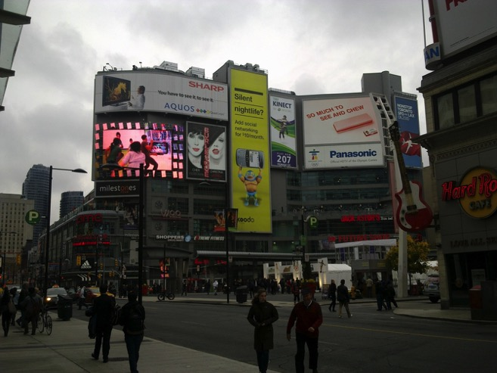
Image 52 Yonge Dundas Square looking North. The building frontages facing the square were emblazoned with supersized advertising billboards and large L.E.D. video screens. The site is a simulation of other famous city centre spaces such as Times Square.

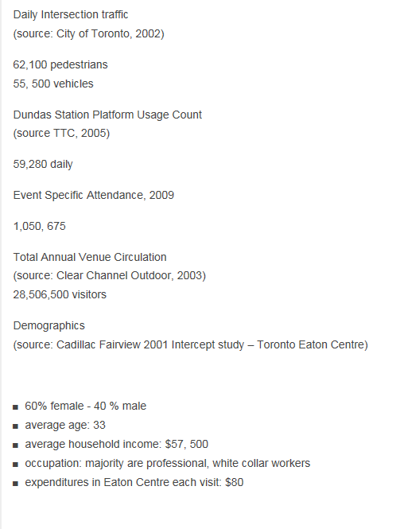
Figure 3 `Demographics of visitors to Eaton Centre and Yonge Dundas Square
http://www.ydsquare.ca/all-about-the-square/who-uses-the-square-demographics.html (Last Accessed 31st July 2013)

In Yonge Dundas Square, a simulation of public life is evident, or being created and shaped. That which appears public, yet is private, and has been crafted to influence occupiers to behave in a certain manner. The square has a neatly presented package set of demographics which can be gleaned from its website Figures given from the website break down the target market. It is a managed space with the illusion of publicness. The advertiser can measure how many of their target market will be passing through or near the square and the potential of attracting them to the space to encounter their product or service.

The open air privately managed shopping agora is not a space where occupiers lose total autonomy, but a space where certain behaviours are encouraged over others. These types of spaces could be considered as an immersive instruction manual that has emerged in the city to tell us how to experience Urban life as the ideal consumer citizen These spaces guide us or offer the possibility to experience the city in a certain way. They do not remove our sense of autonomy, yet they encourage us to recreate a certain type of experience. The reason that this is of concern to us is because there is an increasing veneer of publicness prevailing throughout our towns and cities since the emergence of the first mall

This trend is occurring across the world. There are many other cases where the shopping mall has spread out beyond the confines of its own walls, automatic doors, and service entrances, to spaces which have become the city. Other examples include the Horton Plaza in San Diego, or more recently, Liverpool One, Victoria Square Belfast, Opera Lane in Cork, Ireland, and One New Change in London show that the mall no longer needs to be fully enclosed. The manifestation of this hybrid public space is recreated in these highly regulated controlled imitations of the traditional city street. What emerges is a dialectical image of the type of publicness that is increasingly becoming part of towns and cities across the world.

In the arcade, the flaneur reflected on their relationship with the dreamworld with a sense of distance. In the suburban enclosed shopping mall, the happiness machine relates to the dreamworld by aspiring to the good life they are programmed to desire. In the post-modern shopping mall, a hyperreal simulation of the arcade and city life, offers the individual the chance to experience a carefully choreographed and sanitised version of city life. We need to consider what impact the open public space which has the appearance of publicness but which is privately managed and controlled to create a shopping agora in the heart of downtown. The mall has spread beyond its walls and become the city. The city is becoming like the mall. It attempts to achieve or replicate the aura of downtown shopping and contemporary consumer capitalism. It has to run to stand still, before it too becomes irrelevant. All the time these spaces strive to become the ultimate representation of the dreamworld to those who visit it. It is the making real of the shared dreams and goals of society. It is a place outside the home, where they are encouraged to dislocate themselves and experience a public activity.

The traditional public spaces of urban life such as the street, the square, or even the academy, are becoming increasingly dominated by privatised spaces with the illusion of publicness. The shift from the mall as a world in miniature to a space which is exteriorising and sucking in the space around it can clearly be seen with Eaton Centre and the surrounding areas. We see this on Yonge Dundas Square. Here a privately managed space is sprinkled with a veneer of publicness. The walls and buildings have been taken down, but invisible rules and functions remain for this space. Privatised forces which controlled the mall now control also control the public space.

Yonge Dundas square, like Potzdamer Platz in Berlin imparts the impression of being a public space but is managed privately and given over to the phantasmagoria. It is arranged to encourage consumption activities, and discourage activities which do not fit in with this narrative. The only seating provided in this square is for patrons of the food/coffee kiosk. This is a large open space in a city of millions of people which is an instruction book on how to sing along with the consumerism of contemporary society. The techniques used in the mall to encourage the consumer to consume have been replicated in this space with the aura of publicness. And the idea of aura is important here too. Yonge Dundas square is a simulation of city life. It is an attempt to get closer to the aura we associate with Times Square and other major commercial centres around the world. The electronic billboards and signage bombard the customer with images and brands. The impression given is that this is the centre of commercial and cultural life in downtown Toronto. Yet, it is no more than a phantasmagorical mecca of global brands in an open-air shopping agora which has the outward characteristics of public space. It is hollow and devoid of meaning beyond a hyperreal version of what city life should be in the twenty-first century.

Spaces with the appearance of Publicness

The control of the spaces where we gather and mingle in the contemporary city is increasingly being given over to private developers, property managers and autonomous public bodies. Control is being forfeited by planners and local authorities and handed to non-public bodies. There has been a shift from serving the common good to satisfying the consumeristic desires of the individual in what has been described as the rise of the Neoliberal City (Harvey, 1989; 2003 2008; Davis, 2006). In this type of settlement, there is no room for protest or dissent. Everything is geared towards creating the ideal retail landscape for consumption. Keil (1998 p xxxiv) considers Los Angeles as the best place to illustrate this. Keil touches on the increasing privatisation of Southern California. He highlights Universal Studios Citywalk development as an example of the privatisation of the urban realm. The recreation of an artificial city street complete with bars and chain restaurants creates a fully enclosed private realm where the entertainment functions of city life are recreated in a sanitised controlled sphere. This privatised version of urbanity was replicated in Universal Studios Orlando bringing a mixture of themed restaurants and bars to the resort in a pseudo-urban atmosphere at the entrance to the theme park in central Florida. There is a need to look at the impact which these urban consumption spaces have both architecturally and territorially on public life.
In the case of the shopping mall, the public is expected to abide by the rules which the mall owners prescribe in order to maximize sales revenues (Graham and Aurigi 1997). The quasi-public spaces of the contemporary neoliberal city have come to resemble a shopping mall without walls. They appear public but have a set of rules which fit in with the goals of the property owner. Allen, (2006), identifies this trend in the revitalised Potzdamer Platz in Berlin and identifies this space as an example of ‘publicness’ where a privately managed sense of public life is carefully planned and designed to encourage occupiers of the space to behave in a certain consumeristic manner.

In the Twenty-First Century, there is an increasing body of research on how the city is coming to resemble the enclosed shopping centre. Allen (2006) identifies this trend in Potzdamer Platz which is identified as a private space with the appearance or illusion of publicness. The space has become a simulation of public life. Karrholm (2008; 2009; 2012) identified this trend in research carried out in Sweden. He describes this as a process of retail re-synchronisation where the urban public space in the city comes to resemble the shopping mall as it is being reshaped to suit retailing. Jameson (2003) describes this trend in his description of the Future City where he proposes ‘In the end, there will be little else for us to do but shop’ as we see the ‘expansion of desire around the planet’ which uncovers the ‘meaningless of life’. There leads to the declaration that shopping is taking over the city.

Others who have investigated the public realm include Kohn (2004) who considers the privatization of public space and Graham and Marvin (2001) explore the splintering of urban space into more complex entities. They describe the tendency of shopping areas to ‘withdraw from the wider urban fabric’ (Graham and Marvin 2001 p. 268). However, in order to understand how the literature has emerged more recently it is useful to look at analysis carried out on a particular urban space. Allen (2006) in his analysis of Potzdamer Platz in Berlin, shows how an important political space has been taken over and redesigned by a private landowner. What Allen proposes is that the mall exudes a more ‘modest form of power’ which offers the illusion of free movement and activity in these types of spaces yet limits those movements in ‘broadly scripted ways’. These spaces stage public life. We see the opening up of space and the exteriorising of controlling forces which exist in the mall. It is the opposite to the interiorisation of the arcade.
The staging of publicness nowadays is not about the sedation of the middle classes, if indeed it ever was, but it is about the production of certain affects which enable people to experience a place as open, accessible, and inclusive—and to act meaningfully within it.
Allen (2006, p445)

Potsdamer Platz was one of the many new developments in post reunification Berlin. The Japanese Corporation’s triangular 26,500 square metre site was of interest to Allen not because it is home Sony’s new European headquarters, but because the forum at its core represents a certain kind of publicness in a staged private setting that is at odds with many of its mall-like predecessors. In this instance, Allen found the experience of the space to be the primal expression of power. Allen (ibid., p. 445) does not believe that is a force of corporate domination at play but “phenomenological sense of power that intentionally sets out to convey a particular form of publicness”. This sensibility is influenced by Sennett (1974, 2000) who identifies a sense of impersonal sociability that emerges in the urban realm; and Simmel, (1974) and the blasé sensibility in the life of the urban dweller.

We need to consider the impact which spaces that have the outward appearance of being public but are privately owned and managed has on life in the city. Allen (ibid., p445) highlights how these spaces are ‘evocative of unrestricted, navigable spaces, where a mix of activities is suggested by the dramaturgical possibilities and defined uses’. He contrasts it with the idea of the ‘eyes and ears’ of Jane Jacobs sidewalks which were informal and unplanned, but they are similar in the sense that these spaces are where (ibid., p446) it is possible to ‘bump into others different from oneself or at least not quite the same.’ It is the space outside the home or the immediate neighbourhood, where the individual can experience urban life. It is the replacement of the public life of the sidewalk with the publicness of the privately managed space. Allen continues (ibid., p. 446) to explain what he means by this phenomenological aspect of power in these spaces.
The sense of power is phenomenological in so far as it is right there in front of you, not concealed in its manipulative intent, but on the surface, so to speak. There is nothing hidden from view, no phenomena round and about the place that obscure a deeper, more duplicitous set of motives. All in all, the symbols and the signs, the uses and the practices, the cues and the prompts, are given to us as they are, for us to apprehend. Yet whilst much of what is around us may appear superficial and the feelings they evoke seem familiar, that does not mean that their significance is obvious.

Overall, what Allen proposes is that these new types of spaces, which exude publicness, yet are staged by private forces, are different from many mall-like predecessors because it is the experience of the spaces itself which is the prime expression of power. He shows how the ambience of Potzdamer Platz affects us before it is understood. We have returned to the age of the unenclosed Agora. The walls of the columned court are being removed or made invisible. We are being presented with the city of late capitalism where the difference between private and public spaces is unclear. However instead of a public space becoming intertwined within the city, it is the privatised shopping agora which placed itself at the heart of the city.

During the field work visit in November 2010, Yonge Dundas square was being used by Microsoft to advertise their Kinect game device, which allows users to control their games console with their own body. The flows of pedestrians who passed by were encouraged to try out the new product. It was an immersive branding experience where an army of Microsoft staff showed users how to use the Kinect device to control the video game on screen with their own body movements. The user of this device is drawn deeper into the game. The barriers of controllers and joysticks have been eliminated. They are free to enjoy the game as a free-flowing happiness machine.

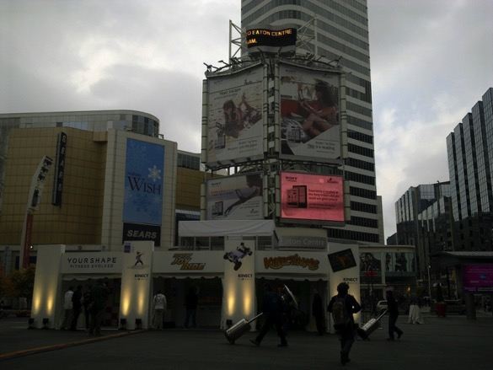
Image 53 Yonge Dundas Square looking West, the Eaton Centre is in the centre left.

They were encouraged to play and dance along to the games, and become the living embodiment of the fully functioning happiness machine which Herbert Hoover wrote to Bernays about in 1928. It is signalling a further erosion of the reality principle as we step closer and closer to becoming immersed in a simulated reality. Boyer (1993) analysed promotional space and writes about the growth of privatised spaces in the city which had the outward appearance of being public, but which were invitation only. Analysing what were newly privatised spaces of New York, such as Battery Park, she describes a kind of corporate programming of needs at play, which manifested itself as an ‘anesthetised social world divorced from the “real” public realm of difference, diversity and antagonism’ (In Allen (2006, p.444). This analysis is still relevant today with the attempts by the Occupy Movement to occupy Zuccotti Park in 2011 and other mass movements across the world with the aim of reclaiming space in the city for public realm.

The privatised city

Minton (2009) looks at the growing culture of fear in the contemporary built environment. She focuses on a key site 'Liverpool One' a massive retail led regeneration in the centre of Liverpool which was entirely privately owned by the Duke of Westminster's Grosvenor Group. Minton looks at the impact of Private Security and explains how this adds to a feeling of security and fear in the contemporary city. Using case studies from across the United Kingdom, Minton highlights the emergence of Bollards separating privatised enclaves in the city such as East Village in Liverpool.

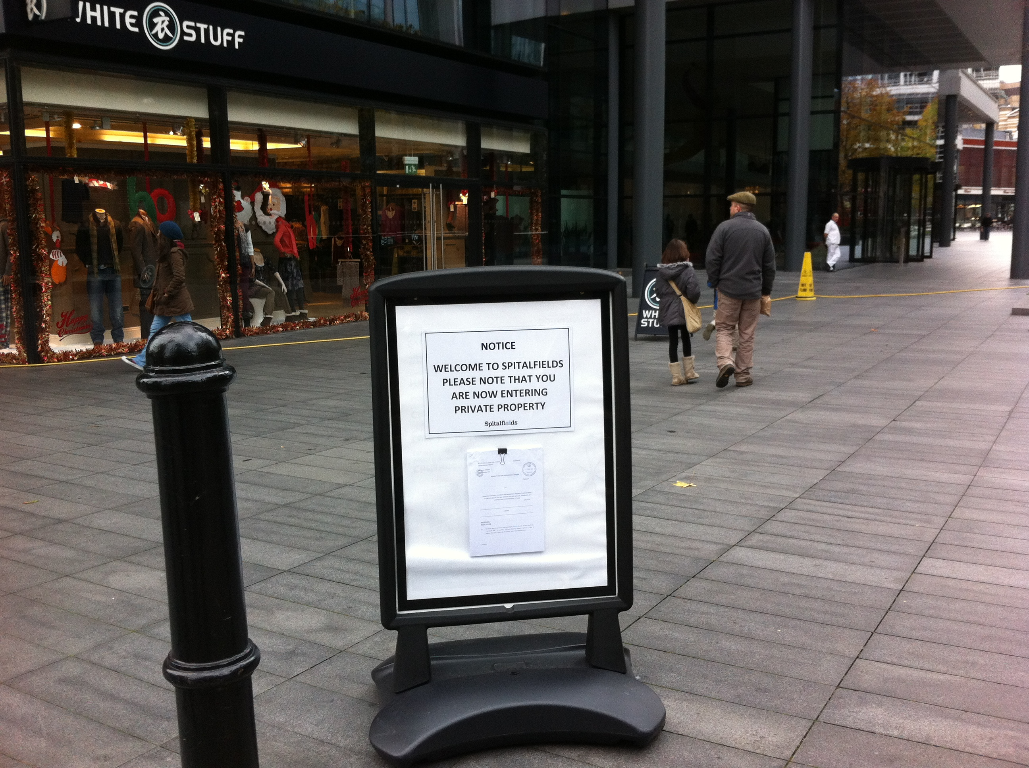
Image 54 Bollards and signage to indicate you are entering Private Property in Spitalfields, London (Authors own, taken December 2011)

Although this pattern of privatised City development can be identified in the Georgian Squares and parks of the city, Minton describes this trend as a large-scale reversal of public space which is an increasing urban trend. Minton identifies two models of the Privatised City. The first is Private Ownership - Canary Wharf is the key example - a private site, developed to suit of the needs of international finance. This development a model for re-development of deindustrialised cities across the United Kingdom. The second model is Private Management of the City in the guise of the Business Improvement District. This model emerges first in Toronto and was refined and deployed in New York and other cities across the globe. And in this type of space, Minton argues that the logic of Maslow’s hierarchy of needs is employed to develop a hierarchy of needs for a city. At the top of the pyramid is the clean, safe places with successful marketing' which attracts residents and tourists to come to the area. Minton argues that what we get as a result is a choreographed city landscape where buskers are auditioned and street performers are positioned to impart excitement.
For Minton, what is happening is not just the unstoppable pace of globalisation but the adaption and cherry picking of U.S. models of re-development and their deployment in the UK. She argues that architects and planners now aim to fit in with the requirement of the client. The place becomes the product and the main aim to keep property prices high. The impact of this is not just the privatisation of public space but also of planning policy.
In the UK Planning and Development Act 2004, public good was replaced with economic development. Minton explains that the sites which are produced, exhibit pre-Victorian patterns of ownership. We see single private landowners such as the Duke of Westminster own large parts of the city in a way landlords and estates did. Minton argues that this undermines the diversity of the landscape.

Yonge Dundas is the result of the deployment of neoliberal planning policies which aim to facilitate private development. However, Yonge Dundas Square is not the only space in this area that exudes a sense of publicness. The Toronto Eaton Centre, although enclosed and privately owned, is a space where citizens can experience a communal existence, united through consumption. We will now consider how and why the Toronto Eaton Centre owners instigated a major revitalisation of the shopping mall over 30 years after it opened. From the material gathered during the field work and other documentary evidence, attention will be paid to the attempts that were made to ensure that the Toronto Eaton Centre remains a centre for the experience of a form of public life for Torontonians and tourists who venture to downtown Toronto

Revitalisation of the Eaton Centre

‘In line with our best-in-class strategy, Cadillac Fairview recognizes the importance of continually updating Toronto Eaton Centre to remain a relevant and vital part of the downtown core. Over the years, the Centre has continued to reinvent itself with numerous updates and cosmetic renovations, including: the Yonge Street Facade and Media Tower addition, which changed the face of Yonge and Dundas Streets forever; the addition of significant retail and in partnership with Ryerson University, the introduction of the Ted Rogers School of Management at Bay and Dundas, 20 Queen Street West office tower lobby renovation; and many other interior upgrades and renovations.’
Tenant communication from the Cadillac Fairview Corporation Limited 2010

The Eaton Centre must constantly develop the offer in terms of the retailer mix and physical environment to maintain its status the key centre of retailing in downtown Toronto. It faces competition from suburban malls such as Yorkdale, and other city districts. Surpassing any previous renovation of Toronto Eaton Centre, Cadillac Fairview embarked upon a $120,000,000 revitalization project in 2010, to update the Centre’s common area, and remodel the dining experiences”. The process of ‘revitalisation applied a veneer of contemporary commercial architecture. The revitalisation process that was underway during the visit involved replacing 230,000 sq. ft. of flooring, the renovation of three washrooms, and replacing the white metal hand rails with new ones made with glass and steel caps to ‘enhance sight lines’. The important factor here is that the replacement of the hand rails will improve the sight lines within the centre. This is to ensure the maximum visibility for all tenants within the mall. The removal of the white vertical railing and their replacement with translucent glass opens up the multiple levels of the mall. It improves the selling abilities of the mall. It is a refinement, a rational approach to increase revenue for tenants.

Along with these major cosmetic changes, the escalators and elevators were being refinished, the tiling replaced on all columns and the doors were to be replaced on all entrances to the centre. In addition to this, new lighting was being provided in the Galleria, the fiscus trees on level 2 and 3 were being removed and new shopping facilities for guests including a ‘Guest Service Kiosk’, “Mall floor directories’, ‘select enhanced seating and planters’ were being added. According to Cadillac Fairview, ‘one of the most highly visible additions to the Centre will ‘an inspiring new sculpture to be suspended from the ceiling of the galleria’. This sculpture has been commissioned by United Artists and the owners claim that is will ‘reinforce Toronto Eaton Centre as the go-to destination for visitors and shoppers’. This aim is in line with the original aims that Douglas Haldenby outlined when he was making a presentation about the Eaton Centre proposal back in the 1960’s. The owners of the Centre recognise the role the centre plays in giving the downtown shopping area of Toronto an identity. The addition of a new light sculpture is contributing to this.



Image 55 6th Jun 2010 Revitalisation Overview

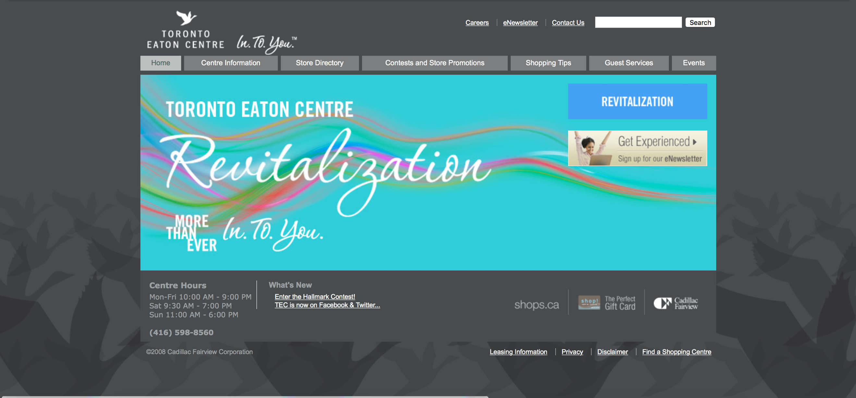

Image 56 Eaton Centre Homepage 8th Feb 2011

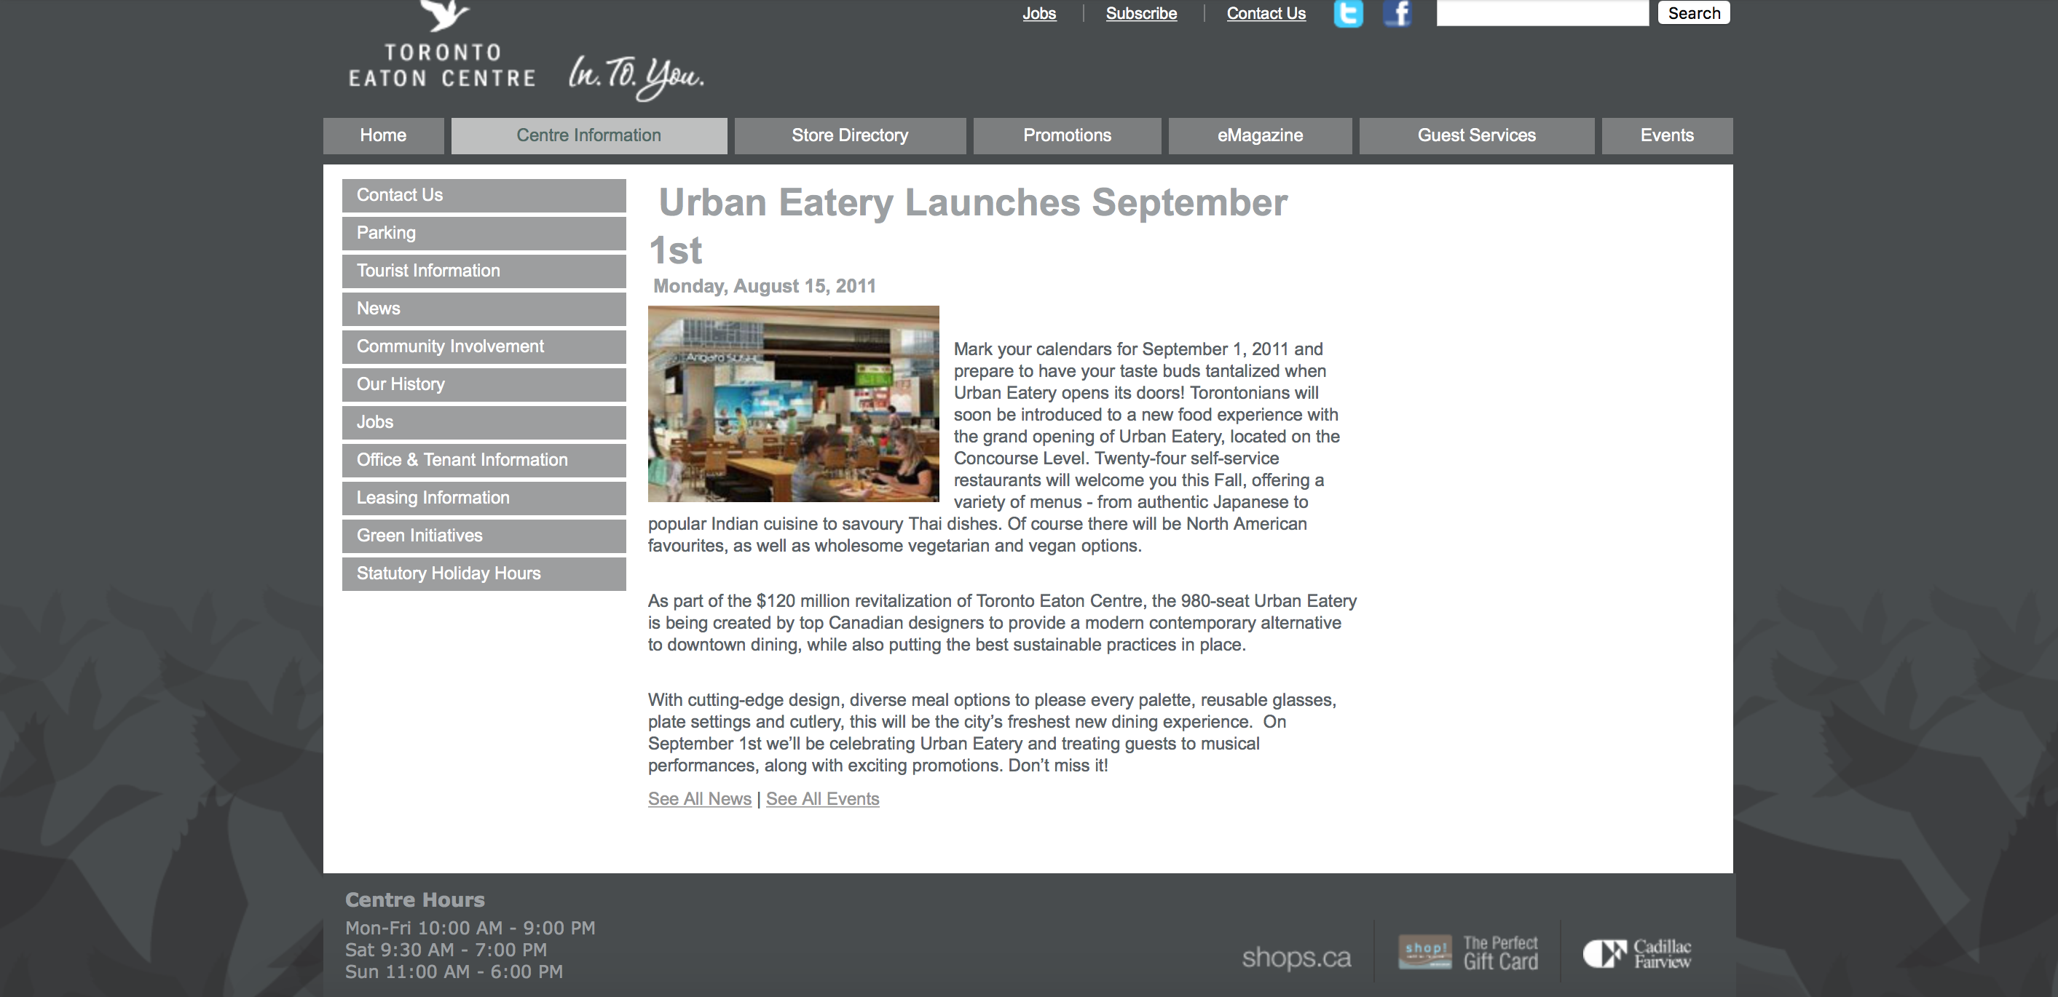
Image 57 Urban Eatery Launches September 1st, 2011


Image 58 Homepage 2nd Sept 2011

‘MORE THAN EVER In. To. You.’
Beyond the changes to the visual appearance of the mall, there is also a major restructure of the dining facilities in the centre. This was to see the transformation of the Northern Foodcourt into an ‘Urban Food Market’ The owners describe this as ‘an elevated dining experience for visitors’ The transformation involved the introduction of new seating, fixtures, and amenities. The aim is to build facilities which have ‘... elevated design and build-out criteria for retail client spaces to establish a consistently appealing and sophisticated dining destination’. The key aim is to create a space which the shopper has come to expect from urban shopping environments. To compete, and remain a centre of activity the Eaton Centre must adapt. The traditional food court with its fast food restaurants such as McDonalds and Kentucky Fried Chicken, Asian Buffets, and Pizza bars was to be replaced with a contemporary dining experience. In the brochure outlining the product rationale for tenants, there are artist impressions of the form which the new food court will take. It was snap shot of what the repositioned centre will look like which as the advertising and promotional material states ‘MORE THAN EVER In. To. You.’.

The veneer of urbanity has also been applied to the dining options available in the centre. As part of the revitalization process, a key focus was on providing new dining options to customers. The Urban Eatery opened on September 01, 2011 on the concourse level of the centre. This is a space which hosts over 24 fast-food restaurants. These include traditional food court tenants such as McDonalds, Sbarro and Subway. The idea of revitalising the dreamworld was not only limited to the cosmetic appearance or the dining options. There was also a concerted effort to update the tenant mix to provide customers with ‘best in class’ ‘first in Canada’ type retailers. This was an attempt to give the customer what they are looking for in terms of the brands and retailers which are relevant to the contemporary global dreamworld.

We see how the forces of territorial production and the creation of privatised shopping focused urban spaces have spread out beyond the enclosed mall and exteriorised themselves to reshape and reimagine the city. The barrier between public space of the city and the privatised shopping space becomes weaker and weaker.

Maintaining the dream – preventing the ruin

According to the owners, the Eaton Centre attracts over 50 million visitors annually (Cadillac Fairview, 2011) and can be considered as one of Canada’s most well-known retail centres. Cadillac Fairview also claims that about 25% of its visitors being tourists (Cadillac Fairview, 2011). At the time of this study the Toronto Eaton Centre was undergoing a major $120 million redevelopment over a period of 18 months, beginning 1st July 2010. In this transitory stage, the developers claimed that no store would close. The study aimed to capture the fragile nature of the dream and identify attempts to keep the dream alive during this transformation process. This site is the ideal testing ground for the thesis. As an early post-modern space, a private realm at the heart of an urban downtown, this model has been seen as key to the regeneration of towns and cities across the world. Downtown Toronto has become more like the suburban shopping mall in order to compete and ensure its survival. The original plan was for a superblock, territorially divided development, with shopping around a plaza surrounded by high buildings. Instead a post-modern space was constructed which produced which encompassed elements of an arcade in Paris, the galleria in Milan, and the suburban Malls of Southdale. It used the rhythms in terms of movement, and location of other downtown shopping - the established urban rhythms to create a new space. Deleuze and Guattari, (1988) speak about musical metaphors and how birds sing to mark their territoriality - each territory is shaped by a certain rhythmic activity or refrain which marks its territory. These territories need to maintain and recited in order to remain effective (Karrholm, 2009 p434).
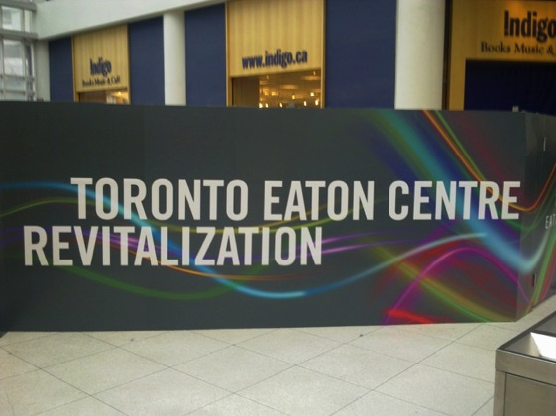
Image 59 Taken on Level 4 of the hoarding which was placed to hide the building work.

When the Eaton Centre opened in 1977 it positioned itself as ‘life in the city’ for the emerging postmodern consumer. As suburban and international competition evolved, the Eaton Centre must evolve to remain relevant to the shoppers who travail its’ passageways. It must sing to the visitors and keep encouraging them to consume. The centre needed to evolve to compete with the other private shopping spaces available to visitors throughout the Greater Toronto area (Yorkdale, Don Mills). On June 18, 2010, Cadillac Fairview announced a $120,000,000 investment in the redevelopment of Toronto Eaton Centre. It was claimed that the 24-month project will commence on July 1, 2010, and will be the largest transformation since the Toronto Eaton Centre opened its doors in 1977. This was to be the impetus for what the owners Cadillac Fairview call the Toronto Eaton Centre revitalization. The money being spent on the centre was mainly cosmetic. It was the refashioning of the appearance of the mall to give it the veneer of contemporary consumer society. It is an attempt to re-establish and re-affirm the vital role that the centre has in the collective dreamworld of downtown Toronto.

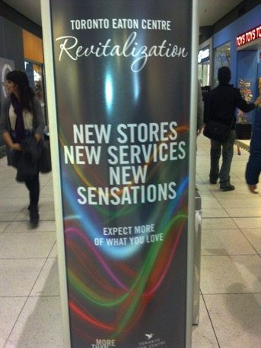
To continue being ‘life in the city’ the Eaton Centre needs to focus on the constant generation of new wants in those who visit. This section will explore the impact of global trends and brands on the centre and the efforts to keep the dream alive. It will deal with re-vitalisation, hoarding, scaffolding, Imagery – ‘Sorry for the disruption’ and the pressure to get ‘first in Canada retailers’. To sustain regeneration, a site needs to have economic activity. The Toronto Eaton Centre has a huge metro area to sustain it, and the mall is part of the wider economic life of the downtown area. The re-vitalisation of the Eaton Centre is an illustration of how the problems of aging in consumer society the can always be re-incorporated into the system.
Image 60 Revitalisation poster

Two more phases were added and opened in 1990, and in 1999 when changes were also made to the Centre's Yonge Street façade. Further redevelopment referred to as the ‘Dundas Expansion’ (Cadillac Fairview, 2013). The Centre underwent a major $120 million redevelopment over a period of 18 months, beginning 1st July 2010, which saw cosmetic changes to the interior of the centre, including the replacement of the flooring and railings. Another major aspect of this redevelopment was the upgrade of both foodcourts and the creation of a new branded space called Urban Eatery. At the time of the study, the Mall owners also explain that it is expanding to house new retailers, additional parking spaces, and extra class spaces for Ryerson University. During the site visit, most of the shopping mall was covered in scaffolding. The scaffolding highlights the temporary and hollow extent of the physical reality of the mall. It can be re-clad and re-coloured to re-shape how it is viewed by those who visit the mall.

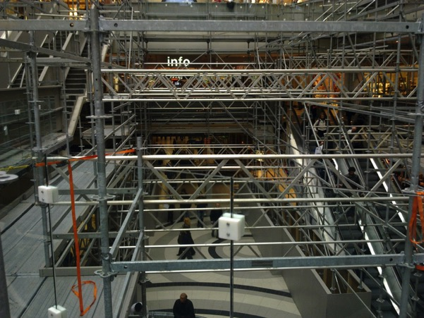
Image 61 View of Eaton Centre scaffolding

As we have discussed, there has been a tendency towards creating a capitalist space which seems to be public but which controls the totality of human life. Shields (1988) in his study of the suburban West Edmonton Mall and the Toronto Eaton Centre elaborates on this to explain the tendency to try to establish an alternative environment which their users are encouraged to imagine as an alternative reality --a "hyperreality" as Baudrillard referred to it. In his two Canadian examples, Shields identified the malls as false zones of liminality and sites of consumer “jouissanceis” where there is an implied pressure to enjoy oneself. He also identified the social implications of the semi-feudal style of control over these spaces by owners and their use of exclusionary practices. However, the impact of this alternative reality is not just limited to the shopping mall. It has spread beyond the walls of the mall.

The City of Late Capitalism

The panic which we feel when we realise we live in Baudrillard’s simulation, leads us to search for any sort of authenticity. In Postmodernism, or, the Cultural Logic of Late Capitalism, Jameson (1991) refers to the Toronto Eaton Centre and the Westin Bonaventure hotel complex in Los Angeles, to illustrate the emergence of the spaces which he considers to be part of the realm of globalised late capitalism. These buildings of the late 1970s are a world apart from the modernist superblock of the 1950’s and 1960’s These multi-function centres become the city in miniature and to an extent they demonstrate a totalitarian impulse in their aim to be fully enclosed cities. They also act as spaces where a hyperreal simulation tries to create a sense of authenticity through nostalgia. This turn towards the simulation and pastiche is what characterised the post-modern movement in architecture and urban planning. By turning the focus on to a mythologised version of city life and reimagining it for modern life it turns the focus inwards, from the city to the internal realm.

In terms of consumption, needs can be met and desires can be sated. As Bauman (2001) explained, consumer society needed the shopper to generate new wants. Their goal is to never be fully satisfied and always generating new wants inspiring new occasions to consume. These post-modern individuals live in a liminal society. They were born in the shopping mall and grew up in its arcades and passageways. Much like the Flaneur was the product of nineteenth century Paris and it’s the arcade, the happiness machine who constantly creates new ‘wants’ is the product of the mall. It is the subject who is comfortable without limits. This postmodern subject can cut themselves off from the outside world, with headphones and their glass firmly placed on their smartphone. Online, they inhabit a limitless realm where there is the illusion of complete freedom, yet it is shaped by private corporations and mediated through interactions on social networks.

Jameson (1991) describes a post-modern distinction between authentic knowledge and counterfeit knowledge. The age of mechanical reproduction, has highly refined and improved the form of our mass communications media. The ability to reproduce the real has been greatly improved. Jameson explains that counterfeit experience eventually substitutes authentic experience. We are left with the glow of electrically lit signs and the hum of air conditioning units, which lurk in the background maintaining our reality. However, as the wattage dims and the air conditioning coolant leaks, cracks begin to appear. What appeared real suddenly becomes junk. This gives us an image of contemporary urban society which is akin to Terry Gilliam’s film Brazil (1985) where technology is overly complicated and breaks easily or does not last.
Aging in Junkspace is non-existent or catastrophic; sometimes an entire Junkspace—a department store, a nightclub, a bachelor pad—turns into a slum overnight without warning: wattage diminishes imperceptibly, letters drop out of signs, air conditioning units start dripping, cracks appear as if from otherwise unregistered earthquakes; sections rot, are no longer viable, but remain joined to the flesh of the main body via gangrenous passages.
Koolhaas (1998)

Here we see the fragile empty nature of contemporary spaces. These empty spaces bombard us with images and signs, where the ‘wattage diminishes imperceptibly until suddenly they become obsolete overnight. The world of electric light comes to symbolise the artificial enlightenment these spaces give us. Yet they do not last, and they become obsolete. What we see in the revitalisation of the Toronto Eaton Centre is the attempt to prevent the ruin. It is an effort to instil new values in the space and maintain its role in the collective dreamworld

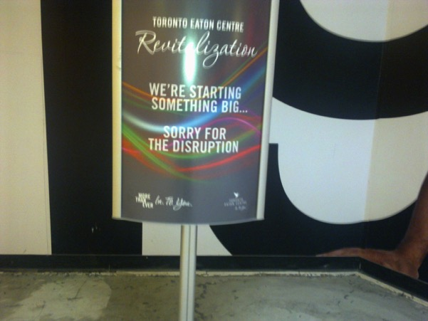
Image 62 ‘Sorry for the Disruption’ Freestanding sign outside The Gap clothing store which was under refurbishment.

During the redevelopment work attempts are made to mask some of the scaffolding with advertising imagery for current retailers or lifestyle images for what type of space the mall owners hope to create once the redevelopment has been completed. The mall just changes its skin. Most of the centre appeared to be covered in a giant machine-like exoskeleton which was wrapping itself around the fixtures and fittings of the centre. The purpose of this structure was to allow work be carried out replacing the 1970’s era white metal railings with sleek, frameless glass railings. The scaffolding was akin to a machine which was in the process of reimaging and regenerating itself. The vista of this stainless-steel entity slowly sweeping over the centre became a moment of ‘stillstellung’ during the fieldwork visit. This was not only a visible illustration of the fabricated nature of the reality within the mall but the structures which create this reality or the impetus behind the dreamworld had been exposed and visible to the naked eye. At times, it felt like the virtual world of a video game, where the landscape loads slowly on the screen before you can become fully immersed. Certain features appear slowly and build up until the full virtual vista had loaded and you can start playing the video game. In other ways, it was like seeing a progress bar on a computer screen of a half-loaded website. It was the pause or glitch in the dreamworld in which a greater understanding of the site could be gleaned.

The scaffolding sweeps over the centre re-imagining and renewing the phantasmagorical realm. There were elements of Terry Gilliam’s dystopic film Brazil (1985) which created a retro vision of the future, in which society depends on poorly maintained and overly complicated machines. However, in the contemporary phantasmagoria, this is only temporary, a glitch before the appearance of the dreamworld can be restored back to ‘normal service’. However, the appearance of the mall during the revitalisation was not poorly thought out and overly complicated like in Gilliam’s Brazil. Even when the mall was under renovation, the focus was on how the customer would perceive the mall visually During a walkthrough of the site with Brian O’Hoski, the Tenant Relationship Manager from Cadillac Fairview, he explained that each scaffolding pole had been customised, by removing the stickers from each one, to maintain a clean and uncluttered visual impact. In the centre of the images below, it is only on close inspection that the marks from where the stickers on each pole used to be can be seen. There was a concerted effort to ensure that no unnecessary signage and the least amount of visual obstruction would be created during the work on the centre. In the centre of the Image 62 the faint outline of the sticker can be seen. The Sticker on each scaffolding beam had been removed before being installed to reduce visual clutter.
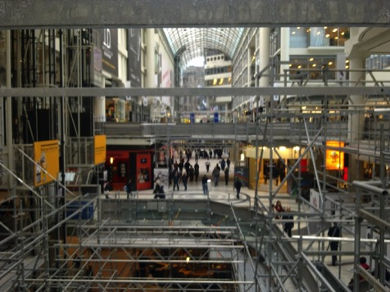
Image 63 Interior view of Eaton Centre looking south illustrating the scaffolding encasing the centre.
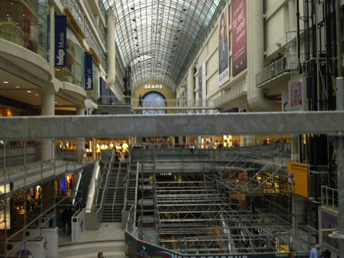
Image 64 Interior view of the Eaton Centre looking North towards Sears (Eaton’s).

Walking through the centre promises are made of what the revitalization will herald for the centre. This could also be seen where certain retailers had branded the hoarding outside their store, with company decals. The aim was to grab the attention of the potential customer. To remind them that the retailer was still open or to catch the attention of those who were visiting the centre for the first time. Examples can be seen below of attempts to reinforce the branding of the store and maintain the impact of their visual identity. If their store front was blocked, many retailers made sure that the scaffolding was festooned with their imagery and logos so that the shoppers would know they were there.

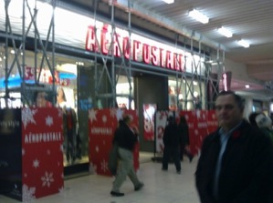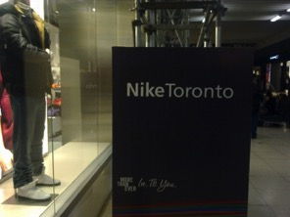
Image 65 Hoarding with retailer imagery – Aéropostale Image 66 Hoarding with retailer imagery- Nike
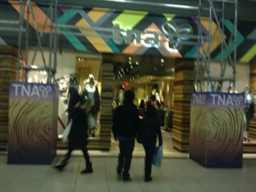
Image 67 Hoarding with retailer imagery - TNA

The tenant relationship manager, Brian O’Hoski spoke of the special arrangements made with certain retailers to have lower hoarding and increased visibility of their corporate branding. This is another example of the way retailers attempt to sing to their customers. It was disclosed during the interview and subsequent walk about, how one retailer made efforts to keep their key demographic of customers happy, by making sure that the hoarding covering the scaffolding outside their store, was lower, so that their shoppers could still see the shop window. This is an example of how retailers in the mall manage the space not only inside their store, but the reception that their shopfront will receive. In Image 66 we see the Arizla women’s clothing store, which primarily caters for Petite customers, and who made a specific request to have the hoarding outside their store branded in their company imagery and the hoarding lowered to ensure their customers could see their store.
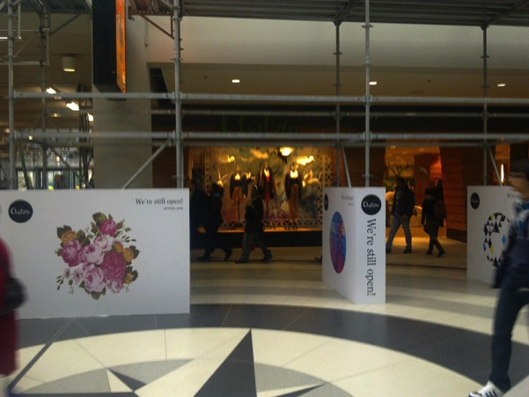

Image 68 Lowered Hoarding in front of Arizla women’s clothing store.

Some of the elements are similar in the description of the initial project and the revitalisation of the centre, but some of the elements which were highlighted as important features are now being removed and replaced. The railings are being ripped out and replaced with glass railings. Security is no longer the main concern. Modern building materials allow a similar structural protection to be given around the courts, with glass railings. The glass railing is the hallmark of the shopping mall of the 21st century. The Eaton Centre needs to compete with other later developments, or competitors who have already revitalised and cast a veneer of contemporariness over their interiors.

Everything is transient and temporary in the mall. The tenants are subject to the pressures of performing well and contributing to the overall vitality of the mall. This can be enforced by lease agreements on what type of good the retailer can sell, and other factors such as their opening hours. Another way this can be enforced is by the rental rates or commercial lease agreements. Independent traders and smaller chains can be priced out of the space by larger chain stores that have the financial backing and security to commit to a lease. The glitches are constantly being covered over. Out of fashion retailers are pushed out to bring in fresh new brands which sing to the customer.
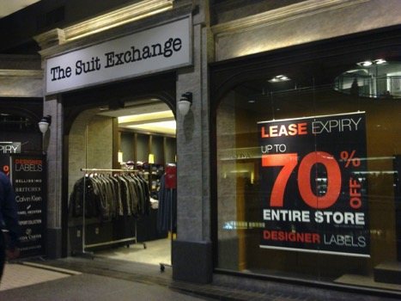
Closing down sale in a store which would be soon replaced with something more fitting of the ‘Best in Class’ mall which the Toronto Eaton Centre aims to be.

Image 69 The Suit Exchange, closing due to lease expiry

Creating the Secret – Being first in Canada

At the time of the field visit, Victoria’s Secret was one of the latest international retailers to open in the mall. The store is famous for its catalogue and high-profile advertising campaigns. The store thrives on an imbued aura of female sexuality. The name elicits a secret personalised version of sexuality. The shopfront is blank and the passer-by cannot see into the store. The lack of windows creates a private space which draws the user within. The shopper is encouraged to enter the store to see what is on offer. In a sense, the store frontage aligns with Freud’s ideas of the suppression and sublimation of the desire. In the mall, female sexuality is confined to the interior of a store which sells the latest trends in a fashionable version of sexuality. This is not like the brothels in the arcades of Paris, this is a sexualised space where women are the key target customer. Women are buying underwear in a secret gendered space which has the aura of meeting consumer society’s version of sexual fantasy. This is the outlet for sexuality in the Mall. The ideals of sexual revolution are espoused in a windowless box with only one entrance. The store exterior can be read in a few ways. The imagery portrays a safe version of the female body. It is softly lit and does not expose intimate areas. It is the illusion of the nakedness which has the aura of sex. The image of the model can consume on an egotistical level in terms of female body image and personal self-esteem or can be consumed as a pre-packaged lust inducer. It plays on the insecurity of the women who shop there to be sexual in a certain manner.

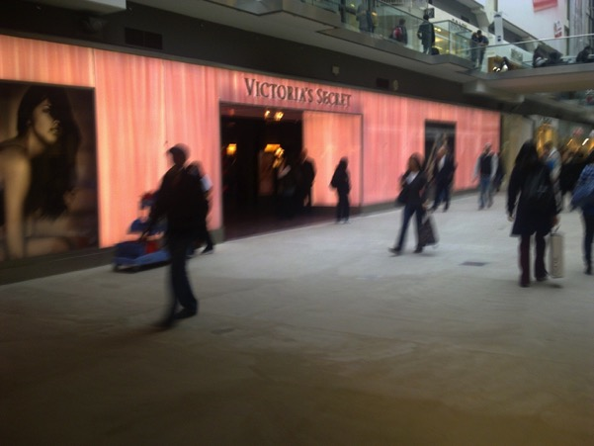
Image 70 Frontage of the Victoria’s Secret Store is blank besides for two posters. The imagery has the aura of sexuality but does not expose any intimate aspects.

Victoria’s Secret takes a normal everyday object – underwear and gives it the aura of a female sexual identity. The opening of Victoria’s Secret was an achievement, in contributing to the mall owner, Cadillac Fairview’s ‘best in class strategy’. During the interview with Brian O’Hoski from Cadillac Fairview, he spoke about the company’s vision to bring retailers to the mall with their first in Canada store. They are competing with suburban Yorkdale, which is owned by another company for the status and footfall that can be generated when these global brands arrive and shoppers flock to buy a piece of image it exudes. This can also be seen in the screencap from the Toronto Eaton Centre website captured from January 2006 as it is proudly announced that the centre will be home to the first Canadian outlet for an American youth fashion brand – Hollister.
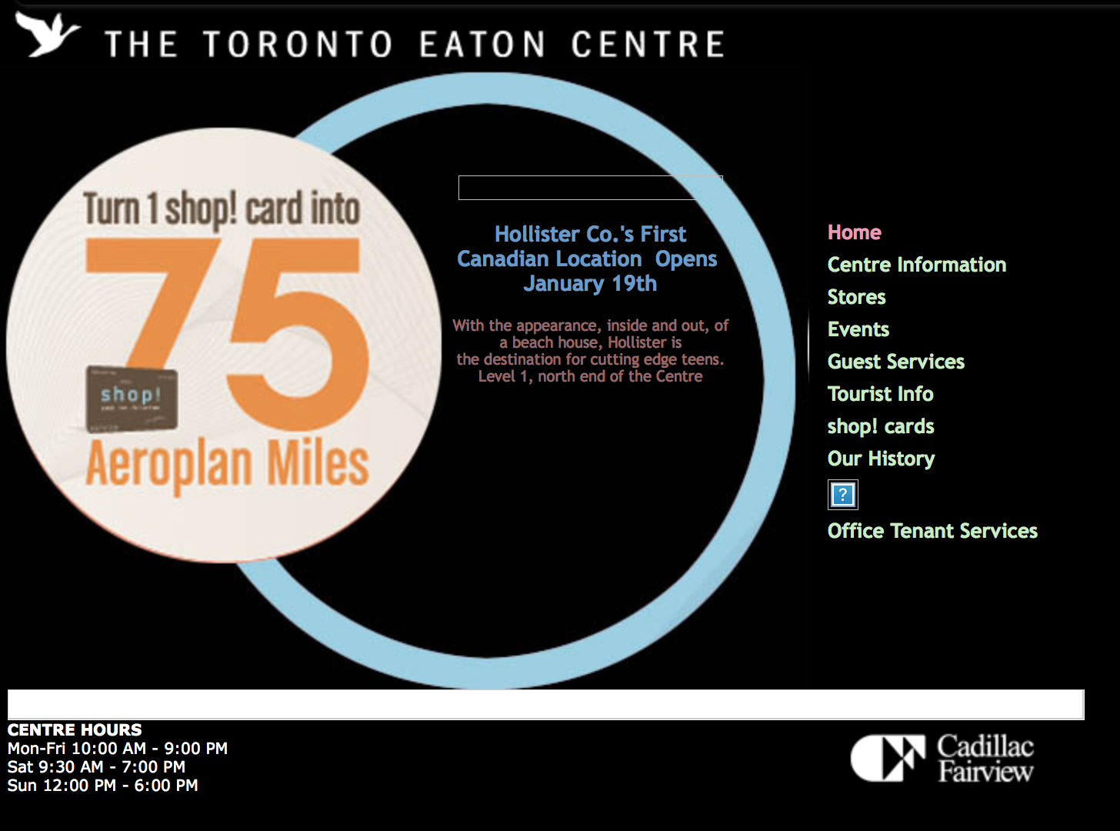
Image 71 Screencap of www.torontoeatoncentre.com from 4th Jan 2006 – Advertising the first in Canadian branch of Hollister Co. – an American Youth casual fashion brand.

Shoppers at the Eaton Centre have been exposed to these brands, while visiting the United States or making purchases online. Shoppers want to consume the signs and images that are sold in this type of retailer and if they are not provided in the Eaton Centre, they will look elsewhere for it. In this context, the Toronto Eaton Centre constantly must reinvent itself to remain relevant to its target demographic of shoppers. The Eaton Centre is a space continuously running to stand still. In a sense, it is running after the rabbit in Alice in Wonderland, trying to capture and reproduce the aura of the dream of consumer capitalism. It cannot stay still because the way the space is territorialised is in constant flux. Each territory is shaped by a certain rhythmic activity or refrain constituting the base for different melodies signal or loops (Deleuze and Guattari, 1988) ... "Territories need to be maintained and immersed in order to be effective, and the management of territories often involves strategies of time" (Karrholm, 2009 p. 434) The Toronto Eaton centre from its genesis to its revitalisation is an example of this shift toward territorial production in the contemporary capitalist city.

The dialectical image that emerged from the fieldwork is that that the Toronto Eaton Centre constantly needs to reinvent itself to keep up with the whims or ever-changing nature of capitalism. It needs to keep the dream alive, to be the first in Canada to satisfy the consumer demand for new brands, new trends, or new novelty. It also needs to focus to an even greater extent than its competitor on satisfying the target shoppers by being More than even, In. To. You. This is the key element of what the neoliberal city promotes – a privately managed realm which is focused on satisfying individual desires. This occurs to the detriment of those who cannot participate in the consumer society. The shared communal experience of the public street is being imitated and replaced by spaces which facilitate a communal experience which is solely focused on encouraging consumption. However, these spaces are not totalising spaces. There is room for dissent and subversion in the neoliberal city. What we will see in the next chapter is that while there is still room for agitation and rebellion in the neoliberal city, it is limited in where and when it can occur.

Chapter Seven: The ‘right type of people’ for the City

In previous chapters, it has been discussed how spaces such as the Toronto Eaton Centre and Yonge Dundas Square played a role in revitalisation of Toronto City centre. These developments borrowed elements of the enclosed and privately managed type of shopping space which existed in suburban Yorkdale and replicated it downtown. This helped to maintain downtown Toronto as a major retail and leisure centre in the Metropolitan region by providing a venue for middle class consumer culture. It allowed downtown to compete with the suburban competition such as Yorkdale, which has been consistently ranked as the top performing retail centre in Canada with the highest sales per square foot of any centre in the country, making it also one of the top performing centres in North America. The Toronto Eaton Centre competes in the same league, normally coming two to three placed behind Yorkdale in terms of the sales performance per square foot. This is one way to measure the impact of the centre which focuses on the amount of money spent in the centre, the profitability of the retailers who locate here, and it also hints at the premium that a retailer must pay to secure floor space in the centre. But the question that needs to also be considered is the impact that this centre and the neighbouring Yonge Dundas Square has on public life in the city.

In this chapter, the fieldwork carried out in Toronto will be analysed and the impact of the Toronto Eaton Centre on public life will be considered. Key to this will be a consideration of how the typical activities we associate with city have shifted or been changed by spaces which are privately owned or managed. This was interrogated through fieldwork observation and through an analysis of an array of texts which were uncovered during the research. It has been discussed how the development of Yonge Dundas Square became an exercise in revitalising a public space in the city for a public – who would spend money consuming goods and services. With the redevelopment, there were new controls on what type of activity could occur in this space. During the field work, specific attention was paid to the spaces where protest and political demonstrations could occur. Following on from this, attention will be paid to new types of public spaces which have emerged online. The key type of text that will be discussed is the virtual spaces that have emerged through the social media presences of the Centre on Facebook and Twitter. The opportunity to opt into a virtual community of Facebook fans or Twitter follower of the Toronto Eaton Centre will be analysed. This will also lead to a consideration of the opportunity that these mediums offer for dissent and subversion of the dominant neoliberal perspective that governs this type of space will be discussed. Overall this chapter will seek to identify the counter-narratives that emerge which contrast with the image of city life that is manufactured by property developers, business owners and the local authority

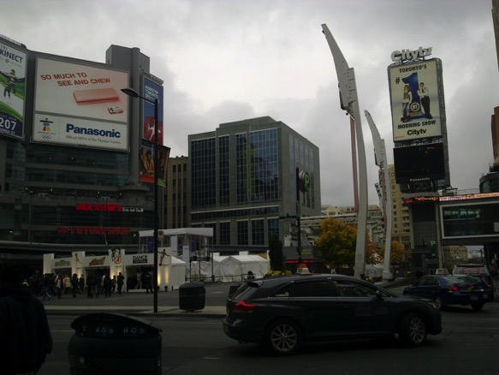
Image 72 Yonge Dundas Square Looking East

The opening of Yonge Dundas Square in 2003 demonstrates how the territorial realities that the shopping mall has refined in terms of privately controlled spaces, have spread beyond the confines of its physical nature to the city itself. This square appears public, but is managed by board of the City of Toronto which is charged with running the site as an events space which generates profit. This chapter will show how the rules which govern the management of privately owned spaces such the Eaton Centre have become embodied in the privately managed spaces that have emerged in the city which are influenced by neoliberal approaches to planning and forms of new public management which sees the municipality retreat from public life.

Yonge Dundas Square is the ‘Heart of the City ‘presented by Virgin Mobile. The square is run by the Yonge Dundas Square Board of Management which is a board of the City of Toronto. It is publicly owned but it is privately managed. This contrasts with nearby Nathan Phillips Square which is available to book by non-profit and charitable organisations and is governed under chapter 270 of the pre-amalgamation Municipal code. The conditions on use of the Nathan Phillips square are limited to requiring anyone who uses the square to comply with the Ontario Human Rights Code and once they don't carry out prohibited criminal actions. The Yonge Dundas Square is covered under a different section of the Toronto Municipal Public code. Chapter 636 specifically covers Yonge Dundas Square and outlines the authority and responsibility bestowed on the Board of Management.

ARTICLE II
- H. The Board is authorized to undertake requests for proposal or solicit expressions of interest for revenue sources for the Square, including but not limited to third-party outdoor advertising, provided that, through the Commissioner of Economic Development, Culture and Tourism, the Board advises City Council of the results of such requests and reports its recommendations to City Council. [Added 2002-10-31 by Bylaw No. 889-2002]

In Article II above, there is specific permission bestowed on the Board to use the square to generate revenue. This chapter of the municipal code also allows for restrictions to be made on the types of activities that are permitted

TORONTO MUNICIPAL CODE CHAPTER 636, PUBLIC SQUARES

ARTICLE III
Use of the Square
No person shall, within the limits of a square:
- Climb or be on any tree, roof of a building or any part of a building, structure or fixture, except any portion which is a public walkway.
- Set off fireworks except a theatrical special effects pyrotechnics under Class 7.2.5 of the Federal Explosives Regulations as authorised by permit.
- (Reserved)
- Stand on any receptacle or container for plants, shrubs or trees.
- Wear any ice skates other than on the part of a square that is physically laid out and intended for use by the public as an ice rink area.
- Drop or throw any object from a roof of a building.
- Throw or in any way propel any stone or other missile or projectile in a manner which may cause injury or damage to or endanger any other person or property or which interferes with the use and enjoyment of a square by any other person.
- Light any fire.
- Ride or stand on any skateboard, roller skate or roller blade.
- Release or hand out helium-filled balloons.
- Light or carry any candle or torch, except a light stick.
- Camp or erect or place a tent or temporary abode of any kind. [Added 2005-07-21 by By-law No. 655-2005]
- Smoke, except on that part of a Square which is located on a highway. [Added 2014-04- 03 by By-law No. 285-2014]

§ 636-12. Activities requiring permits.

No person shall, within the limits of a square, except in accordance with terms and conditions of any permit:
- Solicit for or engage in any trade, occupation, business or calling, including producing, manufacturing, selling or offering for sale any goods, wares or merchandise, but this subsection does not apply to the sale of newspapers.
- Sell items by registered charities and not-for-profit organizations.
- Ride a bicycle.
- Drive or park any motor vehicle.
- Use any apparatus, mechanism, or device for the amplification of the human voice, music, or other sound, or any sound-producing or noise-making instrument or device.
- (Reserved)2
- Erect or place a tent, device, booth or structure of any kind.
- Affix any signage, flyer, fabric or other substance to any building, walkway or column.
- Set off any theatrical effects pyrotechnics under Class 7.2.5 of the Federal Explosives
- Regulations; and
  - Any application for a permit to set off these types of fireworks is subject to the approval of the Chief Fire Official.
- Display an exhibit of any kind.
- Carry on or engage in a demonstration of any sport.
- Present or take part in any dramatic, musical, artistic or other performance; and
- Poetry reading is deemed not to be an artistic or other performance within the meaning of this subsection, but is deemed to the public speaking.

This list of activities which require a permit are extensive and serve to tightly restrict the types of activities that can occur in the space. The primary function of these restrictions appears to be to ensure that the square is available for revenue generating activity at all times.

In the Nineteenth and for the first half of the Twentieth Century, public life has played out on Toronto’s public streets. This began to change as privately-owned shopping centres began to take over as commercial centres for the citizens of the Metropolis. This in turn has shaped how people experience the city. As in the Greek Agora, there is a place for learning on Yonge Dundas Square. To the North-west Corner of the centre lies Ryerson University. With the development of the Ted Rodgers School of Management in the northern section of the Eaton Centre on Dundas, the University is linked to the commercial shopping core. But, this is not a public agora, it is one which is privately controlled and where activities must fit in with the commercial environment. This campus is surrounded by private spaces which restrict mass gatherings or protest. This had a direct impact on what it can do in terms protest in a public realm.

Smokers on the edge

During the first day of the site visit I walked the exterior of the mall, beginning at the North-West Entrance next to Sears, and working my way clockwise around the exterior of the mall back to where I began. As I walked around the perimeter to get a sense of the space, which took approximately 25 minutes to complete, I gained a greater sense of the scale of the Eaton Centre in relation to the surrounding street. While some effort has been made to bring street life to Yonge Street, the frontage is punctuated by a large entrance to the Multi-story car park and a variety of service entrances. Some of the entrances to the former Eaton’s Store, which Sears now occupies, were not in use. Along the other edges of the centre there are numerous entrances, including a mixture of service and individual store entrances facing Dundas, and Queen Street. At the service entrances, there was evidence of activity which had been excluded from the mall. Here I saw staff members congregating; some dressed in uniforms, most with a jacket or coat worn over them. Most were smoking. Amongst one group of workers was a man listening to music on at the speaker on his phone. This was the realm of the smokers and off duty workers; congregating in service entrances on the edge of the centre. Out of view from the shoppers in the mall, the public city street had become a backstage area for the interior phantasmagoria. The shoppers in the mall would never see this unless they left the mall. The activity has been sanitised from the mall. The smell of smoke and the harmful second-hand exhalations are banished. Smoke does not fit in with the contemporary dreamworld of the privatised shopping space. These people are relegated to the periphery in the doorways, or the backdoors to the mall. Here at the edge of the mall, there was evidence of other activities which were excluded from the interior.

Protest on the periphery

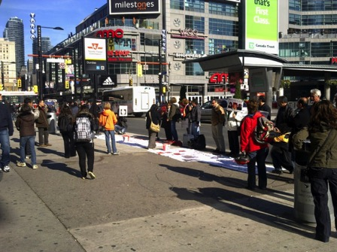
During the interview conducted with Brian O’Hoski, the tenant relationship manager from Cadillac Fairview, he mentioned that the only time that he was aware that the mall had to close was during the G8 riots the previous year, when the mall had to close for safety reasons. During the field work, there were daily protests which could observed on the pavement outside on the periphery of the mall. In general, this was characterised by a hive of activity at the corner of Yonge and Dundas. In the photo above there is a group of people protesting the stoning of a woman in Iran.
Image 73 Narrow strip of pavement outside North East Corner of Toronto Eaton Centre on Yonge Street.
Speakers outlined the situation with a public-address system and a large banner was laid out on the pavement detailing the plight of an Iranian political prisoner Sakineh, who was at risk of receiving the death penalty by stoning. The banner on the pavement could be signed by passers-by who supported this cause. The banner was emblazoned with images of the Iranian woman and messages including ‘In Iran they hang people in front of kids’, ‘Stop Stoning’ and ‘Free all political prisoners in Iran now’.
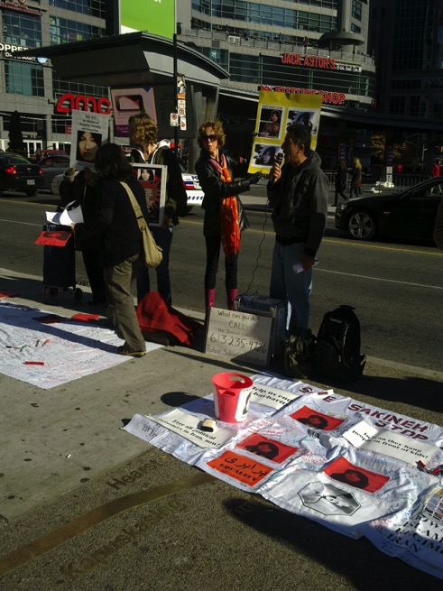
Image 74 Protest outside Eaton Centre, with Yonge Dundas Square in the background.

This strip of pavement is a completely different type of space to experience public life. It is one which is not focused on the phantasmagoria. This space is where the citizen can engage with the political and cultural aspects of society. Still, it is dwarfed in comparison to the vast shopping agora inside the mall. There is a stark contrast between this and the vast open-air pedestrian mall which had been created on Yonge Street in the summers of the early 1970s. The street was given over to the people of the city. Here there is a strip of pavement around one-metre-wide which acts as public space


Image 75 Front and back of a Leaflet being handed out at the Entrances to Sears from Yonge Street

In Image 74 we can see the leaflets which the United Steelworkers union were handing out. They were protesting over the way in which Sears has treated its employees. It claims that workers who failed to sign new contract with new terms and conditions were locked out of the company and not allowed to return to their jobs. The key message it is trying to communicate to shoppers who were passing by on this particular day is to ‘shop elsewhere until this lockout ends’

Another protest which was encountered in this space during the fieldwork was in relation to planned job losses at Sears. Protesters were handing out leaflets and stood with a metre-high banner proclaiming ‘Shame on Sears Lock out hurts children’. People were also standing near the entrance to Sears, asking customers not to shop here and handing out leaflets outlining their grievances with the company. This dispute focused on an industrial dispute between Sears and workers in one of their warehouses. As a small group of protesters chanted and handed out leaflets, imploring shoppers to boycott Sears, the tide of shoppers was no match for their protest and most shoppers politely accepted the flyer as they walked into the store. There was no evidence of protest inside the Eaton Centre. Two entrances from the main mall were free of protest. If the visitor had entered the centre by subway or through the PATH underground system of pedestrian walkways, they would not have seen any sign of the protest.

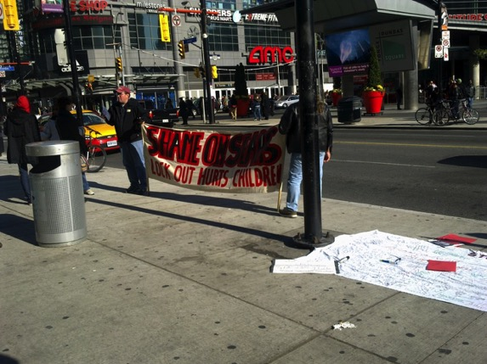
Image 76 Sears workers protest the implementation of new contract terms.
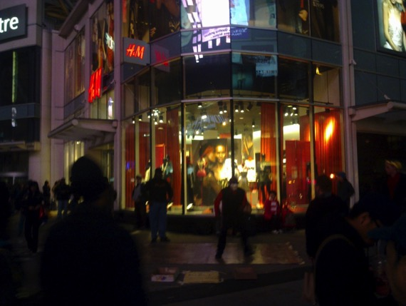
Image 77 Break-dancers perform at the Yonge and Dundas corner of the Eaton Centre.

A strip of pavement between the Eaton Centre and the Yonge Street was the focus for non-shopping activities typically associated with a public city street. There were not only incidents of protest in this space but there was busking, hip-hop dancers and a preacher spontaneously yelling at passers-by to get their attention. These activities were located outside the privatised sphere of the mall. They were excluded from the space which exudes publicness but has restrictions with what can happen inside there.

Inside the walls of the Toronto Eaton Centre

Once the shopper crosses the threshold of the Toronto Eaton Centre, the atmosphere changes. There is a difference in noise level. There is nobody trying to grab your attention with protest banners, loudspeakers, or intricate street performances. In the Eaton centre, the activity is subdued and encourages a blasé sensibility. Whilst protestors campaigned against Sears actions against their warehouse workers and against human rights abuses outside the centre, the only non-shopping display trying to grab one’s attention was a group of War veterans were selling poppies for Remembrance Day. This display of publicness was the only acceptable political and nationalistic message that was acceptable within the walls of the centre. The other key factor, which has a major impact on how people use the space is the difference of temperature. Just as the Southdale Mall pioneered the ‘ideal shopping environment’ hermetically sealed from the harsh Minnesota climate, the Eaton Centre is sealed off from the harsh extremes of the Toronto climate. Entering the centre, one is immediately transported to a comfortable room temperature. It is the ideal shopping environment where shoppers can take time to linger and immersive themselves in the privatised shopping space which has been laid out for their pleasure.

In the Toronto Eaton Centre, you don’t have to deal with protest; it is relegated to the periphery. You do not need to encounter homelessness, besides the few people who occupy the benches scattered throughout the centre, holding on until the private mall security moves them on. During the time spent in the mall, the contrast between the interior and exterior drew up questions. The Mall was always busier and the primary focus was on shopping. During the field work the time spent in the Eaton Centre was focused on finding the glitches in the collective dreamworld. The aim was to find moments of insight which allow us to look beyond the fabricated reality of the urban shopping mall. The glitches are the moments which offer the chance to achieve a dialectical insight into the reality that exists here. Echoing Benjamin’s attempt to achieve a dialectical understanding of nineteenth century consumer society, we will now look beyond the confines of the contemporary collective dreamworld of consumerism.

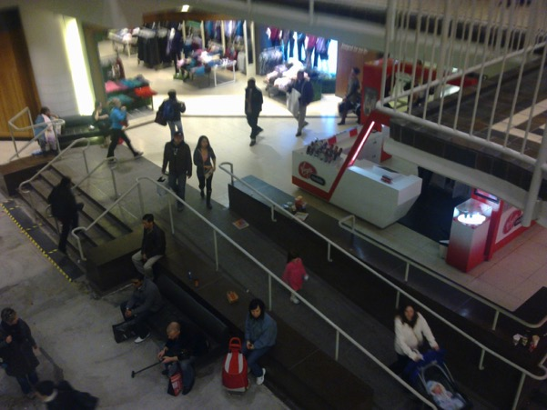
Image 78 Shot of interior of the centre.
Not everybody in the Eaton Centre is shopping or consuming. There are benches dispersed throughout the centre which encourage the weary passer-by to pause for a moment. The image above shows where a change in floor levels has been fashioned to create a ledge to sit on. At the time of the fieldwork this area had yet to be fully revitalised. The tiling on the floor had been removed and was about to be replaced with a more contemporary covering. The late 1970’s veneer was being erased and replaced. The white metal handrails were shortly to disappear. We can see how this space acts as not only a space to rest but it was also a place to watch and survey the surrounding space. Most people occupying these spaces looked tired. On one occasion, an intoxicated man had fallen asleep, spilling a drink on the floor. It was not long before he was moved on, the spill cleaned up and all evidence of this glitch removed. The people who paused on these spaces added a sense of animation to certain points of the centre. They gave the space a sense of purpose. There is a sense of public ownership about the benches and ledges in this space. They become a space where one is free to sit as any public space, once you conform to the rules of the collective dreamworld. You must dress as the other shoppers in the mall and look like any other potential shopper. This is a space which is controlling. The user is subtlety encouraged to behave in a certain manner. This links to Crilley (1993 p 153) who describes how the public realm is increasingly being reshaped as urban theatre: ‘Significantly, however, it is theatre in which a pacified public basks in the grandeur of a carefully orchestrated corporate spectacle’. We see the idea that the occupiers of these spaces are manipulated or their movements orchestrated to suit a corporate goal and to ensure that the space is only used in the way the owners intended. The seating areas provided in the Toronto Eaton Centre serve a purpose in an orchestrated corporate spectacle. They not only provide a brief resting point for tired shoppers, but they also animate the shopping centre with a simulation of activities that would normally occur on a public street or in a public square.

Susan Christopherson (1994) considers the rise of the ‘fortress city’ caused by the growth of privatised spaces where citizenship can only be displayed by consuming.
Beneath the surface, the signal qualities of the contemporary urban landscape are not playfulness but control, not spontaneity but manipulation, not interaction but separation. The need to manage urban space and particularly to separate different kinds of people in space is a pre-eminent consideration in contemporary urban design, matched only by the ever-present requirements to gratify the egos of developers. The soft images of spontaneity are used to disguise the hard reality of administered space.
(Christopherson, 1994, p. 409)
Christopherson has highlighted how the freedom espoused in these privatised spaces is only at the surface level. She explains that this space is managed and only suitable activities are permitted. This echoes Jacobs criticism of the demise of the chance encounter on the city street. While the shopping mall was designed to facilitate the pedestrian, it was in fact a highly controlled and privately administered space. If any of the people captured in Image 77 begin to engage in activities which interfere with the carefully orchestrated spontaneity, they will be swiftly removed by the private mall security force.

In spite of the efforts to create a carefully managed urban spontaneity in the Toronto Eaton Centre, there were two events which occurred in the Toronto Eaton Centre during the research which help to illustrate that there are still moments when this reality is threaten and shaken by major upheavals. The first being a fatal shooting in the food court which occurred in 2012 and the second being an ‘unauthorised’ protest for held in the centre by the Idle No More group which campaigns for the rights of indigenous First Nations people.

Shooting in the Food court

A shooting incident occurred on June 2nd, 2012 which was reported widely around the world due the graphic images that were distributed. Christopher Husbands entered the Toronto Eaton Centre food court and fired 14 shots which killed two men and injured 5 others. Video of the shootings was shared widely on the World Wide Web including footage of the shooter taking aim at one of the victims. In the subsequent court case, the Crown prosecution put forward the argument that Husbands opened fire to get revenge on the men who had attacked him months earlier and the jury found him guilty in December 2014. Hundreds of shoppers were evacuated that day as mall security and the police sought to bring the situation under control. The Toronto Eaton Centre remained closed for the rest of the day. Extracting the data from the Facebook page, it is possible to see how the event was dealt with through the social media channels. There was an outpouring of shock and remorse over the event, and users posted on the Facebook page to express their grief. There were no posts referring to the event issued by the Toronto Eaton Centre on the page. The first post that the Toronto Eaton Centre issues after the event was over a month after the shooting had occurred when they created a post on 9th August 2012 in relation to a preview of upcoming event for a mall retailer – La Senza. It is possible that the Toronto Eaton Centre may have removed posts after the event as the page owners, but the responses from users remained on the page when the data was extracted and they are illustrative of the role that the centre plays in the lives of those that visit the centre.

The responses below are gathered from the Toronto Eaton Centre page from users who posted in the aftermath of the event. The usernames were gathered during the collection process but the posts have been anonymised. The posts fall under two categories. The first relates to a general outpouring of grief in light of the tragic event that had occurred in the centre.

Post4615 6/6/2012

2 injured 6 shoot at eatons 1 dead hope everyones ok

This post was the earliest post on that day and corresponds with how news of the event unfolded on social media as confusion and panic struck those hearing the news.

Post 4607 6/6/2012

Due to ongoing investigations, the Toronto Eaton Centre will remain closed today. So tragic, our prayers and thoughts go out to the families of the victims.

One of the retailers posted this message to express sympathy and also inform users that the centre was closed for the rest of the day.

Post 4606 6/6/2012

I was there at the other end of the mall near Queen when i saw hundreds of people running towards the Queen exits. Thats when I found out that there has been shooting in the food court.

This post captures the sense of panic that shoppers experienced when Husbands opened fire. The video footage released after the event corroborates this.

Post 4605 6/6/2012

Would like to sends my regards to all my old staff members and friends at the Eaton Center. Hope ur all ok. Xx

Post 4602 6/6/2012

My family and I were admiring the beauty of this place not but a month or two earlier. I feel so lucky. This is such a heartbreaking thing to see, my thoughts to the victims. Much love from Chicago.

Post 4599 6/6/2012

I have been there just one week before that tragic incident. Had my really good “Crazy Burger” in the food place. I cannot believe that something like that happens in such a place. And that innocent people have to pay anyones “bill”. I am so sorry for the victims, their families and friends.

The messages posted above illustrate the role that Toronto Eaton Centre Facebook page assumed for the users who posted here. It became an outlet for their public expression of shock and emotion. There is a palpable sense of disbelief that ‘something like that happens in such a place’. In this case the Toronto Eaton Centre Facebook page allowed users to sympathise with the victims of the event and express their disbelief. It became a virtual communal space where users could express a public expression of shock. The air of shock and grief was soon accompanied by expressions of anger. The posts below question the security of the mall and ask why this had happened in this enclosed centre.

Post 4600 6/6/2012

Time for metal detectors at all the doors. They will nicely compliment the big brother street cameras that were installed pursuant to the Creba incident. I actually don’t mind more invasive police practices if it ensures we can go out for the evening without being murdered in cold blood. That is something I never thought i would say but it has sadly become the far lesser of two evils.

Post 4601 6/6/2012

The incidents are not a sign of any weakness in Eaton Centre. Just some crazy idiots. I will definitely be back with my kids, Toronto is better than this and we won’t let these punks stop us from living. My prayers are with the innocent victims

Post 4603 6/6/2012

An idea to prevent future incidents like this from happening is adding metal scanners at the entrances of the mall. I know incidents like this are rare to happen in Toronto but its always good to be safe. Canada’s Wonderland added metal scanners in response to a 2003 shooting incident and so far those metal scanners really help even though a shooting would be rare to happen there. This is just an idea to consider.

Post 4604 6/6/2012

American shopping centres have thought about this same thing in response to shooting/terrorism concerns however it’s just not practical. We have to contend with the fact that malls and schools will always be soft targets for these kind of things

Post 4613 6/6/2012

The Toronto Eaton Centre will remain close because of the tragic shooting this evening Saturday and for more further police investigation, RIP to the person who died from the injuries, and prayers to those who got injured for a fast recovery. Hope they will find those bastards ASAP, “Canada is a peaceful country, just some damn stupid idiots that don’t deserve to be here. They should rot in prison! Period

The posts above reflect a sense of anger at the events that had breached the walls of the Toronto Eaton Centre and present ideas on how to prevent this type of event happening again which involve increased security and surveillance. Suggestions include metal detectors/scanners at the entrances. The impetus amongst these posters is to deal with the person who has caused this as swiftly and as harshly as possible and take whatever measure necessary to prevent this happening again. The suggestions made go beyond what would be acceptable to protect citizens on a public city street, outside of a war zone. The posters expect a higher level of security and protection from the Toronto Eaton Centre.

The events that unfolded on this day do not fit in with the image that the centre had created of being a safe and family friendly environment where crime and violence were kept at a distance protected by walls and a private security force. These measures were unable to prevent this tragic event rupturing the peacefulness of the mall. Some of these posters are advocating the creation of the ‘fortress city’ which Christopherson (1994) identified. They also reflect Twitchwell’s (1999) analogy of the mall as a walled city and describes it as akin to a totalitarian Eden in which the public are fully complicit
…the mall offers the ancient trifecta of enclosure, protection, and control. The analogy is not with a well-policed downtown but with a small, thoroughly fascist medieval city-state. Your neighbourhood suburban fortress has its own rules and private police to enforce them, its own internal public relations department, a tenant’s association to handle messy situations, and a hermetically controlled environment... If anything the mall approaches a totalitarian Eden into which the innocent and the oppressed enter eagerly, lured by the dream of riches. The size of each store, the character of its advertising displays, the hours it keeps, the specific product it sells- all of these and more are decided by the management of the mall.
(Twitchwell, 1999: p 21).

In the contemporary mall, shoppers have come to expect that they will experience enclosure, protection, and control. External urban factors are eliminated from the contemporary enclosed shopping mall to create the ideal shopping environment. When these three elements are threatened or absent, it causes shock and confusion. As more and more of the negative externalities of urban life are eliminated in privately managed spaces such as the shopping mall, we are seeing a deeper retreat from public life into a privatised realm. The issue that this presents, is where is if more and more of the spaces in the city are privately owned or managed, what is the effect that this has on protest and the ability to express counter-narratives in the urban realm. An interesting example of how this plays out in the Toronto Eaton Centre can be seen in a protest which was held by the Idle No More group in December 2012.

Idle No More protest

Around 250 people took part in a flash mob protest at The Toronto Eaton Centre on Sunday 30th December 2012 as part of ‘Idle No More’, a movement that had gained momentum nationwide in the previous weeks. This movement was set up in response to introduction by the Canadian government of the Omnibus Budget Bill C-45, which significantly eroded Indigenous sovereignty and environmental protections (Kutner, 2012). Indigenous communities immediately voiced concerns and Idle No More begun a series of national protests from early December that year. Although this event did not generate a significant amount of posts or comments on the Toronto Eaton Centre page, there was one post which questioned why the centre management allowed such a protest to occur. The response is illustrative of the reality of the privately owned and managed city.

Post 4258 from 01/01/2013

Just curious as to why the Eaton Centre allowed itself to be a staging ground for a very large political protest on Sunday. Seems like poor judgement for a shopping centre to get involved in a very divisive political issue, not to mention the safety risks these rallies pose to customers if they become violent (which they often do).

This poster is questioning why the Idle No More group were permitted to hold an event inside the centre. They question why the ‘Eaton Centre’ allowed itself to be a staging ground for this event.

Response 4259 on 03/01/2013

Hi Jamie,

Thank you for sending us this message. Security is a top priority for us so we appreciate your concern in the matter. We were not advised of the Idle No More protest in advance of its occurrence, nor did we provide permission for the Idle No More members to protest on our property. It is our policy to limit large gatherings that may cause alarm or potential safety issues for our guests, including protests, flash mobs, sit-ins, etc. The policy is enforced by our onsite security team. The Idle No More protest was monitored by our onsite security team and Toronto Police Services who advised our security team on the proper process and protocol for a protest of this nature.

Thank you again for the message, we do appreciate your concern. If you do have any additional questions, please do not hesitate to message us

Response from the Toronto Eaton Centre.

The key line in the response is ‘We were not advised of the Idle No More protest in advance of its occurrence, nor did we provide permission for the Idle No More members to protest on our property’. As a privately-owned space, the centre owners can decide what type of event occurs within. It is the centre policy to ensure that any activity which would prevent their ‘guests’ from spending money will be restricted.

Virtual Communities: opting in.

The social media presences of the Toronto Eaton Centre on Facebook and Twitter were created in July 2010. They provide a vast data set which is already in a digital format, and which could be extracted without researcher intervention in the communications that was generated. To extract this data from these sources, NVivo, and a browser plugin called N-capture for Google Chrome was used. N-capture plugin browser is a tool for extracting large volumes of data from websites and social media pages including Facebook and Twitter. Using these tools, data was gathered directly from the Facebook and Twitter profile pages. This was a rich source of data which has been created by key actors: the mall owners and the customers.


Image 79 First Tweet from @CFtoeatonCentre [https://discover.twitter.com/first-tweet#CFtoeatonCentre]

The social media interactions, albeit moderated by the Centre owners and in some cases possibly by moderators from the social network, is a data source which is unmediated by the researcher. I have not instigated it or inspired it. I have recorded and collected it without interfering with the reality that exists in the site. These communications between the property owners/managers and customer show that the mall is not a completely totalising space – there is room for dissent and complaints within certain boundaries. The aim of the collation and analysis of data from social media was to uncover evidence of the exercise of the right to the city and the creation of new types of public realms in the online world. What is interesting in this section is how the use of social media by the centre evolved and how it became more strictly controlled by the Centre owners. The question that will arise, is whether these new types of public realms eventually get limited and regulated in a similar manner to the privately managed spaces of the shopping centre.

During the collation of the data, it was discovered that a full data set of Twitter posts from the first tweet could not be extracted with the tools that were available. It was only possible to extract data for the previous 12 months (05/06/2014 until 02/06/2015). This was in contrast with the amount of data that could be extracted from the Facebook page. It was possible to extract and record 6329 Facebook interactions between 07/07/2010 and 20/05/2015. This gave a total dataset of interactions (N= 6329) more than what was possible from Twitter. In both Twitter and Facebook, it was not possible to establish how much if any interactions were not gathered because they were private, or that users had deleted from the page. The final size of each data set was:

Facebook Interactions included in final analysis (n =6145)

Image 80 Facebook Interactions

Twitter Interactions included in final analysis (n =2927)

Data extracted from @toeatoncentre between 05/06/2014 and 02/06/2015

Total Interactions on Twitter page during this period N = 3258

Tweets from other accounts which were Re-Tweeted by @toeatoncentre N = 331

Total tweets extracted for this period by @toeatoncentre n= 2927

Image 81 Twitter Interactions

Due to the inability to extract the same amount of data from Twitter, an alternative method of highlighting key interactions was used. Using the data collected from the Facebook page between 2014 and 2015 and comparing it with the Twitter posts over the same period, it became evident that the CF Toronto Eaton Centre social media operators were using the same hashtags on both mediums. By identifying key Facebook posts with a significant number of responses, it was possible to extract data using N-Capture for Twitter posts with the same hashtag. This allowed tweets for the collation of all tweets that included these hashtags over the previous 12 months to be identified from both the Toronto Eaton Centre and other users on Twitter.

Rules of the Toronto Eaton Centre Facebook page

To participate in the virtual Toronto Eaton Centre community that has been cultivated by the mall owners, user must adhere to a set of rules which govern what they can say and who they say it to. Any form of solicitation ranging from commercial, personal, political, or ideological is at risk of being removed from the page. Below are the rules taken from the Facebook page on March 23rd, 2016.

The CF Toronto Eaton Centre Facebook page is meant to be fun! It provides you with information about upcoming sales and promotions, about our various contests and much more! We invite you to interact with us and other Facebook users. Please note that we do not endorse the information, opinions, claims or advice shared by other Facebook users, and we are not responsible for the accuracy of their comments.
We strongly advise all users to respect our members and their comments. To ensure respectful and appropriate comments, we reserve the right to remove any comment that will not comply with the following rules:
1. Any type of solicitation (such as, commercial, personal, political or ideological) is not allowed.
2. Inappropriate comments that contain unlawful, abusive, offensive, threatening, slanderous, discriminatory or obscene contents will not be tolerated.
3. Name-calling, intimidation, harassment and personal attacks will not be tolerated.
4. Violation of our intellectual property will not be tolerated.
Please remain transparent and honest. If you decide to post a comment, please do it under your own name and do not falsely impersonate others or use a pseudonym.
This Facebook page is not the place for political or ideological debates. If you wish to do so, please take all such debates to more appropriate forums.
Please show respect to our members and their comments on this Facebook page.
Thank you for being part of the CF Toronto Eaton Centre Facebook community. We hope to stay in touch with you!

The CF (Cadillac Fairview) Toronto Eaton Centre Facebook page is intended only to host forms of behaviour and commentary which is ‘fun’. Pseudonyms are banned and all users are urged only to post as themselves. The users are encouraged only to post under their real names, in contrast to other online forums and communities where the internet allows the opportunity to remain relatively anonymous. The most far reaching rule is that the Facebook page is not intended as a place for political or ideological debates. Users are advised to take these debates to ‘more appropriate forums’.

In analysing the data from the Facebook page, the posts with the most comments were an initial focus for the research. These provide an insight into not only the type of posts that the mall owners considered acceptable on the page, but it also showed where users responded in greatest numbers. We will now look at the three posts which generated the most responses. The first post to consider is one which involved a competition for signed Toronto Blue Jays paraphernalia. Users were encouraged to interact with the page by leaving a comment on the Facebook page outlining how they are looking forward to an upcoming Major League Baseball game. It mixes local pride and patriotism to build a rapport with their target shoppers. The language used in the post indicates that people who shop in the Toronto Eaton Centre are Toronto Blue Jays supporters.

Post 1058 12/01/2015
Let us know in the COMMENTS below which Toronto Blue Jays you are looking forward to seeing on January 17th for the #WT2015:
Jose Bautista, R.A. Dickey, Aaron Loup, Todd Redmond or Dalton Pompey and you could win autographed merchandise.

There are five prizes available to be won. Two Jose Bautista autographed bats, two R.A. Dickey autographed balls and one R.A. Dickey jersey available to be won.
A Random draw on January 15th, 2015 will determine 5 winners, first name drawn get’s first choice of the five prizes, second name drawn get choice of 4 remaining prizes and so forth until all prizes are awarded. If contact can’t be made after 48hrs, alternate names will be drawn until all prizes are awarded. Prizes to be picked up at Toronto Eaton Centre. Photo I.D. must be shown to pick up prize. Total prize value approx. $930. Full rules: http://www.torontoeatoncentre.com/SiteCollectionDocuments/Jays%20Giveaway.pdf

Contest ends on January 15th, 2015 at 11:59PM. Maximum of ONE entry per user.

**This promotion does not have a connection with Facebook in any way and is not sponsored, supported or organized by Facebook. The recipient of the information provided by you is not Facebook, but Toronto Eaton Centre**

This post generated over 460 responses, which in the dataset covers entries from 1059 to 1519. There was generally a positive sentiment towards this post and users were eager to win this prize. The aim of this post was to build the profile of the centre by aligning it with a local team. It generated comments in a manner which fits in directly with the aims of the page as a place for ‘fun’ but only that which fits in with a commercially friendly vision of what it means to be a contemporary Torontonian – apolitical, who keeps their political perspectives to themselves while lining up with their neighbours to support their sports team. It is a narrow vision which is designed not to offend any prospective shoppers.

The second post which is worthy of analysis is a post which encouraged users to mark the run up to Mother’s Day with comments under the topic #LessonsFromMom. This series of posts encourages customer engagement with a set of values which are focused on consumerism. This post includes a 2m 43 second documentary style interview in which participants are invited to share lessons they received from their mother. As of November 4^{th,} 2016, this video had over 33,000 views, 160 likes, 14 comments, and 46 shares. The participants in the video are said to represent all Canadians, coming from different ethnic backgrounds and both Francophone and Anglophone.

This #MothersDay, we asked Canadians to tell us what Mom has taught them over the years. It's time to celebrate the one who loves us the most and thank her for all of her valuable lessons. Share your own using #LessonsFromMom.



Image 82 Facebook page #MothersDay promotion

The #LessonsFromMom video is filmed in a documentary interview style with participants speaking directly to the camera, sharing their personal stories about lessons that they learned from their mother. The campaign is an attempt to engage users and get them to share their own thoughts on an upcoming shopping occasion. It does not overtly encourage the users to come to the Toronto Eaton Centre to spend money buying a gift for Mother’s Day, but it tries to associate itself with emotional bonds that shoppers may have with their family. The video espouses a certain set of values and tells us that your mother was always right. The Toronto Eaton Centre is aligning itself with a particular view of what constitutes family life and it is telling us that we need to mark the lessons we learned from our mothers on a commercial occasion like Mother’s Day. It is an attempt at building an intimate relationship with the Facebook users and prospective shoppers.

The attempt to reach out to shoppers is not only limited to emotional family bonds, it is also in relation to shape how Torontonians view the city itself. This manifests in a campaign that the Toronto Eaton Centre initiated to educate social media users what the correct name for the centre is, according to what the centre owners would like. Where this became clear was in an analysis of the hashtags used in the tweets collated from the Toronto Eaton Centre Twitter feed where it became clear that the hashtag #ToTheCity was the most frequently used. Over 570 uses of this hashtag were made by the @toeatoncentre account between January 2014 and March 2015. In comparison, it was used over 9 times more often than the next most popular hashtag #worldcup.

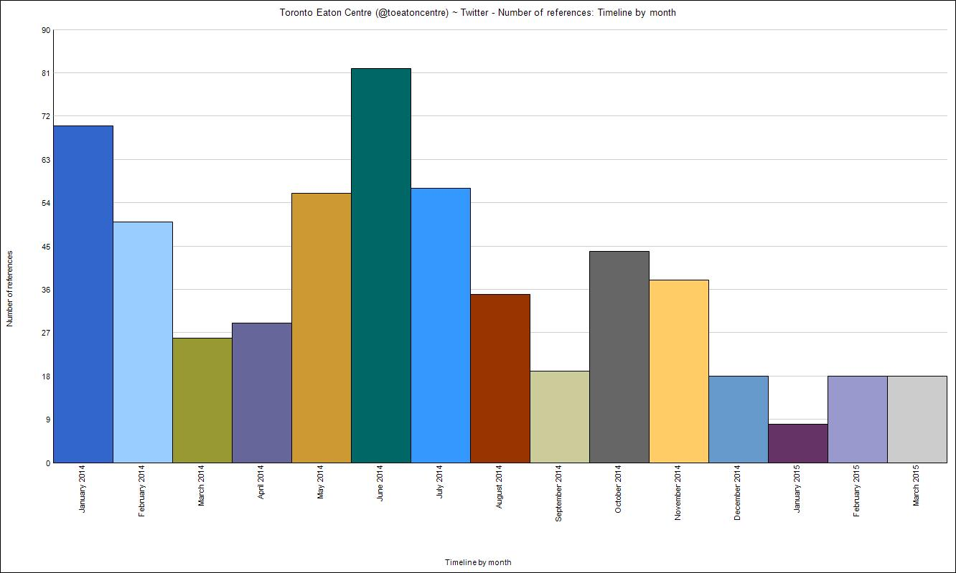
Figure 4 Twitter number of references by month to #ToTheCity

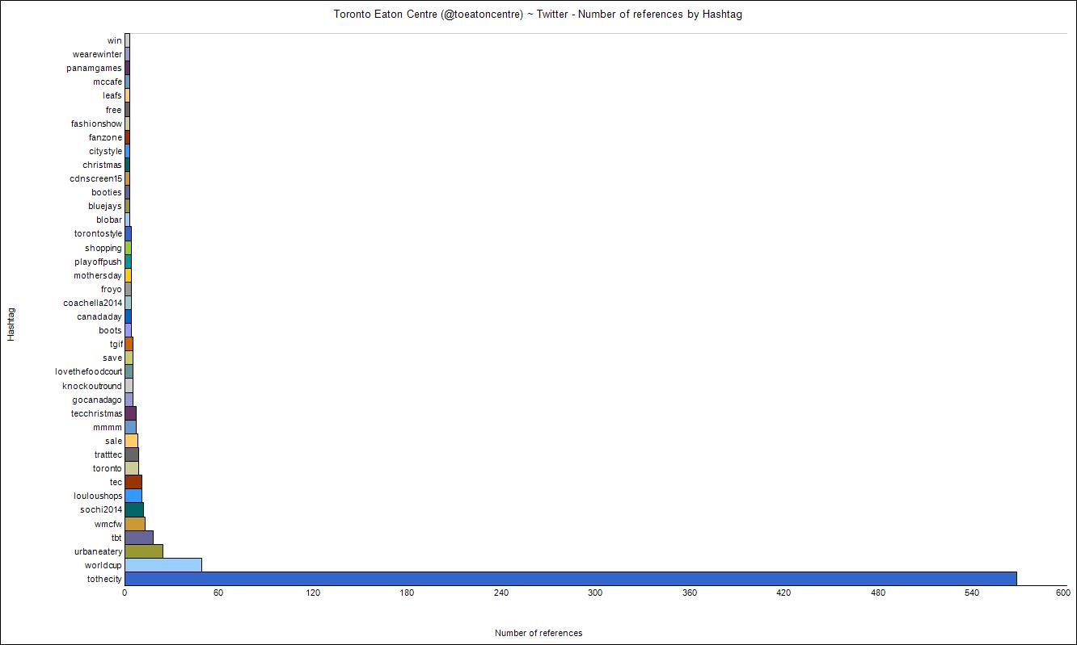
Figure 5 Number of references by Hashtag


Figure 6 Volume of connections #ToTheCity

The use of the hashtag #ToTheCity in the Toronto Eaton Centre social media campaigns emerges while a campaign was initiated to define what name the centre should be referred to. This is captured in a video released on January 8th, 2014. The opening of the short 1 minute 10 second video pitches it as a ‘… chat to with a few of our shoppers to see how much they know about us.’ In the remainder of the video, shoppers are asked the question: ‘What’s our full name?’.

We chatted with a few of our shoppers to see how much they REALLY know about Toronto Eaton Centre. Like many beloved landmarks, Canadians have established their own versions of our name. Similar to Timmies, The Skydome, and The Leafs, the use of our full name is rarity.

This year we will re-establish our true name, Toronto Eaton Centre, by revealing our NEW brand identity and celebrating with our guests throughout the year. #ToTheCity

The Toronto Eaton Centre is claiming what it deems to be its true identity and the video it plays outs as a re-educational tool for both the interviewees and the viewers. The duped interviewees demonstrating a level of ignorance to what the ‘correct’ name for the Toronto Eaton Centre is. It is an attempt by the brand managers and Centre owners to take back control of their name and eliminate the tendency amongst many Torontonians to refer to the centre by abridged names which are highlighted in the video such as ‘The Eaton Centre’. When this video was realised, the Centre is about to undergo one of the most significant changes in the centre since Eaton’s department Store was taken over by Sears which saw the Eaton’s name eventually removed from the Northern anchor of the centre. In this campaign, the name Eaton’s has been retained and it embraces the links that this site has had to the Eaton’s department store and the role it played in the history of Yonge Street. With the closing of Sears and the pending arrival of American retailer Nordstrom in its place there was further move away from the original history of this space looming on the horizon.


Image 83 Homepage of Toronto Eaton Centre 23 Sept 2014

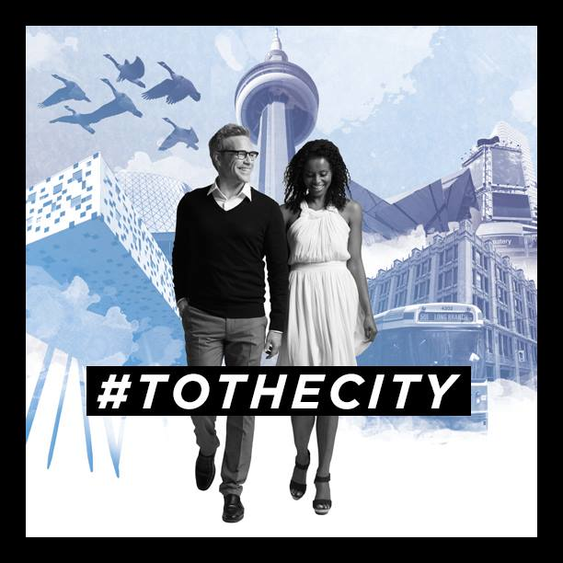
Image 84 #TOTHECITY promotional material

The Toronto Eaton Centre through the #ToTheCity campaign is re-affirming itself as a location which is at the centre of Life in the City in downtown Toronto. Despite the new anchors and new developments, it is reiterating its claim that it will be the centre of city life for Toronto. The hashtag #ToTheCity was used extensively throughout the centre in terms of interior and exterior hoarding. It was also used extensively on the website as illustrated in the images above. What is notable is that the imagery used is that from outside the centre. It is imagery of key Toronto landmarks and photographs taken of fashionable Torontonians on the streets of the city. It is an attempt to create a link to the fashion, tourism and culture that has blossomed outside the centre and in effect the Centre exteriorises the City.

The virtual spaces that have emerged through the social media presences of the Toronto Eaton Centre on Facebook and Twitter give users an opportunity to opt into a virtual community which has the ideal of being public and offer the possibility for dissent and subversion of the dominant neoliberal perspective that governs this type of space chapter, We have seen the impact that social media has in terms of online communities and the manner in which individuals can choose to opt in to the group. What we are seeing is a space which Allen (2006) describes as possessing a sense of publicness but is privately managed and there are limits on the type of behaviours that are acceptable here. In the analysis, post 1552 from the data gathered on 11/11/14 appears to be the last time that users were permitted to post to the page directly.

Post 1152 11/11/2014

I would love to spend a nice relaxing weekend with my daughter and my boyfriend’s daughters he is such a hard working single father who needs to be shown some love for that he does for the girls… true definition of a GREAT father

This comment on the Facebook page is in response to a competition where users were asked to post who they would like to spend a weekend with in Toronto. From this date onwards, users are limited to posting through comments on posts made by the Centre, but not permitted to start a new thread on the page. The page still gives the user the freedom to post freely in the review section. From this point onwards, the Toronto Eaton Centre could exert greater control on what posts were made to its pages and in turn maintain control over how the Centre was being portrayed to its friends and followers.

Chapter Eight Discussion & Conclusion

It has been discussed how the dominant approach embraced by Urban Planning in the revitalisation of the contemporary city has been a move towards neoliberal policies such as the entrepreneurial city and forms of new public management. The result is a city which prioritises public investment to turn the city, or sections of the city, into a vessel for attracting international mobile capital. With this shift, there is an increasing tendency towards spaces which are privately owned or managed as the municipal city relinquishes control to organisations which are motivated by revenue generation. The central argument is that the neoliberal city is dominated by consumption, and that dominant governance principles revolve around attracting forms of global capital that facilitate and bolster ‘globalised consumer culture. To evaluate the hypothesis, a case study of the development of downtown Toronto was conducted. The case acts as the foundation on which to base observations and assess whether the general understanding of the neoliberal city that has emerged in urban and sociological theory applies to a specific site. What became evident is that there is a tendency in the city to reshape and adjust itself to suit the prevailing political and economic doctrines.

Four iterations of in the development of the shopping centre were identified in this study. Using the extended case study of Toronto, it was demonstrated how these four iterations in the development were important stages in the genealogy of the neoliberal city. The period covered began with the development of the first enclosed arcades in Paris and London in the early eighteenth century. In Toronto, as in other industrial cities of the nineteenth century such as Paris and London, there was a reimagining of the city to suit newly emerging consumption cultures. This led to the development of shopping arcades, department stores and large-scale transportation systems which helped bring shoppers and workers to the commercial cores of the vast industrial city. This focus on the commercial core at the heart of the city continued up until the middle of the twentieth century when the focus shifts towards the suburbs.

The rise of the suburban enclosed mall is characterised by the rise of suburban individualism. These new hermetically sealed spaces acted as a pedestrian friendly city in miniature for suburban communities. With the shift to the suburbs, the central core is faced with issues of deindustrialisation and de-population. In many North American Cities, especially New York City, this developed into an ‘urban crisis’ in the 1970s as the combination of urban decline, economic upheaval, and the rise of neoliberalism. Offe (1993) describes this increasing influence of Neoliberal economics as the retreat of the Political Administrative system from many aspects of its role in regulatory services and provision of welfare. There is a consensus from the literature discussed that with the retreat of the political administrative system from public life, the balance is shifting towards urban spaces which are privately owned or managed.
The shift to the suburbs and the resulting decline in the centre of the City leads to the transplanting of the enclosed shopping mall downtown, to create new enclosed downtown areas in the centre of the city.

The final iteration that was discussed is characterised by the increasing dominance of the Neoliberal approach to city revitalisation. It is focused on the development of open-air shopping and entertainment spaces which created a consumption focused urban environment that becomes more like the enclosed shopping mall. In spaces such as Yonge Dundas square, which is managed by a QUANGO, the city street no longer acts as a public place where all citizens can interact freely. Instead, city authorities have relinquished control of this space to a board whose motivation is manage the square in an entrepreneurial manner. The square has become a tightly managed and controlled space for the ‘right type of public’. It offers a programme of events and is rented out to companies to display their wares. It is a hyperreal city square which offers a simulacrum of Times Square in downtown Toronto. It allows the citizen to interact with the world of the globalised consumer culture once they obey a specific set of rules governing their behaviour.

During the study, the key research question which was considered is the connection between the advent of and transformations in retail spaces in the city of Toronto to the emergence of neoliberal urbanism. The literature points to the emergence of the Neo-liberal city as the dominant trend that drove the reinvention of city centres which experienced industrial and commercial decline. In Toronto, there was a concerted effort by local authorities and the planning department from the mid-1950s to maintain the downtown area of the City as the Centre of commercial life. Strategic planning was evident in early indicative plans for the Eaton Department Store Site, with Project Viking and other long-term development goals set out in the construction of the city subway system. Unlike many other North American cities, Toronto encountered a highly successful urban preservation movement which triumphed in limiting the impact of highway construction on the downtown area such as the construction of the Spadina Expressway. Groups such as Friends of Old City Hall mobilized widespread support to prevent the demolition of Old City Hall. These efforts to preserve the downtown area became a central part of Planning in Toronto in the form the 1976 Central Plan

The 1976 Central Area Plan changed the way of thinking about planning in the City of Toronto. It was an example of the earliest efforts in the development of a mixed-use Retail Planning approach to the Main Streets in the Downtown area. The Plan was unique in North America in that it made a co-ordinated approach to creating greater linkages between residential and retail opportunities in the downtown area. The efforts to sustain an integrated approach to retail in the downtown area was re-iterated in the subsequent Cityplan ’91. However, the reality facing the Canadian and Toronto economies was to have an impact on the motivations and strategic aims of this plan. The recession which begun in 1989 and lasted up until the mid-1990s put pressure on local authorities and the planning department to engage in policies which promoted economic development and which could generate employment. There was a perceived decline in key areas of downtown, namely Yonge Street and the intersection with Dundas Street. Retailers, business owners and property investors made submissions to the consultation process for the new development plan urging the City to intervene.

With the election of the new Premier of Ontario Mike Harris, who came to power on a platform which promised to fix Ontario’s economy via huge tax cuts, the reduction of social programs, and the introduction of workfare and law-and-order measures we see the shift towards neoliberal forms of public management and the retreat of municipal government and in turn urban planning from public life. In the case study of Toronto, it became clear that there had been a trend towards the privatization of the spaces where public life is found in the downtown area beginning with the opening of the Toronto Eaton Centre in 1977. The recession of the early 1990’s and the election of Harris’s neoliberal ‘common sense reform’ government saw the increasing dominance of neoliberal approaches to public administration. This manifested itself in the political structures of the municipal government in Toronto. The doctrine of New Public Management was embraced as changes in the how the planning department was organised and new entities were created to manage revitalization in the city whose focus was on economic development and the generation of profit. The authority previously yielded by the political administration begun to be placed in the hands of government QUANGOs, property developers, Real Estate Investment Trusts (REITs), and architects to provide what the market demands.

How Neoliberal revitalization has recast the City

The hypothesis that materialized from the literature is that the contemporary City has been recast by Neoliberal urban policy as a site of profit accumulation, where the shape and structure constantly needs to be renewed to facilitate the capitalist appetite for growth and profit. The key finding which emerges from the study is that the balance shifted between public and private space in the city with the increasing influence of Neoliberal economics and the decreasing influence of the political administrative authorities. The result of this is that the city starts to resemble a suburban shopping mall with a veneer of local images and metaphors. Planners, City officials, and the public, no longer have control over the realities created in our towns and cities. Global retailers, international trends and the ever-present pursuit of the latest styles, fashions and the ‘ever-new’ are the driving forces in these spaces.

The downtown area of the City of Toronto, Yonge Dundas Square has become a site of engagement between the entrepreneurial city, new public management, and a venue for facilitating engagement with international mobile capital. As a publicly owned space which is managed by a board of the City of Toronto which is tasked with running the site for profit, the square is an architype of the of neoliberal urban planning approaches to urban revitalisation. The consensus that can be drawn from the case study discussed above is that in the City of Toronto, the balance shifted towards urban spaces which are privately owned or managed. Looking at this case, we can see how this can be problematic. planners, cities officials and the public, no longer have complete control over the spaces where life in public is conducted in our towns and cities. This has an impact on the types of activities that can be carried out in these spaces. It limits the space for protest and decent. It also can force restrictions on any type of activity which does not fit in with the uses that have been programmed for the space.

Figure 7 The shift balance between Public V Private since the nineteenth century shows that the city is a site of contested interests and perspectives
Figure 7 above is an illustration of the shift towards privately owned or privately managed spaces in the urban realm. What makes the Neoliberal City so dominant is that it tends to co-opt the dissent and incorporate it into the capitalist narrative. However, the Neoliberal city still has sites of resistance, and it is in these sites that have not yet been subsumed and co-opted into the capitalist system where we can find evidence of the problems that it creates. We can see beyond the ‘right type of people’ and look at those who are excluded. These counter narratives emerge and act as points of resistance to the dominant paradigm. In cities when you look carefully you will see sites of resistance. Some may be overt but some may be more obscure. The communities that inspire these resistance movements are no longer limited to geographical locations with the internet and social media.

The Neoliberal City and public life

With the increasing dominance of neoliberal approaches to revitalization in the city, we are seeing the increasing shift towards either the privately owned or private management of the spaces where public life is found in the contemporary city. The general principles of enclosure, sanitization and control characteristic of the arcade, have now come to organize city streets. As a result, planners, cities officials and the public, no longer have control over the spaces where life in public is conducted in our towns and cities. This has an impact on the types of activities that can be carried out in these spaces. It limits the space for protest and dissent. It also can force restrictions on any type of activity which does not fit in with the uses that have been programmed for the space. During the fieldwork, the impact of this was illustrated in the limits that have been placed on protest and political demonstration in downtown Toronto. The space for Political activity is restricted to a strip of pavement outside the Toronto Eaton Centre. This was where political pamphleting, religious preaching, and striking workers could be seen. These activities are not permitted inside the shopping centre or in the neighbouring Yonge Dundas Square. These are spaces for engagement with middle class consumption cultures, and any forms of protest or dissent is restricted and discouraged.

The growth of privately owned or managed spaces has an impact on the types of activities that can be carried out in the City. It limits the space for protest and decent. It also can force restrictions on any type of activity which does not fit in with the uses that have been programmed for the space. When the spaces where most people gather and experience a form of communal public life, activities which could interfere with the consumption activities are strictly discouraged. We can see this in the reaction to the ‘Idle No More’ flash mob from the Toronto Eaton Centre. In response to a post on the Facebook page criticising the protest, they reiterate that it is Toronto Eaton Centre ‘policy to limit large gatherings that may cause alarm or potential safety issues for our guests, including protests, flash mobs, sit-ins, etc. The policy is enforced by our onsite security team.’ In this case Civil Society is being problematized as a potential safety issue. It is being pushed to the margins in the privatised spaces of the contemporary city.

The Neoliberal city still has sites of resistance, and it is in these sites that have not yet been subsumed and co-opted into the capitalist system that we can see the limits of the definition of who constitutes the public space. These sites bring into focus the question of who has the right to occupy these spaces. The sites of resistance may be overt such as in the spaces where protest was observed on the pavement between the Toronto Eaton Centre and Yonge Dundas Square. Acts of resistance may also be more obscure and can transcend physical barriers with the use of social media and other technological mediums. These counter narratives emerge and act as points of resistance to the dominant paradigm. The communities that inspire these resistance movements are no longer limited to geographical locations with the internet and social media. These types of tactical movements were identified by Alinsky (1971) in Rules for Radicals which drew from personal experiences as a community organiser in Chicago in the 1960’s the methods Alinsky developed and practiced were described in his book as a guide on future community organizing for the new generation of radicals and they still hold true in the era of social media and instant communication. Examples of community activist groups in Toronto which use social media to reach out to mobilise communities include the Open Streets Project Toronto which emerged out of a movement that began in early 2010 and spread across North America, with a focus on examining the breadth and diversity of open streets initiatives in the United States and Canada. It’s stated goal is to share information about open streets and increase the number, size, and frequency of initiatives occurring across North America.

Open Streets programs take place in cities around the world, usually on Sunday mornings and typically last for about 4-6 hours. Participants can bike, run, rollerblade, hopscotch, do yoga, skateboard, unicycle ... you get the picture.
(www.opernstreets.org 2016)

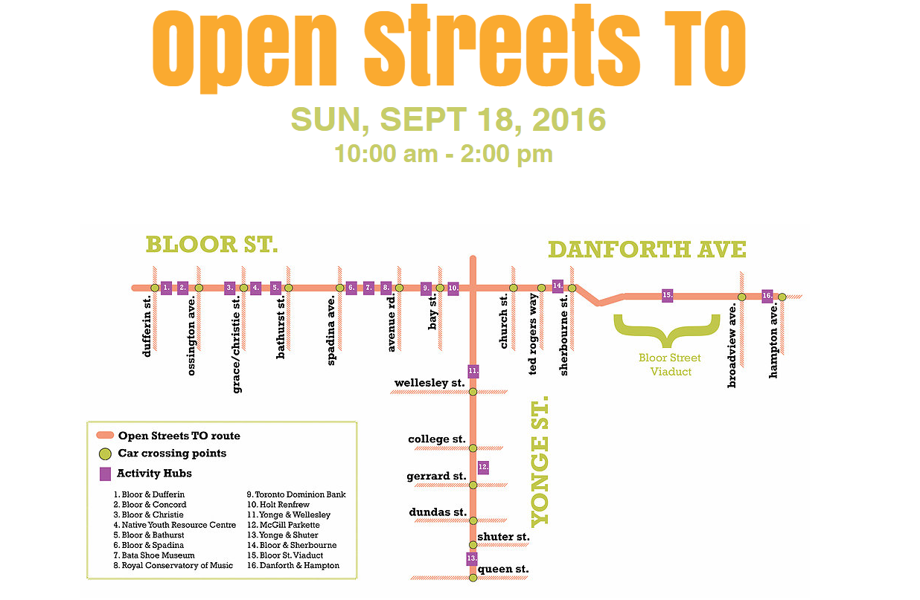
Image 85 Open streets TO

#OpenStreetsTO has run several events which involves taking over a street in the city for day or couple of hours. The event above involves briefly closing parts of Bloor & Yonge for four hours on a Sunday to give the street over to pedestrian, cyclists and other non-car uses. Business owners on the street are encouraged to get involved and hold activities on the street to provide a festival like atmosphere. This initiative is not led from the Planning department or local authority but by motivated members of the community. They have secured co-operation form the civic authorities but the responsibility for organising the event is outside of the political administration system.

Other examples of non-governmental organisations which have emerged include the Toronto Public Space Committee which states that it aims to ‘empower citizens to reclaim, democratise and beautify our public spaces’. This organisation has organised events such as chalk sidewalk art and campaigns to remove unwanted fences.
The common spaces we all share - our roads, sidewalks, alleyways and parks - are an opportunity to celebrate Toronto's creativity, diversity and innovation.
The way we use our public spaces reflects who were are as a community and what our values are. Our streets should be as expressive and dynamic as our hearts.
We are passionate volunteers, who love Toronto.
(http://www.publicspace.ca/ November, 2016)

Social media is used extensively by both non-governmental organisation to express their message and promote an alternative view of how public spaces should be used in the City.
These are operating the in space outside the political administrative system and are seeking to build a legitimate input into the way public space is managed. In a sense, these organisation are examples of the effect of the communicative turn in urban planning (Healey, 1992) which embraces the idea that participation is fundamental to the planning process happening. If Planning authorities make a decision without the involvement of concerned interests such as the residents and the concerned NGOs, it is a failure in the planning process.

There is a process of negotiation currently in play in relation to the future of parks and public spaces in Toronto. There is currently consultation underway by the City Planning Division for the drafting a Downtown Parks and Public Realm Plan. This is in context of the fact that the City has been expanding the public space inventory in the Downtown area through ‘Privately Owned and Publicly Accessible Open Spaces’ (POPS), which are an extracted public benefit from private development and is controlled through the development approvals process. As of 2015 there with over 100 POPS in the Downtown. The key aims of the plan are outlined below. City staff will:
- Undertake a Public Life Study in the Downtown to understand people’s needs and aspirations for public space and provide insight on how public life can be fostered through strategic investment in the public realm.

The important aspect of this aim is the categorisation of investment as strategic. It is an attempt to extract the greatest benefit from the minimal investment of public money. This will happen either by the further retrenchment of the political authority from funding public realm improvement and the resulting decline, or it will see increased private investment through initiatives like POPS which are designated public but are privately owned. The path that brought us to this is not only the shift towards neoliberal economic policies and new public management, but it has its roots in the rise of suburban individualism and the demise of the idea of universalism in terms of rights and responsibilities which can be linked back to the growth of suburbia from the 1950s onwards. As the city suffered the decline of deindustrialisation and de-population, it had to reinvent itself to reflect similar values.

The impact of suburban individualism and the demise of universal Utopian Dreams

The rise of the automobile suburb and the growth of the suburban shopping centre, is the key moment is the rise of a suburban individualism. During the mid-twentieth century, society became focused on satisfying the wants and needs of this new mobile consumer. This individual is typified as the ‘push-button’ consumer illustrated in the 1956 film/instructional movie ‘In the Suburbs’ for the magazine Redbook. This is a consumer who rolls their cart around the suburban malls of Hillsdale California or Southdale Minnesota, filling up their car with everything they need before returning to their suburban tract home. In this utopian promise, there is a greater perceived freedom being granted to the consumer to create their own ‘fantasy land’ where all their desires and wants are met. With a blank exterior and windowless shield from the outside world, it encourages the user to gaze inwards, at the plate glass windows of the stores that line its passageways. Helping to reinforce this sense of freedom is the Utopian promise that consumer society will satisfy your desire. It can be said that the ‘happiness machine’ is bound to live within a collective dreamworld where desires are constantly stimulated and satisfied. Ultimately, the individual may retreat deeper and deeper into the phantasmagorical realm of this privatized shopping agora. This is bound to have a negative effect on both society and the individual.

Full employment and the growth of universal benefits through the expanding Welfare State helped to fuel the dreams of mass car and home ownership. Beginning with federally mandated programmes to deal with the post-war housing crisis, this era shaped the development of towns and cities of North America for the next 30-40 years. The Utopian ideals which were behind the design of the Southdale Mall saw the open spaces of the suburbs as a tabula rasa upon which a new type of social life for the suburbs could be implanted. In terms of the dream of a mass utopian consumer society, the Southdale Mall also acted as an important symbol of what made the United States different from Soviet Russia. Mennel (2004) illustrates the concerns of the Cold War era that helped to shape the Southdale Centre. In the West during the twentieth and early twenty-first centuries, there has been a significant growth of Utopic consumer spaces. The consumption spaces such as the department store, became the site of transmission and reproduction of the consumer fantasy. The people which occupied these spaces (Hoover, 1928) were presented with the opportunity to achieve the ideal through shopping. In comparison with the Communist dream, the Western dreamworld is firmly individualistic and focused on satisfying the wants and desires of the individual. It becomes a society which aims to fulfil the wishes and desires of the autonomous happiness machines created by the advertising industry. The dreamworld of the East was that of collective struggle and effort. (Buck-Morss, p 181).
... this collective dream dared to imagine a social world in alliance with personal happiness, and promised to adults that its realization would be in harmony with the overcoming of scarcity for all.
Buck-Morss (2002., xi)
In a similar manner which Sennett (1994) outlines how the nakedness of the body in the agora of Ancient Greece acted as a marker of civilisation in contrast to the Barbarians, social relations within the Southdale Mall served to emphasise what made the United States different from the Soviet Union. The centre was not only the idealised shopping space, but also a complete insular community that could act as the template in the reimagining of an ideal capitalist society. This society was decentralised and focused on the satisfaction of individual desires. The commodity fetish was celebrated in the Southdale Mall in a manner like the plated glass displays of the arcade which brought the Utopian possibility of plenty closer to the city dwellers of nineteenth century Europe. With the rise of the enclosed shopping mall, suburban America gained their own version of the arcade on a larger scale with easy automobile access.

The enclosed shopping mall became a building morphology that spread across the world. We have now reached a situation where what has come to be known as the shopping mall has become a standard feature of life for most inhabitants of consumer society. The original Southdale Mall, which the architect Victor Gruen designed as something akin to an oasis of urbanity in suburban America was created to combat the post-war sprawl he saw drastically altering the urban structure of America. Instead, the shopping mall morphed into a highly controlled and regulated consumption space exacerbating the sprawl it was designed to combat. The dream became all encompassing. It enveloped every aspect of the human experience. It became a dreamworld in which the shopper is free to buy which ever product they wish, once they have the financial means to do so. There is a constant emphasis on the new because constant change allows hope that the future can be better. (Buck-Morss, 2002 p. x). It has shaped the development of spaces outside the home throughout the twentieth century. We saw the increasing fabrication of the spaces we spend our daily life. As the ruin of the city left behind by the shift to the suburbs new opportunities for c occur. This leads to the next generation of the privatised shopping spaces. The enclosed mall is re-appropriated and re-shaped to fit back into the city.

As people moved further and further out into the suburbs, some cities saw major decline in their traditional centres. Mass utopia has shifted towards a privatised individualised version of the good life in the suburbs.
Commodities have not ceased to crowd people’s private dreamworld; they still have a utopian on a personal level. But the abandonment of the larger social project connects this personal utopianism with political cynicism, because it is no longer thought necessary to guarantee to the collective that which is pursued by the individual. Mass utopia, once considered the logical correlate of personal utopia, is now a rusty idea. It is being discarded by industrial societies along with the earliest factories designed to deliver it.
Buck-Morss, (2002 p. X)
The closed factories and abandoned buildings are testament to how changing economic factors, such as cheaper foreign imports, an oil crisis, and subsequent economic decline can cause areas to fail and become deserted. But it also signifies the privatisation of the society. The role of Urban Planner was handed over to the developer or architect. The mass dreamworld which was promised after World War II began to fade and became a ‘rusty idea’

After Neoliberalism: The role of planning

The contemporary Planner needs to operate within the complex dynamics of the Neoliberal city with the increased emphasis on value for money and extracting the best outcome from public investment. This has resulted in the retreat of the political administrative authority from aspects of public life and the handing over of responsibility to Non-Governmental Organisations (NGOS), Quasi Autonomous Non-Government Organisations (QUANGOS) or private interests. If planning is to strive to create an inclusive city which benefits all its citizens it needs to focus on the groups and ‘publics’ who are not represented or are excluded from ‘public life’ and confined to the margins. We have seen how there has been a thread of confrontation and rebellion in terms of how space is used in Toronto from politically divisive sectarian marches in the nineteenth century to the efforts of the Urban preservation movement in the late 1960s and the early 1970s. What allowed these conflicts or counter narratives to emerge was that they had an outlet to voice and express their perspectives. In the Neoliberal City, any sort of activity which is political or interferes with profit generation is discouraged. Online outlets such as social media do offer the chance to broadcast dissenting messages but as we have illustrated in the evolution of how the Toronto Eaton Centre uses and manages its Facebook page, these can also be managed and controlled to present a choreographed image

Image 86 The role of the City Planning in the 21st Century should be as a marshal between competing interests

The role of Planning should be to balance the needs of competing interest groups in the contemporary city. It should grasp a marshalling role in the process of negotiation and discussion of the future form that urban life should take. Planners must recognise the impact of neoliberal approaches to urban planning to understand the impact that the management and government of these spaces can have on excluding certain groups from public life. The retreat of municipal power from providing universal services for the common good of citizens manifests itself clearly in the rise of the shopping mall and its progeny, the open-air shopping and entertainment area such as Yonge Dundas Square. When there are restrictions on how citizens can use a space, planners must consider the impact that this has on certain groups, especially those who are most vulnerable in society. If more and more of our city spaces are revitalised along Neoliberal lines to create space which are akin to exteriorised shopping malls which are strictly controlled and managed, there is a further distance being placed between the city and the citizen. It facilitates the development of a blasé attitude of suburban individualism in the city centre. It places the citizen further away from the issues of urban poverty and homelessness when they are occupying spaces on which there is strict control and management of the type of activities that can occur. It is recreating the city for the ‘right type of people’ to the detriment of those who cannot afford to engage in the consumer fantasy world that it strives to become.

The spaces of the neoliberal city which are outside of the traditional public ownership are not totalising. There is room for activities which are subversive but they can quickly be excluded either through restricting access or discouraging certain types of behaviour using surveillance or in terms of architectural designs. Citizens cannot be prevented from using spaces in a manner different from how it was initially intended to be used. When spaces are taken over by the public, it subverts the intended use. However, with the continued problematizing of civil society by discouraging protest and political activity in these spaces. It is being pushed to the margins in the privatised spaces of the contemporary city. In the research, there is evidence of the efforts that civil society continues in to carve out space with in which there is room for dissent and for a public sphere. The private interests of the property owner do not embrace the needs of the general population. In this type of society, Planning must assume the role as the protector of the counter narrative to maintain the values of the common good. The planner needs to re-affirm their responsibility to reconcile the needs of public and the private – protecting the common good and public interest.

Bibliography

- Adorno, T. and Horkheimer, M. 1944(1979) Dialectic of Enlightenment. London Allen Lane
- Arendt, H. 1958 The Human Condition. University of Chicago Press.
- Arpee, E. 1963 Lake Forest, Illinois; history and reminiscences, 1861-1961 Rotary
Club of Lake Forest: Chicago
- Auge, M. 1995 Non-places : introduction to an anthropology of supermodernity /
Marc Augé ; translated by John Howe. London: Verso
- Allen, J. 2006 Ambient power: Berlin’s Potsdamer Platz and the seductive logic ofpublic spaces. Urban Studies, 43(2), pp. 441–455.
- Avison Young, 2016 Canada’s Retail Landscape & Mall Performance (Last Accessed 1st November 2016 http://www.avisonyoung.com/fileDownloader.php?file=files/content-files/Research/Links/2016/CanadaRetailLandscapeMallPerformanceInfographic.pdf)
- Baggott, J. 2005 A Beginners Guide to Reality. Pegasus Books.
- Bailey, R. 1984 The Crisis Regime: The M. A. C., the E. F. C. B., and the Political Impact of the New York City Financial Crisis SUNY Press
- Baker, Alden, ‘Eaton’s refuses to revive $260 million development’ The Globe and Mail 20 May 1967
- Bateman, C. 2013 A brief history of the first shopping mall in Toronto [Last Accessed 23/10/2016 http://www.blogto.com/city/2013/06/a_brief_history_of_the_first_shopping_mall_in_toronto/]
- Bauman, Z. 2007 Consuming life Cambridge: Polity Press.
- Bauman, Z. (1993) ‘From pilgrim to tourist – or a short history of identity’. In S. Hall
and P.du Gay (eds) Questions of Cultural Identity, London: Sage, pp18-36
- Bauman, Z. 2006, Liquid Fear, Cambridge: Polity Press.
- Bauman, Z. 2000, Liquid Modernity, Cambridge: Polity Press.
- Baudrillard, J. 1988 America London:Verso
- Baudrillard, J. 1988 Consumer society. In M. Poster (ed). Jean Baudrillard. Selected
Writings, Cambridge: Polity Press, pp 26-43
- Baudrillard, J. 1988 Simulations. In Jervis, J. (ed.) Exploring the Modern, Oxford:
Blackwell Press: p 335.
- Baudrillard, J. 1983 Simulations Semiotext Inc.: New York.
- Baudrillard, J. 1994 Simulacra and Simulations. University of Michigan Press:
Michigan.
- Baudrillard, J. 2008 Simulation and Transaesthetics: Toward the Vanishing Point of
Art. In International Journal of Baudrillard Studies Vol. 4, No. 2.
- Baudrillard, J. 1991 The Gulf War did not take place; Translated by Patton, P. 1995.
Bloomington: Indiana University Press.
- Baudrillard, J. 1996 The System of Objects. Verso: London
- Beck, U. 1992 Risk Society, London: Sage.
- Beddington, N. 1982 Design for Shopping Centres London: Butterworth Scientific
- Benjamin, W. 1932 Excavation and memory [unpublished]
- Benjamin, W. 1936 The Work of Art in the Age of Mechanical Production. Last accessed December 17th 2013 [https://www.marxists.org/reference/subject/philosophy/works/ge/benjamin.htm]
- Benjamin, W. 1985 One-way street and other writings; translators, Edmund Jephcott,
Kingsley Shorter. London: Verso, 1985.
- Benjamin, W. 1999 The Arcades Project. Cambridge MA and London: Harvard
University Press.
- Benjamin, W. 1982 Unpacking my Library: A Talk about Book Collecting In
Illuminations, (Engl. trans.) London: Fontana
- Benjamin, Walter, 2003. The origin of German tragic drama; translated by John Osborne.New York : Verso
- Berchem, F.R. 1996 The Yonge Street Story, 1793-1860: An Account from Letters, Diaries and Newspapers
- Bernays, E. 1928 Propaganda (Last accessed 11 August 2010 http://www.historyisaweapon.org/defcon1/bernprop.html)
- Bernays, E. 1947 Engineering Consent
- Bernstein, W. and Cawker, R. 1982 Contemporary Canadian Architecture: The Mainstream and beyond. Fitzhenry and Whiteside Ltd. Ontario
- Best, Michael ‘$200 million complex in Queen-Bay Area’. The Toronto Daily Star, 15 April 1964
- Binnet, A. 1887 (1888 pub in English0 Animal Magnetism New York, D. Appleton and
company,
- Blackshaw, T. 2005 Zygmunt Bauman. Oxon: Routledge
- Bostrom, N. 2002, Existential Risks, In the Journal of Evolution and Technology,
(Last accessed 28th June 2009 http://www.nickbostrom.com/existential/risks.html)
- Bourdieu, P. 1984 Distinction: A Social Critique of the Judgement of Taste London:
Routledge and Hall.
- Bradbury, K., Downs, A, et. al. 1982 Urban Decline and the Future of American
Cities Washington D.C. The Brookings Institution.
- Brown 2006 American Nightmare: Neoliberalism, Neoconservatism, and De-
Democratization. In Political Theory, Vol. 34, No. 6 pps 690-714.
- Buck-Morss, S. 2002 Dreamworld and Catastrophe: The Passing of Mass Utopia in
East and West. Massachuesetts: MIT Press
- Buck-Morss, S. 1989 The Dialectics of Seeing: Walter Benjamin and the Arcades
Project Massachuesetts: MIT Press
- Buck-Morss, S. 1977 The Origin of Negative Dialectics. Sussex: The Harvester Press
Limited
- Bukatman, S. 1991 There’s Always Tomorrowland: Disney and the Hypercinematic
Experience. In October, Vol. 57 pp 55-78
- Buraway, M. 1998 The Extended Case Method. Sociological Theory, 16: 4–33.
- Catalano E. and Sonenberg, N. Consuming Passions: Help for Compulsive Shoppers.
Oakland: New Harbinger Publications, 1993.
- Burawoy, M. 1998 Uncertain Transition: Ethnographies of Change in the
PostSocialist World. Edited with Verdery, K. Lanham: Rowman and Littlefield.
- Burgess, A. 1962 A Clockwork Orange London: William Heinemann.
- Cadillac Fairview, c.1977 The Eaton Centre [Unpublished]
- Cadillac Fairview, 2010 Revitalisation Guide for Tenants. [Unpublished]
- Cadillac Fairview, 2013 Toronto Eaton Centre [www.torontoeatoncentre.com]
- Carr, S. [et al.]. 1993. Public Space. Cambridge: Cambridge University Press,
- Cooke, M. 2006 Re-Presenting the Good Society, MIT Press
- Coleman, 2006 Shopping Environments: Evolution, Planning and Design. Oxford:
Architectural Press.
- Christopherson, S. 1994 The Fortress City: Privatized Spaces, Consumer Citizenship,
in Post-Fordism: A Reader (ed A. Amin), Blackwell Publishers Ltd, Oxford, UK.
Chuihua Judy Chung, Jeffrey Inaba, Rem Koolhaas and Sze Tsung Leong, eds, Great Leap Forward, Harvard Design School Project on the City, 722 pp, Cologne 2002; and Guide to Shopping, Harvard Design School Project on the City, 800 pp, Cologne 2002.
- City of Toronto Planning Board (CTPB), 1958 Project Viking
- Crilley, D. (1993) Megastructures and urban change: aesthetics, ideology and design, in: P. L.
- Cox, 1993 The Local and the Global in the New Urban Politics: A Critical View
Knox (Ed.) The Restless Urban Landscape, pp. 127-164.
- CBC Digital Archives Website Satisfaction guaranteed. Last updated: Aug. 14, 2003
http://archives.cbc.ca/economy_business/consumer_goods/topics/377-2335/ [Page
consulted on Jan. 21, 2012.]
- CBC Digital Archives Jewel in the crown. Feb. 23, 1977 Website. Canadian Broadcasting Corporation. Last updated: Sept. 1, 2009.
203 http://archives.cbc.ca/economy_business/business/topics/377-2339/ [Page consulted on Jan. 21, 2012.]
- City of Toronto 2016. Historic Yonge Street Hetitate Conservation District Plan: Appendix D.
- Chamberlayne, P., Bornat, J. and Wengraf, T. 2000 The turn to biographical methods
in social science: comparative issues and examples. New York : Routledge,
- Curtis, A. 2004 The Power of Nightmares. BBC Documentary
- Cholodenko, A. 2004 “The Borders of Our Lives”: Frederick Wiseman, Jean
Baurdrillard, And the Question of The Documentary. In The International Journal of
Baudrillard Studies Vol. 1., No. 2.
- Clandinin, D.J. and Connelly, F.M 2000 Narrative Inquiry. Jossey-Bass Inc.,
Publishers: San Francisco.
- Collins, J. 1995. Architecture of Excess: Cultural Life in the Information Age.
London: Routledge.
- Coleman, P. 2006 Shopping Environments, Evolution, Planning and Design Architectural Press: Oxford.
- Colton, T. J. (1980). Big Daddy. Toronto, Ontario: University of Toronto Press
- Crawford, M. (1992) The World in a Shopping Mall. In Sorkin M. (ed.) Variations on
a theme park: the new American city and the end of public space. New York : Noonday Press, pp 3-30.
- CRAWFORD, M.,(2002), Suburban Life and Public Space, Sprawl and Public Space:
Redressing The Mall , ed. Smiley, D.J., Robbins, M., Princeton Architectural Press,
New York, USA, 21-30
- Deleuze G. and Guattari F., 1984, Anti-Oedipus: Capitalism and Schizophrenia,
London: Athlone.
- Dendy, W., Kilbourn, W. et al 1986 Toronto Observed: Its Architecture, Patrons, and
History Published by Oxford University Press, Toronto
- Dennis, R. 2006 Working Women Downtown: Single Women in Toronto 1900–1930. In London Journal of Canadian Studies Vol. 22: 2006/2007
- Denzin, N. 1991. Images of Postmodern Society, Social Theory and Contemporary
Cinema. Sage: London
- Denzin, N. and Lincon, Y. (2000) Handbook of Qualitative Research: Second Edition.
London: Sage Publications.
- DeSarbo WS and Edwards EA. “Typologies of Compulsive Buying Behaviour: A
Constrained Cluster-Wise Regression Approach.” Journal of Consumer Psychology
1996; 5: 231-252, 1996.
- Desmond, M. 2016 Evicted: Poverty and Profit in the American City. Crown: New York.
- Dick, P.K. 1969 UBIK New York: Doubleday
- Dicks, B., Mason, B., Coffey, A. and Atlinson, P. 2005 Qualitative Research and
Hypermedia: Ethnography for the Digital Age. Sage: London.
- Douglas, M (1996) Thought Styles: Critical Essays on Good Taste, London: Sage.
- Drache, D. 2008 Defiant Publics The Unprecedented Reach of the Global Citizen,
Polity Press Cambridge
- Dufour, D.R. 2008 The Art of Shrinking Heads Polity Press: Cambridge
- Dunleavy P and Hood C (1994) From old public administration to New Public Management. Public Money and Management 14(3): 9–16.
- Dyer, S. 2003 Designing “Community” in the Cherry Hill Mall: The Social Production of a Consumer Space. In Perspectives in Vernacular Architecture Vol. 9 Constructing Image, Identity and Place. Pp 263-275
- Edwards, T. 2000 Contradictions of Consumption: concepts, practices and politics in
consumer society. Buckingham: Open University Press.
- Elliott, R. 1994 “Addictive Consumption: Function and Fragmentation in Postmodernity.” Journal of Consumer Policy, 17, 159-179,
- Faber, R. J., O’Guinn, T. C. and Krych, R. “Compulsive Consumption.” Advances in
Consumer Research, 14, 132-135, 1987.
204
- Federal Works Agency. "2nd Annual Report." Washington, D.C.: GPO, 1941
- Ferlie, E. 1996 The New Public Management in Action Oxford: Oxford University Press
- Fischler, R. 1998 Toward a genealogy of planning: zoning and the Welfare State. In Planning Perspectives, 13:4, 389-410
- Flinders M 2008 Delegated Governance and the British State. Oxford: Oxford University Press.
- Florida, R. 2002. The rise of the creative class: and how it's transforming work, leisure, community and everyday life. New York, NY, Basic Books.
- Florida, R. 2005 Cities and the Creative Class. Psychology Press
- Fratianni M., Marchionne F. (2009), The Role of Banks in the Subprime Financial Crisis On SSRN: (last accessed 28th June 2009 http://papers.ssrn.com/sol3/papers.cfm?abstract_id=1383473)
- Foucault, M. 1971 Nietzsche, Genealogy, History. In Theory and Method (https://noehernandezcortez.files.wordpress.com/2011/04/nietzsche-genealogy-history.pdf) Last Accessed August 15th 2017
- Foucault, M. 1972 Power/Knowledge. In Seidman, S. & Alexander, C. [eds.] 2001 The New Social Reader. London: Routledge
- Foucault, M. 1991 Discipline and punish: the birth of the prison ; translated from the French by Alan Sheridan. London: Allen Lane.
- Fredriksson, C. The making of a Swedish Department Store Culture: In Falk, P. et. Al. 1997 The shopping Experience.
- Freud, S. 1899 [1975] The Interpretation of Dreams Harmondsworth: Penguin
- Freud, S.1920 A General Introduction to Psychoanalysis
- Freud, S.1920 Beyond the Pleasure Principle
- Freud, S. 1923 Ego and ID
- Freud, S. 1930 Civilization and its Discontents
- Frisby, D. and Featherstone, M. (eds) 1997 Simmel on culture : selected writings.
Imprint London: Sage, 1997.
- Friskin, F. 2007The Public Metropolis: The Political Dynamics of Urban Expansion in the Toronto Region, 1924-2003‬ Canadian Scholars’ Press, Political Science‬‬‬‬‬‬‬‬‬‬‬‬‬‬‬‬‬‬‬‬‬‬‬‬‬‬‬‬‬‬‬‬‬‬‬‬‬‬‬‬‬‬‬‬‬‬‬‬‬‬‬‬‬‬‬‬‬‬‬‬‬‬‬‬‬‬
- Fukuyama, F. 1992 The End of History and the Last Man Harmondsworth: Penguin.
- Gador, M. 2003 Global Civil Society: An Answer to War. Cambridge: Polity Press.
- George, A. & Bennett, A. 2004 Case studies and theory development in the social
sciences. Imprint Cambridge: London
- Garner, H. 1968 Cabbagetown: A novel. Ryerson Press
- Genosko, G. 1998. Undisciplined Theory. London: Sage
- Genosko, G. 1994 Baudrillard and signs: Signification Ablaze. London: Routledge
- Gillette Jr, H. (1985) The Evolution of the Planned Shopping Center in Suburb and City, Journal of the American Planning Association, 51:4, 449-460,
- Gillham, B. 2000 Case Study Research Methods. London: Continuum.
- Gilloch, G. 1996 Myth and Metropolis Cambridge: Polity Press. p 92
- Goodchild, P. 1996 Deleuze and Guattari London: Sage
- Gladwell, M. 2004 The Terrazzo Jungle The New Yorker March 15, 2004 [http://www.newyorker.com/magazine/2004/03/15/the-terrazzo-jungle] Last Accessed 02/01/2017
- Goffman, E. 1959. The Presentation of Self in Everyday Life. Anchor Books
- Goheen, P G. 1994 Negotiating access to public space in mid-nineteenth century Toronto
- Goss, J 1999 Once-Upon-a-Time in the Commodity World: An Unofficial Guide to
Mall of America. In Annals of the Association of American Geographers, Vol. 89, No.
1 pp 45-75.
- Goss, J. 1993 The ‘Magic of the Mall”: An Analysis of Form, Function and Meaning
in the Contemporary Retail Built Environment. In Annals of the Association of
American Geographers, pp. 18-47. Journal of Historical Geography 20.4 (Oct 1, 1994): 430.
- Gottdiener, M. 1982 Disneyland: A Utopian Urban Space Journal of Contemporary Ethnography July 1982 Vol. 11 no. 2 pps 139- 162
- Gottdiener, M. 1986 The City and the Sign Columbia University Press
- Girard, R. 1976 Deceit, Desire, and the Novel: Self and Other in Literary Structure.
Translated by translated by Yvonne Freccero.
- Girard, R. 1977 In Mimesis, Masochism, & Mime: The Politics of Theatricality in
Contemporary
- Grandin, G. 2009 Fordlandia: The rise and fall of the Forgotten Jungle City. New York:
Henry Holt and Company.
- Gray, J. 2007 Black Mass: Apocalyptic Religion and the Death of Utopia London: Penguin Books
- Graham T. 1993 "Restructuring Toronto: Post-Modern Culture and the Creation of the Space Economy of Post-Fordism In Problématique (http://www.yorku.ca/problema/Issues/Problematique0306.pdf)
- Greenberg, K. 2011 Walking Home: The Life and Lessons of a City Builder. Toronto: Random House Canada.
- Gruen, V. 1965 The heart of our cities: The urban crisis: diagnosis and cure, Thames and Hudson, London.
- Gruen, V. 1972 Downfall and Rebirth of City Cores on Both Sides of the Atlantic, Los Angeles: Gruen Foundation for Environmental Planning,
- Gruen, V. and Smith, L. 1960 Shopping Towns USA Rheinhold Publishing
- Hollands, R. G. 2008 Will the real smart city please stand up? Intelligent, progressive or entrepreneurial ? City 12 (3): 303-320
- Hood, C. 1991 A Public Management for All Seasons‟ Public Administration, 69 (1), pp. 3-19.
- Howard, E 1902 Garden Cities of To-morrow,
- Howard, E. 1965 Garden cities of tomorrow Faber and Faber
- Haase, U. 2008 Starting with Nietzsche Continuum: London
- Harris, N. 2000 Practice Through a Lens: A Metaphor for Planning Theory. In
Journal of Planning Education and Research Vol 19 p.309.
- Harvey, D. 1989 “From Managerialism to Entrepreneurialism: The Transformation in Urban Governance in Late Capitalism.” Geografiska Annaler. Series B, Human Geography, vol. 71, no. 1, 1989, pp. 3–17. JSTOR, www.jstor.org/stable/490503.
- Harvey, D. 2000 Spaces of Hope. University of California Press: Berkeley.
- Harvey, D. 2003 Paris, Capital of Modernity Taylor & Frances: New York
- Harvey, D. 2008 The right to the city New Left Review 53, September-October 2008
- Harvey, D. 2010 The Enigma of Capital Profile Books Ltd.: London
- Hopkins, J. 1990 West Edmonton Mall: landscape of myths and elsewhereness. In
Lowe, M. and Wrigley, N. (eds) Reading Retail: A geographical perspective on
retailing and consumption spaces, London: Arnold, p222.
- Hourihane, A. 2000 She moves through the Boom, Dublin: Sitric Books Ltd.
- Huges, E. W. 1970 The Humble and the Proud: The Comparative Study of Occupations. Sociological Quarterly, Vol. 11: pp. 147–156.
- Huton, J. 1963 Across the Face of France: Liberation and Recovery 1944-1963.
Indiana: Purdue University Press.
- International Council of Shopping Centres, 2004 Shopping Centre Categories
(http://www.icsc.org/srch/lib/USDefinitions.pdf Last accessed 20/08/2008)
- Jacobs, J. 1958, Downtown is for People. In Fortune Magazine, Republished
September 18th 2011 Last Accessed 03/09/2014
[http://fortune.com/2011/09/18/downtown-is-for-people-fortune-classic-1958/]
- Jacobs, J 1961, The life and Death of Great American Cities
- Jacobs, J. 1969 The economy of cities. Vintage Books, New York.
- Jacobs, J. 1984 Cities and the wealth of nations. Random House, New York.
- Jacobs, J. 2000 The nature of economies. Modern Library, New York
- Jackson, K. 1996 All the World’s a Mall: Reflections on the Social and Economic
Consequences of the American Shopping Center. In The American Historical Review,
Vol. 101, No. 4, pp. 1111-1121.
- Jackson, K. 2011 ‘The Drive-In Culture of Contemporary America” In Gedes, R and Stout, F.2011 The City Reader New York: Routledge. p. 66
- James, O. 2008 Affluenza London: Vermilion.
- Jameson, F. 2007. Archaeologies of the Future: The Desire Called Utopia and Other Science Fictions. Verso: London
- Jameson, F. ‘Cognitive Mapping’, Marxism and the Interpretation of Culture, In Nelson, C. and Lawrence Grossberg (eds.) Urbana: University of Illinois Press p 353.
- Jameson, F. 2003 Future City. In New Left Review Vol. 21. pp 65-79.
- J.C. Williams Group, 2015 TOCore Planning Downtown Retail and Service Commerical Land Use Study Appendix C: Retail Historical Context
- Jervis, J. (1998) Exploring the Modern Oxford: Blackwell Publishers.
- Kayden, J. Et Al. 2000. Privately Owned Public Space: The New York City Experience. John Wiley & Sons: New York
- Karrholm, M. 2008. The Territorialization of a Pedestrian Precinct in Malmo. Urban
Studies, 45:9 pp. 1903 -1924
- Karrholm, M. 2009. To the Rhythm of Shopping, on Synchronisations in Urban
Landscapes of Consumption. Social and Cultural Geography, 10: 4 pp. 421 -440
- Kitchin, R., Gleeson, J. et al 2010 A Haunted Landscape: Housing and Ghost Estates
in Post-Celtic Tiger Ireland. NIRSA (Last retrieved 18.08.2010:
http://www.nuim.ie/nirsa/research/documents/WP59-A-Haunted-Landscape.pdf)
- Kirwan, M. 2005 Discovering Girard Imprint Cambridge, Mass: Cowley
Publications.
- Kohn, M. 2004 Brave New Neighborhoods – The Privatization of Public Space. New
York: Routledge.
- Koolhaas, R. and Mau, B. 1998 Small, medium, large, extra-large: edited by Jennifer
Sigler ; photography by Hans Werlemann. Office for Metropolitan Architecture, New
York: Monacelli Press
- Koolhass, R. 2001 Junkspace [Last Accessed 31/12/2016: http://www.cavvia.net/junkspace/)
- Kuhling, C and Keohane, K. 2007 Cosmopolitan Ireland: Globalisation and Quality
of Life. London: Pluto Press.
- Kurzweil, R. 2005. The Singularity is Near. New York: Viking Books.
- Kutner, P. 2012 Case Study: Idle No More and the Round Dance Flash Mob
(Last Accessed 07/11/2016 http://beautifultrouble.org/case/idle-dance-flash-mob/)
- Lakoff, G. and Johnson, M. 1980 Metaphors We Live By. London: The University of
Chicago Press.
206
- Landry, C. and, Bianchini, F.1995 - Cities and towns – Demos
- Landry, C. 2000, The creative city : a toolkit for urban innovators, Comedia : Earthscan, Near Stroud, U.K
- Langford, M, 2014 Michael Snow: life & work Art Canada Institute
Massey College, University of Toronto http://www.aci-iac.ca/michael-snow/key-works/flight-stop
- Lambton, G. 1994 Stealing the Show: Seven Women Artists in Canadian Public Art. McGill-Queen’s Press.
- Le Gates, R. and Stout F. [eds] The City Reader Fifth edition Routledge London
- Lefebvre, H. 1991 (translated by Nicholson-Smith, D.) The Production of Space
Oxford: Basil Blackwell Inc.
- Lemon, J.T. 1985 Toronto Since 1918 James Lorimer & Company
- Levine, A. 2014 Toronto: Biography of a city. Douglas & McIntyre: Maderia Park.
- Levitas, R. 1990 The Concept of Utopia. Hertfordshire: Philip Allan
- Liebow, E. 1967 Tallys Corner. Rowman & Littlefield Publishers: Oxford
- Lowe, M. and Wrigley, N. 1996 Retailing, Consumption and Capital. Towards the
New Retail Geography. London: Longman.
- Lupton, D. 2003 Medicine as culture: illness, disease and the body in Western
societies London Thousand Oaks, CA: Sage Publications.
- Lukas, G 1923;1971 History and Class Consciousness: Studies in Marxist Dialectics
The Merlin Press
- Lloyd Wright, F. 1932 The Disappearing City. W. F. Payson: Michigan.
- Lynch, K. 1960 The Image of the City Cambridge: MIT
- Lynd, R. & Lynd, H. 1929 Middletown: A Study in American Culture. Harcourt Brace & Worldv
- Marcuse, H. 1964 One Dimensional Man London Sphere
- Marx, K. 1848 The Communist Manifesto
- Marx, K 1859 (1973) The Grundrisse Last accessed 03/08/2014 [https://www.marxists.org/archive/marx/works/1857/grundrisse/]
- Marx, K. 1867 Das Kapital Vol. 1 Marx/Engels Internet Archive (marxists.org) 1995, 1999 [Last accessed 03/09/2014 https://www.marxists.org/archive/marx/works/1867-c1/]
- Marx, K. 1977 A Contribution to the Critique of Political Economy. Moscow:
Progress Publishers: Marling, S. American Affair: The Americanisation of Britain London: Boxtree, 1993
- McElroy, SL, Phillips KA, Keck PE, Jr. “Obsessive Compulsive Spectrum Disorder.”
Journal of Clinical Psychiatry; 55[10, suppl]: 33-51,1994
- Mennel, T. 2004 Victor Gruen and the Construction of Cold War Utopias Journal of
Planning History May 2004 vol. 3 no. 2 116-150
- Miles, M 1997 Art, Space and the City London: Rutledge
- Miles, S. and Miles, M. 2004 Consuming Cities Hampshire: Palgrave Macmillan
(Zukin and Smith-Maguire, 2004
- Miles, S. 2012 The neoliberal city and the pro-active complicity of the citizen consumer Journal of Consumer Culture Vol 12, Issue 2, pp. 216 - 230
- Miller, D. (et al.) 1998 Shopping, Place and Identity. London: Routledge
- Mitchell, D. 1995. The End of Public Space? Peoples Park, Definitions of the Public, and Democracy. In Annals of the Association of American Geographers, Vol. 85, No. 1. pp 108- 133.Mort, F. 1996 Cultures of Consumption: Masculinities and Social Space in Late Twentieth Century Britain. London: Routledge.
- Minnesota Encyclopedia, Minnesota Historical Society. "Southdale Center." Accessed August 24, 2014. http://mnopedia.org/structure/southdale-center
- Minton, A. 2009; 2012 Ground Control: Fear and Happiness in the Twenty-First Century City. London: Penguin
- Moses, R. 1942 ‘What Happened to Haussmann?’, Architectural Forum, vol. 77 (July 1942), pp. 57–66.
- Newman, M., 1989 Postmodernism. In Jervis, J (ed.) Exploring the Modern, Oxford: Blackwell Press: p 335.
- Norris, T. 2005. Consuming Signs, Consuming the Polis: Hannah Arendt and Jean Baudrillard on Consumer Society and the Eclipse of the Real. In The International Journal of Baudrillard Studies Vol. 2, No. 2
- Norris, T. 2004 Hannah Arendt and Jean Baudrillard: pedagogy in the consumer society In The Encyclopedia of Informal Education, (Last accessed 28.th June 2009 www.infed.org/biblio/pedagogy_consumer_society.htm).
- O'Connell, C. 2011 'Citizenship and Social Exclusion in Limerick' In: Understanding Limerick: Social Exclusion and Change. Cork: Cork University Press.
- Offe, C. 1993 Contradictions of the Welfare State. Mit Press
- Ontario Industrial Loan and Investment Company, 1884 Arcade Guide and Record University of Alberta Microfilm record [Last Accessed 23/10/2016 https://archive.org/details/cihm_00820]
- Osbaldeston 2008 Unbuilt Toronto: A history of the city that might have been. Toronto: Dundrun
- Packard, V. 1960 The hidden persuaders Harmondsworth: Penguin,.
207
- Peck, J. 2005, Struggling with the Creative Class. International Journal of Urban and Regional Research, Vol.29: pp. 740–770
- Perry, N. 1998. Hyperreality and Global Culture. London: Routledge.
- Pinder, D. 2005 Visions of the City Edinburgh University Press Ltd.: Edinburgh
- Putman, R. 2000 Bowling alone: the collapse and revival of American community.
New York : Simon & Schuster.
- Radke, N. 2005 Simveillance in Hyperreal Las Vegas. In The International Journal of
Baudrillard Studies Vol. 2., No. 2.
- Ridgway NM, Kukar-Kinney M, Monroe K. “An expanded conceptualization and a
new measure of compulsive buying.” In Journal of Consumer Research, 35, #4, 350-
406, Dec. 2008.
- Reeve A. and Simmonds R. 2001. ‘Public Realm as theatre: Bicester village and
universal city walk. In Urban Design International, Vol. 6 no. 3-4 p 173-190.
- Robinson, W. 1998 Beyond Nation-State Paradigms: Globalization, Sociology, and the challenge of transnational studies in Sociological Forum, Vol. 13, No. 4
(December 1998) pp 561- 594.
- Rowe, P. 1999 Civic Realism MIT Press
- Ruppert, E. S. 2006 The Moral Economy of Cities: Shaping Good Citizens University of Toronto Press‬‬‬‬‬‬‬‬‬‬‬‬‬‬‬‬‬‬‬‬‬‬‬‬‬‬‬‬‬‬‬‬‬‬‬‬‬‬‬‬‬‬‬‬‬‬‬‬‬
- Scarbrough, E., Tanembaum, E. (eds.) 1998. Research Strategies in the Social
Sciences – A Guide to New Approaches. Oxford: Oxford University Press.
- Sennett, R. 1977. The fall of Public Man. Cambridge University Press: Cambridge.
- Sewell, J 1993 The Shape Of The City: Toronto Struggles With Modern Planning University of Toronto Press: Toronto
- Sewell, J. 2015 How We Changed Toronto The inside story of twelve creative, tumultuous years in civic life, 1969-1980
- Shields, R. 1992 [Ed.] Lifestyle shopping: the subject of consumption Routledge: London
- Shields, R. (1989) Social spatialization and the built environment: The West Edmonton Mall, Environment and Planning D: Society and Space 7 (2): 147
- Simmel, G. 1903 The Metropolis and Mental Life In Gary Bridge and Sophie Watson,
eds. The Blackwell City Reader. Oxford and Malden, MA: Wiley-Blackwell, 2002.
- Simmel, G. 1907 The philosophy of money (edited by Frisby, D. 1990) London
Routledge
- Slattery, D. 2008. Engaging Baudrillard – Papers from Swansea. Minding the Gaps
(Epistemological and Modern) On Dublin’s New Light-Rail System. In The
International Journal of Baudrillard Studies Vol. 5, No. 1.
- Smith, D. E. 1987 The Everyday World as Problematic: A Feminist Sociology. Northeastern University Press: Boston
- Smith, G. [Ed.] 1991 On Walter Benjamin: Critical Essays and Recollections.
Massachusetts: MIT Press.
- Smith, M.P. 1992 Postmodernism, Urban Ethnography, and the New Social Space of
Ethnic Identity. In Theory and Society Vol. 21 No.4. pp. 493-531.
- Smyth, W. J. 2015 Belfast the Toronto, the Belfast of Canada: The Orange Order and the Shaping of Municipal Culture. University of Toronto Press
- Soja, E. 1997 Planning in/for Postmodernity. In Benko, G. And Strohmayer, U. (eds)
1997 Space and Social Theory: Interpreting Modernity and Postmodernity. Blackwell
- Soja, E. 1989 Postmodern geographies: the reassertion of space in critical social
theory. London: Verso.
- Soja, E. and Scott, A. (eds.) 1998 The City Los Angeles and Urban Theory at the End
of the Twentieth Century. London: University of California Press Ltd.
- Solomon, L. 2007 Introduction: Greater Toronto, circa 1900, before the Era of Sprawl. In Toronto Sprawls: A History (pp. 3-8). University of Toronto Press. Retrieved from http://www.jstor.org/stable/10.3138/9781442685062.6
- Sontag S., 1979, Illness as Metaphor, London: Allen Lane.
- Sorkin, M. (ed.) 1992 Variations on a Theme Park. New York: Noonday Press
- Strange, C. 1995 Toronto’s Girl Problem: The Perils and Pleasures of the City, 1880–1930. University of Toronto Press: Toronto
- Taschner, M 1982 Boomerang Boom: San Diego 1941-1942 In The Journal of San Diego History San Diego Historical Quarterly Winter
1982, Volume 28, Number (Last Accessed October 14th 2014 http://www.sandiegohistory.org/journal/82winter/index.htm)
- Varman R. and Belk W. 2011 Consuming Postcolonial identities in India. In Journal
of Marketing Management, 28:1-2, 62-84
- Survey of London 'Burlington Arcade', Survey of London: volumes 31 and 32: St James
Westminster, Part 2 (1963), pp.430-434. Last accessed 02/03/2014 [ http://www.british-history.ac.uk/report.aspx?compid=41483].
208
- Tabb, W. 1982 The Long Default: New York City and the Urban Fiscal Crisis, New York
- Toronto Housing Company, Ltd. 1913 Better housing in Canada. "The Ontario plan." First annual report of the Toronto Housing Company, limited. [Toronto]
- Underhill, P. 2005. The Call of the Mall. Simon & Schuster: New York.
- Weaver, J 1977 Shaping the Canadian City: Essays on Urban Politics and Policy, 1890 -1920 Institute of Public Administration of Canada
- White, R. 2016 Planning Toronto: The Planners, The Plans, Their Legacies, 1940-80
- Whitlock, 2005 T. Crime, Gender, and Consumer Culture in Nineteenth-century England Ashgate Publishing Ltd. Hampshire.
- Whyte, W.H. 1943 Street Corner Society. University of Chicago Press.
- Whyte, W.H. & Underhill, P. 1988. City: Rediscovering the Center. University of Pennsylvania Press,
- Wilson, E. 1991 The Sphinx in the City: Urban Life, the Control of Disorder, and Women. University of California Press: London.
- Wolf, M. 1999. The Entertainment Economy: How Mega-Media Forces are
transforming our Lives. London: Penguin Books.
- Wright, F. L. 1932 The Disappearing City. New York, W. F. Payson,
- Yin, R. 2009 Case Study Research Design and Methods 4th Edition Sage: London
- Yonge Dundas Square, 2016 Why a Square? (Our Purpose) (Last Accessed 15/11/2016 https://www.ydsquare.ca/all-about-the-square/why-a-square-our-purpose.html)
- Yoon, H. & Srinivisan, S. 2014 Are They Well Situated? Spatial Analysis of Privately Owned Public Space, Manhattan, New York City. Urban Affairs Review Vol 51, Issue 3, pp. 358 – 380
- Young W. And Young N. 2007 The Great Depression in America: A Cultural
Encylopedia Volume 1 Connecticut: Greenwood Press.
- Zeidler, E. 2013 Buildings Cities Life: An Autobiography in Architecture, Volume 2 Toronto: Dundrun
- Zimmerman, J. 2008 From brew town to cool town: Neoliberalism and the creative city development strategy in Milwaukee. Cities Volume 25, Issue 4, pp. 230-242
- Zukin, S. 1995. The Culture of Cities. Oxford: Blackwell.

Appendix 1: Archive of the evolution of the Toronto Eaton Centre Website

It was possible to retrieve data from past iterations and publications of the Eaton Centre Website through the use of the Wayback Machine [www.archive.org]. This is a digital archive of the World Wide Web and other information on the Internet created by the Internet Archive. Since 1996, the Wayback Machine has been archiving cached pages of websites onto its large cluster of Linux nodes. It revisits sites every few day, weeks or months and archives a new version. Sites can also be captured on the fly by visitors who enter the site's URL into a search box. The value of this archive is that is allows the capture and archival of content that otherwise would be lost whenever a site is changed or deleted. The grand vision of the machine's creators is to archive the entire Internet.

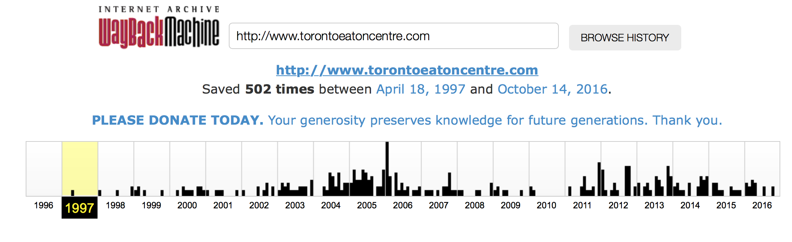

This calendar view maps the number of times http://www.torontoeatoncentre.com was crawled by the Internet Wayback Machine. It does not record the amount of times the site was actually updated but takes a snapshot of the page and archives it. There were over 500 captures of this site from 18th April 1997 up until 14th October 2016. There is a good spread of data available for this site. Having analysed the 502 captures of the site over the period outlined above, the key changes in terms of the appearance and functionality of the site are outlined in the images below. They show not only the evolution of website design and changing Content Management System technology, but it also shows how the technology was used to engage with visitors to the mall and foster a sense of place and community for the shopping centre.

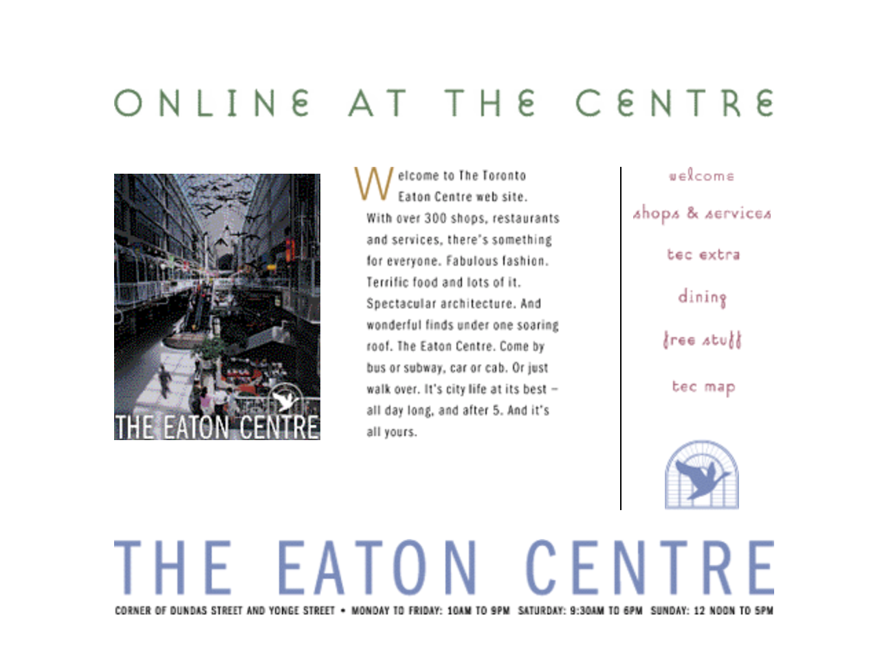
Apr 18th 1997

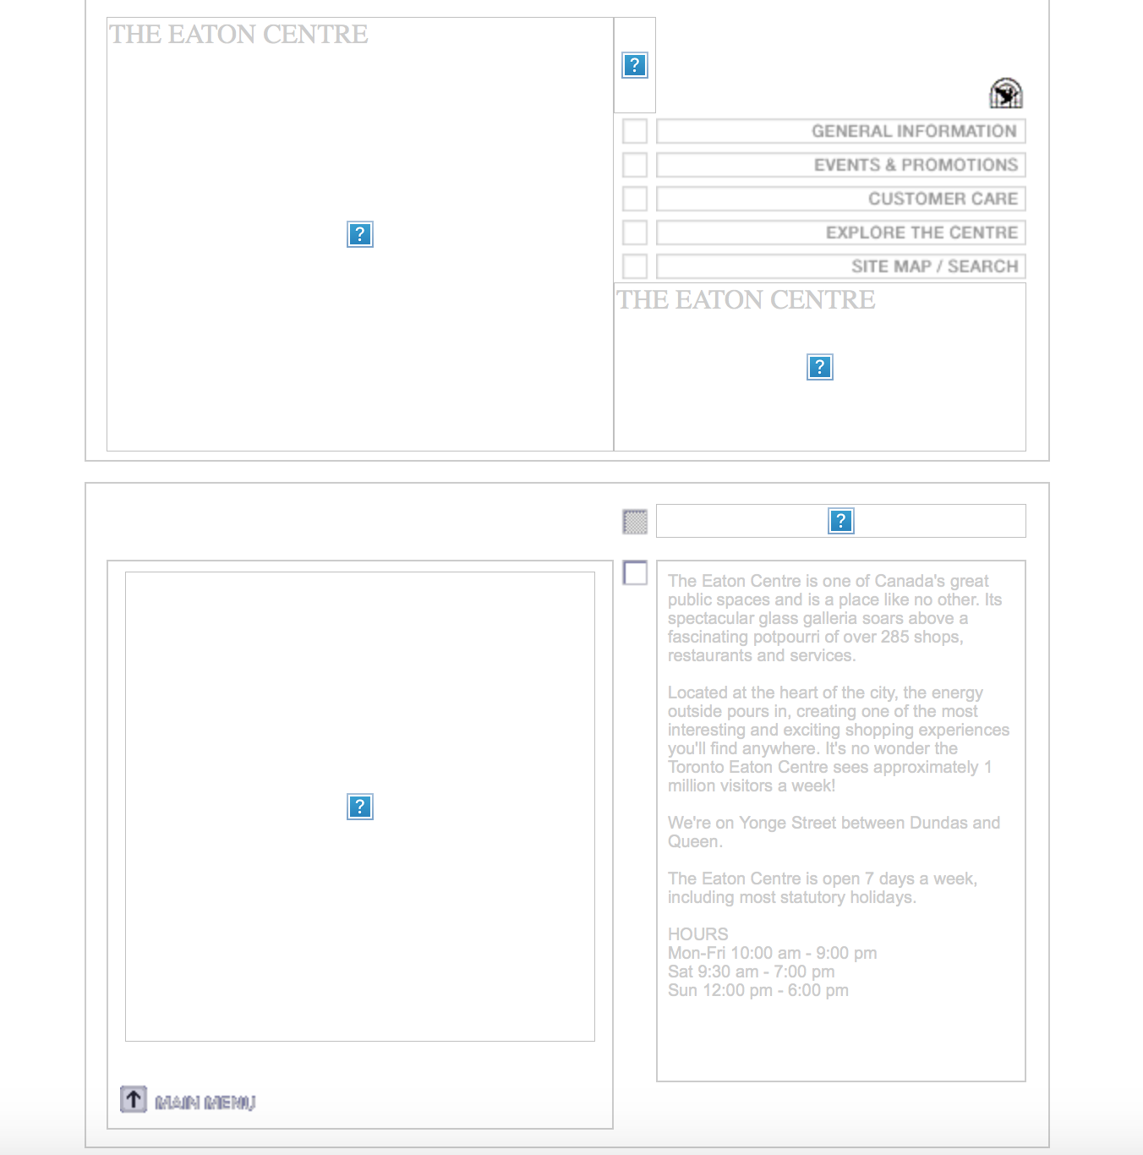
19th January 2001


20th November 2002

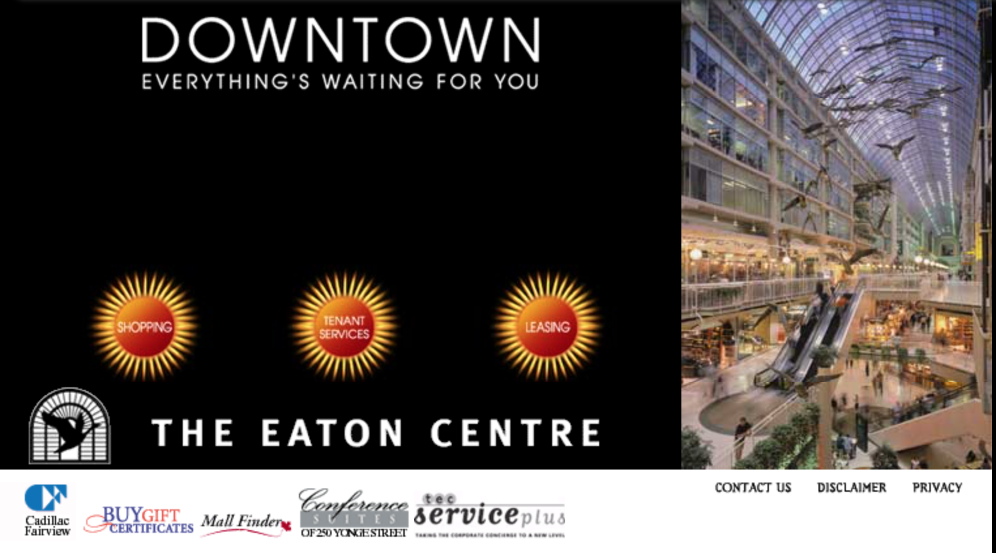
23 March 2003

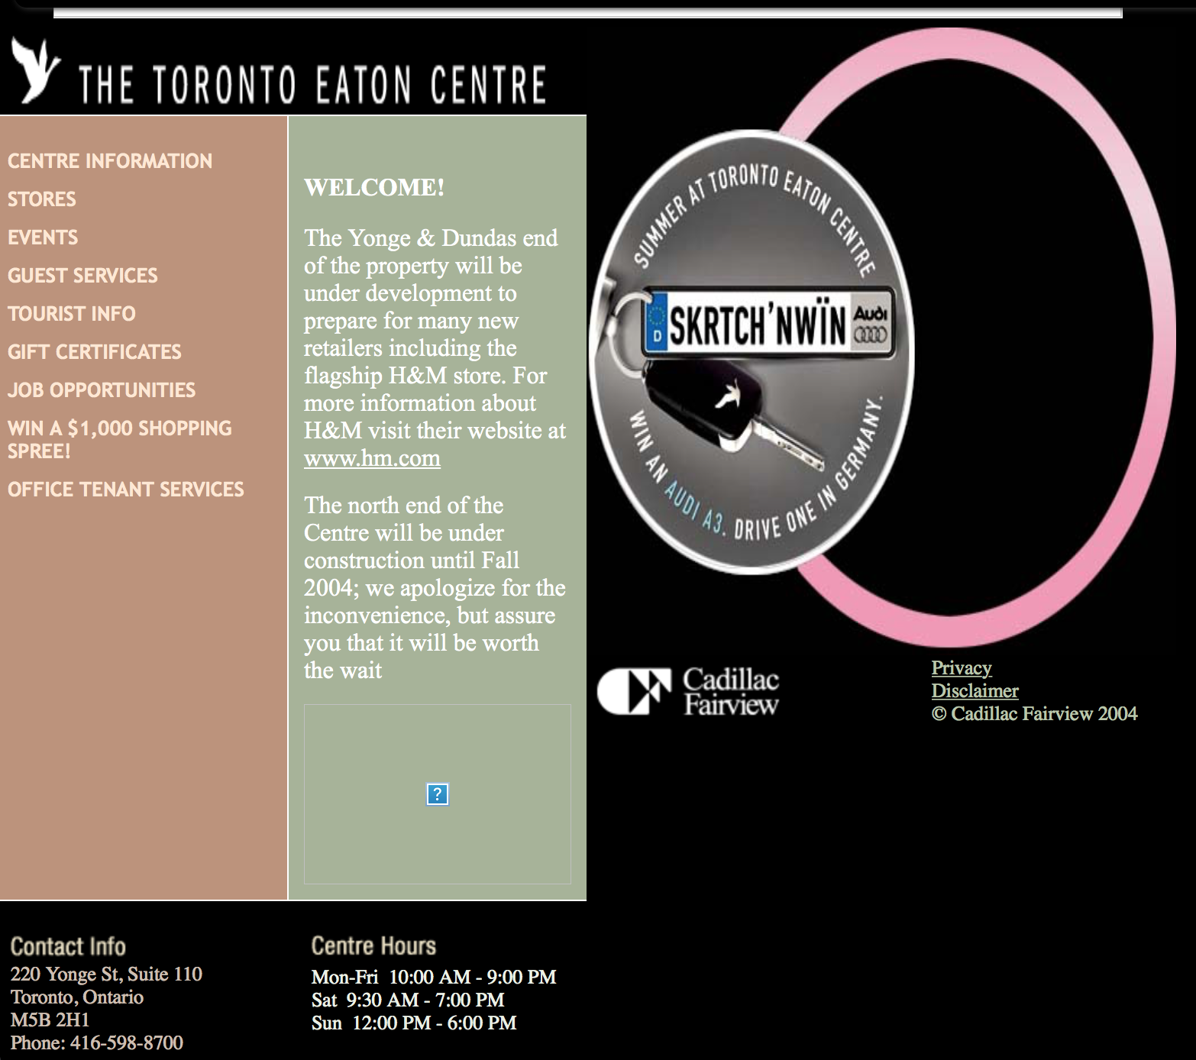
6th April 2004


22 August 2005


15 Apr 2009


17th Sept 2013

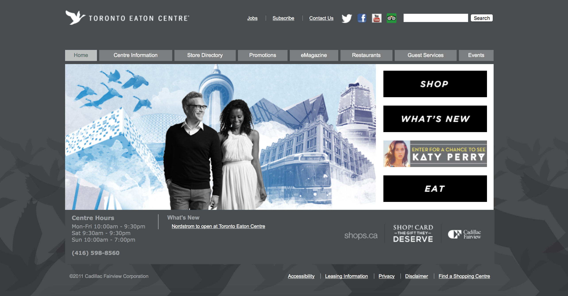
23 Jan 2014


27 March 2015


25/10/2016 [Captured by author through screencap]


25/10/2016 [Captured by author through screencap]

Appendix 2: Mall Map and tenant list from 2010

This single page document with a map and tenant list was being handed to customers as they arrived into the Toronto Eaton Centre from the Southern Entrance during the site visit.

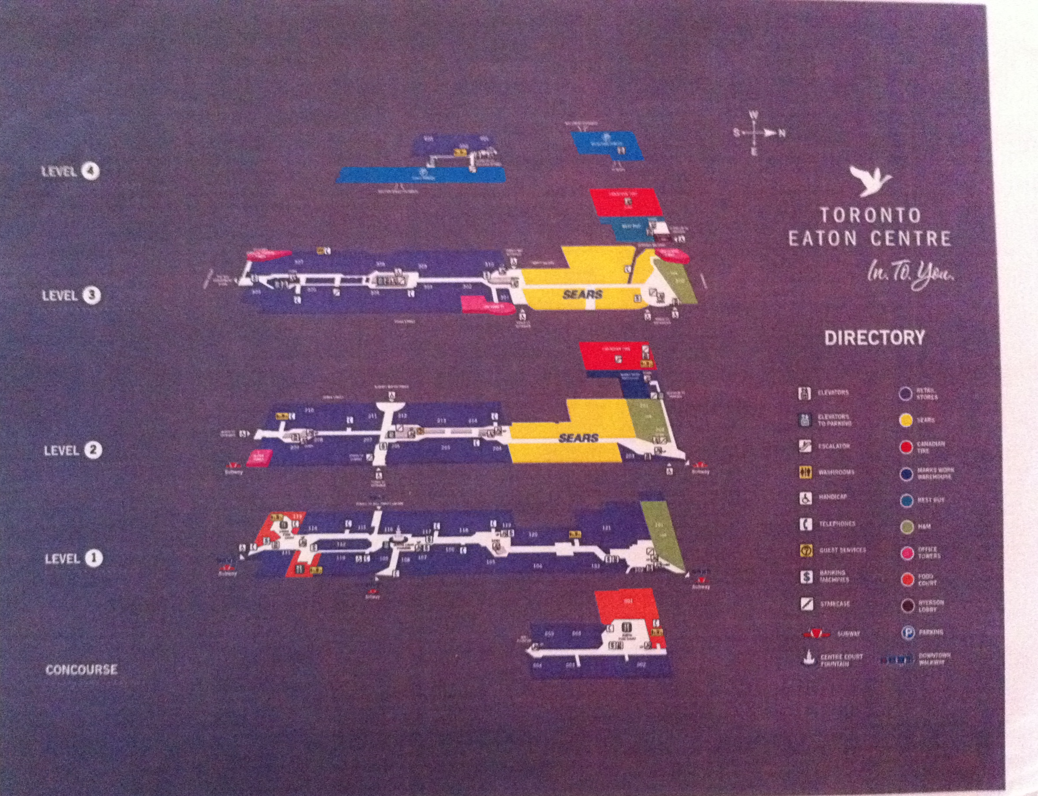
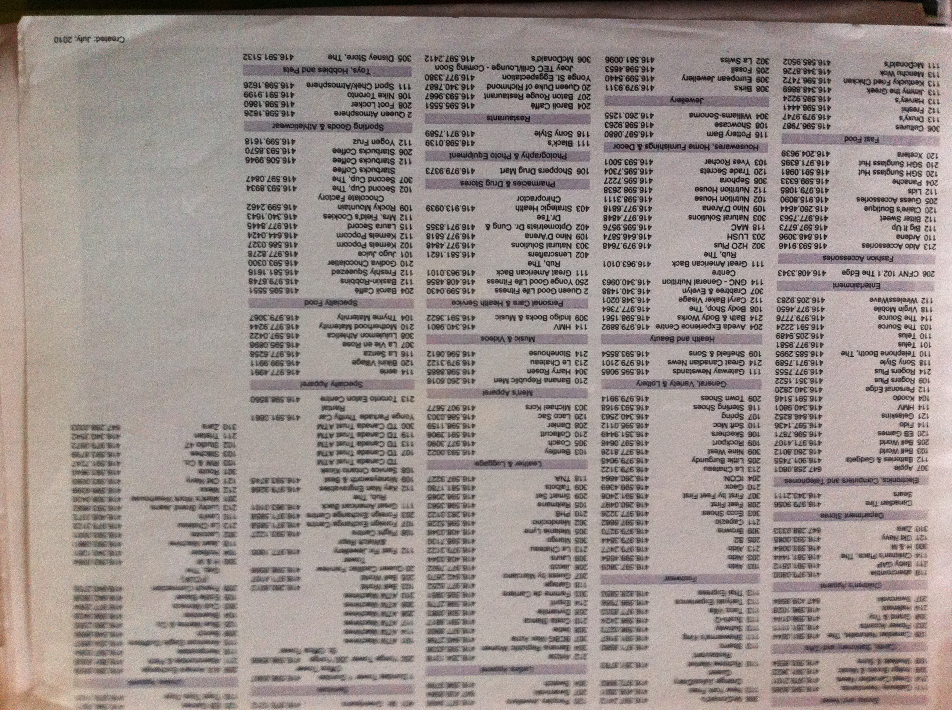

An evaluation of 503 spaces done by Kayden (2000), The New York City Department of City Planning, and The Municipal Art Society of New York (2000) tells that 41% of them are deemed as marginal spaces, where people feel discouraged to come. They attributed this mostly to unappealing and user-unfriendly design, especially for spaces created before the 1975 and 1977 zoning amendments. Other deterrents, such as lack of free access and inappropriate private use by owners, also contribute to the unpopularity of some privately owned public spaces created in the later phase (Kayden, et. Al. 2000; Smithsimon 2008, Whyte & Underhill, 1988).
Yoon and Srinivasan, (2014) in their study of privately owned public space in the city of New York found that the locations of publicly owned public spaces do not closely align with where they may be needed by resident, worker, or tourist populations. They reaffirm the research produced by Kayden (2000) which found that these spaces tend to be concentrated in Manhattan, mainly in four areas: downtown, midtown, Upper East Side, and West Side. These are areas with the most expensive and dynamic property markets. Yoon and Srinivasan found that although some of parks themselves are tourist spots, privately owned public spaces tend to closely located where there is potential demand from working population. They tend not to be within reach of residential populations and this can be seen in North Manhattan, Chelsea and SoHo, where the relatively higher shortage of publicly owned public spaces is not mitigated by the higher level of privately owned public spaces.
UK taxpayers left £275m out of pocket after deal is reached by Olympic Delivery Authority (Kollewe, J. Friday 12 August 2011 https://www.theguardian.com/sport/2011/aug/12/olympic-village-qatari-ruling-family [Last Accessed 27 August 2016])
This space is managed by the London Legacy Development Corporation which was set up in April 2012 and whose purpose is to use the ‘once-in-a-lifetime opportunity’ of the London 2012 Games and the creation of Queen Elizabeth Olympic Park to develop ‘a dynamic new heart for east London, creating opportunities for local people and driving innovation and growth in London and the UK’. (http://queenelizabetholympicpark.co.uk/our-story/the-legacy-corporation)
Yonge Street was designated a Heritage Conservation Districts (HCDs) in 2016. HCDs are designated under Part V of the Ontario Heritage Act for the purpose of conserving, protecting, and enhancing the integrity of resources within the HCD and the cultural heritage value they carry. An HCD provides a framework to conserve the character of a district as defined by its historical context, architecture, streets, landscape, and other physical and visual features. The area designated includes all properties facing onto Yonge Street between the south side of Davenport Road/ Church Street and the North Side of College/Carlton Street.
This production is based on a division of labour in which society is envisioned as being built upon two structures. The Economic Base which is the primary structure, involved with the production of goods. The subsequent Superstructure is built upon the base and tries to hide the base from view. In Capitalist societies, Marx would argue that it is the cultural superstructure which is the realm of consumer desire. A ‘false consciousness’ emerges where the true value of labour is hidden from the bourgeois class and they are inspired to consume based on a historically produced need as opposed to a natural necessity
Walter Benjamin explored these spaces between 1927 and 1940. This collection of convolutes and sketches gives detailed, yet disjointed observations of the remnants of bourgeois society of nineteenth century Paris. The research focused on an area between Rue Croix-des-Petits-Champs, Rue de la Grange-Bateliere, Rue Ventador and Boulevard Sebastapol which was where many of the arcades were located (Miles and Miles, 2004 p.88). The majority of the arcades were built throughout the 1820’s and 1830’s and many were built to replace previous rows of shops. The arcades which Benjamin studied included the Passage Viollet (1820), Passage des Deux Pavillions (1820), Passage des Panoramas (1823, and redeveloped in 1831).
For example, of the Passage de l’Opéra (1823 - image on Benjamin 1999 p. 49) Passage Vivienne (1825 Benjamin, 199 p.35) and Passage Véro-Dodat (1823-1826 Benjamin, 1999 p. 34).
It was built very soon after the Royal Opera Arcade of Nash and Repton, which was the earliest to be planned. That arcade, however, had shops only on one side and according to the Survey of London (1963), the Burlington Arcade appears to be the exemplar in England of the more usual double-sided arcade.
The College Street Store remained open until 1976, and after this became part of the College Park Development. Similarities in the facade can be seen with Selfridges store on Oxford Street in London (opened in March 1909) with a façade dominated by symmetrical Ionic Columns.
‘Slum fiction’ emerges in the last two decades of the nineteenth century portraying the nightmare of life in the slums of London’s East End. A Child of the Jago (Morrison, 1886) was one of the bestselling examples. It gives a fictional account of life in the slums and the impact of child poverty.
The Municipal Corporations Act (Ireland) 1840 (3 & 4 Vict. c. 108), An Act for the Regulation of Municipal Corporations in Ireland, was passed by the Parliament of the United Kingdom on 10 August 1840. It was one of the Municipal Corporations (Ireland) Acts 1840 to 1888. The Act followed similar lines to the Municipal Corporations Act 1835 which reformed municipal boroughs in England and Wales.
The Garden City movement has its origins in his 1898 book To-Morrow: A Peaceful Path to Real Reform, which was republished as Garden Cities of To-Morrow in 1902. Central to Howard’s thesis were the concept of three Magnets which attract people to live in an area. In his plan for the reformed urban settlement he outlines the factors that attract people to the Town, the Country and the Town-Country. The third magnet, the Town Country was meant to overcome the division and ‘unholy, unnatural separation between town and country. This approach that was gaining increasing influence on both sides of the Atlantic, saw reformers advocate the building of ‘garden suburbs’. The Garden City movement had begun in the United Kingdom, the rise of the garden suburb is often traced back to Ebenezer Howard and his Garden City movement. His book Garden Cities of Tomorrow (1898 [1965]) heralded a new type of living for the masses which would combine the advantages of living in the countryside with living in the city.
The Dublin – Kingstown Railway (opened 1834) is one of the earliest examples of a dedicated commuter railway. Around the stations on these lines new centres begin to develop.
In the 1920s, the Ford Motor Company was one of the most influential companies in the world. Churning out the ultimate in contemporary consumer goods, cars rolled off the revolutionary production lines of Detroit and spurned a personal transportation revolution. Henry Ford did not just want to change how people worked, he moved into the realms of town building and urban planning in his attempts to build a new settlement based around production for his company, in South America. Following in the footsteps of other philanthropic industrialists of the nineteenth and early twentieth century, such as William Lever (Port Sunlight Village), Fordlândia was established by Henry Ford in 1928 near Santarém in Brazil. Ford wanted to create a settlement based around a plantation which could mass-produce natural rubber. This project gave Ford the opportunity to not only shape how his workers did their job, but how they lived. The project aimed to recreate an American style town, complete with detached houses and white picket fences, in the Jungle. However, it was built in inadequate terrain and was a major failure. The whole project was designed with no knowledge of tropical agriculture, and it was managed with little understanding or regard for local culture. In 1934, it moved to nearby Belterra, but closed in 1945 and it now lies abandoned and overgrown (Grandin, 2009). Harvey (2010 p.189) refers to Greg Grandin’s 2009 book Fordlandia - ‘Nothing came of it all, even after twenty years of trying and the outlay of astronomical amounts of money. The tropical rainforest won out. Abandoned in 1945, the place is now a ruin in the jungle. Not a drop of rubber latex ever materialised’. The demise of Fordlandia illustrates a tendency in modernity to believe that it can overcome the forces of nature and reinvent completely the way we live. This was identified in previous chapters in terms of the failure of modernist housing projects and is useful to help us understand attempts to completely restructure the city in the twentieth century.
Market Square was listed on the National Register of Historic Places in 1979 as “America’s first planned shopping center”. Marshall Fields opened a branch store here in 1928, which closed in 2007.
What we saw now was the increasing recognition of equality for the consumer, where the balance of power in the transaction of goods and service shifts to become equal between the buyer and seller. There was no haggling, and the customer had a framework of formal justice with their consumer rights. The supermarket was in its infancy around this era. Self-service stores, where goods were put on open display, empowered customers and gave them new forms of shopping. The chain Piggly Wiggly brought the idea of self-service retail to America in 1916 in the form of the grocery supermarket. The first store was opened in Memphis, Tennessee by Clarence Saunders.
changed to "Canada" Mortgage and Housing Corporation in 1979 CMHC, 2016 https://www.cmhc-schl.gc.ca/en/corp/about/hi/
This theory is especially relevant when viewed considering property crashes which occurred in Ireland, Spain and the United States after the global credit crunch began in 2008. The shutdown in capital loans by financial institutions brought these markets to a shuddering halt. This is a pattern which can be identified across many different countries and cities in the course of their development.
Design of the project was entrusted to Macklin Hancock, the son-in-law of Taylor's executive assistant. Still in his mid-20s, Hancock was a graduate student at Harvard when approached for the job. At Harvard Hancock had studied under a number of the founders of modernism and new town planning including Walter Gropius, William Holford, and Hideo Sasaki. These studies lead Hancock to envision a self-contained community distinguished by consistent design principles and a modernist style. Several names were proposed for the new development, including Eptown after Taylor. It was called Yorktown at its initial unveiling, but the name Don Mills was finally adopted at the suggestion of Hancock. After Don Mills was completed Taylor went on to commission a plan for Flemington Park.it was 60 percent more dense with apartment blocks from 12to 16 stories high. However, it was not as commercially successful because the private market had already settled on the Don Mills style of development (p102).
They included Upper Darby Center in West Philadelphia (1927), Suburban Square in Ardmore, Pennsylvania (1928), Highland Park Shopping Village outside Dallas (1931), River Oaks in Houston (1937), Hampton Village in St. Louis (1941), Colony in Toledo (1944), Shirlington in Arlington, Virginia (1944), and Belleview Square in Seattle (1946) (Rae, 1971 p. 230).
Inside of one year, San Diego's population jumped from 203,341 to over 300,000, an increase of almost fifty percent.
Architectural Forum 78 (May 1943): 69-189)
Gruen and Krummeck had moved to Southern California in 1941 from New York. The growth of this part of the country is bound to have had an influence on their subsequent work.
Victor Gruen was born Viktor David Grünbaum in Vienna in 1903. Gruen was forced to flee Nazi oppression in the wake of the Anschluss of Austria by Nazi Germany. He fled to New York in 1938 where he practiced independently as a designer. This is when he changed his name from Grünbaum to Gruen.
During this time he worked with the haberdashery retailer Singer to redesign their shop in 1936. In his design, Gruen moved the ‘shop's structure several meters behind the sidewalk thus creating a space open to the public at the intersection between the street and the store. Framed by large shop windows and centered around a dramatically illuminated glass vitrine, the space created in the overlap area invited the passers-by to wrest themselves from the ongoing flow of movement of the street and to contemplate temporarily the textiles in the shop windows and the hustle and bustle of urban life’ http://kek.org.hu/filmnapok4/en/amerikai-bevasarlovaros-victor-gruen-es-a-bevasarlokozpont/
Gruen worked on General Motors, Futurama which was to become one of the exhibitions most influential exhibitions. It was designed by Bel Geddes and brought visitors on a guided tour over a model of ‘Old City of 1939’ and the remade city of 1960 which had highways, skyscrapers and high speed highways (Hardwick, 2004 p18).
Gruen was divorced from Elsie Krummeck in 1951. In the same year he Married Lazette E. McCormick Van Houten (died in 1962)
Gruen founded Victor Gruen Associates (later Gruen Associates) with Baumfeld, Van Leuven, and consulting engineer Edgardo Contini. Ben Southland and Herman Guttman joined as partners in 1956 and 1957 respectively, and Beda Zwicker became a partner in 1963.
Northland Mall was enclosed in 1974 and expanded to house new retailers.
Received Progressive Architecture Design Award for Urban Redevelopment (Detroit, Mich.)
Gruen returned to Vienna and designed a shopping mall in 1971. The shopping mall came to Europe replicating an Americanised hyperreal simulation of European city life in the realm on which the simulation was based.
built around 100AD by Apollodorus of Damascus, a Syrian-Greek architect and engineer
Bernays employs Freud’s theories to portray the vast majority of society as consuming machines who struggle against the forces of Eros and Thanatos. These consuming machines need to be manipulated to make the ‘right decision’. Bernays believed that Freud’s theories of psychoanalysis could be operationalized to change the way people thought about consumer goods. In a society where the focus shifts towards the satisfaction of desires Bernays believed the individual would be transformed into ‘happiness machines’ that would be docile and easy to govern. The term ‘happiness machines’ was used in a letter which Herbert Hoover wrote to Bernays before he became President in 1929 where he claims ‘You have taken over the job of creating desire and have transformed people into constantly moving happiness machines, machines which have become the key to economic progress.’ Bernays set about to create the desire that would drive these happiness machines. Employing Freud’s theory of Eros, and focusing on the idea that the individual seeks pleasure and avoids pain, he was involved with major advertising and public awareness campaigns, which shaped the way many people viewed the world
The Redbook Magazine had been published since 1903 and aimed at married Women. It had begun to shift its focus to a newly emerging demographic in the 1950’s and was to reposition itself as an instruction manual for how to live in the suburbs. It gave us an image of what the ‘happiness machine’ should look like and how they lived.
FLQ were responsible for the bombing of the Montreal Stock Exchange on 13 February 1969. This was a major attack on a bastion of Anglo-Canadian power. The bomb injured 27 people. In the October Crisis of 1970, FLQ claimed responsibility for the kidnapping of James Richard Cross, the British Trade Commissioner and the kidnapping and murder of Minister of Labour and Vice-Premier of Quebec, Pierre Laporte.
Project Viking was named after the range of own-brand goods sold in Eaton’s stores (Osbaldeston, 2008 p.30)
The 12 other municipalities included the towns of New Toronto, Mimico, Weston, and Leaside; the villages of Long Branch, Swansea, and Forest Hill; and the townships of Etobicoke, York, North York, East York, and Scarborough. In 1967, an internal amalgamation eliminated the seven smallest municipalities in Metropolitan Toronto. Of these, the villages of Forest Hill and Swansea were amalgamated into the City of Toronto.
. Phillips was the first Toronto mayor of the Jewish faith. Until his election all mayors had been Protestant and every mayor in the twentieth century had been members of the Orange Order which dominated the city's political and business establishment (Smyth, 2015) In late nineteenth-century Toronto, municipal politics were so dominated by the Irish Protestants of the Orange Order that the city was known as the “Belfast of Canada.” For almost a century, virtually every mayor of Toronto was an Orangeman and the anniversary of the Battle of the Boyne was a civic holiday. Toronto, the Belfast of Canada (Smyth, 2015) explores the intolerant origins of today's cosmopolitan city.
Webb and Knapp built the Place Ville Marie in Montreal (ibid., p30)
The term ‘superblock’ is a term used by planners to describe large developments that encompass whole city blocks and normally integrating or replacing city streets or laneways. Superblock development normally saw a vast section of the city redeveloped, however criticisms emerged with regards to permeability and the impact that these types of development have on the existing urban fabric.
Don Mills, a suburban planned community was to become the model for suburban development across Canada (Sewell, 1993 p. 81)
John Sewell served as Mayor of Toronto from 1978 – 1980 and was active in many campaigns including that against the levelling of the working class neighbourhoods in the Trefann Urban Renewal Area, which was in the eastern part of downtown Toronto. He was also involved with the fight against the Spadina Expressway.
The Old City Hall was highlighted by the Historic Sites and Monuments Board of Canada, Minute, November 1984: The Old Toronto City Hall and York County Court House is one of Canada’s finest examples of Richardsonian Romanesque architecture. Its massive scale and monumental design reflect its dual function as city hall and court house, the increasing complexity of civic administration, and the desire of city politicians to convey the prosperity and rapid urbanization experienced by Toronto in the second half of the 19th century. Designed by local architect E.J. Lennox between 1883 and 1886, the City Hall and Court House took eleven years to construct, from 1889 to 1899. Its design used a variation of the Romanesque style developed by American architect H.H. Richardson, which was popular for public buildings during the 1880s. Numerous crafts- and trades-people were involved in its construction, including Robert McCausland Limited (stained glass) and George Agnew Reid (muralist). The Richardsonian Romanesque style is evident here in the massive scale and proportions of the building, the richly carved and coloured sandstone surfaces, and the repeated use of towers, round-arched openings, and arch-and-spandrel motifs. The building is dominated by a tall, off-centre clock tower that corresponds with the axis of Bay Street, the heart of the city’s financial power.
The important question which Harvey identifies is why did the investment bankers decide not to extend credit any further for the city? The answer Harvey proposes has to do with both economics and politics. Harvey argues that the investment bankers did not like the way New York City was governed - black power, municipal unions, and community groups could block their plans. They wanted the city to be disciplined. There needed to be a reaffirming of class power and find a way of restarting the capacity of the city absorb the surpluses that capitalism must produce to survive. They had the power to discipline the city through financial measures
In later years the scope of projects undertaken by Gruen Associates also extended to planning new towns, regional planning, general land development, public housing projects, and college campuses. In Shoppingtowns USA Gruen and Smith (ibid., p.267) had already considered the impact which the shopping centre would have on downtowns. They propose that ‘…government-supported Urban Renewal and Redevelopment program offers potentialities for the comeback of downtown areas. Whether this potential will be utilized depends on the wisdom with which it is implemented.’ Gruen Associates undertook projects to revitalize the central business districts of several American and European cities, beginning with a never-executed plan for Fort Worth, Texas (1957) and later with Midtown Plaza (1960) in Rochester, New York which was the first downtown enclosed Mall in the United States. Gruen Associates were also involved in downtown revitalization plans for Kalamazoo, Michigan, Boston, Fresno, California, Urbana, Illinois, amongst others. Kalamzoo Pedestrian Mall (1959) was the first pedestrian mall to be built in the United States by blocking off traffic from three blocks of the main commercial area on Burdick Street. The Mall was financed and promoted by downtown business owners was part of Victor Gruen's 1958 Kalamazoo 1980 plan. It was hoped the mall would revitalize the downtown area to compete with the movement of retail businesses to suburban malls. In 2000, the mall was reopened to limited automobile traffic.
This resulted in the growth of hyperreal urban spaces. Baudrillard explains that consumer society has shifted towards the production of simulations which are more real that the reality they represent. This is encapsulated in Main Street USA, a recreation of an American Main Street, which is present in each of Disney’s themeparks around the world. It is a recreation of a fictional Main Street which never existed but the reality it represents becomes more real that the mythical street it claims to represent. The simulation of an American Main street produces the reality.
The Houston Galleria opened in 1970 and is a mixed-use retail and hotel development in the uptown district of Houston, Texas.
Edward Soja (1989 p. 243-244) describes the manufactured domain of Bonaventure hotel complex as ‘a concentrated representation of the restructured spatiality of the late capitalist city: fragmented and fragmenting, homogeneous and homogenizing, divertingly packaged yet curiously incomprehensible, seemingly open in presenting itself to view but constantly pressing to enclose, to compartmentalize, to circumscribe, to incarcerate. Everything imaginable appears to be available in this micro-urb but real places are difficult to find, its spaces confuse an effective cognitive mapping, its pastiche of superficial reflections bewilder co-ordination and encourage submission instead. Entry by land is forbidding to those who carelessly walk but entrance is nevertheless encouraged at many different levels. Once inside, however, it becomes daunting to get out again without bureaucratic assistance. In so many ways, its architecture recapitulates and reflects the sprawling manufactured spaces of Los Angeles
The Salvation Army building was eventually demolished in the late 1990s to make way for an Eaton Centre expansion. The Indigo Bookstore occupies the space where the building once stood.
This is a pattern which has been replicated elsewhere. In Cork City, Ireland, the Opera Lane Development encompassed the narrow side street Faulkner’s Lane. The development lines either side of the older street, which has now been renamed Opera Lane.
Subsequently operated as The Bay and now a section of this store is home to Saks Fifth Avenue.
According to Parkin(1982) the Art/Advertising Project was one of seven to receive an award from the ‘Financial Post Business and the Arts Awards in 1979.
Lynch explains this with the example of the American who can always spot the corner drugstore, which may be indistinguishable to a ‘bushman’. This example will ring true to a parent who drives past a McDonalds restaurant whose children immediately recognise the eponymous ‘golden arches’ and ask to be taken for a ‘happy meal’. Or the global traveller who spots a passer-by with a white paper cup with a green circular logo signifying a Starbucks is nearby where they can get their caffeine hit.
The concept of Business Improvement Areas (BIAs) originated in Toronto in 1970. A group of business people in the Bloor-Jane area of west Toronto were concerned about the erosion of their marketplace caused by the growing popularity of shopping malls, plus an extended subway system, both of which were drawing shoppers away from their traditional shopping areas. (http://toronto-bia.com/index.php?option=com_content&task=view&id=19&Itemid=66)
Varman and Belk (2011) look at postcolonial identities in India. The aim of the research was to understand consumption in shopping malls in India. Their analysis focused primarily on the narratives among the participants. They combined this with the larger context of the societal discourse about the manner in which transitioning retail servicescapes of the country are embedded. One of the key elements to emerge was an interpretation of these malls as post-colonial sites in which young consumers construct and transform their identities through their engagement with the West.
Along with this, a Downtown Retail Revitalization Committee was also to be formed. The Toronto Board of Trade took the leadership on this initiative and a couple of meetings were held, but no firm actions or directions emerged
Changes after completion included reconfiguration of cinema to more VIP seating with food, increased larger food services including a sports bar, Beer Store, and an improved entrance.
This happening in the US around the same time as there is a shift in the role of urban planning departments from protecting the common good to becomes organisations which facilitate urban development services through new forms of public management.
When referring to the spaces of Postmodern society and the cultural logic of late capitalism, Jameson (1990) refers to Mandel's (1972) three stages of capitalism 1. freely competitive, 1700 - 1850 [emerging industrial revolution], 2. Monopoly capitalism up to 1940 [imperialism] and finally 3. Late capitalism [global corporations and mass consumption]. This is a historical materialist approach to society. It assumes a development of culture over time shaped by the changing nature of capitalism.
This is similar to the reaction to the opening of American chains Hollister and Abercrombie & Fitch in Ireland. When Abercrombie & Fitch opened its first Irish Store in 2013, ‘fans’ of the store queued up waiting for the store to open, to spend money on expensive hoodies and sweatpants. Abercrombie & Fitch staff are referred to as models, and they use sexually suggestive images to ‘sing’ to their demographic and encourage them to consume. An American brand opening in Dublin providing an opportunity to buy authentic American fashion is an example of Benjamin’s conception of our attempts to constantly reproduce technologies which bring us closer and closer to the Aura. In this case the aura is a hyperreal lifestyle image or a simulation of sexual fetish and desire.
Commercial real estate firm Avison Young says Toronto’s Yorkdale Shopping Centre was Canada’s most profitable retail mall in 2015 generating $1,610 in sales per square foot in 2015. In comparison, the Toronto Eaton Centre had $1,509 in sales per square foot in the same year, making it the fourth most profitable mall in Canada according to their metrics.
Square sponsor in 2013
The mall closed for a period after a shooting incident in the Urban Eatery Foodcourt in 2012.
,The Internet Archive is a nonprofit organization, based in San Francisco, California, United States. The Internet Archive launched the Wayback Machine in October 2001. It was set up by Brewster Kahle and Bruce Gilliat, and is maintained with content from Alexa Internet. The service enables users to see archived versions of web pages across time.

