a) | b)
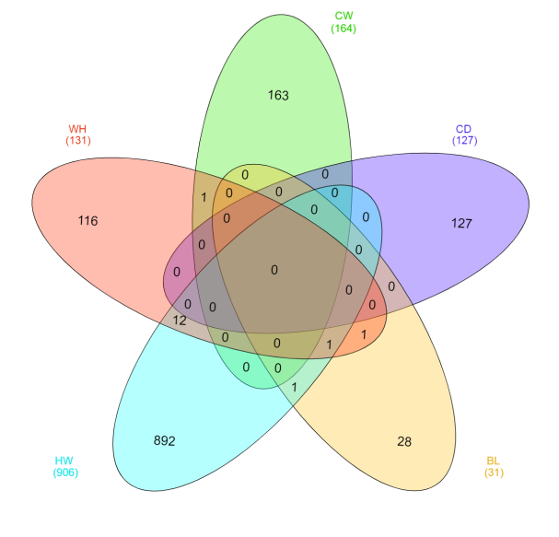 | 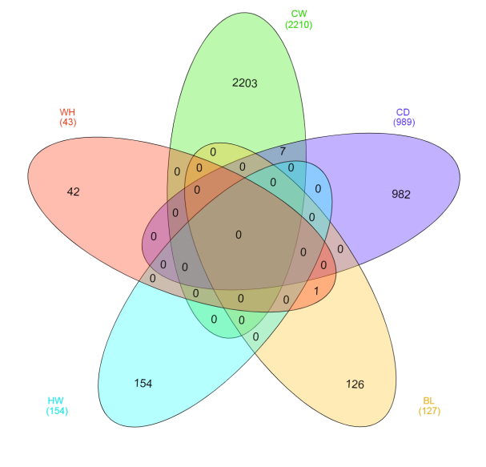
c) | d)
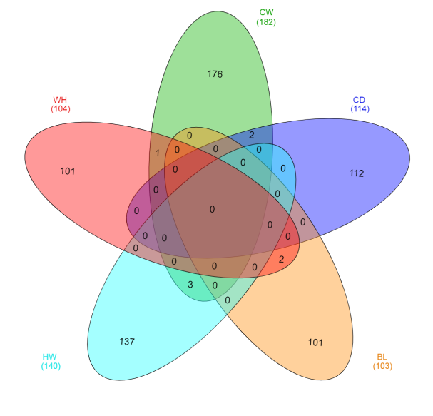 | 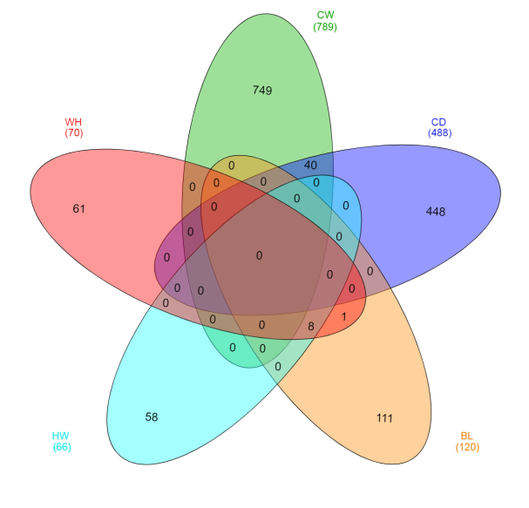
e)
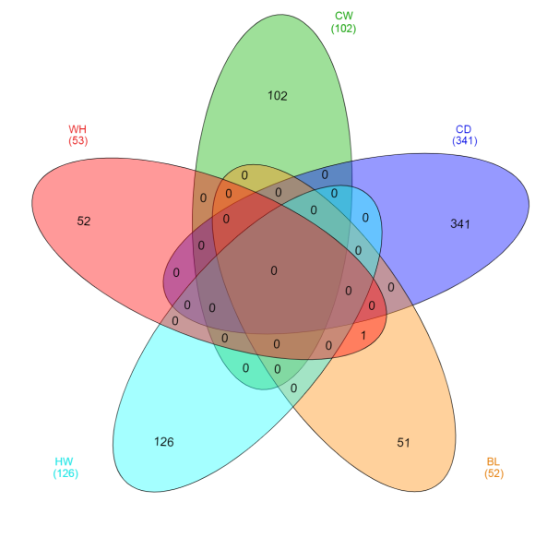

Figure S1: Overlapping 1kb regions that contain at least one suggestively or significantly dimorphic SNP for the 5 skeletal traits in a) Angus, b) Charolais, c) Hereford, d) Limousin, and e) Simmental
*trait abbreviations: CW = chest width, CD = chest depth, BL = back length, HW = hip width, WH = wither height
a) | b)
a) | b)
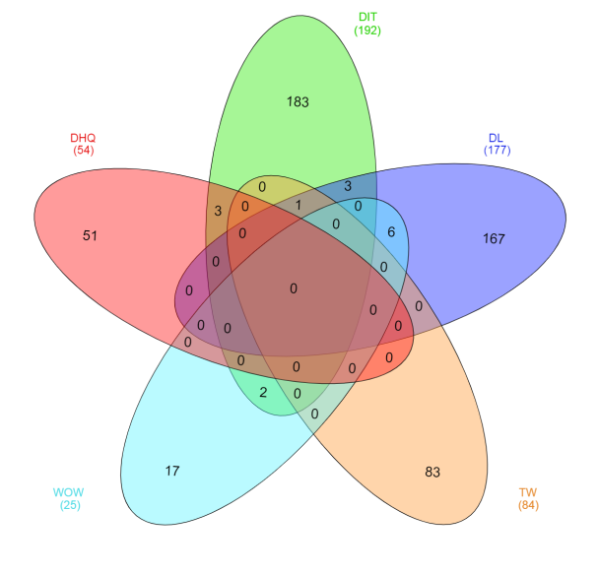 | 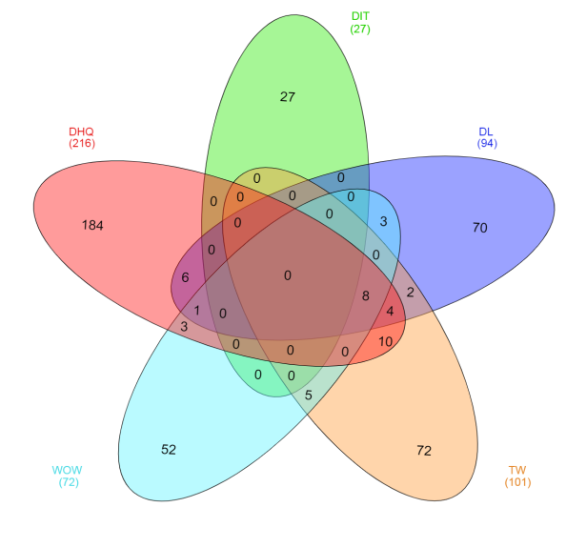
c) | d)
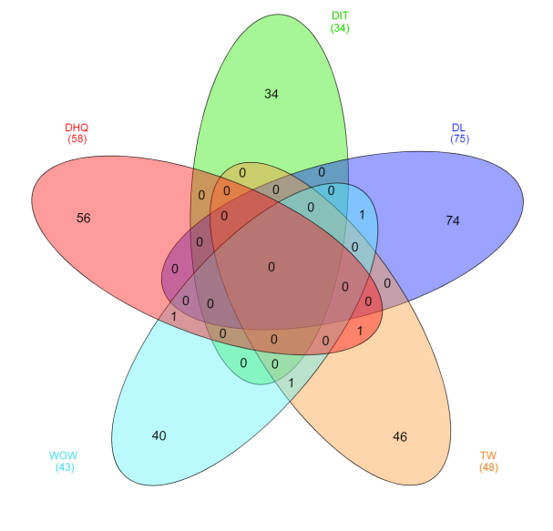 | 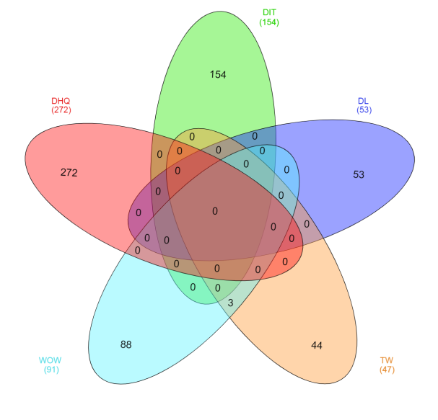
e)
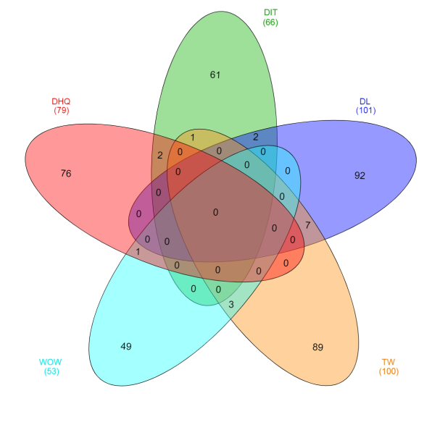
Figure S2: Overlapping 1kb regions that contain at least one suggestively or significantly dimorphic SNP for the 5 muscular traits in a) Angus, b) Charolais, c) Hereford, d) Limousin and e) Simmental
*trait abbreviations: DHQ = development of hind quarter, DIT = development of inner thigh, DL = development of loin, TW = thigh width, WOW = width of wither.

