Appendices

Model validation
The Irish electricity market provides a good test case for this study. It operates similarly to other markets found around the world, has high wind penetration, limited interconnection but excellent grid management. This said, the insights in the paper are independent of Ireland and applicable in general.

1.1 Levelised costs for Offshore Wind Farm (OWF)
A base LCOE of €38.1/MWh was found exclusive of curtailment. This is indicative of a favourable site relatively close to shore (14.5km) potentially eliminating the need for a substation [1]. The high capacity factor also contributes greatly to the low LCOE but is in line with similar developments in the region [2]. This figure is ambitious but not unrealistic though with Fraunhofer reporting offshore wind farm LCOEs as low as €75/MWh in 2018 [3], and IRENA reporting auction database figures under €60/MWh in 2021. In order to achieve the LCOEs modelled in this paper the discount rate (weighted average cost of capital) should be relatively low and capital costs need to fall substantially.
In estimating the power generated by the OWF Eastward and Northward MERRA-2 wind speeds between 01/01/1996 and 29/02/2016 at a temporal resolution of 1 hour were used. As we were modelling 25-32 years of a project, the data was duplicated to produce 40 years of wind data.

1.2 System marginal cost (SMC) profile
Simulation of the SMC is achieved by finding the mean and covariance of prices for each hour of the day in every month. A multivariate normal random numbers function of Matlab then generates random numbers according to this distribution. In order to verify if this method produced sufficiently accurate results it is compared to a robust and validated model of the same energy system.
The following is adapted from a previous work by the author [4] and edited for this appendix. It contains a brief explanation of the model against which the results borne by the methodology in this paper are compared:
The system marginal cost (SMC) can be considered as the hourly island wide wholesale price of electricity. It includes for the cost required to meet the forecast demand and additional costs associated with start-up or operating as a reserve that a generator will need to recover. In general, the SMC is low when there is more than sufficient generation capacity online to meet demand. When the amount of generation online to meet demand is scarce, the resulting SMC is higher. The SMC is set by the marginal costs of the last generator online to meet demand. In the market examined (Ireland) and many others this is often gas fired generation. The SMC is also influenced by zero marginal cost Variable Renewable Electricity (VRE) which tends to supress the SMC in times of high VRE production. In times of excess VRE generation, curtailment may take place. Current electricity market rules offer VRE priority dispatch on the electricity grid, therefore curtailment of VRE is often a last resort. Strong positive correlation has been found between increased shares of VRE and the periodic availability of low-cost electricity [5].
To determine the SMC in 2030, PLEXOS models of the electricity market were developed. PLEXOS Integrated Energy Model is a power systems modelling tool used for electricity market simulations [6]. The power systems model develops an hourly SMC for the Irish electricity market based on current rules, and it has been benchmarked against historic market data and has been validated by the regulator to reproduce realistic results. The model uses deterministic mixed integer linear optimisation to minimise the costs of the electricity dispatched including for fuel costs, start-up costs, penalties for unserved energy, and a penalty cost for not meeting reserve requirements [7]. The model optimises thermal generation (fossil fuel and renewable), VRE, pumped storage, interconnection, as well as reserve classes subject to operational and technical constraints [8,9]. Also included are constraints on the unit operation of each power plant including minimum and maximum generation, minimum and maximum up and down time and the system ramp up and down rates, as well as a system level constraint consisting of an energy balance equation ensuring supply meets regional demand at each period [8]. Three PLEXOS models were tested, at 40%, 50%, and 60% renewable electricity respectively.
Renewable energy is calculated as delivered MW_{e}h of electricity from all renewable sources, as a percentage of total delivered electricity. Variable renewable energy then only includes intermittent sources (wind, solar, and wave), and not those that are dispatchable and therefore do not contribute to the fluctuations in supply that would affect price (CHP, co-firing of biomass, and hydropower). These represent the current and future (2030) targets for electricity systems seeking to decarbonise. The vast majority of this renewable electricity will be provided by wind and other intermittent sources. The 40% RE scenario is representative of a case where the rate of new installed RE capacity does not increase drastically beyond the levels seen today. The 60% RE scenario requires the rate of additional installed capacity of renewable electricity to substantially outpace that of increasing demand. Both scenarios are feasible and therefore their implications on PtG worthy of investigation.
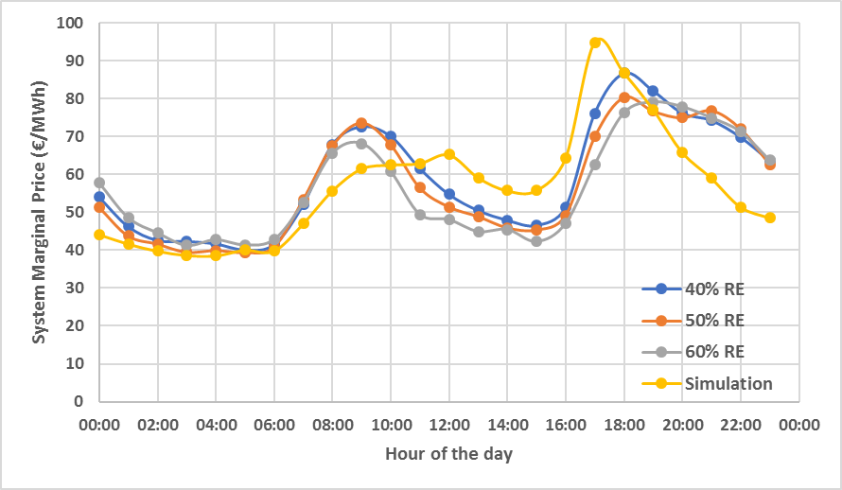
Figure 1: The average system marginal cost (SMC) for each hour of the day across a year for a 40%, 50%, and 60% renewable energy (RE) Irish electricity market. Simulation is the average SMC for each hour of the day across 25 years of simulations using the methodology described in this paper.
Figure 1 shows that the curve does not change greatly with increasing renewables penetration. The author also believes that the method used gives sufficiently accurate data to simulate the revenues of an OWF for the purposes of comparing to a hybrid or H₂ only system. Therefore, the results in the paper are applicable to a wide range of renewable electricity penetrations and insights into the NPV of a system would hold in the real world.

1.3 System load profile
The simulated system load uses the same methodology as the SMC. It is also validated against the same model, as described above. As the system load is based on historic data and as demand is set to increase in 2030, a coefficient of 1.55 was applied to the results to bring them in line with anticipated demand. Predicting additional changes in demand is beyond the scope of this paper.
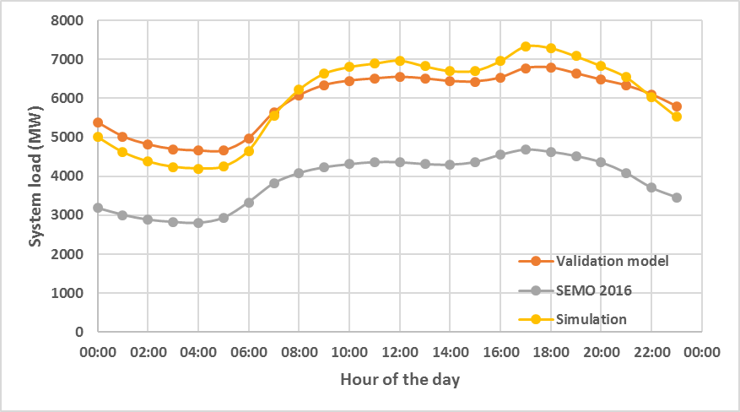
Figure 2: The average system load in each hour of the day for the current Irish electricity market (SEMO 2016), and a model of the market in 2030 (Validation model). Simulation is the average system load for each hour of the day across 25 years of simulations using the methodology described in this paper.
Figure 2 demonstrates that the simulated results agree very closely with the validated model. Thus, as per the methodology for simulating curtailment, it will occur as it would in the real world, predominately during the night and early morning.

Derivation of set point
For the following equations, curtailment values lie between 0 and 1. A curtailment values of 1 implies no curtailment is occurring, values less than 1 imply the output is constrained to a maximum of said value, i.e. curtailment of 0.6 means that a maximum of 60% of the power generated can be accommodated by the electricity grid.
Revenue from an offshore wind farm (OWF):
$Hourly revenue \left(OWF\right)= (OWF power (MWh)×Curtailment)×SMP (€/MWh)$ (1)
Revenue when all power produced is converted to hydrogen (H₂ only):
$Hourly revenue \left(H_{2} only\right)= \frac{OWF power \left(MWh\right)×PtG efficiency×H_{2} Sale price (€/{kg)}}{H_{2} energy density ({MWh}/{kg})}$ (2)
By setting Equations 1 and 2 as equal we find the SMC below which it becomes more profitable to produce and sell hydrogen in the hybrid system. This is a therefore a function of hydrogen value.
$Set point (€/{MWh})= \frac{PtG efficiency×H_{2} Sale price (€/{kg)}}{H_{2} energy density ({MWh}/{kg})}$ (3)

Equations for revenues and economic indicators
Curtailment is again defined as per section 1.1.
Revenue in an OWF alone, or a H₂ only system is given by Equations 1 and 2.
Equations for the revenue in a hybrid system of varying PtG capacity are as follows.
$$Hourly revenue when SMP is above set point=(\left(OWF power \left(MWh\right)×Curtailment\right)×SMP \left(€/{MWh}\right))+\frac{((OWF power \left(MWh\right)×(1-Curtailment)× {PtG efficiency×H}_{2} Sale price (€/{kg) }}{H_{2} energy density ({MWh}/{kg})}$$
Where $\left(1-Curtailment\right)≤$PtG installed (4)
$$Hourly revenue when SMP is below or equal to set point=(\left(OWF power \left(MWh\right)×(1-PtG installed\right)×SMP \left(€/{MWh}\right))+\frac{((OWF power \left(MWh\right)×(PtG installed)× {PtG efficiency×H}_{2} Sale price (€/{kg)}}{H_{2} energy density ({MWh}/{kg})}$$
Where $\left(1-PtG installed\right)≤Curtailment$ (5)
PtG installed refers to the ratio of installed PtG capacity relative to OWF capacity, i.e. 0.5 means that there is 252MW of PtG paired with a 504MW OWF.
For the OWF alone, including for curtailment, the levelised cost of energy (LCOE) is given by Equation 6. Total costs include the CAPEX, DECEX, and O&M of the OWF.
$LCOE \left(€/{MWh}\right)= \frac{\sum_{i=1}^{n}{\frac{Total costs in year i}{{\left(1+Discount rate\right)}^{i}}}}{\sum_{i=1}^{n}{\frac{MWh of electricity deposited on the grid in year i}{{\left(1+Discount rate\right)}^{i}}}}$ (6)

For the hybrid system where all the power generated is converted to hydrogen, the levelised cost of hydrogen (LCOH) is given by Equation 7. Here total costs include the CAPEX, DECEX, and O&M of the OWF and the PtG system.
$LCOH \left(€/{kg}\right)= \frac{\sum_{i=1}^{n}{\frac{Total costs in year i}{{\left(1+Discount rate\right)}^{i}}}}{\sum_{i=1}^{n}{\frac{kg of hydrogen produced in year i}{{\left(1+Discount rate\right)}^{i}}}}$ (7)
Developing a LCOH for the hybrid system would require appropriating costs and benefits between the systems which is beyond the scope of this paper.

The cash flow in a given year is equal to the sum of the hourly revenues from both electricity and hydrogen, minus the costs in the same year. The Net Present Value (NPV) is the same for all scenarios and is given by Equation 8.
$NPV= \sum_{i=1}^{n}{\frac{Net cash flow in year i}{{(1+Discount rate)}^{i}}}$ (8)

Additional results

Detailed results from “Producing only hydrogen” of the main text
Table 1 – Change in NPV/LCOE of the modelled OWF with increasing levels of curtailment.
Curtailment | NPV of OWF  (€millions) | LCOE of OWF  (€/MWh_{e})
0% | 498.55 | 38.1
5% | 428.55 | 40.1
10% | 350.24 | 42.3
15% | 271.11 | 44.8
20% | 192.84 | 47.6
25% | 116.15 | 50.7
50% | -274.34 | 76.1

Table 2 – Change in the NPV of a H₂ only system (all power is converted into hydrogen and sold) with increasing hydrogen values.
Hydrogen value  (€/kg) | NPV of H₂ only  (€millions)
3.5 | -133.62
4 | 117.35
4.5 | 368.31
5 | 619.27

3.2 Additional results from “Hybrid system of varying installed PtG capacity” of the main text

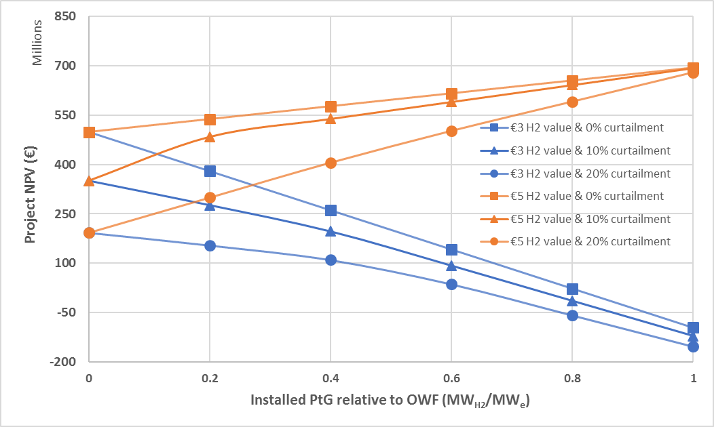
Figure 3: NPV of a hybrid OWF/PtG project as a function of installed capacity for given hydrogen values and levels of curtailment.
As a €4/kg_{H2} hydrogen value was examined in detail in the main text, Figure 3 provides similar results for €3/kg_{H2} and €5/kg_{H2} hydrogen values.

References
[1] Klinge Jacobsen H, Hevia-Koch P, Wolter C. Nearshore and offshore wind development: Costs and competitive advantage exemplified by nearshore wind in Denmark. Energy Sustain Dev 2019;50:91–100. doi:10.1016/j.esd.2019.03.006.
[2] UK offshore wind capacity factors n.d. http://energynumbers.info/uk-offshore-wind-capacity-factors (accessed August 9, 2019).
[3] Kost C, Schlegl T, Thomsen J, Nold S, Mayer J, Hartmann N, et al. Fraunhofer ISE: Levelized Cost of Electricity - Renewable Energy Technologies, March 2018. Fraunhofer ISE Levelized Cost Electr - Renew Energy Technol 2018.
[4] McDonagh S, Wall DM, Deane P, Murphy JD. The effect of electricity markets, and renewable electricity penetration, on the levelised cost of energy of an advanced electro-fuel system incorporating carbon capture. vol. 131. Elsevier Ltd; 2018. doi:10.1016/j.renene.2018.07.058.
[5] Finn P, Fitzpatrick C, Connolly D, Leahy M, Relihan L. Facilitation of renewable electricity using price based appliance control in Ireland’s electricity market. Energy 2011;36:2952–60. doi:10.1016/j.energy.2011.02.038.
[6] Energy Exemplar » Energy Market Modelling » PLEXOS® Integrated Energy Model n.d. https://energyexemplar.com/software/plexos-desktop-edition/ (accessed August 23, 2017).
[7] Foley AM, Ó Gallachóir BP, Hur J, Baldick R, McKeogh EJ. A strategic review of electricity systems models. Energy 2010;35:4522–30. doi:10.1016/j.energy.2010.03.057.
[8] Ahern EP, Deane P, Persson T, Ó Gallachóir B, Murphy JD. A perspective on the potential role of renewable gas in a smart energy island system. Renew Energy 2015;78:648–56. doi:10.1016/j.renene.2015.01.048.
[9] Welsch M, Deane P, Howells M, O Gallachóir B, Rogan F, Bazilian M, et al. Incorporating flexibility requirements into long-term energy system models - A case study on high levels of renewable electricity penetration in Ireland. Appl Energy 2014;135:600–15. doi:10.1016/j.apenergy.2014.08.072.

