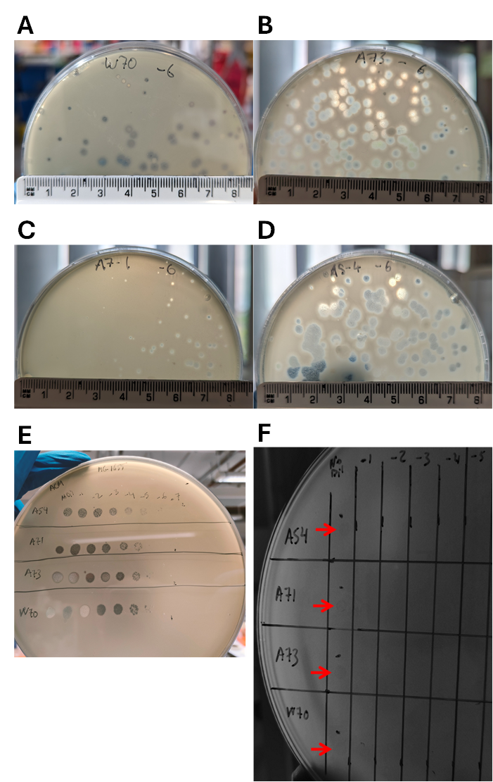
Figure S1. Plaques produced by novel isolated E. coli phages (A) W70, (B) A73, (C) A7-1, and (D) A5-4 when infecting the host E. coli K-12 MG1655. (E) Serial dilutions of the novel E. coli phages (A5-4, A7-1, A73 and W70 from top to bottom) on a plate seeded with the host E. coli K-12 MG1655 forming clear plaques. (F) Spot assay tested in the host range analysis with serial dilutions of E. coli phages in a plate seeded with E. coli 503IE-34 strain showing that is a phage-sensitive strain, producing tiny halos but no clear plaques.

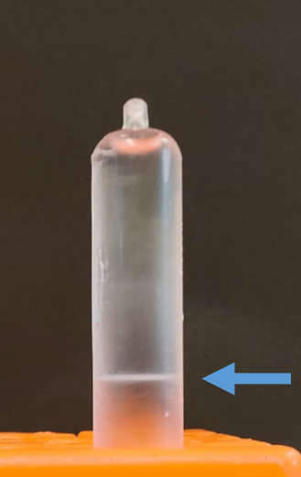
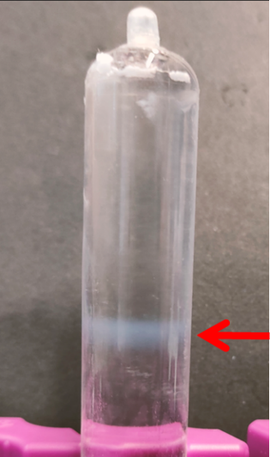
Figure S2. W70 phage bands obtained post-purification (titre > 10¹¹ pfu/mL) through (A) CsCl and (B) sucrose gradient.
B
A

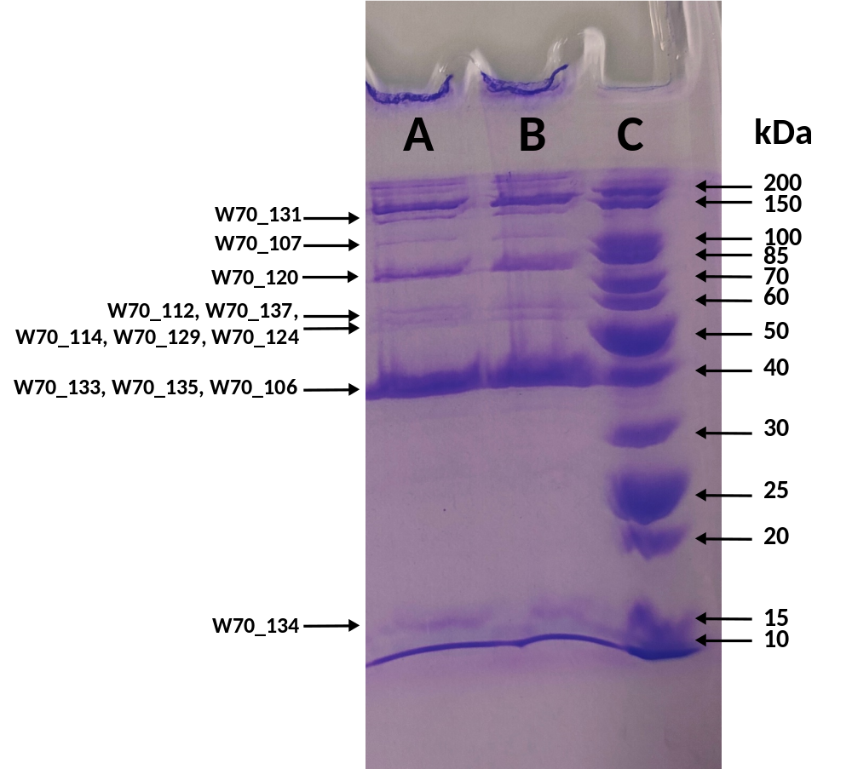
Figure S3. Sodium dodecyl sulphate polyacrylamide gel electrophoresis (SDS-PAGE) analysis of the purified structural W70 phage proteins (lanes A and B) on a 10% SDS-PAGE separation gel alongside an unstained protein ladder (10-200 kDa) (lane C). Peptides with higher spectrum counts that were identified using ESI-MS/MS and whose molecular weights matched the bands obtained on the gel are shown.

