Supplementary Table 1. Bandwidth selection test.
Bandwidth | Regression-discontinuity effect |  |  |  | Bandwidth selection
Bandwidth | Coef. | Std.Err | P | 95% CI | T | P
[-4.33, 4.33] | -21.612 | 7.082 | 0.002 | -35.387~-7.837 | -8.929 | 0.019
[-8.65, 8.65] | -19.727 | 5.687 | 0.001 | -30.873~-8.581 | -5.281 | 0.086
[-17.31, 17.31] | -12.280 | 4.226 | 0.004 | -20.562~-3.997 | -3.035 | 0.313
Note. Sample size determination was based on the Fisherian inference framework for Regression Discontinuity Designs. Bandwidth selection plays a critical role in defining the effective sample size: a larger bandwidth includes more observations and increases statistical power but may introduce bias if the continuity assumption is violated beyond the local region. Accordingly, this study adopted the narrowest bandwidth that met statistical significance criteria. The bandwidth selection test identified the 50% optimal bandwidth as most appropriate (Bandwidth: –4.33 to 4.33; p = 0.019), with a p-value below 0.05 indicating a valid and statistically adequate sample size. The 50%, 100%, and 200% optimal bandwidths corresponded to intervals of [–4.33, 4.33], [–8.65, 8.65], and [–17.31, 17.31], respectively, as reported by the rdrobust command.
Supplementary Table 2. Scores of RHDS, QDTs, and SSFD across three stages.
 | Mean±SD |  |  |  | P
 | Stage 1 (n=198) | Stage 2 (n=117) | Stage 3 (n=96) | Total | P
The scores of RHDS | 83.85±0.94 | 82.69±1.14 | 84.14±1.24 | 83.59±0.63 | 0.65
The scores of QDTs | 87.97±1.14 | 87.09±1.97 | 88.46±1.83 | 87.83±0.89 | 0.84
The scores of SSFD | 70.33±0.84 | 67.80±0.96 | 72.66±1.03 | 70.15±0.55 | <0.001
Note. RHDS: Readiness for Hospital Discharge Scale; QDTs: Quality of Discharge Teaching Scale; SSFD: Self-Rating Scale of Systemic Family Dynamics. One-way analysis of variance (ANOVA) was conducted to examine group differences, assuming normality and homogeneity of variances.
Supplementary Table 3. Continuity test of covariates.
Variable | Coef. | Std.err. | P | 95%CI
Sex | 0.333 | 0.227 | 0.142 | -0.112~0.778
Age | -10.496 | 5.813 | 0.071 | -21.889~0.898
Marital status | -0.371 | 0.335 | 0.268 | -1.029~0.286
Religion | 0.186 | 0.471 | 0.693 | -0.737~1.109
Educational level | -0.510 | 0.824 | 0.536 | -2.124~1.104
Occupation | -0.561 | 0.426 | 0.188 | -1.396~0.274
Monthly family income | -0.633 | 0.829 | 0.445 | -2.258~0.992
Post-discharge caregiver involvement | 0.167 | 0.374 | 0.655 | -0.566~0.900
Healthcare payment method | 0.089 | 0.79 | 0.258 | -0.065~0.244
Alcohol | -0.416 | 0.446 | 0.351 | -1.289~0.458
Smoking behaviours | -0.188 | 0.368 | 0.610 | -0.911~0.534
Weekly exercise frequency | 0.150 | 0.354 | 0.671 | -0.543~0.844
Weekly exercise duration | 1.411 | 0.445 | 0.002 | 0.538~2.284
Regularity of daily routine | 0.005 | 0.014 | 0.725 | -0.023~0.033
Basic medical history | 0.460 | 0.335 | 0.169 | -0.195~1.120
Medications | -0.011 | 0.367 | 0.977 | -0.731~0.709
The scores of QDTS | -14.006 | 6.997 | 0.045 | -27.719~0.293
The scores of SSFD | -2.093 | 3.670 | 0.534 | -8.697~4.510
Note. To account for potential covariate discontinuities that could influence the outcome, continuity tests were conducted to assess regression discontinuity effects across covariates. A p-value of more than 0.05 indicated a significant continuity in conditional regression functions at the cut-off, which were included in the study. The scores for the Readiness for Hospital Discharge Scale (RHDS) were used to measure hospital discharge readiness, with higher scores indicating greater readiness. The Quality of Discharge Teaching Scale (QDTS) scores assessed the quality of discharge teaching, with higher scores reflecting higher quality. The Self-Rating Scale of Systemic Family Dynamics (SSFD) scores measured systemic family dynamics, with higher scores indicating stronger family dynamics. The p-values and 95% confidence intervals (CIs) were robust.

Supplementary Table 4. Bandwidth sensitivity test.
Bandwidth |  | Coef. | Std.Err. | P | 95%CI
50% optimal bandwidth | 4.326 | -21.612 | 7.082 | 0.002 | -35.387~-7.837
75% optimal bandwidth | 6.489 | -20.460 | 6.299 | 0.001 | -32.807~-8.114
100% optimal bandwidth | 8.653 | -19.727 | 5.687 | 0.001 | -30.873~-8.581
125% optimal bandwidth | 10.816 | -17.547 | 5.454 | 0.001 | -28.237~-6.858
150% optimal bandwidth | 12.979 | -15.268 | 5.119 | 0.003 | -25.301~-5.236
175% optimal bandwidth | 15.142 | -14.078 | 4.583 | 0.002 | -23.080~-5.075
200% optimal bandwidth | 17.305 | -12.280 | 4.226 | 0.004 | -20.562~-3.997

Note. To validate the robustness of the estimated causal effect of policy-driven organizational changes on discharge readiness, careful attention was given to bandwidth selection, which critically affects the balance between estimation bias and variance. Narrow bandwidths reduce bias but may increase variance, while wider bandwidths improve precision at the risk of introducing bias. Bandwidth sensitivity analyses were conducted using the rdrobust command. Statistically significant results (P < 0.05) and consistent local average treatment effects across varying bandwidths confirmed the robustness of the findings. The corresponding p-values and 95% confidence intervals further supported the stability of the estimates across specifications.

Supplementary Table 5. Rectangular kernel test and covariate test.
 | lwald | Std.err | P | 95%CI
Default triangular kernel without covariates | -19.727 | 5.687 | 0.001 | -30.873~-8.581
Rectangular kernel | -19.727 | 5.687 | 0.001 | -30.873~-8.581
Covariate test | -22.962 | 4.481 | <0.001 | -31.745~-14.178

Note. Both triangular and rectangular kernel functions were applied to estimate the treatment effect, with the triangular kernel utilizing weighted least squares regression and the rectangular kernel relying on ordinary least squares regression. The consistency of results across kernel types strengthened the reliability of the findings. To ensure the exchangeability of the running variable around the cutoff, only covariates demonstrating continuity (P > 0.05) were included in the Regression Discontinuity in Time (RDiT) model, as verified through continuity tests. The p-values and 95% confidence intervals (CIs) indicated robust estimates. The local Wald estimator (lwald) was used to assess the causal effect by comparing local average treatment effects on either side of the cutoff, particularly under the rectangular kernel specification.

Supplementary Table 6. Placebo tests

Cut-off | Coef. | Std.Err. | P | 95%CI
Before 3 weeks | -0.119 | 0.890 | 0.024 | -0.294~0.056
Before 2 weeks | -0.116 | 0.305 | 0.373 | -0.715~-0.375
Before 1 week | 0.331 | 0.206 | 0.303 | -0.073~0.735
After 1 week | 0.213 | 0.406 | 0.559 | -0.582~-1.008
After 2 weeks | -0.394 | 0.488 | 0.419 | -1.349~0.562
After 3 weeks | -0.317 | 0.094 | 0.055 | -0.501~-0.134

Note. Placebo tests were conducted by shifting the cutoff date from the original policy intervention date (February 23, 2023) to alternative time points where no major public health policy changes occurred. These tests assessed whether significant discontinuities emerged in the absence of actual interventions. The resulting p-values and 95% confidence intervals (CIs) demonstrated robustness, further supporting the validity of the estimated causal effects.

Supplementary Figures.
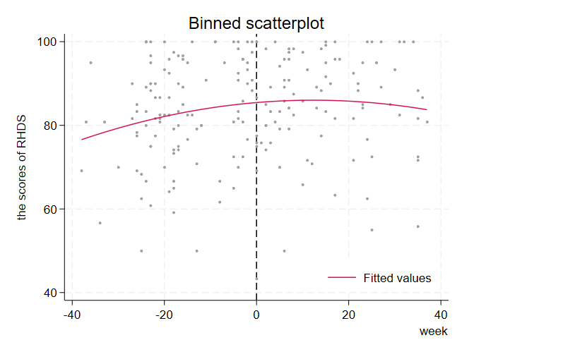
Supplementary Figure 1. Binned scatterplot and global polynomial regression curves illustrating the relationship between RHDS scores and time.
Note. These plots visually represented the association between time (on the x-axis) and RHDS scores (on the y-axis), with separate visualizations for the pre- and post-cutoff periods. A positive association was observed between time (measured in weeks) and RHDS scores, indicating that changes over time were associated with variations in RHDS scores. The binned scatterplots (dots) represent local sample means over non-overlapping partitions (bins) of the running variable. These binned means capture the behavior of the data points and highlight any discontinuities away from the cutoff. The second component of the figure includes two smooth global polynomial regression curves for control and treatment units, offering a flexible global approximation of the regression functions on either side of the cutoff.

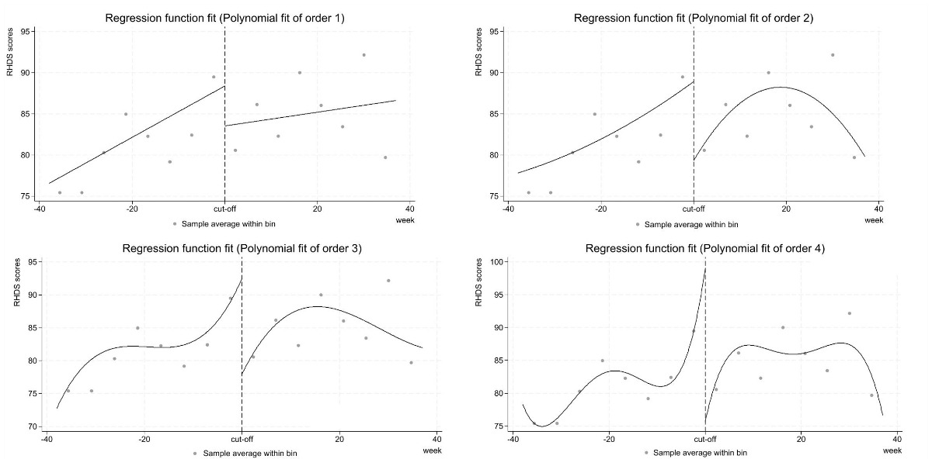
Supplementary Figure 2. Regression discontinuity effect plot of regression function fit in polynomial fit of order 1~4.
Note. The selected polynomial order at optimal bandwidth was used to model time-varying treatment effects, ensuring the effectiveness of local polynomial model fitting. The polynomial regression models provide a locally weighted linear approximation of the outcome (RHDS scores) across different levels of the running variable (week). The binned dots represent local sample means over non-overlapping partitions (bins) of the running variable, effectively capturing the data's behavior and highlighting any discontinuities away from the cutoff.

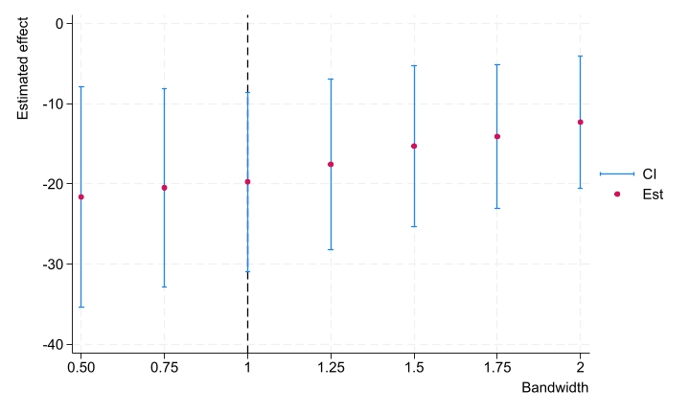
Supplementary Figure 3. Bandwidth: x times MSE-optimal bandwidth

Note. Est: the estimation of the local average treatment effect.
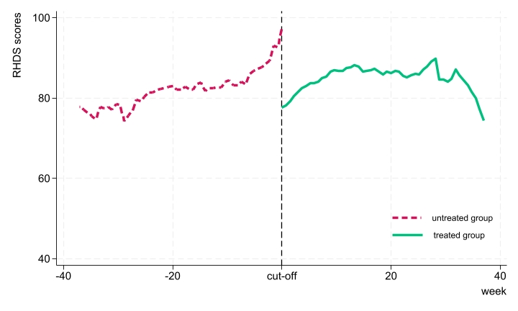
Supplementary Figure 4. Regression discontinuity plot for rectangular kernel test without covariates
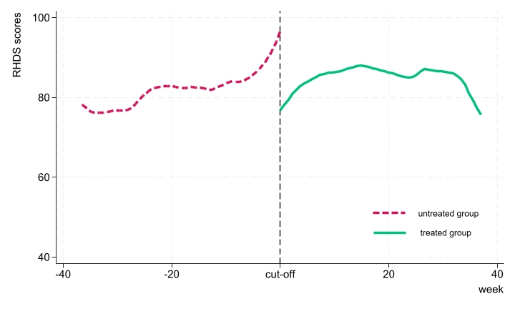
Supplementary Figure 5. Regression discontinuity plot for covariate test in default triangular kenel

