Supplementary materials for “Investigating false memories among “winners” and “losers” in the Prisoner’s Dilemma

Victim/wrongdoer and morality of betrayal scales

Experiment 1
Participants responded to two Likert scale questions immediately after making their initial decision, and again after receiving (and responding to) misinformation about their partner’s choice.
- Victim/wrongdoer scale: “After taking part in this task, people sometimes feel that they are a victim (i.e. that they were wronged by Player 2) or that they are a wrongdoer (i.e. that they wronged Player 2). Where would you say you fall on this scale?” (0-100, where 0 = “I am definitely a victim” and 100 = “I am definitely a wrongdoer”).
- Betrayal scale: “After taking part in this task how do you feel about the morality of betraying your partner?” (0-100, where 0 = “Betraying your partner in this game is the wrong thing to do” and 100 = “Betraying your partner in this game is fine”).

For each outcome measure, a three-way ANOVA was conducted, considering the independent variables of time (before/after learning the outcome of the game), initial choice (testify/stay silent) and misinformation condition (misled/control). The results of these ANOVAs are reported in Tables S-1 and S-2 and illustrated in Figures S-1 and S-2.

Table S-1. Effects of choice, misinformation condition and time on responses to the victim/wrongdoer scale (Experiment 1)
Effect |  | SS |  | df |  | MS |  | F |  | p |  | η²_{p}
Choice |  | 82329.29 |  | 1,405 |  | 82329.29 |  | 220.04 |  | < .001 |  | 0.35
Misinformation Condition |  | 7.49 |  | 1,405 |  | 7.49 |  | 0.02 |  | 0.89 |  | 0.001
Time |  | 10827.46 |  | 1,405 |  | 10827.46 |  | 63.00 |  | < .001 |  | 0.13
Choice*Misinformation Condition |  | 144.38 |  | 1,405 |  | 144.38 |  | 0.39 |  | 0.53 |  | 0.001
Misinformation Condition*Time |  | 278.82 |  | 1,405 |  | 278.82 |  | 1.62 |  | 0.20 |  | 0.004
Choice*Time |  | 14410.06 |  | 1,405 |  | 14410.06 |  | 83.85 |  | < .001 |  | 0.17
Choice*Misinformation Condition*Time |  | 38.85 |  | 1,405 |  | 38.85 |  | 0.23 |  | 0.63 |  | 0.001
Note. Type III Sum of Squares

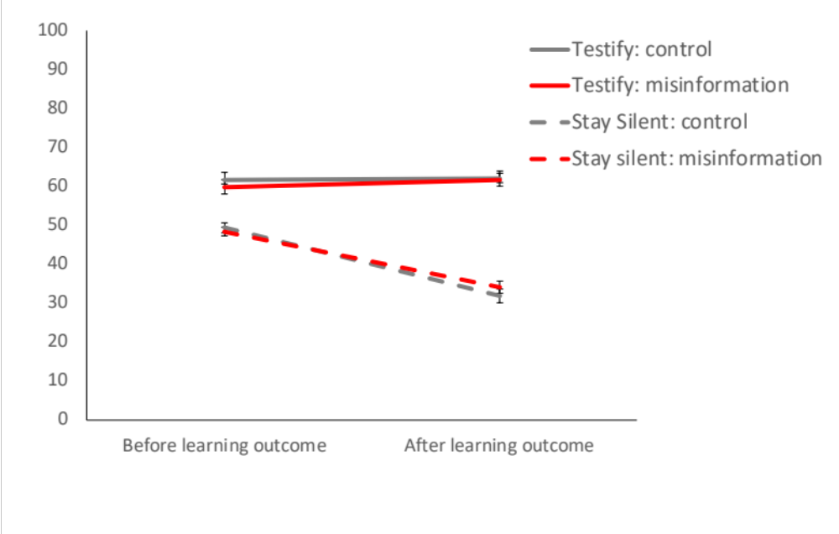
Figure S-1. Mean responses to the victim/wrongdoer scale (Experiment 1). 0 = definitely a victim, 100 = definitely a wrongdoer. Error bars represent standard errors of the mean.
For the victim/wrongdoer scale, significant effects of time and initial choice were superseded by an interaction effect, such that participants who stayed silent felt more like a victim following the procedure than participants who chose to testify. These effects were not moderated by misinformation condition. For the betrayal scale, only a main effect of initial choice was observed, such that participants who chose to stay silent felt that betraying their partner in the game was wrong, whereas participants who testified against their partner were relatively neutral on this question.

Table S-2. Effects of choice, misinformation condition and time on responses to the betrayal scale (Experiment 1)
Effect |  | SS |  | df |  | MS |  | F |  | p |  | η²_{p}
Choice |  | 160500.88 |  | 1,406 |  | 160500.88 |  | 156.64 |  | < .001 |  | 0.28
Misinformation Condition |  | 88.79 |  | 1,406 |  | 88.79 |  | 0.09 |  | 0.77 |  | 0.001
Time |  | 253.08 |  | 1,406 |  | 253.08 |  | 1.42 |  | 0.23 |  | 0.003
Choice*Misinformation Condition |  | 25.30 |  | 1,406 |  | 25.30 |  | 0.02 |  | 0.88 |  | 0.001
Misinformation Condition* Time |  | 81.75 |  | 1,406 |  | 81.75 |  | 0.46 |  | 0.50 |  | 0.001
Choice*Time |  | 1918.01 |  | 1,406 |  | 1918.01 |  | 10.73 |  | 1.15e-3 |  | 0.03
Time*Choice* Misinformation Condition |  | 87.26 |  | 1,406 |  | 87.26 |  | 0.49 |  | 0.49 |  | 0.001
Note. Type III Sum of Squares

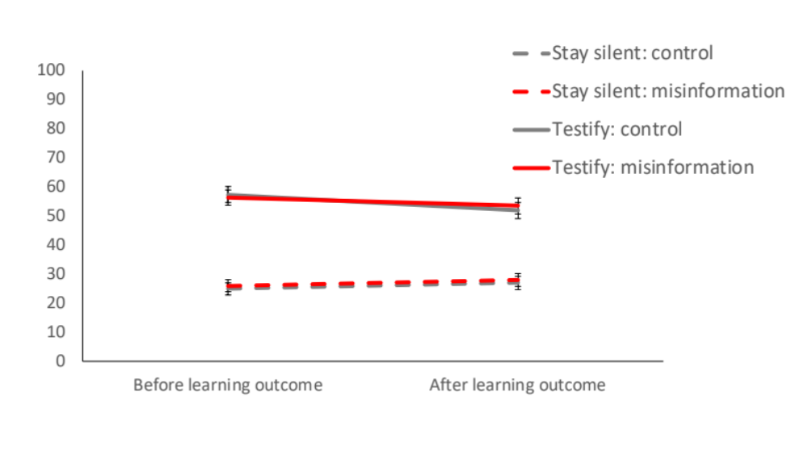
Figure S-2. Responses to the morality of betrayal scale (Experiment 1). 0 = Betraying your partner is wrong, 100 = betraying your partner is fine. Error bars represent standard errors of the mean.

Experiment 2
Participants responded to the same two questions as in Experiment 1, but the first set of questions was now presented after the outcome of the game was announced, but before the misinformation about Player 2’s intentions was presented.

A 2 (choice: stay silent/testify) x 2 (misinformation condition: misled/control) x 2 (time: before/after misinformation) ANOVA was conducted on responses to the victim wrongdoer scale; see Table S-3 for details. A substantial main effect of choice was observed, such that participants who chose to testify felt more like a wrongdoer (M = 65.82, SE = 1.46) while participants who stayed silent felt more like victims (M = 22.47, SE = 1.46). A smaller main effect of misinformation condition was also observed; participants who were misled had lower scores on this measure (M = 41.12, SE = 1.46) than participants who were not (M = 47.16, SE = 1.46). An examination of the means plot in Figure S-3 reveals that misled co-operators felt rather more victimised than their control counterparts, while misled defectors felt slightly less like a wrongdoer than those who were not misled.

Table S-3. Effects of choice, misinformation condition and time on responses to the victim/wrongdoer scale (Experiment 2)
Effect |  | Sum of Squares |  | df |  | Mean Square |  | F |  | p |  | η²_{p}
Choice |  | 367331.16 |  | 1,396 |  | 367331.16 |  | 438.33 |  | < .001 |  | 0.53
Misinformation Condition |  | 7131.69 |  | 1,396 |  | 7131.69 |  | 8.51 |  | 0.004 |  | 0.02
Time |  | 68.09 |  | 1,396 |  | 68.09 |  | 1.57 |  | 0.21 |  | 0.004
Choice* Misinformation Condition |  | 23.03 |  | 1,396 |  | 23.03 |  | 0.03 |  | 0.87 |  | 0.001
Choice*Time |  | 120.17 |  | 1,396 |  | 120.17 |  | 2.77 |  | 0.10 |  | 0.001
Misinformation Condition*Time |  | 52.55 |  | 1,396 |  | 52.55 |  | 1.21 |  | 0.27 |  | 0.003
Time*Choice*Misinformation Condition |  | 5.34 |  | 1,396 |  | 5.34 |  | 0.12 |  | 0.73 |  | 0.001
Note. Type III Sum of Squares

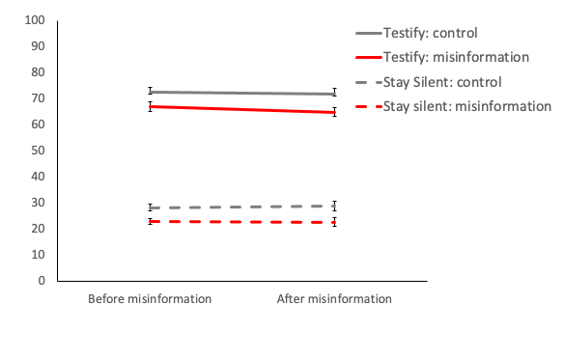
Figure S-3. Mean responses to the victim/wrongdoer scale (Experiment 2). 0 = definitely a victim, 100 = definitely a wrongdoer. Error bars represent standard errors of the mean.
A similar analysis was conducted for the responses to the morality of betrayal question (see Table S-4). A main effect of choice was observed, such that betraying one’s partner in this game was rated as more acceptable by defectors (M = 60.27, SE = 2.10) than co-operators (M = 28.41, SE = 2.10). No other main effects or interactions were observed; see Figure S-4 for an illustration.

Table S-4. Effects of choice, misinformation condition and time on responses to the morality of betrayal scale (Experiment 2)
Effect |  | Sum of Squares |  | df |  | Mean Square |  | F |  | p |  | η²_{p}
Choice |  | 198427.75 |  | 1,396 |  | 198427.75 |  | 113.54 |  | < .001 |  | 0.22
Misinformation Condition |  | 412.99 |  | 1,396 |  | 412.99 |  | 0.24 |  | 0.63 |  | 0.001
Time |  | 2.26 |  | 1,396 |  | 2.26 |  | 0.03 |  | 0.85 |  | 0.001
Choice*Misinformation Condition |  | 1139.93 |  | 1,396 |  | 1139.93 |  | 0.65 |  | 0.42 |  | 0.002
Choice*Time |  | 156.57 |  | 1,396 |  | 156.57 |  | 2.38 |  | 0.12 |  | 0.006
Misinformation Condition*Time |  | 16.56 |  | 1,396 |  | 16.56 |  | 0.25 |  | 0.62 |  | 0.0014
Choice*Misinformation Condition*Time |  | 81.97 |  | 1,396 |  | 81.97 |  | 1.25 |  | 0.26 |  | 0.003
Note. Type III Sum of Squares

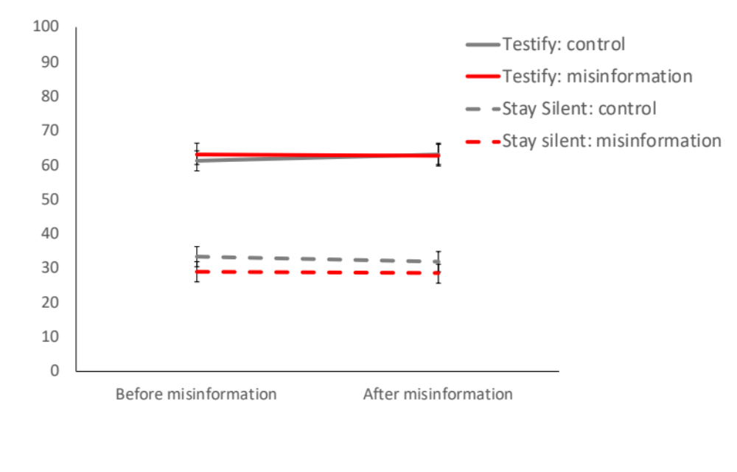
Figure S-4. Responses to the morality of betrayal scale (Experiment 1). 0 = Betraying your partner is wrong, 100 = betraying your partner is fine. Error bars represent standard errors of the mean.

Second round of Prisoner’s Dilemma game: Experiment1
In Experiment 1, participants were invited to play a second round of the Prisoner’s Dilemma game after reporting their memories of Experiment 1 and selecting reasons for their decision, and just before being debriefed as to the purpose of the experiment. Chi square analyses examined the effect of misinformation on second-round decisions for both co-operators and defectors. As Figure S-5 shows, the majority of participants who originally chose to testify in Round 1 (and therefore ‘won’ the game’, as Player 2 stayed silent) elected to testify again in Round 2. Participants who chose to stay silent in Round 1 (and therefore ‘lost’ the game as Player 2 testified) were just as likely to testify as to stay silent in Round 2. These patterns were not affected by the presence or absence of misinformation (co-operators: χ² (1) = 1.37, p = .24, Cramer’s V = 0.025; defectors: χ² (1) = 0.11, p .74, Cramer’s V = 0.08).

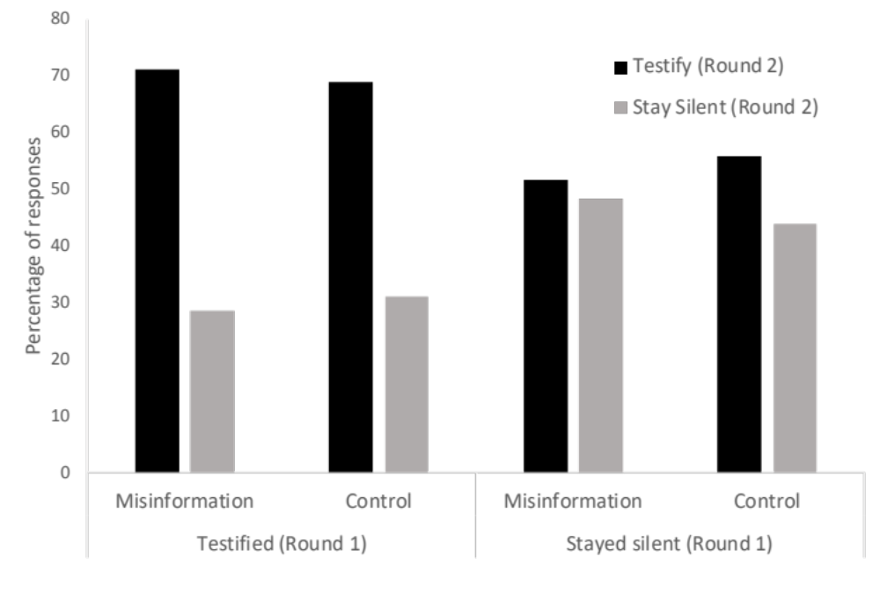
Figure S-5. Percentage of participants who chose to testify or stay silent in a second round of the Prisoner’s Dilemma in Experiment 1.

Reasons for Decision
Figures S-6 to S-10 depict the frequency with which each offered reason for the decision to co-operate or defect was selected in all five experiments. These data demonstrate the wide range of reasons offered by participants for their choice in the game. The most frequently selected reason to co-operate was “Because I thought it was the right thing to do”. “Because I thought it was the best strategy” and “because I believe in looking after other people” were also common reasons.

The most common reason to defect was “Because I thought it was the right strategy”, however a high proportion of defectors in each experiment also selected “other reason”. Player 2 mentioned in their profile that they were a fan of Donald Trump’s book The Art of the Deal, and a cursory examination of the open-text responses describing these other reasons mentioned Mr Trump. The open-text responses provided by these were therefore coded for the presence of a reference to Trump. Across all five experiments, the majority of “other” reasons to defect related to Trump, as depicted in the final column of each figure.

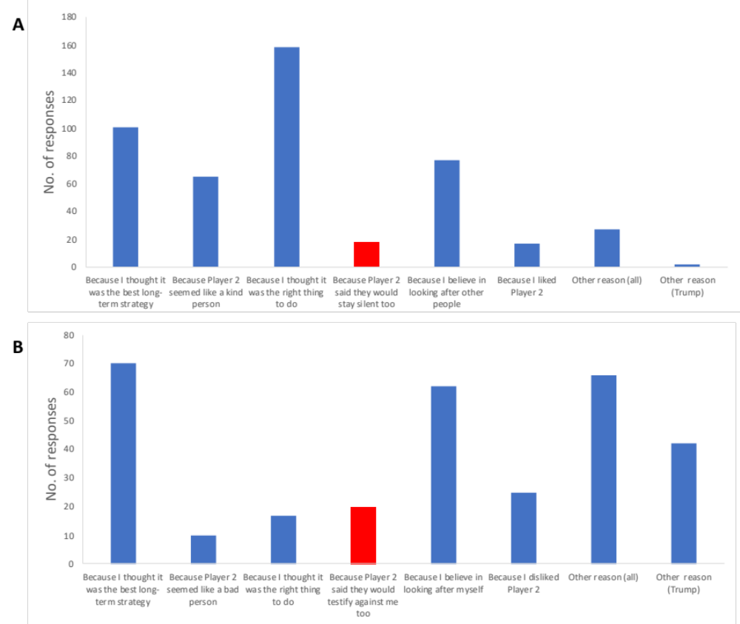
Figure S-6. Number of participants selecting each option as a reason to (A) stay silent or (B) testify in Experiment 1. Misinformation options are depicted in red.

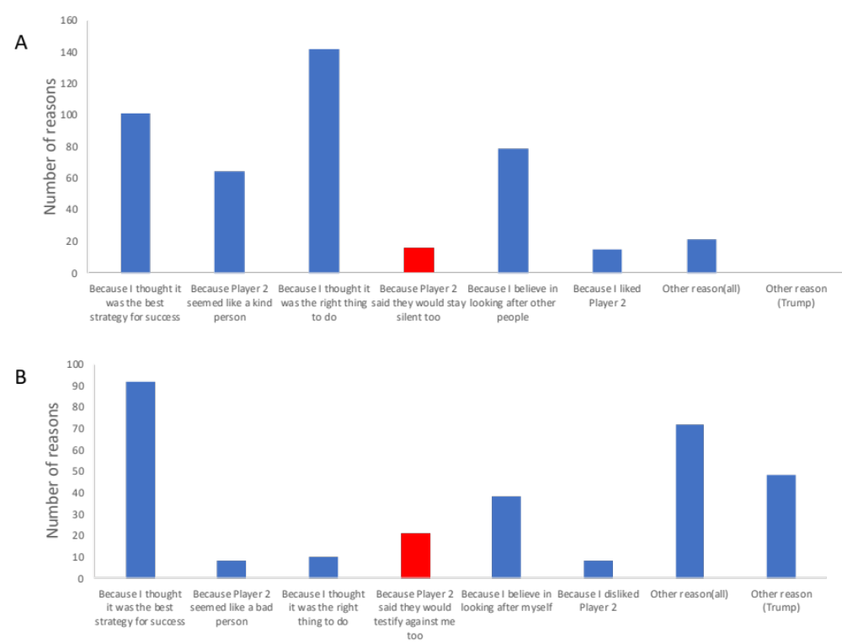

Figure S-7. Number of participants selecting each option as a reason to (A) stay silent or (B) testify in Experiment 2. Misinformation options are depicted in red.

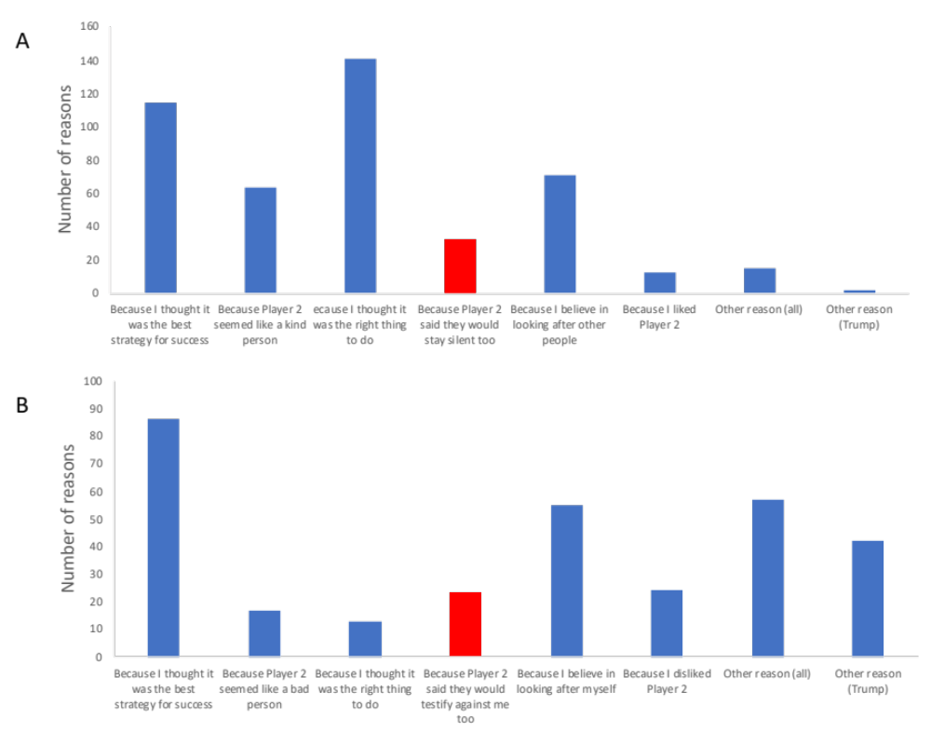
Figure S-8. Number of participants selecting each option as a reason to (A) stay silent or (B) testify in Experiment 3. Misinformation options are depicted in red.

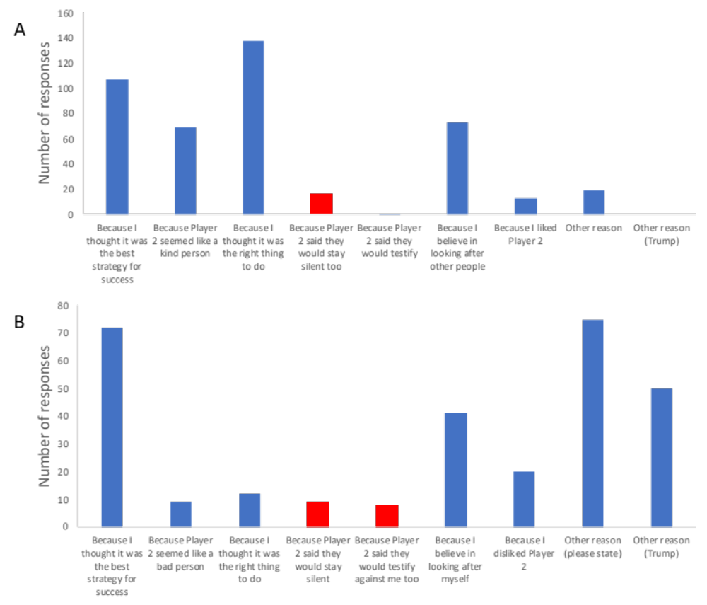

Figure S-9. Number of participants selecting each option as a reason to (A) stay silent or (B) testify in Experiment 4. Misinformation options are depicted in red; ; participants were only presented with the option associated with the misinformation they received earlier in the experiment.

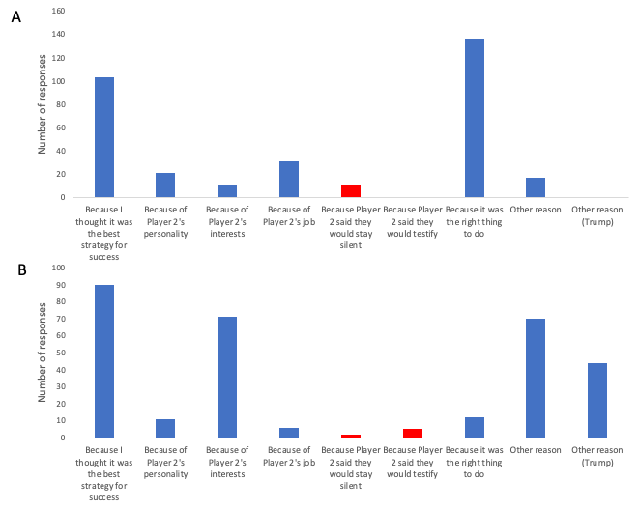
Figure S-10. Number of participants selecting each option as a reason to (A) stay silent or (B) testify in Experiment 5. Misinformation options are depicted in red; participants were only presented with the option associated with the misinformation they received earlier in the experiment.

