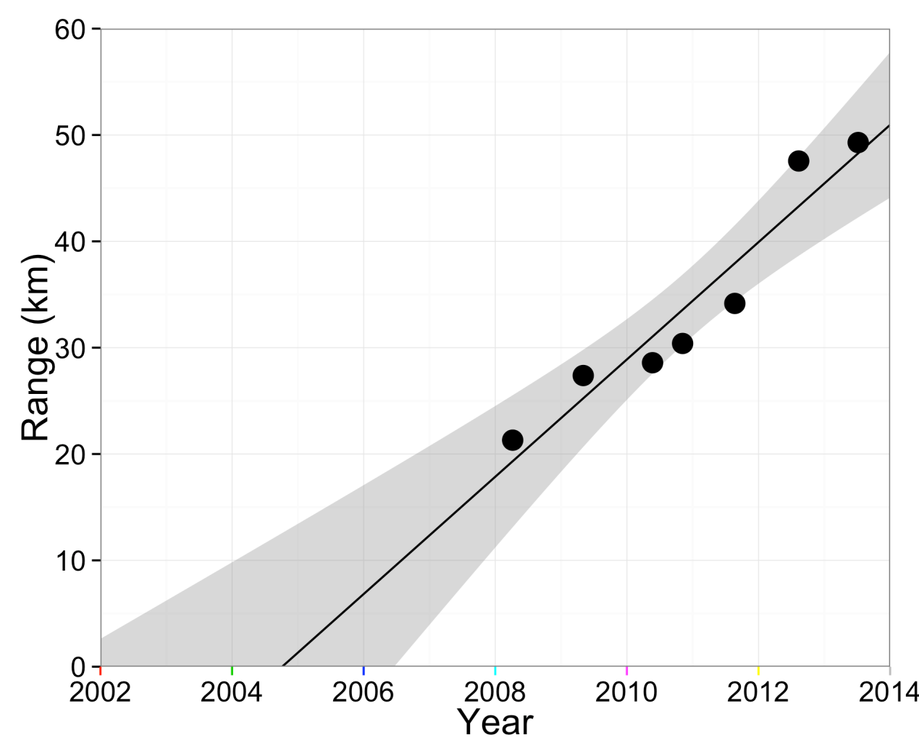
Figure S3. The radial range (km) of the Crocidura russula distribution as a function of time (years). The range is defined as (A/π)^{0.5} where the locations of all C. russula presences up to a certain time are used to calculate the area, A, of the C. russula minimum convex polygon. Linear regression gives a slope of 5.5±0.8 km/yr (the grey shading represents the 95% confidence region).

