Supplementary Table S1 Description of data sources

Name | Time range | Description | Indicator | Coding system used/inclusion criteria | Codes included | Changes in coding or data collection over time period being studied
Hospital In-Patient Enquiry Scheme | 2000-2023 | HIPE is a health information system designed to collect demographic, clinical, and administrative information on discharges from acute hospitals nationally. HIPE is case-basedOne individual may have multiple hospitalisations within a given year. | Crude population rate of hospitalisations in acute hospitals with cocaine identified as either a principal diagnosis and/or additional diagnosis | 2000-2004: International Classification of Diseases, Ninth Revision, Clinical Modification (ICD-9-CM)  2005-2019: International Statistical Classification of Diseases and Related Health Problems, Tenth Revision, Australian Modification (ICD-10-AM)  2020-2023: International Statistical Classification of Diseases and Related Health Problems, Tenth Revision, Australian Modification and Australian Classification of Health Interventions (ACHI) and Australian Coding Standards (ACS), collectively referred to as ICD-10-AM/ACHI/ACS. | 2000-2004 (ICD-9-CM)  304.2 Cocaine dependence unspecified  304.21 Cocaine dependence continuous  304.22 Cocaine dependence episodic  304.23 Cocaine dependence in remission  305.6 Cocaine abuse unspecified  305.61 Cocaine abuse continuous  305.62 Cocaine abuse episodic  305.63 Cocaine abuse in remission  970.81 Poisoning by cocaine  2005–2023 (ICD-10-AM & ICD-10-AM/ACHI/ACS)  F14.0 Mental and behavioural disorders due to use of cocaine, acute intoxication  F14.1 Mental and behavioural disorders due to use of cocaine, harmful use  F14.2 Mental and behavioural disorders due to use of cocaine, dependence syndrome  F14.3 Mental and behavioural disorders due to use of cocaine, withdrawal state  F14.4 Mental and behavioural disorders due to use of cocaine, withdrawal state with delirium  F14.5 Mental and behavioural disorders due to use of cocaine, psychotic disorder  F14.6 Mental and behavioural disorders due to use of cocaine, amnesic syndrome  F14.7 Mental and behavioural disorders due to use of cocaine, residual and late-onset psychotic disorder  F14.8 Mental and behavioural disorders due to use of cocaine, other mental and behavioural disorders  F14.9 Mental and behavioural disorders due to use of cocaine, unspecified mental and behavioural disorder  T40.5 Poisoning by narcotics and psychodysleptics - Cocaine  R782 Finding of cocaine in blood | Coding system changed from ICD-9-CM for 2000-2004, ICD-10-AM for 2005-2019, and ICD-10-AM/ACHI/ACS for 2000-2023.  The number of secondary diagnoses recorded by HIPE changed four times over the study period, from 5 in 2000 to 9 in 2002, 19 in 2005, and 29 in 2011.
National Psychiatric Inpatient Reporting System | 2000-2022 | The NPIRS collects epidemiological and clinical information on all admissions to inpatient psychiatric services in Ireland | Crude population rate of psychiatric hospitalisations with cocaine identified as either a principal diagnosis and/or additional diagnosis | Diagnoses are categorised in accordance with the WHO’s ICD-10 categories | F14.0 Mental and behavioural disorders due to use of cocaine, acute intoxication  F14.1 Mental and behavioural disorders due to use of cocaine, harmful use  F14.2 Mental and behavioural disorders due to use of cocaine, dependence syndrome  F14.3 Mental and behavioural disorders due to use of cocaine, withdrawal state  F14.4 Mental and behavioural disorders due to use of cocaine, withdrawal state with delirium  F14.5 Mental and behavioural disorders due to use of cocaine, psychotic disorder  F14.6 Mental and behavioural disorders due to use of cocaine, amnesic syndrome  F14.7 Mental and behavioural disorders due to use of cocaine, residual and late-onset psychotic disorder  F14.8 Mental and behavioural disorders due to use of cocaine, other mental and behavioural disorders  F14.9 Mental and behavioural disorders due to use of cocaine, unspecified mental and behavioural disorder | From 2000–2020, the primary diagnosis and one secondary diagnosis were recorded. Since 2021, up to four diagnoses can be recorded.
National Drug Related Deaths Index | 2000-2020 | Deaths that occurred and were registered in Ireland | Crude population rate of deaths where cocaine was the underlying and/or contributory cause of death | The primary data source is coroner files. Other data sources include the general mortality register (via the Central Statistics Office), acute hospitals data (via the Hospital In-Patient Enquiry System) and the national opioid agonist treatment register (via the Central Treatment List). |  | The methodology for collecting data on deaths did not change over the study period.
National Drug Treatment Reporting System | 2000-2022 | Collection of alcohol and other drug treatment data from all publicly funded government and non-government agencies which provide one or more specialist alcohol and other drug treatment services. | Crude rate of treatment episodes where cocaine is identified by the client and/or treatment provider as their own drug of concern (i.e. principal or other drug of concern) | We included NDTRS cases where cocaine was identified by the client as (i) their main drug of concern, and (ii) either their main or secondary drug of concern. | Treatment status is self-reported and verified by the service provider | The methodology for collecting treatment data did not change over the study period. However, there may have been changes in the number of treatment agencies and/or their capacity over the study period.

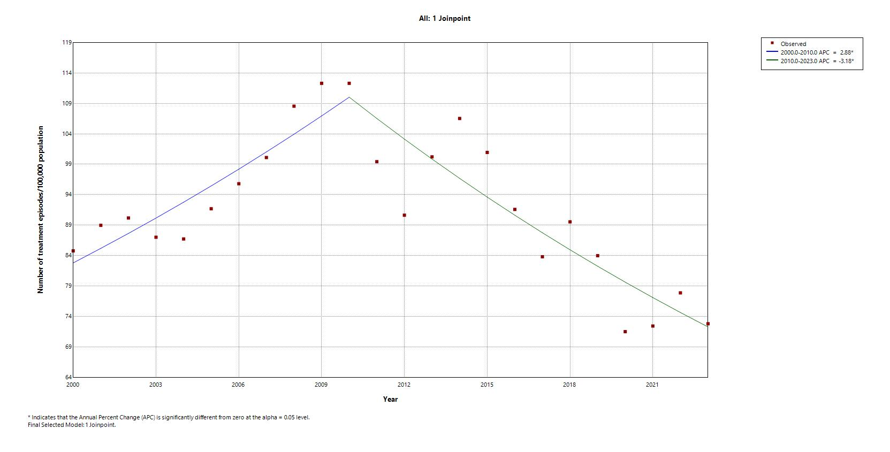
Supplementary Figure S1 Addiction treatment episodes involving opioids as a main problem drug, per 100,000 population in Ireland 2000–2023

