Online Supplementary Material

Biomarkers of vitamin D for Dietary Reference Intake development in children: A systematic review and meta-analysis

Kevin D. Cashman, Christian Ritz, Aoife Carlin and Mairead Kennedy

Address correspondence to: Prof. Kevin D. Cashman, Cork Centre for Vitamin D and Nutrition Research, School of Food and Nutritional Sciences, and Department of Medicine, University College Cork, Cork, Ireland. Tel.: +353 21 4901317; Fax.: +353 21 4270244; E-mail: k.cashman@ucc.ie

Supplemental Table 1. Criteria within the Population Intervention Comparison Outcome (PICO) framework for systematic reviews

Concept | Criteria
Population(s) | Generally healthy infants and children aged 1-9 y (for all serum 25(OH)D and PTH); All age-groups for all other vitamin D biomarkers.
Intervention | Randomized controlled trials using vitamin D₃ or D₂ supplements or vitamin D-fortified foods
Comparator | Placebo supplements, assigned standard-care control vitamin D supplements¹ or unfortified foods
Outcome | Biomarker concentrations/calcium absorption reported in all study groups

¹As long as the standard-care control vitamin D dose is not higher than the current US Adequate Intake for infants (10 μg/d) or age-specific Recommended Dietary Allowance for age-specific vitamin D recommendations for children, adults or older adults (15 or 20 μg/d) [16]

Supplemental Table 2. Characteristics of the included studies of older children, adults and older adults

 | Population
Study |  |  | Country |  | Age |  | Sex |  | Intervention dose |  | Biomarkers measured
Aloia, 2015 [54] |  | USA |  | 60 ± 4.5 y |  | F |  |  | 4000 IU/d vitamin D₃ |  | Bio-25(OH)D, free 25(OH)D
Ala-Houhala, 1986 [30] |  | Finland |  | Mothers |  | F |  |  | 1000 IU/d vitamin D₃ |  | 24,25(OH)₂D,
Alzaman, 2016 [55] |  | USA |  | 59.1 ± 8.6 y |  | M/F (61%/39%) |  |  | 4000 IU/d vitamin D₃ |  | Free 25(OH)D, VDBP
Andersen, 2008 [56] |  | Denmark |  | 10.1-14.7 y |  | F |  |  | 800 IU/d vitamin D₃ |  | Osteocalcin, Pyr, Dpyr
Binkley, 2017 [57] |  | USA |  | 67.8 ± 9.1 y |  | F |  |  | 1800 IU/d vitamin D₃ |  | Free 25(OH)D, 24,25(OH)₂D, vitamin D₃
Björkhem-Bergman, 2018 [58] |  | Sweden |  | 41 y |  | M/F (43%/57%) |  |  | 4000 IU/d vitamin D₃ |  | Free 25(OH)D, VDBP
Cashman, 2014 [59] |  | Ireland |  | 59.9 ± 6.5 y |  | M/F (28%/72%) |  |  | 800 IU/d vitamin D₃ |  | Free 25(OH)D, 24,25(OH)₂D, VDBP, 1,25(OH)₂D
Cashman, 2015 [60] |  | Ireland |  | 59.9 ± 6.5 y |  | M/F (28%/72%) |  |  | 800 IU/d vitamin D₃ |  | C3-epimer of 25(OH)D
Francic, 2019 [61] |  | Austria |  | 62.0 (51.3-68.7) y |  | M/F (43%/57%) |  |  | 2800 IU/d vitamin D₃ |  | Free 25(OH)D, 24,25(OH)₂D, bio-25(OH)D, 1,25(OH)₂D
Ghaly, 2019 [62] |  | Australia |  | >18 y |  | NS |  |  | 2000 IU/d vitamin D₃ |  | C3-epimer of 25(OH)D₃
Ghazi, 2010 [63] |  | Iran |  | 14-20 y |  | M/F (50%/50%) |  |  | 1600 IU/d vitamin D₃ |  | Osteocalcin, BAP
Heaney, 2008 [64] |  | USA |  | 38.7 ± 11.2 y |  | M |  |  | 11000 IU/d vitamin D₃ |  | Vitamin D₃
Hillman, 2008 [65] |  | USA |  | 10.0 ± 2.8 y (arthritis) |  | M/F (33%/66%) |  |  | 2000 IU/d vitamin D₃ |  | Ca absorption
Holmlund-Suila, 2016 [66] |  | Finland |  | 20 ± 3 y |  | M/F (43%/57%) |  |  | 2000 IU/d vitamin D₃ |  | Free 25(OH)D, VDBP
Kane, 2013 [67] |  | USA |  | 60 ± 10 y |  | M/F (53%/47%) |  |  | 1000 IU/d vitamin D₃ |  | Free 25(OH)D
Karsland Åkeson, 2018¹ [68] |  | Sweden |  | 5–7 y |  | M/F (46%/54%) |  |  | 1000 IU/d vitamin D₃ |  | Osteocalcin, BAP
Lehmann, 2015 [69] |  | Germany |  | 39 ± 14 y |  | M/F (33%/67%) |  |  | 800 IU/d vitamin D₃ |  | 24,25(OH)₂D, 1,25(OH)₂D
Lewis, 2013 [70] |  | USA |  | 11.3 ± 1.2 y |  | M/F (50%/50%) |  |  | 2000 IU/d vitamin D₃ |  | Ca absorption
Macdonald, 2017 [71] |  | UK |  | 64.7 ± 2.1 y |  | F |  |  | 1000 IU/d vitamin D₃ |  | 24,25(OH)₂D
Marwaha, 2018 [72] |  | India |  | 6.1-11.8 y |  | F |  |  | 2000 IU/d vitamin D₃ |  | BAP, CTx
Mølgaard, 2010 [73] |  | Denmark |  | 11-12 y |  | F |  |  | 400 IU/d vitamin D₃ |  | Osteocalcin, Pyr, Dpyr
Neyestani, 2014 [74] |  | Iran |  | 9-12 y |  | M/F (46%/54%) |  |  | 200 IU/d vitamin D₃ |  | Osteocalcin, BAP
O’Callaghan, 2018 [75] |  | Ireland |  | 34 ± 4 y |  | F (Pregnant) |  |  | 800 IU/d vitamin D₃ |  | 24,25(OH)₂D
Pilz, 2018 [76] |  | Germany |  | 25 (22-29) y |  | F |  |  | 800 IU/d vitamin D₃ |  | Free 25(OH)D,
Pop, 2017 [77] |  | USA |  | 57 ± 4 y |  | F |  |  | 4000 IU/d vitamin D₃ |  | Free 25(OH)D, bio-25(OH)D
Rajakumar, 2015 [78] |  | USA |  | 11.3 ± 2 y |  | M/F (50%/50%) |  |  | 1000 IU/d vitamin D₃ |  | Osteocalcin, CTx
Schwartz, 2016 [79] |  | USA |  | 87 ± 8 y |  | M/F (37%/63%) |  |  | 4000 IU/d vitamin D₃ |  | Free 25(OH)D,
Viljakainen, 2006 [80] |  | Finland |  | 11.4 ± 0.4 y |  | F |  |  | 400 IU/d vitamin D₃ |  | Osteocalcin, Pyr, Dpyr
Wagner, 2006 [81] |  | USA |  | 29 ± 5 y |  | F (Lactating) |  |  | 6000 IU/d vitamin D₃ |  | Vitamin D₃
Wagner, 2011 [82] |  | Canada |  | 27.6 y |  | M/F (50%/50%) |  |  | 4000 IU/d vitamin D₃ |  | 24,25(OH)₂D
Yao, 2017 [83] |  | China |  | 30 (25, 39) y |  | M/F (31%/69%) |  |  | 2000 IU/d vitamin D₃ |  | Bio-25(OH)D, VDBP
Zhu, 2005 [84] |  | China |  | 10 y |  | F |  |  | 200-320 IU/d vitamin D₃ |  | Osteocalcin, BAP, Dpyr
¹Follow-up to original study [44].
Bio-25(OH)D, bioavailable 25(OH)D; Pyr, urinary pyridinoline; Dpyr, urinary deoxypyridinoline; BAP, serum bone-specific alkaline phosphatase; CTx; serum carboxy-terminal telopeptide; VDBP, Vitamin D binding protein; 1,25(OH)₂D, 1,25-dihydroxyvitamin D.

Supplemental Table 3. Validity of included studies of infants and children aged 1-9 years reporting circulating 25-hydroxyvitamin D and other vitamin D biomarkers in some cases.

 |  |  |  | Number of participants at last time point (dropout)
Study [Ref no.] |  | Study design |  |  |  | Intervention  Arm |  | Control arm |  |  |  | Duration of  Treatment |  |  |  | Randomization |  |  | Compliance |  | Dose check
Abrams, 2013 [26] |  |  | RCT |  |  |  | 32 (0) |  | 31 (1) |  |  |  |  | 8 weeks |  |  | Yes |  |  | Yes |  |  | Yes
Aglipay, 2017 [27] |  |  | RCT |  |  |  | 325 (24) |  | 319 (35) |  |  |  |  | 4 months |  |  | Yes |  |  | Yes |  |  | NS
Akkermans, 2017 [28] |  |  | RCT |  |  |  | 114 (44) |  | 113 (47) |  |  |  |  | 20 weeks |  |  | Yes |  |  | Yes |  |  | NS
Ala-houhala, 1985 [29] |  |  | RCT |  |  |  | 29 (0) |  | 22 (0) |  |  |  |  | 20 weeks |  |  | Yes |  |  | No |  |  | NS
Ala-Houhala, 1986 [30] |  |  | RCT |  |  |  | 16 (0) |  | 17 (0) |  |  |  |  | 15 weeks |  |  | Yes |  |  | No |  |  | NS
Ala-Houhala, 1988 [31] |  |  | RCT |  |  |  | 24 (6) |  | 27 (3) |  |  |  |  | 13 months |  |  | Yes |  |  | Yes |  |  | NS
Brett, 2016 [32] |  |  | RCT |  |  |  | 25 (1) |  | 24 (0) |  |  |  |  | 12 weeks |  |  | Yes |  |  | Yes |  |  | Yes
Brett, 2018 [33] |  |  | RCT |  |  |  | 26 (0) |  | 23 (2) |  |  |  |  | 6 month |  |  | Yes |  |  | Yes |  |  | Yes
Chandy, 2016 [34] |  |  | RCT |  |  |  | 47 (31) |  | 54 (24) |  |  |  |  | 9 months |  |  | Yes |  |  | Yes |  |  | NS
Economos, 2014 [35] |  |  | RCT |  |  |  | 53 (8) |  | 64 (15) |  |  |  |  | 12 weeks |  |  | Yes |  |  | No |  |  | Yes
Gallo, 2013 [36] |  |  | RCT |  |  |  | 13 (3) |  | 29 (10) |  |  |  |  | 3¹ months |  |  | Yes |  |  | Yes |  |  | Yes
Grant, 2014 [37] |  |  | RCT |  |  |  | 70 (16) |  | 74 (13) |  |  |  |  | 6 months |  |  | Yes |  |  | Yes |  |  | NS
Greer, 1981 [38] |  |  | RCT |  |  |  | 9 (0) |  | 9 (0) |  |  |  |  | 12 weeks |  |  | Yes |  |  | Yes |  |  | NS
Greer & Marshall, 1989 [39] |  |  | RCT |  |  |  | 19 (3) |  | 19 (5) |  |  |  |  | 6 months |  |  | Yes |  |  | Yes |  |  | NS
Holmlund-Suila, 2012 [40] |  |  | RCT |  |  |  | 37 (0) |  | 38 (3) |  |  |  |  | 3 months |  |  | Yes |  |  | Yes |  |  | Yes
Hower, 2013 [41] |  |  | RCT |  |  |  | 39 (7) |  | 24 (10) |  |  |  |  | 4 months |  |  | Yes |  |  | Yes |  |  | NS
Loeb, 2019 [42] |  |  | RCT |  |  |  | 553 (97) |  | 542 (108) |  |  |  |  | 8 months |  |  | Yes |  |  | Yes |  |  | NS
Mortensen, 2016 [43] |  |  | RCT |  |  |  | 40 (3) |  | 41 (2) |  |  |  |  | 20 weeks |  |  | Yes |  |  | Yes |  |  | Yes
Ohlund, 2017 (Fair skin) [44] |  |  | RCT |  |  |  | 45 (0) |  | 19 (3) |  |  |  |  | 3 months |  |  | Yes |  |  | Yes |  |  | Yes
Pittard, 1991 [45] |  |  | RCT |  |  |  | 5 (0) |  | 11 (0) |  |  |  |  | 16 weeks |  |  | Yes |  |  | NS |  |  | NS
Ponnapakkam, 2010 [46] |  |  | RCT |  |  |  | 8 (NR) |  | 8 (NR) |  |  |  |  | 6 months |  |  | Yes |  |  | Yes |  |  | NS
Reuter, 2019 [47] |  |  | RCT |  |  |  | 86 (5) |  | 87 (8) |  |  |  |  | 6 months |  |  | Yes |  |  | NS |  |  | NS
Rosendahl, 2018 [48] |  |  | RCT |  |  |  | 421 (71) |  | 411 (84) |  |  |  |  | 24 months |  |  | Yes |  |  | Yes |  |  | NS
Rothberg, 1992 [49] |  |  | RCT |  |  |  | 12 (0) |  | 10 (0) |  |  |  |  | 6 weeks |  |  | Yes |  |  | NS |  |  | NS
Siafarikas, 2011 [50] |  |  | RCT |  |  |  | 14 (6) |  | 14 (6) |  |  |  |  | 6 weeks |  |  | Yes |  |  | NS |  |  | NS
Zhou, 2018 [51] |  |  | RCT |  |  |  | 164 (34) |  | 168 (30) |  |  |  |  | 4 months |  |  | Yes |  |  | NS |  |  | NS
Ziegler, 2014 [52] |  |  | RCT |  |  |  | 26 (15) |  | 39 (17) |  |  |  |  | 9 months |  |  | Yes |  |  | Yes |  |  | Yes
Wicklow, 2015 [53] |  |  | RCT |  |  |  | 18 (0) |  | 19 (0) |  |  |  |  | 6 months |  |  | Yes |  |  | NS |  |  | NS
NR, data not reported; NS, not specified; RCT, randomized controlled trial
¹Primary outcome timeframe

Supplemental Table 4. Validity of included studies of older children, adults and older adults

No. of participants
at last time point (dropout)
Study | Study design |  |  | Intervention  Arm |  | Control arm |  | Duration of  Treatment |  |  | Randomization |  |  |  | Compliance |  |  | Dose check
Aloia, 2015 [54] |  | RCT |  | 18 (0) | 19 (0) |  |  |  |  | 8 weeks |  |  |  | Yes |  |  | NS |  | NS
Ala-Houhala, 1986 [30] |  | RCT |  | 16 (0) | 16 (0) |  |  |  |  | 15 weeks |  |  |  | Yes |  |  | No |  | NS
Alzaman, 2016¹ [55] |  | RCT |  | 45/53 (1/5) | 42/55 (3/4) |  |  |  |  | 16 weeks |  |  |  | Yes |  |  | Yes |  | NS
Andersen, 2008 [56] |  | RCT |  | 7 (2) | 7 (1) |  |  |  |  | 12 months |  |  |  | Yes |  |  | Yes |  | NS
Binkley, 2017 [57] |  | RCT |  | 31 (0) | 31 (0) |  |  |  |  | 4 months |  |  |  | Yes |  |  | Yes |  | Yes
Björkhem-Bergman, 2018 [58] |  | RCT |  | 27 (0) | 32 (0) |  |  |  |  | 6 months |  |  |  | Yes |  |  | NS |  | NS
Cashman, 2014² [59] |  | RCT |  | 27/34 (1/2) | 28/32 (0/1) |  |  |  |  | 15 weeks |  |  |  | Yes |  |  | Yes |  | Yes
Cashman, 2015 [60] |  | RCT |  | 61 (3) | 60 (1) |  |  |  |  | 15 weeks |  |  |  | Yes |  |  | Yes |  | Yes
Francic, 2019 [61] |  | RCT |  | 52 (0) | 54 (0) |  |  |  |  | 8 weeks |  |  |  | Yes |  |  | NS |  | NS
Ghaly, 2019 [62] |  | RCT |  | 11 (0) | 10 (0) |  |  |  |  | 12 months |  |  |  | Yes |  |  | NS |  | NS
Ghazi, 2010 [63] |  | RCT |  | 70 (0) | 69 (0) |  |  |  |  | 6 months |  |  |  | Yes |  |  | Yes |  | Yes
Heaney, 2008 [64] |  | B-A (n=67) |  | N/A | N/A |  |  |  |  | ~4 months |  |  |  | N/A |  |  | NS |  | NS
Holmlund-Suila, 2016² [65] |  | RCT |  | 12/7 (0/2) | 12/9 (0/0) |  |  |  |  | 12 weeks |  |  |  | Yes |  |  | Yes |  | Yes
Hillman, 2008 [66] |  | RCT (CO) |  | 6 or 11 | 9 (0) |  |  |  |  | 6 months |  |  |  | Yes |  |  | Yes |  | NS
Kane, 2013 [67] |  | RCT |  | 26 (0) | 23 (0) |  |  |  |  | 6 weeks |  |  |  | Yes |  |  | Yes |  | Yes
Karsland Åkeson, 2018¹ [68] |  | RCT |  | 83 (2) | 32 (6) |  |  |  |  | 3 months |  |  |  | Yes |  |  | Yes |  | Yes
Lehmann, 2015 [69] |  | RCT |  | 54 (0) | 51 (1) |  |  |  |  | 12 weeks |  |  |  | Yes |  |  | Yes |  | Yes
Lewis, 2013 [70] |  | RCT |  | 61 (3) | 65 (3) |  |  |  |  | 12 weeks |  |  |  | Yes |  |  | Yes |  | Yes
Macdonald, 2017 [71] |  | RCT |  | 55 (N/A) | 46 (N/A) |  |  |  |  | 12 months |  |  |  | Yes |  |  | NS |  | NS
Marwaha, 2018 [72] |  | RCT |  | 75 (5) | 74 (7) |  |  |  |  | 6 months |  |  |  | Yes |  |  | Yes |  | NS
Mølgaard, 2010 [73] |  | RCT |  | 74 (1) | 74 (1) |  |  |  |  | 12 months |  |  |  | Yes |  |  | Yes |  | NS
Neyestani, 2014 [74] |  | RCT |  | 163 (0) | 133 (0) |  |  |  |  | 12 weeks |  |  |  | Yes |  |  | Yes |  | NS
O’Callaghan, 2018 [75] |  | RCT |  | 44 (4) | 40 (8) |  |  |  |  | 22 weeks |  |  |  | Yes |  |  | Yes |  | Yes
Pilz, 2018² [76] |  | RCT |  | 37/53 (0/0) | 29/57 (0/0) |  |  |  |  | 8 weeks |  |  |  | Yes |  |  | Yes |  | NS
Pop, 2017 [77] |  | RCT |  | 19 (10) | 19 (5) |  |  |  |  | 12 months |  |  |  | Yes |  |  | Yes |  | Yes
Rajakumar, 2015 [78] |  | RCT |  | 70 (8) | 63 (16) |  |  |  |  | 6 months |  |  |  | Yes |  |  | Yes |  | Yes
Schwartz, 2016 [79] |  | RCT |  | 20 (3) | 20 (4) |  |  |  |  | 16 weeks |  |  |  | Yes |  |  | Yes |  | Yes
Viljakainen, 2006 [80] |  | RCT |  | 74 (2) | 73 (3) |  |  |  |  | 12 months |  |  |  | Yes |  |  | Yes |  | Yes
Wagner, 2006 [81] |  | RCT |  | NS | NS |  |  |  |  | 6 months |  |  |  | Yes |  |  | Yes |  | NS
Wagner, 2011 [82] |  | RCT |  | 60 (0) | 20 (0) |  |  |  |  | 6 weeks |  |  |  | Yes |  |  | Yes |  | Yes
Yao, 2017 [83] |  | RCT |  | 207 (19) | 204 (18) |  |  |  |  | 20 weeks |  |  |  | Yes |  |  | Yes |  | Yes
Zhu, 2005 [84] |  | RCT |  | 44 (0) | 43 (0) |  |  |  |  | 24 months |  |  |  | Yes |  |  | Yes |  | NS
NR, not reported; NS, not specified; N/A, not applicable; RCT, randomized controlled trial; RCT (CO), cross-over designed RCT; B-A, before and after design study.
¹This study contained two RCTs
²This RCT had two distinct sets of RCT arms

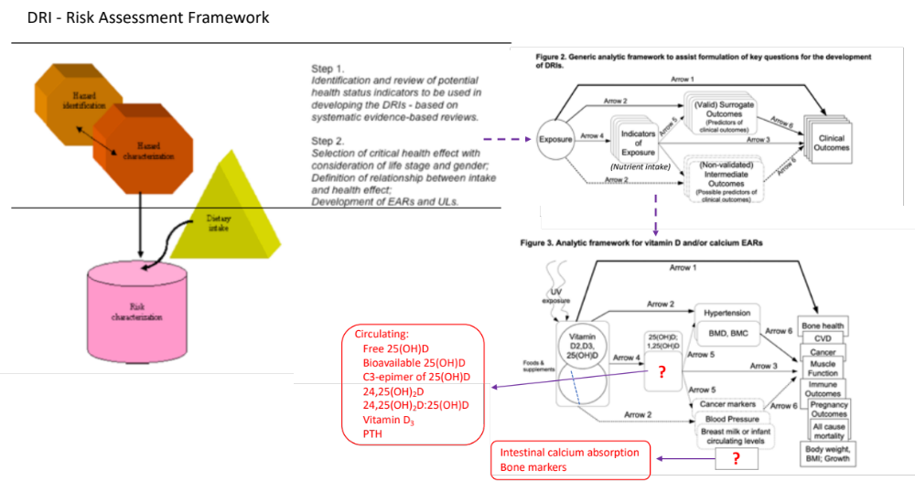

Supplemental Figure 1. Contextualized framework for Dietary Reference Intake (DRI) establishment, including indicators and outcomes (biomarkers) (adapted from [3,4]).

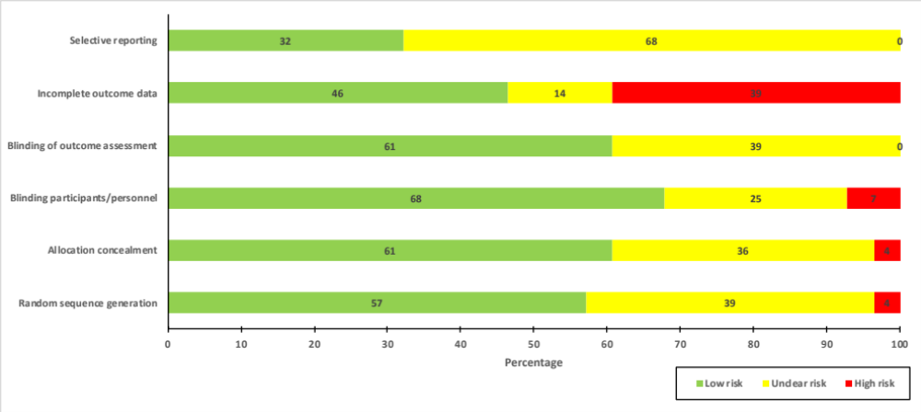

Supplemental Figure 2. Risk of bias summary for key domains across studies of infants and children, presented as percentages deemed a low, unclear or high risk.

A

B

Supplemental Figure 3. Forest plot of the effect of vitamin D supplementation compared with control on A) mean change in circulating 24,25-dihydroxyvitamin D concentration (nmol/L) in infants, children and adults, and B) mean change in ratio of 24,25-dihydroxyvitamin D to 25-hydroxyvitamin D (both in nmol/L) in adults.

Supplemental Figure 4. Forest plot of the effect of vitamin D supplementation compared with control on mean change in circulating free 25-hydroxyvitamin D concentration (pmol/L) in adults.

Supplemental Figure 5. Forest plot of the effect of vitamin D supplementation compared with control on mean change in circulating bioavailable 25-hydroxyvitamin D concentration (nmol/L) in adults.

Supplemental Figure 6. Forest plot of the effect of vitamin D supplementation compared with control on mean change in circulating C3-epimer of 25-hydroxyvitamin D concentration (nmol/L) in infants, children and adults.

Supplemental Figure 7. Forest plot of the effect of vitamin D supplementation compared with control on mean change in circulating vitamin D₃ concentration (ng/mL) in adults.

