A  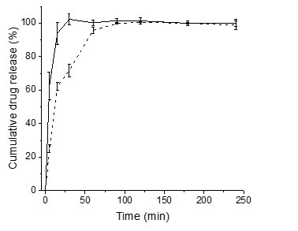 | B  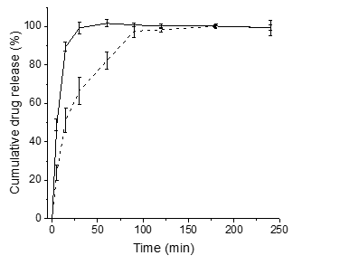
C  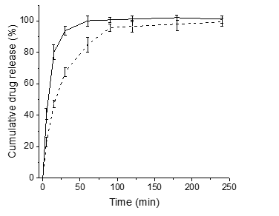 | D  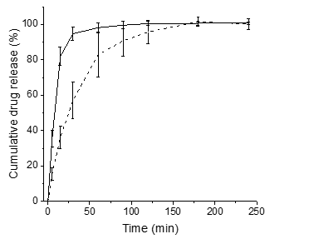
E  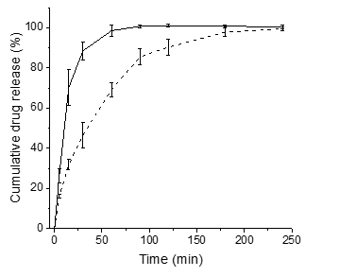 | F  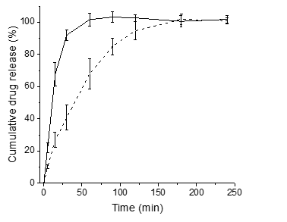
G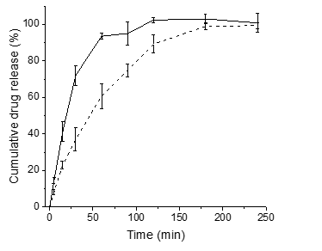 | H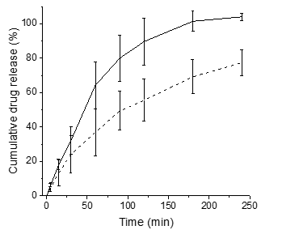
Figure SM-1. Dissolution profiles of tablets containing spray dried MCC (Emcocel®) (solid line) and air stream dried MCC (Vivapur®) (dashed line) containing ibuprofen (a) 2.5 %, (b) 5 %, (c) 7.5 %, (d) 10 %, (e) 12.5 %, (f) 15 %, (g) 20 %, and (h) 30 % w/w. Dashed and solid lines correspond to air stream and spray dried MCCs, respectively. Dissolution was performed in phosphate buffer pH 7.2 at 37ºC. Average values shown with y-error bars indicating standard deviation, n= 5.

Ibuprofen loading (%w/w) | Air stream dried | Spray dried
2.5
5
7.5
10
12.5
15
20
30
Figure SM-2. Focused Beam Reflectance Measurement (FBRM) chord length distributions for tablets with ibuprofen loadings of 2.5 % - 30 % w/w spray dried MCC (Emcocel®) and air stream dried MCC (Vivapur®), respectively, at different time ponts after addition to the disintegration medium, phosphate buffer pH 7.2 and temperature of 37 °C.

A
B

C
D

E
F

G
H

I
Figure SM-3. Raman spectra of tablet of (A) Spray dried MCC (Emcocel®) and Air stream dried MCC (Vivapur®) and of the blends with ibuprofen at (B) 2.5%, (C) 5%, (D) 7.5%, (E) 10%, (F) 12.5%, (G) 15%, (H) 20%, (I) 30% w/w ibuprofen/MCC.

