Supplementary Material

ReS₂/Si 2D/3D vertical heterojunction as a Self-Powered Photodiode
Kimberly Intonti^{1,2*}, Aniello Pelella³, Hazel Neill⁴, Vilas Patil⁴, Paul K. Hurley^{4,5}, Lida Ansari⁴, Farzan Gity^{4*}, and Antonio Di Bartolomeo^{1,2,}
¹Department of Physics “E. R. Caianiello”, University of Salerno, via Giovanni Paolo II, Fisciano, Salerno, 84084, Italy
²CNR-SPIN Salerno, via Giovanni Paolo II, Fisciano, 84084, Italy
³Department of Physics, University of Roma “Tor Vergata”, Via Della Ricerca Scientifica, 1 - 00133, Rome, Italy
⁴Tyndall National Institute, University College Cork, Lee Maltings, Dyke Parade, Cork, T12 R5CP, Ireland
⁵School of Chemistry, University College Cork, Cork, Ireland

- Current-voltage I-V characteristic of Ni/ReS₂/Ni structure
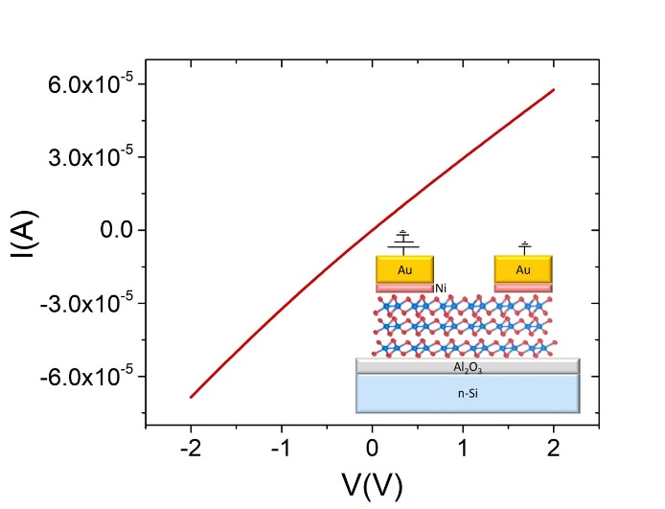
Figure S.1. The I-V curve shows the drain current (I) vs the source-drain voltage (V), at zero gate bias, of the Ni/ReS₂/Ni structure.
The nearly linear behaviour of the I-V characteristic acquired in the transistor configuration represented in Figure S.1 confirms a nearly ohmic behaviour of Au/Ni contacts to ReS₂.

- ReS₂/Si energy barrier extraction from I-V-T measurements
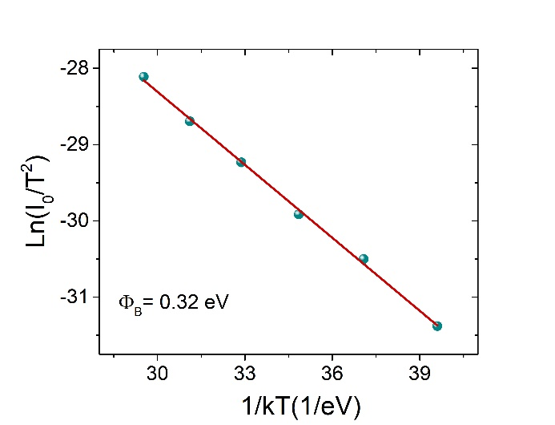

Figure S.2. Arrhenius plot showing the natural logarithm of the saturation current I_{o} over T² as a function of 1/kT, where k is the Boltzmann constant, and T is the temperature. The blue line is the linear fit of the data. The effective energy barrier height is extracted from its slope.
The thermionic emission current equation can be applied to study the temperature dependency of the forward I-V curves^{1,2}:
$$I=I_{0}[\exp\left(\frac{qV}{nkT}\right)-1]$$
where q is the electron charge, k is the Boltzmann constant, T is temperature, and n is the ideality factor. The saturation current I_{o} is defined as:
$$I_{0}=AA^{*} T^{2}\exp\left(-\frac{qΦ_{B}}{kT}\right)$$
in which A is the junction area, A* is the Richardson constant, and Փ_{B} is the energy barrier. The I_{o} values at different temperatures were extracted from the intercepts of the linear fit of the I-V curves at small positive biases, near 0 V. From the Arrhenius plot of $\operatorname{Ln}\left(\frac{Io}{T^{2}}\right)$vs. $1/kT$ plot in Figure S.2:
$$Ln\left(\frac{I_{0}}{T^{2}}\right)=Ln(AA^{*})-\frac{qΦ_{B}}{kT}$$
it is possible to extract the value of AA* and the effective energy barrier^{3–5}, that is around Փ_{B} = 0.32 eV.

- Photoresponse in Ni/Si Schottky diode
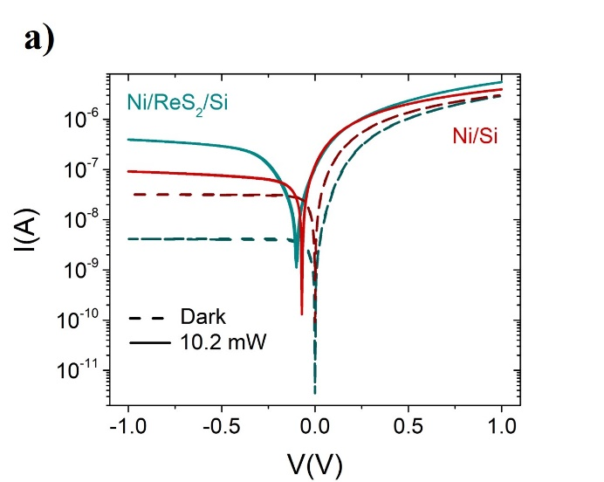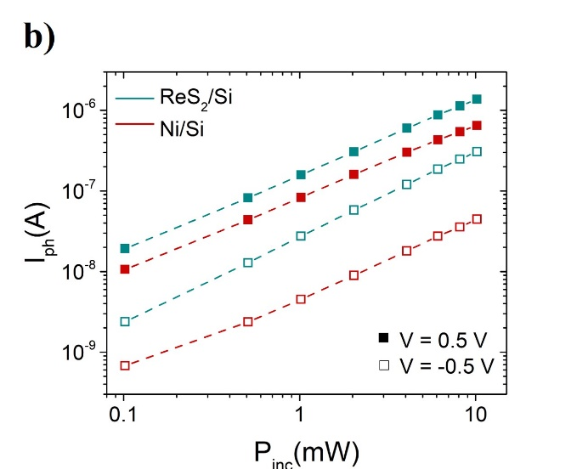
Figure S.3. (a) Comparison between I-V curves in dark (dash line) and under illumination (solid line) of the Ni/ReS₂/Si heterostructure and the Ni/Si Schottky diode. (b) Log-log plot of the photocurrent as a function of the incident optical power of the Ni/ReS₂/Si device (blue) and Ni/Si diode (red), at positive and negative biases.

- Responsivity maps as functions of external bias and incident power

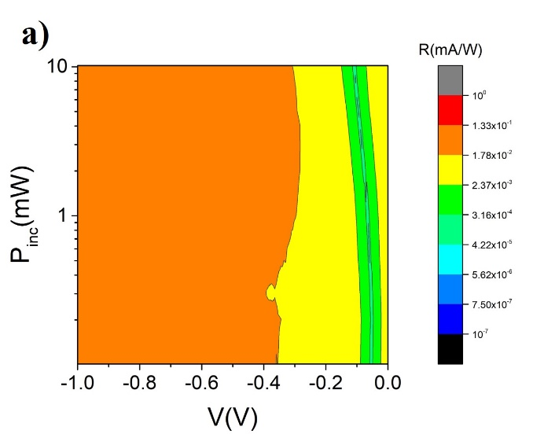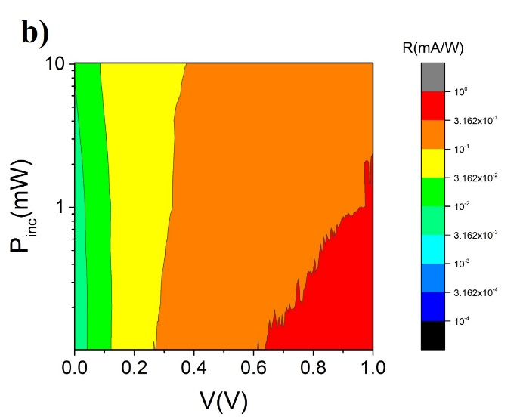
Figure S.4. a,b) Colour maps: responsivity as a function of incident power at a) negative, and b) positive external biases. At each bias responsivity is almost constant as a function of the incident power and increases as a function of the external bias (absolute value).

- Photoresponse under switching light at negative bias voltage
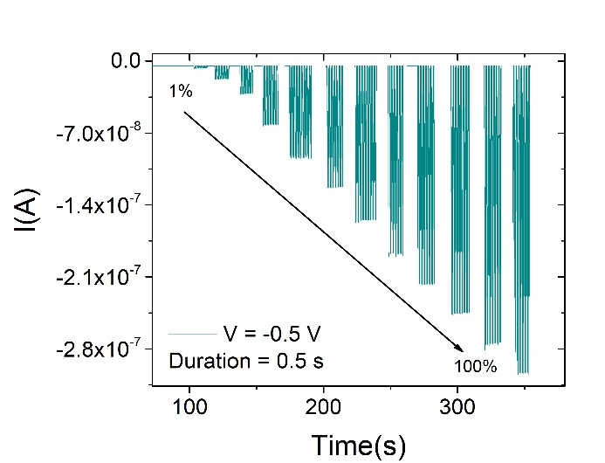
Figure S.5. Test of the switching properties of the device at negative bias in response to several sequences of light pulses with a duration of 0.5 s, exhibiting a stable and repeatable behaviour under all the incident powers.

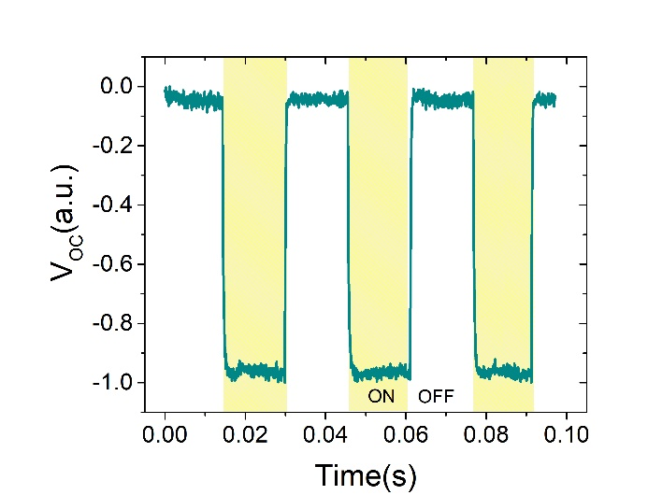
- Transient photovoltage at zero current

Figure S.6. Open circuit voltage measured by means of a digital oscilloscope.

- Nonequilibrium Green’s function (NEGF) calculations
To obtain the band alignment at the Ni-Si and ReS2-Si interfaces, non-equilibrium quantum transport calculations were performed based on first-principles calculations. DFT together with the non-equilibrium Green’s functions (NEGF) technique (DFT+NEGF) was utilized to represent realistic open systems as implemented in QuantumATK⁶ Use of the semi-infinite electrode boundary conditions is in contrast to using periodic boundary conditions normal to the junction interface, which leads to spurious interactions between periodic images of the interface. The use of electrode boundary conditions enables the isolation of a single junction with electrodes at equilibrium with electron reservoirs providing an accurate description of the charge transfer processes at the material interface forming the junction. Recursion iterative scheme has been used for calculating the self-energies⁷. Energy integral to obtain density matrix within the NEGF framework is performed through a complex contour integration, which includes integral over equilibrium states and non-equilibrium states. The integral over the equilibrium states has been done using semi-circular complex contour⁸. The integral over the non-equilibrium states along the real axis is performed using single contour method⁸. Linear combination of numerical atomic-orbital basis set and generalized gradient approximation (GGA) norm-conserving pseudopotentials from PseudoDojo with medium basis sets⁹ are employed in the simulations. Brillouin zone integrations are performed over a grid of k-points generated according to the Monkhorst-Pack scheme¹⁰, with a density of approximately 10 k-points per angstrom. An energy cut-off of 110 Ha is considered for the discretized grid, and all structural relaxation is performed with a maximum force of less than 0.02 eV Å⁻¹. For discretized grid, ∼700 k-point per angstrom have been used for the Green’s function calculations, in the direction normal to the interface plane. Van-der-Waals (vdW) interactions are included by adding a nonlocal vdW term to the local and the semi-local exchange correlation functionals utilizing Grimme’s dispersion correction.¹¹ The strain arising from the lattice constant mismatch between the materials at the ReS₂/Si interface, leading to 0.5% biaxial strain, is applied to the ReS₂ lattice. In the Ni/Si structure, the metal crystallographic orientation with common supercell with minimal strain for Ni[111] has been considered for commensurable interface leading to 1.9% strain which has been applied to the metal electrodes.^{12–14}.The Ni/Si interface structure consists of 224 Ni atoms and 1416 Si atoms (total 1640). The ReS₂/Si interface includes total 1090 atoms (384 ReS2 atoms, 701 Si atoms and 5 hydrogen atoms). To reflect the impact of Si exposure to HF prior to ReS₂ exfoliation the Si surface dangling bonds are passivated with hydrogen.

- Equilibrium band diagram of the Ni/Si structure

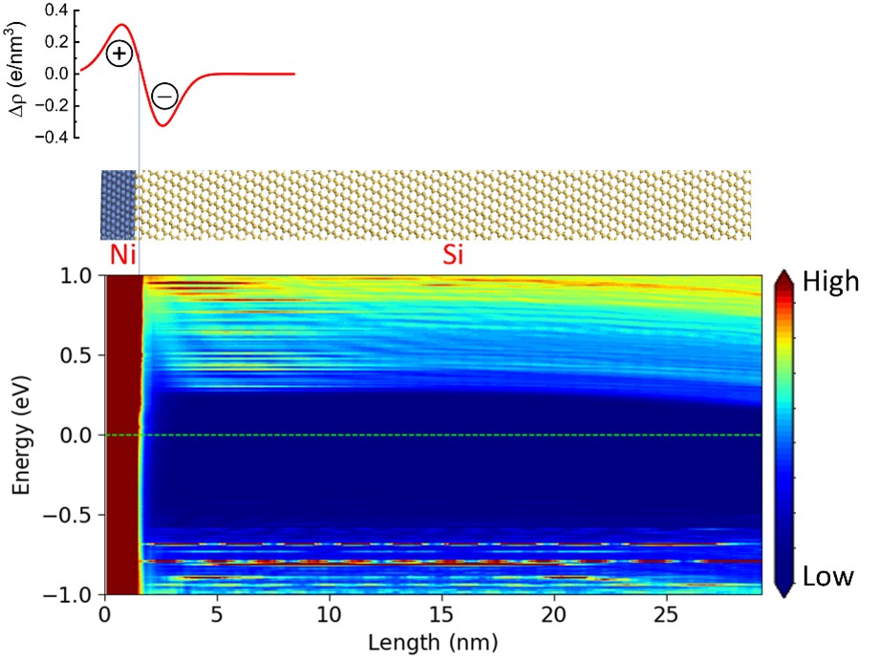

Figure S.7. Planar-averaged CDD, atomic structure and energy-resolved LDoS of Ni/Si.

- Experimental details
The large area 2D ReS2 flakes were mechanically exfoliated and subsequently transferred onto a low-doped n-type Si substrate, post-dipping the Si into dilute HF to etch the Si native oxide. The low-doped n-Si wafer was chosen to allow a broad depletion region leading to reduced dark current and increased photocurrent. Ni (15 nm) /Au (150 nm) metal contacts were then patterned on the flake surfaces using standard lithography and metal lift-off process.
Temperature-dependent current-voltage (I-V) measurements were performed on-wafer in a cryogenic probe station (Lake Shore Cryotronics, Inc.) connected to a Keithley 4200 SCS parameter analyzer. The photoresponse of the device was investigated under local illumination using a nano-positioned optical fiber connected to a supercontinuum white laser with a maximum nominal power of 110 mW and a spectrum in the range of 450-2400 nm. Rise and fall time were measured by using a digital oscilloscope (GW INSTEK MSO-2204E).

References
(1) Di Bartolomeo, A. Graphene Schottky Diodes: An Experimental Review of the Rectifying Graphene/Semiconductor Heterojunction. Physics Reports 2016, 606, 1–58. https://doi.org/10.1016/j.physrep.2015.10.003.
(2) Moun, M.; Kumar, M.; Garg, M.; Pathak, R.; Singh, R. Understanding of MoS2/GaN Heterojunction Diode and Its Photodetection Properties. Sci Rep 2018, 8 (1), 11799. https://doi.org/10.1038/s41598-018-30237-8.
(3) Jadhav, A.; Lyle, L. A. M.; Xu, Z.; Das, K. K.; Porter, L. M.; Sarkar, B. Temperature Dependence of Barrier Height Inhomogeneity in β -Ga2O3 Schottky Barrier Diodes. Journal of Vacuum Science & Technology B, Nanotechnology and Microelectronics: Materials, Processing, Measurement, and Phenomena 2021, 39 (4), 040601. https://doi.org/10.1116/6.0001059.
(4) Di Bartolomeo, A.; Giubileo, F.; Luongo, G.; Iemmo, L.; Martucciello, N.; Niu, G.; Fraschke, M.; Skibitzki, O.; Schroeder, T.; Lupina, G. Tunable Schottky Barrier and High Responsivity in Graphene/Si-Nanotip Optoelectronic Device. 2D Mater. 2016, 4 (1), 015024. https://doi.org/10.1088/2053-1583/4/1/015024.
(5) Al-Ahmadi, N. A. Schottky Barrier Inhomogeneities at the Interface of Different Epitaxial Layer Thicknesses of N-GaAs/Ti/Au/Si: Al0.33Ga0.67As. Heliyon 2020, 6 (9), e04852. https://doi.org/10.1016/j.heliyon.2020.e04852.
(6) Smidstrup, S.; Markussen, T.; Vancraeyveld, P.; Wellendorff, J.; Schneider, J.; Gunst, T.; Verstichel, B.; Stradi, D.; Khomyakov, P. A.; Vej-Hansen, U. G.; Lee, M.-E.; Chill, S. T.; Rasmussen, F.; Penazzi, G.; Corsetti, F.; Ojanperä, A.; Jensen, K.; Palsgaard, M. L. N.; Martinez, U.; Blom, A.; Brandbyge, M.; Stokbro, K. QuantumATK: An Integrated Platform of Electronic and Atomic-Scale Modelling Tools. J. Phys.: Condens. Matter 2019, 32 (1), 015901. https://doi.org/10.1088/1361-648X/ab4007.
(7) Sancho, M. P. L.; Sancho, J. M. L.; Sancho, J. M. L.; Rubio, J. Highly Convergent Schemes for the Calculation of Bulk and Surface Green Functions. J. Phys. F: Met. Phys. 1985, 15 (4), 851. https://doi.org/10.1088/0305-4608/15/4/009.
(8) Brandbyge, M.; Mozos, J.-L.; Ordejón, P.; Taylor, J.; Stokbro, K. Density-Functional Method for Nonequilibrium Electron Transport. Phys. Rev. B 2002, 65 (16), 165401. https://doi.org/10.1103/PhysRevB.65.165401.
(9) van Setten, M. J.; Giantomassi, M.; Bousquet, E.; Verstraete, M. J.; Hamann, D. R.; Gonze, X.; Rignanese, G.-M. The PseudoDojo: Training and Grading a 85 Element Optimized Norm-Conserving Pseudopotential Table. Computer Physics Communications 2018, 226, 39–54. https://doi.org/10.1016/j.cpc.2018.01.012.
(10) Monkhorst, H. J.; Pack, J. D. Special Points for Brillouin-Zone Integrations. Phys. Rev. B 1976, 13 (12), 5188–5192. https://doi.org/10.1103/PhysRevB.13.5188.
(11) Grimme, S.; Antony, J.; Ehrlich, S.; Krieg, H. A Consistent and Accurate Ab Initio Parametrization of Density Functional Dispersion Correction (DFT-D) for the 94 Elements H-Pu. The Journal of Chemical Physics 2010, 132 (15), 154104. https://doi.org/10.1063/1.3382344.
(12) Bokdam, M.; Brocks, G.; Katsnelson, M. I.; Kelly, P. J. Schottky Barriers at Hexagonal Boron Nitride/Metal Interfaces: A First-Principles Study. Phys. Rev. B 2014, 90 (8), 085415. https://doi.org/10.1103/PhysRevB.90.085415.
(13) Zhussupbekov, K.; Ansari, L.; Elibol, K.; Zhussupbekova, A.; Kotakoski, J.; Shvets, I. V.; Duesberg, G. S.; Hurley, P. K.; McEvoy, N.; Ó Coileáin, C.; Gity, F. Revealing the Influence of Edge States on the Electronic Properties of PtSe2. Applied Materials Today 2023, 35, 101926. https://doi.org/10.1016/j.apmt.2023.101926.
(14) Stradi, D.; Martinez, U.; Blom, A.; Brandbyge, M.; Stokbro, K. General Atomistic Approach for Modeling Metal-Semiconductor Interfaces Using Density Functional Theory and Nonequilibrium Green’s Function. Phys. Rev. B 2016, 93 (15), 155302. https://doi.org/10.1103/PhysRevB.93.155302.

