Additional information
Fabrication of Transparent Composites for Non-Invasive Surface Enhanced Raman Scattering (SERS) Analysis of Modern Art Works
Abeer Alyami,ª Antonio Mirabile,^{b} Daniela Iacopinoª
ªTyndall National Institute, University College Cork, Dyke Parade, Cork, Ireland
^{b}Mirabile, 11 Rue de Bellefond, 75009 Paris 09, France
*corresponding author email: daniela.iacopino@tyndall.ie, ORCID: 0000-0003-2301-9401

Characterization of Ag nanoparticles
Ag nanoparticles were synthesized according to a method described by Rainville et al.. The UV-vis spectrum of as synthesized particles in aqueous solution is characterized by a maximum absorption centered at 388 nm and a shoulder at 425 nm. The UV-vis spectrum of Ag nanoparticle/PDMS composite presents a broad absorption band from 420 to 800 nm, ascribed to the plasmonic coupling between neighboring Ag nanoparticles.

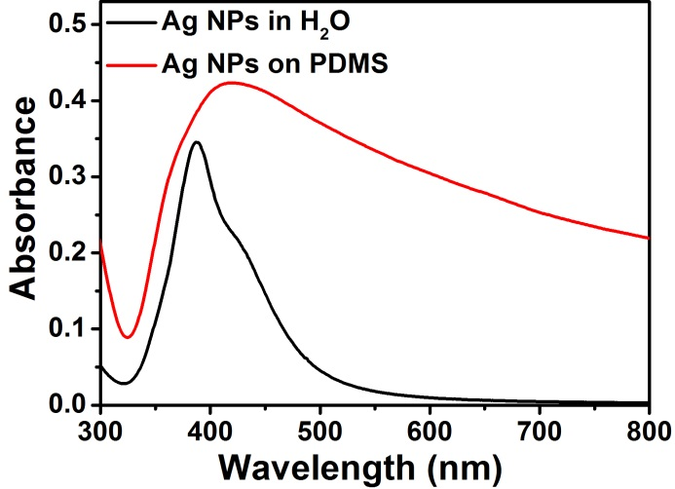
Figure S1. UV-vis spectra of as synthesized Ag nanoparticles in aqueous solution (black line) and Ag nanoparticles transferred on PDMS substrate.
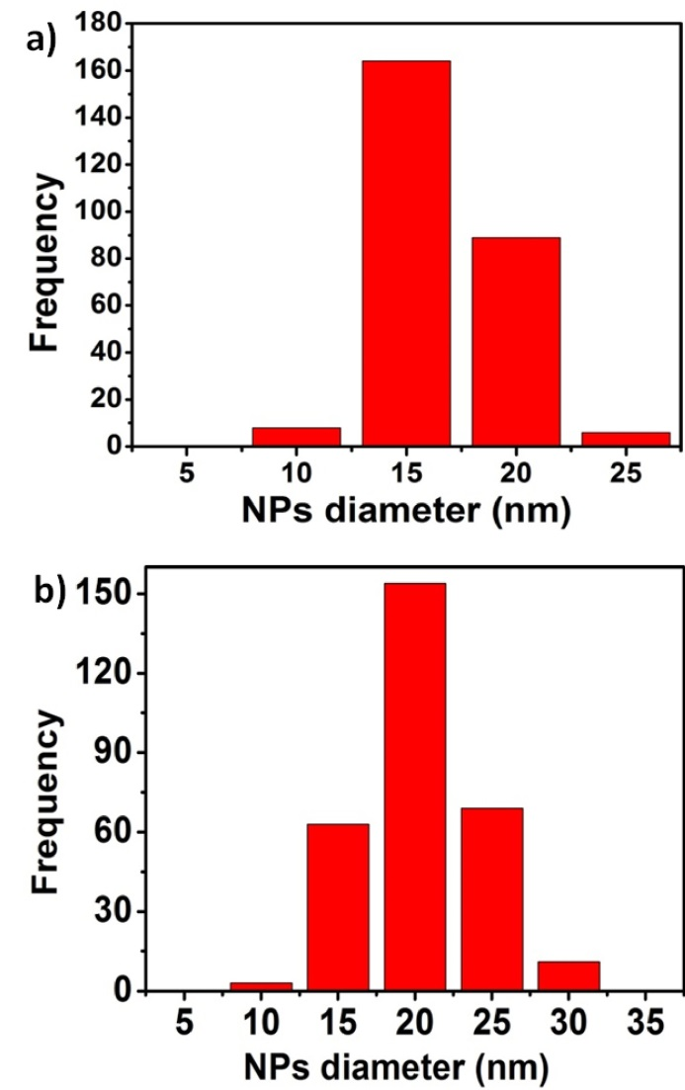
Figure S2: a) Size distribution of as synthesized Ag nanoparticles in aqueous solution; b) Size distribution of Ag nanoparticles transferred to glass and PDMS support.

The average size of nanoparticles obtained in water solution was 15± 5 nm (see Figure S2,a), as calculated from SEM images of 300 nanoparticles deposited on SiO₂ substrates. The average size of Ag NPs deposited on glass and PDMS substrates was 20± 3 nm as shown in Figure S2,b.

UV-vis spectra of BIC pens and reference dyes
Figure S3 show UV-vis spectra of analyzed pen inks dissolved in MeOH and reference dyes found by Raman/SERS analysis. The spectrum of the red medium BIC ballpoint pen (Figure S3a) was characterized by a maximum band centered at 554 nm, which overlapped the absorption spectrum of rodhamine B. An additional band centered at 416 nm, attributable to an unidentified yellow component, was present in the spectrum of Bic medium pen. The UV-vis absorption spectrum of BIC purple crystal pen (Figure S3b) also overlapped with the spectrum of rhodamine B, displaying a maximum at 554 nm. The overlap between the rodhamine B band and the Raman excitation wavelength (514 nm) was responsible for the strong fluorescence observed in the Raman spectra of the red and purple dyes. However, the purple crystal ink showed an additional shoulder at 588 nm, which well overlapped with the absorption band of crystal violet dye. A small additional band at 663 was also observed and attributed to a phthalocyanine compound, possibly blue 38. The UV-vis absorption spectrum of BIC medium green pen showed bands overlapping with reference dye blue 38 at 665 and 340 nm. Additional small bands were found at 416 and 623 nm, indicative of yellow and blue components, respectively.
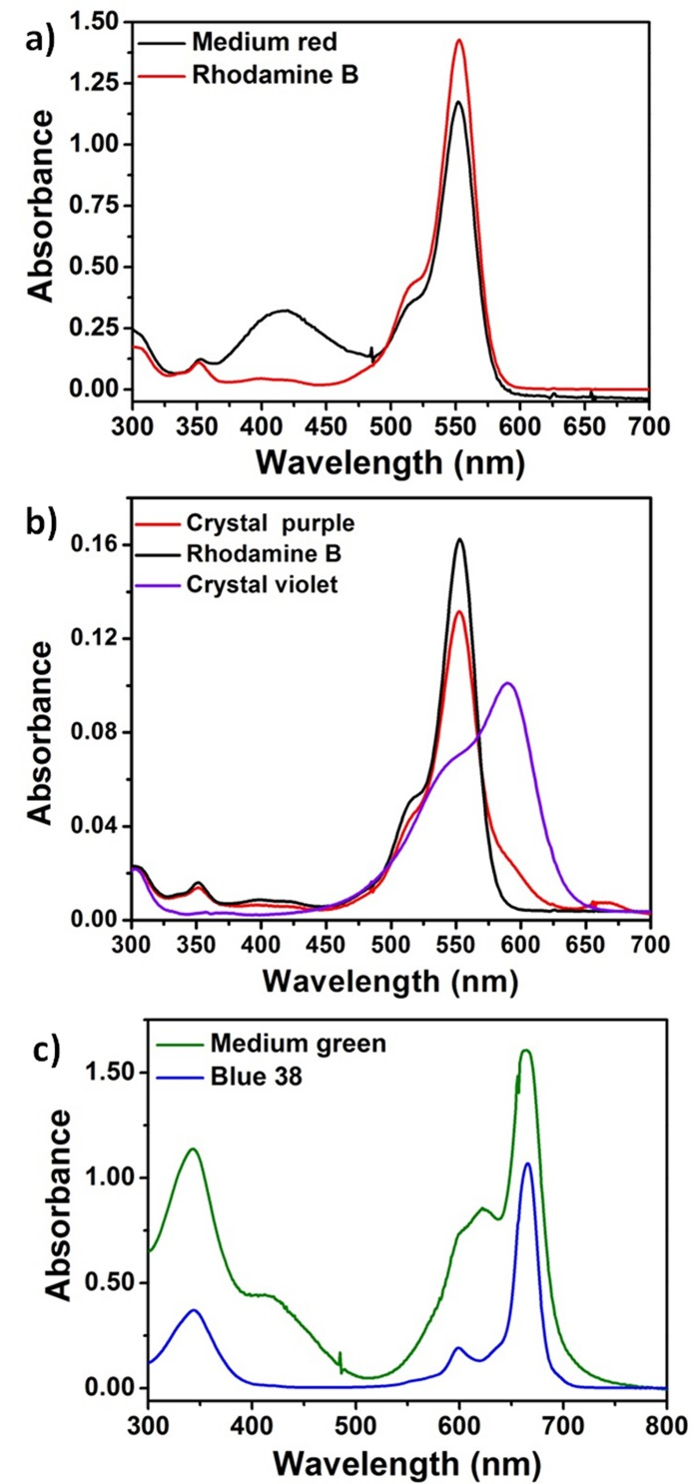
Figure S3. UV-vis spectra of a) BIC ballpoint medium red pen and reference dye rodhamine B; b) BIC ballpoint crystal purple pen and reference dyes rodhamine B and crystal violet; c) BIC ballpoint medium green pen and reference dye blue 38.

Blank SERS spectra
Figure S4 shows blank spectra of Ag nanoparticle/glass and Ag nanoparticle/PDMS, respectively. Spectra were taken by applying the SERS probes on a blank paper surface with the Ag nanoparticle phase in contact with the paper. The Ag nanoparticle/glass shows a broad peak at 941 cm⁻¹ attributed to the paper. The Ag nanoparticle/PDMS probe showed sharp and intense peaks at 1412, 1259, 708, 616 and 487 cm⁻¹, attributable to PDMS. During analyte measurements the contribution from these peaks was avoided by focusing the laser excitation at the Ag nanoparticle/analytical surface interface.
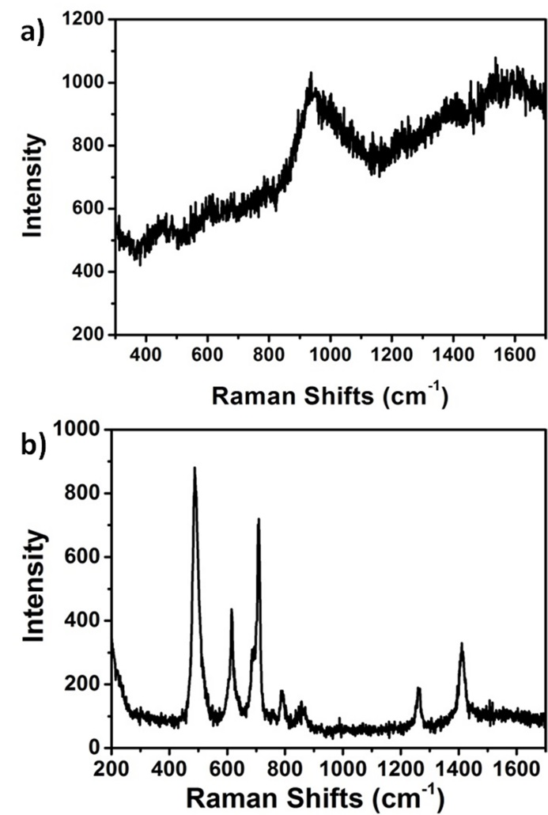
Figure S4. Blank SERS spectra of a) Ag nanoparticle/glass and Ag nanoparticle/PDMS probes on paper. Excitation wavelength 514 nm.

SERS spectrum of 4-aminobenzenethiol
Ag nanoparticle /PDMS substrates were tested with model molecule 4-aminobenzenethiol (4-ABT) prior testing on real works of art. For this purpose 4-ABT was dissolved (1×10⁻⁶ M) in MeOH. A droplet of solution was dropped on a glass slide and left to evaporate. The Ag nanoparticle/PDMS composite was deposited on the 4-ABT dried droplet and SERS analysis was performed by back illumination. The SERS spectrum of 4-ABT is shown in Figure S5 and showed bands centered at 1078, 1141, 1471 and 1577 cm⁻¹ associated with the a₁ vibrational, in plane, in phase modes of 4-ABT. In addition to a₁ bands, SERS spectra showed b₂ in plane, out of phase vibrational modes at 1188, 1389 and 1433 cm⁻¹. The formation of b₂ peaks has been observed in SERS spectra of 4-ABT recorded on nanostructured surfaces and has been attributed to a metal-molecule charge transfer related to a chemical enhancement process.
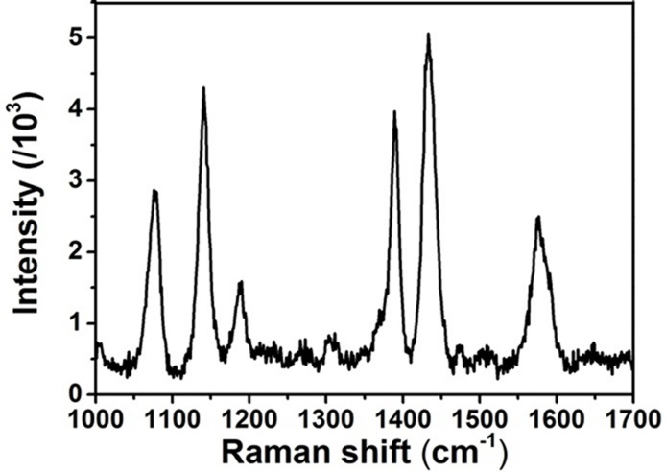
Figure S5. SERS spectrum of 4-ABT obtained by application of Ag nanoparticle/PDMS composites and recorded with 514 nm wavelength illumination.

