Supplementary data

Characterization of gastrointestinal transit conditions in pigs using a telemetric motility capsule

Laura J. Henze¹, Niklas J. Koehl¹, Harriet Bennett-Lenane¹, René Holm^{2,3}, Michael Grimm⁴, Felix Schneider⁴, Werner Weitschies⁴, Mirko Koziolek⁴, Brendan T. Griffin¹

¹ School of Pharmacy, University College Cork; Cork, Ireland
² Drug Product Development, Janssen Research and Development, Johnson & Johnson, Turnhoutseweg 30, 2340 Beerse, Belgium
³ Department of Science and Environment, Roskilde University, Universitetsvej 1, DK-4000 Roskilde, Denmark
⁴ Department of Biopharmaceutics and Pharmaceutical Technology, Institute of Pharmacy, University of Greifswald, Felix-Hausdorff-Straße 3, 17489 Greifswald, Germany

Content | Page
Individual gastric profiles P3, P6, P44 (Fig. S1) | 2
Summary of the meal type and study protocols, used in the assessment of gastrointestinal transit with the SmartPill® in humans, dogs and pigs. (Table S1) | 3
Video

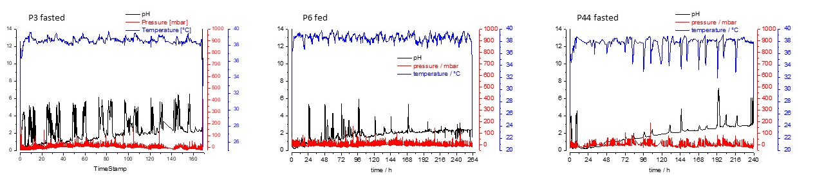
Fig. S1. Individual gastric profiles after the SmartPill® administration in three landrace pigs at different intake conditions. (P3, P44 fasted; P6 fed). Post mortem investigations detected that the capsule was remained in the stomach of pigs.

Table S1 Summary of the meal type and study protocols, used in the assessment of gastrointestinal transit with the SmartPill® in humans, dogs and pigs.
 | Postprandial study conditions
 | Kcal | Kcal/ kg body weight ratio | Preparation | Time of food intake before SmartPill® administration | Time of food intake after SmartPill® administration
Humans | 965 | 13.8 | non-homogenized | 30 min | 4.5 h
Pigs | 444 | 26.1 | non-homogenized | 30 min | 8 h
Dogs | 203 | 11.3 | ‘Mastermix’  (9 mL/kg) | 5 min | 6 h

