Supporting Information:
The interplay between extrinsic and intrinsic factors in determining flexible decisions in brown trout (Salmo trutta): an experimental study
Louise C. Archer*^{1,2}, Stephen Hutton^{1,2}, Luke Harman^{1,2}, Michael N. O’Grady³, Joseph P. Kerry³, W. Russell Poole⁴, Paddy Gargan⁵, Philip McGinnity^{1,4}, Thomas E. Reed^{1,2}
¹ School of Biological, Earth and Environmental Sciences, University College Cork, Distillery Fields, North Mall, Cork, Ireland.
²Environmental Research Institute, University College Cork, Lee Road, Cork, Ireland
³Food Packaging Group, School of Food and Nutritional Sciences, University College Cork, Cork, Ireland.
⁴Marine Institute, Furnace, Newport, Co. Mayo, Ireland.
⁵Inland Fisheries Ireland, 3044 Lake Drive, Citywest Business Campus, Dublin, D24 Y265, Ireland.

Figure S1

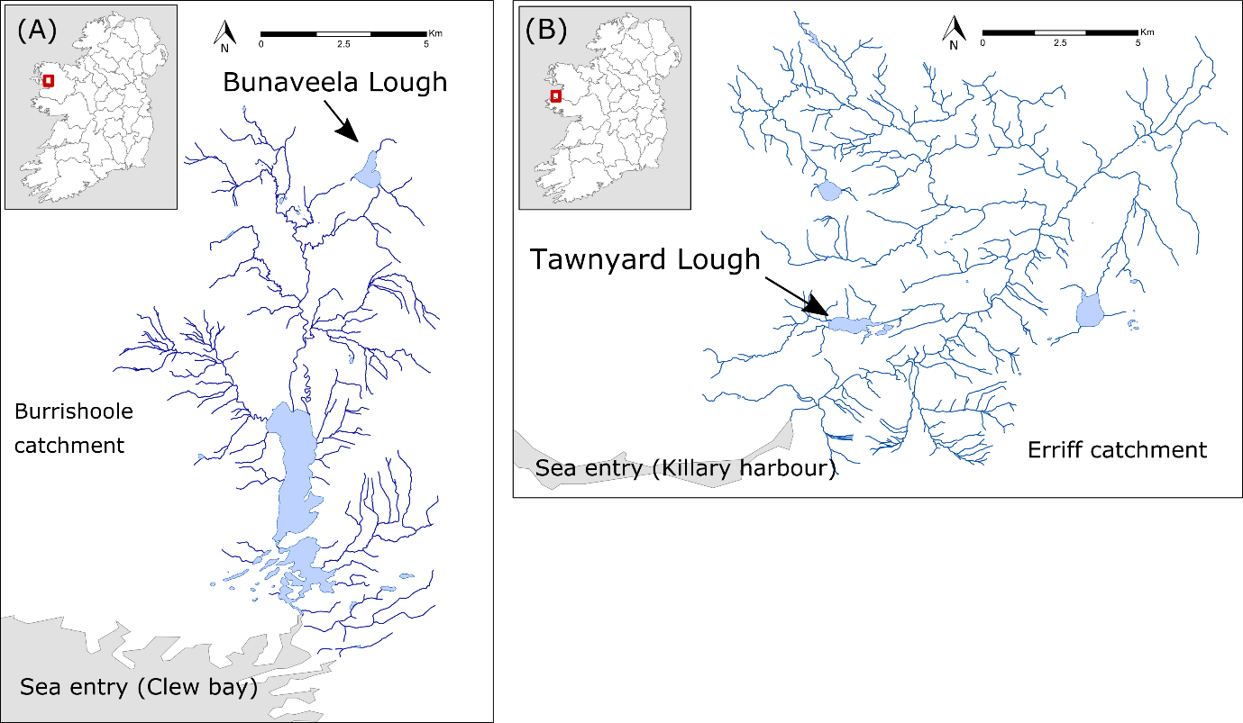

Figure S1: Locations in the west of Ireland of brown trout brood stock collected by seine netting in winter 2015, and used to produce F1 offspring for an experimental tank-rearing study. Fish with a non-anadromous-population background were offspring of brown trout collected from (a) Bunaveela Lough in the Burrishoole catchment (no natural occurrence of anadromy). Fish with an anadromous-population background were offspring of brood stock collected in (b) Tawnyard Lough in the Erriff catchment (a high natural frequency of anadromy).

Table S1: Brood stock crossing design for producing F1 offspring of wild-origin brown trout collected by seine netting from two populations (Bunaveela Lough and Tawnyard Lough) in the west of Ireland. Each female was stripped of eggs, which were then fertilised by the milt of two males from the same population and incubated in a hatchery facility within the Burrishoole catchment. Offspring produced from the Bunaveela population were considered to have a non-anadromous-population background, and offspring produced from the Tawnyard population were considered to have an anadromous-population background.
Stripping date | Population | Catchment | Sex | ID | Male cross #1 | Male cross #2
22/12/2015 | Bunaveela | Burrishoole | Female | BF1 | BM1 | BM2
22/12/2015 | Bunaveela | Burrishoole | Female | BF2 | BM1 | BM2
22/12/2015 | Bunaveela | Burrishoole | Female | BF3 | BM3 | BM4
22/12/2015 | Bunaveela | Burrishoole | Female | BF4 | BM3 | BM4
22/12/2015 | Bunaveela | Burrishoole | Female | BF5 | BM5 | BM6
22/12/2015 | Bunaveela | Burrishoole | Female | BF6 | BM5 | BM6
22/12/2015 | Bunaveela | Burrishoole | Female | BF7 | BM7 | BM8
22/12/2015 | Bunaveela | Burrishoole | Female | BF8 | BM7 | BM8
22/12/2015 | Bunaveela | Burrishoole | Female | BF9 | BM9 | BM10
22/12/2015 | Bunaveela | Burrishoole | Female | BF10 | BM9 | BM10
22/12/2015 | Bunaveela | Burrishoole | Female | BF11 | BM11 | BM12
22/12/2015 | Bunaveela | Burrishoole | Female | BF12 | BM11 | BM12
22/12/2015 | Bunaveela | Burrishoole | Female | BF13 | BM13 | BM15
22/12/2015 | Bunaveela | Burrishoole | Female | BF14 | BM13 | BM15
22/12/2015 | Bunaveela | Burrishoole | Female | BF15 | BM17 | BM18
22/12/2015 | Bunaveela | Burrishoole | Female | BF16 | BM17 | BM18
22/12/2015 | Bunaveela | Burrishoole | Female | BF17 | BM19 | BM20
22/12/2015 | Bunaveela | Burrishoole | Female | BF18 | BM19 | BM20
22/12/2015 | Bunaveela | Burrishoole | Female | BF19 | BM22 | BM23
22/12/2015 | Bunaveela | Burrishoole | Female | BF20 | BM22 | BM23
22/12/2015 | Bunaveela | Burrishoole | Female | BF21 | BM25 | BM26
27/11/2015 | Tawnyard | Erriff | Female | TF4 | TM6 | TM7
27/11/2015 | Tawnyard | Erriff | Female | TF5 | TM6 | TM7
27/11/2015 | Tawnyard | Erriff | Female | TF6 | TM9 | TM10
10/12/2015 | Tawnyard | Erriff | Female | TF7 | TM12 | TM13
Table S2: Feeding guidelines (as % body mass fed per day), used to adjust absolute daily feeding rations on a monthly basis according to body mass and rearing temperature of brown trout reared in a recirculating aquaculture system for 22 months. Type of feed (based on fish size) is listed in italics (Skretting, Norway).
Fish mass (g) |  | Rearing temperature
Fish mass (g) |  | 4 °C | 6 °C | 8 °C | 10 °C | 12 °C | 14 °C | 16 °C | 18 °C
Nutra Parr
2 - 6.5g |  | 1.6 | 1.9 | 2.2 | 2.6 | 3 | 3.4 | 3.8 | NA
6.5 - 8g |  | 1.5 | 1.8 | 2.1 | 2.5 | 2.9 | 3.3 | 3.7 | NA
Horizon
8 - 12g |  | 1.21 | 1.53 | 1.73 | 2.1 | 2.42 | 2.78 | 3.06 | 3.57
12 - 21g |  | 1.21 | 1.36 | 1.57 | 1.87 | 2.16 | 2.55 | 2.84 | 3.34
Elite FR
21 - 35g |  | 1.22 | 1.47 | 1.71 | 1.95 | 2.2 | 2.57 | 2.93 | 3.42
35 - 80g |  | 0.96 | 1.2 | 1.32 | 1.56 | 1.8 | 2.16 | 2.4 | 2.76
80 - 150g |  | 0.68 | 0.88 | 1.08 | 1.28 | 1.48 | 1.68 | 1.88 | 2.08
150 - 300g |  | 0.52 | 0.72 | 0.92 | 1.12 | 1.32 | 1.48 | 1.64 | 1.8
300 - 500g |  | 0.46 | 0.61 | 0.76 | 0.94 | 1.1 | 1.24 | 1.38 | 1.52
500g + |  | 0.34 | 0.48 | 0.62 | 0.76 | 0.89 | 1.02 | 1.16 | 1.3

Table S3: Parameter estimates with associated standard errors (SE) for mixed model analyses testing the effects of life-history tactics, population-background, food treatment, and sex on the fork length (cm), weight (g), and condition factor (K) trajectories of brown trout over two years of experimental tank rearing. Measurements were taken at key periods denoted by “month”. Effects were contrasted against mature female fish from the anadromous-background in the Low-Low treatment. Statistical significance was assessed at p < 0.05.
Effect | Estimate | SE | t-value | p-value
Mixed model for length
Intercept | 7.103 | 0.387 | 18.336 | < 0.001
Month | 0.699 | 0.013 | 54.865 | < 0.001
Life-history: Smolt | -2.310 | 0.596 | -3.876 | < 0.001
Population: Non-anadromous-background | -0.252 | 0.438 | -0.576 | 0.565
Food: Low-High | 3.322 | 0.429 | 7.736 | < 0.001
High-Low | 2.646 | 0.415 | 6.382 | < 0.001
High-High | 5.434 | 0.425 | 12.798 | < 0.001
Sex: Male | -0.033 | 0.215 | -0.154 | 0.878
Month: Smolt | 0.067 | 0.032 | 2.068 | 0.039
Non-anadromous-background: Low-High | -0.774 | 0.600 | -1.289 | 0.198
Non-anadromous-background: High-Low | -2.382 | 0.630 | -3.781 | < 0.001
Non-anadromous-background: High-High | -3.066 | 0.594 | -5.160 | < 0.001
Mixed model for weight
Intercept | -73.06 | 8.11 | -9.01 | < 0.001
Month | 9.47 | 0.28 | 34.24 | < 0.001
Life-history: Smolt | 22.61 | 12.69 | 1.78 | 0.075
Population: Non-anadromous-background | -1.36 | 9.07 | -0.15 | 0.881
Food: Low-High | 76.57 | 8.87 | 8.63 | < 0.001
High-Low | 37.75 | 8.56 | 4.41 | < 0.001
High-High | 114.86 | 8.78 | 13.09 | < 0.001
Sex: Male | -0.99 | 4.45 | -0.22 | 0.824
Month: Smolt | -3.08 | 0.70 | -4.39 | < 0.001
Non-anadromous-background: Low-High | -19.85 | 12.43 | -1.60 | 0.111
Non-anadromous-background: High-Low | -38.59 | 13.05 | -2.96 | 0.003
Non-anadromous-background: High-High | -57.67 | 12.32 | -4.68 | < 0.001
Mixed model for condition factor (Fulton’s K)
Intercept | 1.193 | 0.016 | 76.858 | < 0.001
Month | -0.004 | 0.001 | -5.341 | < 0.001
Life-history: Smolt | -0.001 | 0.027 | -0.025 | 0.980
Population: Non-anadromous-background | 0.023 | 0.016 | 1.430 | < 0.001
Food: Low-High | 0.123 | 0.016 | 7.923 | < 0.001
High-Low | 0.070 | 0.015 | 4.746 | < 0.001
High-High | 0.139 | 0.015 | 9.034 | < 0.001
Sex: Male | 0.002 | 0.008 | 0.285 | 0.776
Month: Smolt | -0.006 | 0.002 | -3.564 | < 0.001
Non-anadromous-background: Low-High | -0.036 | 0.022 | -1.644 | 0.101
Non-anadromous-background: High-Low | -0.081 | 0.023 | -3.461 | 0.001
Non-anadromous-background: High-High | 0.041 | 0.022 | 1.838 | 0.067

Table S4: Parameter estimates with associated standard errors (SE) for mixed model analysis testing the effects of life-history tactics, population-background, food treatment, and sex on the final fork length (cm), condition factor (K) and whole body lipids (%) of brown trout after two years of experimental tank-rearing. Effects were contrasted against mature female fish from the anadromous-background in the Low-Low treatment. Statistical significance was assessed at p < 0.05.
Effect | df | Estimate | SE | t-value | p-value
Response: Length
Intercept | 437 | 20.00 | 0.41 | 48.58 | < 0.001
Life-history: Smolt | 437 | -0.59 | 0.35 | -1.66 | 0.097
Population: Non-anadromous-background | 437 | 0.38 | 0.54 | 0.70 | 0.487
Food: Low-High | 437 | 5.06 | 0.44 | 11.39 | < 0.001
High-Low | 437 | 2.41 | 0.55 | 4.42 | < 0.001
High-High | 437 | 6.83 | 0.54 | 12.56 | < 0.001
Sex: Male | 437 | 0.01 | 0.22 | 0.07 | 0.947
Non-anadromous-background: Low-High | 437 | -1.30 | 0.63 | -2.05 | 0.040
Non-anadromous-background: High-Low | 437 | -2.14 | 0.75 | -2.86 | 0.004
Non-anadromous-background: High-High | 437 | -3.90 | 0.76 | -5.17 | < 0.001
Response: Condition factor (Fulton’s K)
Intercept | 437 | 1.079 | 0.018 | 60.095 | < 0.001
Life-history: Smolt | 437 | -0.121 | 0.015 | -7.948 | < 0.001
Population: Non-anadromous-background | 437 | 0.061 | 0.024 | 2.559 | 0.011
Food: Low-High | 437 | 0.195 | 0.019 | 10.212 | < 0.001
High-Low | 437 | 0.048 | 0.024 | 2.007 | 0.045
High-High | 437 | 0.192 | 0.024 | 8.063 | < 0.001
Sex: Male | 437 | -0.017 | 0.009 | -1.831 | 0.068
Non-anadromous-background: Low-High | 437 | -0.066 | 0.027 | -2.439 | 0.015
Non-anadromous-background: High-Low | 437 | -0.078 | 0.032 | -2.404 | 0.017
Non-anadromous-background: High-High | 437 | 0.025 | 0.033 | 0.742 | 0.458
Response: Whole body lipids
Intercept | 144 | 5.38 | 0.21 | 26.21 | < 0.001
Life-history: Smolt | 144 | 0.51 | 0.19 | 2.69 | 0.008
Population: Non-anadromous-background | 9 | 2.59 | 0.29 | 8.83 | < 0.001
Food: Low-High | 144 | 3.18 | 0.29 | 11.07 | < 0.001
High-Low | 144 | 0.84 | 0.27 | 3.17 | 0.002
High-High | 144 | 3.31 | 0.32 | 10.29 | < 0.001
Sex: Male | 144 | -0.25 | 0.17 | -1.43 | 0.155
Non-anadromous-background: Low-High | 144 | -1.41 | 0.42 | -3.39 | 0.001
Non-anadromous-background: High-Low | 144 | -2.09 | 0.48 | -4.32 | < 0.001
Non-anadromous-background: High-High | 144 | -1.36 | 0.65 | -2.10 | 0.037

