Supporting Information:
Food and temperature stressors have opposing effects in determining flexible migration decisions in brown trout (Salmo trutta)
Louise C. Archer*^{1,2}, Stephen A. Hutton^{1,2}, Luke Harman^{1,2}, Stephen D. McCormick³, Michael N. O’Grady⁴, Joseph P. Kerry⁴, W. Russell Poole⁵, Patrick Gargan⁶, Philip McGinnity^{1,5}, Thomas E. Reed^{1,2}
¹ School of Biological, Earth and Environmental Sciences, University College Cork, Distillery Fields, North Mall, Cork, Ireland.
²Environmental Research Institute, University College Cork, Lee Road, Cork, Ireland.
³U.S. Geological Survey, Leetown Science Centre, S.O. Conte Anadromous Fish Research Laboratory, Turners Falls, MA, 01376, USA.
⁴Food Packaging Group, School of Food and Nutritional Sciences, University College Cork, Cork, Ireland.
⁵Marine Institute, Furnace, Newport, Co. Mayo, Ireland.
⁶Inland Fisheries Ireland, 3044 Lake Drive, Citywest Business Campus, Dublin, D24 Y265, Ireland.

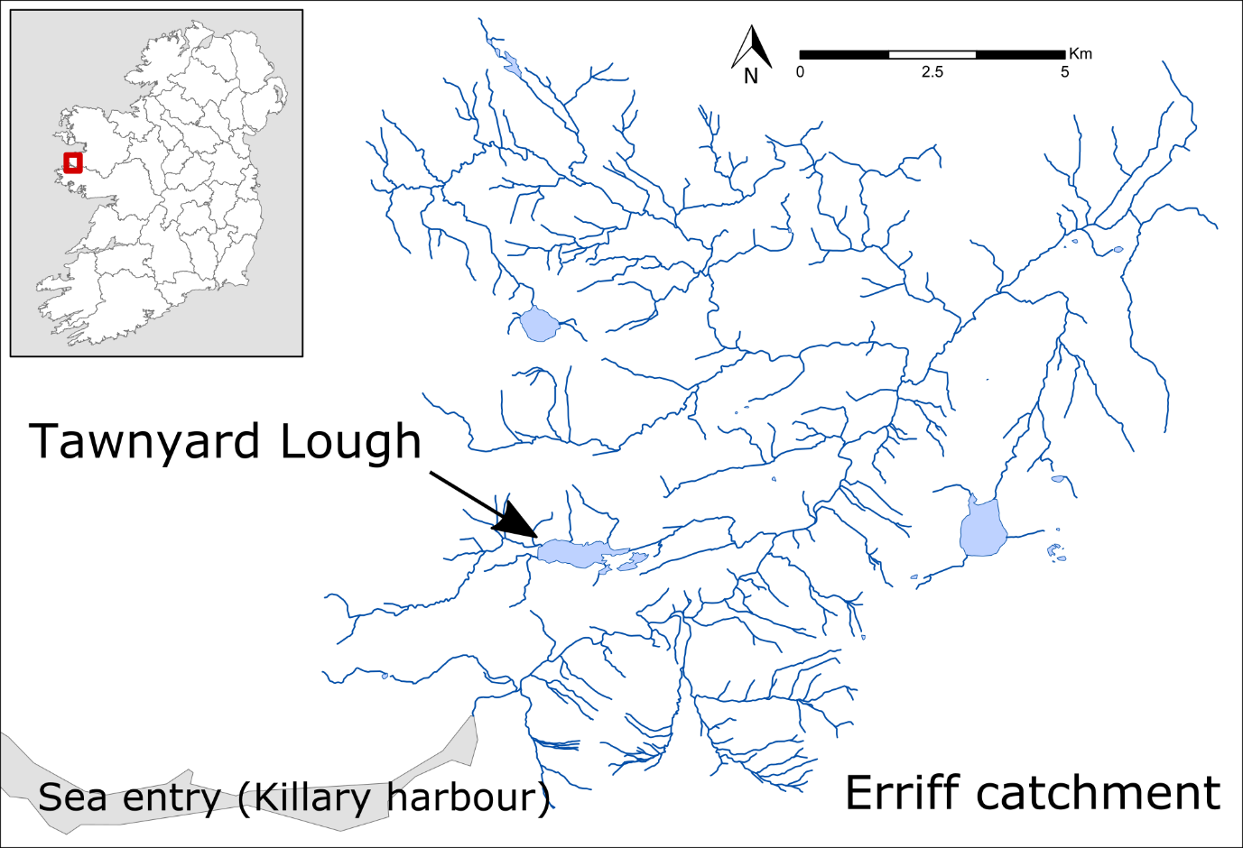

Figure S1: Location in the west of Ireland of brown trout brood stock collected by seine netting in winter 2015, and used to produce F1 offspring for an experimental tank-rearing study. Fish used in the study were offspring of brood stock collected in Tawnyard Lough in the Erriff catchment (a population with a high natural frequency of anadromy).

Figure S2: Weekly temperatures (open circles) for the three years preceding the study, as recorded at the Marine Institute long-term monitoring station at Newport, Mayo (west of Ireland), close to the Erriff catchment where brood stock used in the experiment originated. Red and blue lines are the mean weekly temperatures (averaged across tanks) for the cool and warm treatments in the laboratory experiment. The grey line represents the thermal growth optimum for trout (13.9 °C) (Elliott and Hurley 2000).

Figure S3: Final measures of (A) length, (B) condition, and (C) whole body lipids of brown trout offspring classed as either smolts (migratory) or unassigned a life-history tactic at the end of the experimental study. Median values of length, condition, and whole body lipids are represented by the white horizontal lines in each box in (A), (B), and (C).

Table S1: Brood stock crossing design for producing F1 offspring of wild-origin brown trout collected by seine netting from a population in Tawnyard Lough in the west of Ireland. Each female was stripped of eggs, which were then fertilised by the milt of two males from the same population and incubated in a hatchery facility within the Burrishoole catchment. Fish were subsequently reared in two separate groups according to fertilisation date, where “November fertilisation group” refers to offspring produced from crosses made on 12th November 2015, and “Nov-Dec fertilisation group” refers to offspring produced from crosses on 27th November and 10th December 2015.
Stripping date | Fertilisation  Group | Population | Catchment | Sex | ID | Male cross #1 | Male cross #2
12/11/2015 | Nov | Tawnyard | Erriff | Female | TF1 | TM1 | TM2
12/11/2015 | Nov | Tawnyard | Erriff | Female | TF2 | TM1 | TM2
12/11/2015 | Nov | Tawnyard | Erriff | Female | TF3 | TM3 | TM4
27/11/2015 | Nov-Dec | Tawnyard | Erriff | Female | TF4 | TM5 | TM6
27/11/2015 | Nov-Dec | Tawnyard | Erriff | Female | TF5 | TM5 | TM6
27/11/2015 | Nov-Dec | Tawnyard | Erriff | Female | TF6 | TM7 | TM8
10/12/2015 | Nov-Dec | Tawnyard | Erriff | Female | TF7 | TM9 | TM10

Table S2: Parameter estimates with associated standard errors (SE) for mixed model analyses testing the effects of food treatment, temperature treatment, fertilisation group, and sex on the fork length (cm), mass (g), and condition trajectories of brown trout over 18 months of experimental tank rearing. Measurements were taken at key periods denoted by “time”. Effects were contrasted against female fish from the Nov-Dec fertilisation group in the high food and cool temperature treatment. Responses are z-standardised and statistical significance was assessed at p < 0.05.
Effect | Estimate | SE | t-value | p-value
Mixed model for length
Intercept (Female, Nov-Dec, Cool, High) | 0.48 | 0.07 | 7.28 | < 0.001
Time | 0.87 | 0.02 | 51.23 | < 0.001
Time² | -0.22 | 0.01 | -17.45 | < 0.001
Sex: Male | -0.04 | 0.05 | -0.85 | 0.397
Fertilisation group: Nov | 0.42 | 0.06 | 7.53 | < 0.001
Temperature: Warm | -0.24 | 0.08 | -3.23 | 0.001
Food: Low | -0.90 | 0.07 | -12.06 | < 0.001
Time × Warm temperature | 0.06 | 0.02 | 3.02 | 0.003
Time × Low food | -0.32 | 0.02 | -16.08 | < 0.001
Low food × Warm temperature | 0.42 | 0.11 | 3.96 | < 0.001
Mixed model for mass
Intercept (Female, Nov-Dec, Cool, High) | 0.58 | 0.07 | 8.18 | < 0.001
Time | 0.89 | 0.03 | 32.55 | < 0.001
Time² | -0.13 | 0.02 | -8.09 | < 0.001
Sex: Male | -0.08 | 0.05 | -1.41 | 0.159
Fertilisation group: Nov | 0.28 | 0.06 | 4.93 | < 0.001
Temperature: Warm | -0.29 | 0.08 | -3.66 | < 0.001
Food: Low | -1.03 | 0.08 | -13.26 | < 0.001
Time × Warm temperature | -0.01 | 0.04 | -0.15 | 0.880
Time × Low food | -0.62 | 0.04 | -16.05 | < 0.001
Low food × Warm temperature | 0.41 | 0.11 | 3.69 | < 0.001
Time × Low food × Warm temperature | 0.15 | 0.06 | 2.72 | 0.007
Mixed model for condition
Intercept (Female, Nov-Dec, Cool, High) | 0.76 | 0.09 | 8.36 | < 0.001
Time | -0.29 | 0.04 | -7.88 | < 0.001
Time² | -0.17 | 0.03 | -5.83 | < 0.001
Sex: Male | 0.04 | 0.07 | 0.54 | 0.593
Fertilisation group: Nov | -0.21 | 0.07 | -2.94 | 0.003
Temperature: Warm | -0.14 | 0.10 | -1.41 | 0.160
Food: Low | -1.02 | 0.09 | -10.74 | < 0.001
Time × Warm temperature | 0.13 | 0.04 | 3.08 | 0.002
Time × Low food | -0.27 | 0.04 | -6.31 | < 0.001
Low food × Warm temperature | 0.35 | 0.13 | 2.64 | 0.009

Table S3: Parameter estimates with associated standard errors (SE) for mixed model analyses testing the effects of life-history tactics, fertilisation group, and sex on the fork length (cm), weight (g), and condition trajectories of brown trout classed as smolts (migratory) or mature (non-migratory) over 18 months of experimental tank rearing. Measurements were taken at key periods denoted by “time”. Effects were contrasted against mature female fish from the Nov-Dec fertilisation group. Responses are z-standardised and statistical significance was assessed at p < 0.05.
Effect | Estimate | SE | t-value | p-value
Mixed model for length
Intercept (Female, Nov-Dec, Mature) | 0.18 | 0.06 | 3.06 | 0.002
Time | 0.74 | 0.01 | 52.94 | < 0.001
Time² | -0.23 | 0.02 | -13.91 | < 0.001
Life-history: Smolt | -0.48 | 0.12 | -3.93 | < 0.001
Sex: Male | -0.07 | 0.07 | -1.06 | 0.290
Fertilisation group: Nov | 0.33 | 0.07 | 4.48 | < 0.001
Mixed model for mass
Intercept (Female, Nov-Dec, Mature) | 0.16 | 0.08 | 2.18 | 0.029
Time | 0.64 | 0.02 | 32.27 | < 0.001
Time² | -0.13 | 0.02 | -5.95 | < 0.001
Life-history: Smolt | -0.54 | 0.15 | -3.47 | 0.001
Sex: Male | -0.10 | 0.08 | -1.19 | 0.234
Fertilisation group: Nov | 0.19 | 0.09 | 2.11 | 0.036
Time × Smolt | -0.20 | 0.06 | -3.10 | 0.002
Mixed model for condition
Intercept (Female, Nov-Dec, Mature) | 0.42 | 0.09 | 4.81 | < 0.001
Time | -0.32 | 0.03 | -11.99 | < 0.001
Time² | -0.16 | 0.03 | -4.63 | < 0.001
Life-history: Smolt | -0.80 | 0.16 | -4.87 | < 0.001
Sex: Male | 0.02 | 0.09 | 0.18 | 0.859
Fertilisation group: Nov | -0.32 | 0.10 | -3.37 | 0.001
Time × Smolt | -0.24 | 0.09 | -2.53 | 0.012

Table S4: Parameter estimates with associated standard errors (SE) for mixed model analysis testing the effects of food treatment, temperature treatment, fertilisation group, and sex on the final fork length (cm), condition, and whole body lipids (%) of brown trout after 18 months of experimental tank-rearing. Effects were contrasted against female fish from the Nov-Dec fertilisation group in the high food and cool temperature treatment. Responses are z-standardised and statistical significance was assessed at p < 0.05.
Effect | Estimate | SE | t-value | p-value
Mixed model for length
Intercept (Female, Nov-Dec, High, Cool) | 0.61 | 0.14 | 4.50 | < 0.001
Sex: Male | 0.02 | 0.07 | 0.37 | 0.714
Fertilisation group: Nov | 0.40 | 0.19 | 2.12 | 0.078
Temperature: Warm | -0.20 | 0.09 | -2.16 | 0.031
Food: Low | -1.53 | 0.16 | -9.68 | < 0.001
Low food x Warm temperature | 0.55 | 0.13 | 4.13 | < 0.001
Mixed model for condition
Intercept (Female, Nov-Dec, High, Cool) | 0.80 | 0.15 | 5.31 | < 0.001
Sex: Male | -0.12 | 0.08 | -1.60 | 0.110
Fertilisation group: Nov | -0.45 | 0.20 | -2.25 | 0.065
Temperature: Warm | -0.01 | 0.11 | -0.02 | 0.987
Food: Low | -1.36 | 0.18 | -7.65 | < 0.001
Low food x Warm temperature | 0.35 | 0.16 | 2.21 | 0.027
Mixed model for whole body lipids (%)
Intercept (Female, Nov-Dec, High, Cool) | 0.65 | 0.16 | 4.08 | < 0.001
Sex: Male | -0.17 | 0.13 | -1.36 | 0.177
Fertilisation group: Nov | 0.03 | 0.17 | 0.15 | 0.887
Temperature: Warm | 0.25 | 0.13 | 1.95 | 0.054
Food: Low | -1.25 | 0.16 | -7.84 | < 0.001

Table S5: Parameter estimates with associated standard errors (SE) for mixed model analysis testing the effects of life-history tactics, fertilisation group, and sex on the final fork length (cm), condition and whole body lipids (%) of brown trout after 18 months of experimental tank-rearing. Effects were contrasted against mature female fish from the Nov-Dec fertilisation group. Responses are z-standardised and statistical significance was assessed at p < 0.05.
Effect | Estimate | SE | t-value | p-value
Mixed model for length
Intercept (Mature, Female, Nov-Dec) | -0.11 | 0.27 | -0.40 | 0.688
Life-history: Smolt | -0.28 | 0.13 | -2.08 | 0.038
Sex: Male | 0.03 | 0.07 | -0.35 | 0.726
Fertilisation group: Nov | 0.44 | 0.52 | 0.84 | 0.435
Mixed model for condition
Intercept (Mature, Female, Nov-Dec) | 0.27 | 0.23 | 1.17 | 0.241
Life-history: Smolt | -0.73 | 0.17 | -4.40 | < 0.001
Sex: Male | -0.14 | 0.09 | -1.51 | 0.133
Fertilisation group: Nov | -0.48 | 0.43 | -1.11 | 0.309
Mixed model for whole body lipids (%)
Intercept (Mature, Female, Nov-Dec) | -0.23 | 0.35 | -0.67 | 0.504
Life-history: Smolt | 0.61 | 0.17 | 3.67 | < 0.001
Sex: Male | -0.17 | 0.14 | -1.26 | 0.209
Fertilisation group: Nov | 0.43 | 0.67 | 0.64 | 0.547

Table S6: Parameter estimates with associated standard errors (SE) for mixed model analysis testing the differences in the gill NKA activity (log transformed) and plasma chloride concentration of brown trout classed as smolts (migratory tactics), mature or unassigned (non-migratory tactics) after 24 saltwater immersion. Effects were contrasted against mature female fish from the Nov-Dec fertilisation group. Statistical significance was assessed at p < 0.05.

Effect | Estimate | SE | t-value | p-value
Mixed model for gill NKA activity (log transformed)
Intercept | 0.12 | 0.16 | 0.77 | 0.445
Life-history: Smolt | 0.81 | 0.11 | 7.41 | < 0.001
Life-history: Unassigned | 0.02 | 0.12 | 0.15 | 0.879
Sex: Male | -0.09 | 0.08 | -1.12 | 0.266
Fertilisation group: Nov | 0.23 | 0.27 | 0.84 | 0.442
Mixed model for plasma chloride concentration
Intercept | 161.61 | 3.59 | 45.00 | < 0.001
Life-history: Smolt | -16.24 | 2.92 | -5.56 | < 0.001
Life-history: Unassigned | 13.68 | 3.69 | 3.71 | < 0.001
Sex: Male | 3.84 | 2.36 | 1.63 | 0.105
Fertilisation group: Nov | -9.04 | 6.45 | -1.40 | 0.210

Table S7: Parameter estimates with associated standard errors (SE) for mixed model analysis testing the effects of fork length, food treatment, temperature treatment, fertilisation group, and sex on the gill NKA activity and plasma chloride concentration after 24 saltwater immersion of brown trout smolts after 18 months of experimental tank-rearing. Effects were contrasted against female fish from the Nov-Dec fertilisation group in the high food and cool temperature treatment. Responses are z-standardised and statistical significance was assessed at p < 0.05.

Effect | Estimate | SE | t-value | p-value
Mixed model for gill NKA activity
Intercept | 0.57 | 0.59 | 0.98 | 0.342
Fork length | -0.06 | 0.29 | -0.21 | 0.840
Food: Low | -0.09 | 0.62 | -0.15 | 0.889
Temperature: Warm | -0.42 | 0.52 | -0.80 | 0.435
Sex: Male | -0.64 | 0.47 | -1.37 | 0.189
Fertilisation group: Nov | -1.12 | 0.69 | -1.64 | 0.200
Mixed model for plasma chloride concentration
Intercept | -0.88 | 0.47 | -1.90 | 0.072
Fork length | -0.43 | 0.20 | -2.18 | 0.041
Food: Low | 1.08 | 0.53 | 2.06 | 0.109
Temperature: Warm | 0.54 | 0.40 | 1.34 | 0.194
Sex: Male | -0.34 | 0.30 | -1.13 | 0.271
Fertilisation group: Nov | 0.79 | 0.53 | 1.49 | 0.211

