Supplementary data for the manuscript entitled:
Molecular, biochemical and behavioural evidence for a novel oxytocin receptor and serotonin 2C receptor heterocomplex.
Barbara Chruścicka^{af}, Caitlin S.M. Cowanª, Shauna E. Wallace Fitzsimonsª, Dasiel O. Borroto-Escuela^{b}, Clémentine M. Druelleª, Panagiota Stamouª, Cristian A. Bergmannª, Timothy G. Dinan^{a,c}, David A. Slattery^{d}, Kjell Fuxe^{b}, John F. Cryan^{a,e}, Harriët Schellekens^{a,e,*}
ªAPC Microbiome Ireland, University College Cork, Cork, Ireland.
^{b}Department of Neuroscience, Karolinska Institutet, Stockholm, Sweden.
^{c}Department of Psychiatry and Neurobehavioural Science, University College Cork, Cork, Ireland.
^{d}Department of Psychiatry, Psychosomatic Medicine and Psychotherapy, University Hospital Frankfurt, Frankfurt, Germany.
^{e}Department of Anatomy and Neuroscience, University College Cork, Cork, Ireland.
^{f}Małopolska Centre of Biotechnology, Jagiellonian University, Kraków, Poland.
Corresponding author
*Harriët Schellekens, Department of Anatomy and Neuroscience, 3.85 Western Gateway Building, University College Cork, Cork, Ireland.
E-mail H.Schellekens@ucc.ie

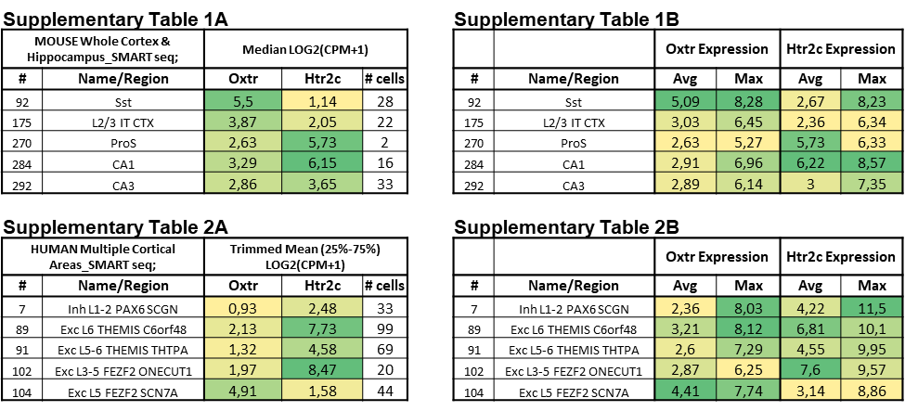
Fig. S1. In silico analysis of the 5-HTR_{2C} and OTR co-expression in the brain. In silico analysis of the 5-HTR_{2C} (Htr2c) and OTR (Oxtr) co-expression in the brain using RNA-sequencing data of the mouse whole cortex and hippocampus (Table 1) and human cortex (Table 2) in the Allen Brain Atlas (https://celltypes.brain-map.org/rnaseq/mouse_ctx-hip_smart-seq). The median expression values (Table 1A) are depicted for the mouse cortex and hippocampus, the trimmed mean expression values for expression in human cortical neurons (Table 2A), and the averages and maximum expression (Table 1B and Table 2B).
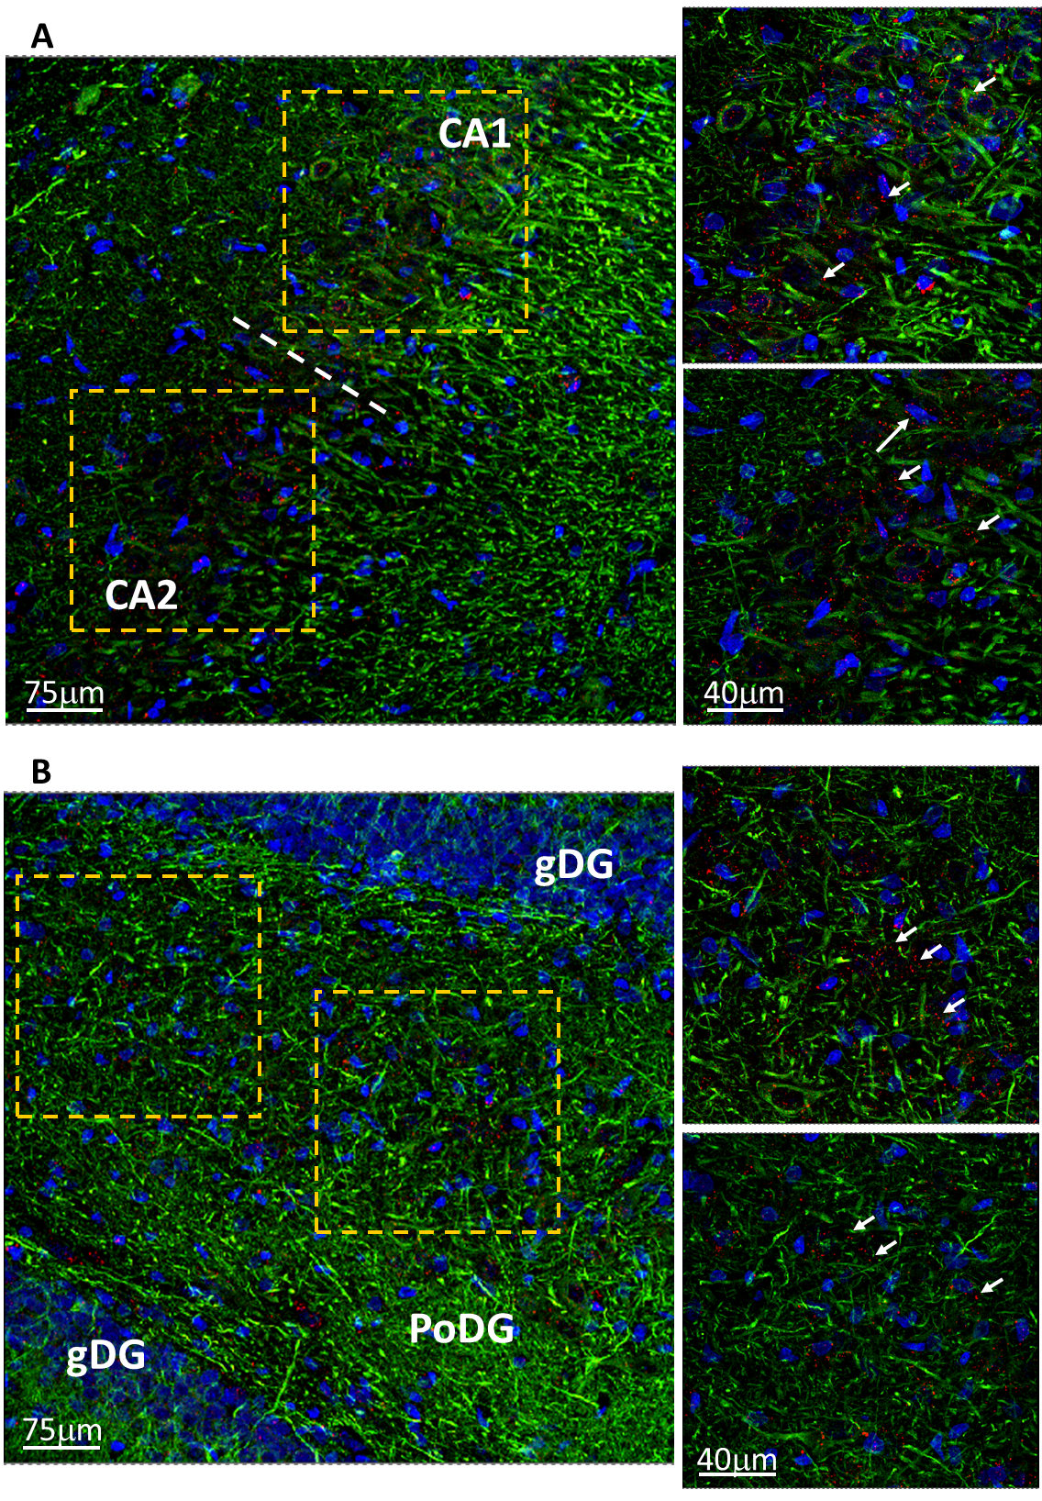
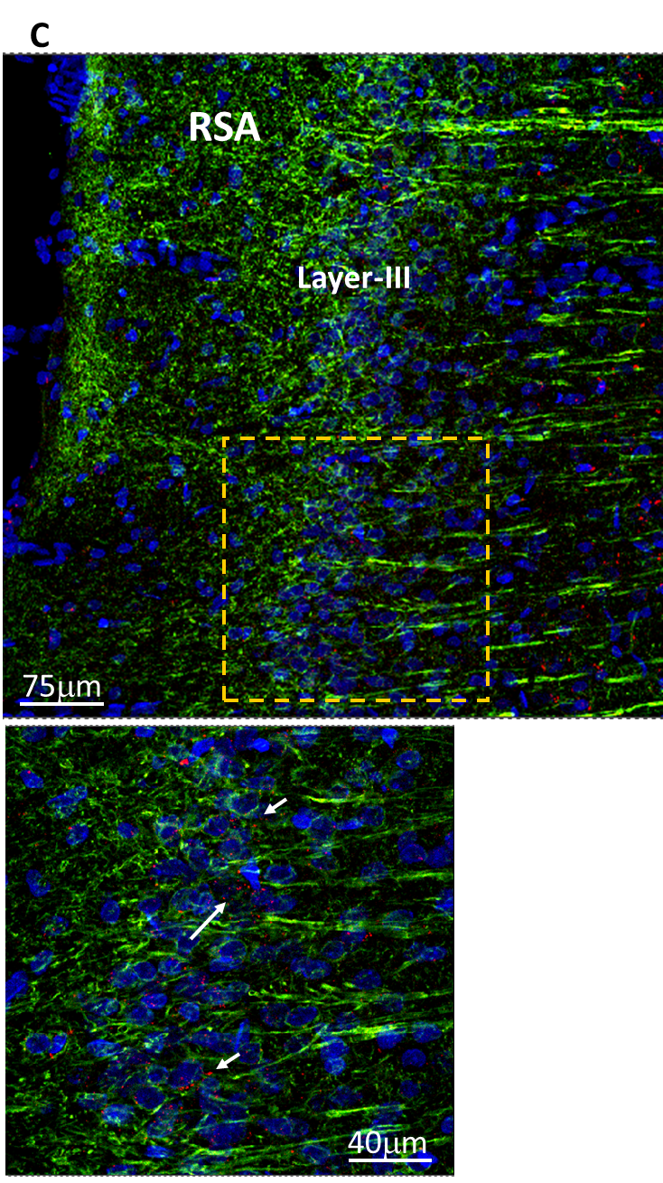
Fig. S2. PLA signal between the 5-HTR_{2C} and OTR in distinct brain regions. Photomicrophotographs from transverse sections of the rat brain show the distribution of OTR/5-HTR_{2C} heteroreceptor complexes in the pyramidal cell layer and in GABA interneurons of CA1 and CA2 regions of hippocampus (A), in the polymorphic layer of dentate gyrus (B) and in the retrosplenial granular and agranular cortex (C) using the in-situ proximity ligation assay (PLA) technique and confocal laser microscopy. The positive PLA signal is demonstrated as red blobs (clusters with examples indicated by white arrows), nuclei are shown in blue (DAPI), and neuronal cells in green (Alexa488 conjugated Neuro-Chrom Pan neuronal marker).

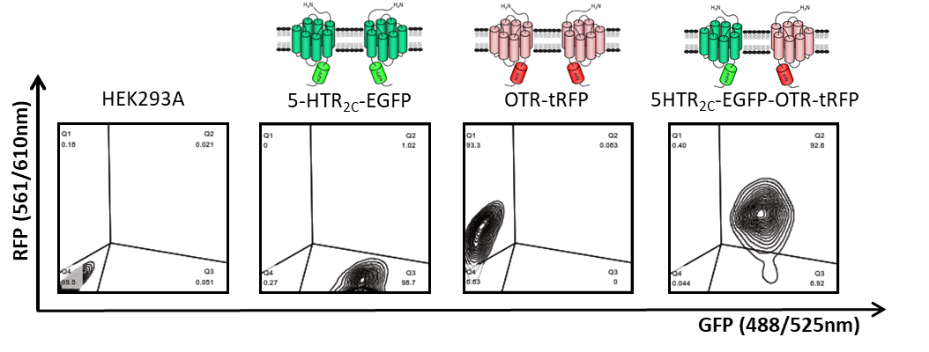
Fig. S3. Flow cytometry analysis of the 5-HTR_{2C} and OTR with EGFP and tRFP tags. Dot plots demonstrate the percentage of EGFP or/and tRFP positive cells. Cells stably expressing the 5-HTR_{2C} tagged with EGFP showed 95.7% of EGFP positive cells. Wild-type HEK293A cells after transient transduction with the OTR tagged with tRFP show 93.3% of tRFP positive cells. Cells stably expressing the 5-HTR_{2C} tagged with EGFP after transient transduction with the OTR tagged with tRFP show 82.6% of double EGFP/tRFP positive cells.
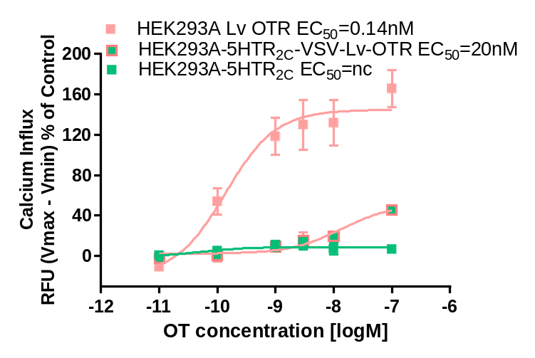
Fig. S4. Co-expression of the OTR and 5-HTR_{2C}-VSV depletes OTR-mediated Gαq-dependent signalling. Intracellular calcium release induced by increasing concentration of OT in HEK293A cells stably expressing the 5-HTR_{2C}-VSV-EGFP, in cells transiently expressing the OTR-tRFP, and in cells co-expressing both receptors. Intracellular calcium mobilization is presented as a percentage of maximal calcium response elicited by the control (3% FBS). Graphs represent means ± SEM from two independent experiments run in duplicates.

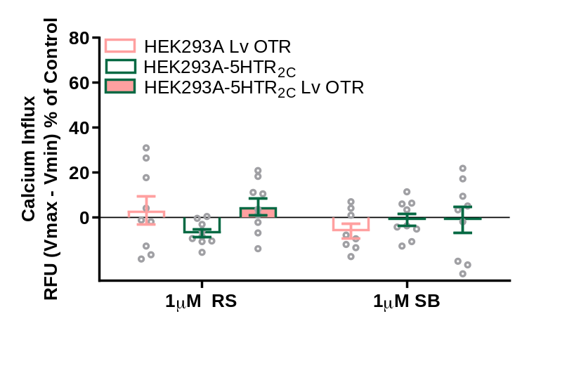
Fig. S5. No effect of 5-HTR_{2C} antagonists on intracellular calcium release in cells. None of the 5-HTR_{2C} antagonists (RS102221, SB242084) were able to induce a calcium influx in HEK293A cells stably expressing the 5-HTR_{2C}, in cells transiently expressing the OTR, and in cells co-expressing both receptors. Intracellular calcium mobilization is presented as a percentage of maximal calcium response elicited by the control (3% FBS). Graphs represent means ± SEM from five independent experiments run in duplicates.

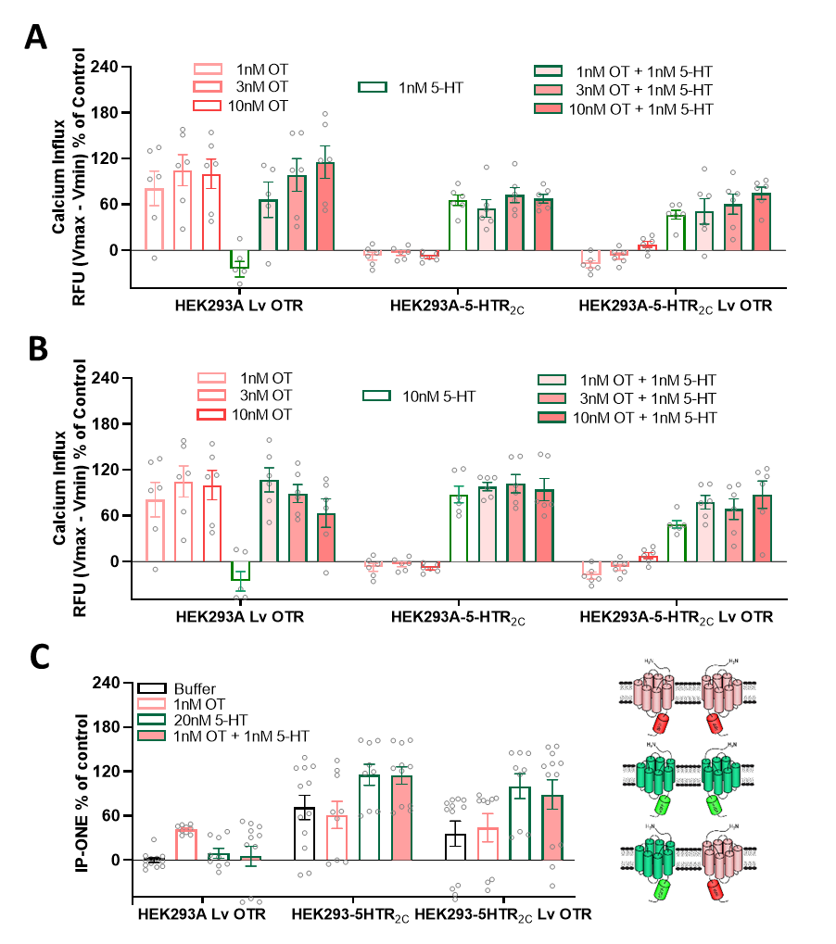

Fig. S6. No additive/synergistic effect of OT and 5-HT co-administration on Gαq-dependent signalling. Intracellular calcium release induced by increasing concentration of OT in the presence of 1nM 5-HT (A) and 10nM 5-HT (B) in HEK293A cells stably expressing the 5-HTR_{2C}-EGFP, in cells transiently expressing the OTR-tRFP, and in cells co-expressing both receptors. IP₁ production induced by co-administration of 1nM OT and 20nM 5-HT in HEK293A cells expressing 5-HTR_{2C}-EGFP, OTR-tRFP, and co-expressing both receptors (C). Results are presented as a percentage of maximum response. All graphs represent means ± SEM from at least two independent experiments run in triplicates, presented as percentage of maximum response.

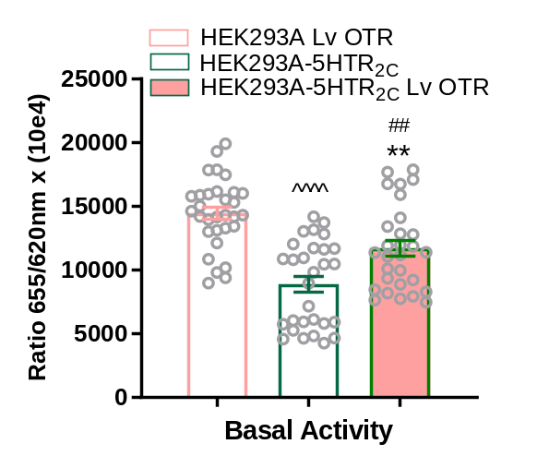
Fig. S7. Co-expression of the OTR and 5-HTR_{2C} attenuates basal IP₁ production. Ligand independent IP₁ production in cells expressing 5-HTR_{2C}-EGFP, OTR-tRFP, and co-expressing both receptors. Graph represents means ± SEM from eight independent experiments run in quadruplicates presented as fluorescence signal (raw data) inversely proportional to the level of endogenous IP₁ (fluorescence from labelled IP₁). Statistical significance compared to cells solely expressing OTR denoted by #, and compared to cells solely expressing 5-HTR_{2C} denoted by *.
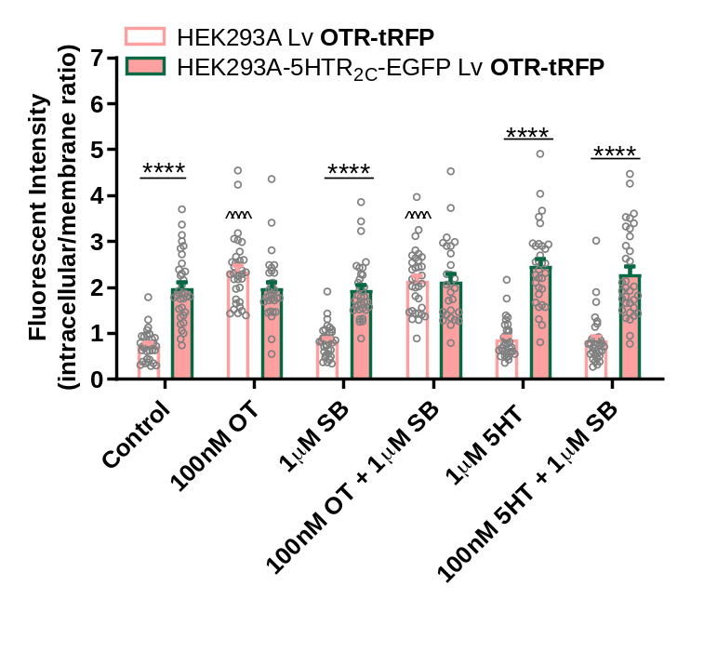
Fig. S8. Cellular trafficking of the OTR. Qquantitative analysis of basal and ligand-mediated internalisation of the OTR tagged with tRFP in cells expressing a single receptor versus cells co-expressing both receptors after 30 minutes incubation with ligands (100 nM OT or 1 µM 5-HT). Graphs represent mean ± SEM from four independent experiments. Statistical significance compared to cells solely expressing a single receptor denoted by *. Statistical significance compared to untreated control condition in cells solely expressing OTR denoted by ^.

