Supplementary file
Assessment of integration of methane-reduced ceria chemical looping CO₂/H₂O splitting cycle to an oxy-fired power plant
Azharuddin Farooqui^{1, 2, 3}, Archishman Bose⁴, Marta Boaro⁵, Jordi Llorca³, and Massimo Santarelli¹
¹Department of Energy, Politecnico di Torino, Italy
²German Aerospace Center (DLR), Institute of Engineering Thermodynamics, 70569,
Stuttgart, Germany.
³Institute of Energy Technologies, Department of Chemical Engineering and Barcelona Research Center in Multiscale Science and Engineering, Universitat Politècnica de Catalunya, Barcelona, Spain
⁴Marine and Renewable Energy Research (MaREI) Centre, Environmental Research Institute, School of Engineering and Food Science, University College Cork, Lee Road, Cork, T23 XE10, Ireland
⁵Polytechnic Department of Engineering and Architecture (DPIA), Universita di Udine, Italy

Corresponding email id: azharuddin.xxx@polito.it; azharuddin0613@gmail.com

Table S1 Rate and integral expressions for different solid-state kinetic models [43] based on X, which indicates the conversion, f(X) represents the differential form of the kinetic model, and g(X) is the integral form of the model.
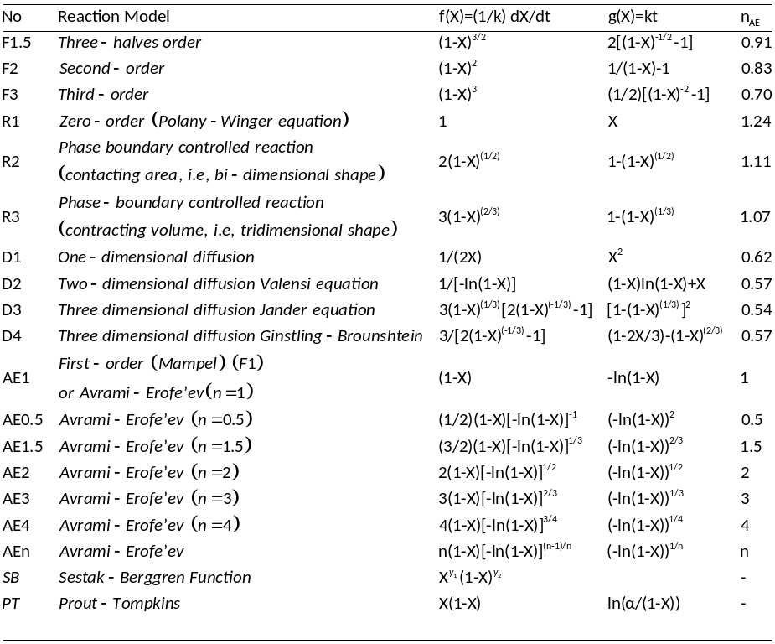
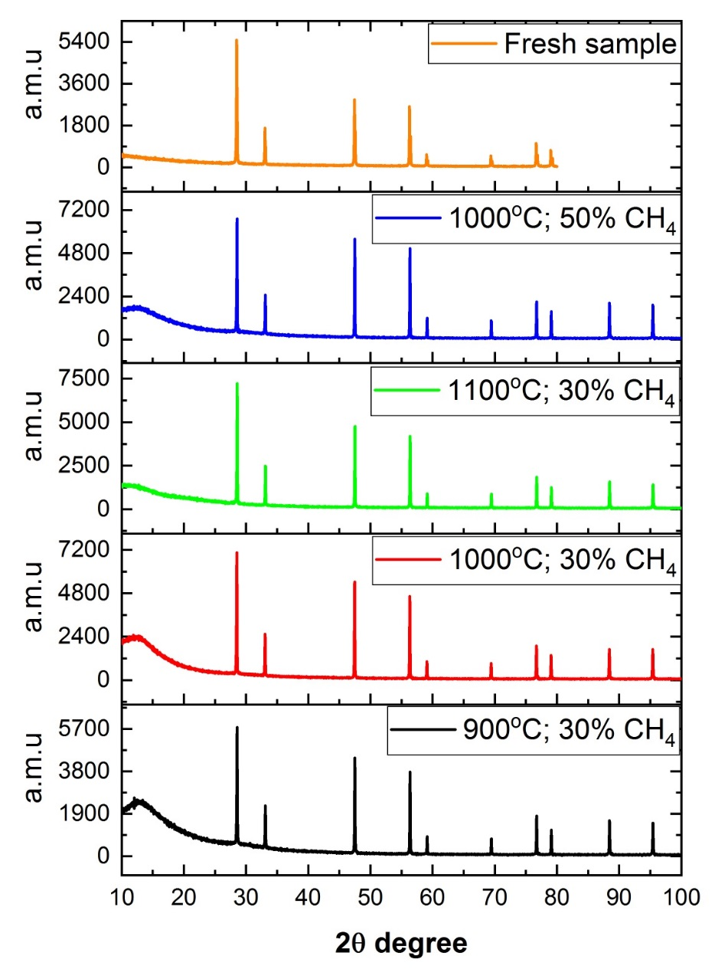
Figure S1. XRD images of fresh and used samples of ceria with methane reduction at different temperatures and concentration.
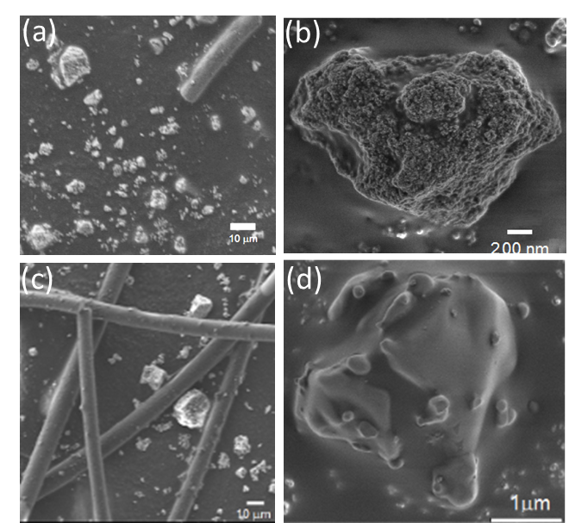
Figure S2. (a) and (b) represents microstruture of 900°C and 30%CH_{4;} and (c) and
(d) 1100°C 30% CH₄ at different magnification.
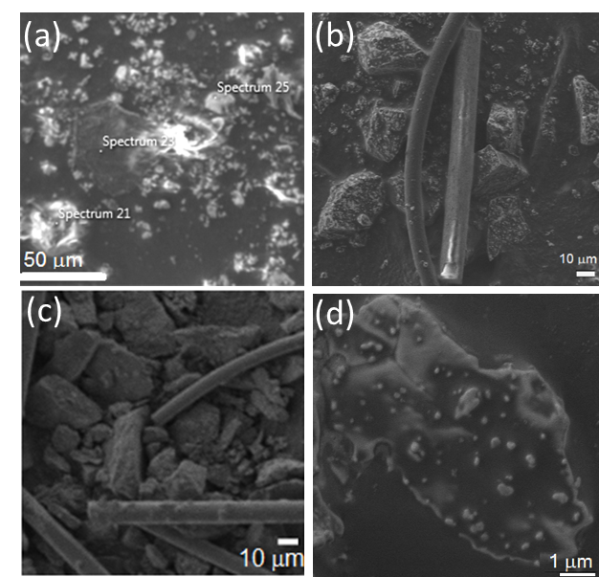
Figure S3. (a) and (b) represents the SEM of 1000ºC and 30%CH₄ after 1st and 5th cycle (c) and (d) represents 1000ºC and 50% CH₄ after 1st and 5th cycle.

Table S2: Methane conversion for different temperatures at constant methane feed of 30%.
Temp (ºC) | CH₄ conversion (%)
900 | 20.11±2.5
950 | 21.3±0.39
1000 | 44±1.5
1050 | 46±0.44

Table S3: Assumption adopted in simulation of OXY-CC-CL-K
Unit | Parameters
ASU | O₂ purity: 99.9% (by volume); O₂ and N₂ delivery pressure: 1.2 bars; O₂ compression pressure: 26 bars;  No use of N₂ was considered in the layout.
Turbo Expander (TURBOEXP) | P_{in, NG}: 70 bars; Expansion Ratio: 35; T_{in, NG}: 325º C.
Combustion Chamber | Excess Oxygen over stoichiometry for oxy-combustion: 5%; ΔP_{drop}: 0.1 bar; P_{combustor} for COMB-1: 26 bars and COMB-2: 18 bars
Reduction Reactor (RED) and Combustion Chamber (COMB-1) | Reactors were modelled separately with complete heat integration. RED is modelled as moving bed reactor with COMB-1 as RGIBBS.  Working pressure: 26 bars in Combustor Side and P_{RED}: 2 bars; Non-stoichiometry generated in RED: 0.29; T_{RED}: 1000ºC;
Oxidation reactor (OXI) | Reactor Type: Moving bed and Adiabatic, jacketed for high-temperature steam generation  T_{oc,inlet}: 1000ºC; T_{oc,outlet}: 1350ºC; T_{gas, inlet}: 921ºC; T_{gas,outlet}: 1120ºC; P_{OXI}: 2 bars.
CO₂ Drying and Compression | P_{delivery}: 110 bars; T_{delivery}: 40ºC; η_{isentropic, compressor}: 90%; η_{mechanical,compressor}: 98%.
Gas Turbine/ Expander | η_{isentropic, turbine}: 90%; Maximum pressure ratio: 18:1; P_{discharge}: 1.04 bar; TIT: 1373ºC
Steam Turbine and HRSG | Single Stage Expansion; η_{isentropic, turbine}: 90% IP  P_{steam}: 150 bars; P_{condenser}: 0.04 bar; η_{isentropic, pump}: 0.8;  All of the steam generated in gasification island, chemical looping and syngas cooling unit was expanded together;  T_{min, approach}: 10ºC, no pressure drop.

Table S4. Stream flow rate data of the layout of OXY-CC-CL and OXY-CC-CL-K
State | Fluid/solid | Mass Flow | Pr. | Mass Flow | Pr.
 |  | kg/s | bar | kg/s | bar
1 | Air | 335.028 | 1.013 | 342.512 | 1.013
1a | Compressed O₂ | 76.684 | 26 | 78.397 | 26
1b | Compressed N₂ | 256.334 | 1.2 | 262.060 | 26
2 | Fuel | 20.486 | 70 | 20.486 | 70
2a | Fuel after Initial preheater | 20.486 | 70 | 20.486 | 70
2b | Fuel after Expander | 20.486 | 2 | 20.486 | 2
2c | Fuel into RED Reactor | 20.486 | 2 | 20.486 | 2
3 | Syngas 1-1, RED Outlet | 33.802 | 2 | 28.329 | 2
4 | Syngas 1-2 | 33.802 | 2 | 28.329 | 2
5 | Syngas 1-3 | 33.802 | 2 | 28.329 | 2
6 | Syngas 1-4, to Compressor Inlet | 33.802 | 2 | 28.329 | 2
7 | Syngas 1-5, Compressor Outlet | 33.802 | 26.1 | 28.329 | 26.1
8 | Hot GT Inlet Gas | 503.838 | 26 | 562.41 | 26
9 | GT1 Exhaust Gas | 503.838 | 2 | 562.41 | 2
10 | GT1 Second Stage Inlet Gas | 458.372 | 2 | 530.803 | 2
11 | GT1 Second Stage Exhaust Gas | 458.372 | 1.02 | 530.803 | 1.02
12 | Exhaust Gas to OXI | 45.466 | 2 | 31.609 | 2
13 | Exhaust Gas Inlet to OXI | 45.466 | 2 | 31.609 | 2
14 | Syngas 2-1, OXI Outlet | 32.15 | 2 | 23.774 | 2
15 | Syngas 2-2, Inlet to HRSG2 | 32.15 | 2 | 23.774 | 2
16 | Syngas 2-3, Exhaust from HRSG 2 | 32.15 | 2 | 23.774 | 2
17 | Syngas 2-4, Inlet to Compressor | 30.175 | 2 | 23.140 | 2
18 | Syngas 2-5, Compressor Outlet | 30.175 | 18.1 | 23.140 | 18.2
19 | Hot GT2 Inlet Gas | 166.924 | 18 | 111.957 | 18
20 | Exhaust Gas GT2 | 166.924 | 1.02 | 111.957 | 1.02
21 | Mix Exhaust Gas, to HRSG | 625.296 | 1.02 | 642.758 | 1.02
22 | Exhaust Gas HRSG Outlet | 625.296 | 1.02 | 642.758 | 1.02
23 | Exhaust Gas To Condenser | 625.296 | 1.02 | 642.758 | 1.02
24 | H₂O liquid separated | 42.104 | 1.02 | 43.471 | 1.02
25 | Pure CO₂ Captured | 583.192 | 1.02 | 599.289 | 1.02
26 | CO₂ to Sequestration Compressor | 55.092 | 1.02 | 54.513 | 1.02
27 | CO₂ Compressed for Sequestration | 55.092 | 110 | 54.513 | 110
28 | CO₂ to Combustor 1 | 405.237 | 1.02 | 465.286 | 1.02
29 | CO₂ to Combustor 2 | 122.863 | 1.02 | 79.218 | 1.02
30 | CO₂ inlet to Combustor 1 | 405.237 | 26.1 | 465.286 | 26.1
31 | CO₂ inlet to Combustor 2 | 122.863 | 18.1 | 79.218 | 18.1
32 | Oxygen Heated for Combustor 1 | 64.799 | 26 | 68.798 | 26.1
33 | Oxygen Throttled for Combustor2 | 13.885 | 18 | 9.600 | 18.1
34 | Oxygen Heated for Combustor 2 | 13.885 | 18 | 9.600 | 18.1
35 | Saturated Water after Pump | 188.973 | 150 | 183.035 | 150
36 | Sat. Water to HRSG 1 | 171.577 | 150 | 164.732 | 150
37 | Sat. Water to HRSG 2 | 17.396 | 150 | 18.304 | 150
38 | Steam from HRSG 1 | 171.577 | 150 | 164.732 | 150
39 | Steam from HRSG 2 | 17.396 | 150 | 18.304 | 150
40 | Steam Inlet to ST | 188.973 | 150 | 183.035 | 150
41 | Steam Exhaust from ST | 188.973 | 0.05 | 183.035 | 0.05
42 | Condensate | 188.973 | 0.05 | 183.035 | 0.05
43 | CeO₂ out from OXI | 286.492 | 2 | 284.669 | 2
44 | CeO₂ to RED | 286.492 | 2 | 284.669 | 2
45 | Ce₂O₃/CeO_{2-δ} out from RED | 273.176 | 2 | 276.928 | 2

Table S5. Syngas composition from the Reduction Reactor (RED) and the Oxidation Reactor (OXI) of the Chemical Looping Unit (CL)
 | Thermodynamics |  | Kinetics
Mole Fraction (%) | From RED | From OXI | From RED | From OXI
CO | 28.43 | 61.4 | 22.41152 | 48.47176
H₂ | 54.23 | 9.84 | 44.82303 | 12.8039
CO₂ | 0.85 | 18.87 | 0.275885 | 34.19911
H₂O | 0.35 | 9.63 | 0 | 4.40159
CH₄ | 15.71 | Trace | 29.45483 | Trace
N₂ | 0.43 | 0.26 | 0.55177 | 0.0959439
Ethane | Trace | Trace | 2.31743 | Trace
Propane | Trace | Trace | 0.165531 | Trace
Total | 100 | 100 | 100 | 100

