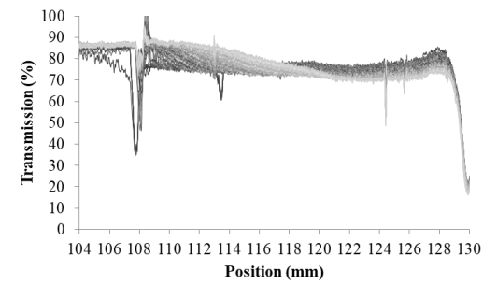

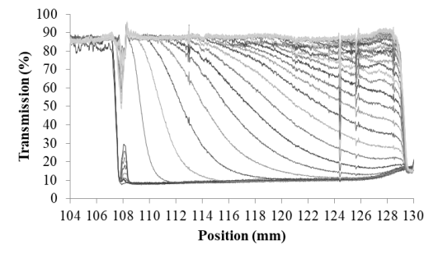

Fig. S1. Transmission of near-infrared light during centrifugation of solutions of β-casein concentrate (BCC) prepared in simulated milk ultrafiltrate (SMUF). Transmission data was collected across the length of the sample cuvette, from top (104 mm) to bottom (130 mm). Solutions were incubated at 37°C (top) or 60°C (bottom) for 30 min before centrifugation. A cycle of two centrifuge speeds was applied at a controlled temperature of 37°C, the first at 36 g for 10 min followed by 2300 g for 60 min. Curves transition from dark grey to light grey as the centrifugal cycle progresses (total time of 4000 s). Arrows are used to highlight general trends in clarification (upwards arrow) and turbidity development (downward arrow) during centrifugation.

