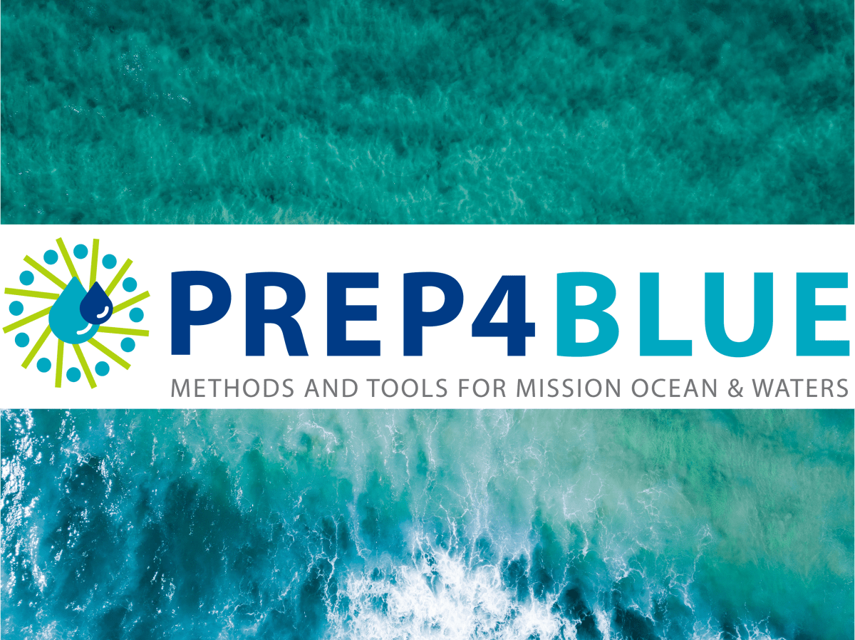

Citizen Science Interview guidelines

Corresponding Author: Line Debaveye. Flanders Marine Institute (VLIZ), Oostende, Belgium. Email: line.debaveye@vliz.be
Cite as: Debayeve, L. 2023. Citizen science interview guidelines. PREP4BLUE Project Documents.

The goal of the interview
By conducting an in-depth interview, we aim to gain more insights into the motivations and the choice of certain paths that were taken by interesting/remarkable citizen science (CS) projects. We also want to know what choices you would make if you would plan to start a new CS project or Europeanise an existing initiative. The focus is set on collecting advice or best practices for future citizen science projects or strengthening existing ones. Note that an interesting project is not per se a successful one, often, many things can be learned from a citizen science project that had a very strong initial drive, but was ‘unsuccessful’ or did not meet its set goals in the end. Similarly, we also want to learn from ‘less good’ choices that were later adjusted.
The prepared interview questions (which you will find below) touch upon different facets of making/running a citizen science project. With this selection of questions, we hope to reveal the ‘why’ and ‘how’ of starting/running a citizen science project and hope to discover some recommendations that can help the future of citizen science.

Interview questions
For the interview, we have a set list of questions with topics we would like to touch upon. However, the interviewer is allowed to ask extra questions in between to deepen a certain topic or motivation of the interviewee or let certain questions out if they seem irrelevant to the project.
For example, imagine that the project you are interviewing has many years of experience. It could be very interesting to ask them how they were successful in building out the project over such a long time period. This question is valuable to ask to a project that has many years of practice but can be less relevant for projects that just started.
If the interviewee prefers this, the questions can be sent to them in advance. Note that this can ease the conversation and make the interviewee feel more comfortable. However, this could also lead to ‘eligible’ answers instead of spontaneous and honest opinions.
Note that, to stay within a reasonable time frame (+/- 1h), the interviewees can answer briefly/to the point to the asked interview questions. The interview questions can be found on the next page.

Interview questions

Topic 0: Introduction of the project. (around 5’)
Let the interviewee explain what their project is about, when it started, whether it is still running and where citizen science comes in.
Topic 1: Setting up your project.
- How did your idea for your CS project originate? Why did you choose this particular subject?
- How did you specifically define your research question? Where does it originate from?
Topic 2: Selecting a target group from the broader public.
- Did you have a specific target audience (e.g. divers, schoolchildren, fishermen, water sports enthusiasts etc.) in mind when developing your CS project? If so, why did you choose this target group? How did you adapt your CS project to your target group?
- Do you see opportunities in using certain ‘atypical’ target groups? Or does this bring too many challenges to the field?
Topic 3: Involving citizens.
- What is the key to persuading citizens to participate in a CS project? How did you do this? How can you get people to ‘care’ about the project and participate? Do you consider your ‘involvement’ methods successful? Why were they (un)successful?
- What is the hardest aspect of reaching/involving interested citizens? Did you overcome this obstacle? How?
- Once you have an interested group, how can you expand it and gather more participants? How did you approach this in your project?
Topic 4: Motivating citizens.
- How did you motivate your participants? Was this successful? What was the reason for this (un)success?
- How can you keep participating citizens motivated in the long term? What is the key to success?
- Where do you think the root cause of inaction amongst citizens lies? How can we remedy this?
- Did you focus on building a community amongst the participants in your CS project? Do you think this is important/not important? Why (not)?

Topic 5: Creating connections/synergies/partnerships.
- Did you collaborate with other players in the research field (e.g.: other cs projects/research projects/industry etc.) while starting up your project? Was this useful? Would you recommend this to a starting CS project?
- Did you use certain networks or partners to roll out your CS project? How did you find these networks or partners? What was their added value?
Topic 6: Inclusivity/breaking barriers.
- Does the project consciously take inclusiveness into account? I.e. including all types of people (incl. people with special needs) and treating them all fairly and equally. Why was this specific choice made? How was your project adapted to being inclusive?
- In many projects, the main public that is involved are highly educated, white, older males. How can we make citizen science more inclusive and fitting for our diversifying society? How can we include more layers of the population into citizen science? How can we make citizen science for everyone? What links are missing to achieve this?
Topic 7: Practicalities.
- Where did you get your funding from? Did you have trouble securing this funding? Do you think there are enough funding opportunities available for people who want to start/expand a citizen science project?
- How much budget did you need to roll out your project? How did you spend the project money?
- How can a running project grow or secure continuous funding? How was your experience with this? What would you recommend for running projects?
Topic 8: Communication with the broader public and promotion of the project.
- Was a communication plan set up before the project started? If so, which milestones did you define in this strategy? If not, how did you proceed during the project? Was it essential for your project campaign?
- How (which media) and what (results, updates etc.) did you communicate about your project with the broader public? Were participating citizens involved in the communication strategy? How?
- Do the participants have the chance to be in direct contact/interaction with scientists/professional researchers? How was this connection established?
Topic 9: Research methods.
- How did you set up the methodology of your CS project? Did you create it yourself?
- What was the most challenging aspect of creating your project methodology?
- Is there something special about starting a marine or coastal CS project? Are there different steps to take than in a ‘terrestrial’ project? Different tools to apply? Are there some special aspects we need to consider? Specific safety measures?
- Biodiversity and marine litter are the most common themes in marine citizen science projects. Why are these topics so popular and other topics less popular? How can this be remedied? Should this be remedied?
Topic 10: Used tools.
- Did you use certain guides/advice/guidelines/information sources before starting up the project? Which ones? Are there enough clear frameworks to find on how to start/manage a citizen science project?
- Were certain technological tools (e.g.: data portal, (gamification) app) developed to run your CS project?
Topic 11: Data.
- Was the data verified by the project? Which verification steps did you use? Why did you use these?
- Is the ‘general science world’ informed enough about the use of citizen science? How can we motivate more scientists to use citizen science? How can we stress that citizen science is reliable and can be a correct way to collect scientific data?
Topic 12: Defining best practices and recommendations.
- What is the one key element of advice you would give to new CS startups?
- What is the key challenge in creating and maintaining a CS project?
- Is there one thing/key element that is a threat to CS projects?
- What would you recommend to people who want to Europeanize an existing CS project?
- If you had one wish regarding the future growth and development of citizen science, what would it be?

