How do you want your steak? Attitudes of European consumers towards 3D printed meat.

Petra Chaloupkovaª, Tersia Kokoskova^{b}, Francisco Ceacero^{b}, Claire Durand^{c}, Stephen Onakuse^{d}, Ladislav Kokoska^{e}

ª Department of Economics and Development, Faculty of Tropical AgriSciences, Czech University of Life Sciences Prague, Prague - Suchdol, 165 00, Czech Republic
^{b} Department of Animal Science and Food Processing, Faculty of Tropical AgriSciences, Czech University of Life Sciences Prague, Prague - Suchdol, 165 00, Czech Republic
^{c} Ecole Supérieure des Agricultures d’Angers / USC Uninté de Recherche en Sciences Sociales (LARESS), 55 rue Rabelais, Angers, 49 007, France
^{d} Department of Food Business & Development, Cork University Business School, O’Rahilly Building, University College Cork, Ireland
^{e} Department of Crop Sciences and Agroforestry, Faculty of Tropical AgriSciences, Czech University of Life Sciences Prague, Prague - Suchdol, 165 00, Czech Republic

Supplementary Material

Figure S1. Path analysis showing the effects of different sensory factors on meat consumption habits. Arrows show the standardized regression weights for each analysed path; black arrows indicate fixed relationships, while purple ones indicate optional paths. Values above the observed variables indicate the amount of variance explained. Circles indicate the errors in the measurement of the variables in the model. The model explains 59% of the variability of the endogenous variable.
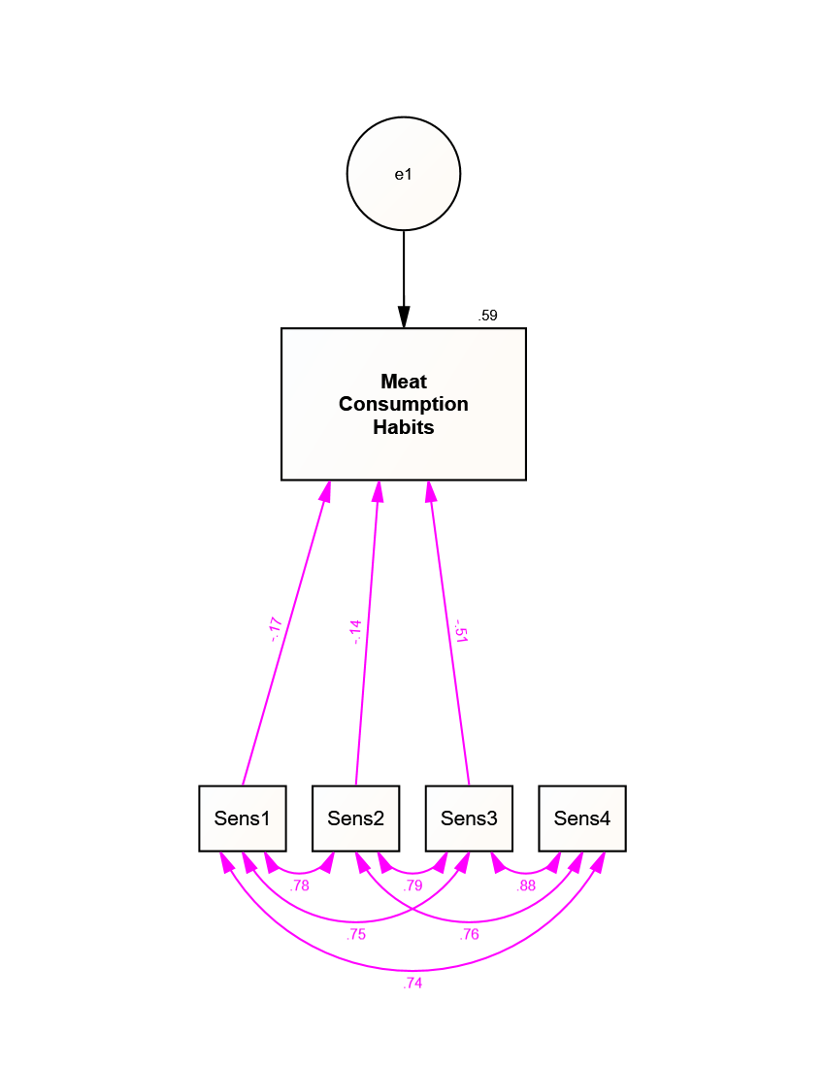
Figure S2. Path analysis showing the effects of different socio-economic factors on meat consumption habits. Arrows show the standardized regression weights for each analysed path; black arrows indicate fixed relationships, while purple ones indicate optional paths. Values above the observed variables indicate the amount of variance explained. Circles indicate the errors in the measurement of the variables in the model. The model explains just 7% of the variability of the endogenous variable.
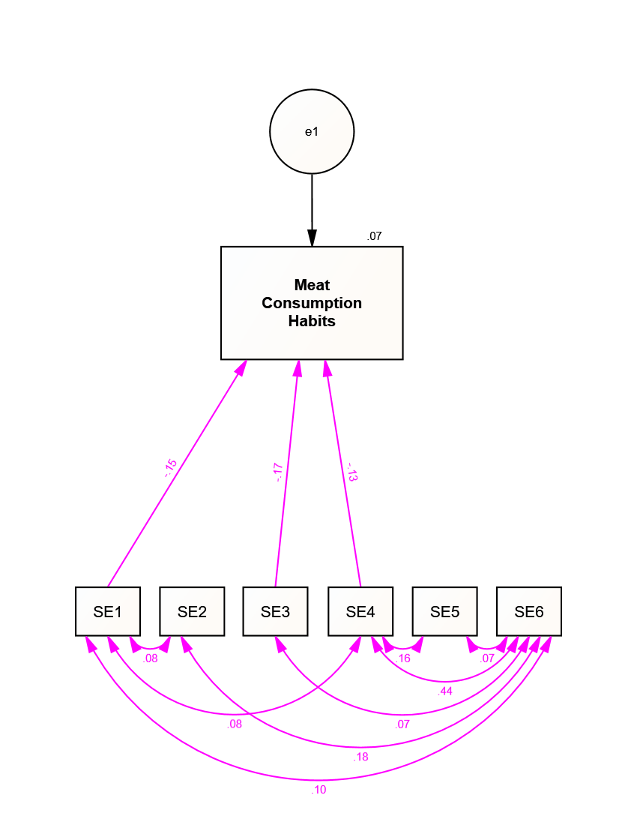
Figure S3. Path analysis showing the effects of different attitude factors on meat consumption habits. Arrows show the standardized regression weights for each analysed path; black arrows indicate fixed relationships, while purple ones indicate optional paths. Values above the observed variables indicate the amount of variance explained. Circles indicate the errors in the measurement of the variables in the model. The model explains 32% of the variability of the endogenous variable.
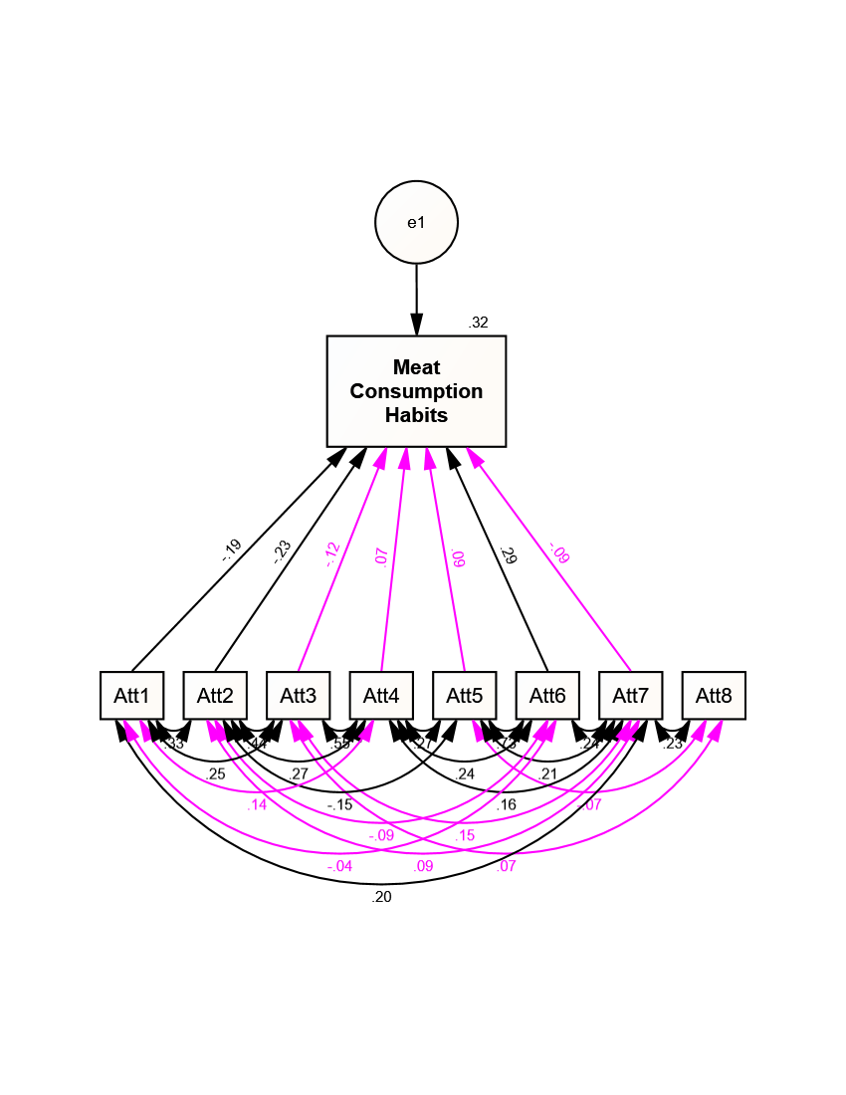
Figure S4. Path analysis showing the effects of different buying behaviour factors on meat consumption habits. Arrows show the standardized regression weights for each analysed path; black arrows indicate fixed relationships, while purple ones indicate optional paths. Values above the observed variables indicate the amount of variance explained. Circles indicate the errors in the measurement of the variables in the model. The model explains 59% of the variability of the endogenous variable.
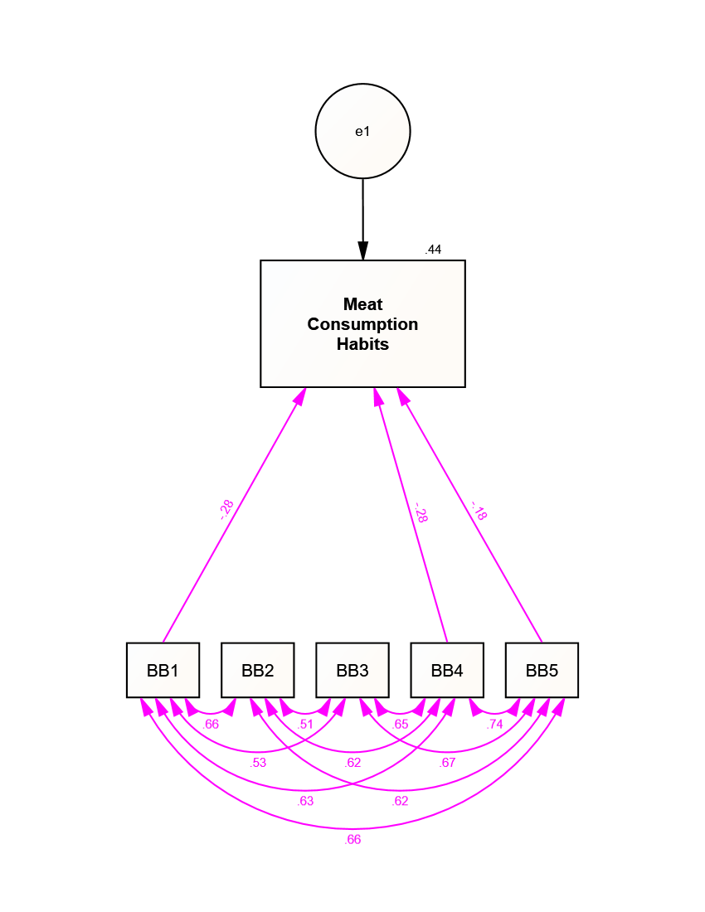
Figure S5. Path analysis showing the effects of different knowledge factors on the interest in 3D meat. Arrows show the standardized regression weights for each analysed path; black arrows indicate fixed relationships, while purple ones indicate optional paths. Values above the observed variables indicate the amount of variance explained. Circles indicate the errors in the measurement of the variables in the model. The model explains just 5% of the variability of the endogenous variable.
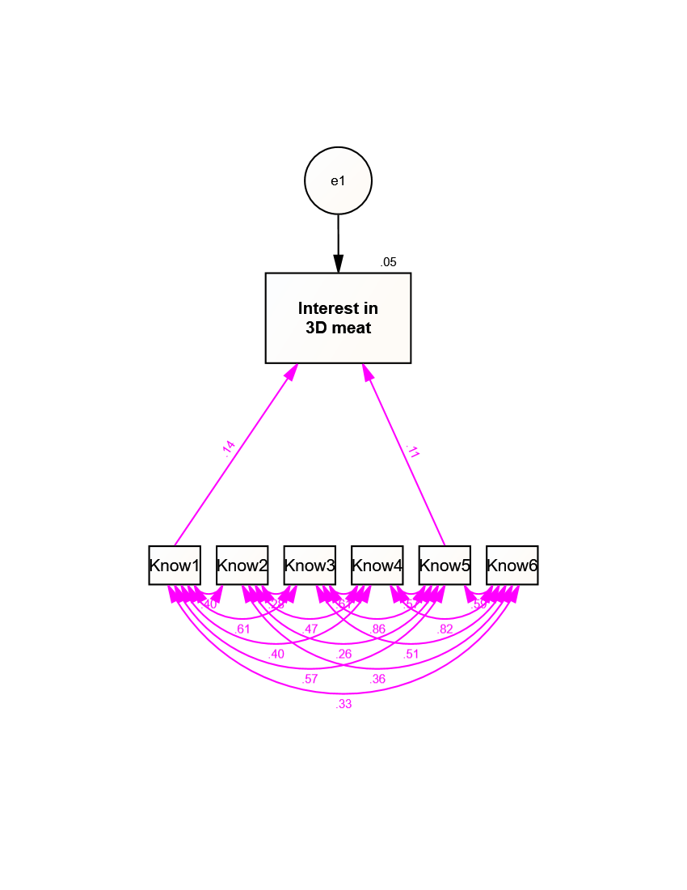
Figure S6. Path analysis showing the effects of different decision-making factors on the interest in 3D meat. Arrows show the standardized regression weights for each analysed path; black arrows indicate fixed relationships, while purple ones indicate optional paths. Values above the observed variables indicate the amount of variance explained. Circles indicate the errors in the measurement of the variables in the model. The model explains 42% of the variability of the endogenous variable.
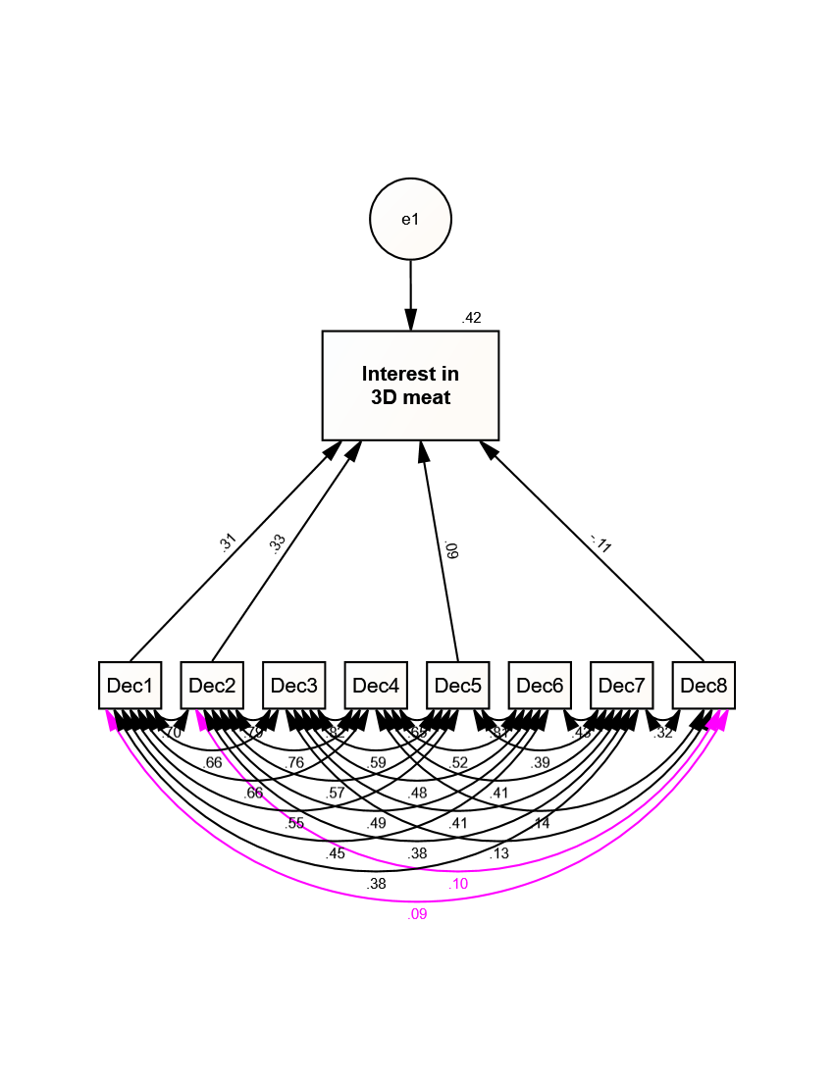
Figure S7. Path analysis showing the effects of different willingness factors on the interest in 3D meat. Arrows show the standardized regression weights for each analysed path; black arrows indicate fixed relationships, while purple ones indicate optional paths. Values above the observed variables indicate the amount of variance explained. Circles indicate the errors in the measurement of the variables in the model. The model explains 38% of the variability of the endogenous variable.
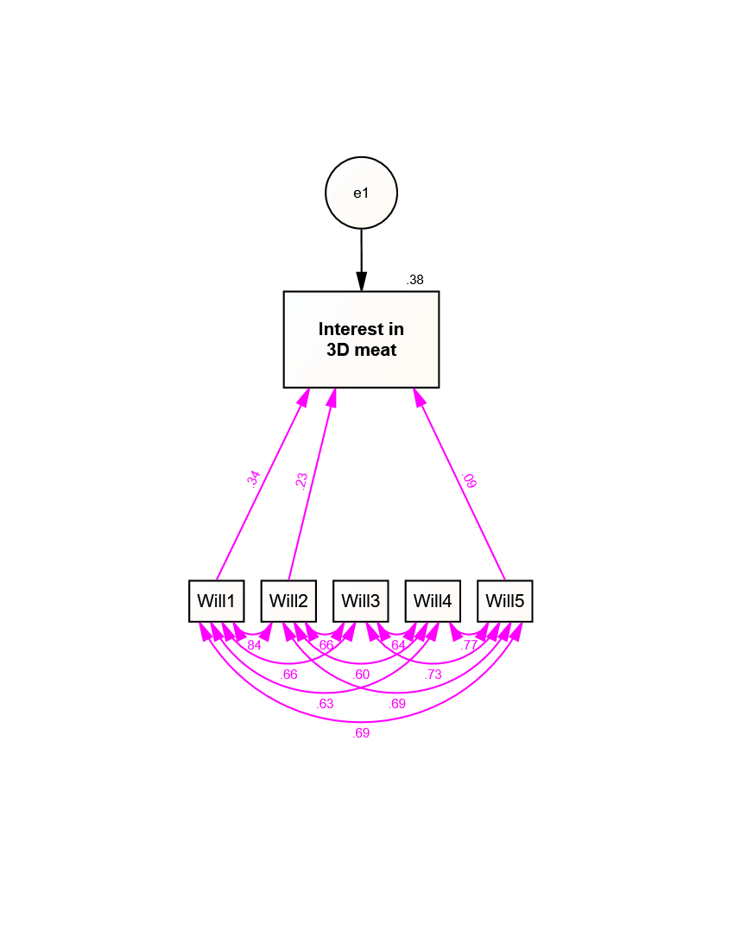
Figure S8. Path analysis showing the effects of different sensory factors on the interest in 3D meat. Arrows show the standardized regression weights for each analysed path; black arrows indicate fixed relationships, while purple ones indicate optional paths. Values above the observed variables indicate the amount of variance explained. Circles indicate the errors in the measurement of the variables in the model. The model explains just 6% of the variability of the endogenous variable.
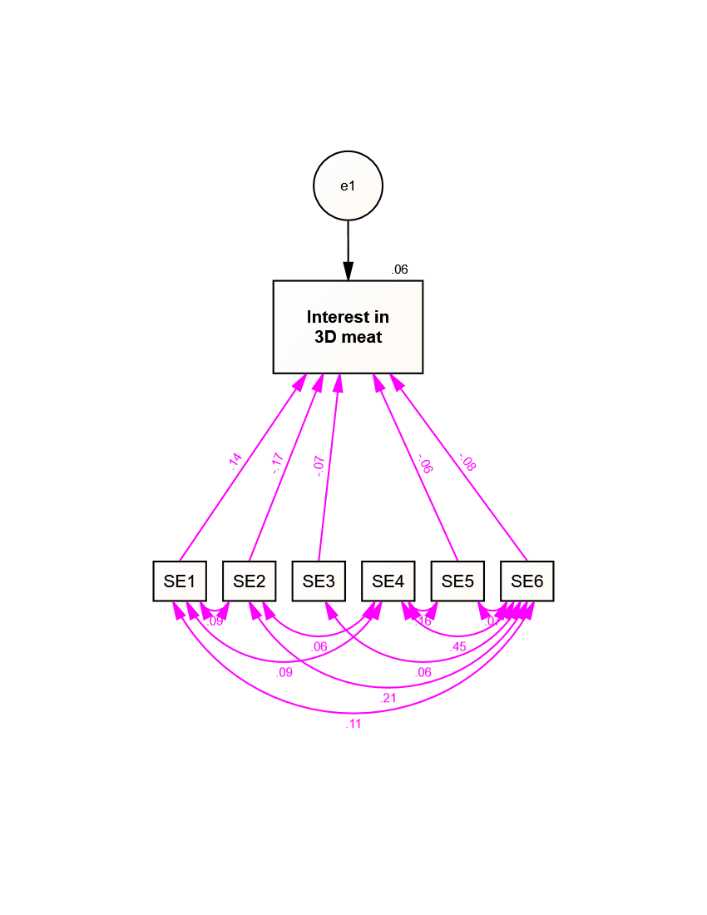
Figure S9. Path analysis showing the effects of different socio-economic factors on the interest in 3D meat. Arrows show the standardized regression weights for each analysed path; black arrows indicate fixed relationships, while purple ones indicate optional paths. Values above the observed variables indicate the amount of variance explained. Circles indicate the errors in the measurement of the variables in the model. The model explains just 5% of the variability of the endogenous variable.
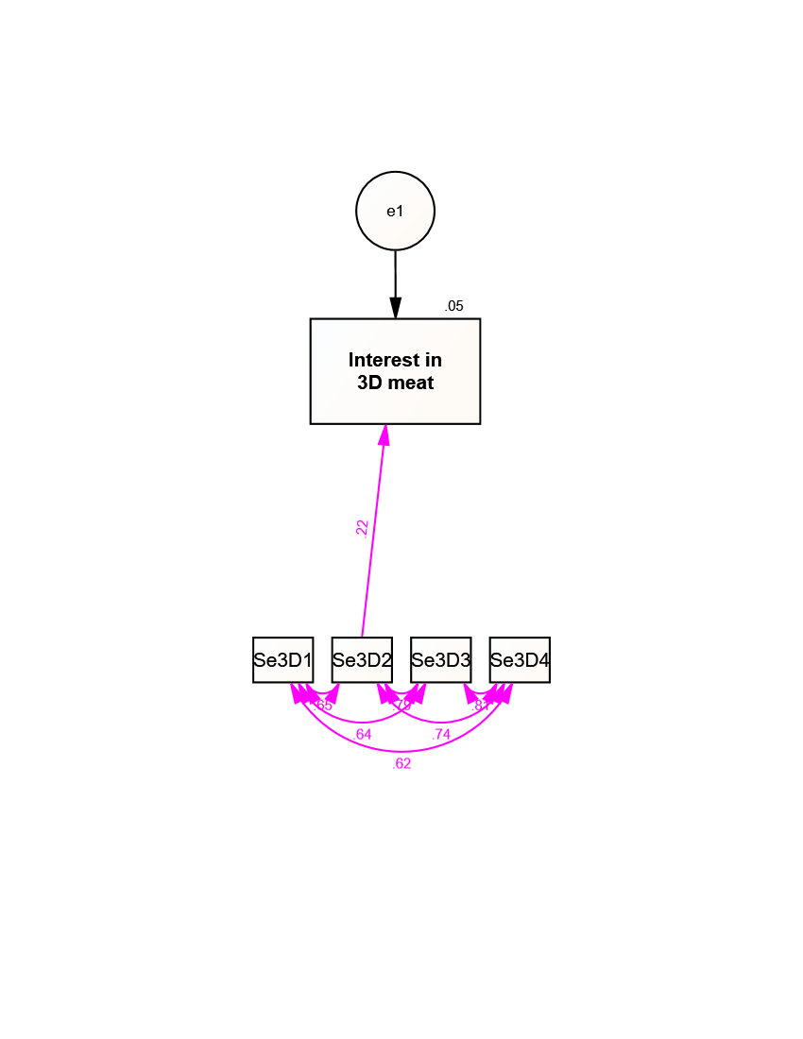
Figure S10. Design of the path analysis shown in Figure 1. Black arrows indicate fixed relationships, while purple ones indicate optional paths.
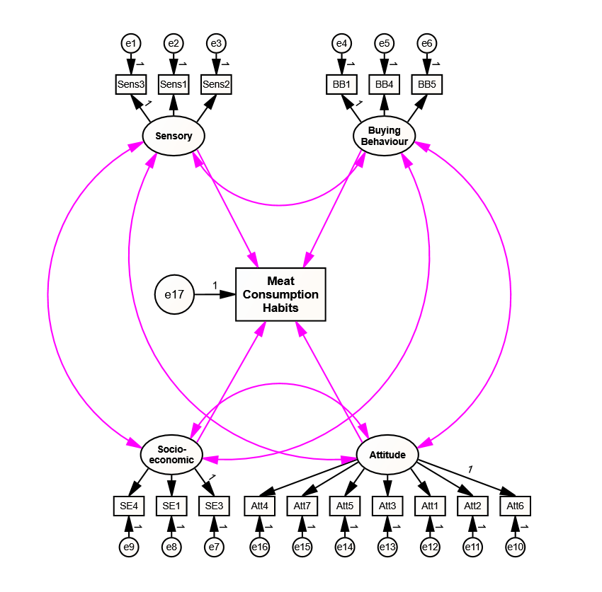
Figure S11. Design of the path analysis shown in Figure 2. Black arrows indicate fixed relationships, while purple ones indicate optional paths. 