Supplementary Material

Table 1: Temperature and pH readings using a hand-held multi-parameter probe and refractometer for each sampling trip at the jetty sampling sites, Port Alfred, South Africa.
Date | Site | Temperature (°C) | Salinity (ppt)
9 September 2021 | Jetty B | 17.4 | 32
 | Jetty D | 17.5 | 33
21 September 2021 | Jetty B | 15.5 | 34
 | Jetty D | 15.8 | 34
23 September 2021 | Jetty B | 17.0 | 34
 | Jetty D | 17.2 | 34
8 October 2021 | Jetty B | 17.2 | 37
 | Jetty D | 17.1 | 36
12 October 2021 | Jetty B | 18.0 | 34
 | Jetty D | 18.1 | 36
13 October 2021 | Jetty B | 17.6 | 35
 | Jetty D | 17.9 | 35
14 October 2021 | Jetty B | 18.4 | 35
 | Jetty D | 18.6 | 36
10 February 2022 | Jetty B | 18.9 | 35
 | Jetty D | 19.0 | 35
15 March 2022 | Jetty B | 16.4 | 34
 | Jetty D | 16.4 | 35
13 April 2022 | Jetty B | 17.3 | 36
 | Jetty D | 17.2 | 36
20 April 2022 | Jetty B | 17.9 | 36
 | Jetty D | 17.9 | 36
21 April 2022 | Jetty B | 18.0 | 36
 | Jetty D | 18.0 | 36

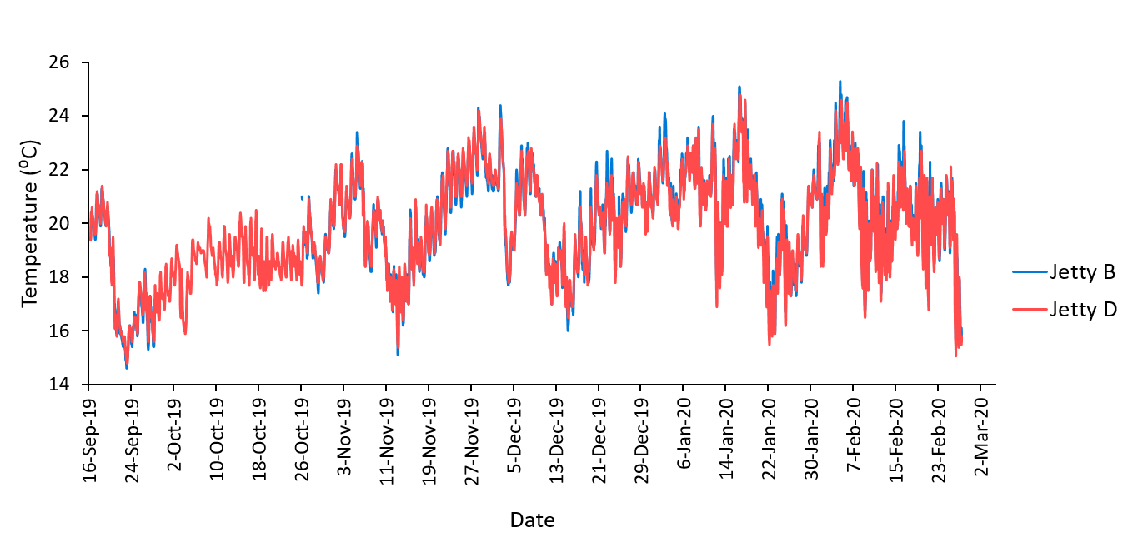
Figure 1. Hourly in situ water temperature data collected between September 2019 and February 2020 at the jetty sampling sites, Port Alfred by Reddy (2022) used to establish the minimum, average and maximum test temperatures for respirometry trials.

