

Applied Materials Today 44 (2025) 102718
Contents lists available at ScienceDirect

Applied Materials Today

journal homepage: www.elsevier.com/locate/apmt

Security inks with silanized zinc oxide quantum dots and cellulose ethers for the safeguarding of cultural heritage objects
Andrea Louise Matulac ª, Themis Krasoudaki ª, Francesca Battaglia ª, Carlo Spadoni ª,
Martina Piletti ^{b}, Daniela Iacopino ^{b}, Rodorico Giorgi ^{a,*}
ª CSGI (Consorzio Interuniversitario per lo sviluppo dei Sistemi a Grande Interfasi) & Department of Chemistry “Ugo Schiff”, University of Florence, Via della Lastruccia 3, Sesto Fiorentino, 50019 Florence, Italy
^{b} Tyndall National Institute, University College Cork, Lee Maltings Complex, Dyke Parade, T12R5CP, Cork, Ireland

A R T I C L E I N F O

Keywords: Quantum dots Zinc oxide Cellulose ethers Security ink
Cultural heritage objects
A B S T R A C T

As crimes involving cultural heritage objects continue to escalate globally, there is a growing demand for new technology-aided interventions. Tagging the objects with security inks can be crucial in crime deterrence and evidence-based validation. In this work, security inks were specifically formulated with zinc oxide (ZnO) quantum dots as the fluorescent agent and nonionic cellulose ethers as the binder for application on artwork surfaces. Comparing naked and silanized nanoparticles, those modified with (3-aminopropyl)triethoxysilane (APTES) exhibited complete dispersibility in water, better fluorescence stability in water against UV light exposure and temperature variation, and tuneable emission properties –allowing the generation of robust, high-level security tags. Meanwhile, the inclusion of nonionic cellulose ethers significantly improved the readability of the ink under 365-nm UV light while retaining invisibility under D65 standard light. The promising formulation containing 3.0 wt. % of ZnO@APTES and 0.5 wt. % methyl 2-hydroxyethyl cellulose in water demonstrated compatibility across several substrates (papers, stone, and ceramic), workability with various application tech-niques (pen-writing, brushing, stamping), and strong resistance to degradation over three cycles of weathering tests.

Introduction

Forgery, theft, and illicit trafficking of art and antiquities continue to proliferate today as criminal organizations develop new strategies to circumvent existing safety measures. Combating these issues therefore requires innovative multi-disciplinary approaches [1–3]. One prospect is the use of security inks obscured from the human eye but revealed upon response to stimuli (e.g. light, heat, chemical exposure, mechanical force) [4]. While they have been widely used for documents, currencies, labels, packaging, and handicrafts [5–9], they have yet to be adopted for cultural heritage objects. Tagging them with security inks can provide an additional layer of protection, forestalling fraudulent activities and serving as identifiers crucial for attribution, authentication, and tracking.
Cultural heritage objects are highly diverse and complex, posing several challenges in formulation. The security ink has to be invisible, or of negligible chromatic and specular aberrations, to respect conserva-tion guidelines on aesthetic maintenance. Stimuli-responsiveness is also
necessary for recognition. Fluorescent compounds only require an external light source and a camera-equipped device for readout which make them suitable for tagging valuable collections. However, it is imperative that the fluorescent agent has good optical properties and stability. Furthermore, there should be compatibility across substrates regardless of surface morphology and porosity. The incorporation of binders in the ink can promote adhesion by fixing the fluorescent compounds in place during application and drying. Finally, considering the main end-users (conservators, museums, and private collectors), the ink should be safe to use and eco-friendly. Opting for an aqueous ink, with minimum use of volatiles, is preferable.
Most traditional photoluminescent inks, especially for anti-counterfeiting, contain organic fluorophores dissolved in organic sol-vents. However, many of these face issues of limited water dispersibility, photobleaching, and degradability [10–12] . With the advancement of nanotechnology, new alternatives have emerged. These materials can be produced from practical, scalable processes and have prolonged use lifetimes [13–16], which are key aspects for the successful

* Corresponding author.
E-mail address: rodorico.giorgi@unifi.it (R. Giorgi).

https://doi.org/10.1016/j.apmt.2025.102718
Received 17 February 2025; Received in revised form 28 March 2025; Accepted 5 April 2025
Available online 11 April 2025
2352-9407/© 2025 The Authors. Published by Elsevier Ltd. This is an open access article under the CC BY license (http://creativecommons.org/licenses/by/4.0/).

implementation on objects that are publicly exhibited, transported, and regularly subjected to cleaning and repair.
Zinc oxide (ZnO) is a promising candidate known for its high pho-tostability and durability. It can occur in zero-, one-, two-, and three-dimensional structures (e.g., dots, wires, sheets, tubes), all of which are nanometric and fluorescent [17,18]. ZnO quantum dots (QDs) have properties readily tuned according to their size, shape, and surface state [19,20]. Using the sol-gel method, the desired properties can be ach-ieved through the adjustment of reaction parameters, such as the pre-cursor [21], the precipitating agent [22], the reaction medium pH [23, 24], and the reaction temperature [25]. The underlying principle is controlling the growth efficiency [26,27] of the QDs and the presence of intrinsic or extrinsic defects [28,29]. This allows a higher level of se-curity as more intricate codes or patterns can be developed which are selectively excited at defined wavelengths.
To improve fluorescence stability and ensure long-lasting perfor-mance, QDs can be modified. An organic molecule with a suitable functional group can induce or remove trapping effects based on their electron-donating or electron-withdrawing properties [30]. Recently, silanized ZnO are of particular interest because of the facile modification process, their mitigation of photocatalysis and free-radical formation, and their resistance to fluorescence quenching in water. While modifi-cation with (3-aminopropyl)triethoxysilane (APTES) can directly impart hydrophilicity, several studies suggest to use it in conjunction with other silanes such as hexadecyltrimethoxysilane (HDS) or (3-glycidylox-ypropyl)trimethoxysilane (GPTMS) for additional passivation [18, 31–34]. For our purpose, the advantages and disadvantages of mono-and bi-silanization in terms of optical stability in water warrants further exploration.
Regarding ink formulations, ZnO nanoparticles have been an integral
component for printed electronics [35–41] and monetary security [18, 32,42]. The nanoparticles work together with various polymers which serve as optical enhancers, viscosity modifiers, or stabilizing agents [18, 32,43–44]. Inclusion of polymers derived from renewable sources offer an additional point of building eco-friendly inorganic-organic hybrid systems [16,45].
In line with this, nonionic cellulose ethers seem favourable as binders due to their excellent film-forming ability, reinforcement effect, anti-microbial property, low toxicity and synergy with ZnO [46–52]. They are also proven to improve fastness for fluorescent inks and prevent fluorescence quenching [53]. Hydroxypropyl cellulose (HPC), also commercially known as Klucel G, 2-hydroxyethyl cellulose (HEC), and methyl 2-hydroxyethyl cellulose (MHEC), also commercially known as Tylose MH 300P, are selected on account of their availability in labo-ratories and proven effectiveness as consolidants, adhesives, and coat-ings in the cultural heritage field [54–59].
Overall, the study introduces a novel water-based security ink with silanized ZnO QDs as the fluorescent agent and cellulose ethers as the binder, offering a reliable alternative to traditional organic photo-luminescent inks which are often prone to degradation over time. This ink ensures long-term stability of its optical properties before and after application and, designed for versatility, it is compatible with various substrate surfaces and workable using different application techniques. Critically, it allows the creation of tags that remain invisible under standard lighting but become sharply readable under UV light, providing an innovative and effective approach to safeguarding cultural heritage objects.

Methods

  - Chemicals

Zinc acetate dihydrate (Sigma-Aldrich). Potassium hydroxide (Carlo Erba). (3-Aminopropyl)triethoxysilane (Sigma-Aldrich). Hexadecyl-trimethoxysilane (Sigma-Aldrich). (3-Glycidyl oxypropyl)trimethox-ysilane (Sigma-Aldrich). Hydroxypropyl Cellulose (Klucel G, DS 2.6, C.
T.S. S.R.L Firenze). Hydroxyethyl cellulose (90,000 Da, DS 1.50, Sigma-Aldrich). Methyl 2-hydroxyethyl cellulose (Tylose MH 300P, DS 1.20, C. T.S. S.R.L Firenze). Quinine Anhydrous (Sigma-Aldrich). Absolute
ethanol (Analytical Grade, Carlo Erba) and Ultrapure Milli-Q water (resistivity 18.2 MΩ.cm at 25 ◦C) were used as solvents.

  - Substrates

20th-century paper from a historical document entitled Catalogo Italiano, 1927; modern drawing paper by Fabriano® (Italy); Arenaria stone, Lecce stone, and Carrara marble samples provided by CNR-ISPC, Italy; and glazed ceramic provided by OBI© (Italy); were used for the experiments.

  - Synthesis of ZnO nanoparticles and their modification with silanes

In a round-bottom flask, 0.2 mmol of Zn(OAc)₂⋅2H₂O was dissolved in 20 mL of EtOH at 80 ◦C for two hours. Separately, an excess amount of KOH was dissolved in 20 mL of EtOH (11.6 mmol for green, 7.2 mmol for
yellow, 3.6 mmol for orange emission). Both solutions were cooled in an ice bath prior to dropwise addition of KOH solution to the ZnO solution. The resulting mixture was stirred for 2 h in the ice bath.
For the naked QDs, the reaction mixture was centrifuged and washed with a 4:1 EtOH/H2O solution. To obtain mono-silanized QDs instead, 4 mL of 50 mM APTES aqueous solution was added dropwise to the re-action mixture and stirred for 2 h. The final product was then collected by centrifugation and washing with 4:1 EtOH/H2O solution. Mean-while, to obtain bi-silanized QDs, 4 mL of either 10 mM HDS or 15 mM GPTMS aqueous solution was first added dropwise to the reaction mixture and stirred for 2 h. After centrifugation and washing with 4:1 EtOH/H2O solution, the preliminary product was redispersed in 40 mL EtOH. Then 4 mL of 50 mM APTES aqueous solution was added drop-wise and stirred for another 2 h. The final product was then collected by centrifugation and washing with 4:1 EtOH/H2O solution. These nano-particles will henceforth be referred to as ZA, ZHA, and ZGA for ease of use.

  - Ink preparation and application

Cellulose ethers were dissolved in ethanol for HPC, or in water for HEC and MHEC, to make 3.0 wt. % solutions. These were further diluted with water to the desired concentration (0.5, 1.0, 1.5, 2.0 wt. %) and QDs were dispersed through stirring and bath sonication (15 min, 30 ºC). The inks were then applied to the available substrates using a fountain pen, brush, or stamp in line with advised handling of cultural heritage objects. Rectangular surfaces with an area of 5.5 cm x 2.5 cm were also covered with 50 μL of ink for color and gloss measurements.

  - Analytical techniques

FT-IR spectra were acquired using the BioRad FTS-40 for the analysis of powder in transmission mode with KBr technique (128 scans, 2 cm⁻¹ resolution) and Thermo Nicolet Nexus 870 for the inks with ATR tech-nique (128 scans, 2 cm⁻¹ resolution) to elucidate chemical structures and interactions. XRD patterns were acquired using the Bruker D8 Advance (0.6 and 2.5 mm slits, 0.03 time/step) to determine microstructure and approximate crystal size based on Pawley Refinement Method. TEM images were taken using the Thermo-Fisher Scientific TALOS F200X G2 (80–200 keV). UV–Vis absorption spectra were acquired using the Agi-
lent Cary Multicell Peltier Spectrophotometer (2.00 nm spectral band-width, 1.00 nm resolution, 20 ◦C) to determine the wavelength range in which the nanoparticles absorb energy. DLS measurements were taken using the Brookhaven BI-90 (90◦ angle, 1 μm dust cutoff, pH 7, 20 ◦C) to
determine effective diameter in water. Photoluminescence spectra were acquired using the Perkin Elmer LS50B spectrofluorometer (2.5 nm slit widths, 1.00 nm resolution, 600 nm/min scan speed, 20 ◦C) to

understand fluorescence behaviour. The relative quantum yield exper-
ΔE ∗ = √( L - L

² + (a - a

² + (b - b
2) (2)

iment was performed with quinine in 0.5 M H₂SO₄ as the standard using UV–Vis spectroscopy and spectrofluorimetry (Eq. (1)). All spectral pro-
ab ( 2 1 )
2 1)
2 1)

cessing was done using OriginLab.
ϕ_{S} = ϕ_{R} (I_{S} / I_{R})((1 - 10^{-AR}) / (1 - 10^{-AS}))(n_{S}/n_{R})² (1)

S is sample, R is the reference, ɸ_{R} is the known quantum yield of the reference standard, I is the integrated photoluminescence intensity, A is the absorbance of the solution at the excitation wavelength (λ_{ex}), and n is the refractive index of the solution solvent.
For visual monitoring, macrophotography was carried out using a Canon EOS5D Mark II Full Frame DSLR camera with a Sigma 105 mm f /
2.8 EX macro lens with light (Kaiser RB 5003 D65 and 18-Watt UV-A lamps) set up 45◦ on both sides. Colour measurements were taken using the X-rite SP60 spectrophotometer with an integrating sphere (1.5 cm sampling spot, standard illuminant lamp, standard observer 2◦) to
determine whether there is perceptible change in the colour of the surface with inks applied (Eq. (2)). Gloss measurements were taken using Rhopoint Novo-Gloss Trio 20◦/60◦/85◦ (5.5 × 2.5 cm² sampling
area, 0.1 gloss unit resolution) to determine whether there is significant
change in the glossiness of the surface with inks applied (Eq. (3)).
ΔE_{ab}* is the color change, L is the lightness/darkness parameter
(0–100), a is the red (+) and green (-) parameter, and b is the yellow (+) and blue (-) parameter.
%G = 100(G_{Final} / G_{Initial}) (3)
%G is percent gloss retention and G are gloss measurements in the initial and final states.

  - Fluorescence stability test

(a) pH - Samples were dispersed in McIlvaine buffer solutions ranging from pH 1 to 14 and the photoluminescence spectra were ac-quired at each level. (b) Temperature - Samples were placed in iced/ heated water baths ranging from 5 ◦C to 80 ◦C for three hours. Samples
were each allowed to return to room temperature before the photo-
luminescence spectra were acquired to avoid interferences. (c) UV light exposure - Samples were irradiated in an enclosed chamber with an overhead 365-nm lamp at five centimetres. (d) Storage - One set was kept in the fridge with a regulated temperature of 4 ◦C and one set was

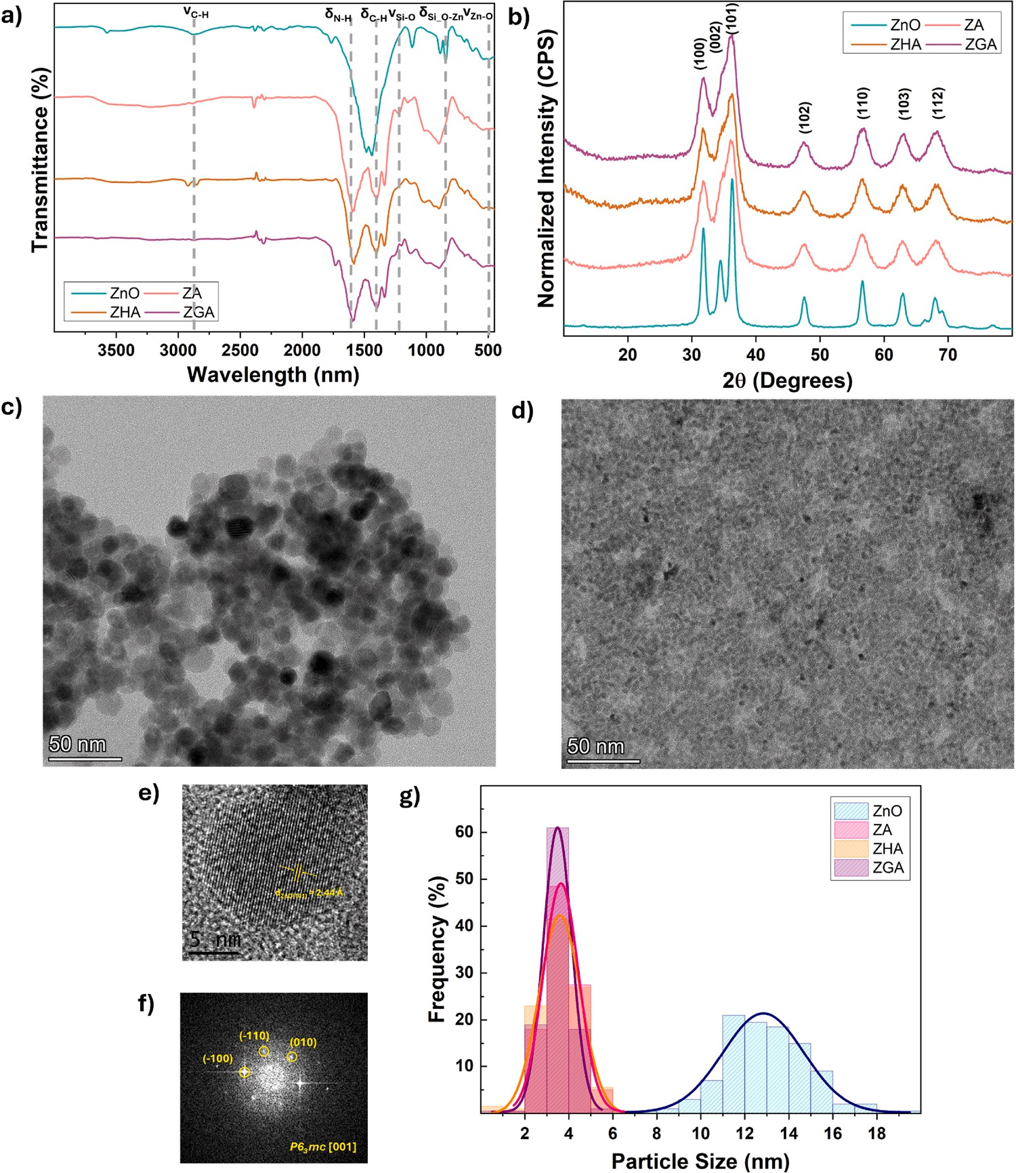

Fig. 1. Characterization of naked and silanized QDs including (a) their FTIR spectra, (b) their XRD patterns, (c) sample TEM images of ZnO QDs and (d) ZA QDs, (e) sample HRTEM images of ZnO QDs and (f) its corresponding SAED pattern, and (g) a histogram for the different particle size distributions.

kept in the cabinet with temperature ranging between 25–30 ◦C and relative humidity ranging from 50–60 %. The photoluminescence spectra were acquired periodically to monitor changes in intensity.

  - Weathering test

To assess the durability of the promising ink against weathering, the substrates with inks were subjected to three cycles of 8-hour exposure to intensive conditions in the Atlas Suntest XXL+ chamber (50 W/m² of
300–400 nm xenon lamps, 30 ◦C temperature, 55 % relative humidity).

Results and discussion

  - Chemical structure of ZnO QDs

Naked and silanized ZnO QDs were characterized through several spectroscopic techniques. Based on the FTIR spectra (Fig. 1a), the characteristic band at 498 cm⁻¹ for Zn-O stretching confirms the for-mation of ZnO. In addition, there are sharp bands at 2920 cm⁻¹ for C–H stretching, at 1400 cm⁻¹ for C–H bending, and at 1586 cm⁻¹ for C–O stretching attributed to partially reacted acetate groups [22]. After modification, the spectra remain similar with some distinctions attrib-uted to the new functional groups. For mono-silanized ZA, there are bands at 1185 cm⁻¹ for Si-O stretching and at 880 cm⁻¹ for Si-O-Zn

bending. The band at 1586 cm⁻¹ appears broader due to the contribu-tion of N–H bending [18]. For bi-silanized ZHA, in addition to these, there are slightly stronger bands between 2800 and 3000 cm⁻¹ for C–H symmetric stretching [23,33]. For bi-silanized ZGA, there are weak bands at 1730 cm⁻¹ for C–O stretching. There should be a band around
1602 cm⁻¹ for the C–C stretching in the epoxide ring but it is difficult to distinguish as it overlaps with the band for N–H bending [34].
Meanwhile, the XRD patterns (Fig. 1b) all show characteristic peaks corresponding to (100), (002), (101), (102), (110), (103) and (112) planes. These demonstrate that the QDs form a hexagonal wurtzite structure and belong to the P63mcs space group. The approximate crystallite sizes are 12.15 nm for ZnO, 4.48 nm for ZA, 4.47 nm for ZHA, and 4.39 nm for ZGA. The general peak broadening and decrease in crystallite size after modification suggests that the introduction of a short alkyl chain and amine group reduces interparticle distance and aggregation. The silanes act as a growth-modulating agent, altering re-action kinetics and limiting Ostwald ripening [32–34]. These results are in accordance with TEM (Fig. 1c, 1d and S1) and HRTEM (Fig. 1e and 1f) images showing spherical QDs with 2.8 Å lattice fringes corresponding to the interference from (002) planes. The particle sizes range between
6.45–19.30 nm for ZnO, 1.65–6.67 nm for ZA, 1.83–6.26 nm for ZHA,
and 1.98–5.37 nm for ZGA. The silanized QDs are generally smaller and have much narrower distribution (Fig. 1g).

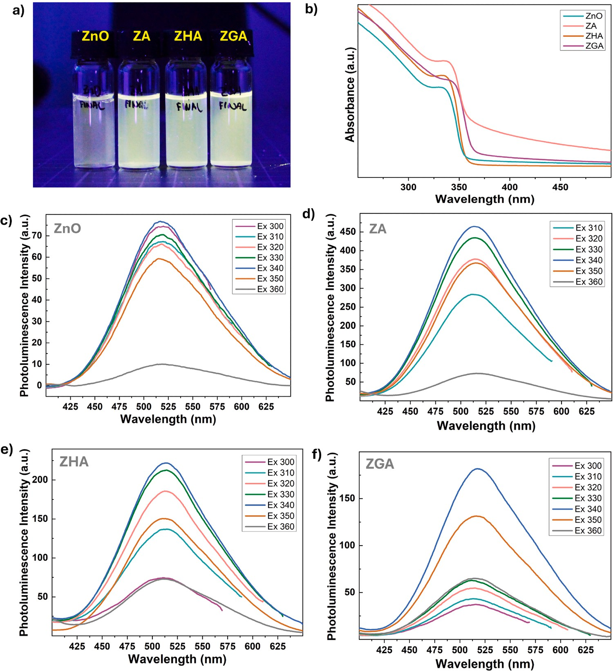

Fig. 2. (a) Photos of QDs dispersions in water under UV light, as well as the (b) UV–Vis spectra and (c-f) emission spectra of 0.01 wt. % QDs dispersion in water at different excitation wavelengths.

  - Optical properties of ZnO QDs

The relative quantum yields were calculated to be 4.71 % for ZnO,
12.19 % for ZA, 7.89 % for ZHA, and 7.04 % for ZGA using λex = 365 nm. While it is difficult to fully elucidate the mechanism, the improve-ment in the relative quantum yield can be related to the recombination
dynamics of the QDs. Modifying ZnO possibly mitigates exciton anni-hilation by donating electrons through inductive and resonance effects [60,61].
Photos of the QDs dispersed in water are shown above (Fig. 2a). Based on their UV–Vis spectra (Fig. 2b), modification increases the en-ergy absorbed by the QDs without significant changes in the absorbance wavelength range. Based on the photoluminescence spectra (Fig. 2c–2f), all QDs have visible emission from 400–650 nm with a maximum in-
tensity at λ_{em} ≈ 520 nm. Silanized QDs have fluorescence intensities at
least twice of naked QDs, with ZA generally exhibiting the highest. These results can be attributed to the enhanced dispersibility of the silanized QDs and, consequently, their limited aggregation-induced fluorescence quenching in water.
It is important to check the fluorescence stability of the QDs in aqueous media. Regarding changes in pH (Fig. 3a), fluorescence quenching occurs below pH 5 but fluorescence intensity increases above pH 5 for all QDs. Maximum fluorescence intensities were recorded at pH
8. However, some precipitation has been observed after several days at alkaline conditions, so all dispersions were kept in a neutral pH moving forward. Regarding temperature variation (Fig. 3b), the fluorescence intensities were retained above 90 % for all QDs submerged in baths
from 5 ◦C to 80 ◦C. Notably, the trend suggests warmer environments
have more impact than cooler environments. Regarding UV light exposure (Fig. 3c), the difference between naked and silanized QDs become apparent. Fluorescence intensity drops below 65 % for naked QDs within six hours of continuous irradiance. Meanwhile, the fluo-rescence intensities were retained above 90 % for silanized QDs. Based on these results, it is clear that modification improves the stability of fluorescence intensity in water with ZA being the most stable among them.
Having considered these, ZA was selected as the fluorescent agent for the security inks. A crucial point of interest though is whether the tuneable emission of ZnO can be translated to ZA such that multi-colored tags can be made in the future. Changing the concentration of the
precipitating agent and, consequently, the pH of the reaction medium proved to be effective (Figure S2) [23,33]. Based on the photo-luminescence spectra (Fig. 4a-b), there is a slight hypso-chromic shift in the maximum λ_{ex} and λ_{em} for ZA relative to ZnO but not enough to produce visual distinction between the solutions. Hence, the various visible emissions are preserved after modification with APTES. Their appearances vary slightly from one substrate to another but have a high enough fluorescence intensity to contrast against different backgrounds (Fig. 4d-g).
Based on DLS measurements (Fig. 4c), an important consequence of modifying the QDs is the reduction of aggregation. For ZnO, aggregates of green-emitting QDs have a larger effective diameter in water than its yellow- and orange-emitting counterparts. As QDs decrease in size, a major fraction of atoms resides on the surface, resulting in higher surface energy. This drives the green-emitting nanoparticles to aggregate more in order to minimize the total surface area and reduce the system’s en-ergy [22–24]. Fluorescence quenching of ZnO due to aggregation and sedimentation can be observed within a few hours.
In contrast, for functionalized particles (i.e. ZA) the effective di-ameters of the aggregates is consistently lower. This means that modi-fication greatly stabilizes the QDs through the hydrogen bonding formation between their amine terminals and water, reducing their tendency to aggregate.

  - Formulation of inks with cellulose ethers

Having chosen the fluorescent compound, the next step was the se-lection of an appropriate binder. Starting from a concentration of 3.0 wt.
% (upper limit in common conservation practices), the cellulose ether solutions were diluted and applied on substrates until ΔE_{ab}* was <3 and
%G was greater than 90 % (Table 1) to ensure imperceptible changes [62–66]. Preliminary experiments showed that the cellulose ethers should be restricted to concentrations of 1.0 wt. % for HPC and 0.5 % for HEC and MHEC to ensure invisibility. These binders also have to be combined with a minimum concentration of 3.0 wt. % ZA QDs to ensure readability.
Based on the FTIR spectra (Fig. 5a), the interactions between the ZA QDs and cellulose seem limited to electrostatic interactions. There is not much distinction in the spectra of cellulose ethers with or without QDs, only a superimposition of bands (Figure S3) . There are bands around

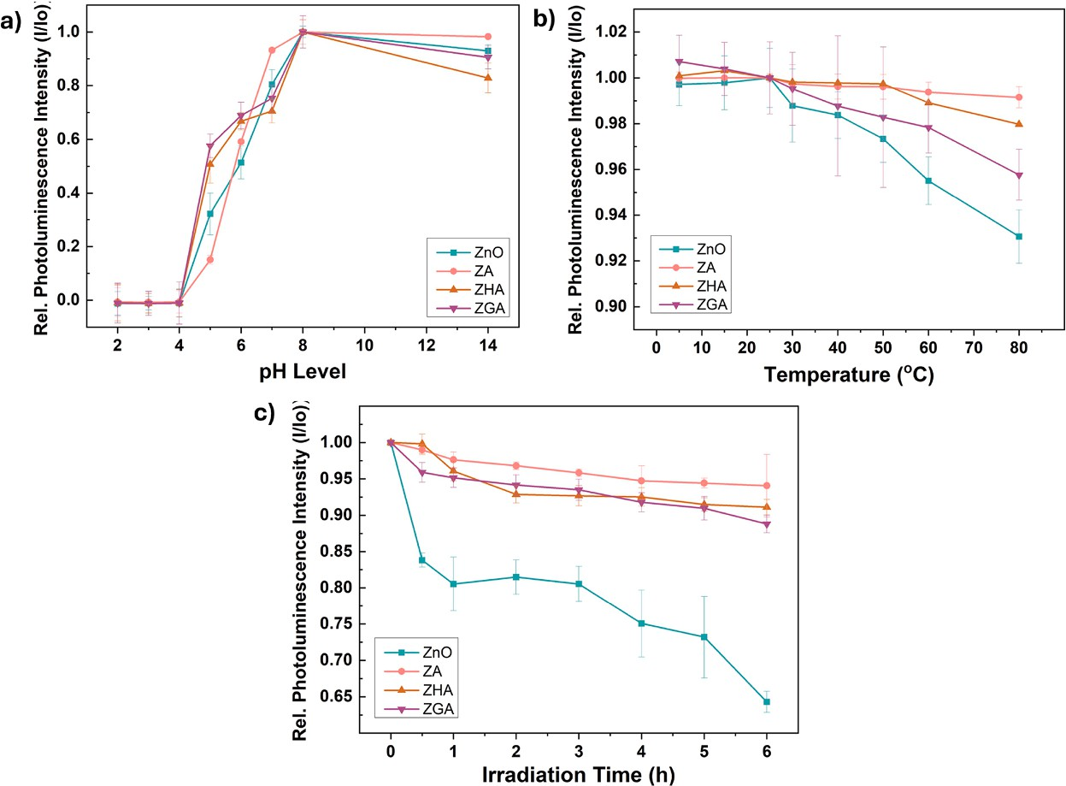

Fig. 3. Relative change in fluorescence intensity of 0.1 wt. % QDs dispersions in water with respect to (a) pH levels (b) cooling or heating temperature for three hours, and (c) 365-nm UV light irradiation time.

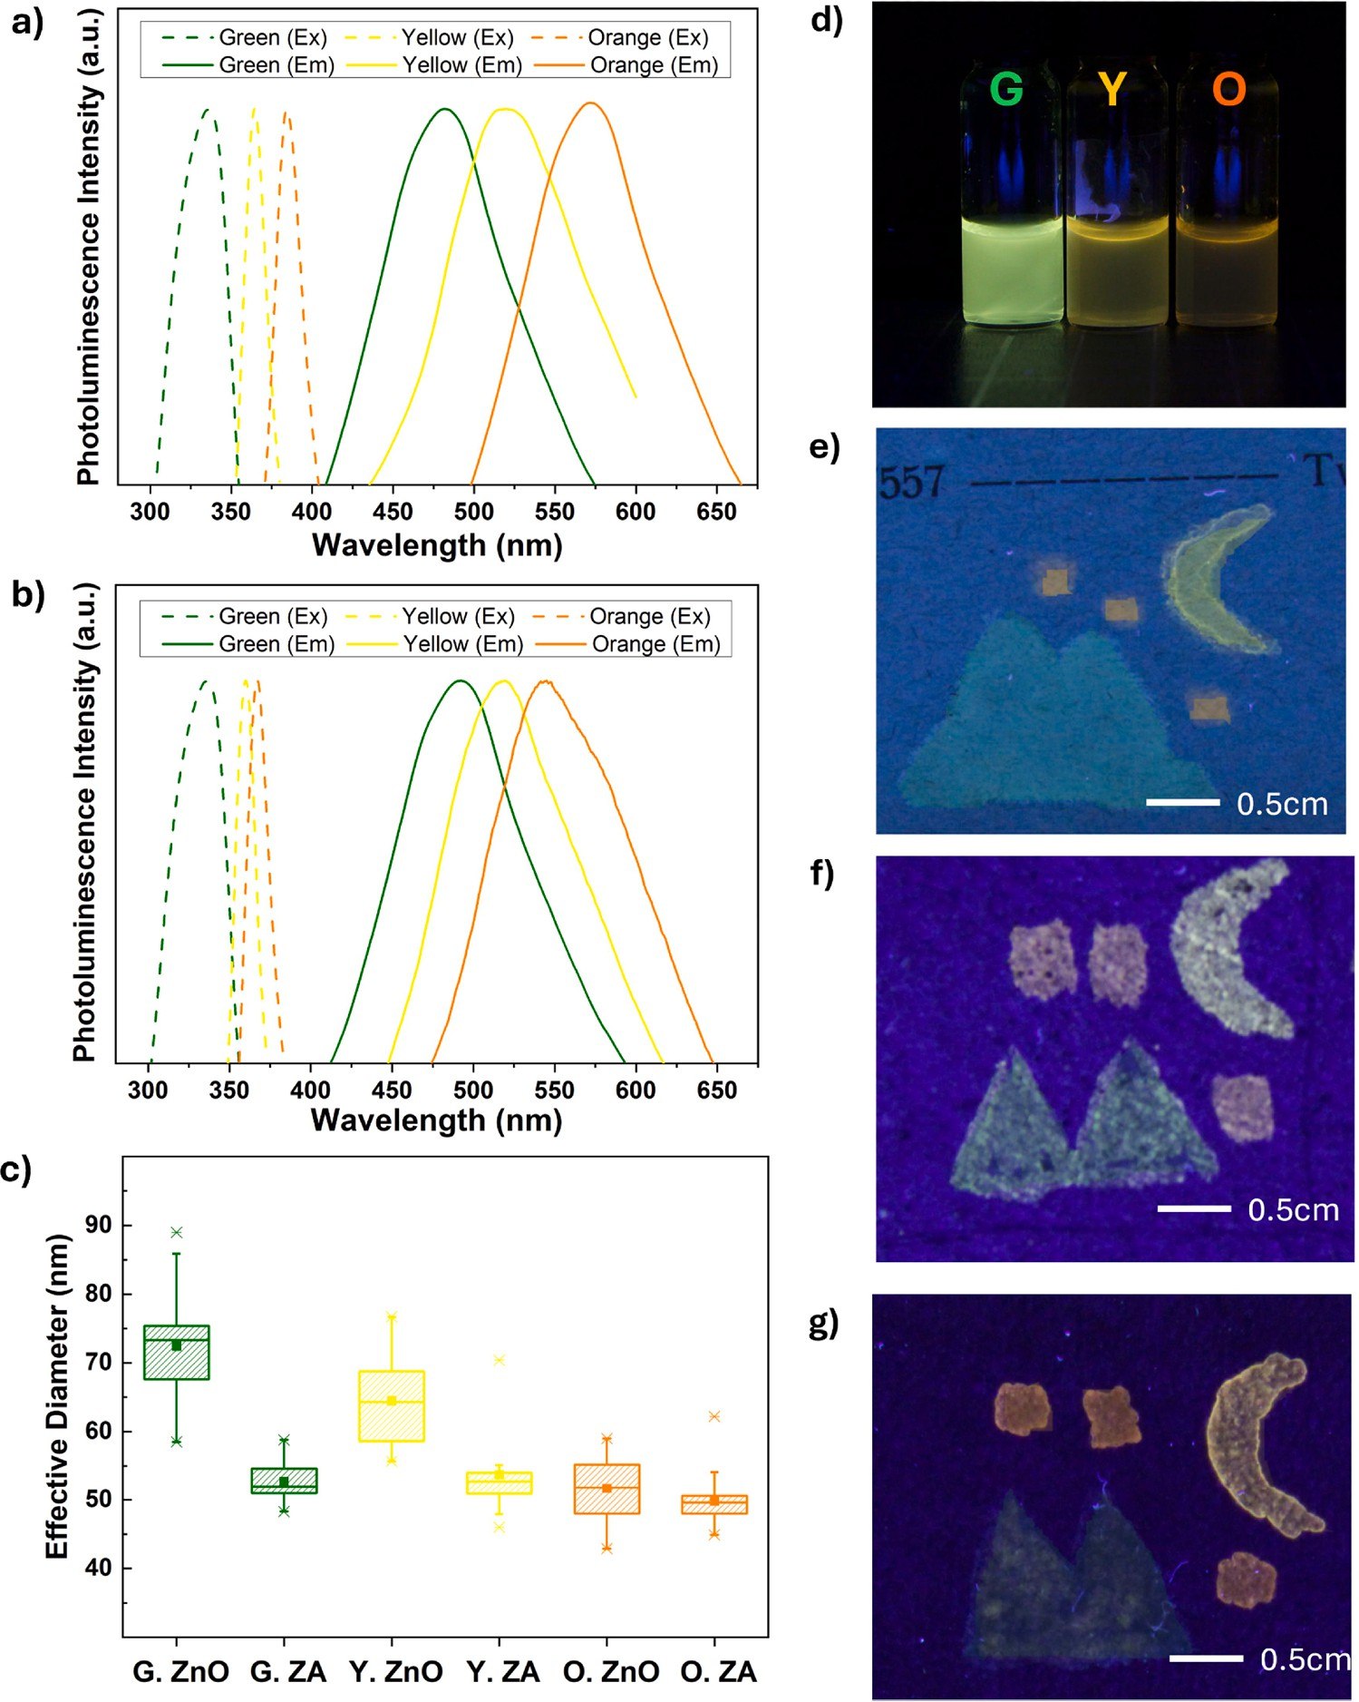

Fig. 4. Excitation and emission spectra of 0.01 wt. % (a) ZnO and (b) ZA QDs dispersions in water. (c) DLS measurements of QDs dispersions in water show dif-ferences in their effective diameter. (d-g) Photos of the green-, yellow-, and orange-emitting ZA dispersions and their test applications on paper, stone, and ceramic through brushing.

Table 1  Colorimetric | and | glossmetric | results | for inks | applied | on three | different
substrates.
Binder |  | Paper |  | Stone |  | Ceramic
 |  | ΔE_{ab}* | %G | ΔE_{ab}* | %G | ΔE_{ab}* | %GU
NONE |  | 0.30 | 98.89 | 0.11 | 97.65 | 0.46 | 95.62
HPC (1.0 wt. | %) | 0.97 | 96.27 | 0.26 | 95.38 | 0.23 | 93.66
HEC (0.5 wt. | %) | 0.75 | 94.15 | 0.47 | 97.59 | 0.56 | 91.04
MHEC (0.5 wt. %) 0.62 |  |  | 92.72 | 0.24 | 96.57 | 0.40 | 92.53

3300 cm⁻¹ for O–H stretching, 2878 cm⁻¹ for C–H stretching, 1050 cm⁻¹ for C–O antisymmetric stretching, at 1020 cm⁻¹ for C–O-C stretching of glucopyranose units, and at 873 cm⁻¹ for β-(1,4) glycosidic linkage [53]. Despite this, the nature of their substituents likely influences their chemical interactions with silanized QDs to some extent. Their sub-stituents alter the physicochemical properties of the cellulose backbone
(e.g. solubility, hydrogen bonding capacity, and polymer chain confor-mation). The presence of propoxy substituents (-CH₂CH(OH)CH₃) in HPC introduces steric hindrance and can reduce the availability of hy-droxyl groups for hydrogen bonding with the amine group of the QDs. In contrast, HEC has ethoxy substituents (-CH₂CH₂OH) which greatly in-creases polarity. It therefore has better solubility in water and can have better affinity with the silanized QDs. MHEC is less polar, having one ethoxy and one methyl substituent. Its hydroxyethyl groups allow the macromolecular chains to easily form strong intermolecular interactions with the amine group of the QDs. While its methyl group imparts some hydrophobicity, its benefit is an increase in surface activity and an improved ability to adhere on surfaces [54,67,68]. Based on the pho-toluminescence spectra (Fig. 5b - 5d), there is also no shift in the emission range upon incorporation of binders. Interestingly, the inks can be excited up to 380 nm albeit obtaining lower fluorescence intensities. It is evident from the applications that the inclusion of cellulose ethers alters the appearance of the ink under 365-nm UV light (Fig. 6). Rather than having a concentration gradient of QDs from border to

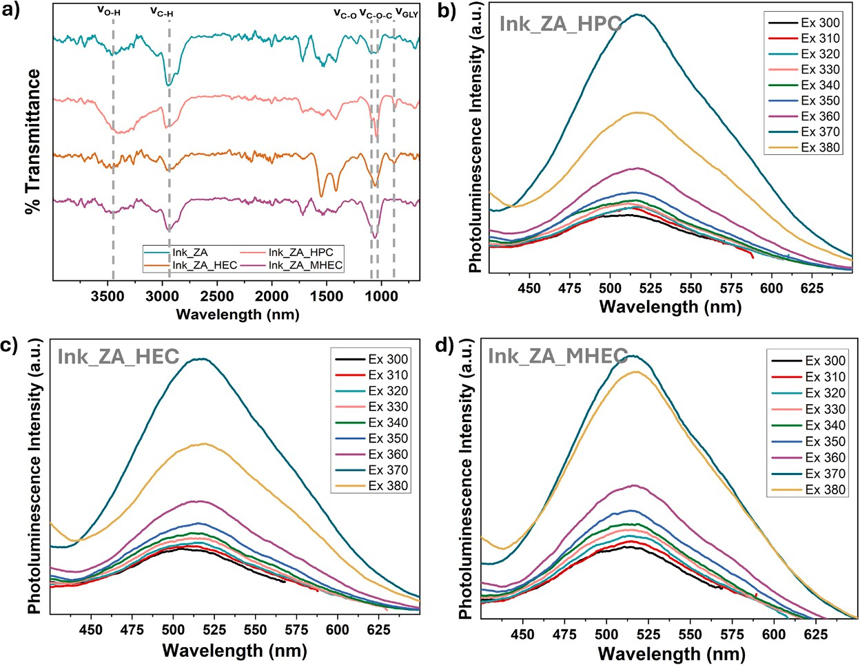

Fig. 5. (a) FTIR spectra of the aqueous inks containing 3.0 wt. % ZA QDs and different cellulose ethers and their corresponding (b-d) emission spectra at different excitation wavelengths.
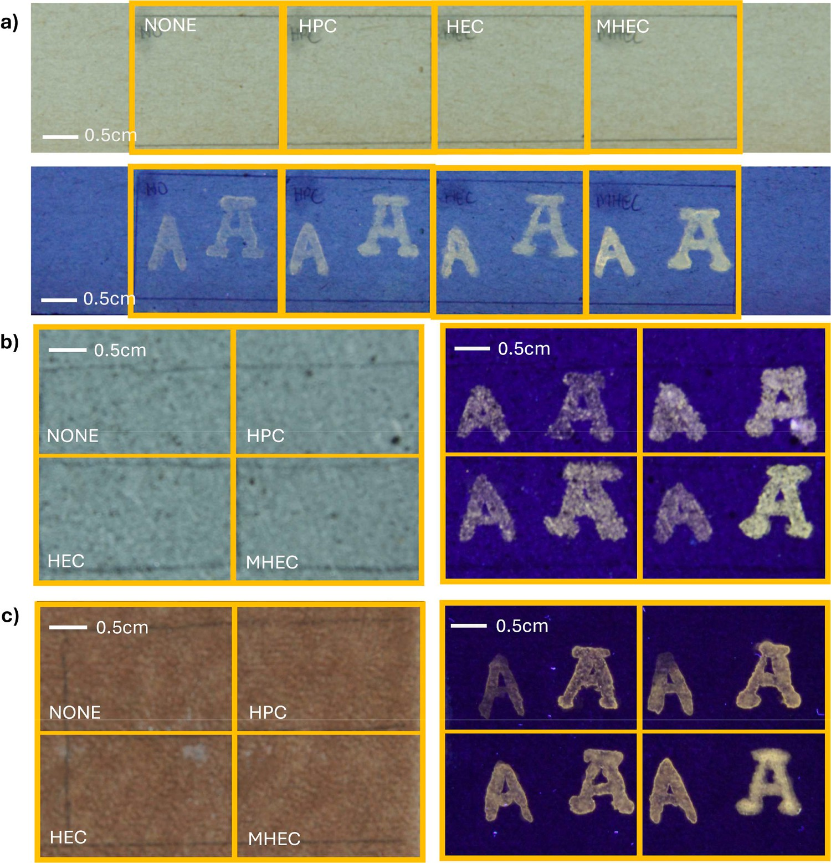

Fig. 6. Sample photos of brushed and stamped "A" on (a) 20th-century paper, (b) Arenaria stone, and (c) glazed ceramic under D65 and 365-nm UV light, using inks containing ZA QDs and cellulose ethers.

centre, the polymer matrix helps stabilize the nanoparticles sterically and reduce migration as the solvent evaporates. Having MHEC as a binder consistently reduced feathering and enhanced brightness. It is important to note though, that the extent of improvement varies ac-cording to the application technique and the substrate. Brushing can sometimes result in ink pooling due to the greater volume of ink deposited, unlike stamping which allows a more even distribution. Meanwhile, tags appear more homogeneous in smoother and less porous substrates because the ink forms a film on the surface and scatters light to a much lesser extent. These differences can be levelled with an in-crease in ink viscosity, i.e., a thicker immovable layer on the surface, but the improvement in readability compromises invisibility.
In terms of workability, the incorporation of cellulose ethers helped facilitate the tagging process. For pen-writing, blotting and skipping were no longer observed. For brushing, there were minimal issues in pooling and more precise strokes could be made. There was significant improvement in stamping since there was less bubble formation on the rubber stamp, instead a definite shape could be transferred. Notably, better surface wetting was achieved with the introduction of MHEC. As mentioned, this particular cellulose ether is classified only as moderately hydrophilic due to its methyl substituent, which allows it to lower sur-face tension, though not as strongly as surfactant-like molecules [68]. In addition to these, the cellulose ethers generally reduced drying period from 15 mins to <5 min regardless of application technique and substrate.
Having chosen MHEC as the most suitable binder, tests were again conducted to assess the effects of the cellulose ethers in the fluorescence stability of the ink. Regarding storage (Fig. 7a), both inks retained above 92 % of their fluorescence intensity within three months. However, for the ink with MHEC, storing in a cabinet is preferred over a cooler refrigerator. This is expected as most polymers change their three-dimensional structure and reduce their solubility at cooler tempera-tures. Regarding temperature variation (Fig. 7b), both inks retain above
98 % of their fluorescence intensity even after being submerged in baths at 80 ◦C. Regarding UV light exposure, both inks retain above 94 % of their fluorescence intensity within six hours of irradiance. The ink with
MHEC performs slightly better, possibly because the polymers can shield the QDs and reduce the intensity of light they receive.
  - Durability against weathering

The aqueous ink with ZA as fluorescent compound and MHEC as binder was applied on several substrates commonly found in cultural heritage objects (Fig. 8). Tags of various forms were invisible under D65 light, except for glazed ceramic where a slight white cast was observed. The tags were readable under 365-nm UV light. Interestingly, there are perceivable differences in emission colour in historic and modern paper probably due to the optical interferences of additives used in their manufacturing.
After the weathering test, the tags remained invisible under D65 light except for paper and glazed ceramic. The tags also remained readable under 365-nm UV light. The inconsistencies require a more in-depth investigation, though currently it seems to be due to the shielding behaviour of QDs rather than their degradation. Recall that for the areas covered with ink, the QDs are able to absorb the energy that otherwise the substrate would have absorbed. The papers and glazed ceramic themselves had a very different appearance after exposure to intensive conditions, suggesting that some of their components also underwent deterioration. Hence, the contrast under D65 and 365-nm light is most apparent in the boundary between the surfaces with ink and the surfaces without ink.

Conclusion

Naked and silanized ZnO QDs were prepared using a sol-gel method. ZnO modified with APTES was selected as the fluorescent compound for the ink due to its solubility in water, its better fluorescence stability in water against temperature variation and UV light exposure, and its tuneable emission. This opens the possibility of creating optically stable tags with more complexity and a higher level of security in the future. Among cellulose ethers used in the conservation, the addition of MHEC as binder reduces feathering and enhances the brightness across sub-strates of different surface morphologies and porosities. It also does not compromise the fluorescence stability of the QDs in water in terms of long-term storage, temperature variation, and UV light exposure. The ink applied to paper, stone, and glazed ceramic were mostly invisible and readable before and after weathering, though some variability in the results merit further studies. The components of the cultural heritage objects and their degradation mechanisms will affect the long-term

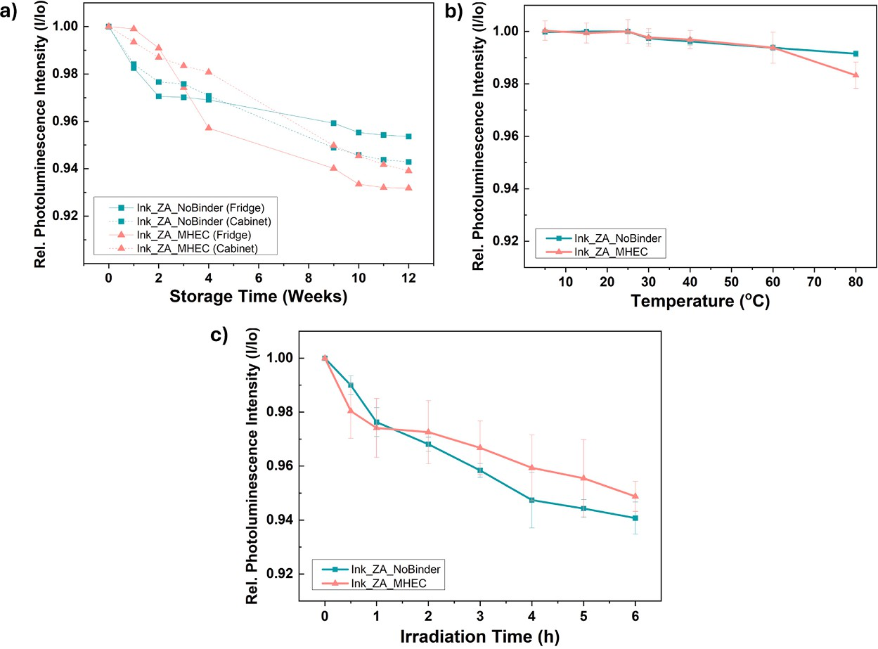

Fig. 7. Change in fluorescence intensity of inks with and without MHEC binder at (a) different storage conditions, (b) cooling or heating temperatures for three hours, and (c) 365-nm UV light irradiation times.

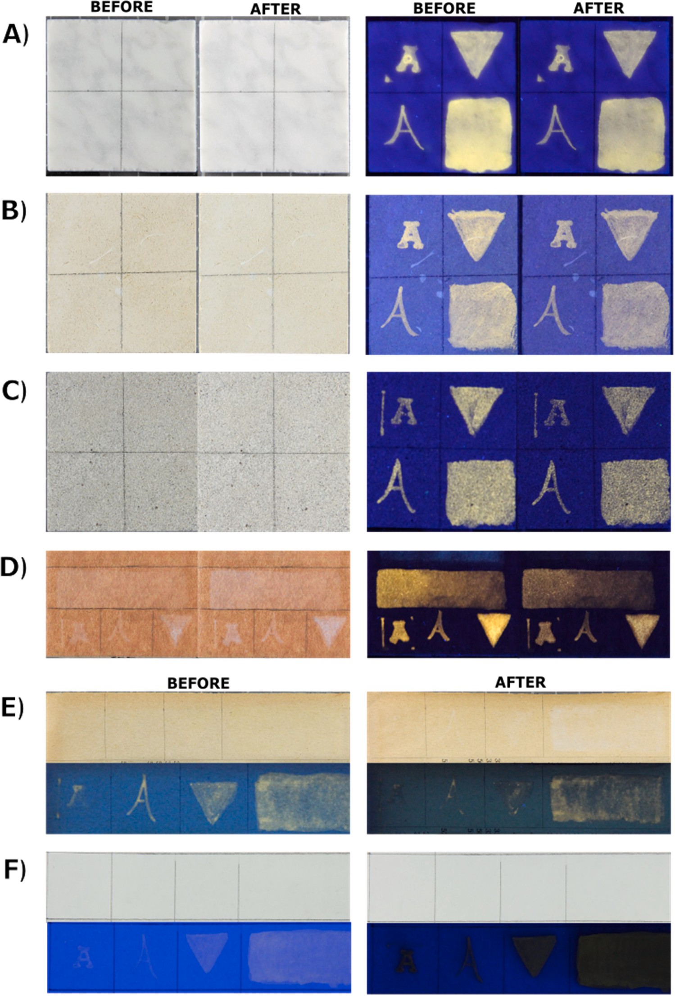

Fig. 8. Sample photos of ink applications under D65 and 365-nm UV light before and after weathering tests on (a) Carrara marble, (b) Lecce stone, (c) Arenaria stone,
(d) glazed ceramic, (e) 20th-century book paper, and (f) modern drawing paper.

performance of the security inks.

Funding source

This work was done under the project "Artwork Unique RecognitiOn and tRacking through chemicAl encoded data, miniaturized devices and blockchain alliance (AURORA)" and supported by Grant agreement no 101,094,245 under the HORIZON–CL2–2022-HERITAGE-01–07 topic
from the European Research Executive Agency.

CRediT authorship contribution statement

Andrea Louise Matulac: Writing – original draft, Methodology, Investigation, Formal analysis, Conceptualization. Themis Krasoudaki: Investigation, Formal analysis. Francesca Battaglia: Investigation. Carlo Spadoni: Investigation. Martina Piletti: Investigation. Daniela Iacopino: Writing – review & editing, Formal analysis. Rodorico Giorgi: Writing – review & editing, Supervision, Methodology, Formal analysis, Conceptualization.

Declaration of competing interest

The authors declare that they have no known competing financial interests or personal relationships that could have appeared to influence the work reported in this paper.

Acknowledgment

The authors also acknowledge Dr. Antonio Mirabile for his valuable discussions.

Supplementary materials

Supplementary material associated with this article can be found, in the online version, at doi:10.1016/j.apmt.2025.102718.

Data availability

Data will be made available on request.

References

- R. Sloggett, Art crime: fraud and forensics, Austr. J. Forensic Sci. 47 (2015) 253–259, https://doi.org/10.1080/00450618.2014.957348.
- S. Fleming, Art forgery: some scientific defenses, Proc. of the Am. Philos.Soc. 130 (1986) 175–195.
- L. Casertano, Combating the illicit trafficking of cultural property: the multifaceted response to a complex challenge, Glob. Jurist 20 (2020) 20190025, https://doi. org/10.1515/gj-2019-0025.
- B. Yoon, J. Lee, I.S. Park, S. Jeon, J. Lee, J.M. Kim, Recent functional material based approaches to prevent and detect counterfeiting, J. Mater. Chem. C 1 (2013) 2388–2403, https://doi.org/10.1039/C3TC00818E.
- T. Bozhkova, I. Spiridonov, K. Shterev, Overview of security printing types and trends in its future development, Bulg. Chem. Commun. 49 (2017) 195–201.
- A. Kaminska, Don’t copy that: security printing and the making of high-tech paper, Convergence 25 (2019) 590–606, https://doi.org/10.1177/1354856519845748.
- S.J. Simske, J.S. Aronoff, M.M. Sturgill, G. Golodetz, Security printing deterrents: a comparison of thermal ink jet, dry electrophotographic, and liquid electrophotographic printing, J. Imaging Sci. Technol. 52 (2008) 050.
- H. Mardani, E. Bayrak, S. O¨ zçelik, M. Babazadeh-Mamaqani, M.U. Kahveci,
H. Roghani-Mamaqani, M. Salami-Kalajahi, Anti-counterfeiting ink based on polymer nanoparticles containing spiropyran and Aza-BODIPY for artificial industries, React. Funct. Polym. 187 (2023) 105593, https://doi.org/10.1021/ acsapm.2c01251.
- H. Mardani, H. Roghani-Mamaqani, S. Shahi, D. Roustanavi, Anti-counterfeiting inks based on fo¨rster resonance energy transfer in microcrystalline cellulose-grafted poly (Amidoamine) for artificial industries, ACS Appl. Polym. Mater. 5 (2023) 1092–1102, https://doi.org/10.1016/j.reactfunctpolym.2023.105593.
- S.V. Atulbhai, R.K. Singhal, H. Basu, S.K. Kailasa, Perspectives of different colour-emissive nanomaterials in fluorescent ink, LEDs, cell imaging, and sensing of various analytes, Luminescence 38 (2023) 867–895, https://doi.org/10.1002/ bio.4272.
- K. Muthamma, D. Sunil, P. Shetty, Luminophoric organic molecules for anticounterfeit printing ink applications: an up-to-date review, Mater. Today Chem. 18 (2020) 100361, https://doi.org/10.1016/j.mtchem.2020.100361.
- A.P. Demchenko, Photobleaching of organic fluorophores: quantitative characterization, mechanisms, protection, Methods Appl. Fluoresc. 8 (2020) 022001, https://doi.org/10.1088/2050-6120/ab7365.
- P. Kumar, S. Singh, B.K. Gupta, Future prospects of luminescent nanomaterial based security inks: from synthesis to anti-counterfeiting applications, Nanoscale 8 (2016) 14297–14340, https://doi.org/10.1039/C5NR06965C.
- A. Abdollahi, H. Roghani-Mamaqani, B. Razavi, M. Salami-Kalajahi, Photoluminescent and chromic nanomaterials for anticounterfeiting technologies: recent advances and future challenges, ACS Nano 14 (2020) 14417–14492, https://doi.org/10.1021/acsnano.0c07289.
- K. Muthamma, D. Sunil, P. Shetty, Carbon dots as emerging luminophores in security inks for anti-counterfeit applications-An up-to-date review, Appl. Mater. Today 23 (2021) 101050, https://doi.org/10.1016/j.apmt.2021.101050.
- X. Fu, G. Li, S. Cai, H. Yang, K. Lin, M. He, X. Liu, Color-switchable hybrid dots/ hydroxyethyl cellulose ink for anti-counterfeiting applications, Carbohydr. Polym. 251 (2021) 117084, https://doi.org/10.1016/j.carbpol.2020.117084.
- A. Apostoluk, Y. Zhu, P. Gautier, A. Valette, J.M. Bluet, T. Cornier, S. Daniele, Improved visible emission from ZnO nanoparticles synthesized via the Co-precipitation method, Materials (Basel) 16 (2023) 5400, https://doi.org/10.3390/ ma16155400.
- X. Chen, Q. Wang, X.J. Wang, J. Li, G.B. Xu, Synthesis and performance of ZnO quantum dots water-based fluorescent ink for anti-counterfeiting applications, Scientific Rep 11 (2021) 5841, https://doi.org/10.1038/s41598-021-85468-z.
- D. Bera, L. Qian, T.K. Tseng, P.H. Holloway, P. H. Quantum dots and their multimodal applications: a review, Materials (Basel) 3 (2010) 2260–2345, https:// doi.org/10.3390/ma3042260.
- S. Kargozar, S.J. Hoseini, P.B. Milan, S. Hooshmand, H.W. Kim, M. Mozafari, Quantum dots: a review from concept to clinic, Biotechnol. J. 15 (2020) 2000117, https://doi.org/10.1002/biot.202000117.
- A. Kołodziejczak-Radzimska, T. Jesionowski, Zinc oxide—From synthesis to application: a review, Materials (Basel) 7 (2014) 2833–2881, https://doi.org/ 10.3390/ma7042833.
- X. Zhang, S. Luo, X. Wu, Y.Li M/Feng, H. Han, W. Li, Effect of alkali bases on the synthesis of ZnO quantum dots, Open Chem 19 (2021) 377–384, https://doi.org/ 10.1515/chem-2021-0027.
- X. Tang, E.S.G. Choo, L. Li, J. Ding, J. Xue, Synthesis of ZnO nanoparticles with tunable emission colors and their cell labeling applications, Chem. Mater. 22 (2010) 3383–3388, https://doi.org/10.1021/cm903869r.
- M. Jay Chithra, M. Sathya, K.J.A.M.S. Pushpanathan, Effect of pH on crystal size and photoluminescence property of ZnO nanoparticles prepared by chemical precipitation method, Acta Metallurgica Sinica (Engl. Lett.) 28 (2015) 394–404, https://doi.org/10.1007/s40195-015-0218-8.
- E. Moyen, J.H. Kim, J. Kim, J. Jang, ZnO nanoparticles for quantum-dot-based light-emitting diodes, ACS Appl. Nano Mater. 3 (2020) 5203–5211, https://doi. org/10.1021/acsanm.0c00639.
- G.H. Carey, A.L. Abdelhady, Z. Ning, S.M. Thon, O.M. Bakr, E.H. Sargent, Colloidal quantum dot solar cells, Chemi. Rev. 115 (2015) 12732–12763, https://doi.org/ 10.1021/acs.chemrev.5b00063.
- P.S. Hale, L.M. Maddox, J.G. Shapter, N.H. Voelcker, M.J. Ford, E.R. Waclawik, Growth kinetics and modeling of ZnO nanoparticles, J. Chem. Educ. 82 (2005) 775, https://doi.org/10.1021/ed082p775.
- I. Ayoub, V. Kumar, R. Abolhassani, R. Sehgal, V. Sharma, R. Sehgal, Y.K. Mishra, Advances in ZnO: manipulation of defects for enhancing their technological potentials, Nanotechnol. Rev. 11 (2022) 575–619, https://doi.org/10.1515/ntrev-
2022-0035.
- V. Gurylev, T.P. Perng, Defect engineering of ZnO: review on oxygen and zinc vacancies, J. Eur. Ceram. Society 41 (2021) 4977–4996, https://doi.org/10.1016/ j.jeurceramsoc.2021.03.031.
- D. Vasudevan, R.R. Gaddam, A. Trinchi, I. Cole, Core–shell quantum dots: properties and applications, J. Alloys Compd. 636 (2015) 395–404, https://doi. org/10.1016/j.jallcom.2015.02.102.
- F. Grasset, N. Saito, D. Li, D. Park, I. Sakaguchi, N. Ohashi, E. Duguet, Surface modification of zinc oxide nanoparticles by aminopropyltriethoxysilane, J. Alloys Compd. 360 (2003) 298–311, https://doi.org/10.1016/S0925-8388(03)00371-2.
- U. Ngoensawat, A. Parnsubsakul, S. Kaitphaiboonwet, T. Wutikhun,
C. Sapcharoenkun, P. Pienpinijtham, S. Ekgasit, Luminescent nanohybrid of ZnO quantum dot and cellulose nanocrystal as anti-counterfeiting ink, Carbohydr. Polym. 262 (2021) 117864, https://doi.org/10.1016/j.carbpol.2021.117864.
- S. Li, Z. Sun, R. Li, M. Dong, L. Zhang, W. Qi, H. Wang, ZnO nanocomposites modified by hydrophobic and hydrophilic silanes with dramatically enhanced tunable fluorescence and aqueous ultrastability toward biological imaging applications, Scientific rep 5 (2015) 8475, https://doi.org/10.1038/srep08475.
- H.Q. Shi, W.N. Li, L.W. Sun, Y. Liu, H.M. Xiao, S.Y. Fu, Synthesis of silane surface modified ZnO quantum dots with ultrastable, strong and tunable luminescence, Chem. Comm. 47 (2011) 11921–11923, https://doi.org/10.1039/C1CC15411G.
- A.K. Aliyana, P. Ganguly, A. Beniwal, S.N. Kumar, R. Dahiya, Disposable pH sensor on paper using screen-printed graphene-carbon ink modified zinc oxide nanoparticles, IEEE Sens. J. 22 (2022) 21049–21056, https://doi.org/10.1109/ JSEN.2022.3206212.
- H. Dong, W. Liu, Y. Li, X. Chen, D. Wang, Fully Printed Flexible Zinc Oxide Patch for Wearable UV Light Sensing, Adv. Elec. Mater. 9 (2023) 2300469, https://doi. org/10.1002/aelm.202300469.
- G. Hassan, J. Bae, C.H. Lee, A. Hassan, Wide range and stable ink-jet printed humidity sensor based on graphene and zinc oxide nanocomposite, J. Mater. Sci: Mater. Elec. 29 (2018) 5806–5813, https://doi.org/10.1007/s10854-018-8552-z.
- J.J. Schneider, R.C. Hoffmann, J. Engstler, O. Soffke, W. Jaegermann, A. Issanin,
A. Klyszcz, A printed and flexible field-effect transistor device with nanoscale zinc oxide as active semiconductor material, Adv. Mater. 20 (2008) 3383–3387, https://doi.org/10.1002/adma.200800819.
- J. Figueira, C. Gaspar, J.T. Carvalho, J. Loureiro, E. Fortunato, R. Martins,
L. Pereira, Sustainable fully printed UV sensors on cork using zinc oxide/ ethylcellulose inks, Micromachines (Basel) 10 (2019) 601, https://doi.org/ 10.3390/mi10090601.
- S. Sharma, S.S. Pande, P. Swaminathan, Top-down synthesis of zinc oxide based inks for inkjet printing, RSC Adv. 7 (2017) 39411–39419, https://doi.org/ 10.1039/C7RA07150G.
- K.S. Suganthi, K. Harish, N.M. Nair, P. Swaminathan, Formulation and optimization of a zinc oxide nanoparticle ink for printed electronics applications, Flex. Print. Elec. 3 (2018) 015001, https://doi.org/10.1088/2058-8585/aaa166.
- N.T. Phuong, Synthesis of ZnO nanoparticles-based fluorescent ink for information encryption and security applications, Opt. Mater. 157 (2024) 116296, https://doi. org/10.1016/j.optmat.2024.116296.
- S. Liufu, H. Xiao, Y. Li, Investigation of PEG adsorption on the surface of zinc oxide nanoparticles, Powder Technol. 145 (2004) 20–24, https://doi.org/10.1016/j. powtec.2004.05.007.
- J. Pulit-Prociak, K. Pszczo´łka, J. Chwastowski, P. Staron´, A. Staron´, E. Sikora,
M. Banach, Preparation of PVA-based composites with the addition of zinc oxide nanoparticles, J. Inorg. Org. Polym. Mater. 29 (2019) 390–401, https://doi.org/ 10.1007/s10904-018-1009-2.

- A.B. Siddique, V.P. Singh, A.K. Pramanick, M. Ray, Amorphous carbon dot and chitosan based composites as fluorescent inks and luminescent films, Mater. Chem. Phys. 249 (2020) 122984, https://doi.org/10.1016/j.matchemphys.2020.122984.
- S. Roy, D. Biswas, J.W. Rhim, Gelatin/cellulose nanofiber-based functional nanocomposite film incorporated with zinc oxide nanoparticles, J. Composites Sci. 6 (2022) 223, https://doi.org/10.3390/jcs6080223.
- A. Abu Krorra, W. Noshy, A. Oun, M. Abu Elleif, Evaluation of hydroxypropyl cellulose, zinc oxide nanoparticles and nanocellulose for tracing papers consolidation, Adv. Res. Conservation Sci. 2 (2021) 21–30, https://doi.org/ 10.21608/arcs.2021.65487.1012.
- B.S.M. Mazen, B.M. Ismail, R.R. Ali Hassan, M. Ali, W.S. Mohamed, Use of carboxymethyl cellulose, Klucel G, gum Arabic and zinc oxide nanoparticles nanocomposite as strength agents for inked papyrus, Pigment Resin Technol 54 (2014) 224–239, https://doi.org/10.1108/PRT-12-2023-0123.
- E. Salim, Influence of ethocel polymer (EC) loaded with inorganic nanoparticles (ZnO-NPs) on the chemical and physical properties of wooden paper, Egypt. J. Archaeol. Restor. Stud. 14 (2024) 11–18, https://doi.org/10.21608/ ejars.2024.361164.
- A. Koochakzaei, Z. Ghane, M.M. Achachluei, Zinc oxide nanoparticles in leather conservation: exploring the potential of hydroxypropyl cellulose/zinc oxide nanocomposite as a leather consolidation agent, Heritage 6 (2023) 7547–7558, https://doi.org/10.3390/heritage6120396.
- S.W. Zhao, C.R. Guo, Y.Z. Hu, Y.R. Guo, Q.J. Pan, The preparation and antibacterial activity of cellulose/ZnO composite: a review, Open Chem 16 (2018) 9–20, https://doi.org/10.1515/chem-2018-0006.
- Y. Xie, Y. Pan, P. Cai, Cellulose-based antimicrobial films incorporated with ZnO nanopillars on surface as biodegradable and antimicrobial packaging, Food Chem. 368 (2022) 130784, https://doi.org/10.1016/j.foodchem.2021.130784.
- A.H. Tayeb, E. Amini, S. Ghasemi, M. Tajvidi, Cellulose nanomaterials—Binding properties and applications: a review, Molecules 23 (2018) 2684, https://doi.org/ 10.3390/molecules23102684.
- R.L. Feller, M.H. Wilt, Evaluation of Cellulose Ethers for Conservation, Getty Publications, CA, 1991.
- N. El-Hadidi, M.F. Mohamed, Cellulose-based materials for the consolidation of archaeological wooden artifacts, Adv. Res. Conservation Sci. 5 (2024) 42–63, https://doi.org/10.21608/arcs.2024.271433.1047.
- M. Bonet, C. Quijada, S. Mun˜oz, F. Cases, The roles of the degree of substitution
and the degree of polymerization on the behaviour of cellulose ethers applied as adhesives for artwork conservation, J. Adhesion Sci. Technol. 19 (2005) 95–108, https://doi.org/10.1163/1568561053148458.
- P. Ropret, R. Zoubek, A.S. Sˇkapin, P. Bukovec, Effects of ageing on different binders for retouching and on some binder–pigment combinations used for restoration of wall paintings, Mater. Charact. 58 (2007) 1148–1159, https://doi.org/10.1016/j. matchar.2007.04.027.
- S.P. Li, S.A. Martellucci, R.D. Bruce, A.C. Kinyon, M.B. Hay, J.D. Higgins III, Evaluation of the film-coating properties of a hydroxyethyl cellulose/ hydroxypropyl methylcellulose polymer system, Drug Dev. Industrial Pharm. 28 (2002) 389–401, https://doi.org/10.1081/DDC-120003000.
- T. Jurczykov´a, E. Kmeťova´, F. Kaˇcík, M. Lexa, D. Dˇediˇc, Evaluating the
effectiveness of cellulose-based surfactants in expandable graphite wood coatings, Polymers (Basel) 16 (2024) 2832, https://doi.org/10.3390/polym16192832.
- A. Van Dijken, E.A. Meulenkamp, D. Vanmaekelbergh, A. Meijerink, The kinetics of the radiative and nonradiative processes in nanocrystalline ZnO particles upon photoexcitation, J. Phys. Chem. B 104 (2000) 1715–1723, https://doi.org/ 10.1021/jp993327z.
- R. Crapanzano, I. Villa, S. Mostoni, B.Di Credico M/D’Arienzo, M. Fasoli, A. Vedda, Morphology related defectiveness in ZnO luminescence: from bulk to nano-size, Nanomaterials 10 (2020) 1983, https://doi.org/10.3390/nano10101983.
- Y. Ohno, CIE fundamentals for color measurements, Soc. Imaging Sci. Technol. 16 (2000) 540–545, https://doi.org/10.2352/ISSN.2169-4451.2000.16.1.art00033_2.
- H. Xu, Y. Yaguchi, S. Shioiri, Testing CIELAB-based color-difference formulae using large color differences, Opt. Rev. 8 (2001) 487–494, https://doi.org/10.1007/ BF02931740.
- F.B. Leloup, G. Obein, M.R. Pointer, P. Hanselaer, Toward the soft metrology of surface gloss: a review, Color Res. Appl. 39 (2014) 559–570, https://doi.org/ 10.1002/col.21846.
- E. Scrinzi, S. Rossi, P. Kamarchik, F. Deflorian, Evaluation of durability of nano-silica containing clear coats for automotive applications, Prog. Org. Coat. 71 (2011) 384–390, https://doi.org/10.1016/j.porgcoat.2011.04.009.
- G.F. Molina, R.J. Cabral, I. Mazzola, M. Burrow, Surface gloss, gloss retention, and color stability of 2 nano-filled universal resin composites, Restor. Dent. Endod. 47 (2022) 4, https://doi.org/10.5395/rde.2022.47.e43.
- T. Heinze, O.A. El-Seoud, A. Koschella, Cellulose derivatives: synthesis, structure, and Properties, Springer, Cham, 2018, https://doi.org/10.1007/978-3-319-73168-1.
- B. Persson, S. Nilsson, R. Bergman, Dynamic surface tension of dilute aqueous solutions of nonionic cellulose derivatives in relation to other macromolecular characterization parameters, J. Colloid Interface Sci. 218 (1999) 433–441, https:// doi.org/10.1006/jcis.1999.6449.

