Supplementary A: IRGC Risk Governance Framework

The IRGC Framework informs and guides holistic approach to risk governance, with consideration for interconnected and systemic risks (IRGC, 2017). Importantly, it recognises the centrality of multidisciplinary and multi-stakeholder approach to risk management, with normative principles that promote transparency, effectiveness, efficiency, accountability, strategic focus, sustainability, equity and fairness, law, and the feasibility of the proposed interventions in their political, legal and ethical dimensions (ibid). Inclusive and open communication are placed at its core, to ensure that stakeholders make informed choices about risks, and that they remain able to balance evidence alongside their own interests, concerns, and resources (figure 9). As such, societal context is also emphasized, in consideration of the needs of those involved.

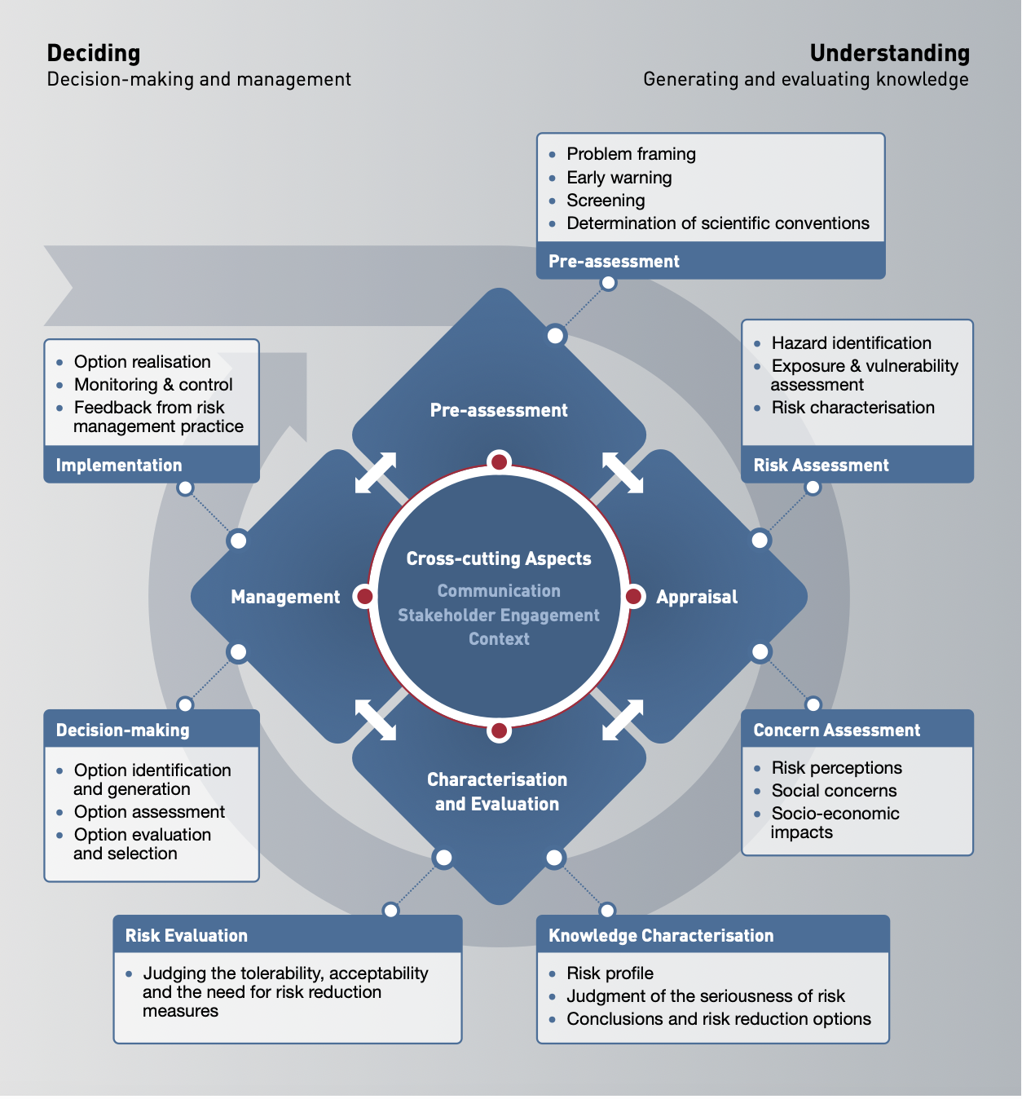
Figure 9. The IRGC Risk Governance framework (IRGC, 2017).

Figure 9. outlines the IRGC approach to early identification and handling of risks, comprising four interlinked elements and their cross-cutting aspects. Based on IRGC’s guidance (2017) these include:

Pre-assessment, clarifying questions and perspectives on risks, aids in defining the issues, and forms baselines on their management. Some of the questions include:

- What are the risks and opportunities to be addressed?
- Who are stakeholders relevant to framing and managing the problem?
- What are the socio-political or environmental dimensions of risk?
- How are the boundaries of the evaluation defined?
- What are the current legal and regulatory systems, and how do they affect the problem?
- What are the organisational capabilities of relevant actors involved?

Appraisal, developing and synthesising knowledge regarding risk, and what are the options for preventing, mitigating, adapting to, or sharing it (or, whether or not it should be taken at all). This stage goes beyond conventional risk assessments, comprising both risk assessments and concern assessments. The latter refers to stakeholders’ opinions, perceptions and priorities associated with the risk and its perceived consequences. Potential questions for risk assessment include:

- What are the potential damages or adverse effects associated with the risk?
- What are the processes that create risk (or control it)?
- What accident scenarios can occur (probability, severity, etc)?
- Can the risk be quantified, and how reliable are probability estimates?
Questions for concern assessments may include:

- What are the stakeholders’ opinions, values and concerns about the risk?
- Are there biases that affect risk perception?
- What is the social response to the risk? How would people react?
- Are there constraints affecting the actors’ ability to manage risk?
- What role do existing institutions and governance structures play?

Characterisation and evaluation aim at comparing the outcome of risk appraisal with specific criterion, in efforts to determine the acceptability of the risk, and to design interventions. For this purpose, The questions of complexity, uncertainty, and ambiguity are highlighted, in efforts to inform evaluation by stakeholders. Evaluation, however, should be also informed by probabilities, in efforts to help evaluation in the dimensions of acceptability, tolerability and intolerability. Other ey considerations for evaluation include:

- Ethical issues that must be considered
- Societal values and norms that affect tolerability and acceptability
- Commitment of stakeholders to want certain outcomes from risk governance processes
- What are the constraints?
- What is the political or strategic appreciation of the societal, environmental or economic benefits?
Management focuses on the tolerable risks that should be met with adequate risk reduction and management measures. The process involves design and implementation of actions to reduce (prevent, adapt, mitigate), transfer, or retain risks. Key questions include:

- Who are the actors and stakeholders that should be engaged in risk management processes? What are their responsibilities in decision making?
- What management options should be chosen? How are they evaluated and prioritised?
- What are the likely impacts and benefits of risk-reduction options?
- What are the potential trade-offs?
- Is there appropriate support for international/regional cooperation and harmonisation for global systemic risk dynamics?
- What measures are needed to ensure effectiveness of proposed solutions?

Cross-cutting aspects apply to all phases of the framework, adding three that are critical for the success of any risk governance process. These include communication, stakeholder engagement, and the social context. Questions for developing communications include:

- Is there a facilitator in charge of the communication process?
- How can it be organised among stakeholders within organisations?
- How can it be facilitated across multiple disciplines and stakeholders?
- How can communication support two-way sharing information?
- Does communication take risk perception into account?
- What is the role of the media?

To assess how and when engage different stakeholders, and emphasises that both those affected and those managing risk should be involved (incorporating a wide range of perspectives). For this purpose, the framework provides a “stakeholder engagement escalator” (figure 10). 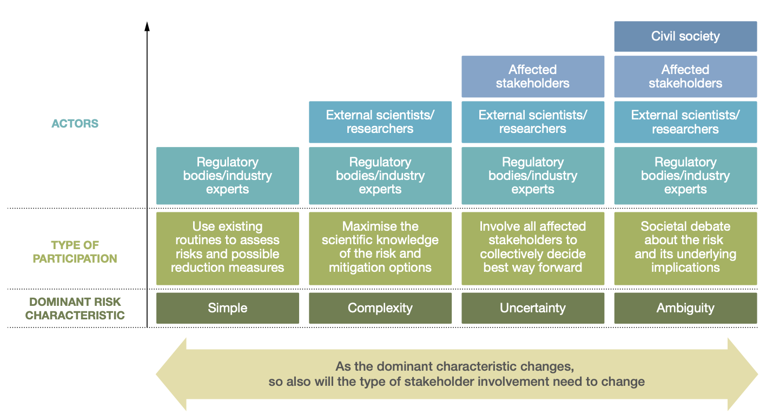
Figure 10. Stakeholder engagement escalator (IRGC, 2017).

Context provides guidance for incorporating elements of the social, institutional, political and economic contexts that affect risk governance processes. Given that they frame risk-related decision-making, and affect the capability of key actors to fulfil their roles and mandate, these elements are central when assessing risks and options for their management (figure 11). 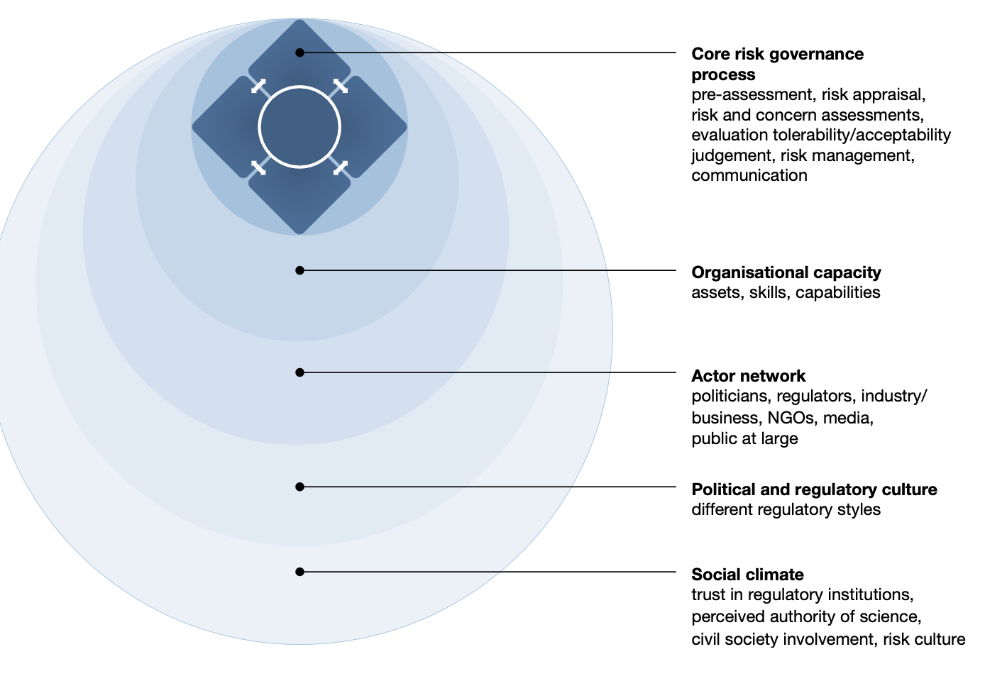
Figure 11. Risk governance in context (IRGC, 2017).

Supplementary B: SHIELD Model

Developed under the ESPREssO (Enhancing Synergies for Disaster Prevention in the European Union) project, the SHIELD model proposes a guideline for enhancing risk management capabilities (Lauta, et al., 2018). Its primary focus is to integrate climate change adaptation and disaster risk reduction, integrate science and legal issues to enhance capabilities, and to improve national regulations to prepare for transboundary crises. It revolves around the four phases of disaster management (figure 2). Following Lauta, et al., (2018) its components can be summarised as follows (full list of guiding questions not included here):

- Sharing knowledge seeks to key issues affecting communication between DRR and CCA actors, and during the phases of DRM. Guiding questions were developed to respond to is challenges of 1) knowledge transfer between sectors and institutions; 2) Information overload and lack of synergies between existing platforms; 3) Limited data and information access due to issues such as licensing and the value of data; 4) Knowledge siloes that prevents effective communication. Based on these, it provides suggestions for:

- Mapping and engaging relevant actors, who should give and receive knowledge and information about DRR and CCA
- Bridging knowledge gaps between science and policy
- Building diverse networks for knowledge sharing
- Providing incentives for knowledge sharing
- Balancing national and local scales to support flows of information.

- Harmonizing capacities. This step seeks to identify and harmonize capacities between actors working within risk governance, in efforts to support collaboration between sectors, disciplines, and levels of governance. Primary identified issues informing suggestions include 1) Lack of skilled employees at different government levels; 2) Changing landscape of risks, vulnerabilities and hazards; 3) Transboundary events, and; 4) Lack of continuity. Suggestions to harmonize capacities include:

- The mapping of existing capacities that already exist, and can be strengthened
- Assess and balance capacities to advance the management of risks from a shared starting point
- Match capacities to risk issues
- Evaluate and learn from the process, and to improve operations where possible.
- Creating partnerships to relieve strain on individual stakeholders and organisations (between public and private sector, for instance).

- Institutionalising coordination. This stage seeks to advance coordination between sectors and disciplines toward integrated risk management, and throughout the phases of the DRM cycle. Highlighted challenges include: 1) Professional and legal mandates that limit the ability of actors to coordinate response, recovery and risk reduction or climate change adaptation; 2) limited coordination between levels of governance, and disconnect in between; 3) Limited coordination of tasks between DRR and CCA; and 4) Limited coordination between EU member states. As a recommendation, SHIELD proposes:

- Clarifying mandates for coordination through a comprehensive stock take
- Acknowledging the need for balance and flexibility, sometimes through informal relationships
- Practicing and exercising roles, including training for emergency response
- Setting up forums for coordination
- Aligning and streamlining priorities among stakeholders
- Building partnerships for transboundary crisis management

- Engaging stakeholders seeks to inform multi-stakeholder engagement, in recognition of the limitations of “traditional” command-and-control approaches. Identified priorities that require addressing include: 1) Lack of clarity regarding relevant stakeholders across levels (who should be involved?); 2) Lack of common understandings regarding risk issues, and competing terminologies; 3) Competing interests that limit the possibility of building shared priorities; 4) Lack of sustained engagement, and; 5) Barriers affecting stakeholder engagement. Suggestions include:

- Clarifying the role of stakeholders, including their motivations and interests
- Creating incentives for stakeholder participation
- Creating online platforms for multi-stakeholder engagement
- Locating mediators and experiment with roles
- Utilizing local stakeholder knowledge for DRR action
- Ensuring sustained commitment

- Leveraging investments is highlighted due to the centrality of funding for response and planning of DRR and CCA. SHIELD identifies key issues that require solutions; 1) Lack of clarity regarding the ownership of risk, and who should pay for its management; 2) Short-term political commitment; 3) Narrow focus on funding for preparedness and response; 4) Damaging investments. Responding to these, the model suggests:

- Increasing the visibility of DRR investments
- Connecting politicians and affected communities
- Innovating existing disaster risk financing structures
- Creating partnerships for DRR investments with the private sector
- Making long-term political agreements
- Identifying overlaps for CCA and DRR

- Developing communication seeks to guide risk management in the information age, in efforts to improve how knowledge is transferred and communicated between actors (and the public). Identified issues include: 1) Lack of risk awareness among the public; 2) Lack of media expertise in public entities; 3) Priorities of the media industry; 4) Social media and big data trends. Suggestions highlighted are:

- Creating multi-media platforms for risk awareness
- Cooperating with media partners
- Strengthening and streamlining early warning platforms
- Innovating risk awareness campaigns
- Bringing risk management into classrooms

Supplementary C: Risk Layering

As previously indicated, the risk-layer approach was initially developed within insurance applications (Hochrainer-Stigler and Reiter 2021). Already here one can implicitly distinguish between frequent and infrequent events as the primary insurer usually focuses on smaller losses which occur with higher frequencies and transfers more infrequent events with larger corresponding losses to reinsurers. Losses from rare but catastrophic (very extreme) events cannot be managed through insurance and assistance is needed, e.g., the government steps in as an insurer of last resort. Not only risk financing but also risk reduction can be included in such risk-layering approaches with the assumption that risk reduction may be especially useful for tackling frequent risks (Linnerooth-Bayer and Hochrainer-Stigler 2015). The risk layer approach was expanded to include different types of risk management options, especially risk reduction, risk financing and assistance for different layers of risk (Mechler et al. 2014), figure 12.
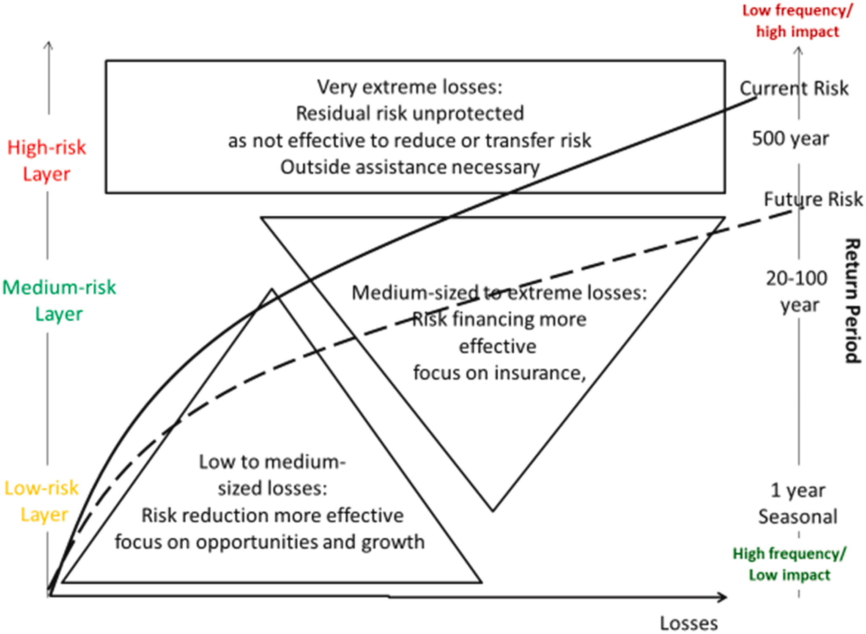
Figure 12. Layered disaster risk management (Hochrainer-Stigler et al., 2021).

For each of these risk layers, different risk metrics may be used to represent such kind of events. For example, for frequent events one may use average losses while for infrequent events one may use Expected Shortfall or Tail measures. Sometimes these events cannot be quantified but are seen by the risk bearer to belong to a given category, both in terms of events/risks as well as instruments to reduce them. Due to the inclusion of assessment and management aspects within risk-layering it can be applied to all the IRGC Risk Governance Framework’s steps within the Risk-Tandem Framework and can be related not only to quantitative dimensions (models and data across scales) but also to governance processes and policies (as shown and related to the other circles). It especially also should show possible frictions as well as overlaps and gaps across different stakeholders in the complex system under study. In that regard, the question of how an event cannot be coped with, either due to the lack of risk management measures or due to insufficiency of the resources to cope with, may have effects on other risks of different stakeholders that may be exposed and can be identified therefore as well.

Supplementary D: Tandem framework

The Tandem framework seeks to inform the co-design of climate services (Daniels, et al., 2020), providing practical questions and guidance for enabling knowledge co-production in diverse contexts, based on learnings and good practice. It is intended to be tailored in its application contexts and remains non-prescriptive, in efforts to support local ownership (Bharwani, et al., 2024). Its most recent updates (Figure 4) has been informed by its application in case studies in Southeast Asia, Sweden, and Latin America, in efforts to support its applicability across geographic and socioeconomic contexts (ibid. ). In summary, steps and associated guiding questions inform:

Scoping, identifying and engaging stakeholders who are responsible for, or affected by the adaptation challenges/risks. Guiding questions associated with this step inform:

- Scoping of risks, challenges and the decision context, including initial scope and relevant challenges (that may not be climate focused)
- Identifying relevant actors and champions (to nurture collaborations and partnerships)
- Engaging relevant actors and champions

Co-explore, phase which advances deeper cross-sectoral and transdisciplinary examination of climate challenges and related socio-economic issues. This process is also likely to reveal context-led indicators for monitoring progress toward shared ambitions for resilience. It is sub-divided into three thematic areas:

- Co-exploring vulnerability and adaptation challenges, including from the perspective of those affected
- Co-exploring governance landscape and issues that affect (or enable) the design of solutions (such as climate services)
- Co-exploration of information needs and knowledge domains across stakeholders (including specific climate data and information required by users, and the capacity building interventions need to interpret and apply them).

Co-produce seeks to inform the process of building shared solutions upon the results of co-exploration, with a focus on creating a consensus regarding priorities, and a sense of ownership among stakeholders for long-term sustainability. This stage informs:

- Co-exploration and identification of solutions based on the identified challenges and issues.
- The co-design of solutions, including considerations and guidance for the process.
- Appraising solutions, to assess related uncertainty, maladaptation potential, synergies, trade-offs as well as co-benefits.

Integrating new knowledge and partners aims to distil lessons learned from the MEL process, and solidify relationships between stakeholders. This step also provides guidance evaluating progress toward goals, and includes considerations for reflexive learning that can sustain the process beyond projects’ timelines.

Cross- cutting elements include guidance for integrating MEL throughout the co-production process (including feedback mechanisms), tailored communication of information (in consideration of differing understandings and terminology), capacity development and partnerships (on-going by-products of the co-production process), and financing (to support the operationalizing and institutionalising proposed solutions and climate services.

