Supplementary Material for
Thickness Control of Dispersion in Opal Photonic Crystals
Alex Grant¹, Alex Lonergan¹, and Colm O’Dwyer^{1,2}*

¹School of Chemistry, and Environmental Research Institute, and Tyndall National Institute,
University College Cork, Cork, T12 YN60, Ireland
²Advanced Materials and BioEngineering Research Centre, Trinity College Dublin, Dublin 2, Ireland

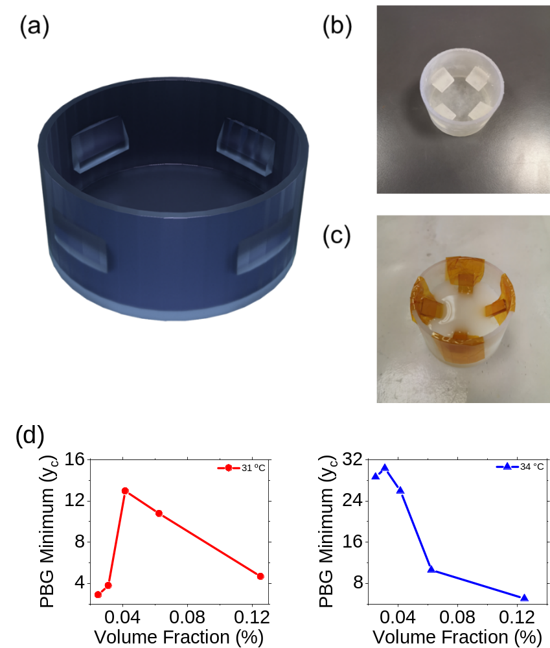
Figure S1. SLA 3D printed beaker designed with substrate rests at an angle of 30° to the vertical used for opal growth by EISA. (a) 3D rendered image of beaker. (b) Photograph of beaker. (c) Photograph depicting FTO substrates immersed in PS sphere solution inside beaker. (d) Intensity of central PBG frequency as a function of sphere solution volume fraction for opals grown using EISA at evaporation temperatures of 31 °C and 34 °C.

Fig. S1 shows the 3D printed polymer beakers that were formed from Formlabs Clear Photoreactive Resin using a Formlabs Form 2 stereolithography (SLA) printer. All beakers were cleaned using the same sonication process described above, followed by UV-ozone treatment for 1 h. The diameter of each beaker was 6cm and substrate rests were orientated at an angle of 30° to the beaker walls. Fig. S1 (d) show the relationship between volume fraction and the transmission intensity at the central PBG frequency at normal incidence for opals grown at evaporation temperatures of 31 °C and 34 °C, respectively. A general trend of decreasing PBG minimum occurs as a function of volume fraction for both temperatures. At 31 °C the outliers at low volume fraction significantly affect the trend. For 34 °C, the trend is similar to that observed for the slowest evaporation at 28 °C case.
Figure S2. Cross-sectional SEM images of opals as examples used for thickness measurements provided to establish relationship with volume fraction. Evaporation temperatures are 28 °C, 31 °C, 34 °C, increasing from columns 1-3. Sphere solution volume fractions: (a)-(c) 0.025%, (d)-(f) 0.0625% (g)-(i) 0.042%, (j)-(l) 0.031% , (m)-(o) 0.025%.

Fig. S2 shows sample SEM images which were used as contributions to calculations of the thickness measurements used as data points in Fig. 3 (a) of the main text. All opals were sputtered with Nickel with a total sputtering thickness of 20 nm prior to imaging to enhance resolution and reduce charging effects.
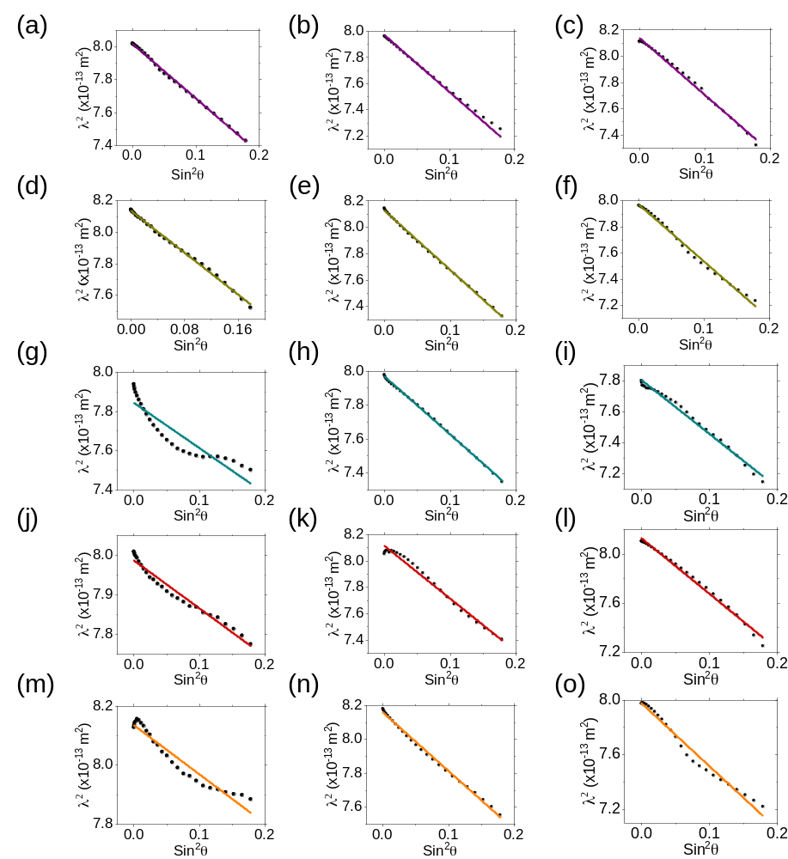
Figure S3. Bragg-Snell plots based on the central frequency of the primary transmission dip observed in the optical spectra of opals obtained in the incident angle range of 0-25 °. Evaporation temperatures are 28 °C, 31 °C, 34 °C, increasing from columns 1-3. Sphere solution volume fractions: (a)-(c) 0.125%, (d)-(f) 0.063% (g)-(i) 0.042%, (j)-(l) 0.031%, (m)-(o) 0.025%.

In Fig. S3, Bragg-Snell plots are provided under all investigated evaporation temperatures and volume fractions. Each data point in a Bragg-Snell plot is determined based on the square of the central wavelength of the PBG as a function of the square of the sine of the central wavelength of the PBG is defined as occurring at the minimum of the (111) transmission dip in the associated transmission spectrum. The incident angle is defined relative to the normal to the (111) plane of an fcc lattice. The incident angle range investigated was 0 – 25°. The extent to which each plot can be approximated by a linear fit indicates the dominance of the (111) fcc symmetry and can be used to determine the structural quality of each opal, quantified in this study using the adjusted R² value.

Temp (°C) | D_{meas} (nm) | D_{Eq. 3} (nm) | ΔD/D_{Meas} (%) | d_{Meas} (nm) | d_{Eq. 3} (nm) | Δd/d_{Meas} (%)
28 | 398.2 | 1046 | 162.68 | 487.69 | 457 | 6.29
31 | 400 | 439 | 9.75 | 489.9 | 486 | 0.8
34 | 405.2 | 451 | 11.3 | 496.27 | 493 | 0.66
Table S1. Comparison of experimentally measurements and calculations using Eq. 3 for opal sphere diameters and interplanar spacings at each evaporation rate.

Table S1 shows a comparison of the structural parameters of sphere diameter and interplanar spacing from experimental measurements and based on calculations using the geometric approach in Eq. 3. Calculated sphere diameter D_{Eq. 3} was obtained from the y-intercept of the linear fits applied to each dataset in Fig. 1 (b) of the main text. The calculated interplanar spacing was equated to the slope of each linear fit, where D_{Eq. 3} = $\sqrt{\frac{3}{2}}D$. Good agreement between data occurs at the higher two temperatures, while the lowest temperature shows a significant contrast in results.
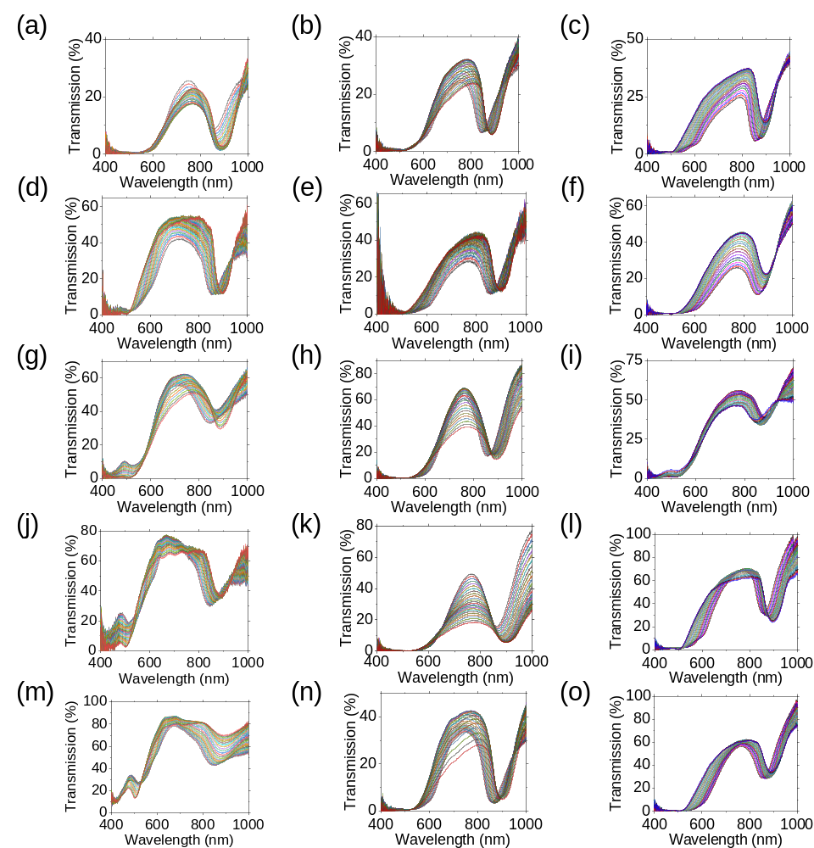
Figure S4. Transmission spectra of opals obtained in the incident angle range of 0 – 25° relative to the normal to the (111) plane of an fcc lattice. Evaporation temperatures are 28 °C, 31 °C, 34 °C, increasing from columns 1-3. Sphere solution volume fractions: (a)-(c) 0.125%, (d)-(f) 0.063% (g)-(i) 0.042%, (j)-(l) 0.031%, (m)-(o) 0.025%.

Transmission spectra for opals grown under all investigated volume fractions and evaporation rates in the incident angle range of 0 – 25° are shown in Fig. S2. In all cases, the primary stopband corresponding to the photonic band gap (PBG) is observed. The PBG is blue shifted as incident angle increases. Transmission level at the center of the PBG decreases with increasing volume fraction and hence thickness.
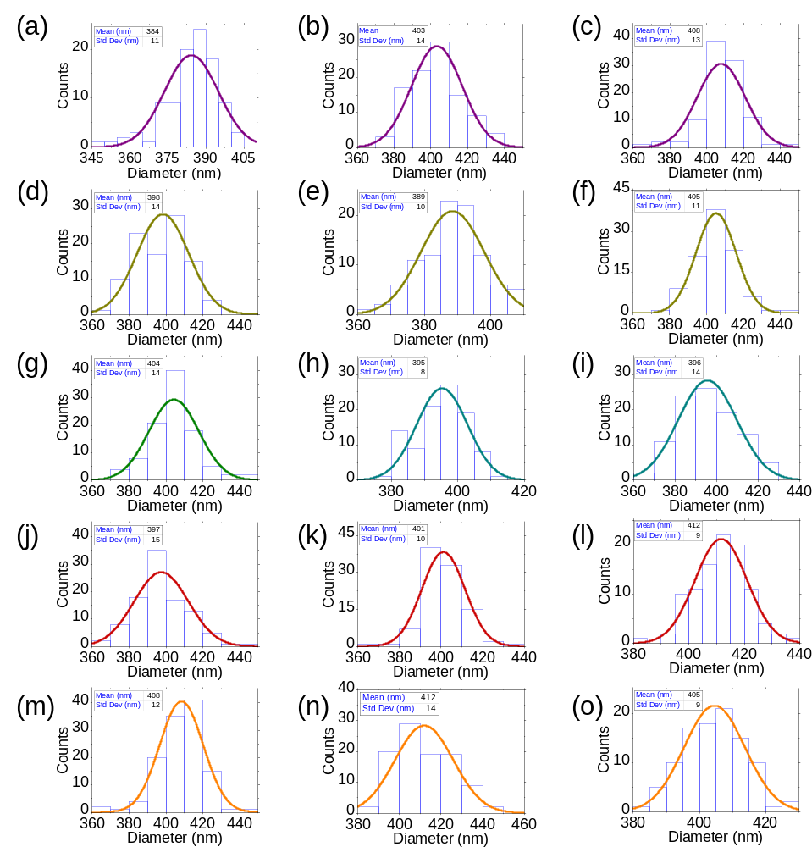
Figure S5. Size distributions for opals grown from sphere solutions with a nominal sphere diameter of 370 nm. Evaporation temperatures are 28 °C, 31 °C, 34 °C, increasing from columns 1-3. Sphere solution volume fractions: (a)-(c) 0.125%, (d)-(f) 0.063% (g)-(i) 0.042%, (j)-(l) 0.031%, (m)-(o) 0.025%.

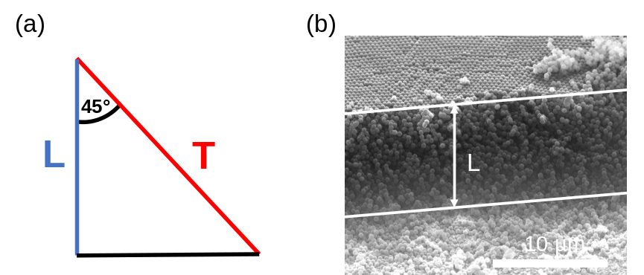
Figure S6. (a) Schematic of the determination of opal thickness. (b) Sample cross-sectional SEM image illustrating the method used to acquire thickness measurements.
Thickness measurements were obtained using cross-sectional SEM images. The mathematical method used to determine the actual thickness is shown in Fig. S6 (a), out detailed in the Experimental section of the main text. A sample image is shown as an example in Fig. S6 (b). The white lines depict where the line measurement L was determined.
Experimental detection of the PBG, along with any other stopbands which occur in a photonic crystal, can be performed across the full range of the electromagnetic spectrum. Photonic stopbands commonly refer to frequencies from the UV to IR range. However, the iridescent colours characteristic of photonic crystals can only be observed if the stopbands occur in the visible region of the spectrum which is 380 nm – 740 nm.¹ Analysis shows that there is little change in the position of the PBG for opals formed under each set of conditions which can be attributed to their ordered nature and the narrow size distributions. For opals grown here from sphere solutions with a nominal diameter of 370 nm, the PBG lies between 890 nm and 901 nm at normal incidence, corresponding to the near-IR region of the electromagnetic spectrum. A stopband in this range can make no contribution to the observed color in the visible range. Instead, the structural colour of the samples can be explained using Bragg-Snell theory for second order reflections.
While the FCC dominant stacking arrangement causing the (111) transmission dip which forms the PBG is evident throughout this work, secondary Bragg reflections can also be observed in transmission spectra acquired. A sharp increase in transmission can be observed at ~ 485 nm, following higher order transmission dips from the (220) planes. Here, the secondary transmission dips are fully formed only for the two lowest volume fractions with a central wavelength of ~ 500 nm. For the three higher volume fractions, the dips are suppressed. We evaluate the transmission dips for low volume fractions as the result of secondary Bragg reflections due to the most common form of disorder observed in opals, which are stacking faults. We evaluate the disappearance of the transmission dips at higher volume fractions to the attenuation of propagating light in this frequency range as a function of crystal thickness like that experienced by the primary Bragg reflection which constitutes the PBG.
Calculations in the main text have been performed only for reflected frequencies based on growth perpendicular to the (111) plane of an fcc lattice. Secondary Bragg reflections are a result of the interaction of propagating light with alternative lattice planes. Consequently, a correct model for secondary Bragg reflections must incorporate the orientation of the corresponding lattice plane to the (111) lattice plane. The angle α between two such planes defined by the miller indices (h₁k₁l₁) and (h₂k₂l₂) can be calculated using
$α=\cos^{-1}\left(\frac{h_{1}h_{2}+k_{1}k_{2}+l_{1}l_{2}}{\sqrt{h_{1}^{2}+k_{1}^{2}+l_{1}^{2}}\sqrt{h_{2}^{2}+k_{2}^{2}+l_{2}^{2}}}\right)$ (6)
The relation above must be incorporated for planes orientated at an angle to the (111) plane. However, the predicted (220) reflection lies parallel to the (111) plane. Artefacts corresponding to allowed Bragg reflections in the (200), (220), (311), and (400) directions may also be observed for self-assembled opals, especially at low incidence angles.²⁻⁴, but are not observed in the spectral range for our samples.

References
¹ N. Vogel, S. Utech, G. T. England, T. Shirman, K. R. Phillips, N. Koay, I. B. Burgess, M. Kolle, D. A. Weitz, and J. Aizenberg, Proceedings of the National Academy of Sciences 112, 10845 (2015).
² J. Hilhorst, J. Wolters, and A. Petukhov, CrystEngComm 12 (2010).
³ E. Vekris, V. Kitaev, D. D. Perovic, J. S. Aitchison, and G. A. Ozin, Advanced Materials 20, 1110 (2008).
⁴ J. P. Hoogenboom, D. Derks, P. Vergeer, and A. v. Blaaderen, The Journal of Chemical Physics 117, 11320 (2002).

