Supplementary Table I: Preferred Reporting Items for Systematic reviews and Meta-Analyses extension for Scoping Reviews (PRISMA-ScR) Checklist
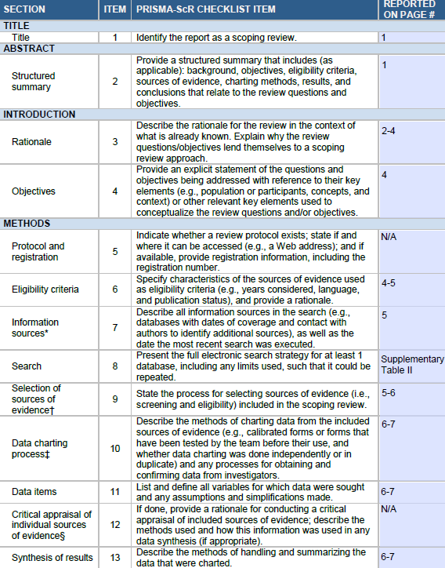
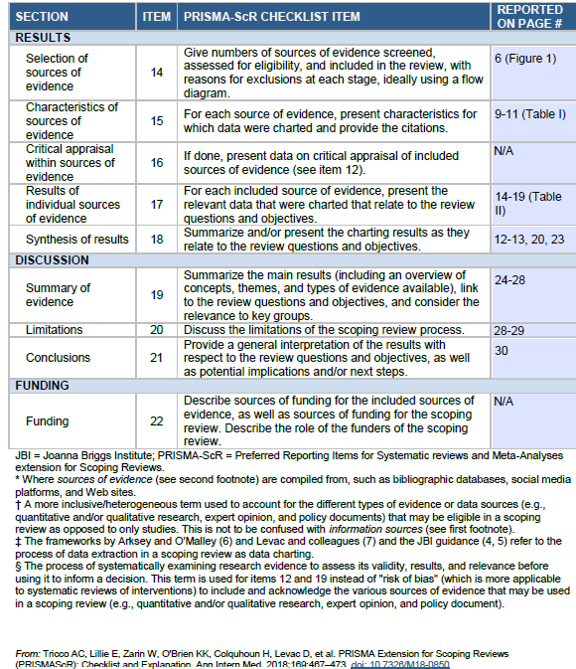

Supplementary Table II: Full electronic search strategy terms for database Pubmed
Database: Pubmed
Date: 07/05/2023
 | Search Terms | Results
Concept 1 Problem
 | TI/AB Depriv*
 | TI/AB Poverty
 | TI/AB Inequal*
1 | Search with OR | 177,205
Concept 2 Setting
 | TI/AB Area-level
 | TI/AB Area
 | TI/AB Neighbourhood*
 | TI/AB Index*
 | TI/AB Geograph*
 | TI/AB Measure
 | TI/AB Location
 | TI/AB Score*
 | TI/AB Calculation
 | TI/AB Formula*
 | TI/AB Social
 | TI/AB Sociodemographic*
 | TI/AB Socioeconomic*
2 | Search with OR | 5,083,059
Concept 3 Population
 | TI/AB Fetal
 | TI/AB Perinatal
 | TI/AB Pregnanc*
 | TI/AB Intrauterine
 | TI/AB Neonat*
 | TI/AB Intrapartum
 | TI/AB Infant
3 | Search with OR | 1,170,367
Concept 4 Impact and Outcome
 | MESH Stillbirth
 | MESH Fetal death
 | MESH Perinatal mortality
 | MESH Miscarriage
 | TI/AB Loss
 | TI/AB Death
 | TI/AB Demise
 | TI/AB Mortalit*
4 | Search with OR | 2,731,496
5 | 1 AND 2 AND 3 AND 4 | 1,902

Supplementary Table III: Deprivation indices included in this review
Deprivation index | Specific measures used
Index of Multiple Deprivation (IMD) | Income, employment, education, health, crime, barriers to housing and services and living environment.
Welsh Index of Multiple Deprivation (WIMD) | Income, employment, health, education, access to services, housing, community safety, physical environment.
Bavarian Index of Multiple Deprivation (BIMD) | Income, employment, education, municipal/district revenue, social capital, environment, security.
Multiple Deprivation Index (MDI) Chile | Crime, education, surrounding green areas, housing, demographics, and Mapuche population.
New Zealand Deprivation Index (NZDep) | In single parent families and aged under 60, on means tested benefit and aged 18-59, below threshold for equivalised household income, without access to a car and aged 18 or over, without qualifications and aged 18-59, unemployed and aged 18-59, separated or divorced and aged 18-59, not in owned home, below threshold for equivalised occupancy, separated or divorced and aged 60 or over.
Dutch index of deprivation | Housing, employment, education, integration and safety.
Social deprivation index (SDI) Brazil | Proportion of permanent private homes that are: a) without water supply connected to the main network, b) with no garbage removal service, c) without a bathroom for the exclusive use of people living there, d) without sewage collection through the main general network for either sewage or pluvial discharge, e) with no nominal monthly income, and f) in which the person responsible for the home was illiterate.
Social Deficiency Index (ICS) Brazil | Proportion of women heads of household, without complete elementary school, and with children under 15 years of age; dependency ratio; distortion rate of secondary education due to total administrative dependency (state, municipal, federal or private); proportion of the population with bathroom and running water; proportion of unemployed persons aged 18 years old or older; and proportion of the extremely poor and mean household income of those vulnerable to poverty.
Socioeconomic status indicator (SESI) Argentina | Percentage of the population who lived in an urban area, had no access to running water or sewer system, had gas connection, met any indicator of unmet basic needs (UBNs), completed only primary education, owned a house, and were employed.
Townsend deprivation score (TDS) | Unemployment, non-car ownership, non-home ownership, and household overcrowding.
Jarman score | Percentage of: elderly living alone, children under 5, unskilled workers, overcrowded households, changed address in last year, ethnic minorities, unemployed, households containing lone parents.
Carstairs socioeconomic deprivation score | Car ownership, male unemployment, overcrowding and low social class.
Carstairs-Morris scores | An extension of the Carstairs score, additional variable of low educational attainment and material deprivation.
'Townsend/Carstairs like' index | The proportion of the labour force unemployed; proportion of households with no car access; proportion of households not owner occupied, and the proportion of employed men and women in Social Class 4 or 5.
Index of Relative Socio-Economic Disadvantage for Western Australia | Income between $1 and $25,999 per year, families with children under 15 years of age who live with jobless parents, occupied private dwellings with no internet connection, people aged 15 years and over whose highest level of education is Year 11 or lower, people (in the labour force) who are unemployed, employed people classified as Labourers, occupied private dwellings paying rent less than $215 per week (excluding $0 per week), one parent families with dependent offspring only, people under the age of 70 who have a long-term health condition or disability and need assistance with core activities, people aged 15 years and over who are separated or divorced, employed people classified as Machinery Operators and Drivers, employed people classified as low skill Community and Personal Service workers, occupied private dwellings with no cars, occupied private dwellings requiring one or more extra bedrooms, people aged 15 years and over who have no educational attainment, and people who do not speak English well.
Deprived neighborhoods determined by Dutch government | 40 deprived neighbourhoods identified based on: Physical deprivation, propensity to move, level of education, average disposable income per household, employment rates, physical nuisance based on 4 indicators, social nuisance based on 5 indicators, dwelling dissatisfaction, environment dissatisfactions, rates of notified crime and rates of insecurity.
Department of Environment Index (DoE) UK | Social, economic, housing.
National Operations Department report Sweden | Characterized by low socioeconomic resources with high rates of unemployment, foreign‐born individuals, overcrowding, a high grade of segregation, criminality and norm‐breaking behaviours.

Supplementary Figure 1: Bar chart of most common measures included in indices

