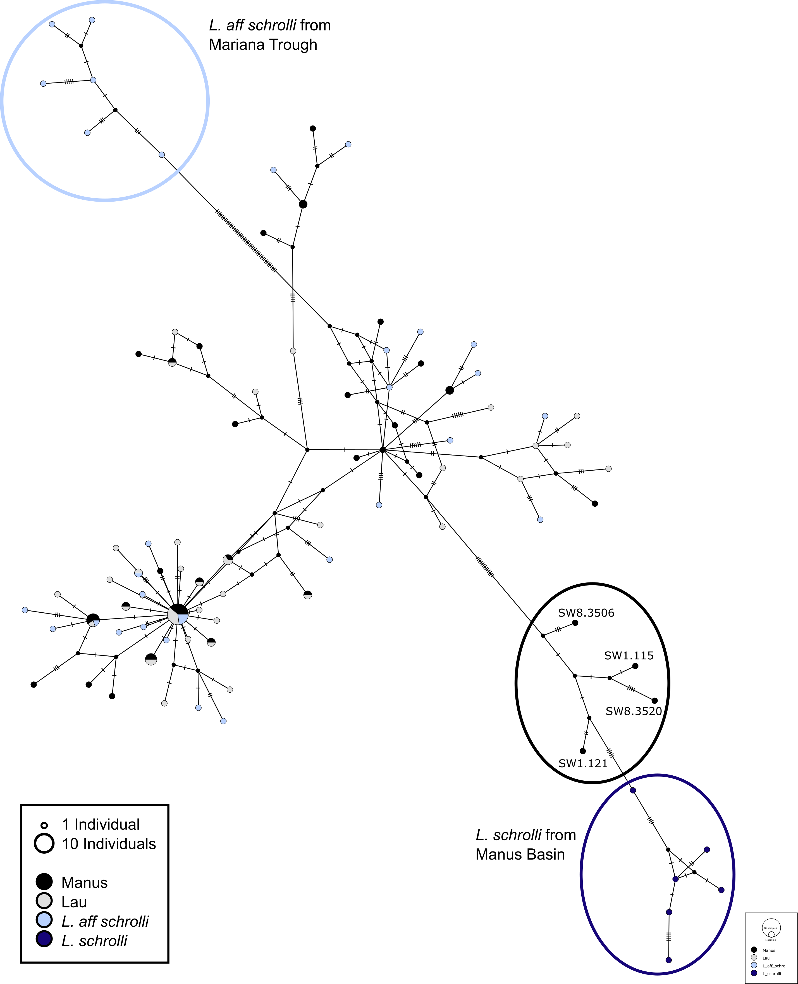
Supplementary Figure 1: Median-Joining tree of Sanger sequenced COI loci form our study compared to those from Johnson et al. (2008). All of our samples cluster with L. aff schrolli collected by Johnson et al. (2008) from the Fiji and Lau Basins (light blue). The four individuals in the black circle are the most distant from L. aff schrolli but OTU analysis assigns them to the OTU containing L. aff. schrolli

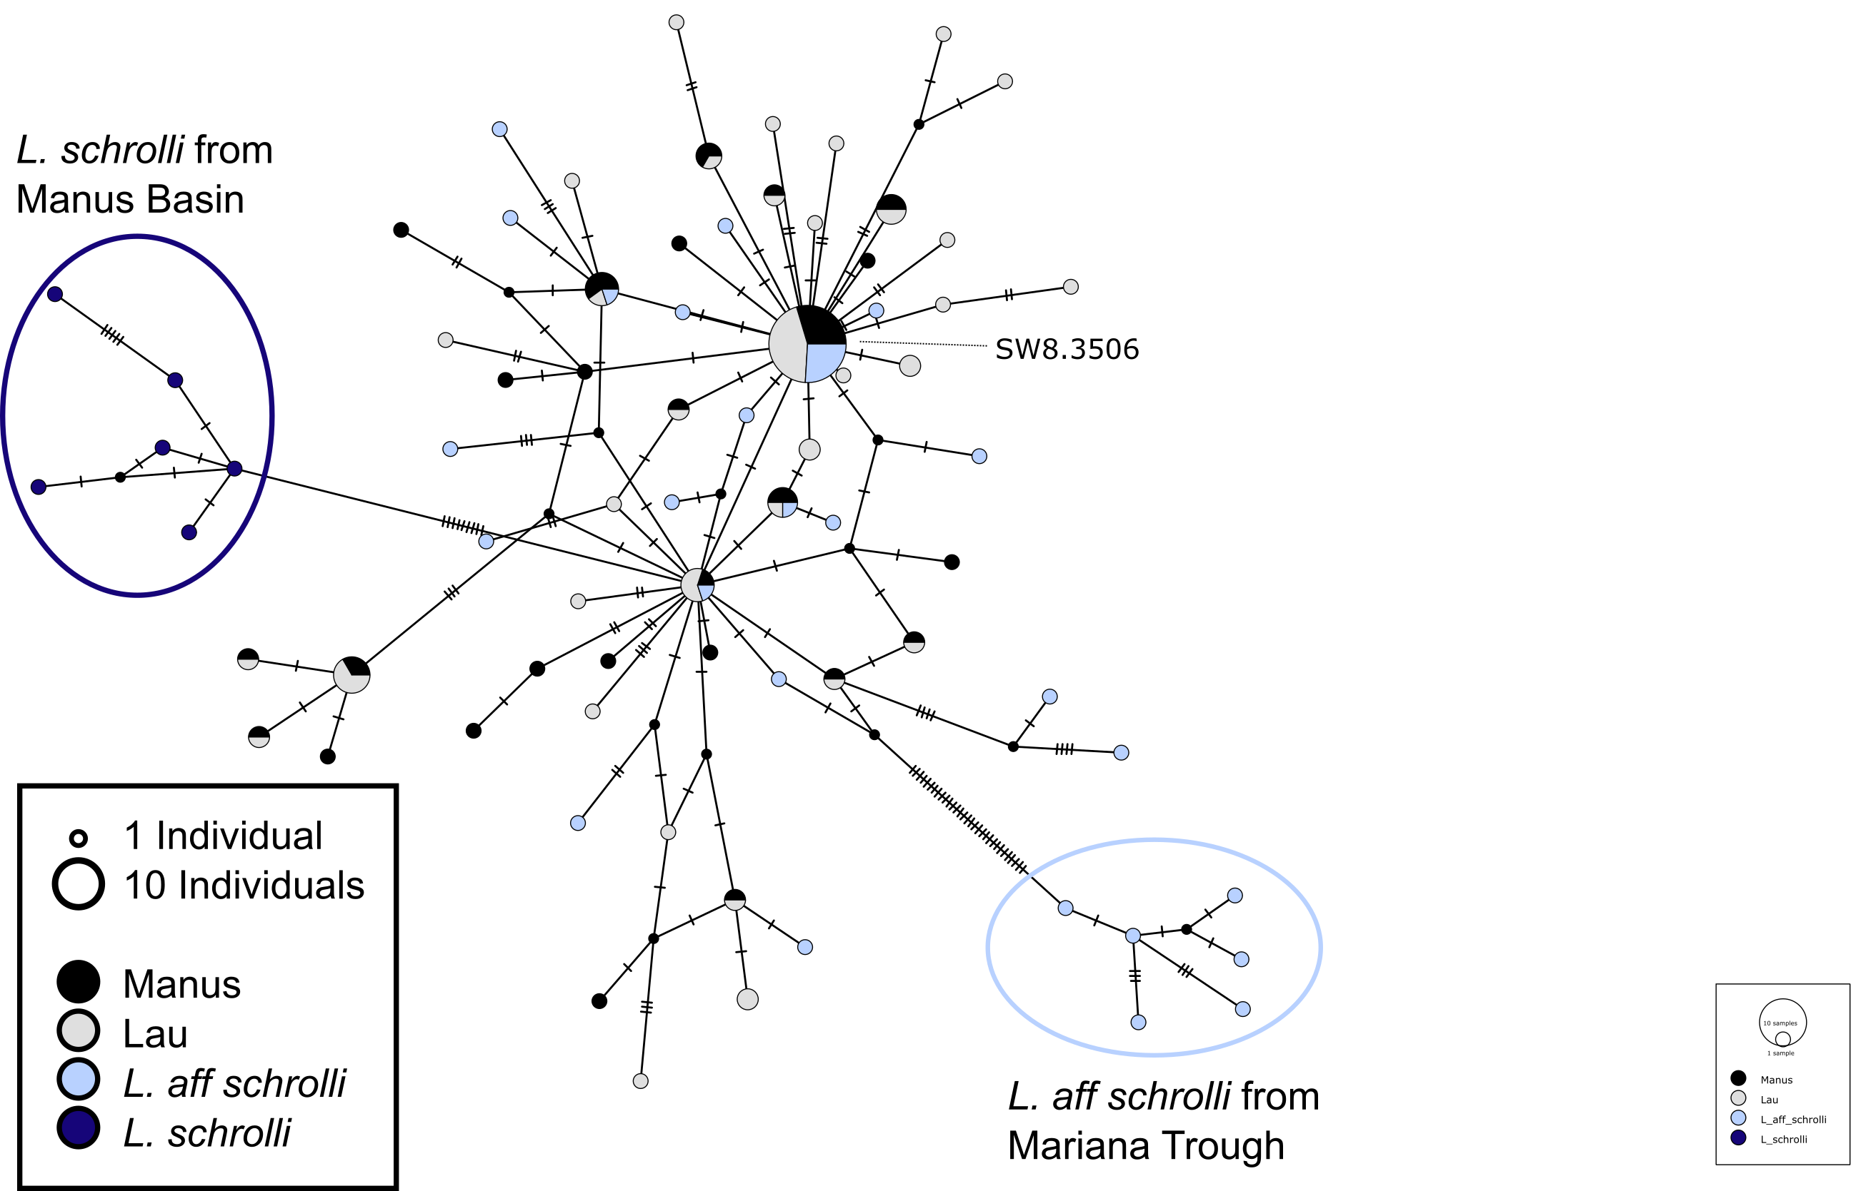
Supplementary Figure 2: Median-Joining tree of 454 sequenced COI loci from our study compared to those from Johnson et al. (2008). All samples collected in this study cluster with L. aff schrolli collected from the Lau and Fiji Basins (light blue).

A)
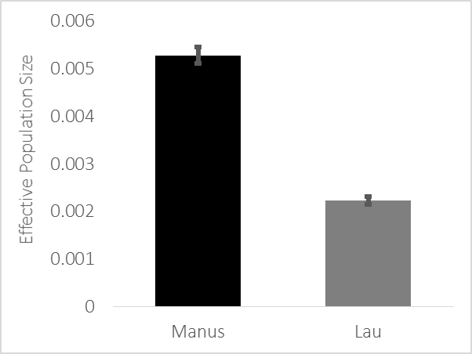
B)
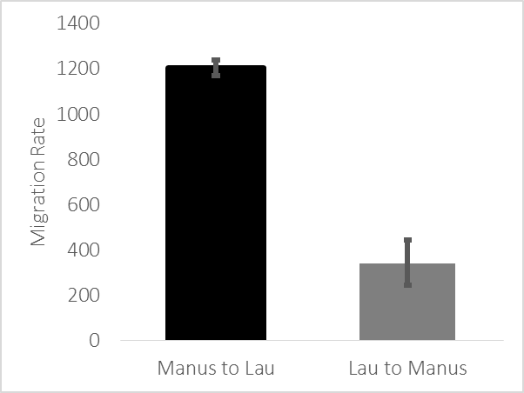
Supplementary Figure 3: Migrate-n results from the 42 loci. A) Effective population sizes estimated by migrate-n show an effective population size in Manus that is twice as large as that in Lau. B) Migration rate from Manus to Lau is estimated in Migrate-n to be over three times larger than that in the opposite direction.

Johnson SB, Waren A, Vrijenhoek RC (2008) DNA Barcoding of Lepetodrilus Limpets Reveals Cryptic Species. Journal of Shellfish Research 27, 43-51.

