Dual-cavity dual-comb interferometric spectroscopy
with incoherent light

Jarni Braal^{a,b}, Satheesh Chandran^{a,b}, Robert Sheehanª,
Anton J. Walsh^{b,1}, Albert A. Ruth^{a,}*

ªSchool of Physics & Sustainability Institute, University College Cork, Cork Ireland
^{b}Centre for Advanced Photonics and Process Analysis, Munster Technological University, Cork, T12 P928, Ireland

*Corresponding author: a.ruth@ucc.ie

¹ Passed away: 9 Feb 2024

Supplementary Material

The Supplementary Material contains additional information on the time segment overlap and cavity mode drift in the context of data retrieval, as well as four extra Figures. Fig. S1: Photograph of the setup; Fig. S2: Schematic illustration of beat spectrum selection criteria; Fig. S3: Brief discussion of fundamental cavity modes; Fig. S4: Illustration of the retrieval of the mirror reflectivity and the associated uncertainty.

Figure S1. Photograph of Dual-Cavity Dual Comb Interferometric (DC-COIN) spectroscopic setup. The number label the following devices in the setup: 0: Adjustable iris; 1a: Inlet line (FEP Teflon 1/8’’), 1b: Outlet line (FEP Teflon 1/8’’); 1c: Cavity tube (FEP Teflon 3/8’’); 2: Kinematic mirror mount; 2a: Mirror holder with gas in/outlet; 3a: Free space fiber coupler and collimator unit (light from SLED); 3b: Fiber optical isolator; 3c: Free space fiber coupler (light from external cavity diode laser, ECDL); 3d: Free space fiber coupler; 3e: Single mode fibre optic coupler; 4: Steering mirror(s); 5: Beam splitter (50:50); 6: Aspherical focussing lens; 7: InGaAs variable-gain avalanche photodetector; 8: Neutral density filter to attenuate ECDL; 9: Carbon fiber rods of cage system; 10: Thermalized breadboard resting on 3 layers of bubble wrap on an optical bench; 11: Perspex housing.
Information on time segment overlaps and cavity mode drift:
The segment duration is inversely proportional to the resolution of the FFT. A resolution of less than half of the cavity mode width was desirable to enable mode-resolved measurements. A segment duration of ~166.6 μs (corresponding to a resolution of ~6 kHz) was applied in our measurements and fulfils this criterion. While longer time segments would in principle lead to better FFT frequency resolution, they would also cause the resulting beat spectra to become less well defined due to the influence of fluctuations of the non-stabilized cavities. Only if the time intervals are short enough the effect of drift and jitter of the cavities on the quality of the beat spectra becomes negligible. Within limits the segment duration appeared to be uncritical. Tests with segment durations of e.g. ~125 μs (~8 kHz) and ~250 μs (4 kHz) showed insignificant variation in the beat spectrum retrieval.
Of more importance for the establishment of beat spectra is the overlapping of segments in the retrieval procedure. The overlapping of segments generally increases the number of spectra that are available for the establishment of an average noise-reduced beat spectrum. For that purpose the Fourier transformed spectra are scrutinized on basis of a few selection criteria that are described in the manuscript in section 2.5 (see also Fig. 3) and in Fig. S2 (below). A certain percentage of Fourier transformed segments is therefore discarded to optimize the quality of the final beat spectrum. In general, the overlapping of FFT segments also helps accounting for fluctuations in the overall time-dependent signal (the interferogram) to better identify beat notes. A maximal overlap of virtually 100% (i.e. a moving segment from datapoint to datapoint) would be the ideal approach in this context. It comes at the expense of computational overhead. An overlap of 90% between time segments was empirically established as a best practical compromise between computational overhead and the maximum number of acceptable beat spectra in the selection process. Large time segment overlaps generally lead to reduced rejection of beat spectra and more robust retrieval performance. The percentage of rejected spectra for the analysis can vary from measurement to measurement and depends on external factors that influence the mechanical stability of the dual cavity setup. For a 90% overlap typically 6-7% of the beat spectra were rejected. A time segment overlap of 95% did merely marginally improve the retrieval quality, but increased the processing time substantially.
The fact that the cavities are only passively stabilized leads to random oscillations (drift/jitter) of the cavity modes as shown in Figure 3(E) in the main body of this publication. Depending on the general stability of the hardware these shifts can in principle be larger than the fundamental beat frequency difference (on some rare occasions up to ~3-4 times the fundamental beat frequency difference was observed (cf. Fig. 3(E)). It should be noted that the amplitude of the randomly drifting modes is not critical for the data-processing as long as the shift happens on a time scale of milliseconds (low frequency region, e.g. <2 kHz) and the mode position can be easily tracked and corrected. In contrast very high frequency mode oscillations are difficult to track and compensate, however, very fast random mode changes with significant amplitude were indeed not observed with our passively stabilized setup.

Schematic illustration of beat spectrum selection criteria:
Figure S2. Schematic illustrating the selection of acceptable beat note spectra. Since the cavities are not stabilized and the experiment is not triggered (but free running), beat note spectra can lie in different relative frequency ranges (see also Figures 5(A) & 5(C), 6(A) & 6(C) in the main text). Some of the spectra cannot be used for dual comb spectroscopy and are thus discarded in the evaluation procedure, illustrated in this figure.

Fundamental mode description:
A fit of Lorentzian profiles to the fundamental modes is shown in Fig. S3(A) in comparison with the 10-point FFT smoothed data from the paper in Fig. S3(B) (=Fig. 4 in the main paper text). Analysis of 26 fundamental mode profiles (Fig. 3(C)) showed that the underestimate of the FWHM based on the Lorentzian fit was of the order of ~2-3 kHz corresponding to an underestimate of the reflectivity of ca. δR ~ 0.00003. Error limits in the main text are based on the measurement of 26 fundamental profiles (see also Fig. S4).
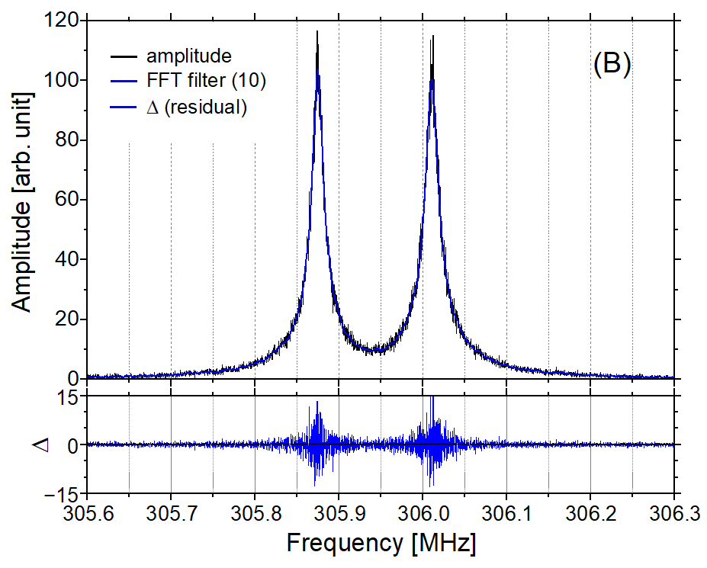
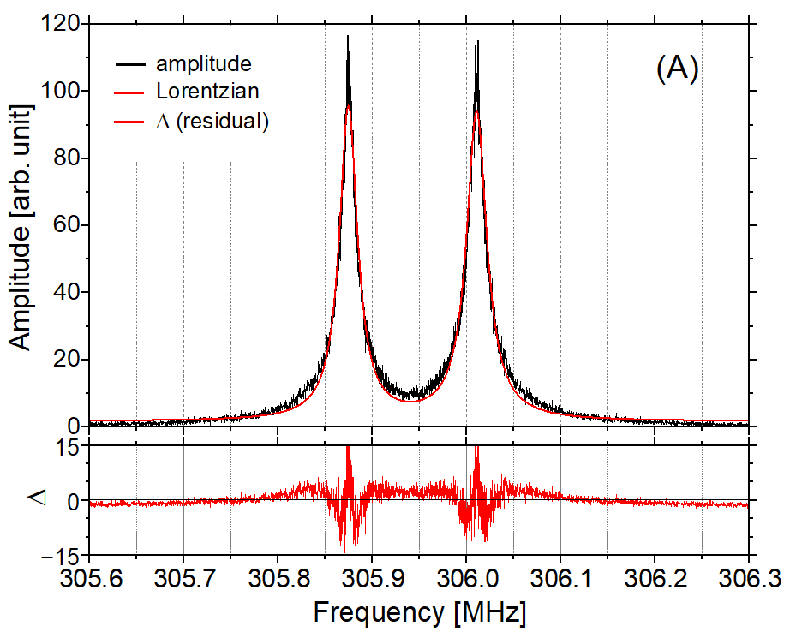

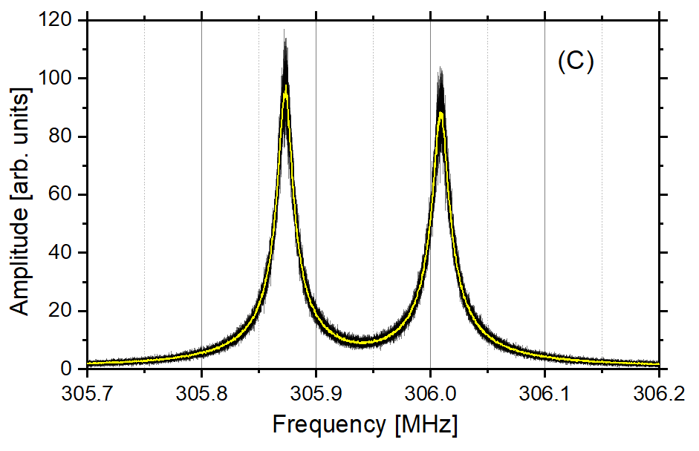

Figure S3. (A) Lorentzian profile fitted to the fundamental modes of the two cavities and corresponding residuals in the lower viewgraph. (B) Interpolated (10-point FFT smoothed) fundamental modes of the two cavities and correspodning residuals in the lower viewgraph. (C) 26 measurements of fundamental modes (black) to determine the FWHM in panel (B). The averaged trace is shown in yellow.
Figure S4. Black solid line: Reflectivity as a function of the finesse. Solid red lines: Finesse based on average δν (FWHM) of the two fundamental modes of the cavities (vertical), and the corresponding reflectivity (horizontal). Solid black dashed lines: Error margin on reflectvity R (horizontal) and finesse (vertical) as determined from 26 measurements of the fundamental modes shown in Fig. S3(C).

