Supplementary information

Figure S1. Cell viability of the ST14A cells. Viability of ST14A cells were determined using an MTT assay and expressed as a percentage of the non-treated cells. Mean ± S.E.M of 3 technical replicates performed in triplicate. One-way ANOVA followed by Dunnet’s post hoc test.

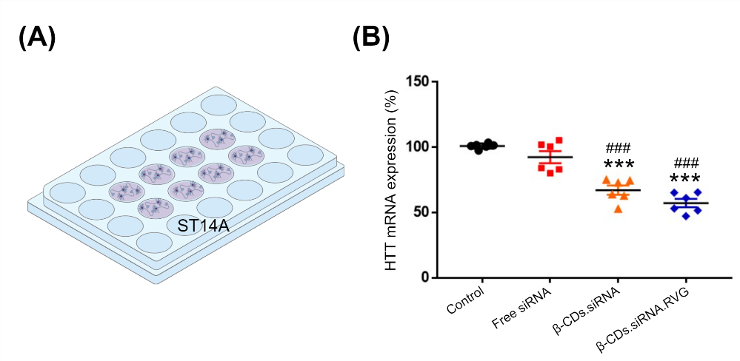
Figure S2. Efficient downregulation of HTT by siRNA. (A) Schematic illustration of in vitro monoculture system of ST14A cells; (B) mRNA levels of HTT of ST14A cells measured 48 h post-transfection by SYBR Green qPCR and normalized to 18S ribosomal. n = 6, three independent experiments. Mean ± S.E.M. One-way ANOVA with Tukey multiple comparisons test. ***p < 0.001 compared to control and ###p < 0.001 compared to Free siRNA.

