Supplementary Information
Flip-chip bonded micro-thermoelectric coolers for on-chip thermal management in integrated photonics
Rajvinder Kaur, Amit Tanwar, Peter O’Brien and Kafil M. Razeeb*
Tyndall National Institute, University College Cork, Lee Maltings, Dyke Parade, Cork T12 R5CP, Ireland
*Corresponding author’s E-mail address: kafil.mahmood@tyndall.ie

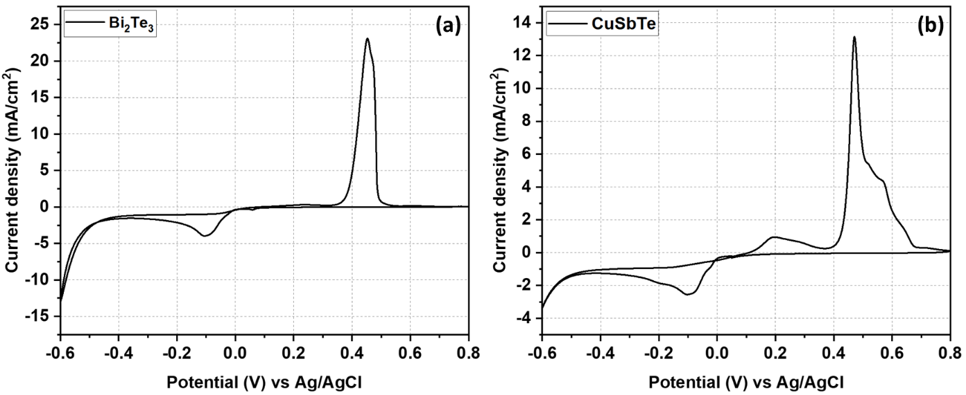
Fig. S1. Cyclic voltammograms using a standard gold electrode at a scan rate of 10mV/s for (a) Bi₂Te₃, and (b) CuSbTe electrolytes.

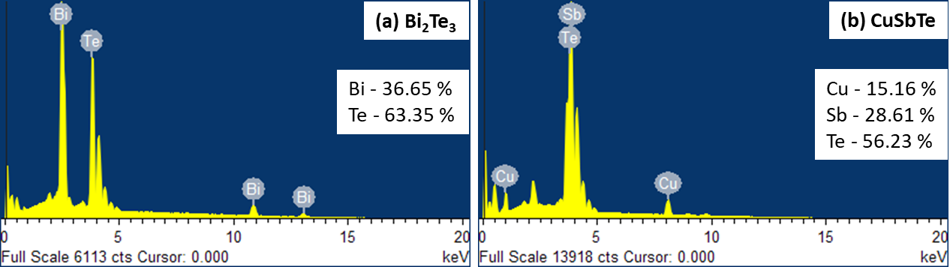
Fig. S2. EDX spectra for chemical composition analysis of (a) Bi₂Te₃, and (b) CuSbTe films.

Table S1. Comparison of the thermoelectric properties of different electrodeposited p-type materials.
TE material | Annealing temperature (°C) | Seebeck coefficient  (µVK⁻¹) | Electrical conductivity (Sm⁻¹) | Power factor  (µWm⁻¹K⁻²)
CuSbTe (this work) | 150 | 29.8 | 9.5 x 10⁴ | 84
Sb₂Te₃ [1] | 150 | 155 | ~1.5 x 10⁴ | ~360
Sb₂Te₃ [2] | 200 | 170 | ~1.3 x 10⁴ | ~370
Bi_{x}Sb_{2-x}Te_{y} [3] | 150 | 130 | ~2.8 x 10⁴ | ~475
AgSbTe₂ [4] | 100 | 325 | ~0.5 x 10⁴ | 553

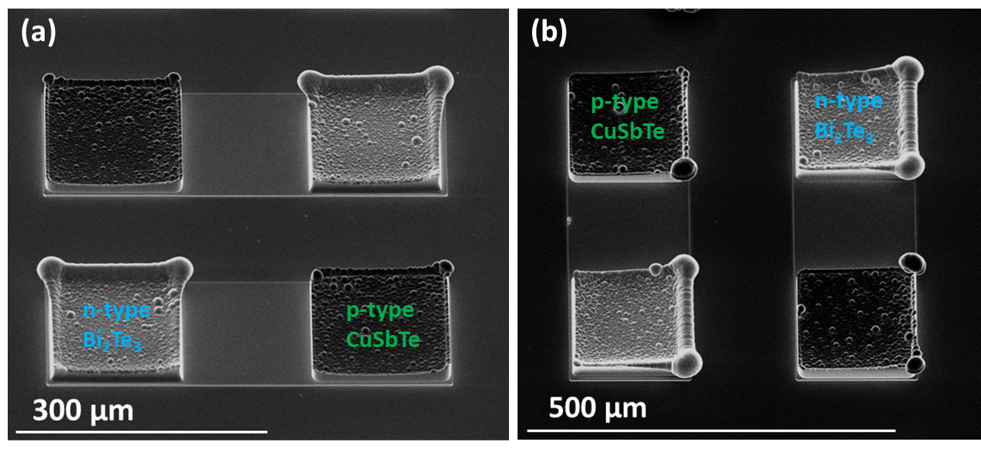
Fig. S3. SEM images of electrodeposited Bi₂Te₃ and CuSbTe legs (a) at high magnification cross-sectional view, and (b) at 90° angle rotation to observe the uneven growth at the centre and edges.
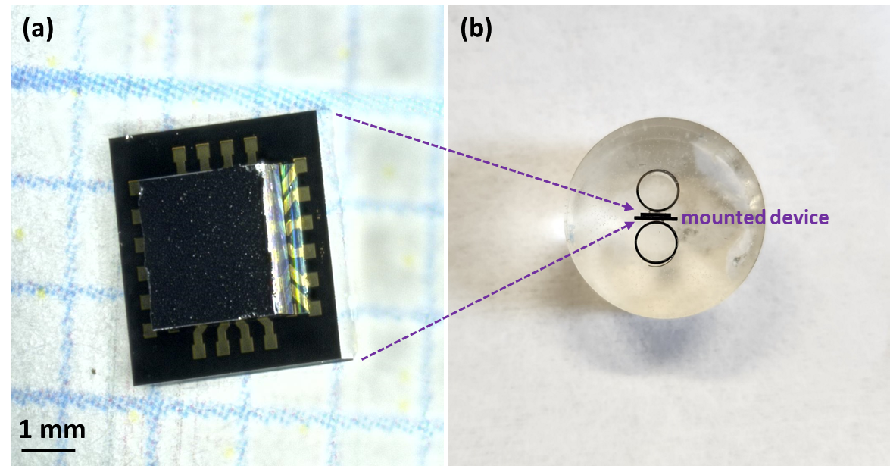
Fig. S4. Microscopic image of (a) flip-chip bonded device, and (b) its mounting between two supporting rings for the cross-sectional SEM imaging of Au/In/Au bonds and TE legs.

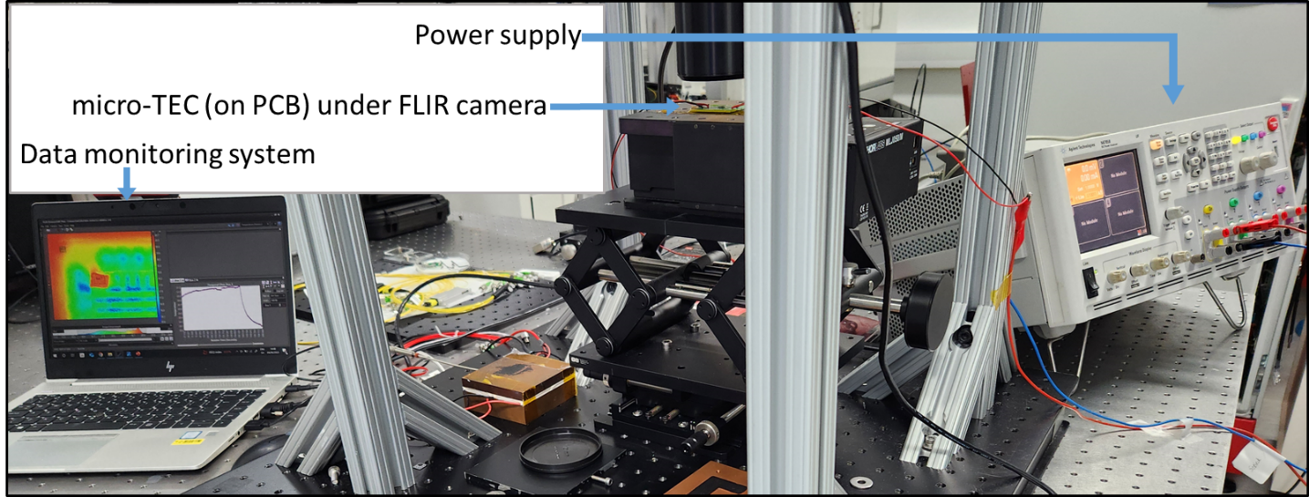
Fig. S5. Measurement setup to evaluate the net cooling (∆T) of micro-TECs.

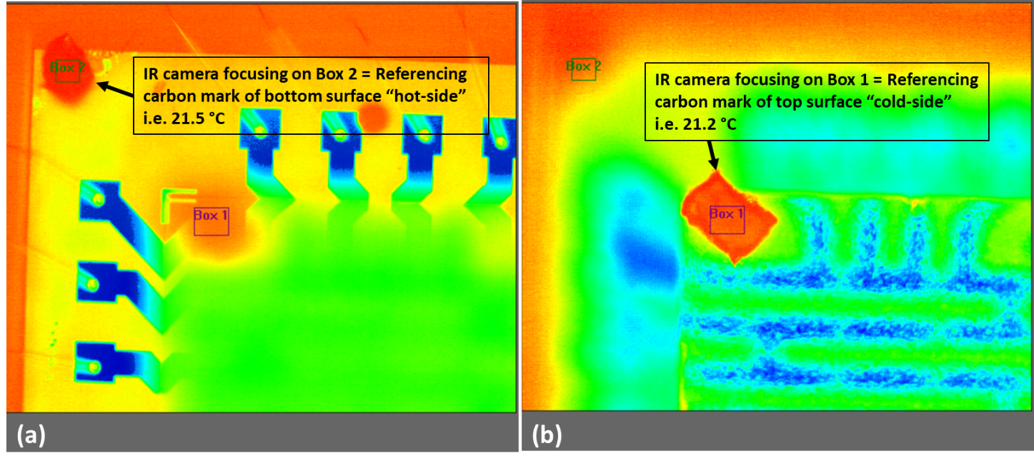Fig. S6. Thermal profile image of (a) bottom and (b) top surfaces of the micro-TEC (Device_2) at an applied current of 20 mA. The temperature is the average surface temperature taken at different carbon markers placed on the device, giving a ∆T of ~0.3 K.

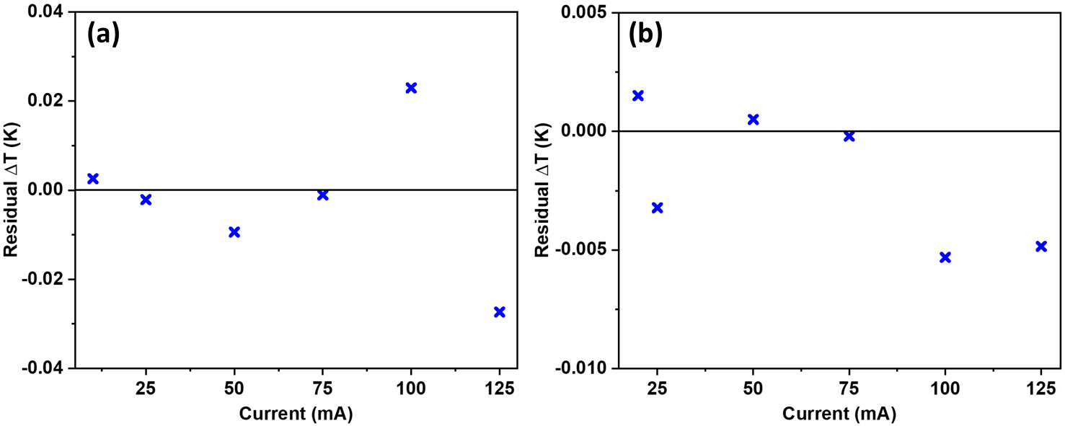
Fig. S7. Residuals (measured-fitted) vs. applied current for (a) Device_1, and (b) Device_2. The horizontal line marks zero residual.

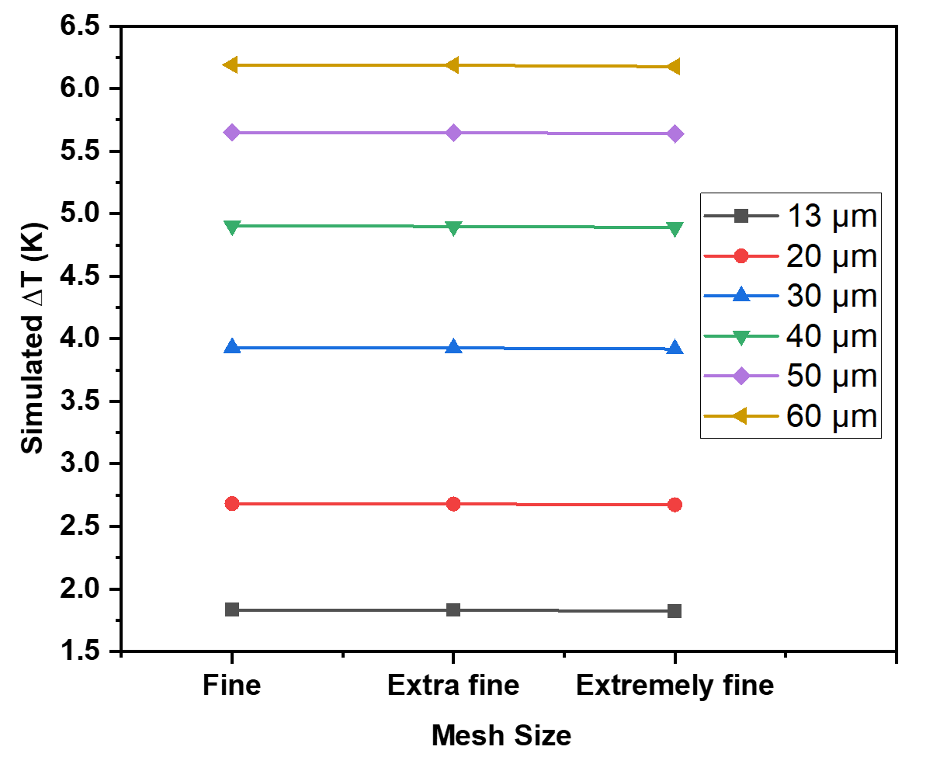
Fig. S8. Simulated net cooling of the device with three mesh sizes for different leg heights (from 13 to 60 µm). The numbers of elements for the fine, extra fine, and extremely fine meshes are 2112, 6512, and 28889, respectively.

References

[1] I.-J. Yoo, Y. Song, D. Chan Lim, N.V. Myung, K.H. Lee, M. Oh, D. Lee, Y.D. Kim, S. Kim, Y.-H. Choa, J.Y. Lee, K.H. Lee, J.-H. Lim, Thermoelectric characteristics of Sb2Te3 thin films formed via surfactant-assisted electrodeposition, Journal of Materials Chemistry A, 1 (2013) 5430-5435.
[2] N. Hatsuta, D. Takemori, M. Takashiri, Effect of thermal annealing on the structural and thermoelectric properties of electrodeposited antimony telluride thin films, Journal of Alloys and Compounds, 685 (2016) 147-152.
[3] J. Kim, J.-H. Lim, N.V. Myung, Composition- and crystallinity-dependent thermoelectric properties of ternary BixSb2-xTey films, Applied Surface Science, 429 (2018) 158-163.
[4] J. Kim, J.-Y. Lee, J.-H. Lim, N.V. Myung, Optimization of Thermoelectric Properties of p-type AgSbTe2 Thin Films via Electrochemical Synthesis, Electrochimica Acta, 196 (2016) 579-586.

