Supplementary Material

In vitro digestibility of bioprocessed Brewer’s Spent Yeast: demonstrating protein quality and gut microbiome modulation potential

Alice Jaeger¹, Laura Nyhan¹, Aylin W. Sahin¹, Emanuele Zannini^{1,2}, Dara Meehan^{3,4}, Junhui Li^{3,4}, Paul W. O’Toole^{3,4} and Elke K. Arendt^{1,3*}.

¹ School of Food and Nutritional Science, University College Cork, T12K8AF Cork, Ireland
² Department of Environmental Biology, Sapienza University of Rome, Piazzale Aldo Moro 5, 00185 Rome, Italy
³ APC Microbiome Institute, University College Cork, T12 YT20 Cork, Ireland
⁴ School of Microbiology, University College Cork, T12 K8AF Cork, Ireland

*Corresponding author: e.arendt@ucc.ie

Supplementary Tables and Figures
Table S1: Composition of control BSY (CBSY) and processed BSY (PBSY), presented as g/100g on a dry matter basis, as previously reported by Jaeger et al. (2024)

Table S2: Amino acid composition of CBSY and PBSY, expressed as g/100 g.

Table S3: Overall in vitro protein digestibility of CBSY and PBSY. Values within the same row sharing the same lowercase letter do not differ significantly.

Table S4: In vitro bioaccessibility (%) of individual AA in CBSY and PBSY, presented as mean ± standard deviation of triplicate experiments. Values within the same row sharing the same lowercase letter do not differ significantly.

Table S5: mg of bioaccessible AA per g protein and Digestible Indispensable Amino Acid (DIAA) ratio (DIAAR), calculated using FAO (2013) reference protein values, presented as mean ± standard deviation. “Aromatic AA” consists of the sum of phenylalanine and tyrosine.

Figure S1: Sequences annotated as L. helveticus (SPINGO) in the PBSY supplemented colon model are likely L. amylovorus FST 2.11 that was initially used to ferment BSY.

Table S1: Composition of control BSY (CBSY) and processed BSY (PBSY), presented as g/100g on a dry matter basis, as previously reported by Jaeger et al. (2024)
 | CBSY | PBSY
Moisture  Protein (N x 6.25)  Fat  Ash  Carbohydrates  Insoluble dietary fibre  High MW Soluble  Low MW Soluble  Total Dietary Fibre  Total Sugars | 6.71 ± 0.38  35.59 ± 1.50  1.36 ± 0.08  5.63 ± 0.32  44.37 ± 1.97  3.13 ± 0.48  2.41 ± 0.06  49.91 ± 2.12  0.30 ± 0.02 | 14.53 ± 0.38  38.74 ± 1.64  1.39 ± 0.00  3.43 ± 0.21  36.72 ± 1.77  2.10 ± 0.39  0.93 ± 0.14  39.73 ± 1.60  10.05 ± 0.64

Table S2: Amino acid composition of control BSY (CBSY) and processed BSY (PBSY), expressed as g/100 g
Amino Acid | CBSY | PBSY
Histidine | 0.832 ± 0.027 | 0.784 ± 0.012
Serine | 1.816 ± 0.014 | 1.934 ± 0.039
Arginine | 2.100 ± 0.051 | 1.707 ± 0.037
Glycine | 1.480 ± 0.027 | 1.459 ± 0.024
Aspartic acid | 2.987 ±0.229 | 3.322 ± 0.058
Glutamic acid | 5.296 ± 0.286 | 4.067 ± 0.045
Threonine | 1.610 ± 0.011 | 1.825 ± 0.039
Alanine | 2.127 ± 0.083 | 2.143 ± 0.017
Proline | 1.918 ± 0.010 | 1.688 ± 0.021
Cysteine | 0.454 ± 0.008 | 0.305 ± 0.018
Lysine | 2.133 ± 0.144 | 2.559 ± 0.052
Tyrosine | 0.984 ± 0.034 | 1.060 ± 0.031
Methionine | 0.497 ±0.008 | 0.611 ± 0.041
Valine | 1.682 ± 0.029 | 2.050 ± 0.014
Isoleucine | 1.385 ± 0.031 | 1.719 ± 0.022
Leucine | 2.154 ± 0.037 | 2.453 ± 0.037
Phenylalanine | 1.394 ± 0.030 | 1.466 ± 0.036
Tryptophan | 0.437 ± 0.011 | 0.434 ± 0.010

Table S3: Overall in vitro protein digestibility of control BSY (CBSY) and processed BSY (PBSY). Values within the same row sharing the same lowercase letter do not differ significantly.
 | CBSY | PBSY
In vitro protein digestibility (%) | 39.97 ± 3.40 ª | 72.97 ± 4.24 ^{b}

Table S4: Bioaccessibility (%) of individual AA in control BSY (CBSY) and processed BSY (PBSY(, presented as mean ± standard deviation of triplicate experiments. Values within the same row which do not share the same lowercase letter are significantly different (p<0.05).
 | Bioaccessibility (%)
Amino Acid | CBSY | PBSY
Histidine | 46.10 ± 6.31ª | 75.31 ± 8.56 ^{b}
Serine | 33.92 ± 12.56 ª | 60.80 ± 10.02 ^{b}
Arginine | 46.08 ± 6.42 ª | 73.20 ± 8.66 ^{b}
Glycine | 16.23 ± 10.63 ª | 61.17 ± 11.36 ^{b}
Aspartic acid | 14.56 ± 5.65 ª | 70.21 ± 4.20 ^{b}
Glutamic acid | 60.80 ± 2.98 ª | 77.27 ± 1.79 ^{b}
Threonine | 27.91 ± 8.80 ª | 62.16 ± 7.81 ^{b}
Alanine | 48.66 ± 2.36 ª | 75.57 ± 2.19 ^{b}
Proline | 61.83 ± 2.60 ª | 75.88 ± 4.02 ^{b}
Lysine | 12.71 ± 3.45 ª | 72.77 ± 0.93 ^{b}
Tyrosine | 58.44 ± 2.16 ª | 90.46 ± 8.11 ^{b}
Valine | 31.05 ± 4.24 ª | 75.68 ± 4.59 ^{b}
Isoleucine | 32.43 ± 4.64 ª | 78.38 ± 4.17 ^{b}
Leucine | 37.45 ± 5.68 ª | 80.87 ± 3.30 ^{b}
Phenylalanine | 43.72 ± 6.33 ª | 79.13 ± 7.67 ^{b}
Tryptophan | 41.11 ± 4.75 ª | 54.76 ± 8.15 ª

Table S5: mg of bioaccessible AA per g protein and in vitro Digestible Indispensable Amino Acid (DIAA) ratio (DIAAR), calculated using FAO (2013) reference protein values, presented as mean ± standard deviation. “Aromatic AA” consists of the sum of phenylalanine and tyrosine.
 | mg bioaccessible AA per g protein |  |  | in vitro DIAAR
Amino acid | CBSY | PBSY | Ref. FAO | CBSY | PBSY
Isoleucine | 13.53 ± 1.94 | 40.69 ± 2.16 | 30 | 0.45 ± 0.06 | 1.36 ± 0.07
Leucine | 24.3 ± 3.68 | 59.92 ± 2.45 | 61 | 0.40 ± 0.06 | 0.98 ± 0.04
Valine | 15.73 ± 2.15 | 46.88 ± 2.84 | 40 | 0.39 ± 0.05 | 1.17 ± 0.07
Lysine | 8.17 ± 2.22 | 56.26 ± 0.72 | 48 | 0.17 ± 0.05 | 1.17 ± 0.01
Tryptophan | 5.41 ± 0.63 | 7.18 ± 1.07 | 6.6 | 0.82 ± 0.09 | 1.09 ± 0.16
Threonine | 13.54 ± 4.27 | 34.26 ± 4.31 | 25 | 0.54 ± 0.17 | 1.37 ± 0.17
Histidine | 11.56 ± 1.58 | 17.83 ± 2.03 | 16 | 0.72 ± 0.10 | 1.11 ± 0.13
Aromatic AA | 35.69 ± 3.18 | 64.01 ± 5.98 | 41 | 0.87 ± 0.08 | 1.56 ± 0.15

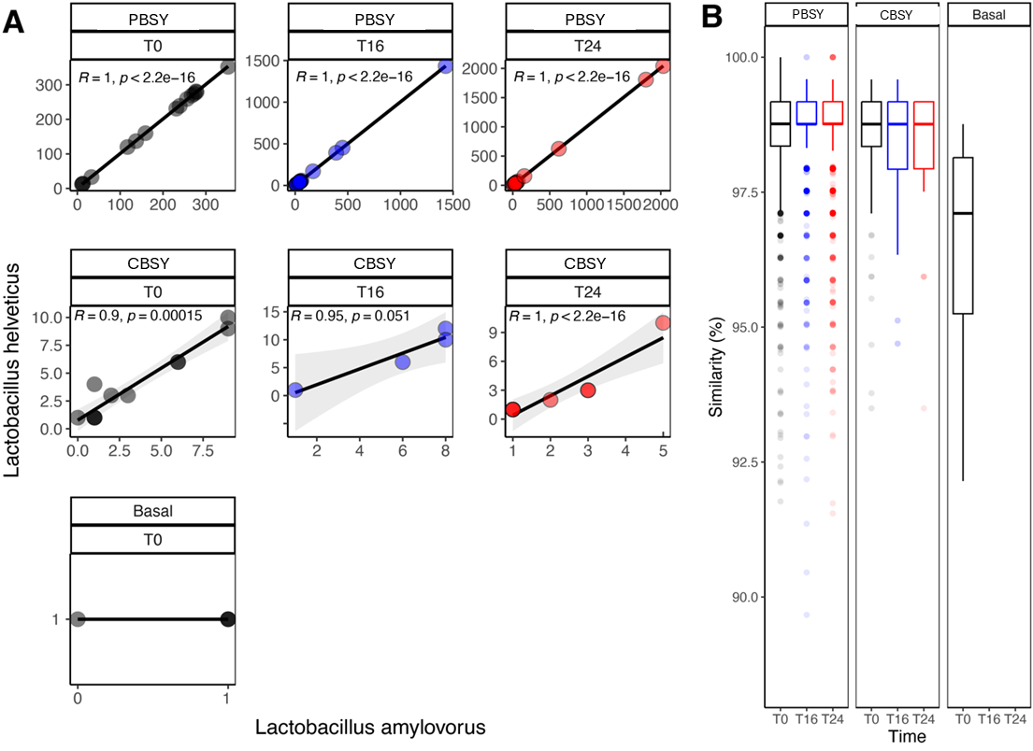

Figure S1: Sequences annotated as L. helveticus (SPINGO) in the PBSY supplemented colon model are likely L. amylovorus FST 2.11 that was initially used to ferment BSY.
Supplementary Text
Differentially abundant species between PBSY and Basal at T24
Among the species detected in at least three donors and being significant in at least two donors (p < 0.05, Wilcox test), 16 species (Clostridium baratii, Lactobacillus helveticus, Catelliglobosispora koreensis, Clostridium bartlettii, Clostridium hylemonae, Enterococcus durans, Gaiella occulta, Gemmatimonas aurantiaca, Ilumatobacter fluminis, Melghirimyces thermohalophilus, Nitrospira japonica, Peptoclostridium difficile, Proteus mirabilis, Pyramidobacter piscolens, Solirubrobacter ginsenosidimutans, Steroidobacter denitrificans) were consistently more abundant in the PBSY across donors, and 34 species (Adlercreutzia equolifaciens, Bacteroides caccae, Bacteroides dorei, Clostridium tertium, Eubacterium cylindroides, Eubacterium desmolans, Eubacterium eligens, Eubacterium rectale, Faecalibacterium prausnitzii, Roseburia intestinalis, Ruminococcus champanellensis, Streptococcus danieliae, Streptococcus equinus, Streptococcus macedonicus, Veillonella atypica, Veillonella dispar, Veillonella rogosae, Anaerostipes butyraticus, Bacteroides cellulosilyticus, Bacteroides faecis, Bacteroides fragilis, Bacteroides intestinalis, Bacteroides ovatus, Bacteroides rodentium, Bacteroides uniformis, Butyrivibrio fibrisolvens, Catenibacterium mitsuokai, Clostridium lactatifermentans, Clostridium lavalense, Eubacterium hallii, Eubacterium ramulus, Haemophilus parainfluenzae, Sutterella stercoricanis, Veillonella parvula) were more abundant in the Basal. Of these species, two species (C. baratii and L. helveticus) were significantly more abundant in the PBSY and 17 species (A. equolifaciens, B. caccae, B. dorei, C. tertium, E. cylindroides, E. desmolans, E. eligens, E. rectale, F. prausnitzii, R. intestinalis, R. champanellensis, S. danieliae, S. equinus, S. macedonicus, V. atypica, V. dispar, and V. rogosae) were significantly more abundant in the Basal in at least three donors, respectively (p < 0.05, Wilcox test).

