Supplementary information
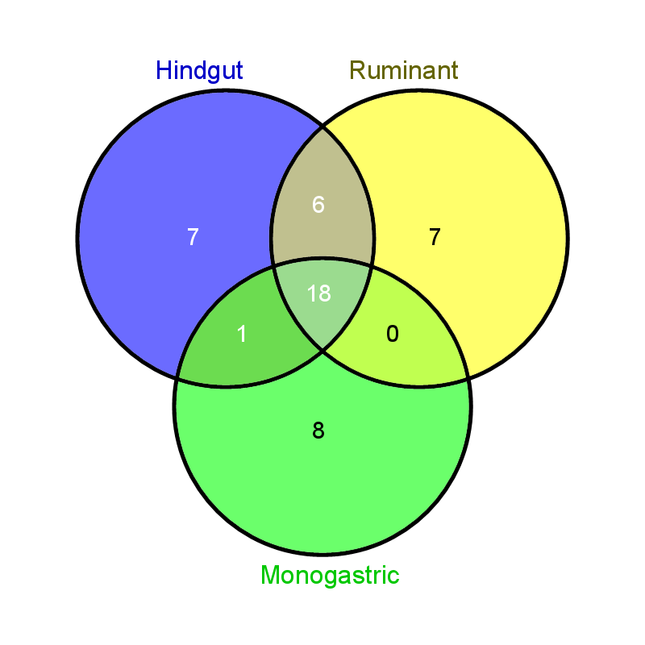

Figure S1. Venn diagram representation of the number of shared, core and unique genera in the microbiota of the ruminant, hindgut fermenters and mono-gastric animals.

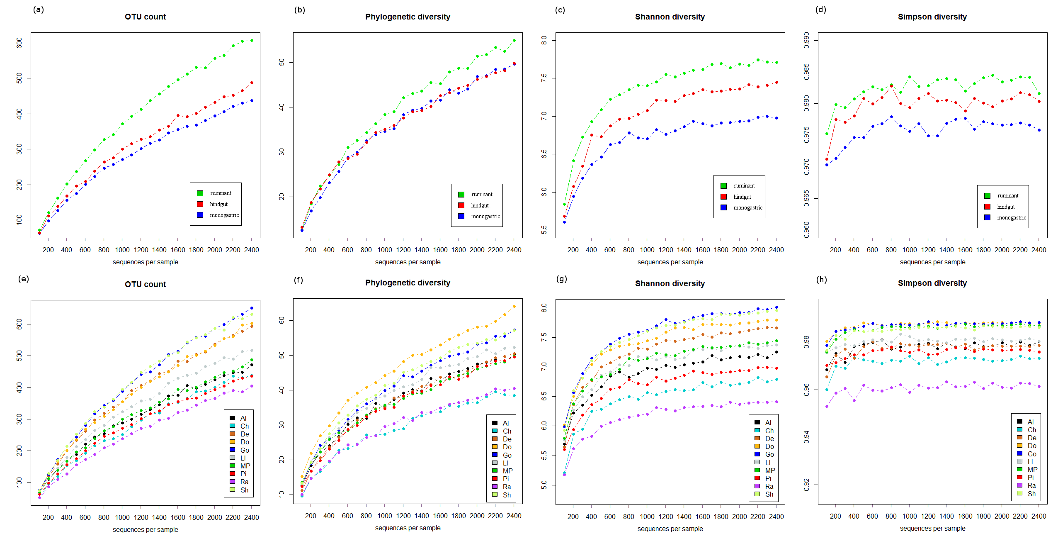
Figure S2. Alpha diversity rarefaction curves. (a) OTU count for each digestion type (b) Phylogenetic diversity indices for each digestion type (c) Shannon diversity indices for each digestion type (d) Simpson diversity indices for each digestion type (e) OTU count for each animal species (f) Phylogenetic diversity indices for each animal species (g) Shannon diversity indices for each animal species (h) Simpson diversity indices for each animal species.
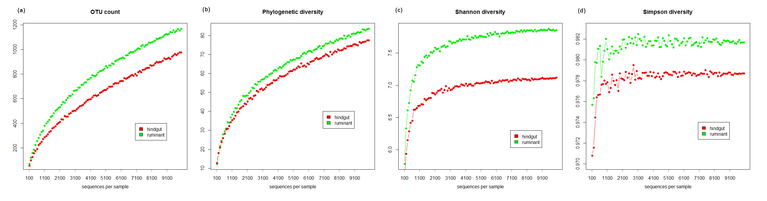
Figure S3. Rarefaction curves for two digestion types; hindgut fermenters and ruminants, using a 10,000 subset sample.
Table S1. Classification of the animals studied
Animal | Taxon level
 | Kingdom | Phylum | Class | Order | Family
Chinchilla | Animalia | Chordata | Mammalia | Rodentia | Chinchillidae
Rabbit | Animalia | Chordata | Mammalia | Lagomorpha | Leporidae
Donkey | Animalia | Chordata | Mammalia | Perissodactyla | Equidae
Miniature ponies | Animalia | Chordata | Mammalia
Deer | Animalia | Chordata | Mammalia | Artiodactyla | Cervidae
Goats | Animalia | Chordata | Mammalia |  | Bovidae
Sheep | Animalia | Chordata | Mammalia
Llama | Animalia | Chordata | Mammalia |  | Camelidae
Alpaca | Animalia | Chordata | Mammalia
Pigs | Animalia | Chordata | Mammalia |  | Suidae

Table S2. Statistically significant differences in the taxon abundance in the microbiota of hindgut fermenters and ruminants
Taxa | Median read percentages (%) |  | P-value
 | Hindgut | Ruminant
Phylum
Firmicutes | 53.111 | 65.346 | *
Actinobacteria | 0.176 | 0.018 | **
Class
Clostridia | 45.912 | 62.651 | **
Bacilli | 0.373 | 0.117 | *
Gammaproteobacteria | 0.336 | 0.056 | **
Alphaproteobacteria | 0.235 | 0.451 | *
Actinobacteria | 0.176 | 0.018 | **
Deltaproteobacteria | 0.175 | 0.372 | *
Betaproteobacteria | 0.133 | 0.013 | *
Epsilonproteobacteria | 0.018 | 0.000 | *
Order
Clostridiales | 44.088 | 60.725 | *
Lactobacillales | 0.306 | 0.065 | *
Pseudomonadales | 0.117 | 0.011 | *
Burkholderiales | 0.077 | 0.013 | *
Desulfovibrionales | 0.037 | 0.012 | *
Aeromonadales | 0.035 | 0.013 | *
Bifidobacteriales | 0.030 | 0.000 | *
Campylobacterales | 0.018 | 0.000 | *
Rickettsiales | 0.000 | 0.062 | *
Family
Ruminococcaceae | 20.480 | 33.461 | **
Marinilabiaceae | 0.402 | 0.002 | **
Bacteroidaceae | 0.363 | 1.853 | *
Clostridiaceae | 0.274 | 0.445 | *
Lactobacillaceae | 0.172 | 0.041 | **
Rikenellaceae | 0.107 | 3.083 | ***
Moraxellaceae | 0.083 | 0.007 | *
Incertae Sedis XIII | 0.050 | 0.142 | **
Desulfovibrionaceae | 0.030 | 0.007 | *
Bifidobacteriaceae | 0.030 | 0.000 | *
Peptostreptococcaceae | 0.000 | 0.104 | ***
Gracilibacteraceae | 0.000 | 0.312 | ***
Rickettsiaceae | 0.000 | 0.052 | *
Genus
Faecalibacteriumª | 1.102 | 0.344 | **
Acetivibrioª | 0.927 | 1.247 | **
Prevotellaª | 0.915 | 0.365 | *
Oscillibacterª | 0.709 | 1.554 | ***
Papillibacterª | 0.449 | 1.651 | ***
Paludibacter | 0.444 | 1.424 | *
Coprococcusª | 0.418 | 0.894 | ***
Anaerophaga | 0.402 | 0.002 | **
Bacteroidesª | 0.363 | 1.853 | *
Acidaminococcus | 0.329 | 0.104 | *
Lactobacillus | 0.172 | 0.041 | **
Subdoligranulum | 0.134 | 0.015 | **
Alistipes | 0.107 | 3.083 | ***
Acinetobacter | 0.083 | 0.007 | *
Parasporobacterium | 0.078 | 0.020 | *
Catenibacterium | 0.078 | 0.025 | *
Anaerostipes | 0.069 | 0.000 | ***
Holdemania | 0.050 | 0.198 | *
Desulfovibrio | 0.030 | 0.007 | *
Acetitomaculum | 0.023 | 0.104 | *
Acetanaerobacterium | 0.015 | 0.199 | **
Lutispora | 0.000 | 0.286 | ***
Orientia | 0.000 | 0.052 | *
a – genera present in the core microbiota both at animal level and digestion method level.
* = <0.05, ** = <0.01, *** = <0.001. Note: Some of the values listed in the table as zero have at least 50% of the values are equal to zero.

