Supplementary materials
- Table- Characteristics of included studies
- Figure- Frequency of behaviour change techniques mapped to the theoretical domains
- Figure- Risk of bias
1. Table Characteristics of included studies
Author (year), study, country, journal | Participants | Intervention / control | Follow-up | Outcome measures |  | Results
 |  |  |  | Primary | Secondary
Altenburg et al (2015), RCT, Netherlandsª  Journal of Respiratory Medicine | Total n=155, IG n=78, CG n=77  102 males, 53 females  Median total age 62 (54-69) years  Mean total FEV₁ 60% pred (40-75%)  Mean total baseline exercise capacity (6MWD)(m) 452(360-515) | Intervention: 12 week PA counselling plus usual care  Control: 12 week usual care  Setting: primary care, secondary care or PR setting | 12 weeks from baseline and 15 months from baseline | Daily stepcount  Daily PA levels (steps + METs) | Spirometry  Fat free mass  6MWD  SF-36  CCQ  CRQ  DEFS  HADS  PPAS  SRQ-E | Daily stepcount change between groups 0-12 weeks IG 618(-137-1771), CG -185 (-1425-969) p=0.001*, 0-15 months IG 218(-1423-1863), CG -201(1809-1006) p=0.32  Daily PA levels change between groups 0-12 weeks IG 1460(-302-3199), CG -754(-1497-1052) p=0.001, 0-15 months IG 443(-2543-2999), CG -685(-3051-597) p= 0.062  6MWD(m) change between groups 0-12 weeks IG 484(416-555), CG 453(375-532), 0-15 months IG 506(422-571), CG 468(417543)
Cruz et al (2016), RCT, Portugal^{b}  Journal of Chronic Respiratory Disease | Total n= 32, IG n= 16, CG n=16  13 males, 19 females  Mean age IG 68.8±8.2years, CG 64.1±8.2yrs  Mean FEV₁ IG 65.5 ±21.1% pred, CG 68.4±19.7% pred  Mean baseline exercise capacity (6MWD)(m) IG 493.8±63.0, CG 476.2±54.9 | Intervention: 12 week PA focused behaviour change intervention during PR and 12 week after PR  Control: 12 week PR only  Setting: primary care | Baseline, 12 weeks from baseline (post PR) and 6 months post PR | Daily PA levels (MVPA, total PA, steps/day) | 6MWD  Quads muscle strength  SGRQ  Self-efficacy | Daily stepcount change between groups 0-12 weeks IG 10440 ±4012.9, CG 6430.0 ±2613.1, 0-6 months IG 9747.9 ±3511.8, CG 6481.0 ±3454.4 p= 0.001*(ES, n² partial 0.27)  MVPA (mins/day) change between groups 0-12 weeks IG 57.8 ±32.8, CG 26.7 ±19.6, 0-6 months IG 51.6 ± 29.4, CG 28.0±26.0 p= 0.030* (ES n² partial 0.21)  Total PA change between groups 0-12 weeks IG 279.5 ±74.0, CG 212.0 ±53.9, 0-6 months IG 269.3 ±61.5, CG 202.9 ±82.5 p= 0.047* (ES n² partial 0.12)  6MWD(m) change between groups 0-12 weeks IG 547.9 ± 47.9, CG 529.7 ± 57.2, 0-6 months IG 540.4± 31.1, CG 519.4 ±50.8 p<0.001* (ES n² partial 0.53)
Demeyer et al (2017), RCT, Belgium, Greece, England, Scotland, Switzerland, The Netherlands^{b}  Thorax | Total n= 343, IG n= 171, CG n= 172  111 males, 232 females  Mean age IG 66±8years, CG 67±8yrs  Mean FEV₁ IG 55±20% pred, CG FEV₁ 57±21% pred  Mean baseline exercise capacity (6MWD)(m) IG 448±106, CG 438±107 | Intervention: 12 week usual care plus semi-automated PA telecoaching  Control: 12 week usual care  Setting: primary, tertiary care and rehabilitation centres | Baseline (1 week pre-randomization) and 11 week post randomization | Daily stepcount | Time in in MPA  Walking time Movement intensity during walking  Spirometry  Isometric quads force CAT  CCQ  6MWD | Daily stepcount change within groups 0-12 weeks IG 4634 ±2697 to +870 (47 to 1292), p≤0.05, CG 5120 ±2932 to -678 (-958 to -399), P≤0.001*  6MWD(m) change 0-12 weeks between group difference −0.085(−0.263 to 0.094) p= 0.352
Kawagoshi et al (2015), RCT, Japan^{b}  Journal of Respiratory Medicine | Total n= 27, IG n= 12, CG n= 15  10 males, 17 females  Mean age IG 74±8years, CG 75±9yrs  Mean FEV₁ IG 58.0±23.2% pred, CG FEV₁ 60.6±20.8%  Mean baseline exercise capacity (6MWD)(m) IG 369±119, CG 404±148 | Intervention: Monthly feedback from a pedometer and PR for one year  Control: PR for one year  Setting: home-based | Baseline and 12 months from baseline | Daily PA (time walking, standing, sitting, lying down) | CRQ  6MWD  PImax  PEmax | Daily PA (walking time) change between groups 0-1 year IG 51.36 ± 3.7, CG 12.3 ±25.5, p= 0.036*  6MWD(m) change 0-1 years IG 369 ±119 to 445 ± 138 within group difference p<0.01*, CG 404 ±148 to 467 ± 151 within group difference p<0.01*
Ko et al (2021), RCT, Singapore^{b}  Journal of Respirology | Total n= 136, IG n=68, CG n=68  132 males, 4 females  Mean age IG 76±8years, CG 74±7years  Mean FEV₁ IG 49±17% pred, CG FEV₁ 46±15% pred  Mean baseline exercise capacity (6MWD)(m) IG 253±92, CG 246±88 | Intervention: 4-8 weeks low intensity exercise training in physiotherapy department, followed by phonecalls every 2 weeks for 1 year  Control: Usual care for 1 year  Setting: at home | Baseline, 12 weeks, 12 months | Rate of hospital admission | Daily stepcount  METs  Sedentary intensity time Light intensity time Moderate intensity time Vigorous to very vigorous intensity time  6MWD  CAT  mMRC  SGRQ | Daily stepcount change 0-13 weeks within group difference IG 0(2276.7) p=0.212, CG 0(2708.09), 0-1 year within group difference IG -302.9(2612.85), CG −712.6 (2541.1), p=0.300  Sedentary intensity time change 0-12 weeks between group difference IG 36.11(19.75), p=0.024*, CG 0.64(9.4), 0-1 year within group difference IG 1.39(10.06), CG 2.09(13.07), p=0.986  6MWD(m) change 0-1 year within group difference IG −6.74 ± 58.55, CG −19.51 ± 61.06, p=0.215
Kohlbrenner et al (2020), RCT, Switzerland^{b}  International Journal of Chronic Obstructive Pulmonary Disease | Total n=74, IG n=37, CG n= 37  50 males, 24 females  Mean age IG 64.35(9.36)years, CG , 67.05(8.51)years  Mean FEV₁ IG 34.19(10.97)% pred, CG FEV₁ 35.89(8,82)% pred  Mean baseline exercise capacity (1MSTS) IG 20.97(7.04), CG 16.06(8.72) | Intervention: 12 weeks motivational support, activity diary, stepcount goals and monitored pedometer use at clinic visits, followed by 9 months observation of PA using pedometer  Control: Usual care for 1 year including blinded use of pedometers  Setting: community-based | Baseline, 12 weeks and 12 months | Daily stepcount | CAT  1 MSTS | Daily stepcount change between groups 0-12 weeks IG 694(1709), CG 423(2258), p=0.585, 0-1 year IG -108(1057), CG -480(2258), p= 0.342  1MSTS(reps) change between groups 0-12 weeks IG 20.97(7.04) to 0.74(3.46), CG 16.06(8.72) to 1.81(5.97), p=0.418, 0- 1 year IG 1.0(7), CG -0.5 (6.9), p= 0.478
Nolan et al (2017), RCT, England^{c}  American Journal of Respiratory and Critical Care Medicine | Total n=152, IG n=76, CG n=76  110 males, 42 females  Mean age IG 68(8)years, CG 68(9)years  Mean FEV₁ IG 50.6(20.7)% pred, CG FEV₁ 50.3(21.8)% pred  Mean baseline exercise capacity (ISWT)(m) IG 267(156), CG 248(138) | Intervention: 8 weeks PR plus weekly reviewed step targets (based on pedometer feedback)  Control: 8 weeks PR, supervised twice/week  Setting: outpatient PR class | Baseline, 8 weeks from baseline and 6 months from baseline | Change in daily time expending ≥ 3 METs, min/d (MPA) at 8 weeks compared to baseline | Change in time ≥3 METs, min/d (MPA) at 6 months compared to baseline Change in stepcount ISWT  CRQ | Daily stepcount change between groups 0-8 weeks IG 272(-342, 782), CG 155(-438, 867), p= 0.99, 0-6 months IG -263(-778, 197), CG -461(-1,168, -62) p= 0.09*  Change in MPA time ≥ 3 METs between groups/ 0-8 weeks IG 11(-1, 33), CG 11(-2, 28), p=0.62, 0-6 months IG 2(-12, 25), CG 12(-7, 31), p=0.16  ISWT(m) change between groups 0-8 weeks IG 60(20, 90), CG 50(10, 90) p=0.80, 0-6 months IG 30(0, 70), CG 10(-30, 70) p=0.25
Rausch et al (2021), RCT, Switzerland^{b}  BMC Pulmonary Medicine | Total n= 43, IG n= 17, CG n=26  21 males, 22 females  Mean age IG 70(7) years, CG 67(9) years  Mean FEV₁ IG 52.5(20)%, CG FEV₁ 45.6(16)% pred  Mean baseline exercise capacity (6MWD)(m) IG 470(90), CG 448(72) | Intervention: 12 weeks PR plus 30 minute PA counselling/ motivational interviewing at weeks 1, 3, 6, 9, 12  Control: 12 weeks PR  Setting: outpatient PR clinic | Baseline, 12 weeks and 6 months from baseline | Daily stepcount | METs  TEE  PAL  IPAQ  BREQ-3  PASC  CRQ  CAT  number of sessions participation  6MWD  1MSTS | Daily stepcount change within groups 0-12 weeks IG 4987(2751) to 5026(2859), CG 5581(3413) to 5651(3582) p=0.61, 0-24 weeks IG 6054(3560), CG 5180(2803) p=0.83  6MWD(m) change within groups 0-12 weeks IG 469(90) to 497(89), CG 447(71) to 469(98), 0-24 weeks IG 477(93), CG 469(77) (p values NR)
Steele et al (2008),RCT, United States of America^{b}  Archives of Physical and Medical Rehabilitation | Total n= 106, IG n= 52, CG n= 54  98 males, 8 females  Mean age total 67 years  Mean FEV₁ IG n=8 stage 2, n=24 stage 3, n=8 stage 4, CG n=7 stage 2, n=22 stage 3, n=16 stage 4  Mean baseline exercise capacity (6MWD)(m) IG 379.2±104.5, CG 352.0±105.5 | Intervention: 8 weeks PR plus 12 weeks PA adherence intervention (weekly phonecalls, home visit, counselling)  Control: 8 weeks PR  Setting: IG participants home, CG outpatient department | Baseline pre-PR, baseline post-PR (week 8), post intervention (week 20), 1 year post study commencement | Daily activity (accelerometery), self-reported daily exercise, functional capacity | 6MWD  SF-36  SOLDQ  Functional status and dyspnea questionnaire | Daily activity change between groups post PR-20 weeks 18±55, CG -2±66, p=0.213, post PR-1 year IG 6±75, CG -11±62, p0.667  6MWD(m) change between groups post-PR to 20 weeks IG -10.7±63.1, CG -35.4±49.1, p=0.023*, post-PR to 1 year IG -21.0±60.7, CG -39.6±65.6, p=0.190
Varas et al (2018), RCT, Spain^{b}  Physiotherapy Research International | Total n= 40, IG n= 21, CG n=19  31 males, 9 females  Mean age IG 69.5±7.4years, CG 64.8±9.1years  Mean FEV₁ IG 45.8±16.5% pred CG FEV₁ 52.3±15.7%  Mean baseline exercise capacity (EST)(m) IG 657±573.8, CG 678.7±553.7 | Intervention: 8 weeks exercise training programme using pedometer feedback  Control: 8 weeks with instruction only to walk more daily and use pedometer  Setting: community-based | Baseline pre-intervention (week 0), post-intervention (week 10), 12 weeks post-intervention, 12 months post-intervention | Daily steps, EST, modified Baecke questionnaire | SGRQ  mMRC | Daily stepcount change between groups 0-12 weeks post intervention 3,767(2,014, 5,520) p= 0.00*, 0-1 year 2,457(675, 4,240) p= 0.009*  EST(m) change between groups 0-10 weeks 3,394(1,540, 5,248) p=0.001*, 0-12 weeks 624(290, 958) p=0.00*, to 1 year 633(223, 944) p=0.00*
Vorrink et al (2016), RCT, The Netherlands^{b}  European Respiratory Journal | Total n= 157, IG n= 84, CG n= 73  79 males, 78 females  Mean age IG 62±9years, CG 63±8yrs  Mean FEV₁ IG 59±20% pred, CG FEV₁ 53±15% pred  Mean baseline exercise capacity (6MWD)(m) IG 465±87, CG 459±73 | Intervention: 12 weeks outpatient PR programme, plus use of monitored smart-phone PA application  Control: 12 weeks outpatient PR programme, plus usual care  Setting: home/community-based | Baseline, 12 weeks, 6 and 12 months from baseline | Daily steps, METs | 6MWD  CRQ | Daily stepcount change within groups 0-12 weeks IG 5717±418 to −512(−1003–−21), CG 6011±402 to −635(−1074–−156) p value NR, 0-6 months IG −593(−1058–−128), CG −833(−1315–−352) p value NR, 0-1 year IG −1225(−1712- –738), CG −1148(−1651–−644) p=0.811  6MWD(m) change within groups 0- 12 weeks IG 456±14 to 4.1(−2.8–11.1), CG 461±8 to 1.9(−4.1–7.9) p value NR, 0-6 months IG 4.8(−3.9–13.5), CG 3.3(−2.9–9.6) p value NR, 0-1 year IG 0.8(−8.8–10.3), CG 4(−2.4–10.3) p=0.585
Wootton et al (2019), RCT, Australia^{b}  Lung | Total n= 86, IG n= 42, CG 44  53 males, 33 females  Mean age IG 70(7)years, CG 69(9)years  Mean FEV₁ IG 43(16)% pred, CG FEV₁ 44(15)% pred  Mean baseline exercise capacity (6MWD)(m) IG 458(87), CG 467(80) | Intervention: 8 weeks ground-based walking training followed by 12 month walking maintenance programme with feedback (telephone calls, pedometer biofeedback, goal setting)  Control: 8 weeks ground-based walking training followed by 12 month walking maintenance programme without feedback  Setting: community-based | Baseline, 8 weeks from baseline (end of walking training) and at 12 months from commencement of maintenance programme | SGRQ | Daily steps  Time in activity  Sedentary time | Daily stepcount change within group 0-8weeks IG −585*(−1155 to −15), p<0.05, change between groups −757(−1617 to 103) p value NR, 8 weeks-1 year CG −1051*(−1687 to −424) p<0.05, between groups −617(−1669 to 435) p value NR

- ª Data presented as median (IRQ). Shaded rows: Valid PA measurement: ≥ 7 days, with ≥ 4 consecutive or nonconsecutive days meeting the criterion of a valid day. A measurement day is considered valid when ≥ 8 h of measurement time is reached. ^{b} Data are presented as mean ± standard deviation, 95% confidence interval. ^{C} Data are mean (95% confidence interval) (if normally distributed) or median (first quartile, third quartile) (if not normally distributed). *Statistically significant improvement p≤0.05 unless stated
- RCT: randomized controlled trial, FEV₁: forced expiratory volume in one second, PR: Pulmonary rehabilitation, PA: physical activity, 6MWD(m): six minute walk distance(metres), SF-36: short form 36, CCQ: clinical COPD questionnaire, CRQ: chronic respiratory questionnaire, DEFS: Dutch exertion and fatigue scale, HADS: hospital anxiety and depression scale, PPAS: perceived physical ability subscale, SRQ-E: self-regulation questionnaire for exercise, SGRQ: St Georges respiratory questionnaire, ES; effect size, MPA: moderate physical activity, CAT: COPD assessment test, PImax: maximum inspiratory mouth pressure, PEmax: maximum expiratory mouth pressure, BMI: body mass index, mMRC: modified medical respiratory council questionnaire, 1MSTS: 1 minute sit to stand, ISWT: incremental shuttle walk test, NR: not reported, TEE: total energy expenditure, PAL: physical activity level, IPAQ: international physical activity questionnaire, BREQ-3: behaviour exercise regulation questionnaire, PASC: physical activity stages of change assessment tool, SOLDQ: Seattle obstructive lung disease questionnaire, EST: endurance shuttle test.

2 Figure: Frequency of behaviour change techniques (inner circle) mapped to the theoretical domains (outer circle)

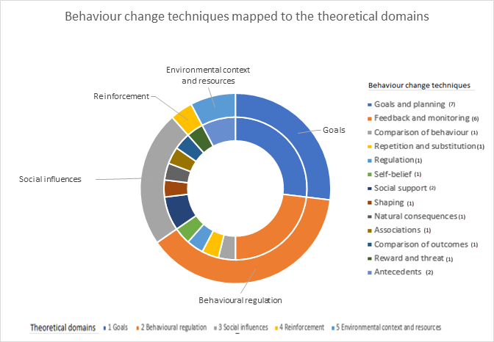

Figure represents the behaviour change techniques identified across all 12 studies (inner circle) including their frequency of use, mapped to the relevant theoretical domains of goals, behavioural regulation, social influences, reinforcement and environmental context and resources (outer circle).

3. Figure
Risk of Bias; Traffic light plot
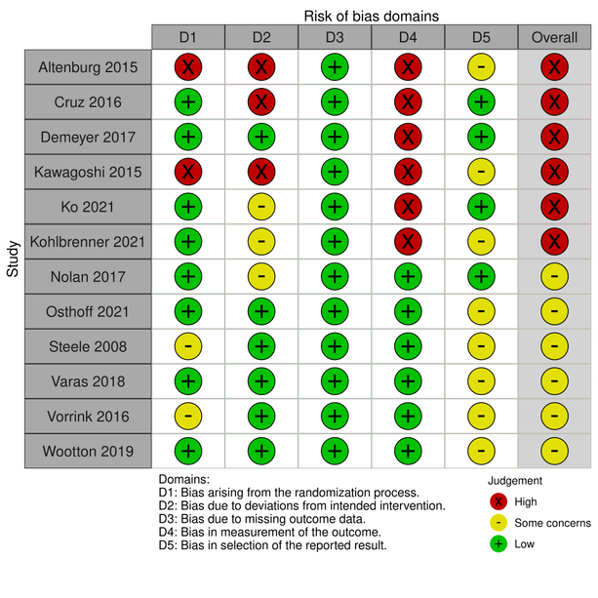

Risk of Bias; Summary plot
