Additional file 1.
Figure S1-S6. Additional figures
Fig. S1 Photographs and line drawings of Orthophlebia extensa. New materials. a Habitus of a male (CNU-MEC-NN2016345); b, c forewing of (a); d the extremely swollen first segment of the metatarsus of (a). e Habitus of a male (CNU-MEC-NN2006046); f, g forewing of (e); h the extremely swollen first segment of the metatarsus. i Habitus of a female (CNU-MEC-NN2014059); k, l forewing of (i); j the non-swollen first segment of the metatarsus. Scale bars represent: 4 mm in (a, e, i); 2 mm in (b, c, f, g, l, l); 1 mm in (d, h, j).
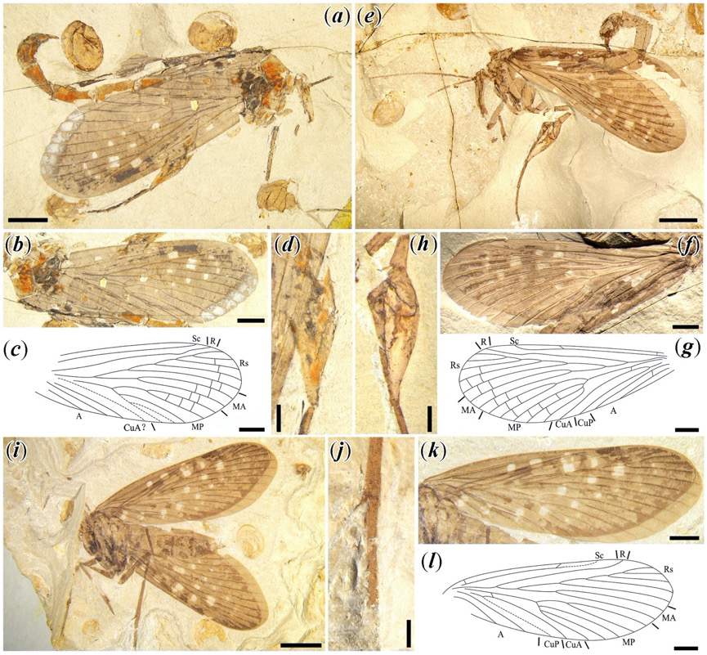

Fig. S2 Photographs and line drawings of Orthophlebia elenae. New materials. a Habitus of an individual of unknown sex (CNU-MEC-NN2014004); c, d forewing of (a); b the slightly swollen first segment of the metatarsus of (a). e Habitus of a male (CNU-MEC-NN2014020); f the slightly swollen first segment of the metatarsus; g, h hind wing of (e). l Habitus of CNU-MEC-NN2014060, male; i, j hind wing of (l); k the non-swollen first segment of the metatarsus. Scale bars represent: 4 mm in (a, e, l); 2 mm in (c, d, g, h, i, j); 1 mm in (b, f, k).
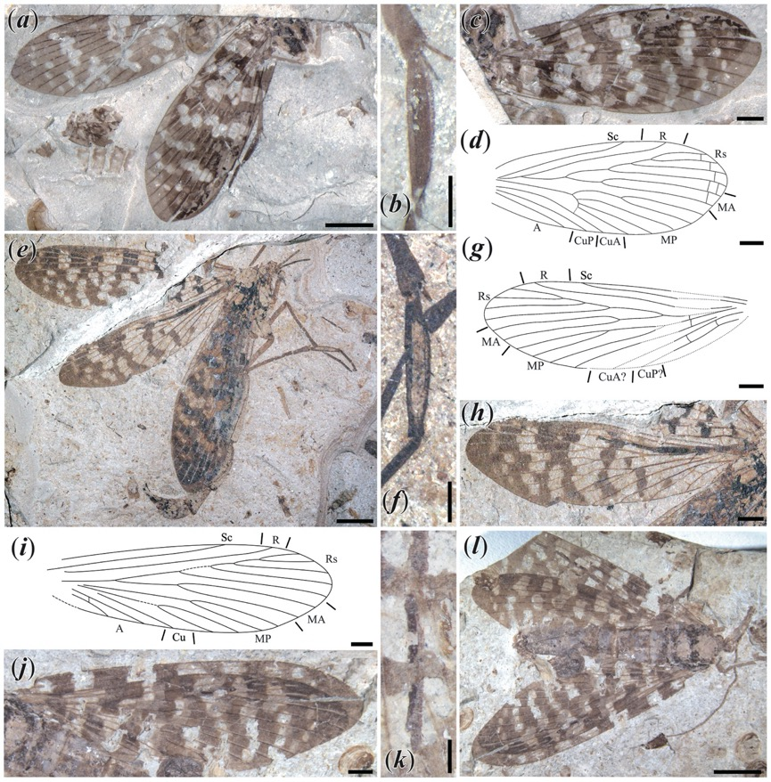
Fig. S3 Photographs and line drawings of Mesopanorpa densa. New materials. a Habitus of male (CNU-MEC-NN2014024); b, c forewing of (a); d the heavily swollen first segment of the metatarsus of (a). e Habitus of an individual of unknown sex (CNU-MEC-NN2016253); f, g hind wing of (e); h the moderately swollen first segment of the metatarsus. l Habitus of female (CNU-MEC-NN2016270); i, j forewing of (l); k the non-swollen first segment of the metatarsus. Scale bars represent: 4 mm in (a, e, l); 2 mm in (b, c, f, g, i, j); 1 mm in (d, h, k).
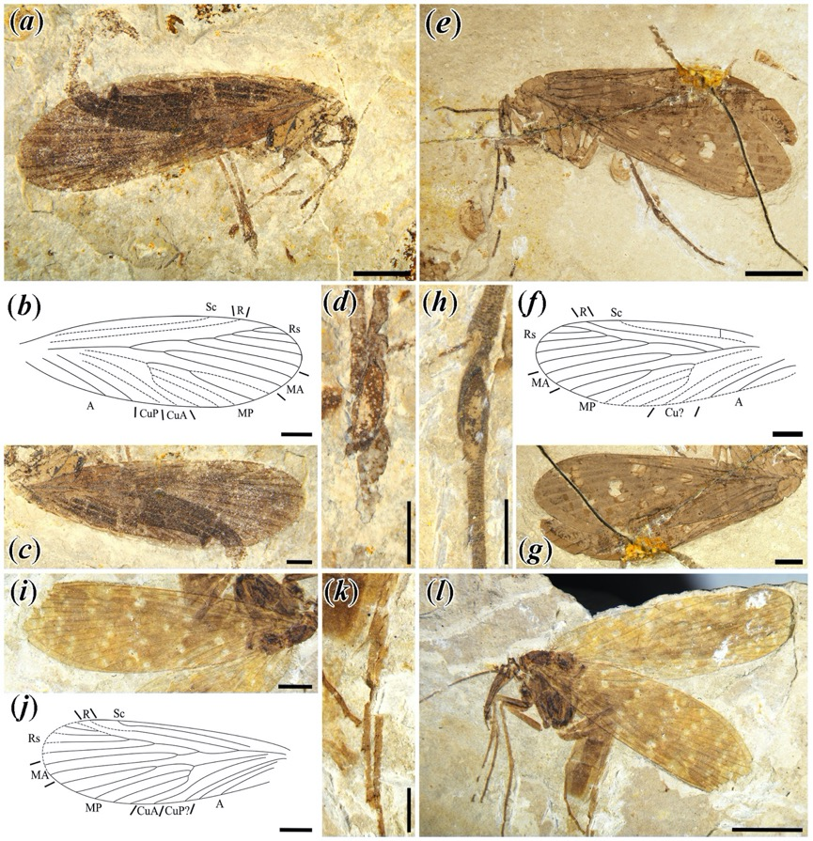

Fig. S4 Photographs and line drawings of Mesopanorpa luanpingensis. New materials. a Habitus of an individual of unknown sex (CNU-MEC-NN2006016); c, d forewing of (a); b the non-swollen first segment of the metatarsus of (a). g Habitus of an individual of unknown sex (CNU-MEC-NN2016222); e, f forewing of (g); h the heavily swollen first segment of the metatarsus. l Habitus of an individual of unknown sex (CNU-MEC-NN2016229); i, j hind wing of (k); k the heavily swollen first segment of the metatarsus. Scale bars represent: 4 mm in (a, g, l); 2 mm in (c, d, e, f, i, j); 1 mm in (b, h, k).
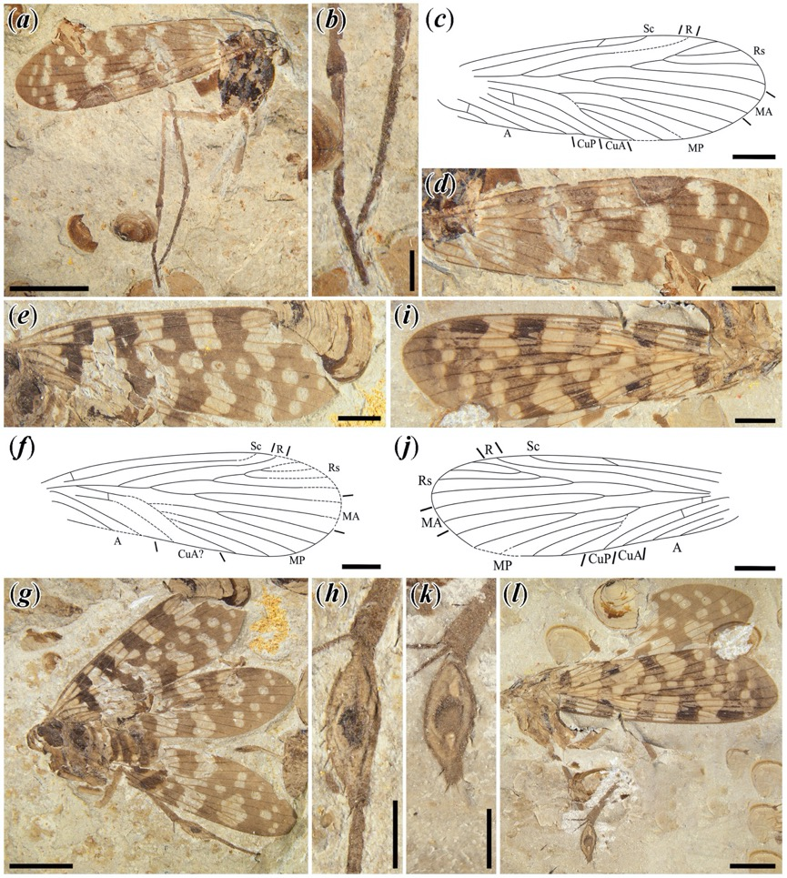

Fig. S5 Photographs and line drawings of Juraphlebia eugeniae. New materials. d Habitus of an individual of unknown sex (CNU-MEC-NN2014033); a, b forewing of (d); c the non-swollen first segment of the metatarsus of (d). e Habitus of an individual of unknown sex (CNU-MEC-NN2014028); g, h forewing of (e); f the moderately swollen first segment of the metatarsus. l Habitus of an individual of unknown sex (CNU-MEC-NN2014001); i, j forewing of (l); k the moderately swollen first segment of the metatarsus. Scale bars represent: 4 mm in (d, e, l); 2 mm in (a, b, g, h, i, j); 1 mm in (c, f, k).
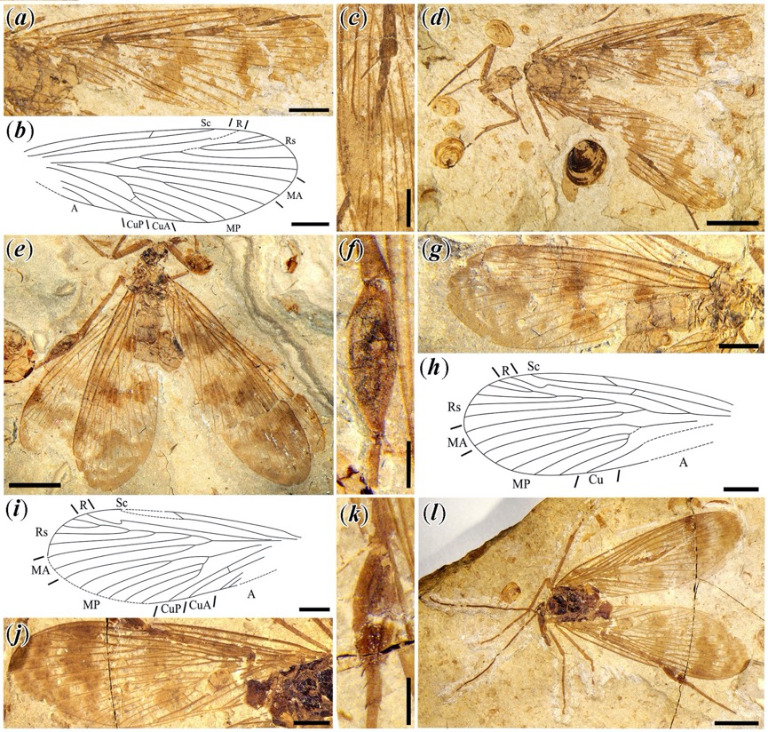

Fig. S6 The aspect ratio of the first metatarsal segment for specimens having non-swollen and swollen tarsi versus wing length (which is used here as a proxy for body size). Trendlines are shown in dotted lines, R² for non-swollen specimens is 0.187 and for swollen specimens, 0.117.

