Supplementary Materials

Predictive computational models for assessing the impact of co-milling on drug dissolution

Nicolas Pätzmann^{1,2}, Patrick J. O'Dwyer¹, Josef Beránek², Martin Kuentz³, Brendan T. Griffin^{1*}

¹ School of Pharmacy, University College Cork, Cork, Ireland
² Department Preformulation and Biopharmacy, Zentiva, k.s., Prague, Czechia
³Institute of Pharma Technology, University of Applied Sciences and Arts Northwestern Switzerland, Muttenz, Switzerland

*Corresponding Author: Prof Brendan T. Griffin

- Apparent solubility values of investigated compounds in Fasted State Simulated Intestinal Fluid (FaSSIF) at 37°C

Table S1: Apparent solubility values of investigated compounds in Fasted State Simulated Intestinal Fluid (FaSSIF) at 37°C after 24 h of dissolution and a stirring speed of 100 rpm with standard deviations
Drug Compound | Apparent solubility [µg/ml] ± SD
Albendazole | 3.3 ± 0.8
Apixaban | 53.2 ± 1.2
Apremilast | 46.7 ± 1.4
Aripiprazole | 27.8 ± 0.9
Candesartan Cilexetil | 19.9 ± 1.2
Carbamazepine | 383.6 ± 3.0
Celecoxib | 42.7 ± 0.8
Ceritinib | 35.9 ± 1.8
Cinnarizine | 14.7 ± 0.6
Dasatinib | 53.1 ± 2.1
Deferasirox | 78.5 ± 3.2
Dipyridamole | 16.9 ± 0.6
Enzalutamide | 5.4 ± 0.1
Etoricoxib | 137.9 ± 2.9
Ezetimibe | 14.9 ± 1.2
Fenofibrate | 4.6 ± 0.6
Gemfibrozil | 667 ± 8.9
Glibenclamide | 4.0 ± 0.5
Griseofulvin | 17.5 ± 2.2
Indomethacin | 426 ± 22.0
Mefenamic acid | 42.5 ± 1.5
Nilotinib | 3.9 ± 0.7
Nimesulide | 24.0 ± 0.9
Olaparib | 127.8 ± 3.2
Rivaroxaban | 7.1 ± 0.5
Sertraline | 168.4 ± 14.1
Sorafenib | 33.9 ± 0.7
Tadalafil | 7.0 ± 0.6
Thiabendazole | 42.1 ± 0.9

- Measured median particle sizes (D50) of drug powders

Table S2: Measured median particle sizes (D50) of drug powders before their use with standard deviations
Drug Compound | D50 [µm] ± SD
Albendazole | 38.11 ± 2.55
Apixaban | 212.4 ± 1.23
Apremilast | 10.6 ± 0.71
Aripiprazole | 185.98 ± 2.4
Candesartan Cilexetil | 15.15 ± 0.38
Carbamazepine | 15.87 ± 2.74
Celecoxib | 8.24 ± 0.53
Ceritinib | 72.51 ± 4.99
Cinnarizine | 96.78 ± 0.36
Dasatinib | 3.62 ± 0.03
Deferasirox | 5.2 ± 0.14
Dipyridamole | 64.35 ± 0.06
Enzalutamide | 148.93 ± 1.26
Etoricoxib | 10.89 ± 0.03
Ezetimibe | 7.88 ± 0.63
Fenofibrate | 255.26 ± 3.35
Gemfibrozil | 23.35 ± 0.50
Glibenclamide | 71.4 ± 0.57
Griseofulvin | 14.96 ± 0.14
Indomethacin | 32.01 ± 0.06
Mefenamic acid | 50.93 ± 0.72
Nilotinib | 83.61 ± 2.10
Nimesulide | 15.1 ± 1.14
Olaparib | 28.2 ± 2.01
Rivaroxaban | 9.5 ± 1.54
Sertraline | 49.05 ± 4.12
Sorafenib | 37.46 ± 0.55
Tadalafil | 15.89 ± 3.89
Thiabendazole | 18.97 ± 0.89

- Co-Milling Dissolution Ratios, 15 min timepoint

Table S3: Percentage of dissolved drug after 15 minutes dissolution in physical mixtures (PM) and co-milled mixtures (COM) with standard deviations and Co-Milling Dissolution Ratios (COMDR_{15 min})
Drug Compound | PM dissolved  15 min ± SD [%] | COM dissolved  15 min ± SD [%] | COMDR_{15 min}
Albendazole | 1.92 ± 0.16 | 3.46 ± 0.82 | 1.8
Apixaban | 3.38 ± 0.22 | 27.18 ± 0.17 | 8.03
Apremilast | 16.88 ± 0.53 | 27.05 ± 0.06 | 1.6
Aripiprazole | 1.72 ± 0.12 | 12.00 ± 1.60 | 6.97
Candesartan Cilexetil | 1.26 ± 1.11 | 5.72 ± 1.62 | 4.55
Carbamazepine | 28.51 ± 0.08 | 31.75 ± 1.87 | 1.11
Celecoxib | 8.40 ± 0.70 | 13.57 ± 1.39 | 1.61
Ceritinib | 6.49 ± 0.22 | 18.5 ± 0.99 | 2.85
Cinnarizine | 1.56 ± 0.18 | 10.90 ± 0.42 | 6.97
Dasatinib | 18.78 ± 1.18 | 30.34 ± 0.60 | 1.63
Deferasirox | 19.15 ± 1.14 | 26.44 ± 0.14 | 1.38
Dipyridamole | 7.37 ± 0.09 | 29.17 ± 3.14 | 3.96
Enzalutamide | 0.99 ± 0.01 | 20.30 ± 2.34 | 20.47
Etoricoxib | 14.07 ± 0.47 | 32.43 ± 1.08 | 2.31
Ezetimibe | 5.23 ± 0.31 | 15.95 ± 0.05 | 3.05
Fenofibrate | 0.33 ± 0.12 | 8.66 ± 0.38 | 26.48
Gemfibrozil | 23.66 ± 0.88 | 30.44 ± 0.69 | 1.29
Glybenclamide | 2.30 ± 0.30 | 27.49 ± 0.70 | 11.94
Griseofulvin | 22.30 ± 0.89 | 35.02 ± 0.33 | 1.57
Indomethacin | 24.64 ± 0.45 | 28.39 ± 2.53 | 1.15
Mefenamic acid | 17.24 ± 0.79 | 29.53 ± 0.86 | 1.71
Nilotinib | 0.67 ± 0.08 | 4.50 ± 1.38 | 6.69
Nimesulide | 22.22 ± 0.47 | 34.48 ± 0.92 | 1.55
Olaparib | 21.64 ± 0.39 | 33.87 ± 0.31 | 1.56
Rivaroxaban | 21.66 ± 3.69 | 30.92 ± 4.49 | 1.43
Sertraline | 20.26 ± 0.31 | 31.36 ± 0.83 | 1.55
Sorafenib | 2.30 ± 0.08 | 7.17 ± 0.91 | 3.12
Tadalafil | 17.60 ± 2.16 | 22.39 ± 2.20 | 1.27
Thiabendazole | 23.90 ± 0.26 | 35.87 ± 0.17 | 1.5

- Co-Milling Dissolution Ratios, 60 min timepoint

Table S4: Percentage of dissolved drug after 60 minutes dissolution in physical mixtures (PM) and co-milled mixtures (COM) with standard deviations and Co-Milling Dissolution Ratios (COMDR_{60 min})
Drug Compound | PM dissolved  60 min ± SD [%] | COM dissolved  60 min ± SD [%] | COMDR_{60 min}
Albendazole | 2.32 ± 0.12 | 12.72 ± 0.50 | 5.49
Apixaban | 5.69 ± 0.20 | 29.86 ± 0.22 | 5.24
Apremilast | 19.43 ± 0.20 | 29.23 ± 0.35 | 1.5
Aripiprazole | 3.09 ± 0.08 | 24.33 ± 2.00 | 7.88
Candesartan Cilexetil | 5.40 ± 0.41 | 15.06 ± 1.09 | 2.79
Carbamazepine | 30.08 ± 0.60 | 30.58 ± 0.87 | 1.02
Celecoxib | 16.95 ± 0.20 | 23.99 ± 1.28 | 1.42
Ceritinib | 8.70 ± 0.25 | 29.37 ± 0.91 | 3.38
Cinnarizine | 3.31 ± 0.24 | 23.09 ± 0.47 | 6.98
Dasatinib | 23.22 ± 0.42 | 35.97 ± 0.42 | 1.55
Deferasirox | 26.57 ± 1.48 | 30.31 ± 0.10 | 1.14
Dipyridamole | 10.85 ± 0.38 | 38.52 ± 1.09 | 3.55
Enzalutamide | 2.67 ± 1.25 | 31.33 ± 2.69 | 11.73
Etoricoxib | 16.47 ± 1.35 | 31.39 ± 0.72 | 1.91
Ezetimibe | 15.11 ± 0.41 | 26.33 ± 0.13 | 1.74
Fenofibrate | 1.18 ± 0.13 | 25.22 ± 0.35 | 21.41
Gemfibrozil | 30.34 ± 0.34 | 31.89 ± 0.42 | 1.05
Glybenclamide | 4.96 ± 2.62 | 30.13 ± 0.98 | 6.08
Griseofulvin | 26.30 ± 0.61 | 36.01 ± 0.30 | 1.37
Indomethacin | 30.42 ± 0.87 | 24.82 ± 1.45 | 0.82
Mefenamic acid | 25.13 ± 0.60 | 33.12 ± 0.23 | 1.32
Nilotinib | 0.97 ± 0.06 | 8.85 ± 1.61 | 9.12
Nimesulide | 29.82 ± 0.78 | 34.61 ± 1.18 | 1.16
Olaparib | 25.48 ± 0.40 | 36.59 ± 0.46 | 1.44
Rivaroxaban | 26.10 ± 4.28 | 39.15 ± 4.19 | 1.5
Sertraline | 18.76 ± 0.60 | 43.82 ± 2.60 | 2.34
Sorafenib | 4.21 ± 0.34 | 22.02 ± 1.38 | 5.22
Tadalafil | 25.48 ± 3.01 | 37.64 ± 3.27 | 1.47
Thiabendazole | 27.89 ± 0.39 | 37.25 ± 0.29 | 1.34

- Multicollinearity diagnosis of established multiple linear regression equations

Table S5: Results of multicollinearity analysis. Following abbreviations are used: Variance inflation factor (VIF), Multiple linear regression (MLR), median drug particle size (D50), calculated partition coefficient at pH 6.5 (clogD_{6.5})
 | VIF | Conditions index
MLR equation logCOMDR_{15 min} |  | 8.1
D50 | 1.3
clogD_{6.5} | 1.6
Kappa 3 | 1.3
MLR equation logCOMDR_{60 min} |  | 7.8
D50 | 1.3
clogD_{6.5} | 1.4
Apparent solubilty | 1.1

- Powder X-ray diffractograms of screened drug compounds in co-milled and physical mixtures

Figure S1: XRPD patterns of albendazole with PVP K25 in co-milled mixtures (black) and physical mixtures (red)
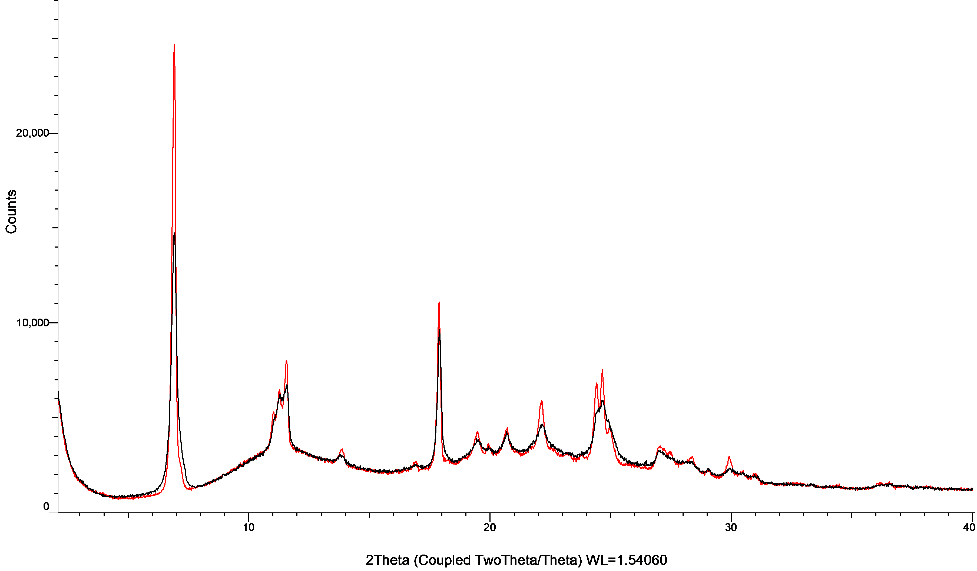

Figure S2: XRPD patterns of apixaban with PVP K25 in co-milled mixtures (black) and physical mixtures (red).
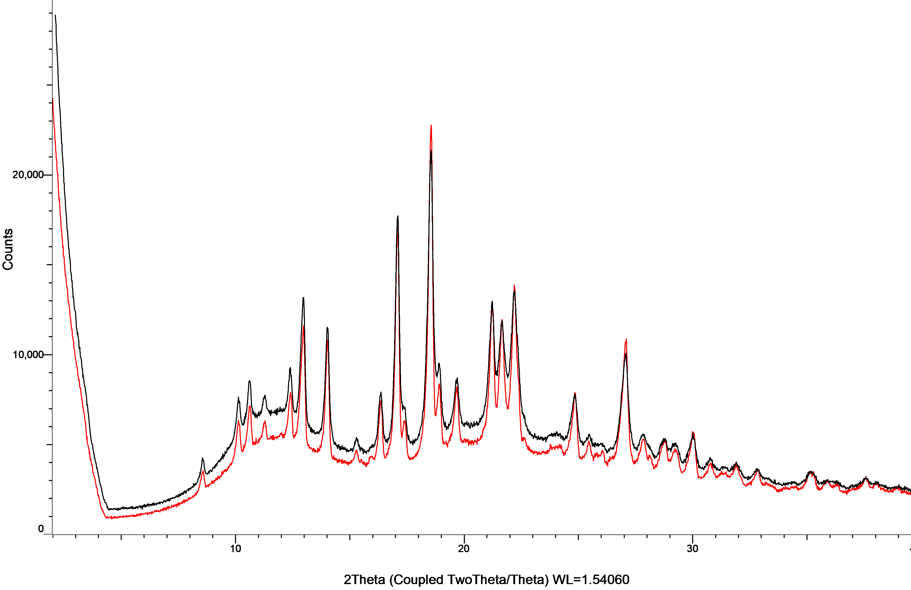
Figure S3: XRPD patterns of apremilast with PVP K25 in co-milled mixtures (black) and physical mixtures (red).
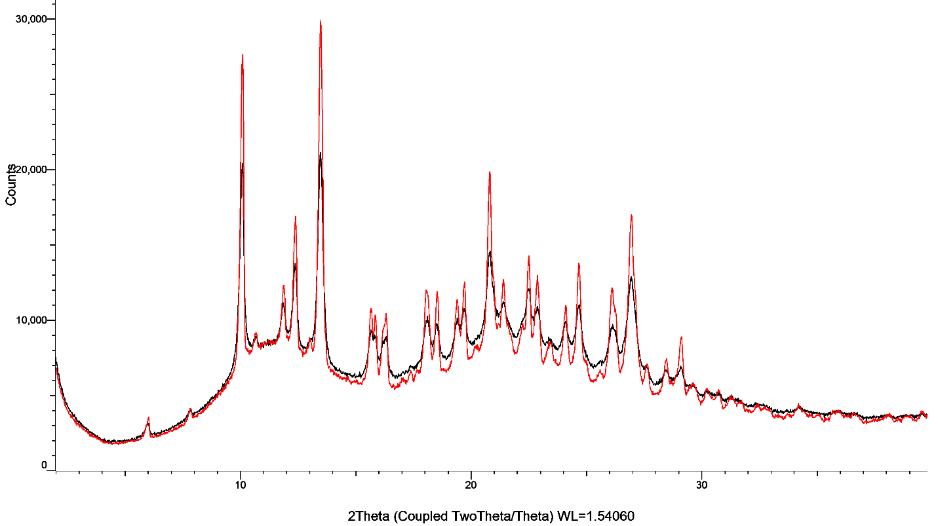

Figure S4: XRPD patterns of aripiprazole with PVP K25 in co-milled mixtures (black) and physical mixtures (red).
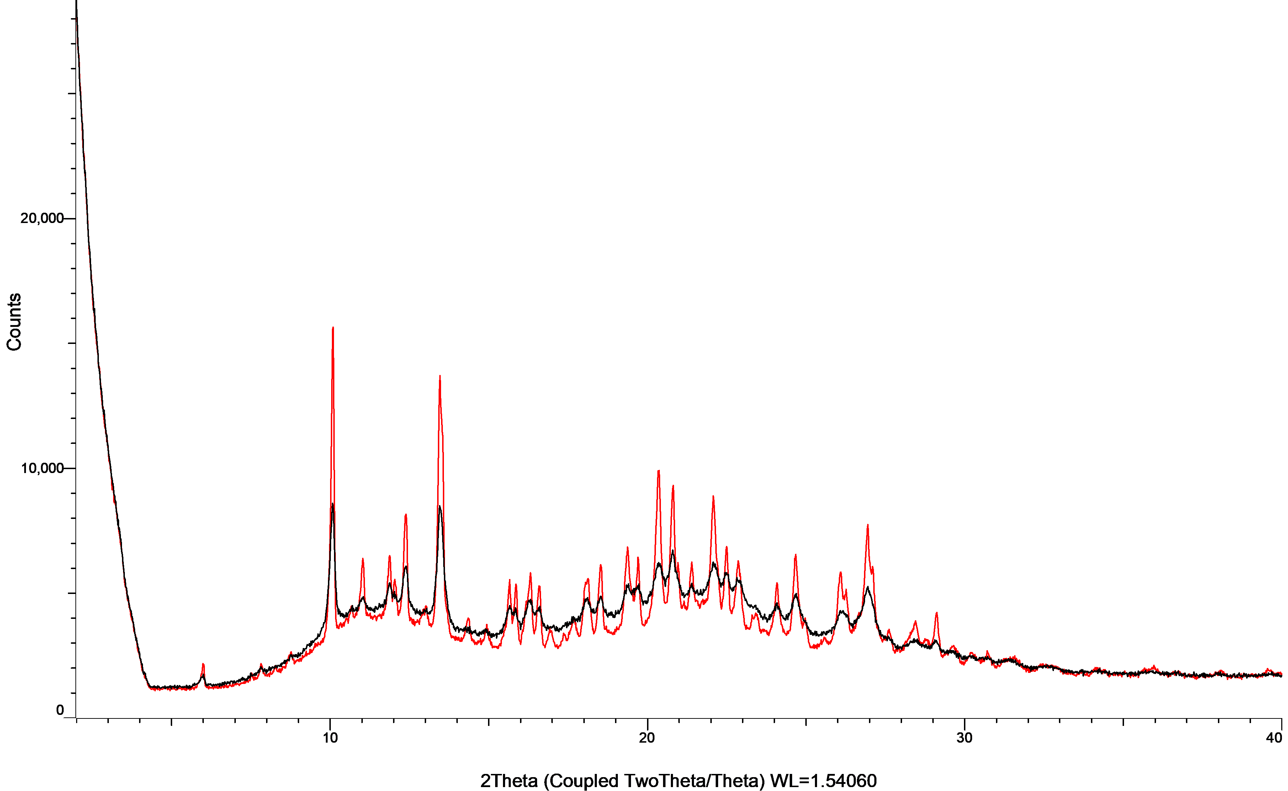

Figure S5: XRPD patterns of candesartan cilexetil with PVP K25 in co-milled mixtures (black) and physical mixtures (red).
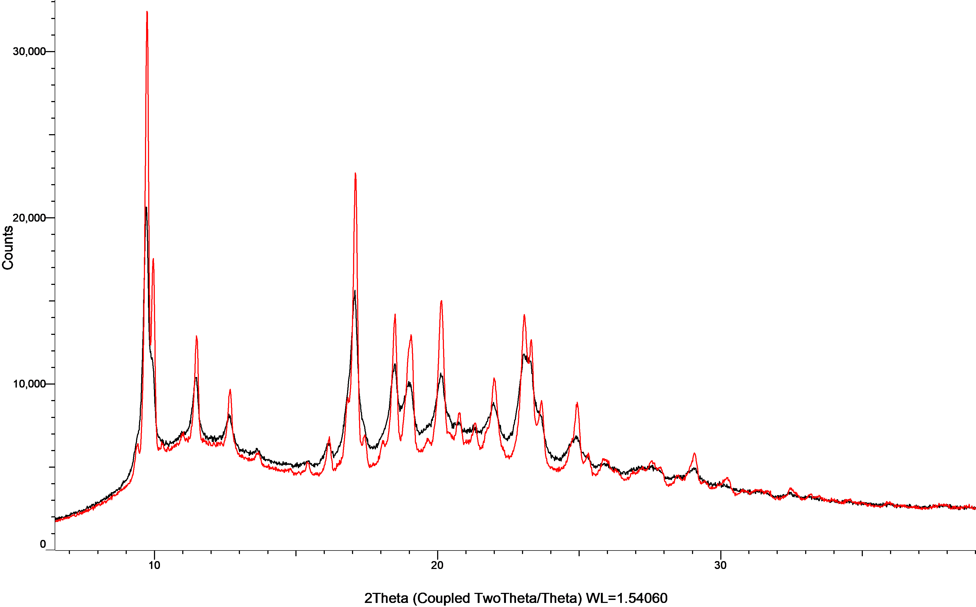

Figure S6: XRPD patterns of carbamazepine with PVP K25 in co-milled mixtures (black) and physical mixtures (red).
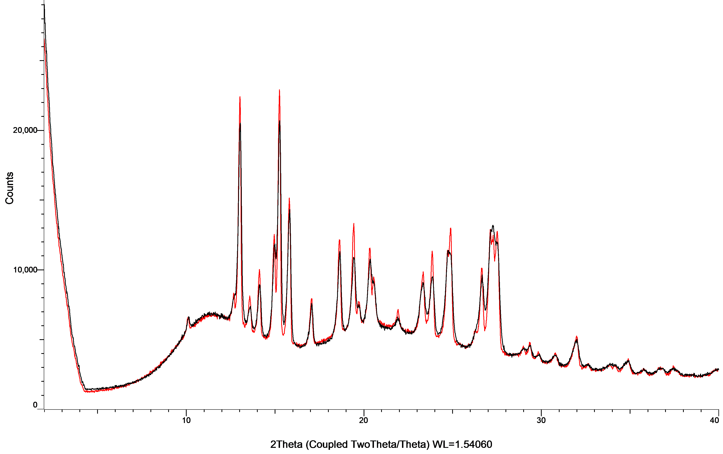
Figure S7: XRPD patterns of celecoxib with PVP K25 in co-milled mixtures (black) and physical mixtures (red).
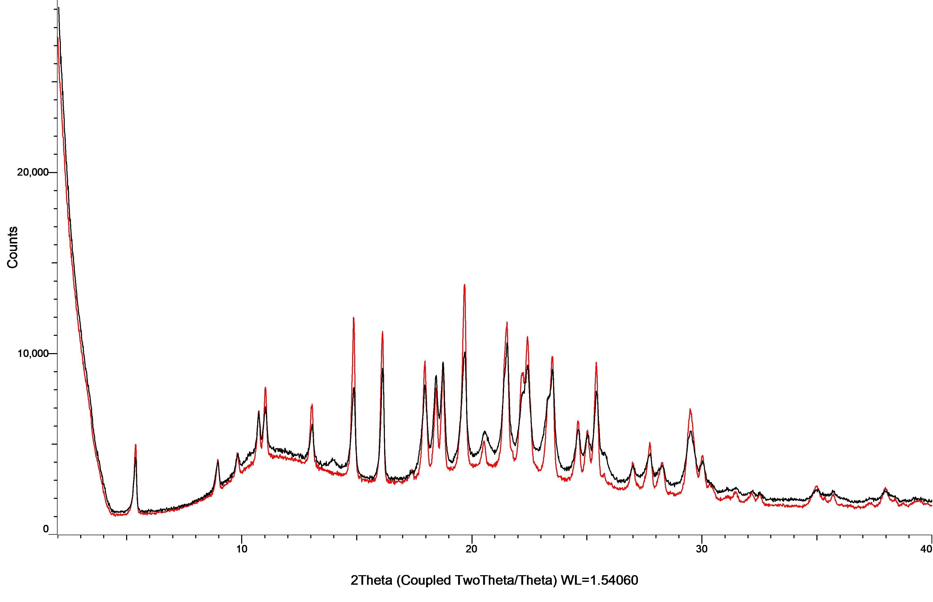

Figure S8: XRPD patterns of ceritinib with PVP K25 in co-milled mixtures (black) and physical mixtures (red).
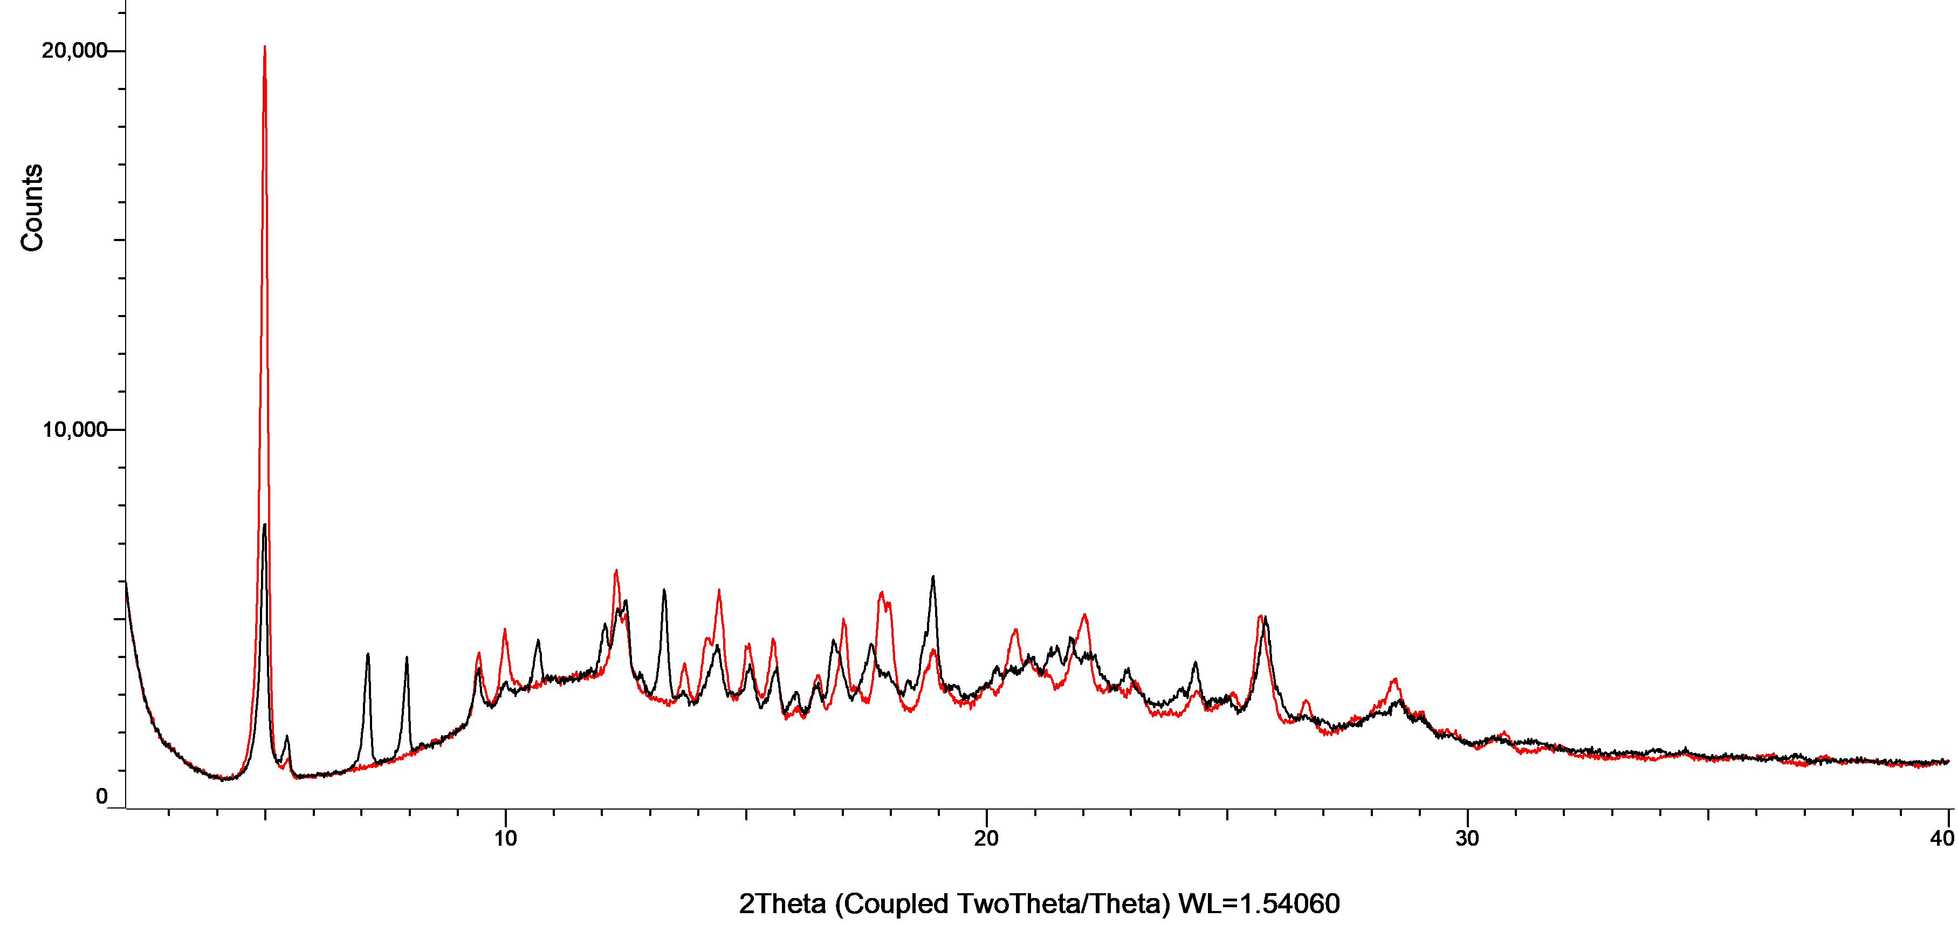

Figure S9: XRPD patterns of cinnarizine with PVP K25 in co-milled mixtures (black) and physical mixtures (red).
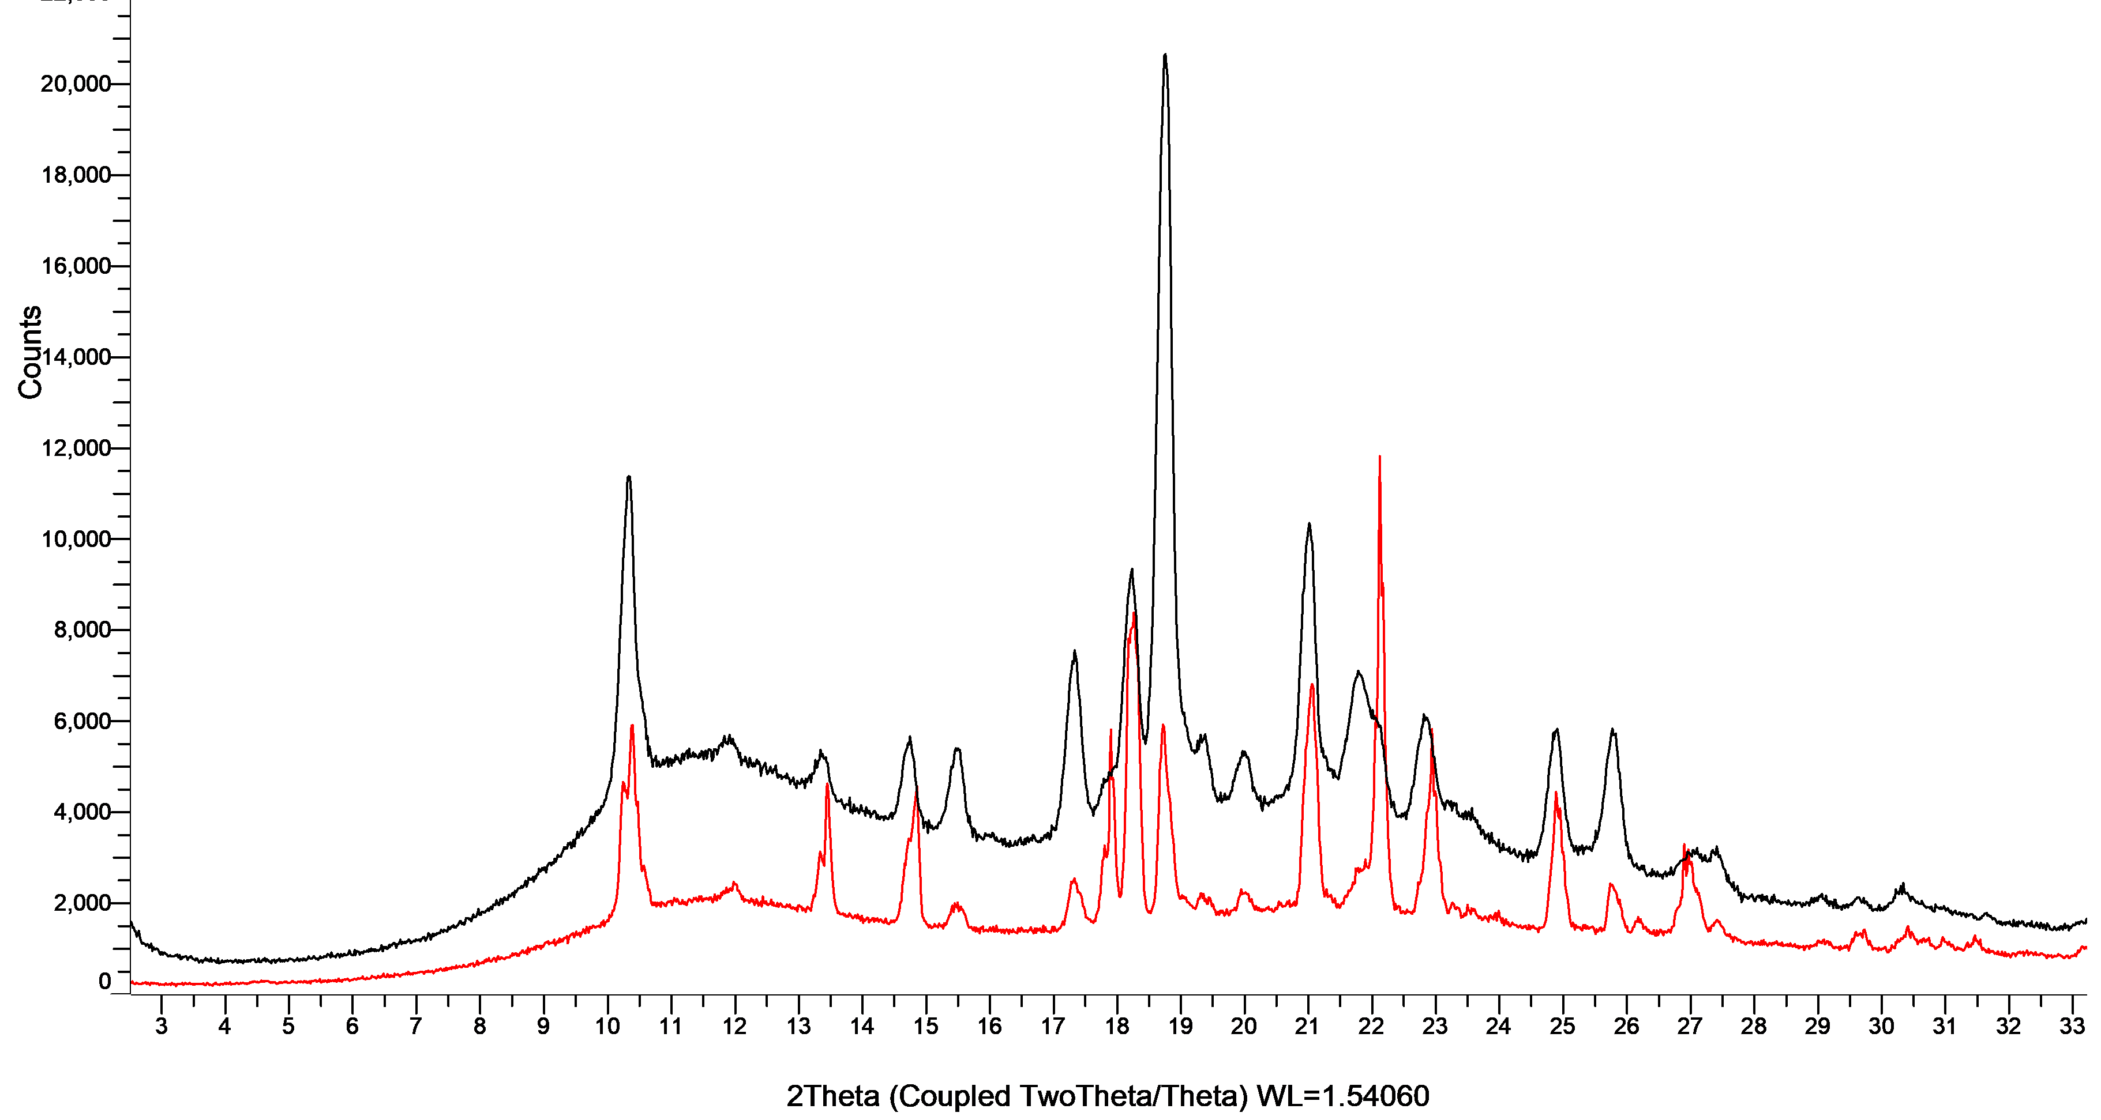

Figure S10: XRPD patterns of dasatinib with PVP K25 in co-milled mixtures (black) and physical mixtures (red).
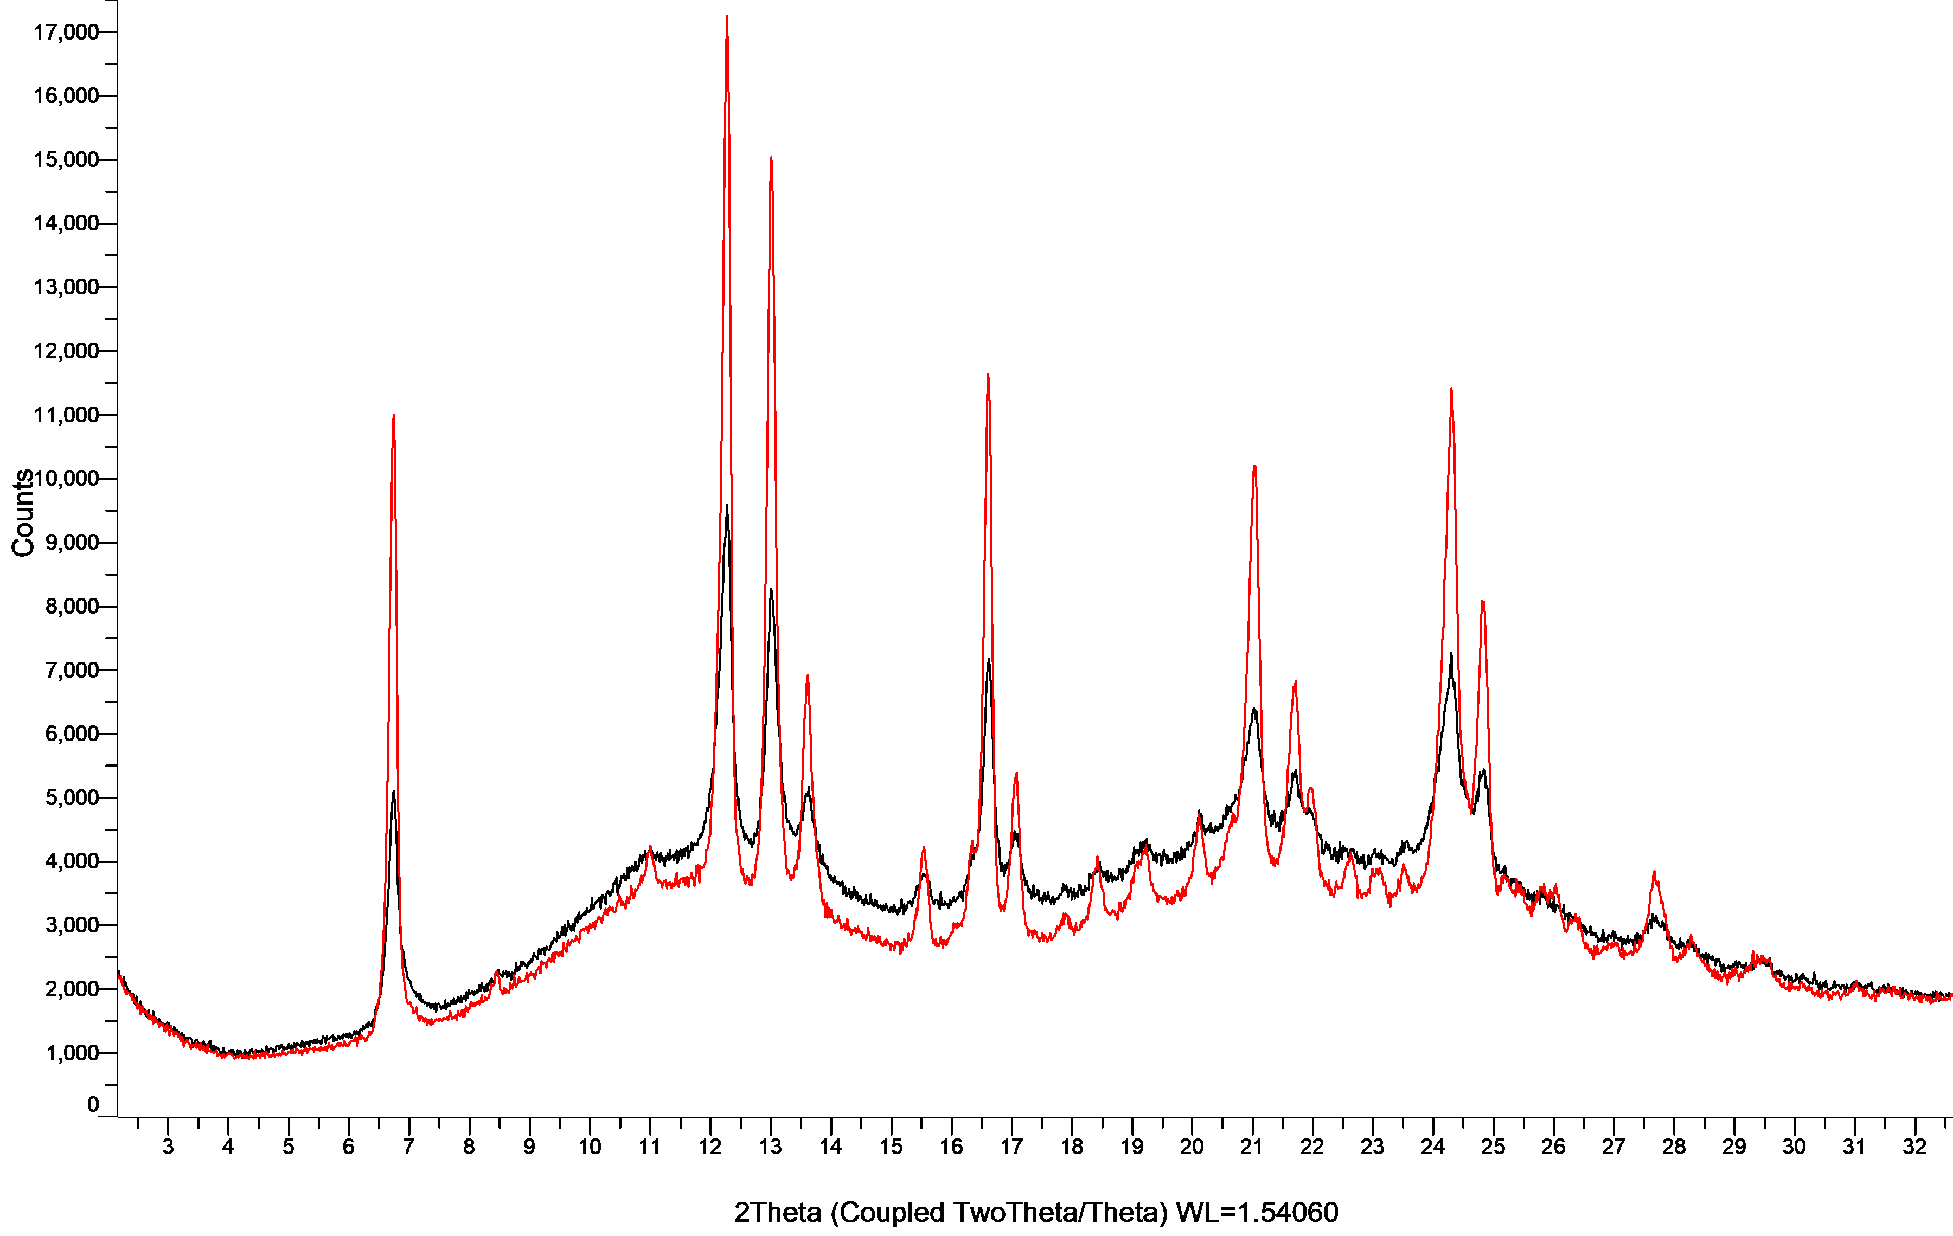

Figure S11: XRPD patterns of deferasirox with PVP K25 in co-milled mixtures (black) and physical mixtures (red).

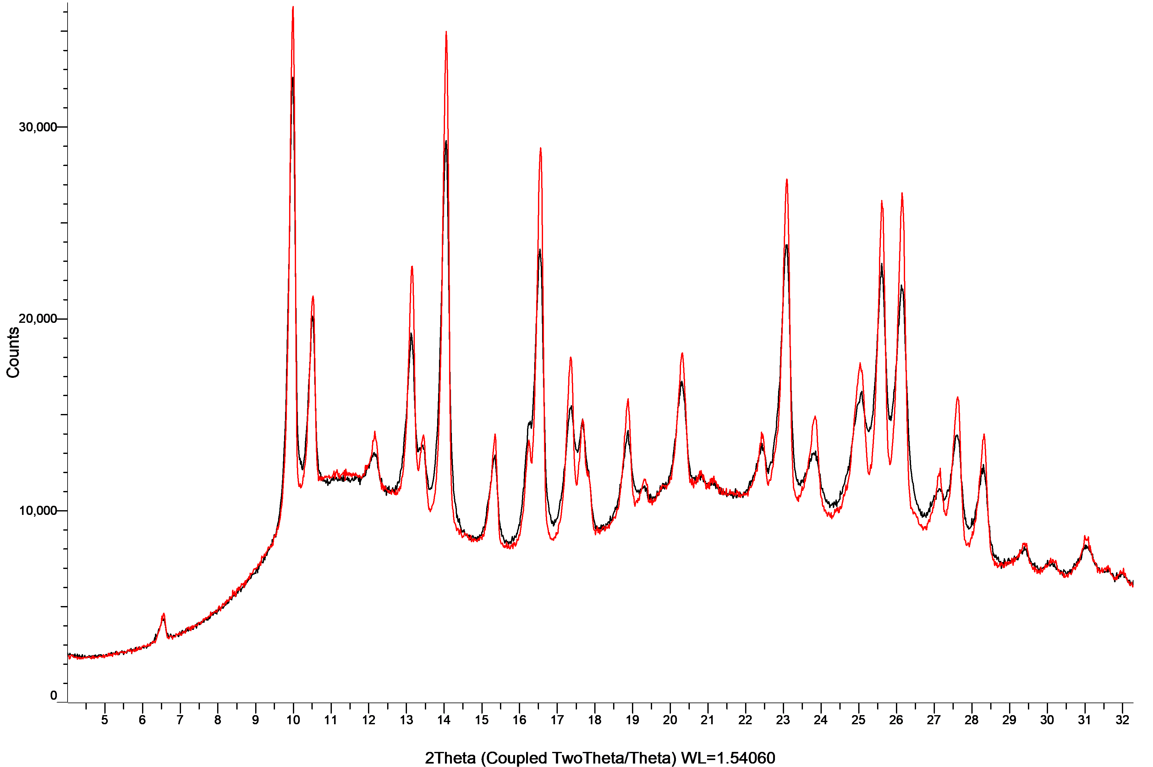

Figure S12: XRPD patterns of dipyridamole with PVP K25 in co-milled mixtures (black) and physical mixtures (red).
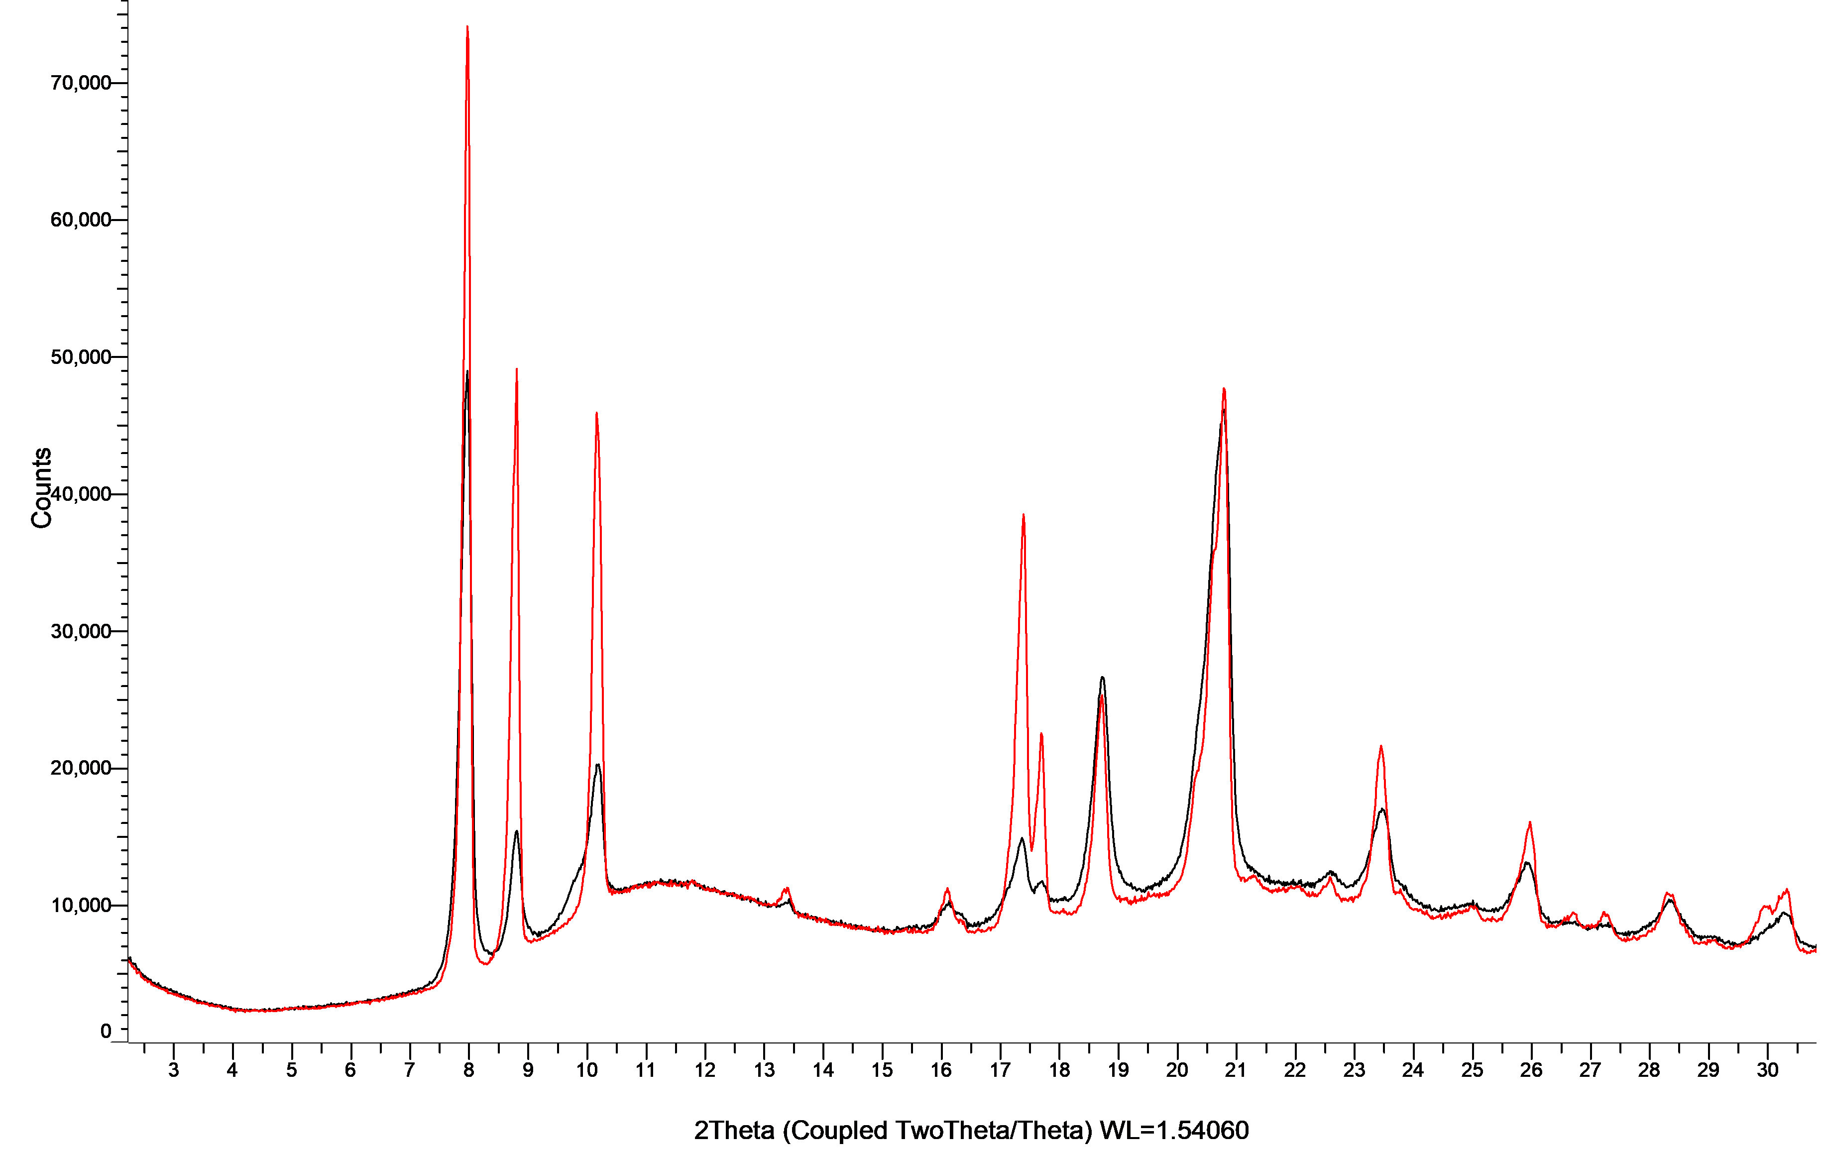

Figure S13: XRPD patterns of enzalutamide with PVP K25 in co-milled mixtures (black) and physical mixtures (red).

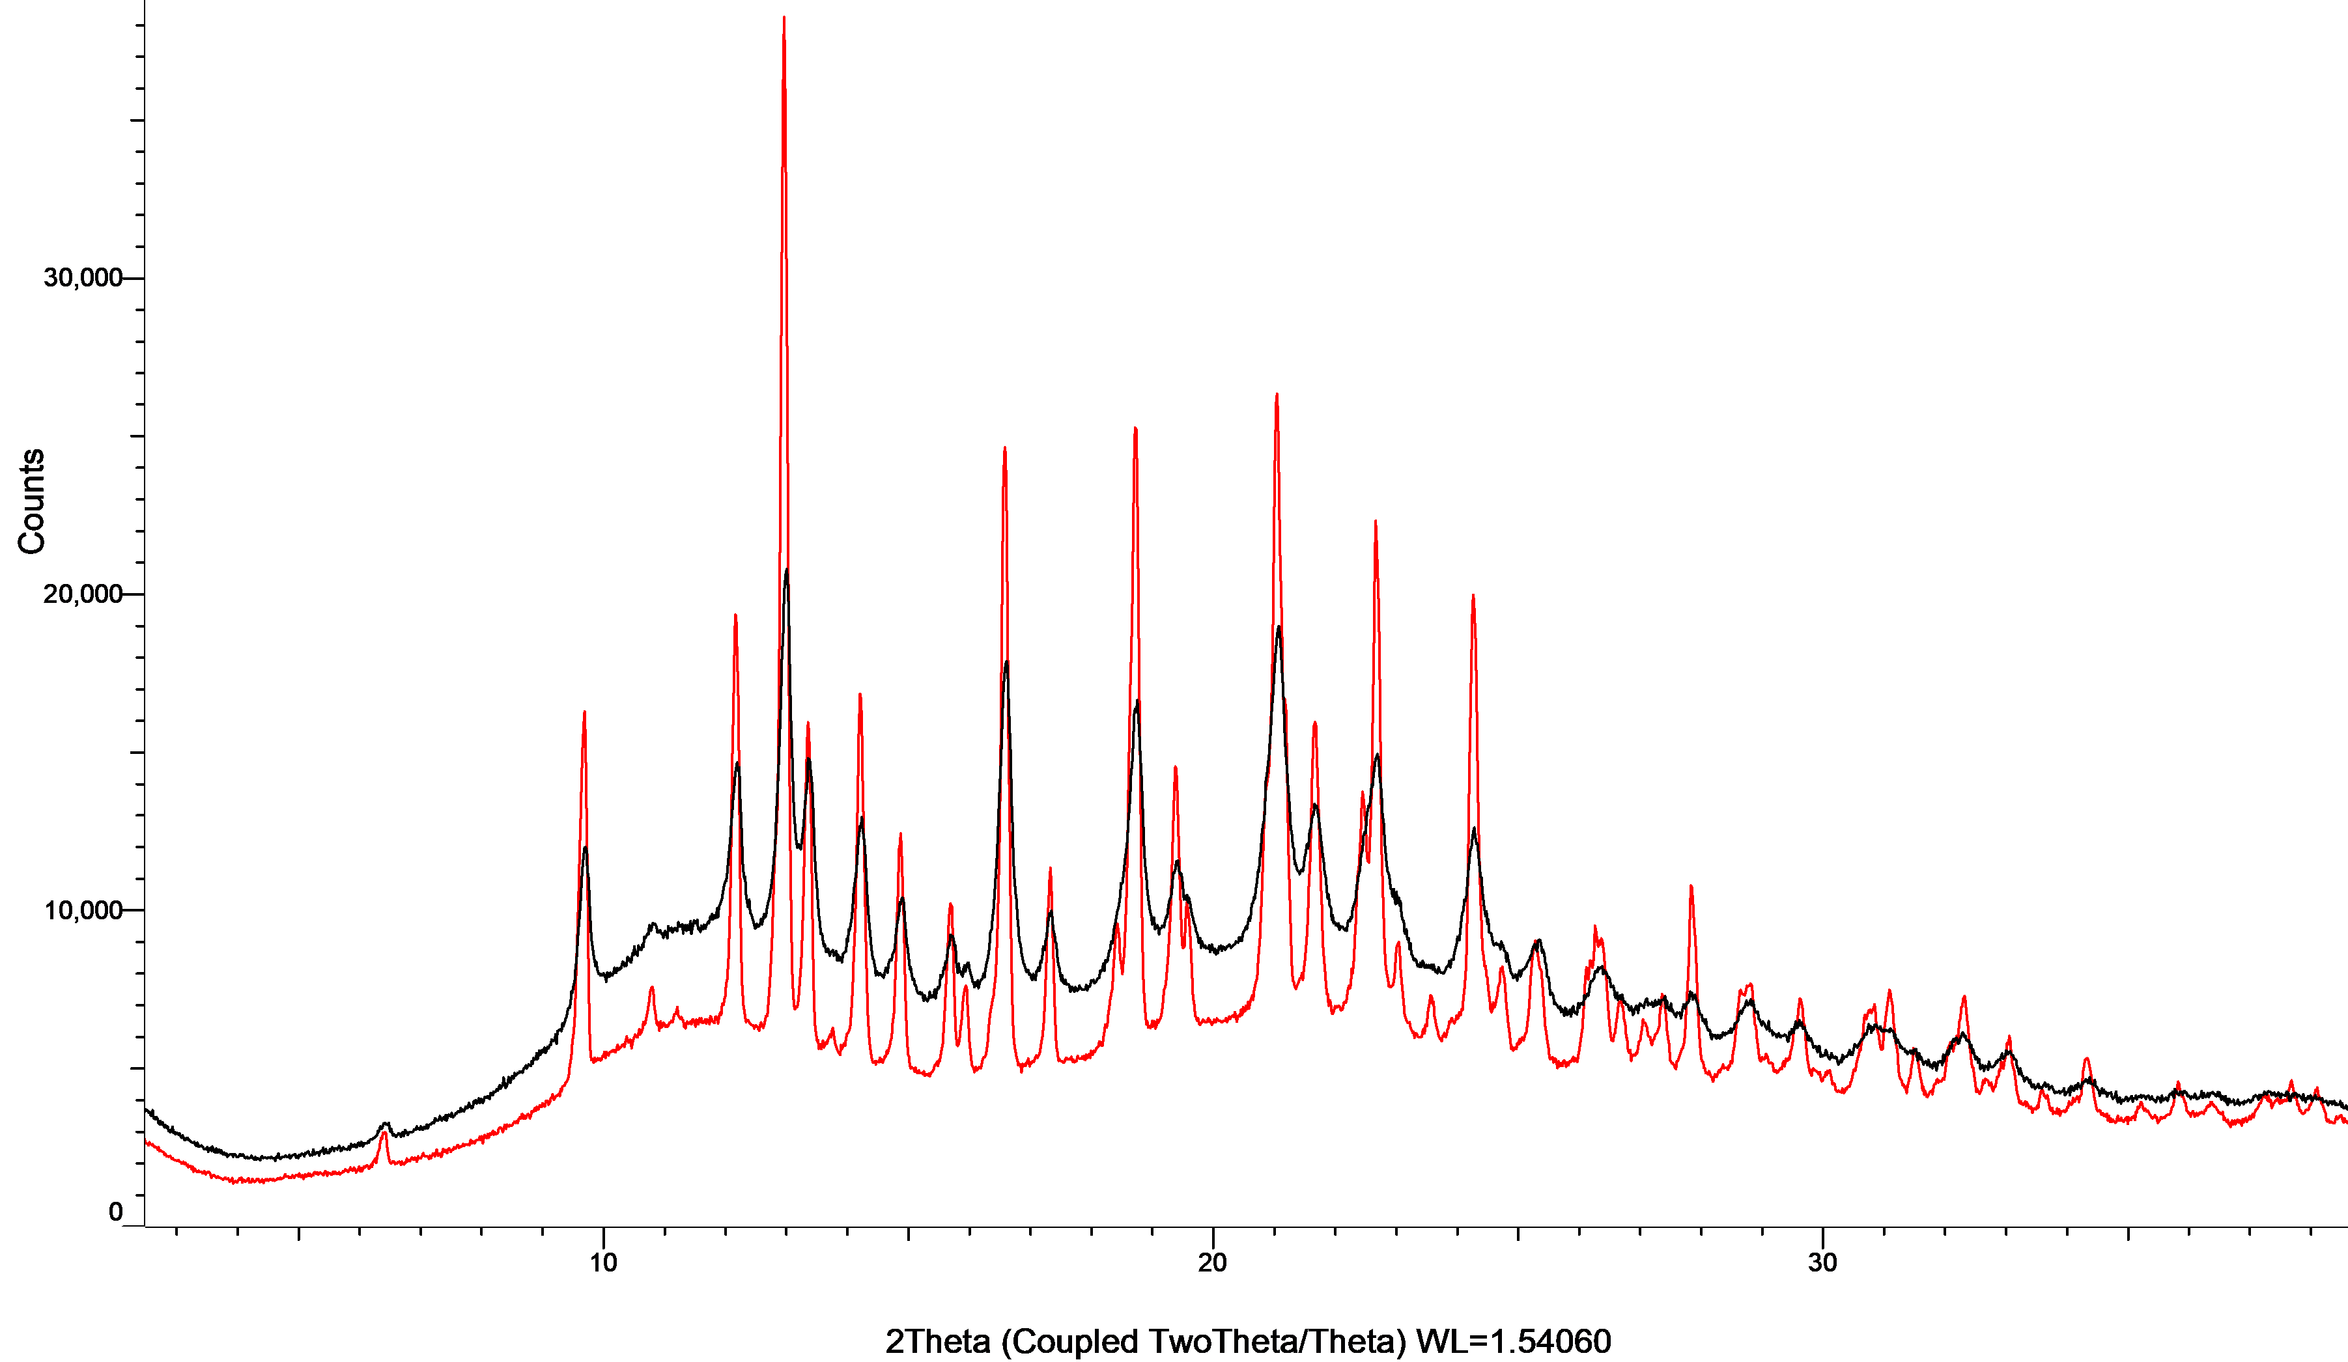

Figure S14: XRPD patterns of etoricoxib with PVP K25 in co-milled mixtures (black) and physical mixtures (red).
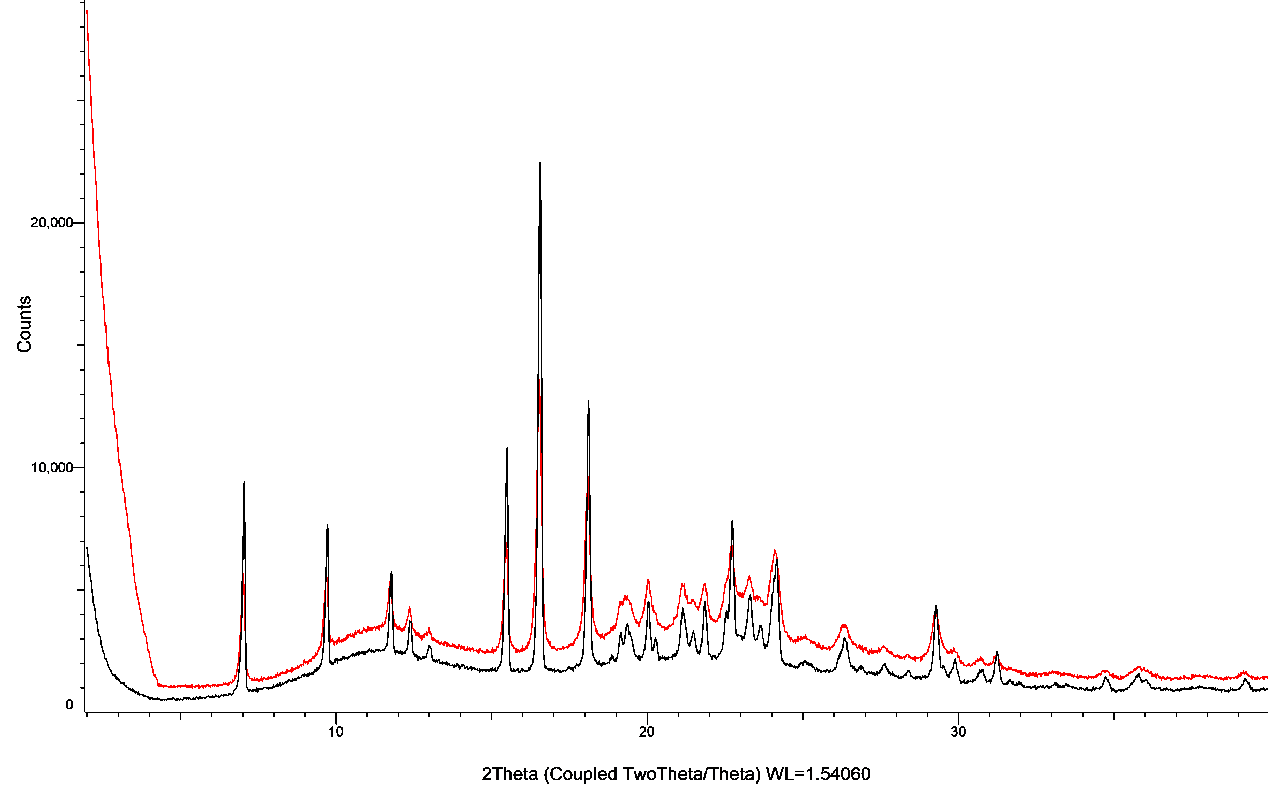
Figure S15: XRPD patterns of ezetimibe with PVP K25 in co-milled mixtures (black) and physical mixtures (red).
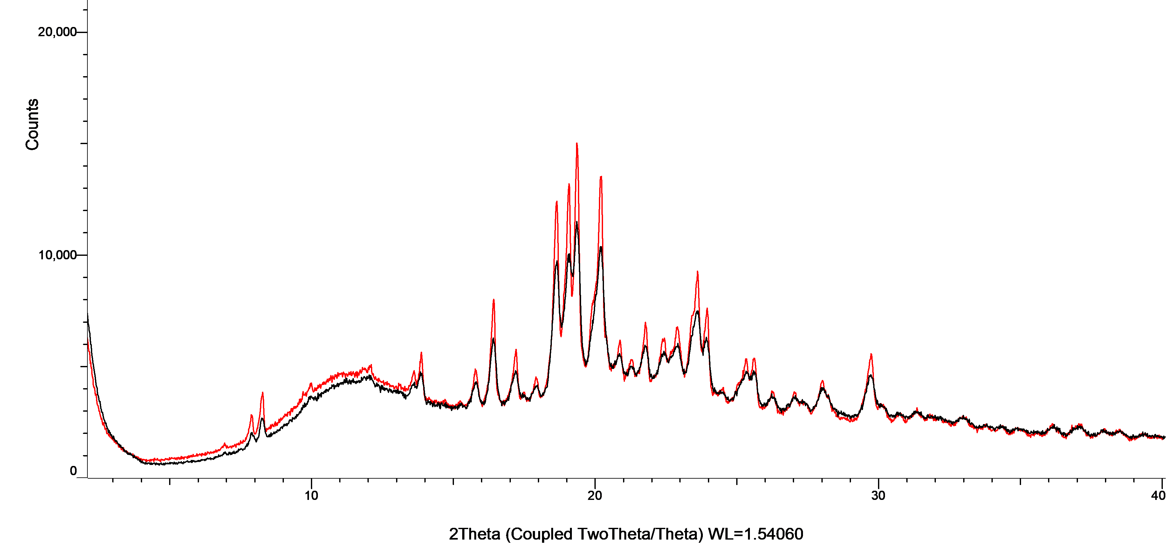

Figure S16: XRPD patterns of fenofibrate with PVP K25 in co-milled mixtures (black) and physical mixtures (red).
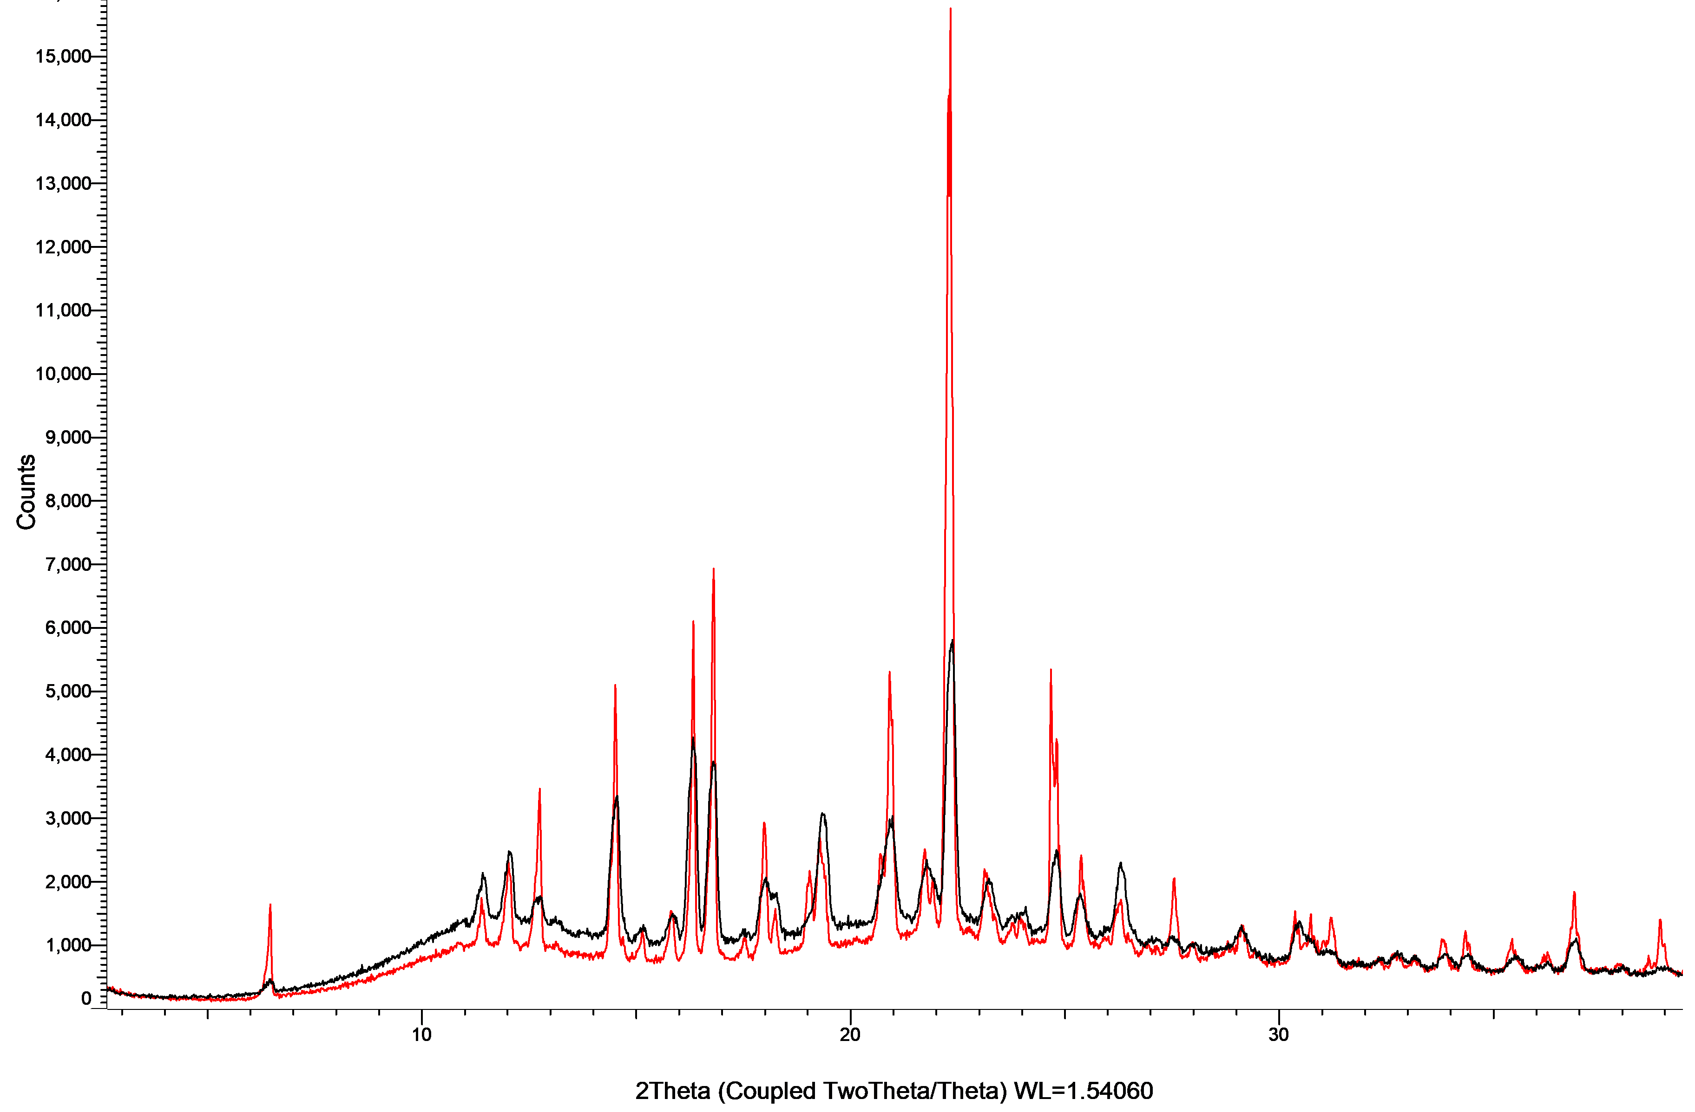

Figure S17: XRPD patterns of gemfibrozil with PVP K25 in co-milled mixtures (black) and physical mixtures (red).
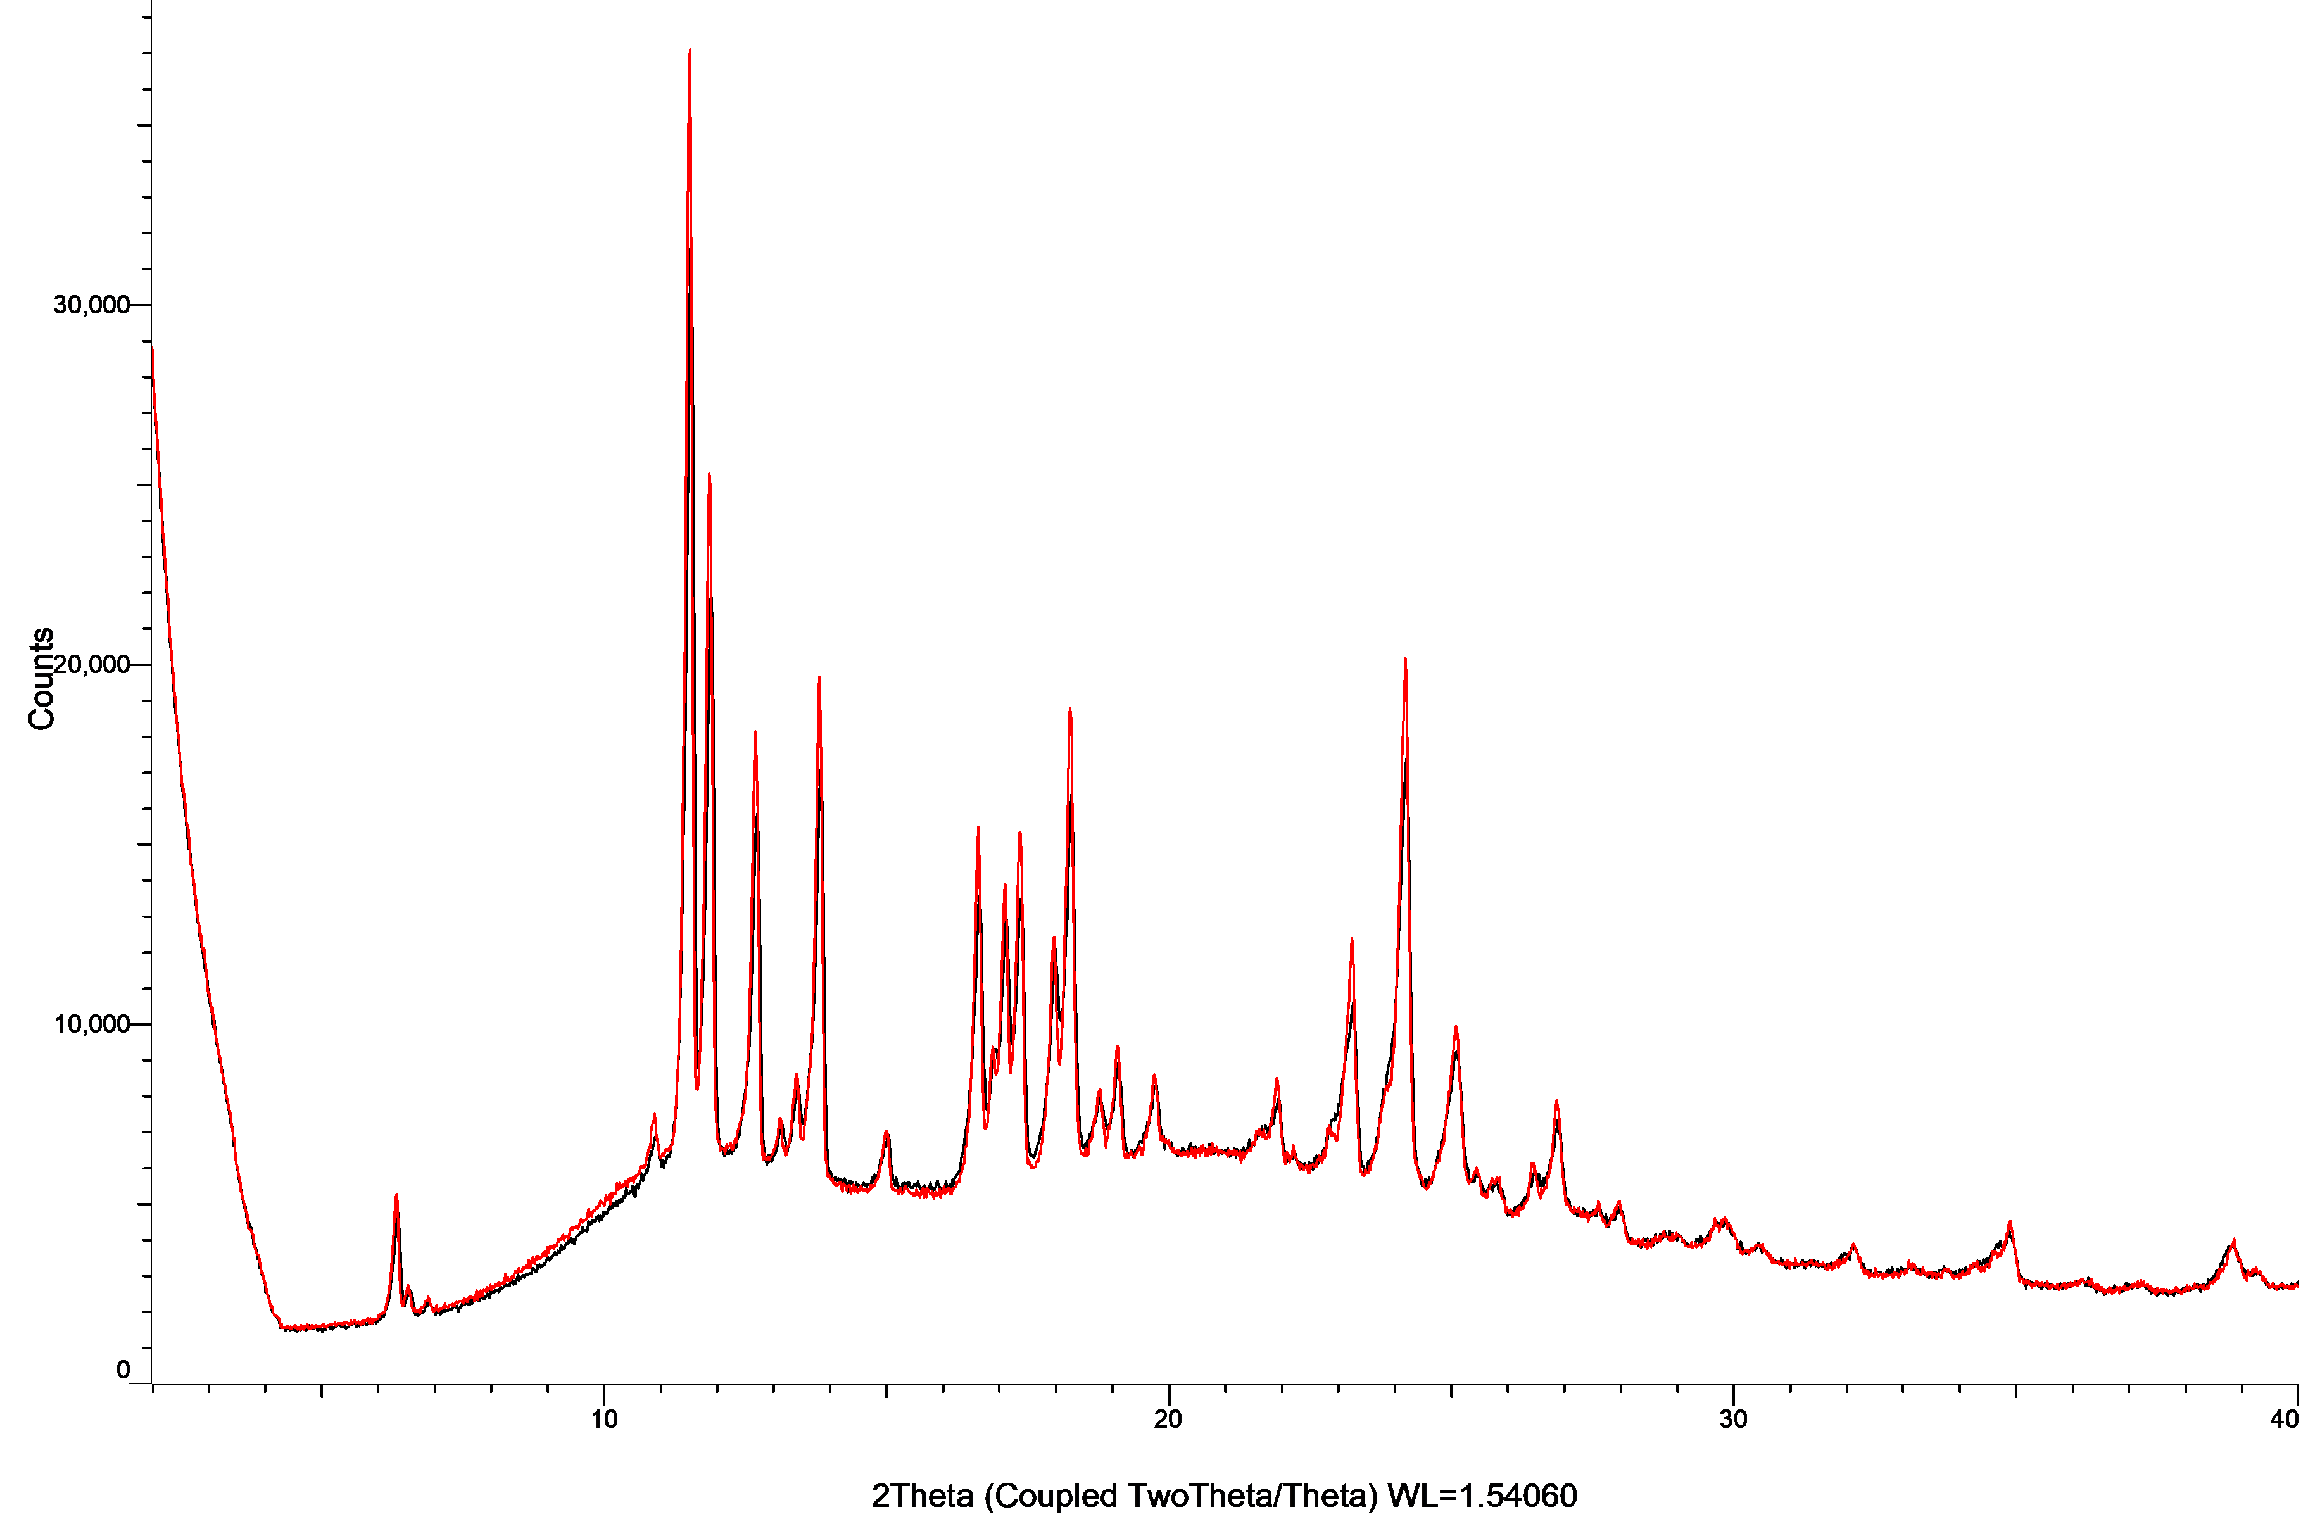

Figure S18: XRPD patterns of glibenclamide with PVP K25 in co-milled mixtures (black) and physical mixtures (red).
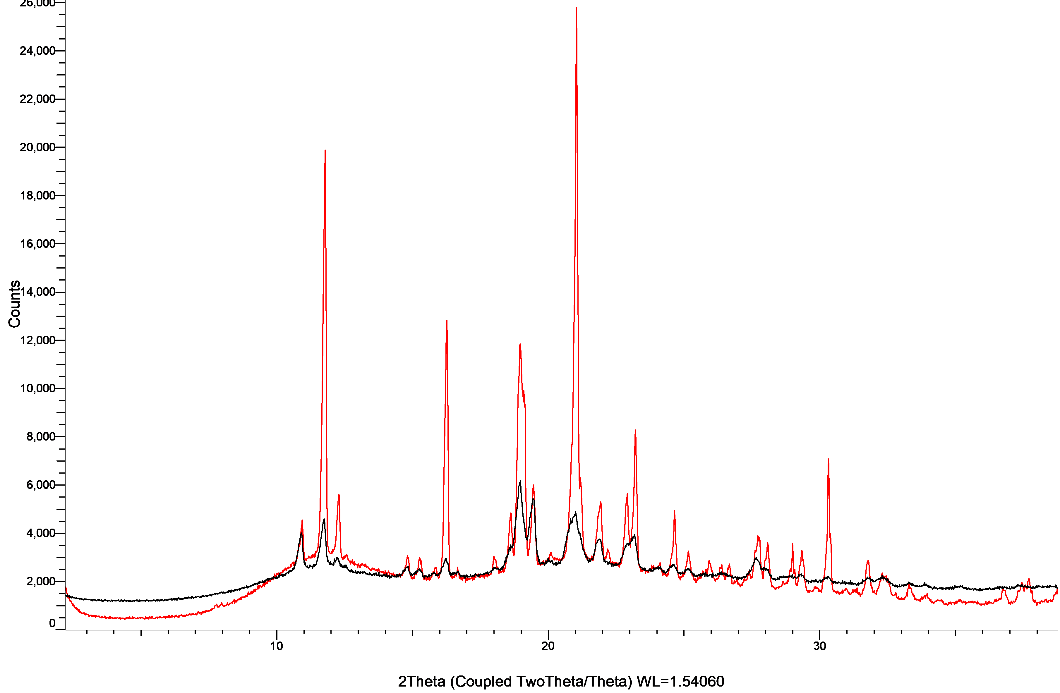
Figure S19: XRPD patterns of griseofulvin with PVP K25 in co-milled mixtures (black) and physical mixtures (red). 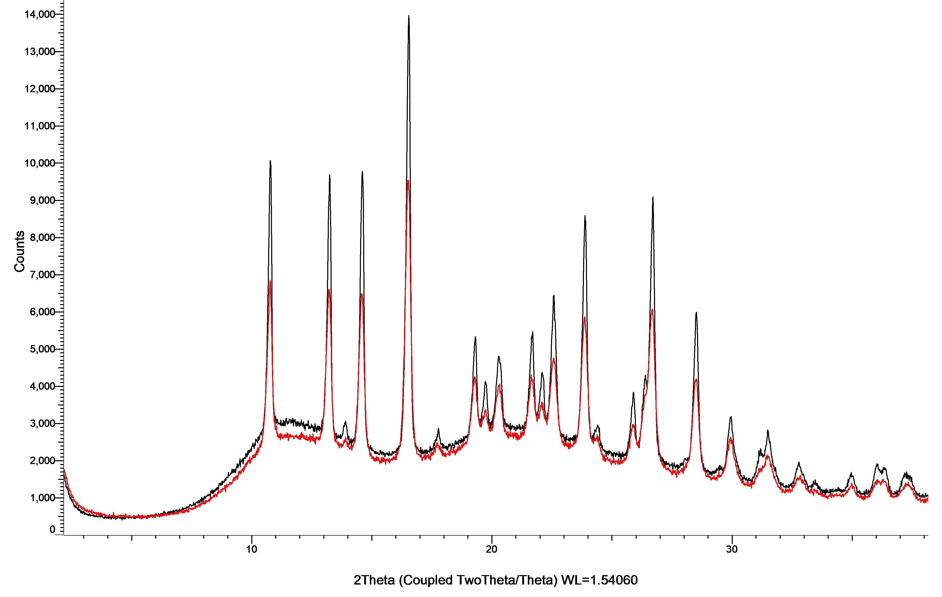
Figure S20: XRPD patterns of indomethacin with PVP K25 in co-milled mixtures (black) and physical mixtures (red).
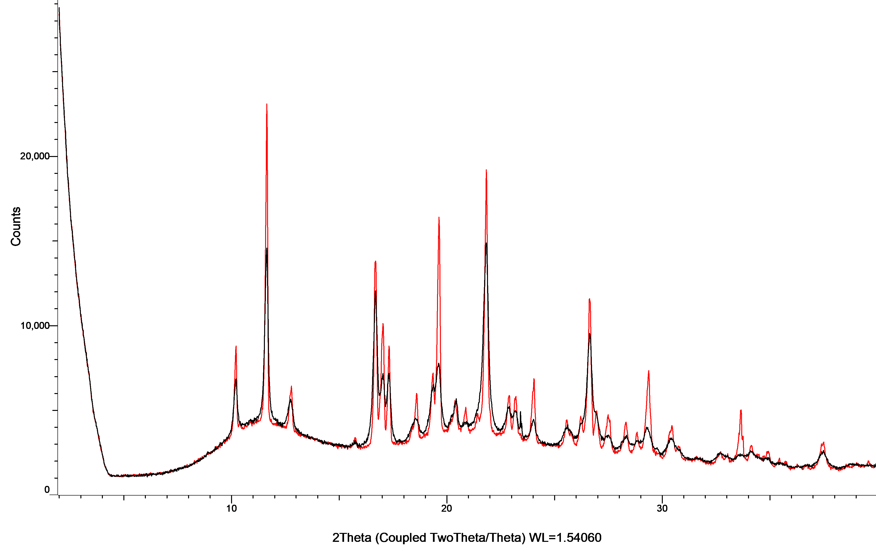

Figure S21: XRPD patterns of mefenamic acid with PVP K25 in co-milled mixtures (black) and physical mixtures (red).
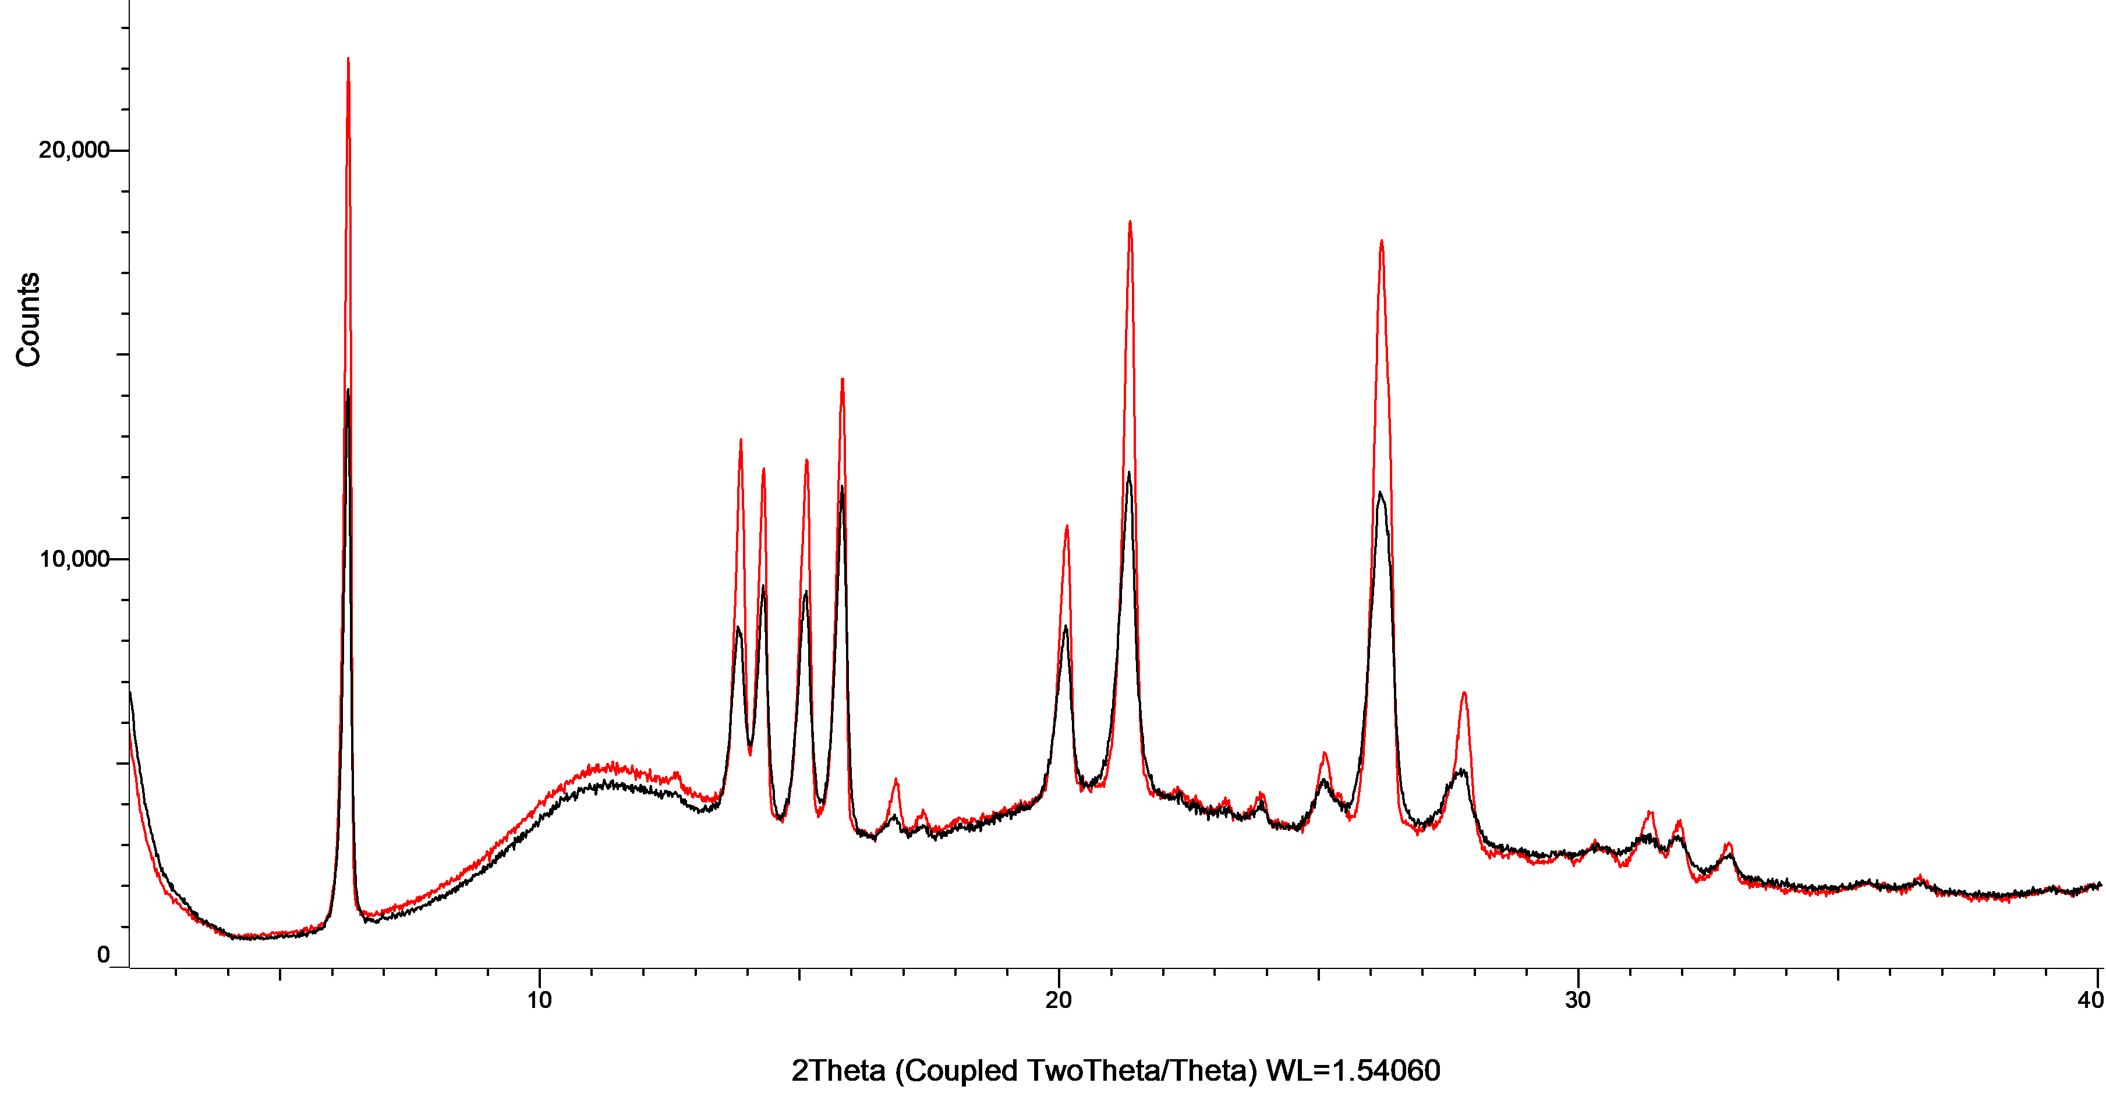

Figure S22: XRPD patterns of nilotinib with PVP K25 in co-milled mixtures (black) and physical mixtures (red).
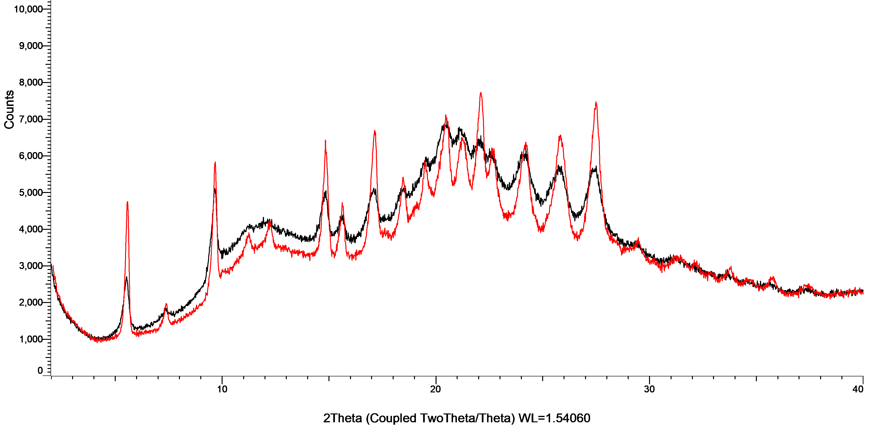

Figure S23: XRPD patterns of nimesulide with PVP K25 in co-milled mixtures (black) and physical mixtures (red).
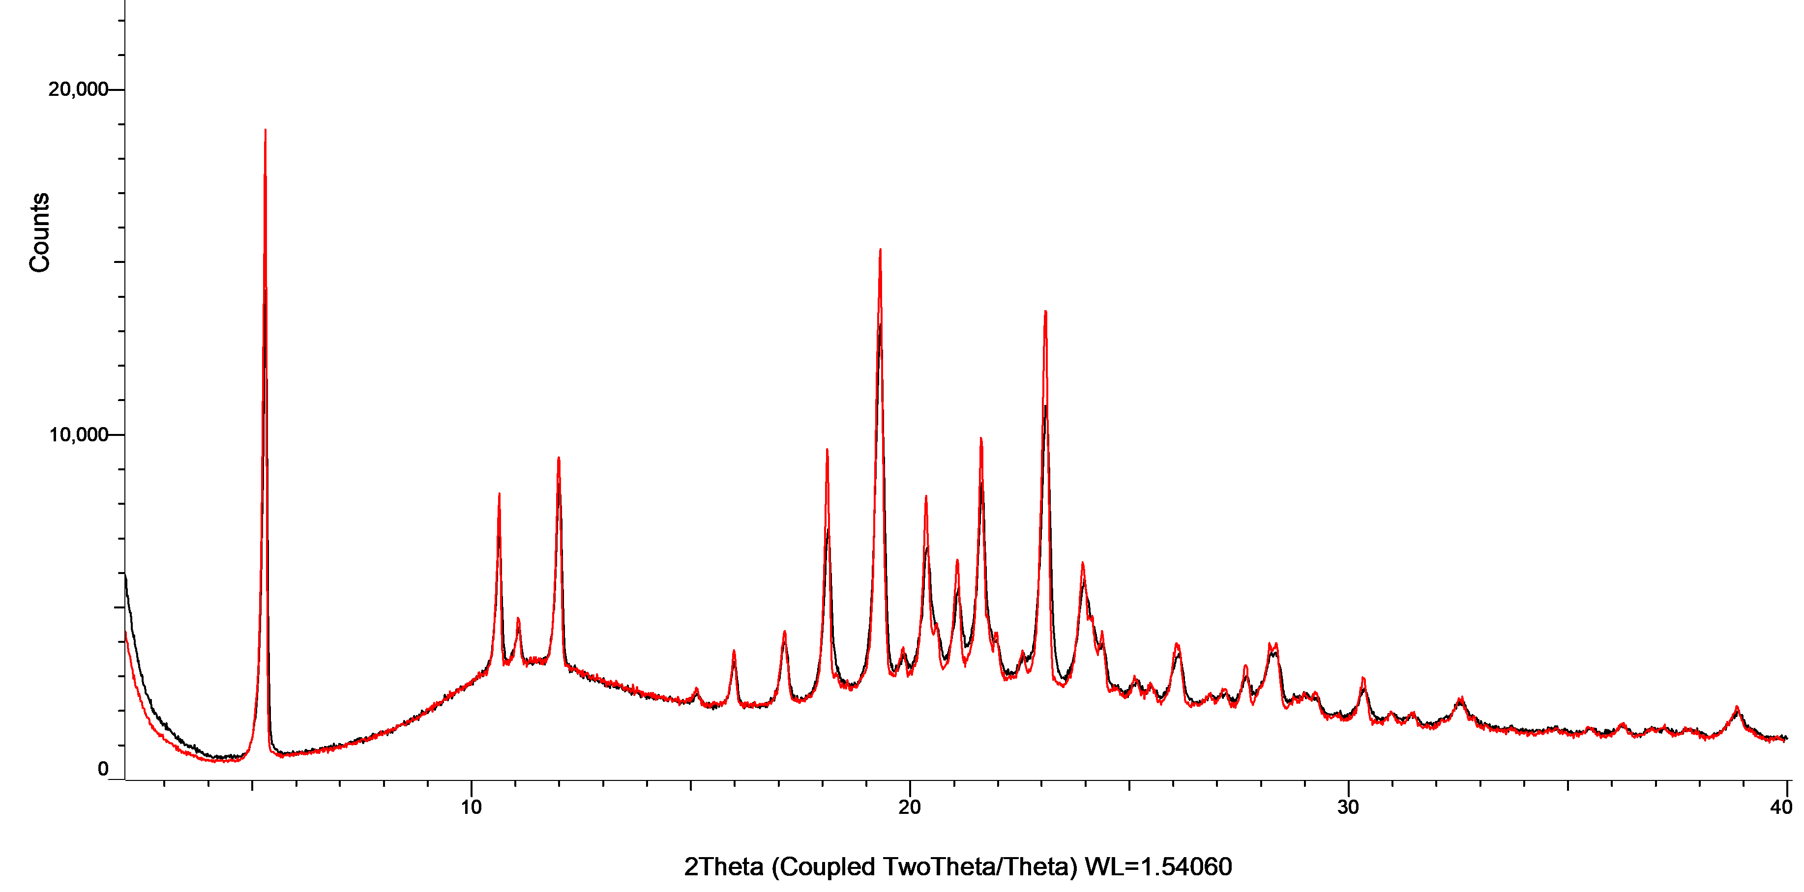

Figure S24: XRPD patterns of olaparib with PVP K25 in co-milled mixtures (black) and physical mixtures (red).
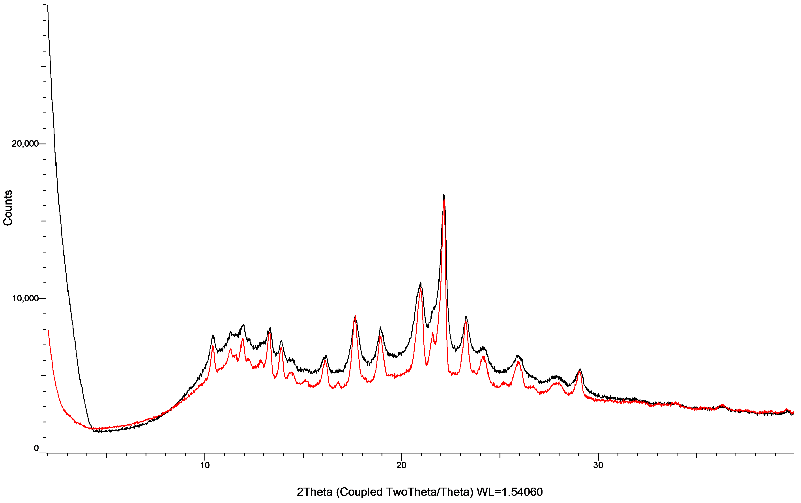

Figure S25: XRPD patterns of rivaroxaban with PVP K25 in co-milled mixtures (black) and physical mixtures (red).
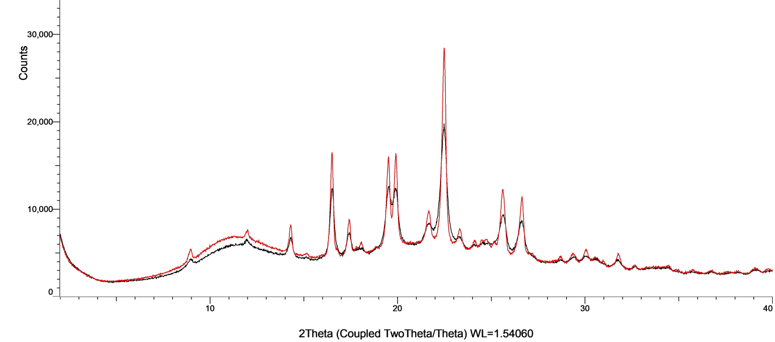

Figure S26: XRPD patterns of sertraline with PVP K25 in co-milled mixtures (black) and physical mixtures (red).
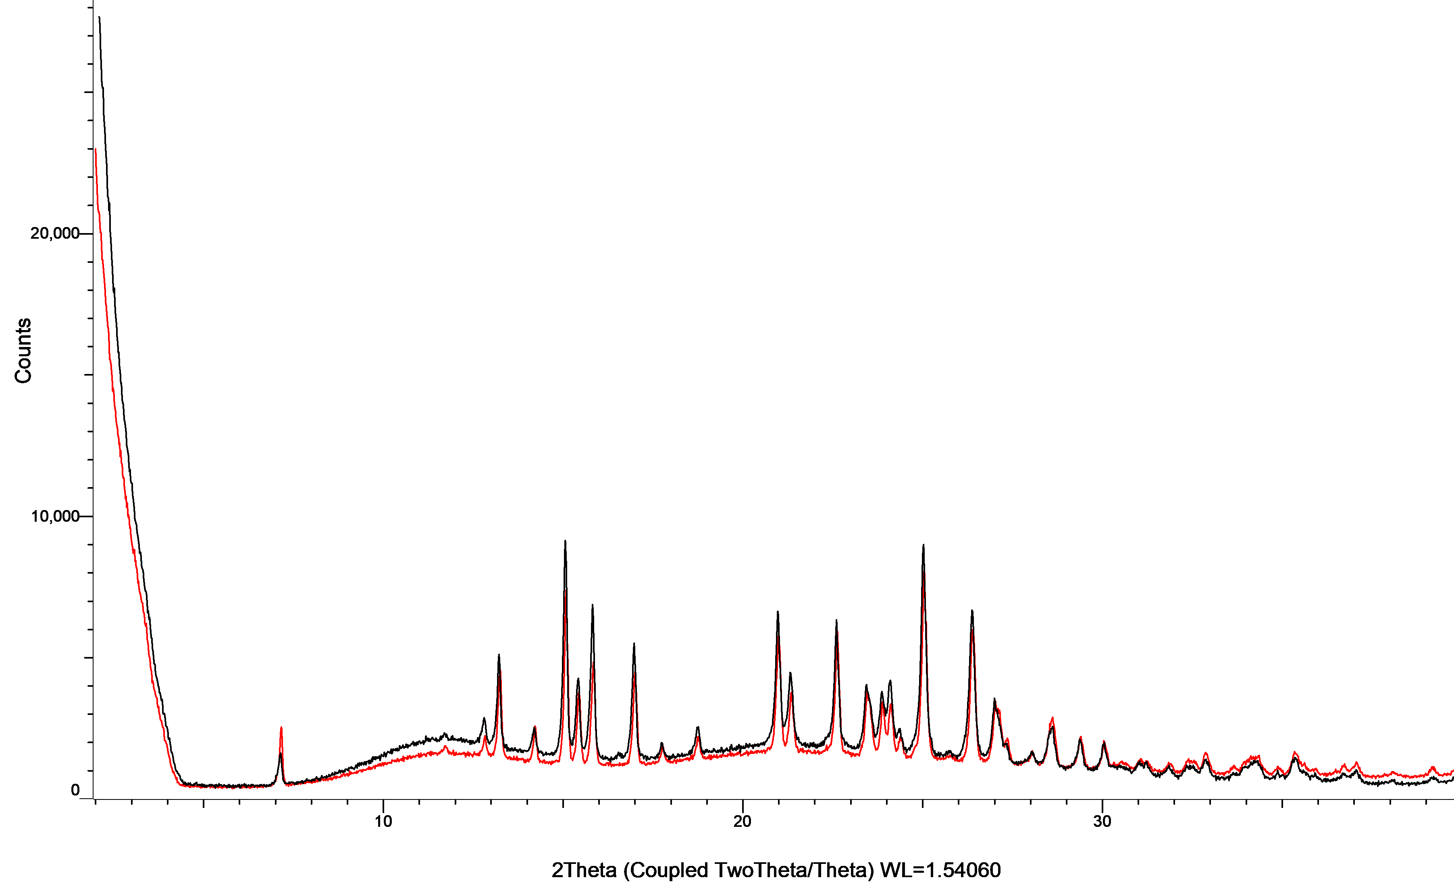

Figure S27: XRPD patterns of sorafenib with PVP K25 in co-milled mixtures (black) and physical mixtures (red).
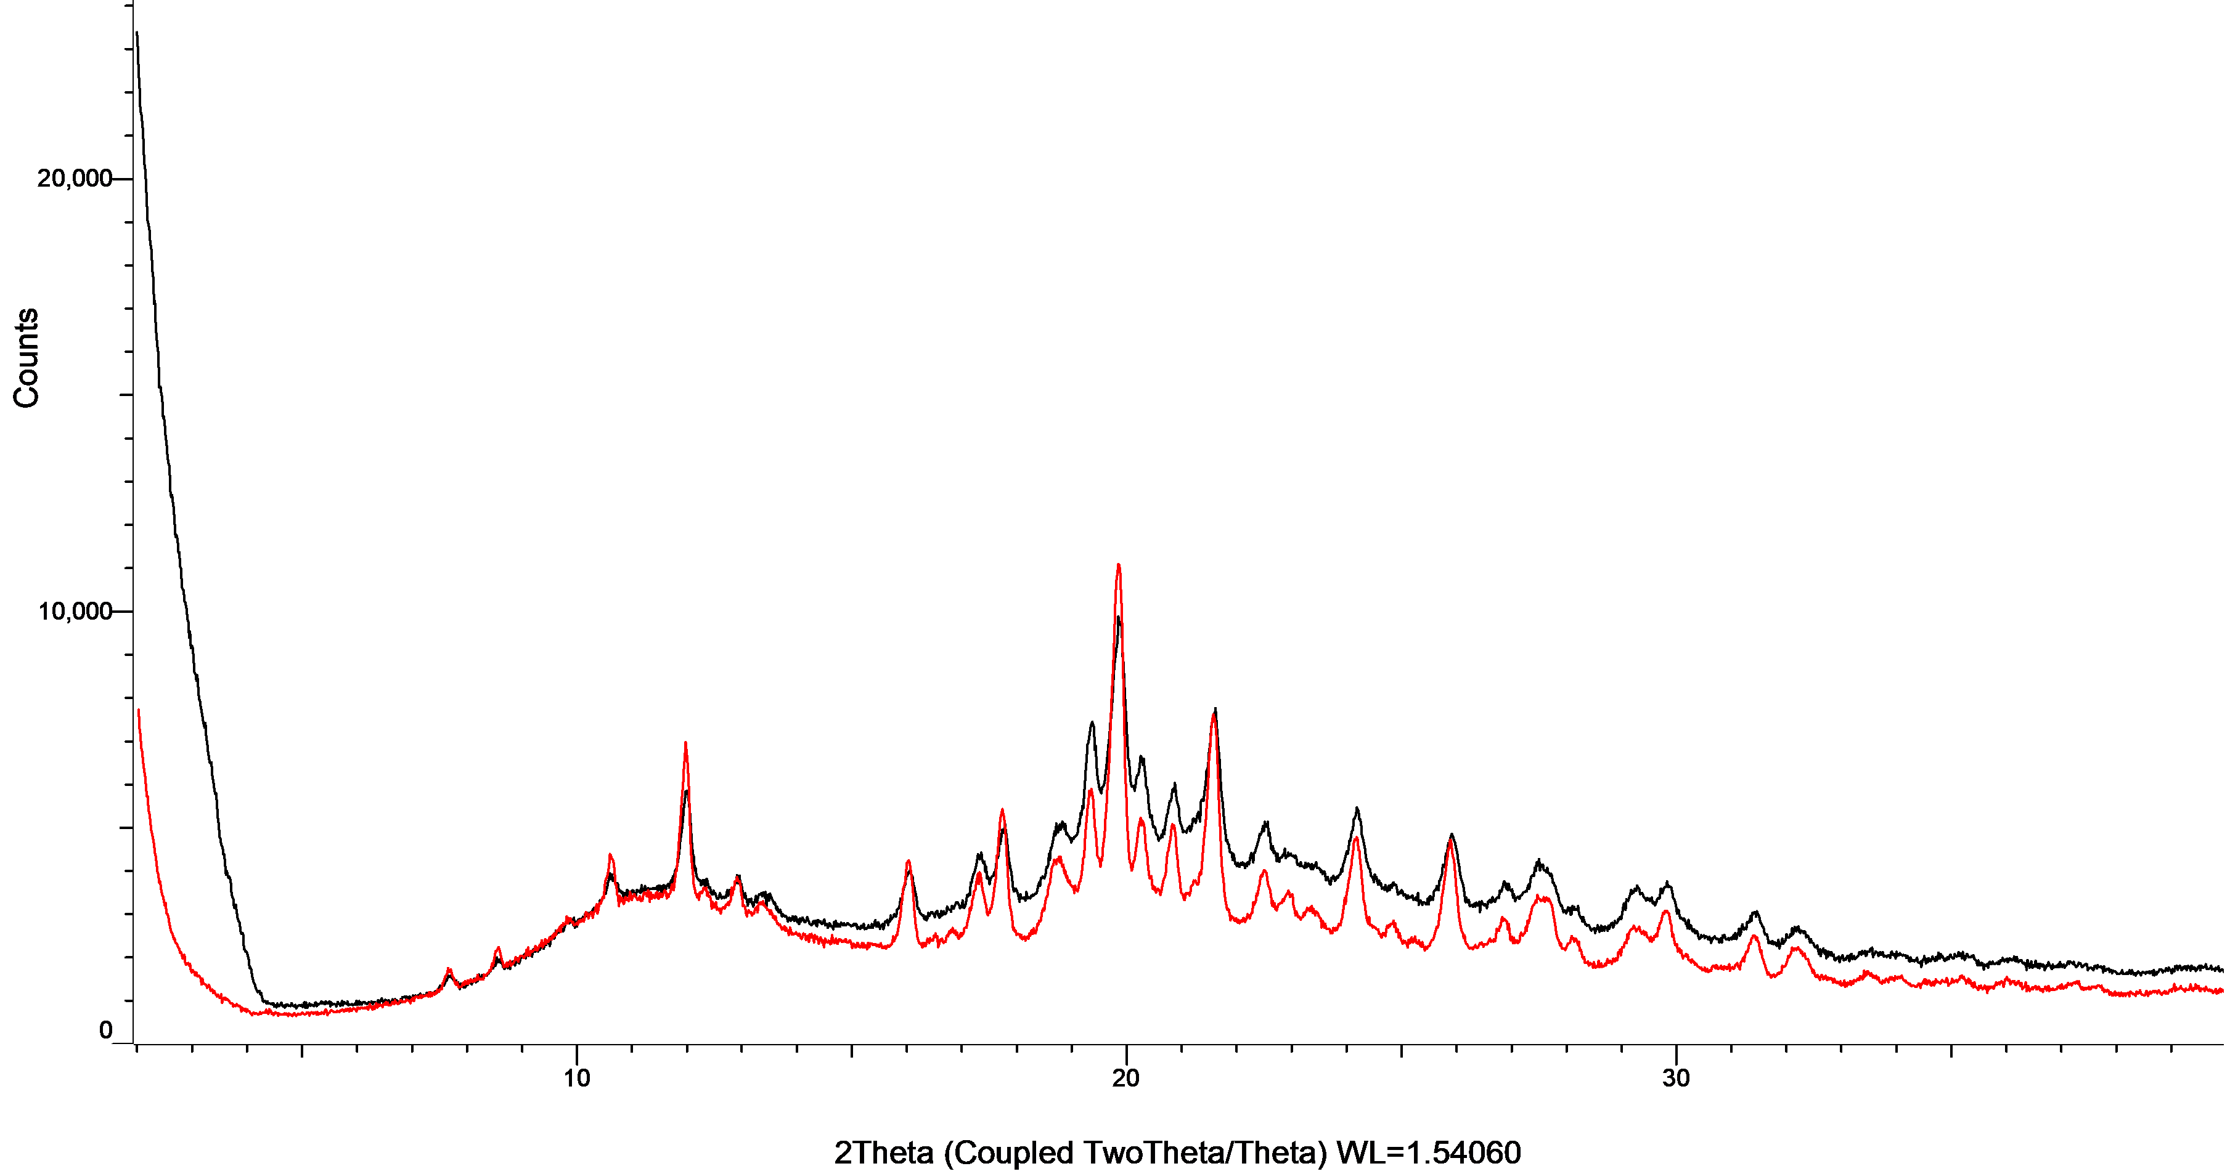

Figure S28: XRPD patterns of tadalafil with PVP K25 in co-milled mixtures (black) and physical mixtures (red).
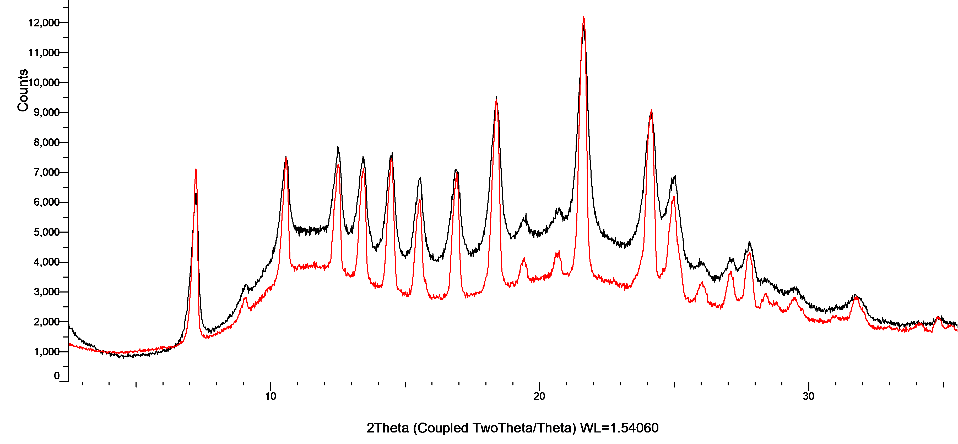

Figure S29: XRPD patterns of thiabendazole with PVP K25 in co-milled mixtures (black) and physical mixtures (red).
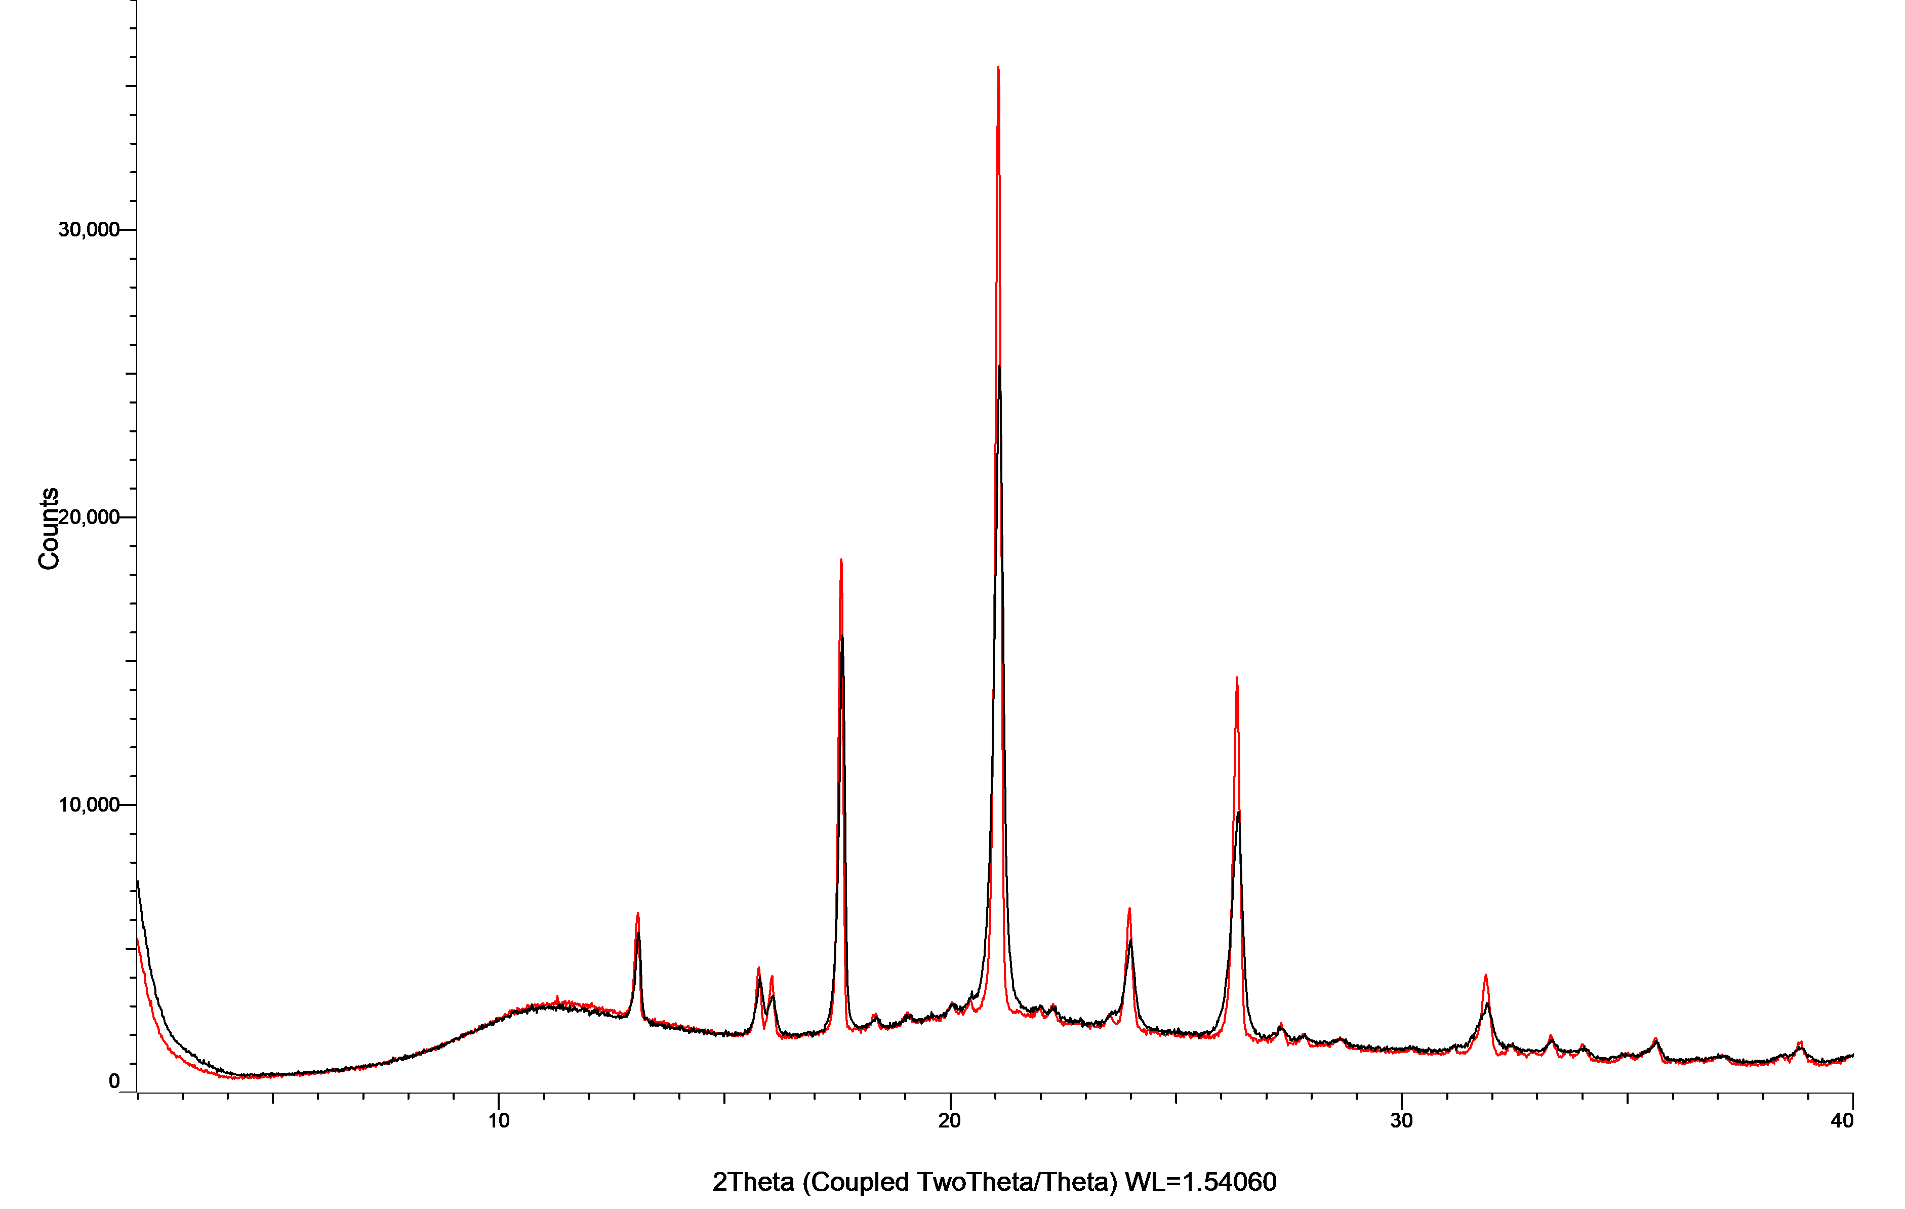

- Powder X-ray diffractograms of of unprocessed drug powder and milled drug powder

Figure S30: XRPD patterns of albendazole powder (blue) and milled albendazole powder (orange).
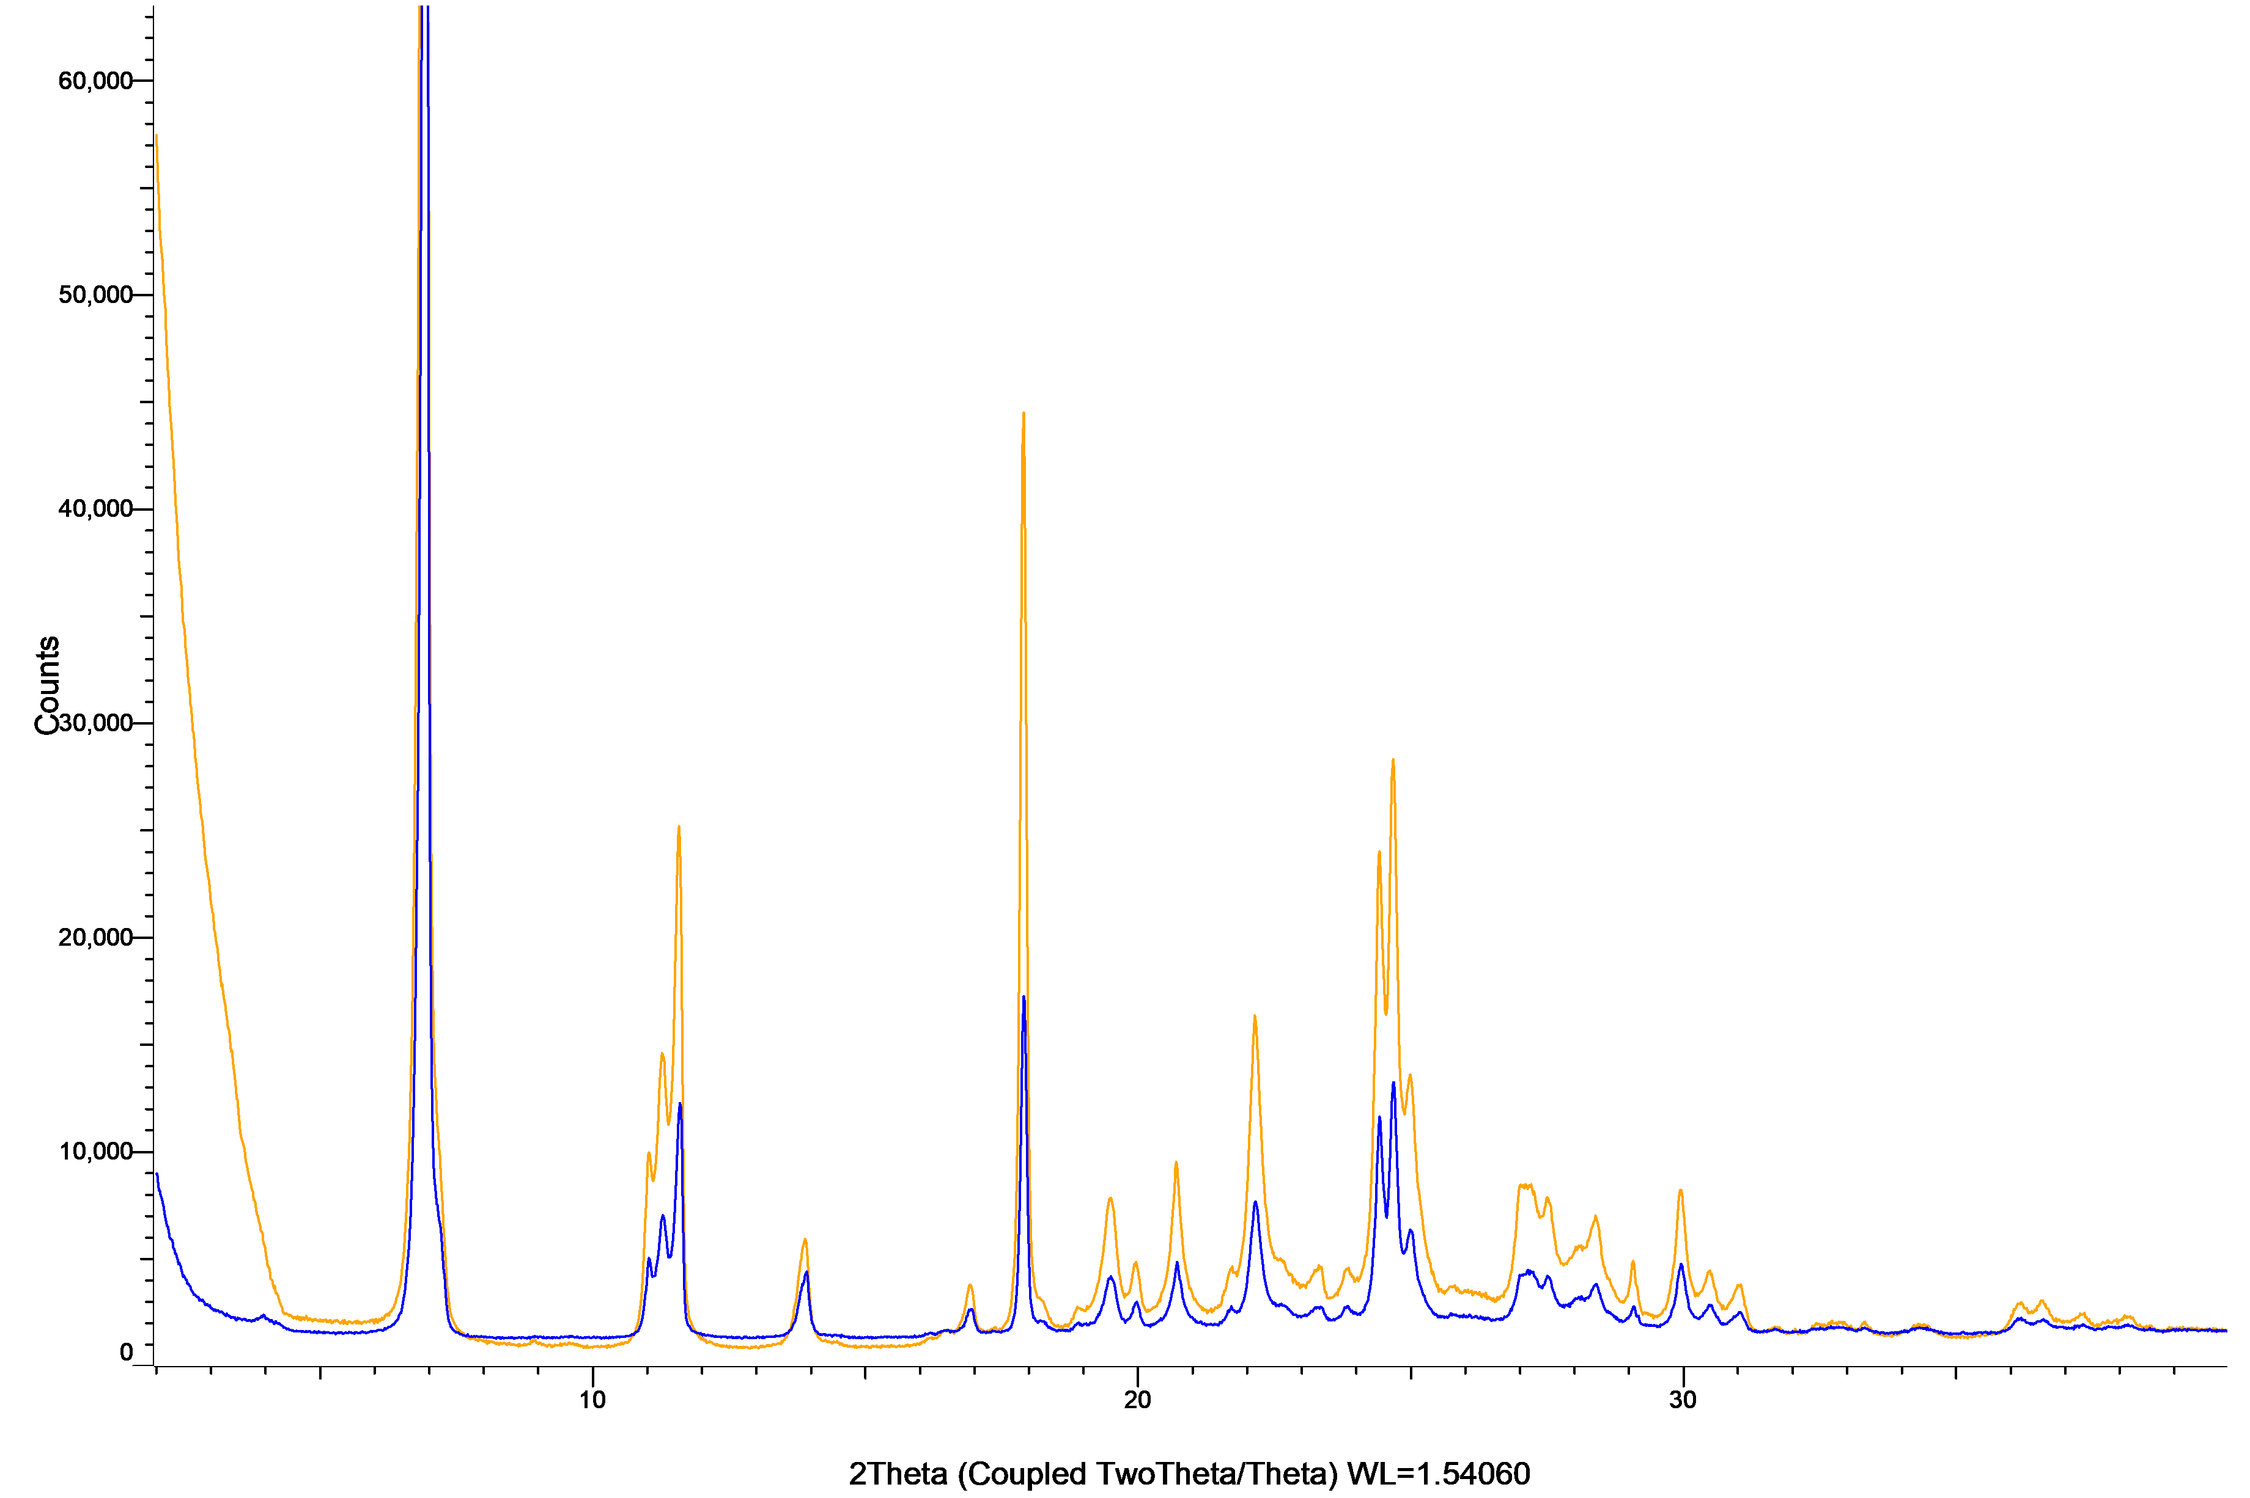

Figure S31: XRPD patterns of apixaban powder (blue) and milled apixaban powder (orange). 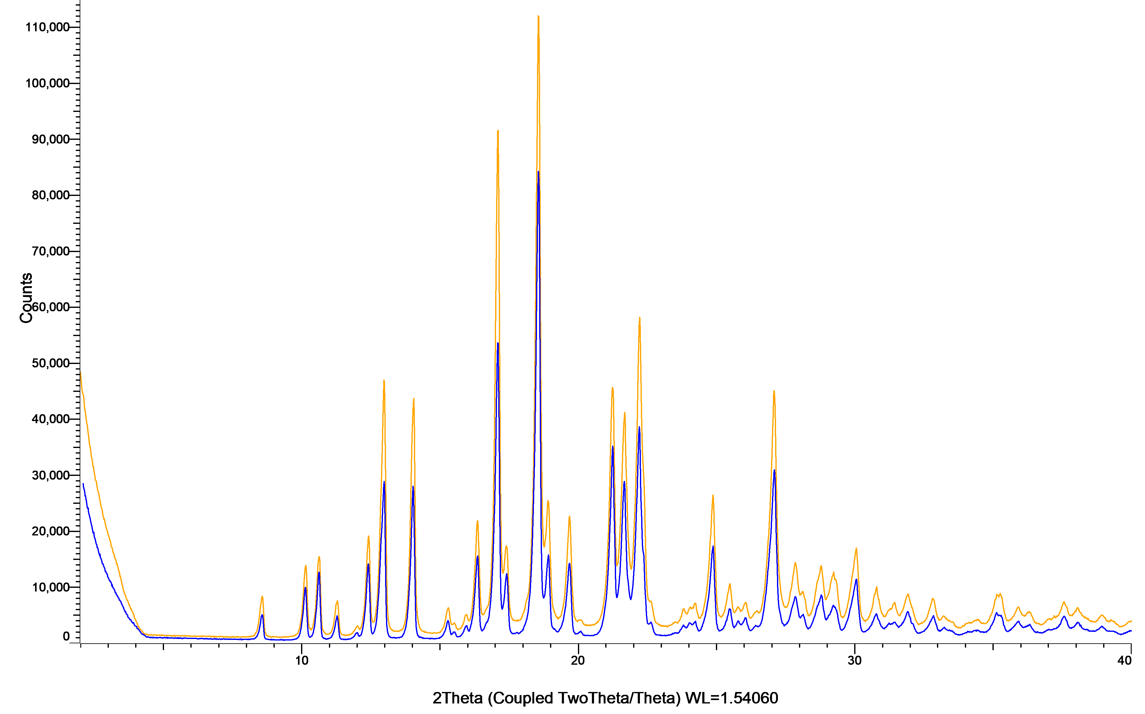

Figure S32: XRPD patterns of apremilast powder (blue) and milled apremilast powder (orange).
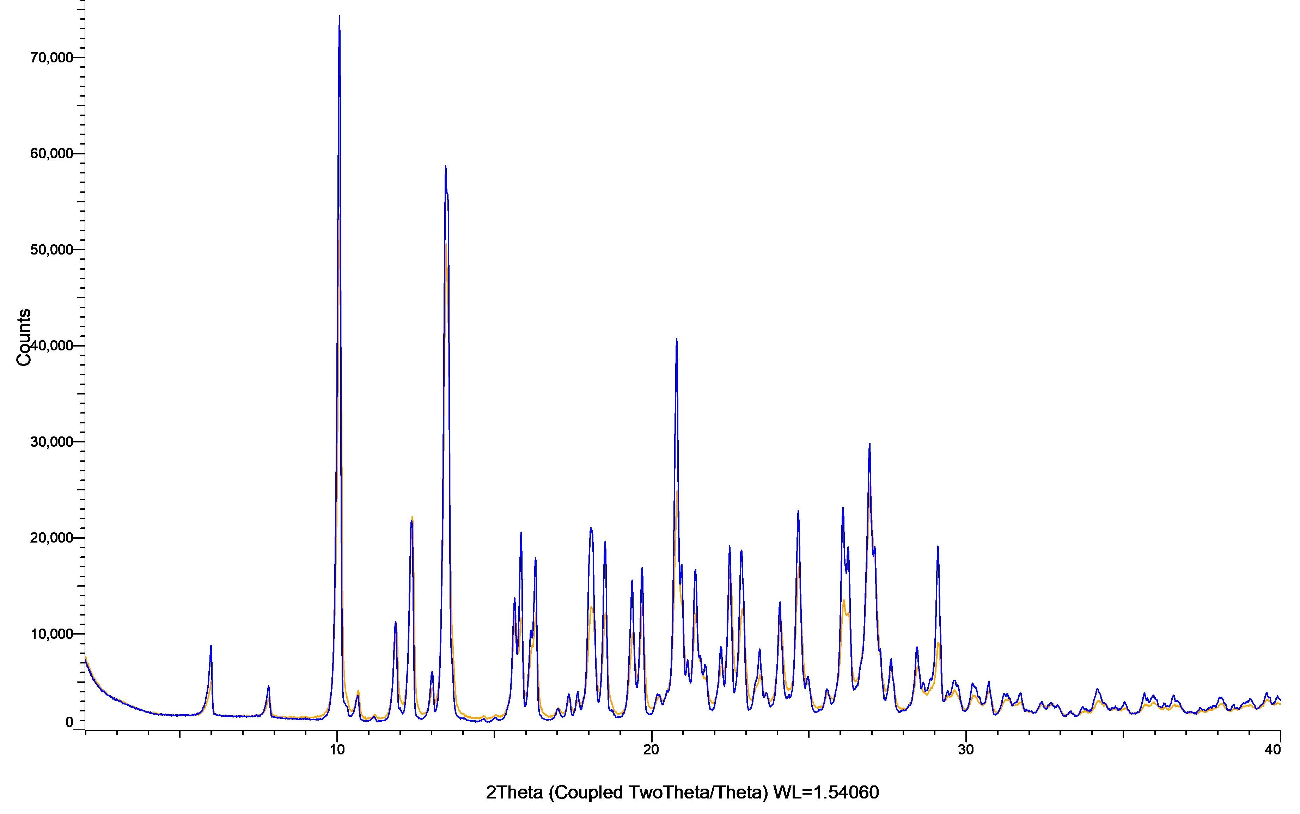

Figure S33: XRPD patterns of aripiprazole powder (blue) and milled aripiprazole powder (orange).
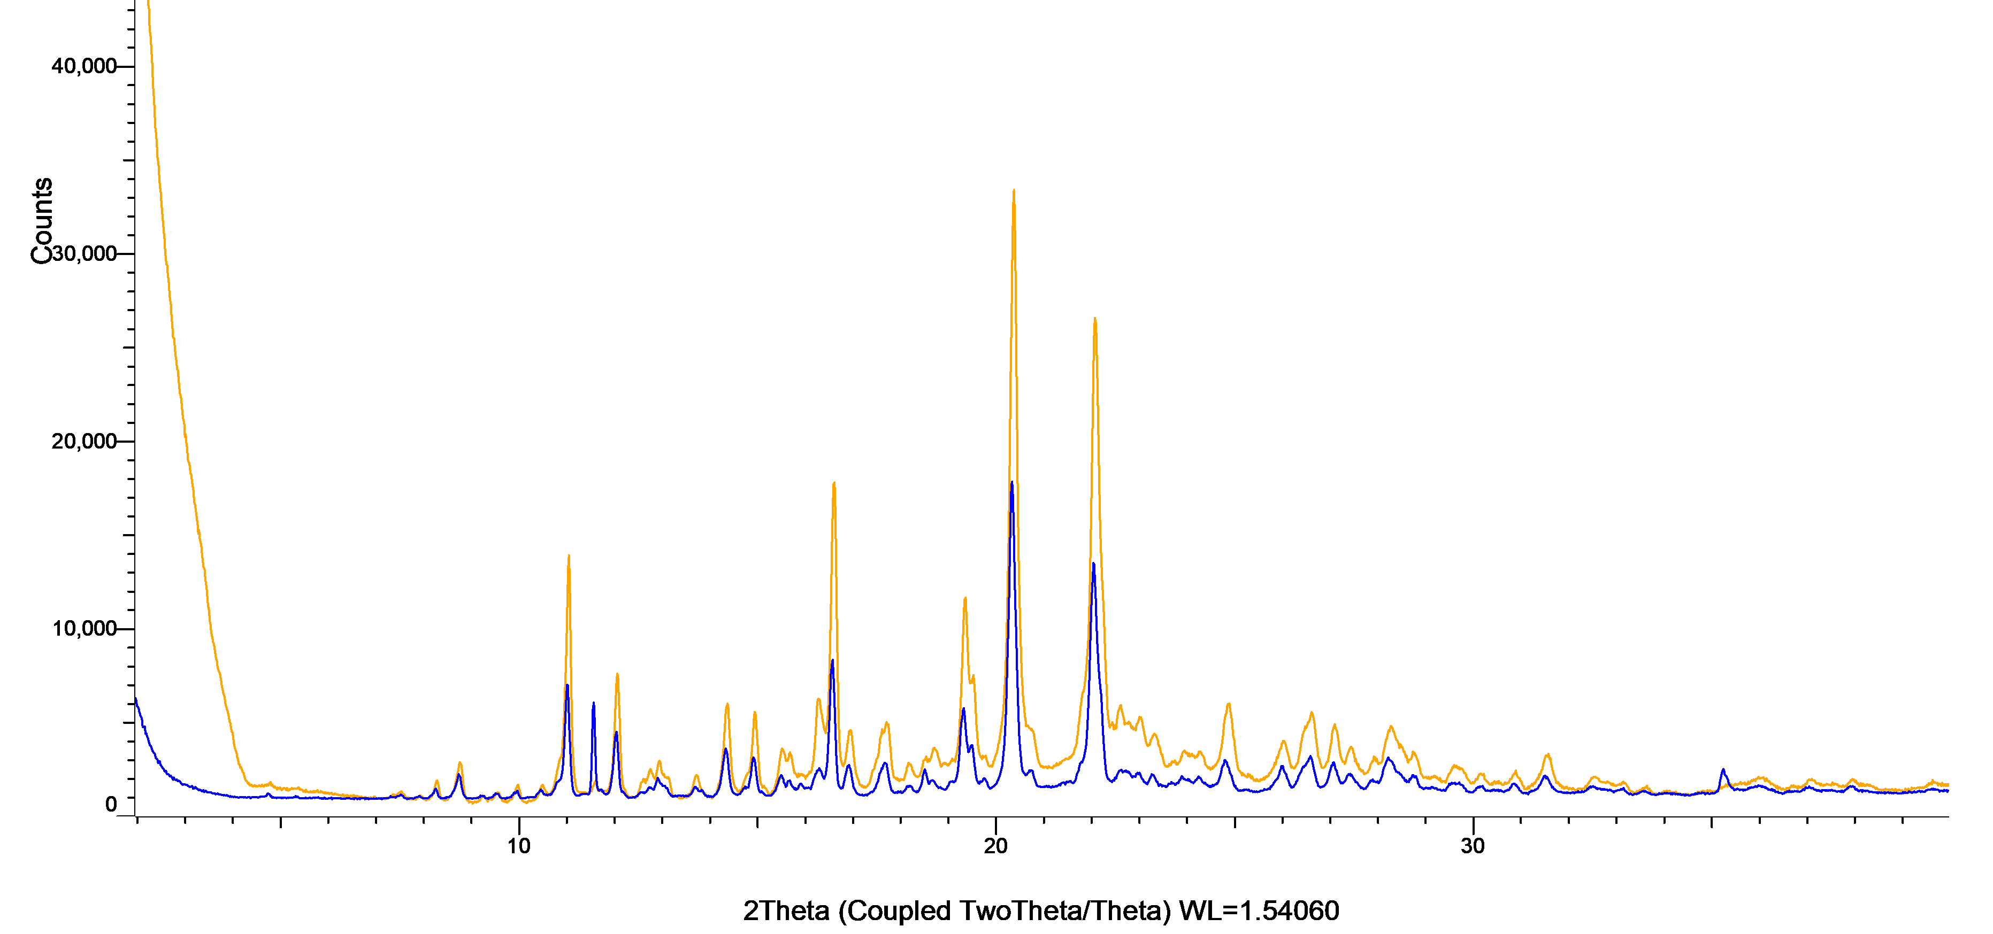

Figure S34: XRPD patterns of candesartan cilexetil powder (blue) and milled candesartan cilexetil powder (orange).
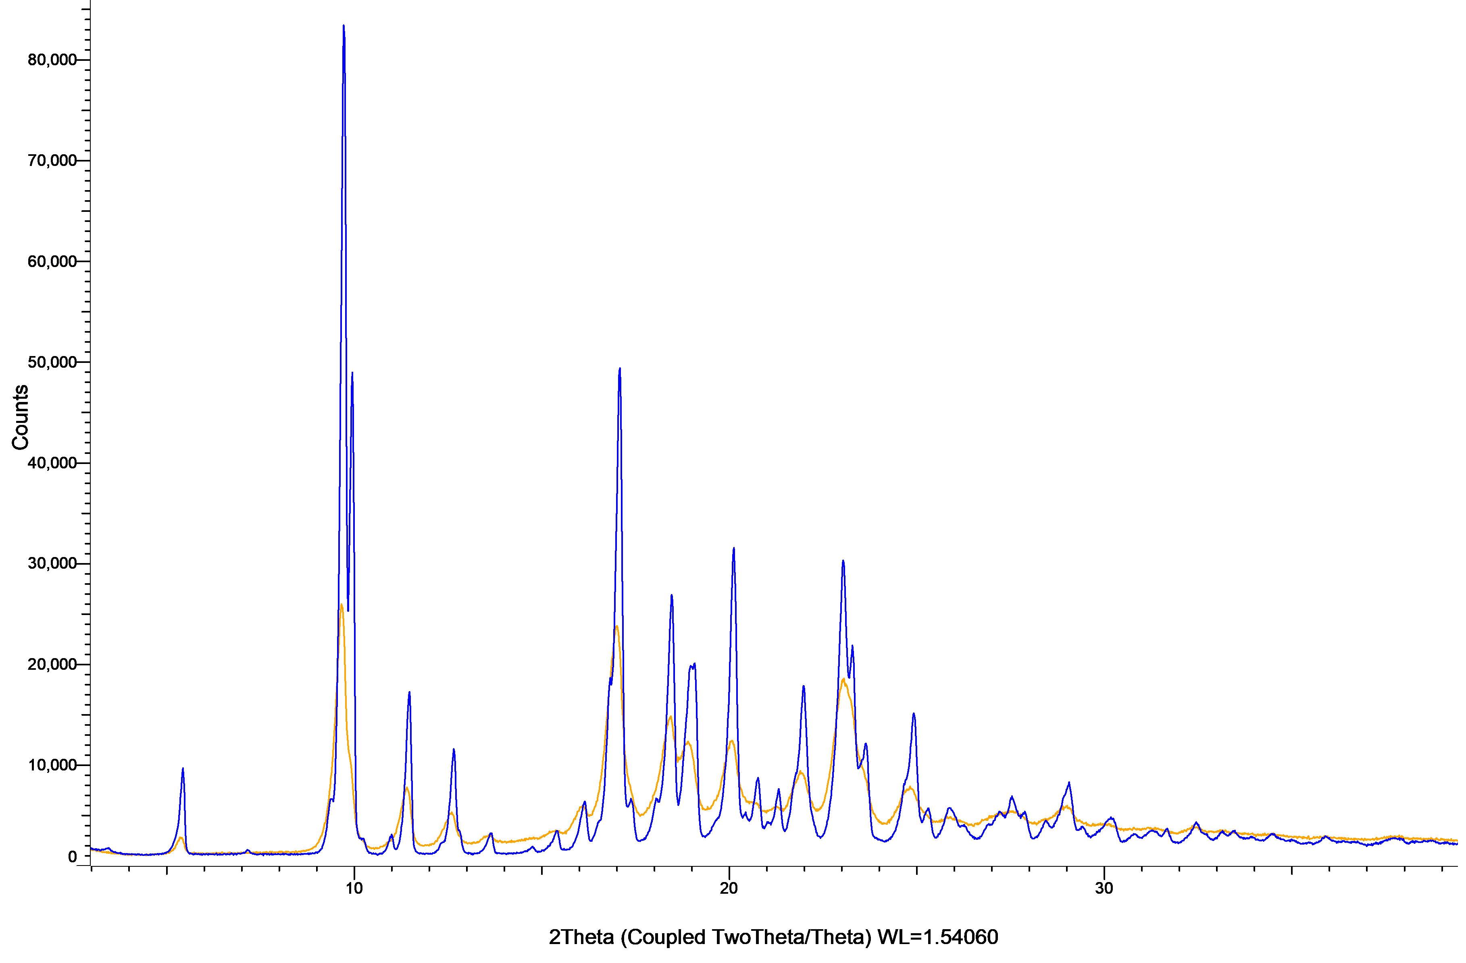
Figure S35: XRPD patterns of carbamazepine powder (blue) and milled carbamazepine powder (orange).
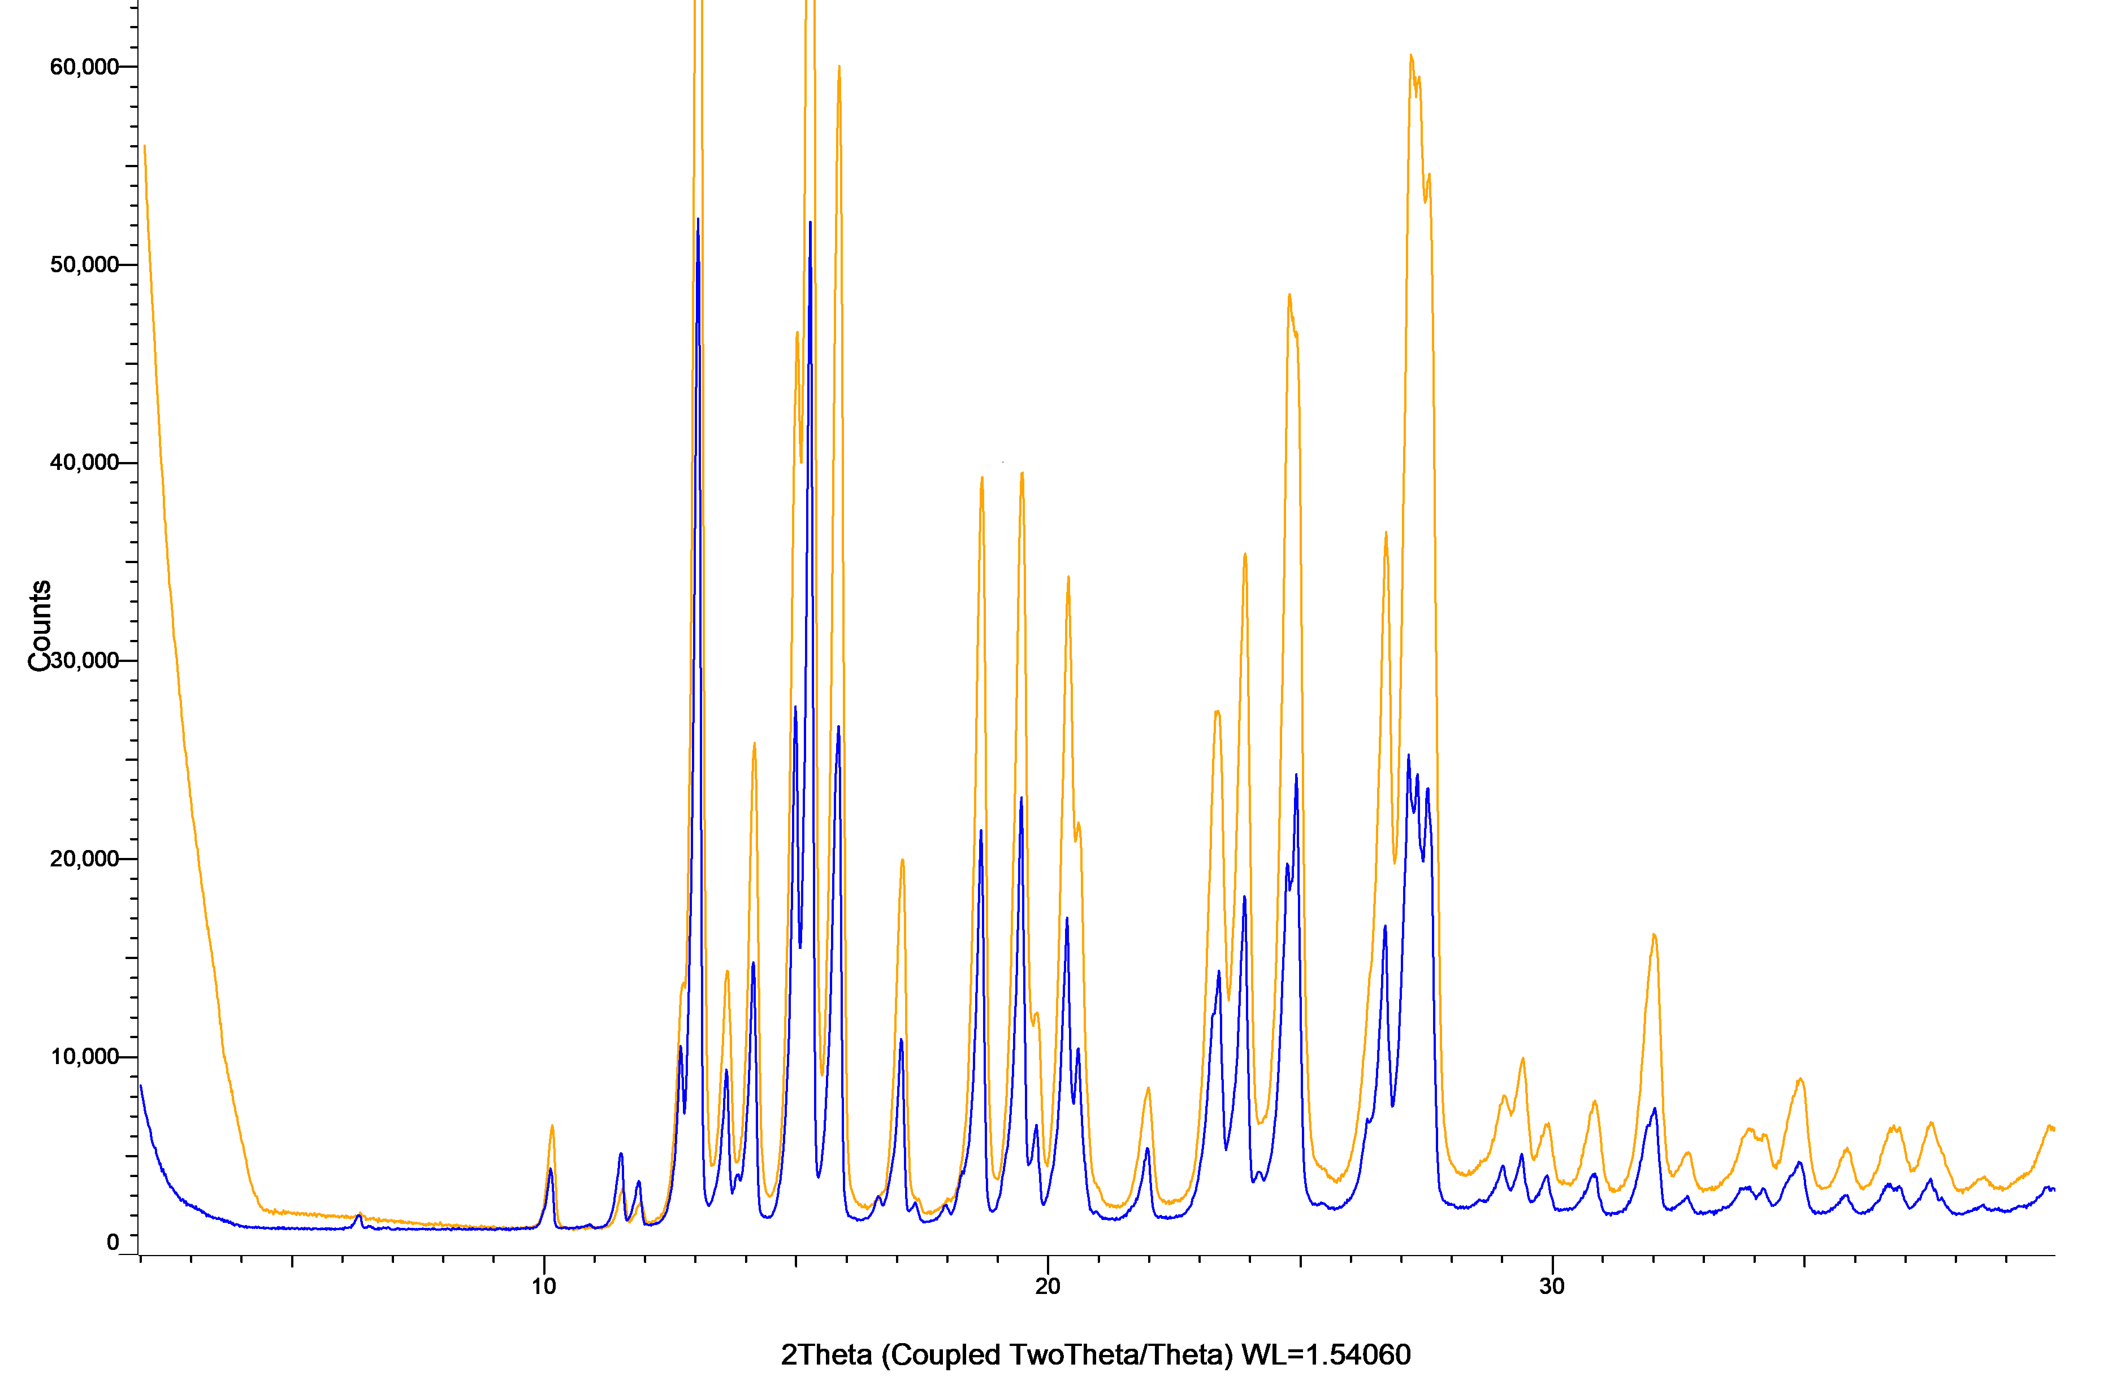

Figure S36: XRPD patterns of celecoxib powder (blue) and milled celecoxib powder (orange).
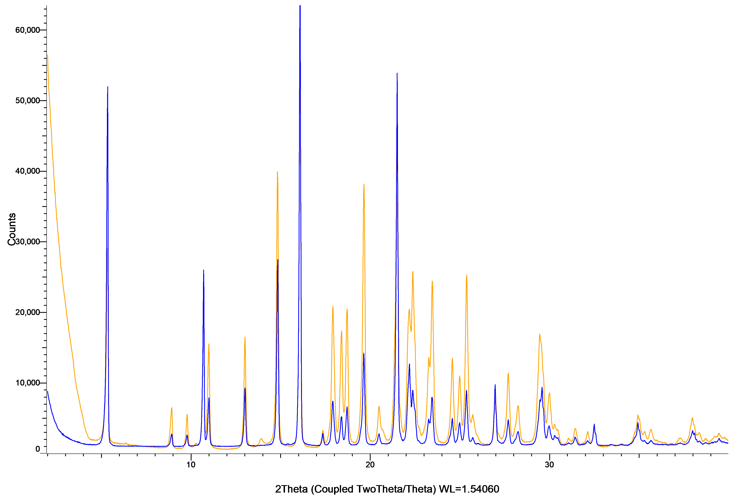

Figure S37: XRPD patterns of ceritinib powder (blue) and milled ceritinib powder (orange). 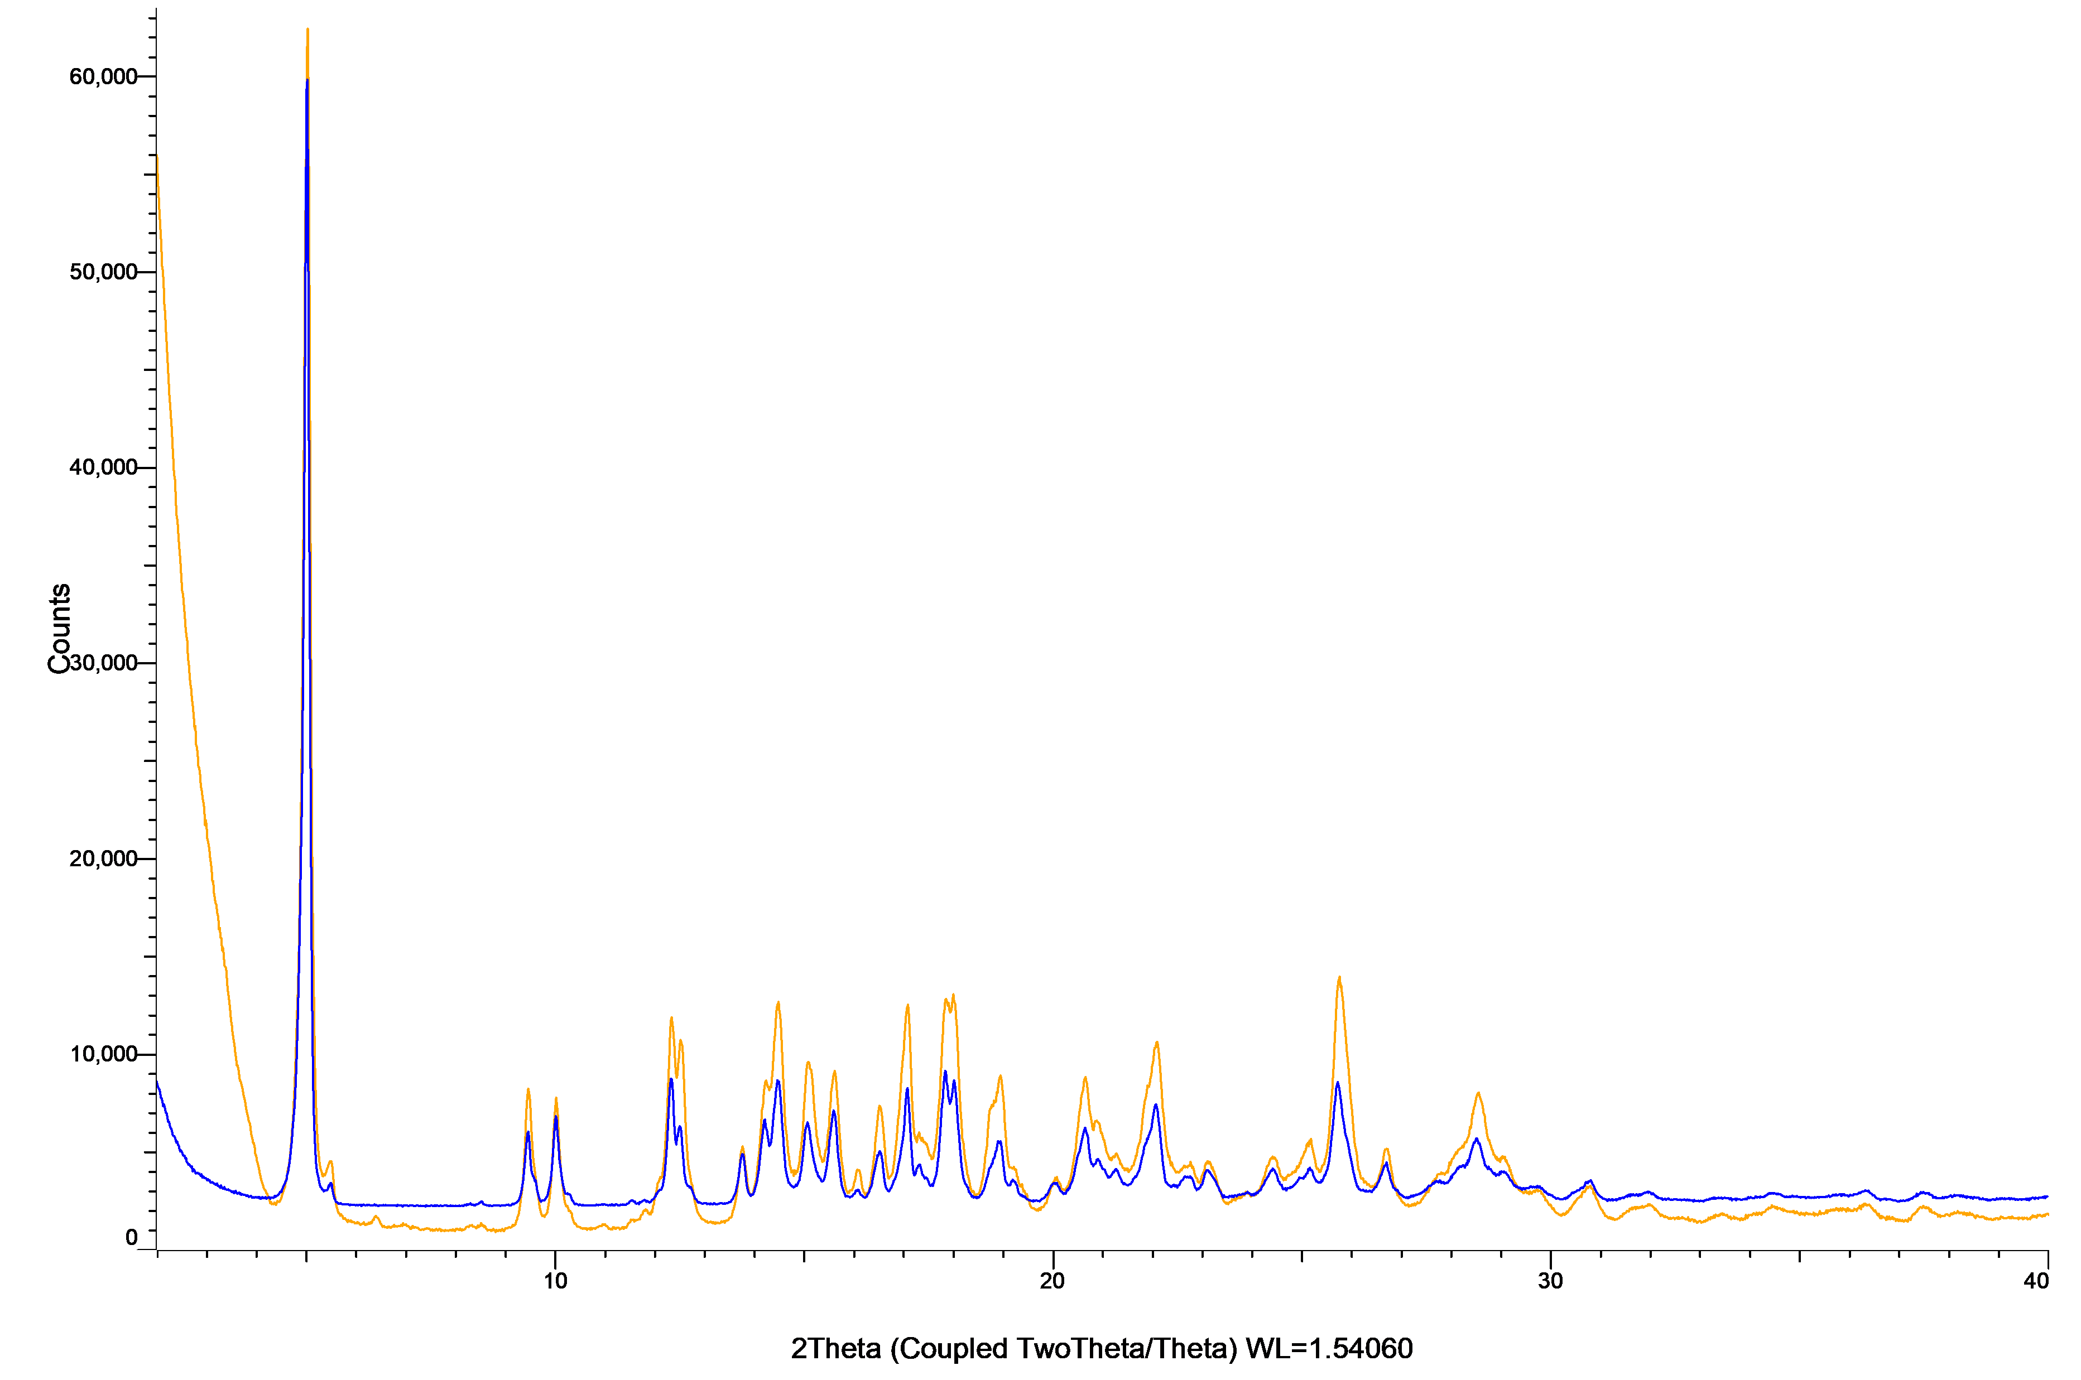

Figure S38: XRPD patterns of cinnarizine powder (blue) and milled cinnarizine powder (orange).
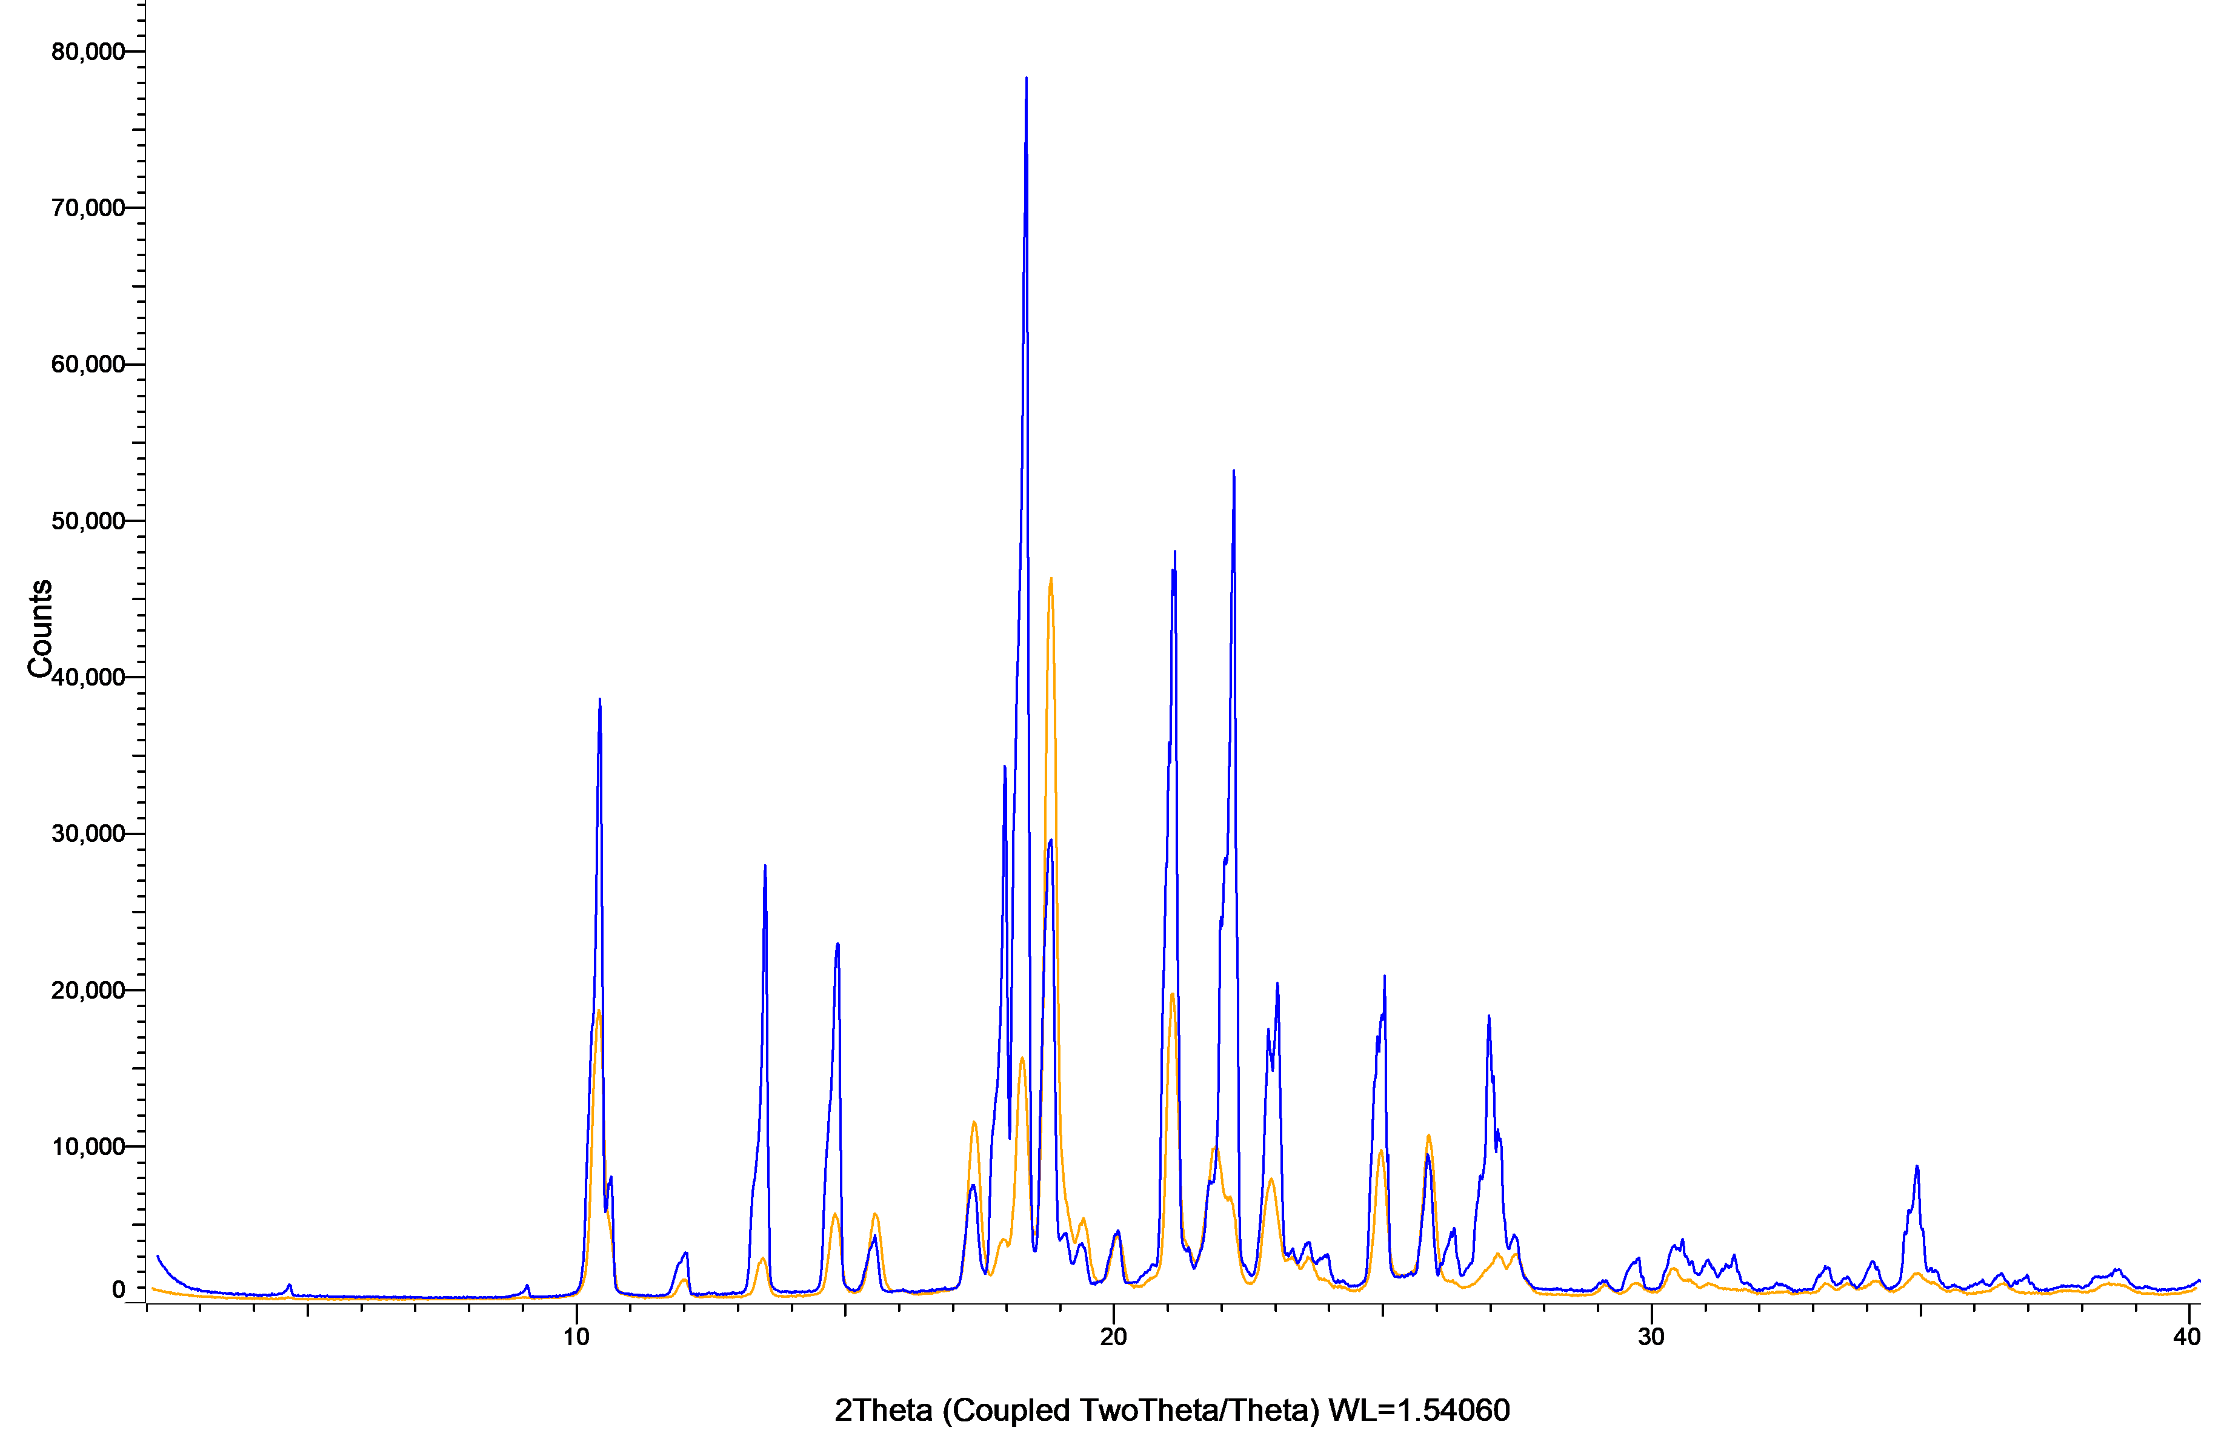

Figure S40: XRPD patterns of deferasirox powder (blue) and milled deferasirox powder (orange).
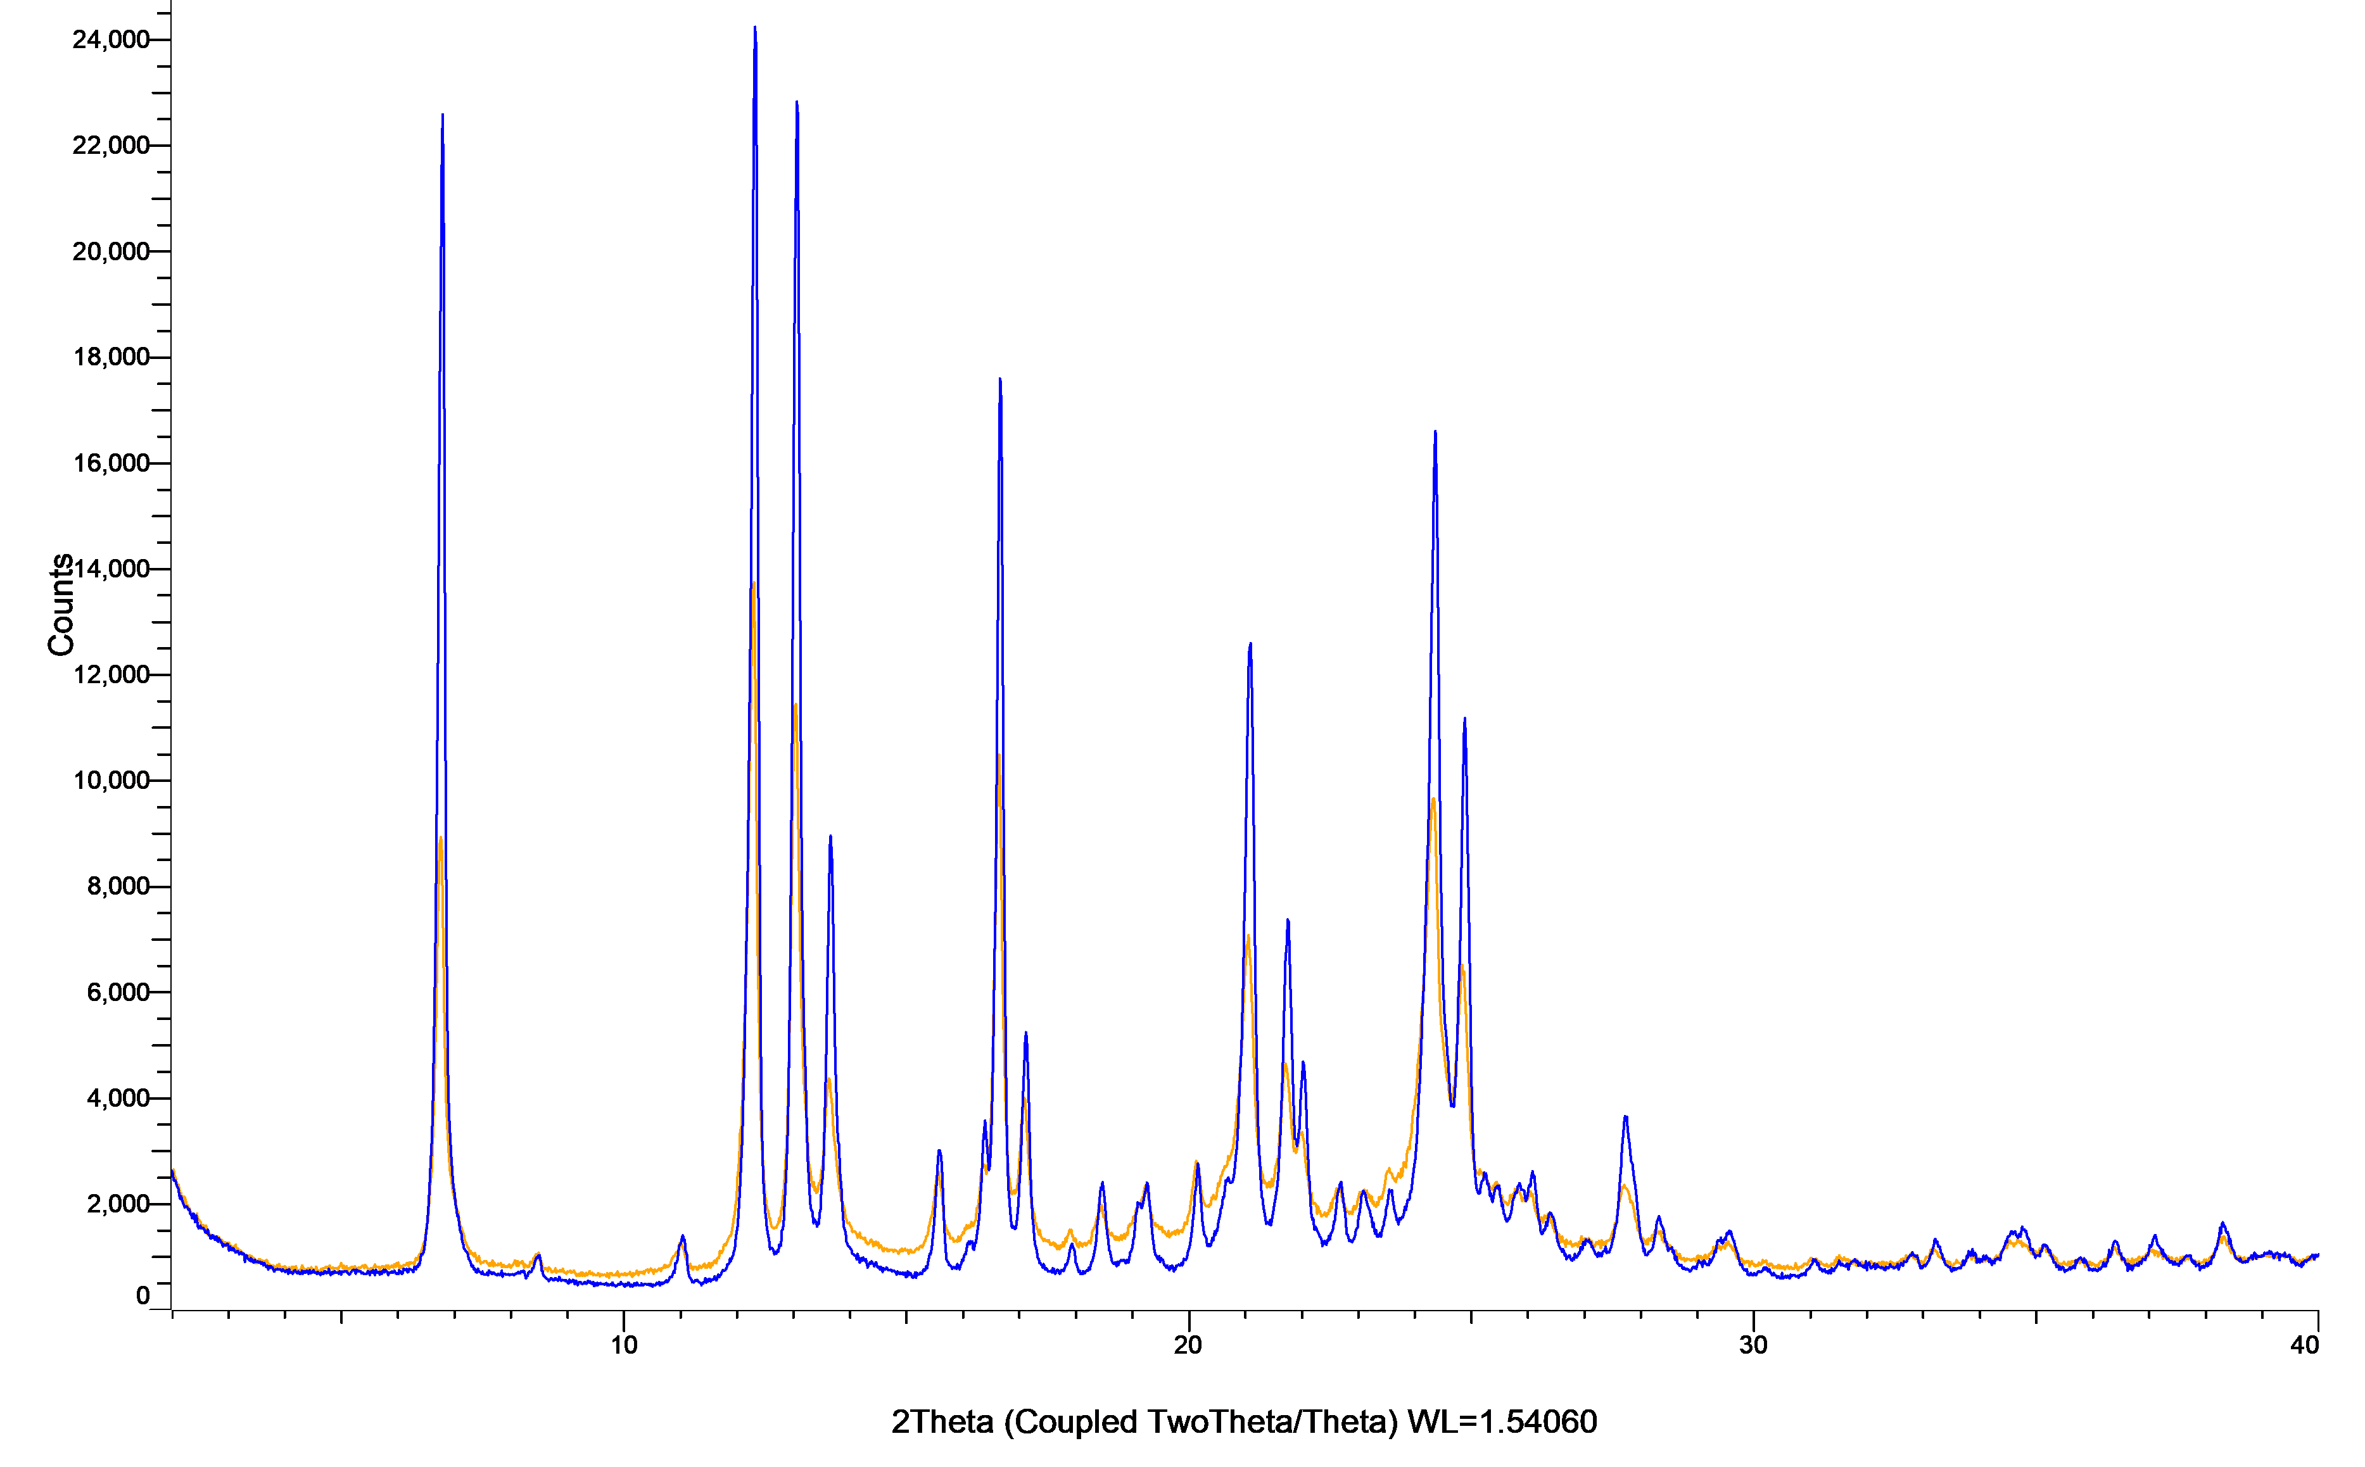

Figure S41: XRPD patterns of dipyridamole powder (blue) and milled dipyridamole powder (orange).
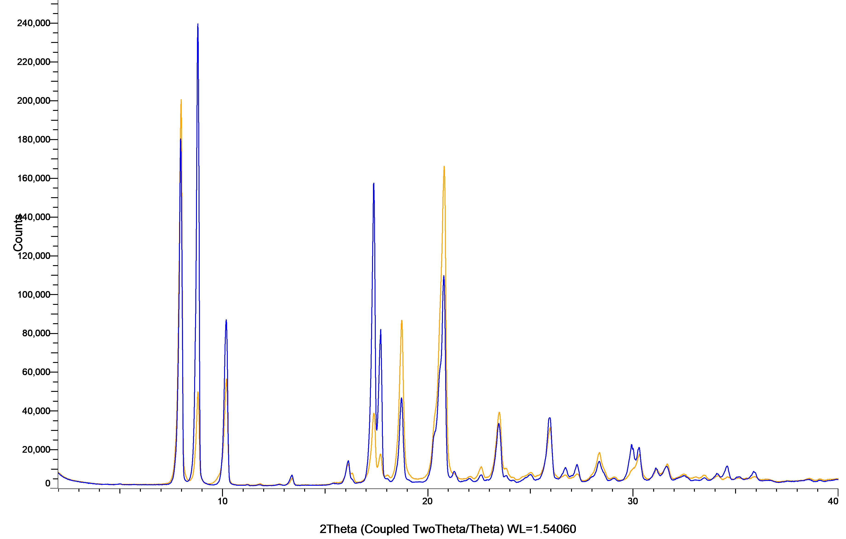

Figure S42: XRPD patterns of enzalutamide powder (blue) and milled enzalutamide powder (orange).
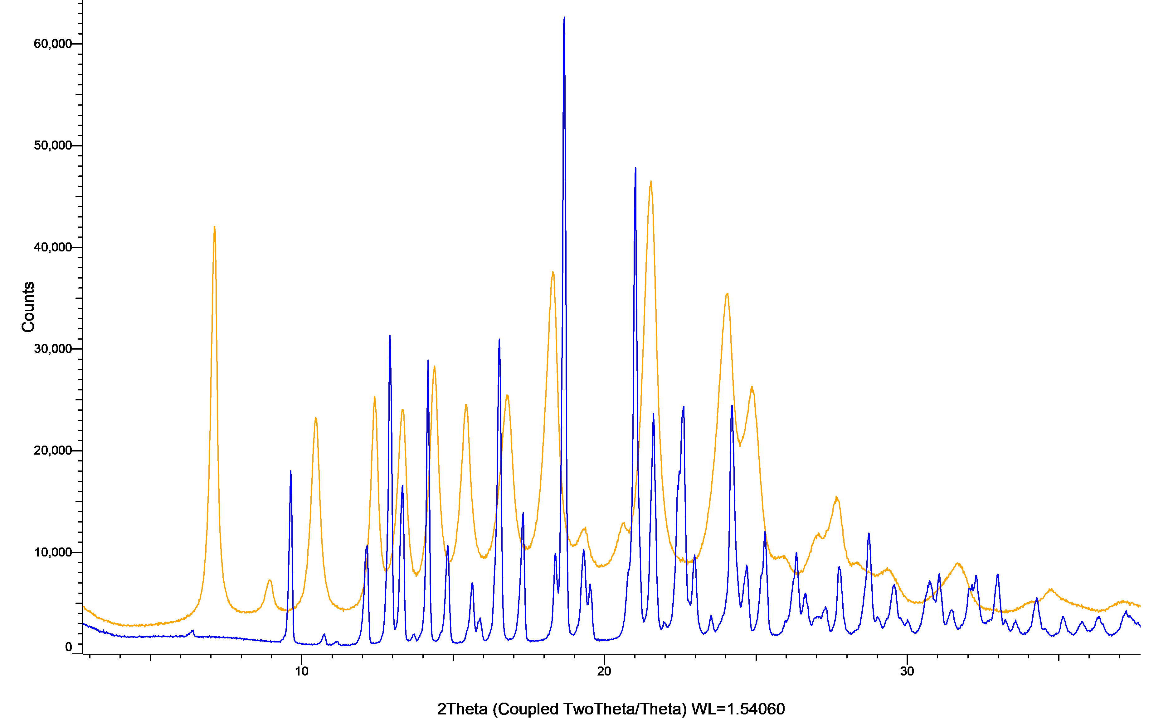
Figure S43: XRPD patterns of etorixcoxib powder (blue) and milled etoricoxib powder (orange).
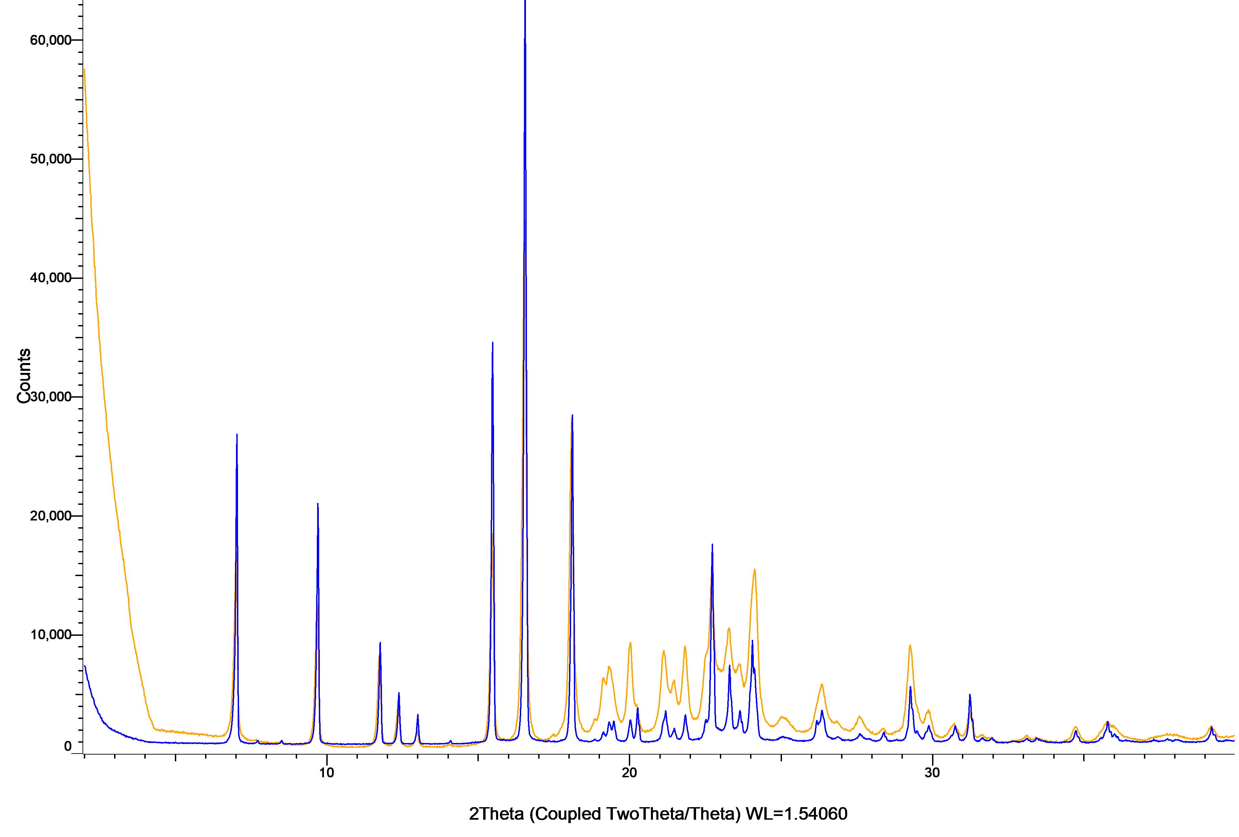
Figure S44: XRPD patterns of ezetimibe powder (blue) and milled ezetimibe powder (orange).
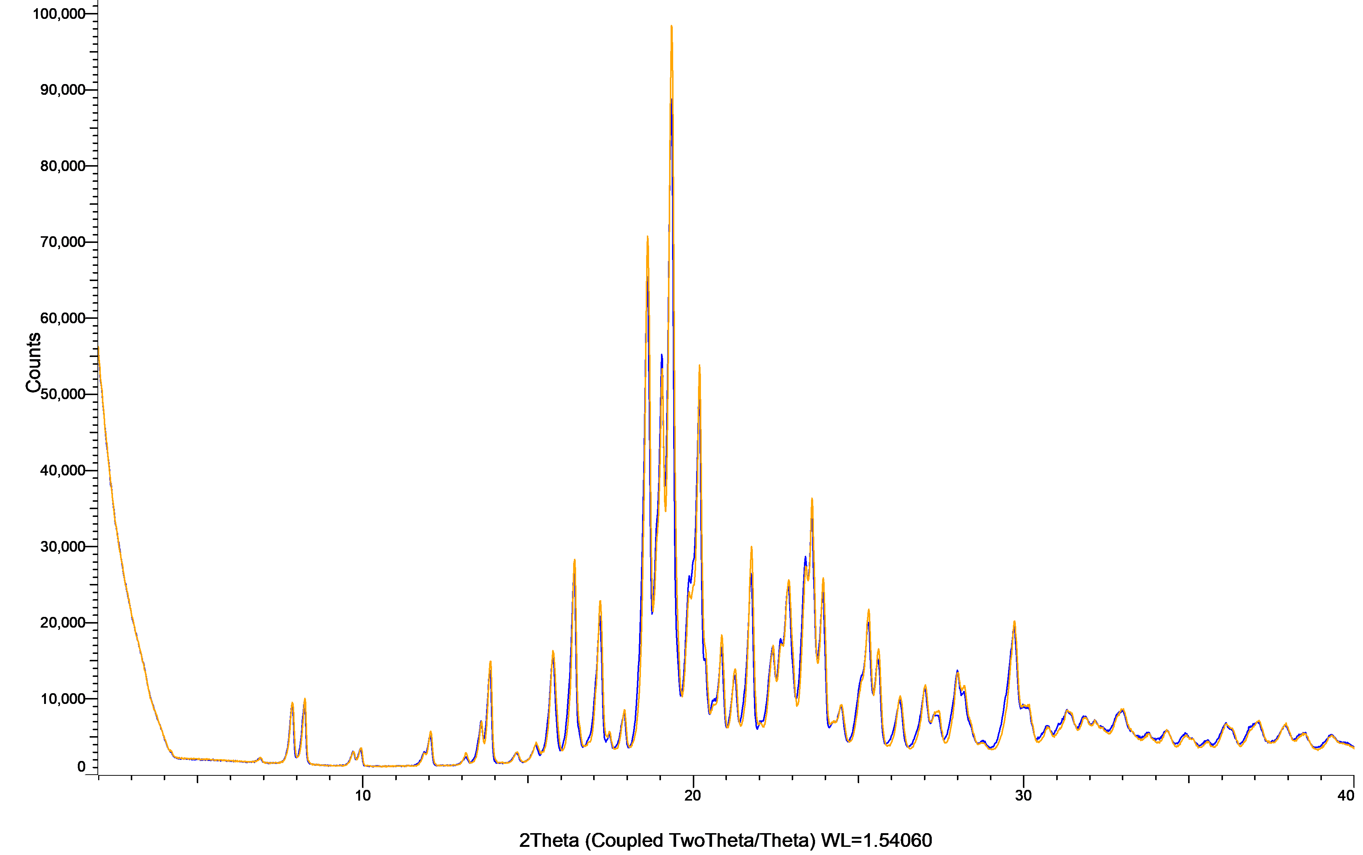

Figure S45: XRPD patterns of fenofibrate powder (blue) and milled fenofibrate powder (orange).
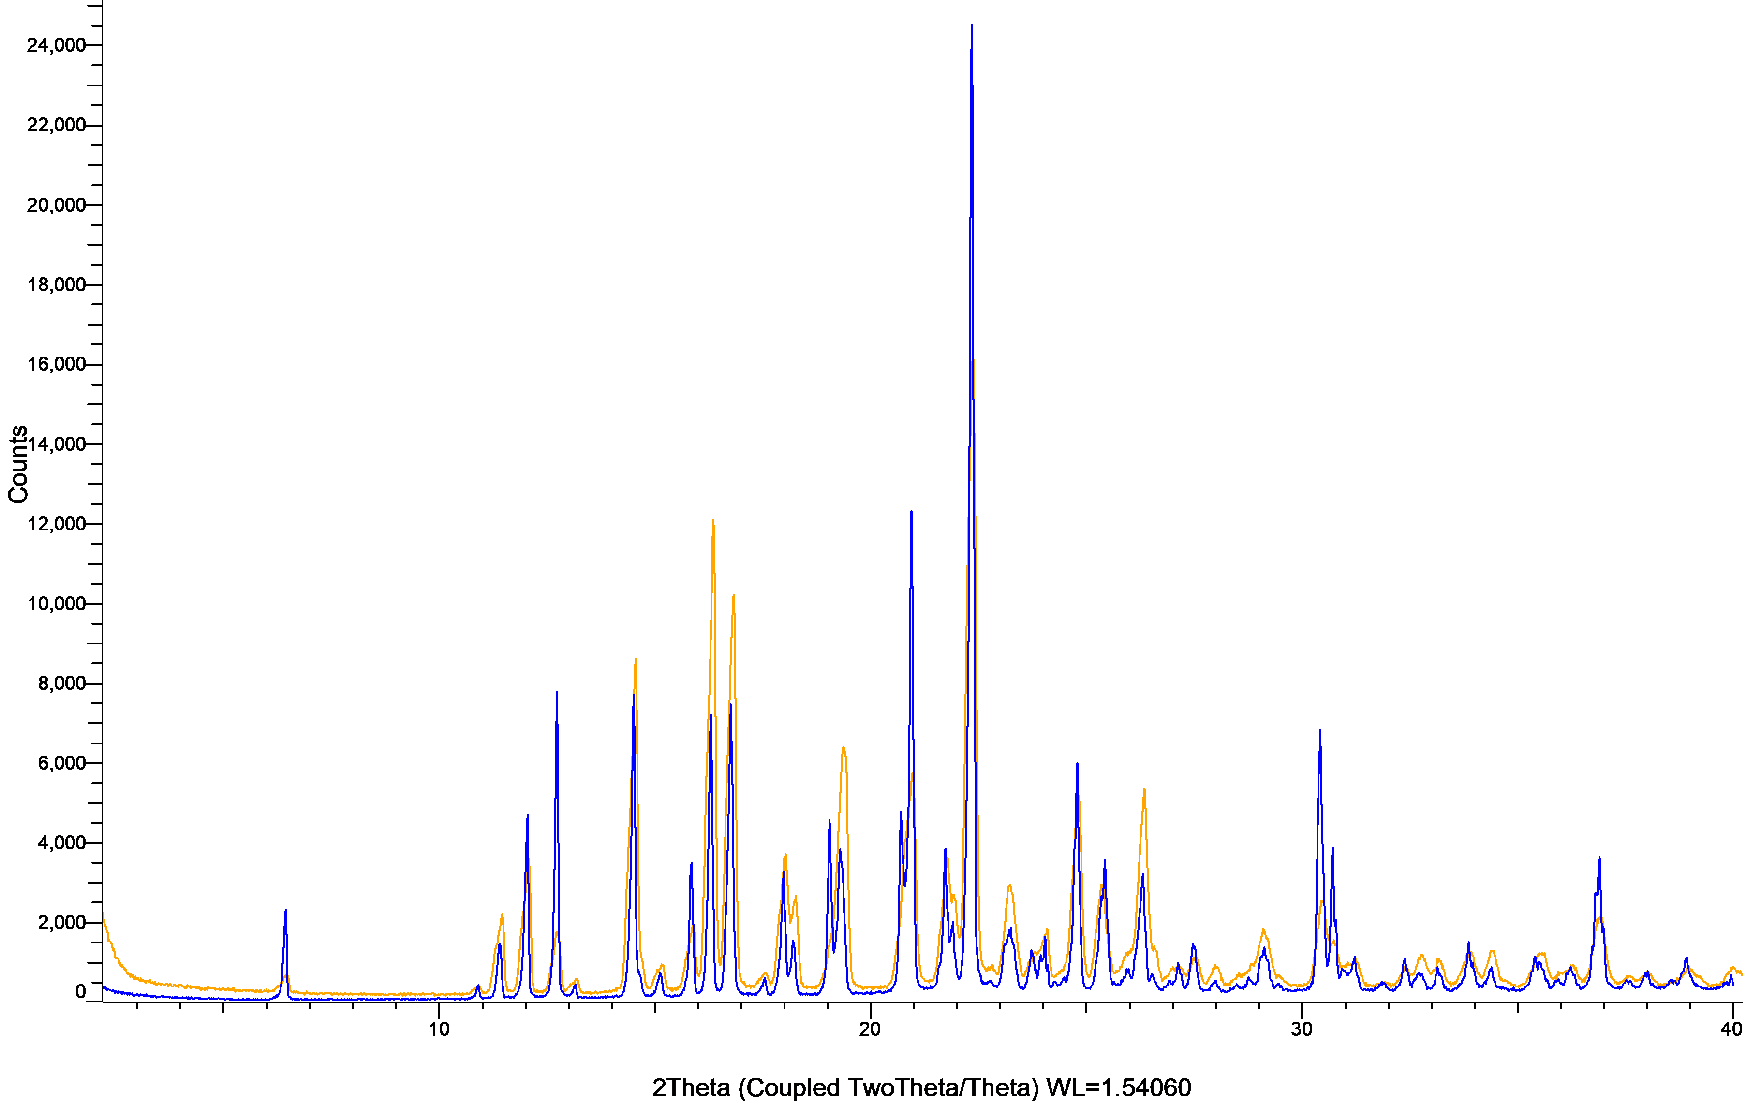

Figure S46: XRPD patterns of gemfibrozil powder (blue) and milled gemfibrozil powder (orange).
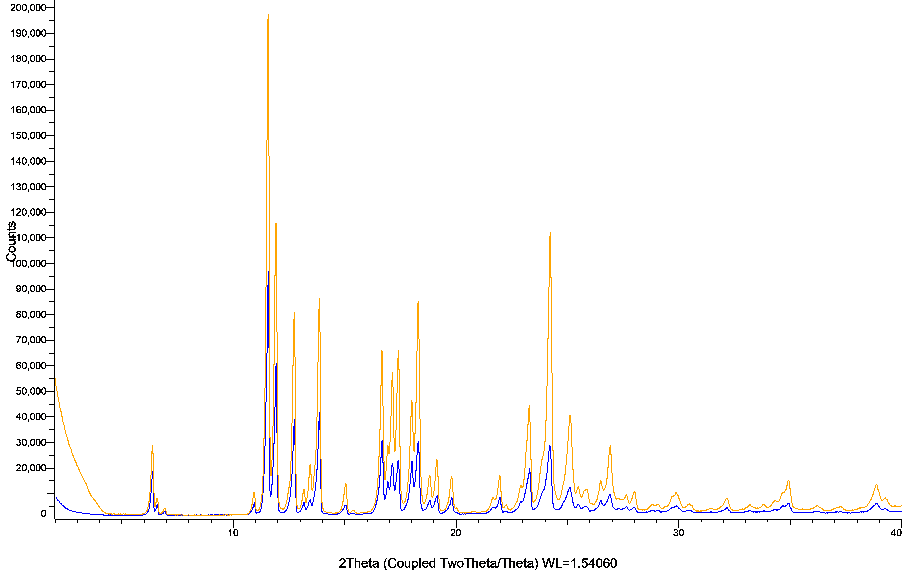

Figure S47: XRPD patterns of glibenclamide powder (blue) and milled glibenclamide powder (orange).
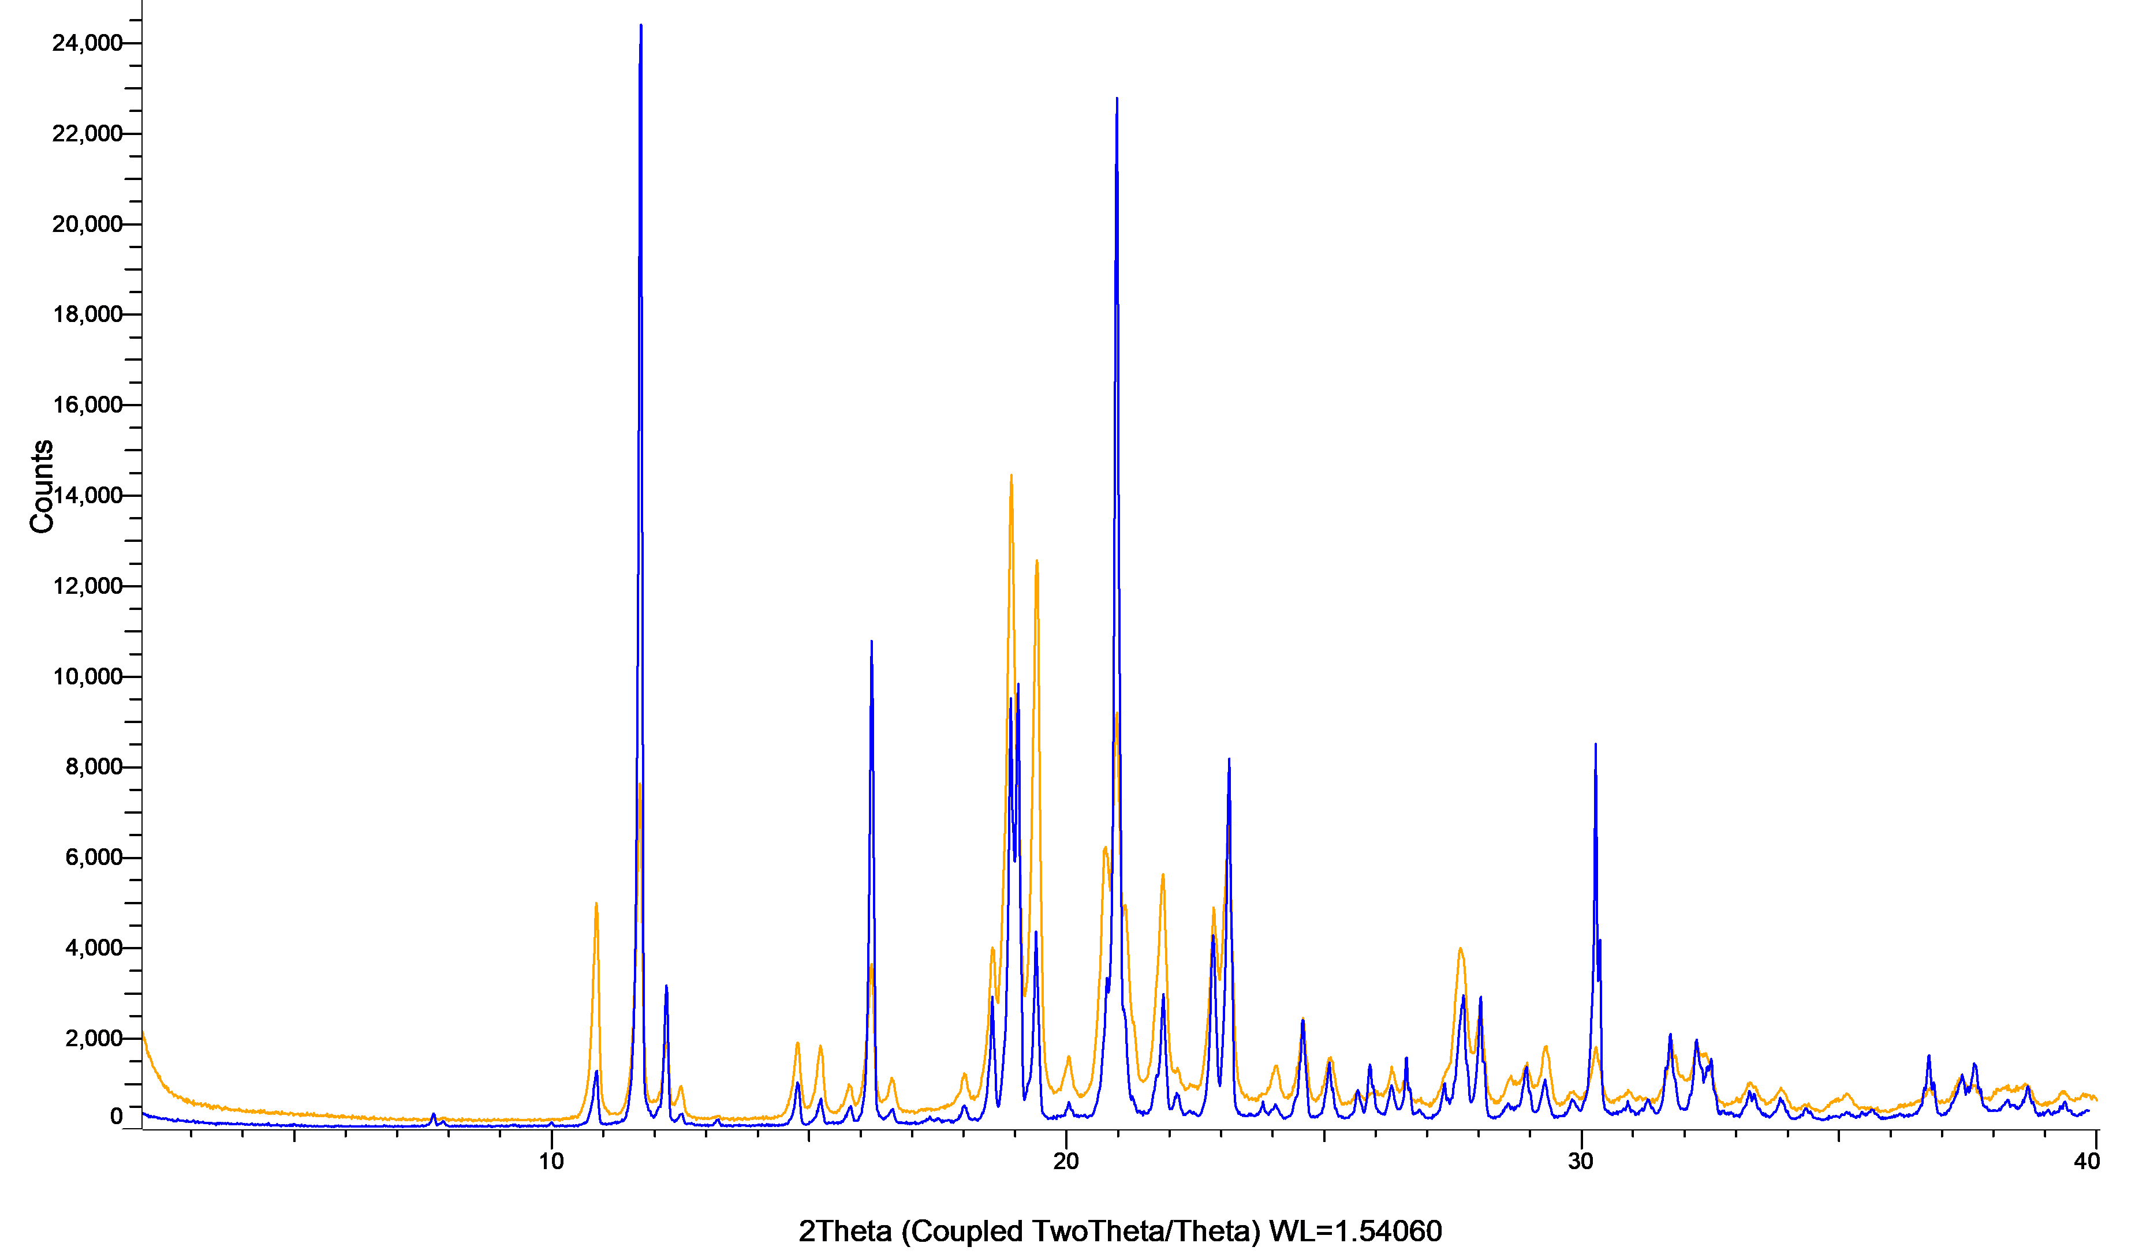

Figure S48: XRPD patterns of griseofulvin powder (blue) and milled griseofulvin powder (orange). 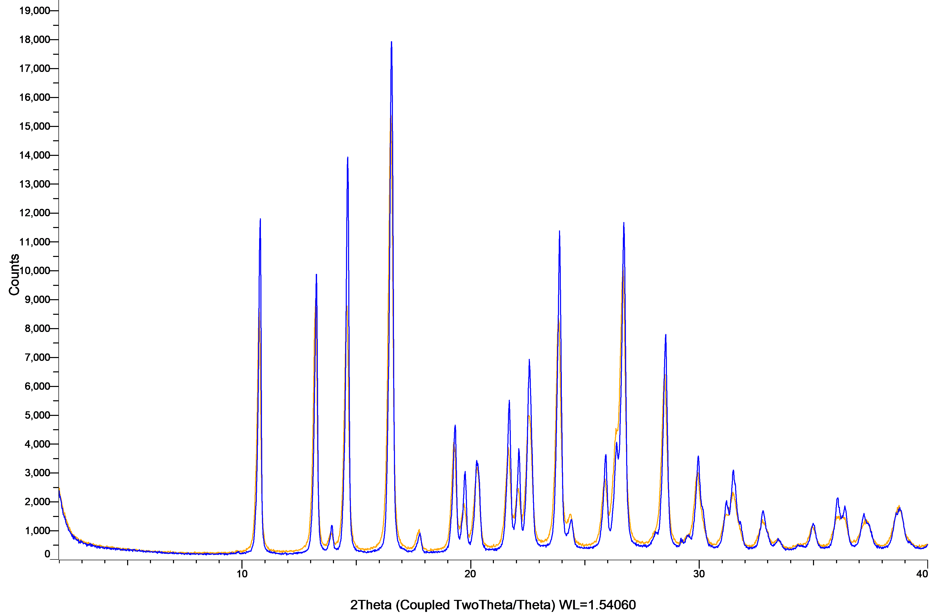

Figure S49: XRPD patterns of indomethacin powder (blue) and milled indomethacin powder (orange).
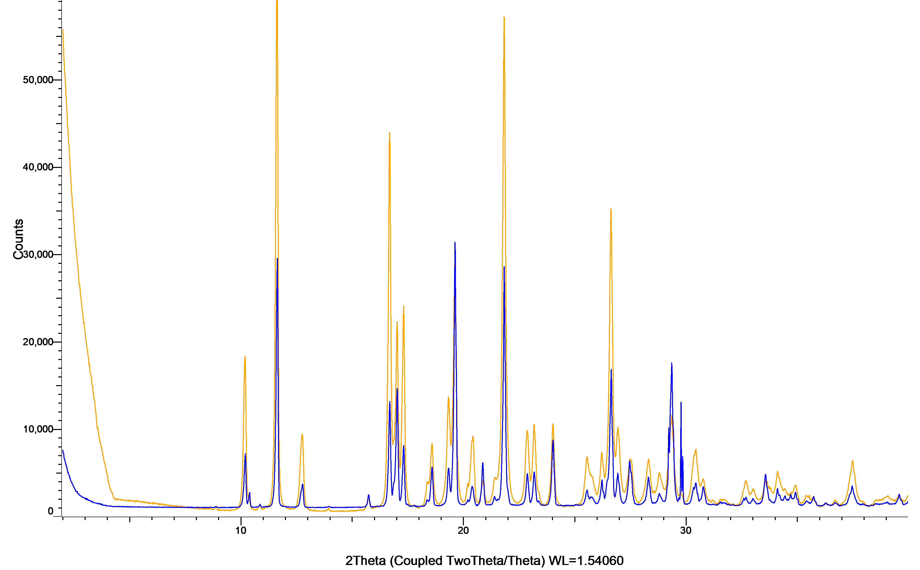

Figure S50: XRPD patterns of mefenamic acid powder (blue) and milled mefenamic acid powder (orange).
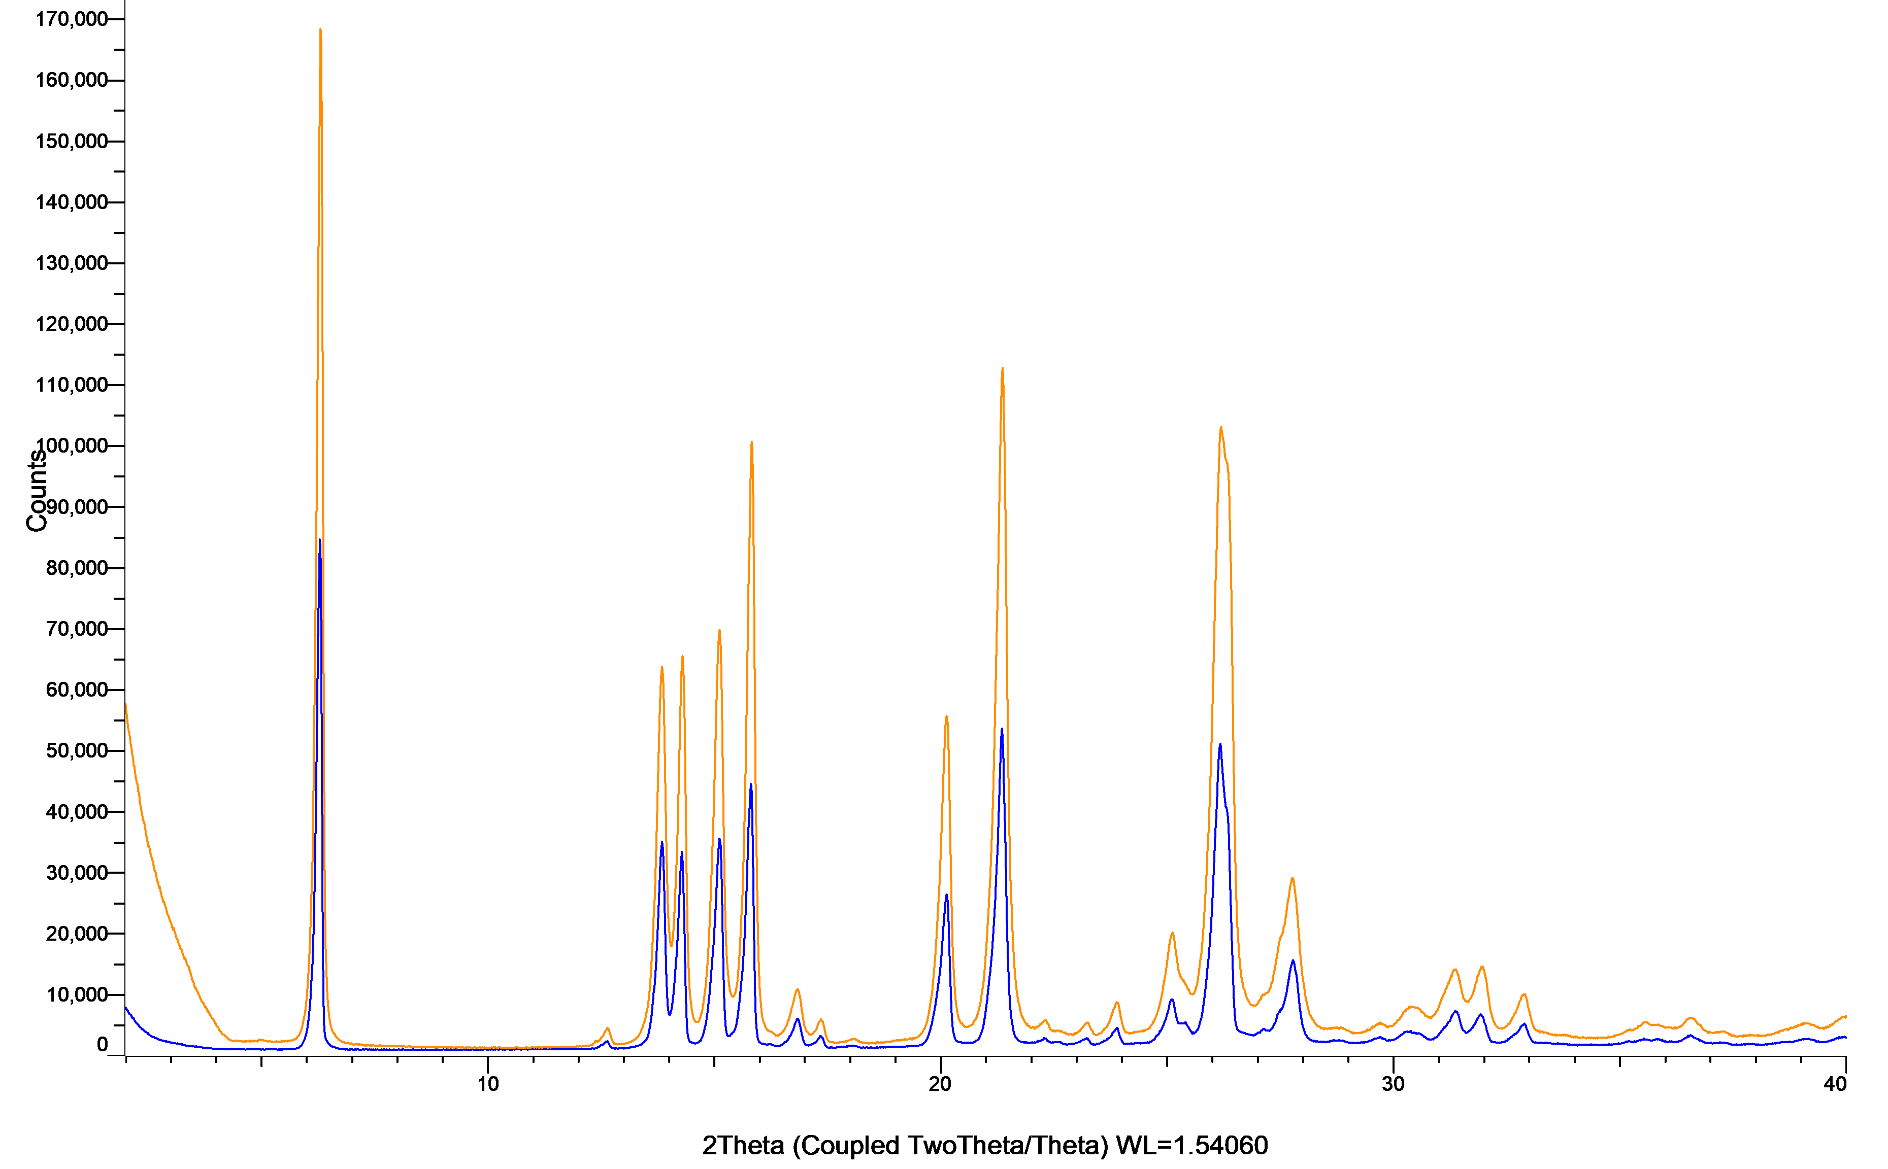

Figure S51: XRPD patterns of nilotinib powder (blue) and milled nilotinib powder (orange).
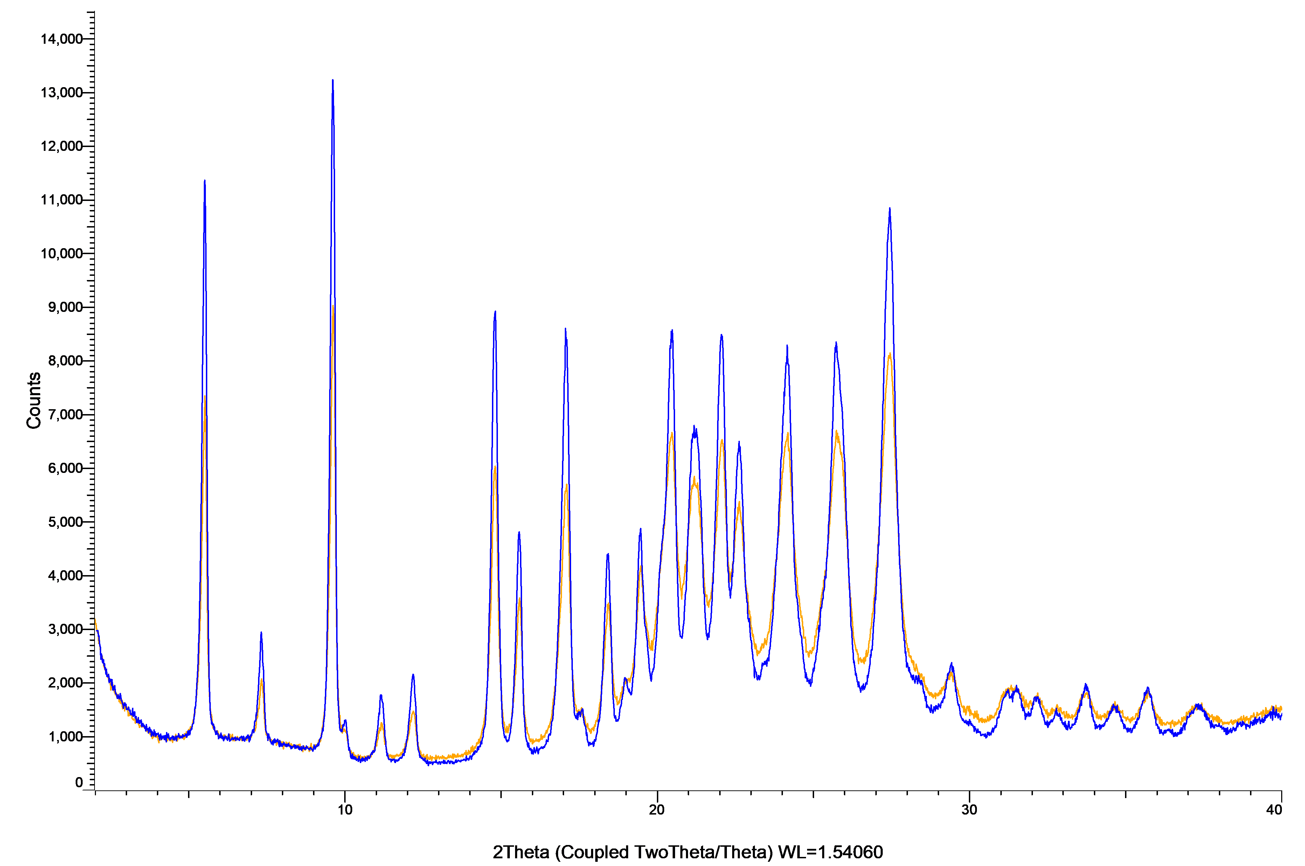

Figure S52: XRPD patterns of nimesulide powder (blue) and milled nimesulide powder (orange).
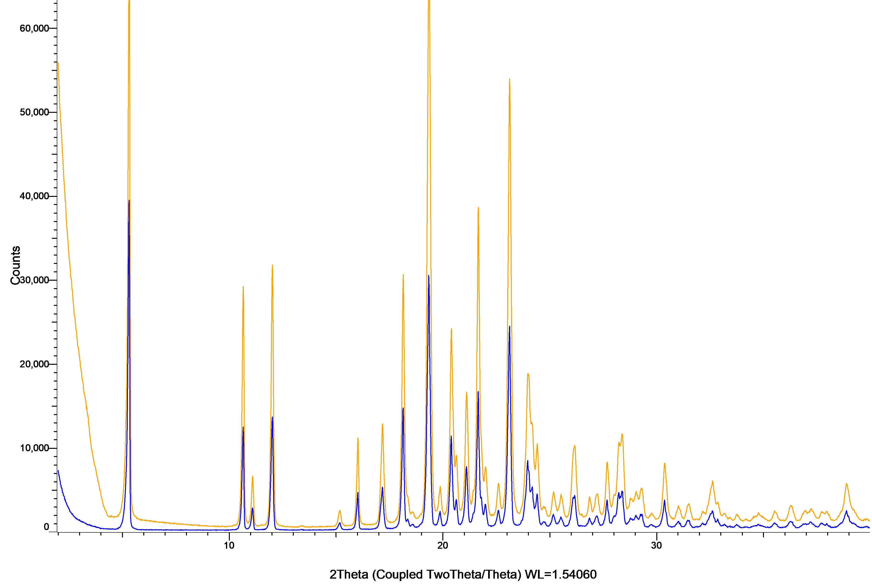

Figure S53: XRPD patterns of olaparib powder (blue) and milled olaparib powder (orange).
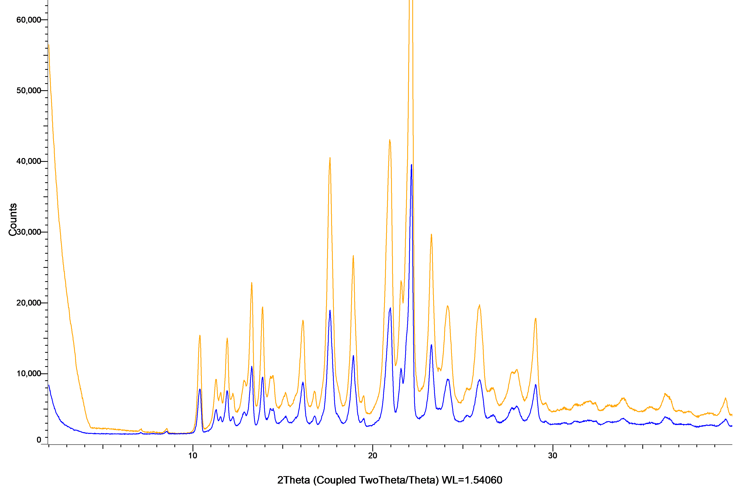

Figure S54: XRPD patterns of rivaroxaban powder (blue) and milled rivaroxaban powder (orange).
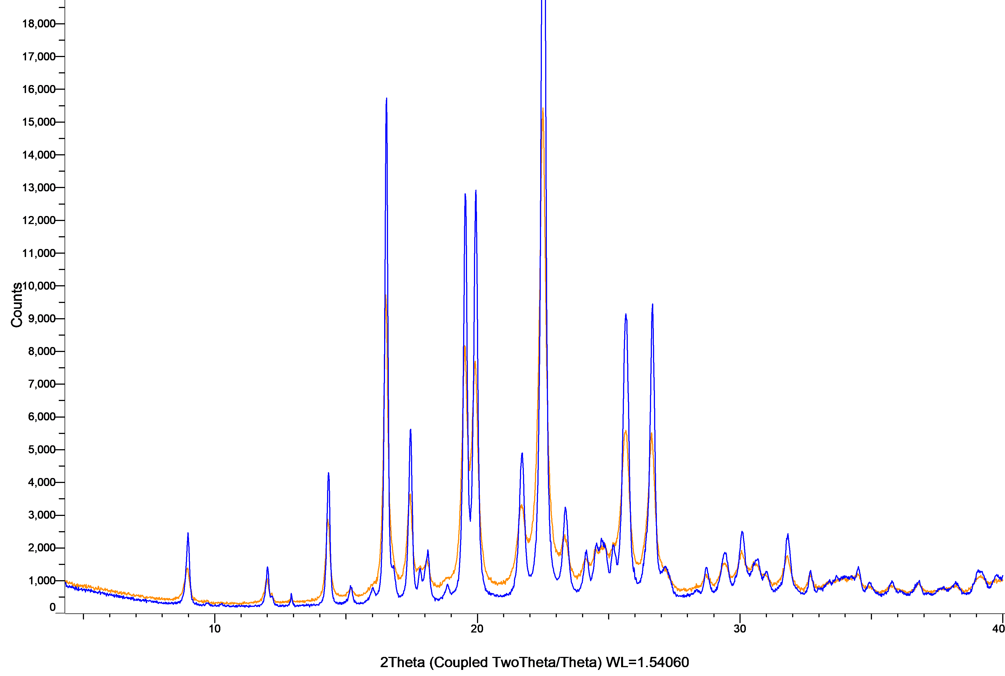

Figure S55: XRPD patterns of sertraline powder (blue) and milled sertraline powder (orange).
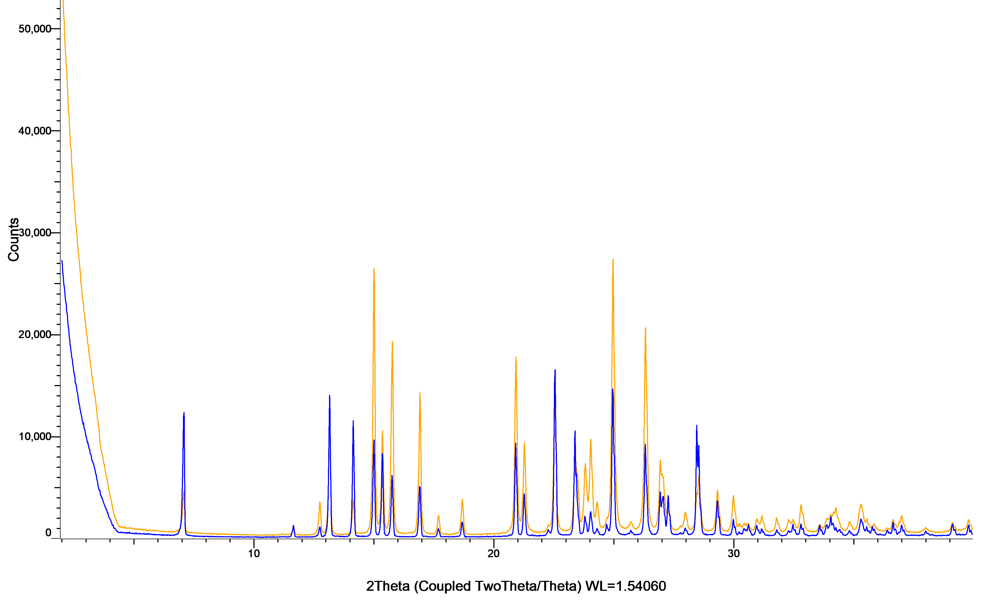

Figure S56: XRPD patterns of sorafenib powder (blue) and milled sorafenib powder (orange).
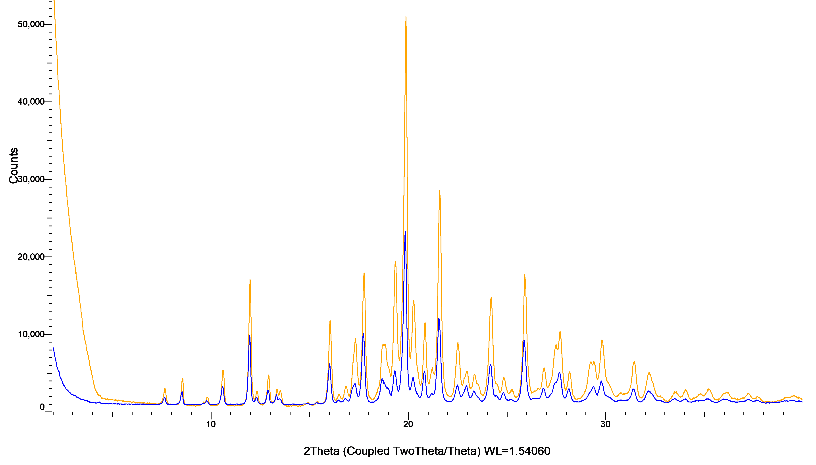

Figure S57: XRPD patterns of tadalafil powder (blue) and milled tadalafil powder (orange).
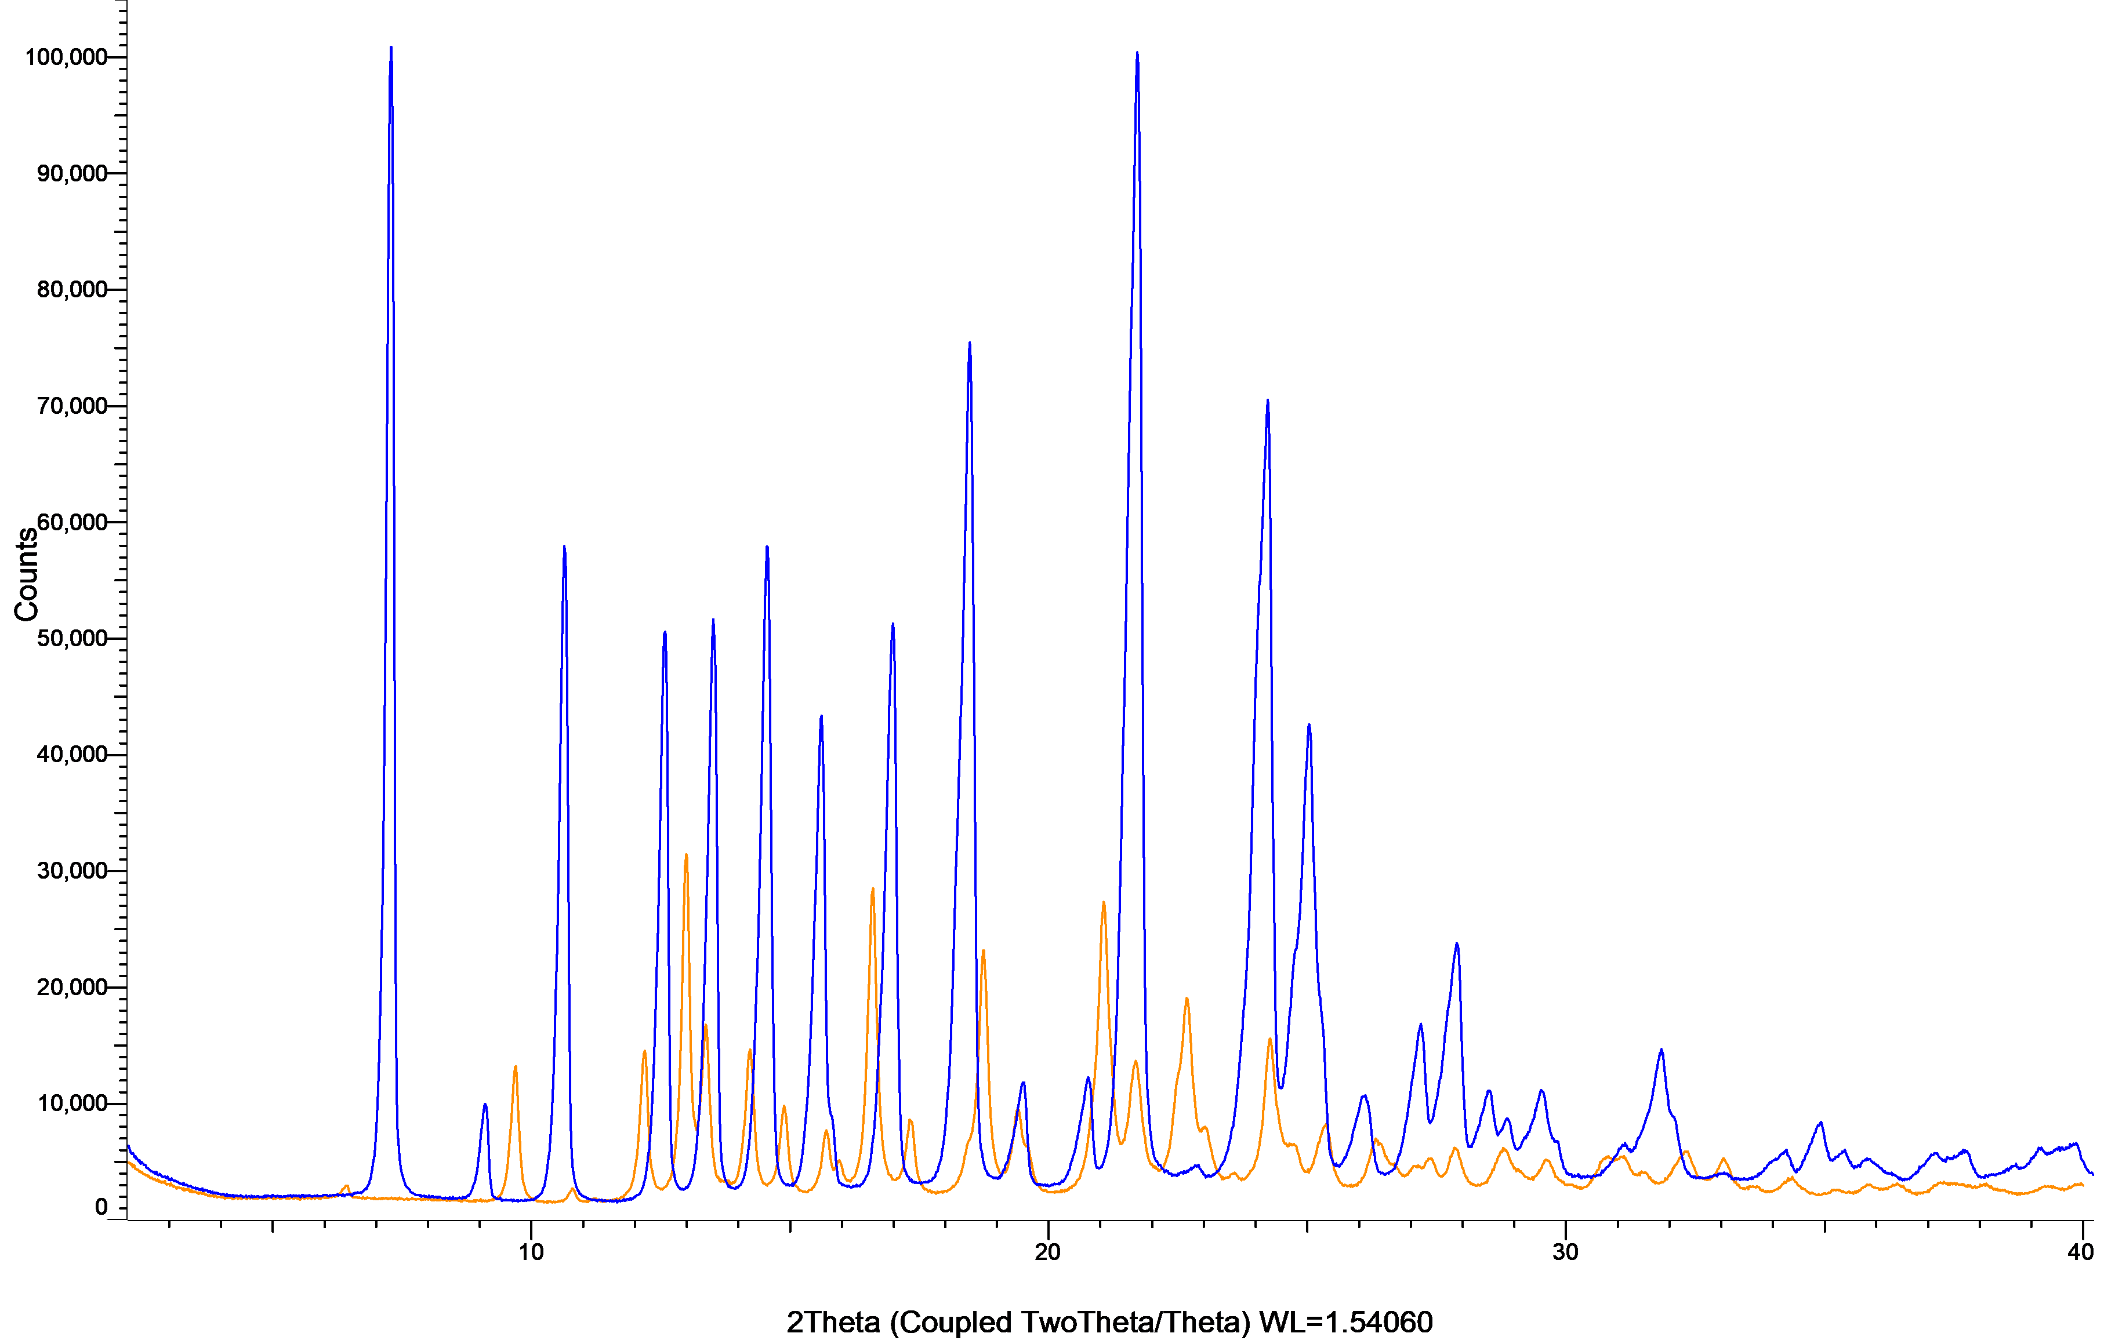

Figure S58: XRPD patterns of thiabendazole powder (blue) and milled thiabendazole powder (orange)
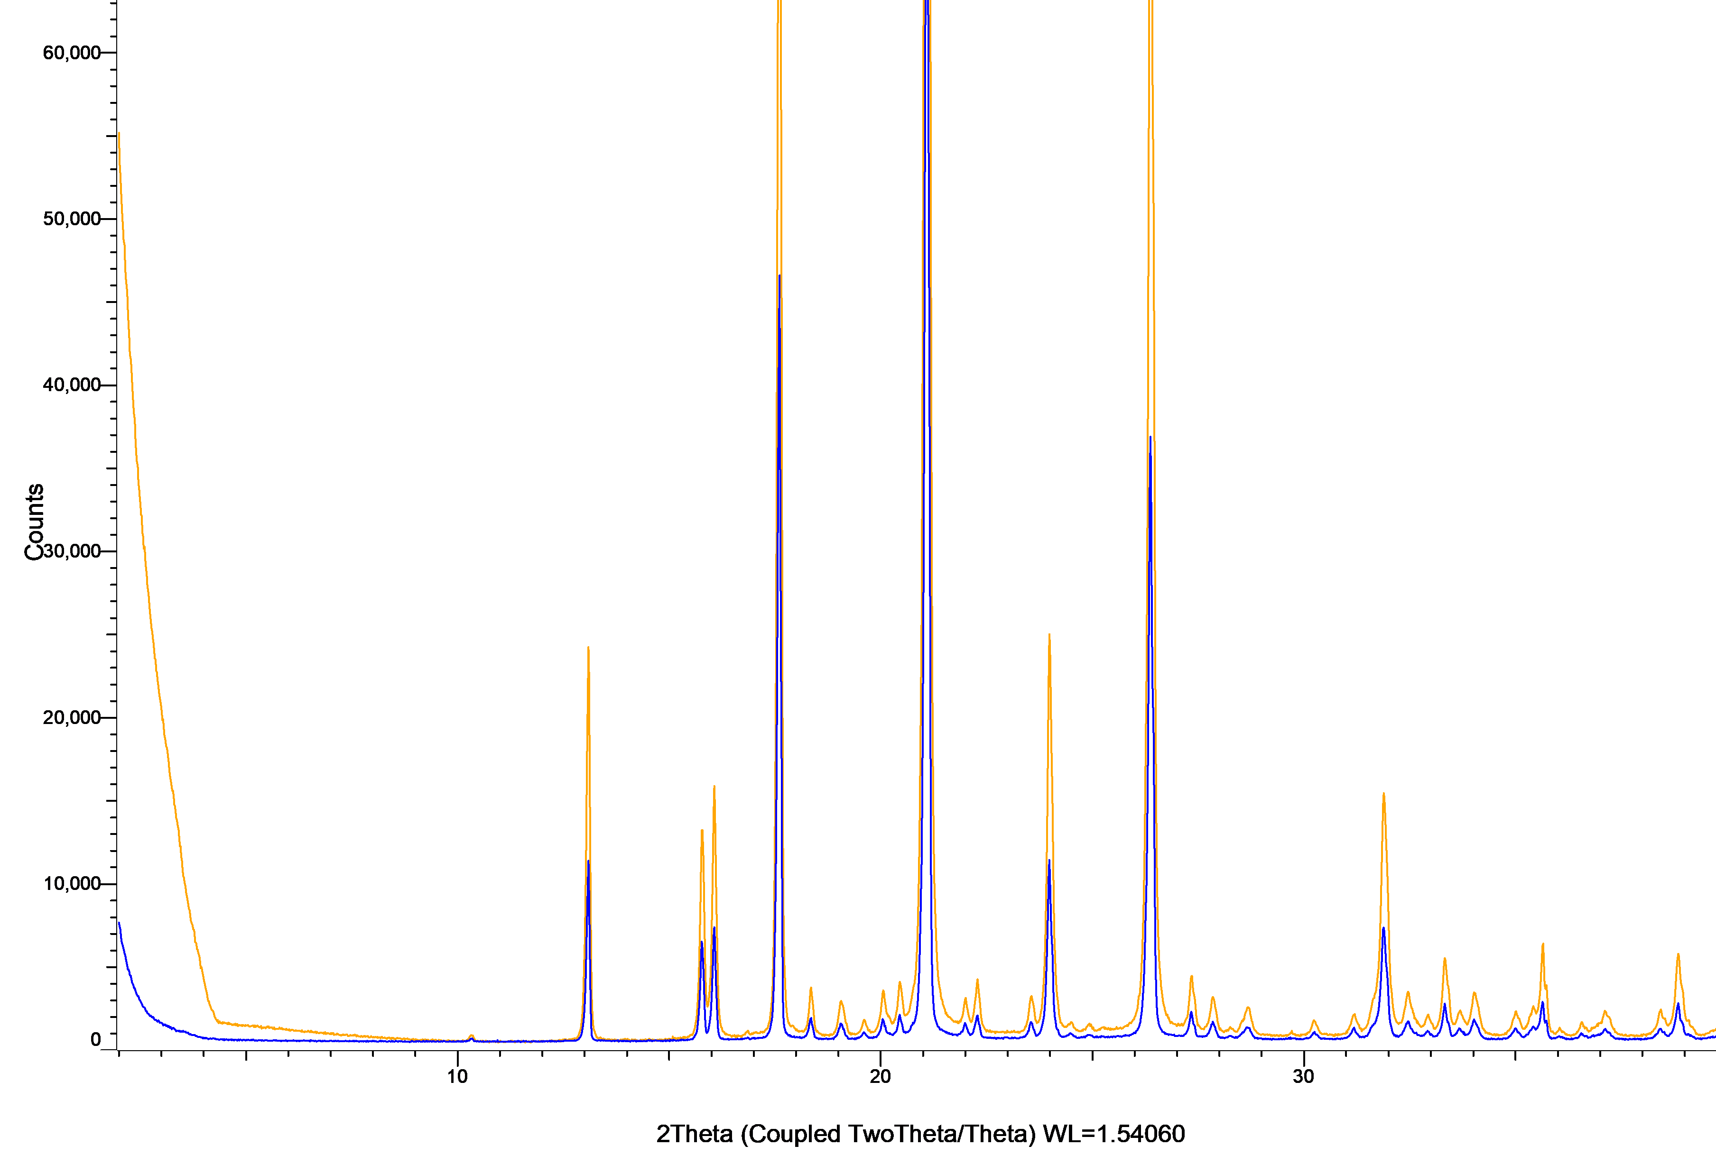

- Polymorphs of investigated compounds

Table S6: List of polymorphs for all screened compounds.
Drug | Polymorph | Reference
Albendazole | Polymorphic form II | DOI: https://doi.org/10.1002/jps.22072
Apixaban | Polymorphic form I | DOI: https://doi.org/10.1021/acs.molpharmaceut.8b00060
Apremilast | Polymorphic form B | Patent No. US 9 , 850 , 205 B2
Aripiprazole | Polymorphic form III | DOI: https://doi.org/10.1016/B978-0-12-397220-0.00001-5
Candesartan Cilexetil | Polymorphic form I | DOI: https://doi.org/10.1021/ie2024855
Carbamazepine | Polymorphic form III | DOI: 10.1016/j.ejps.2017.05.013
Celecoxib | Polymorphic form III | Patent No. US 7476,744 B2
Ceritinib | Polymorphic form 2b | Patent No. WO 2017/016529 A1
Cinnarizine | no polymorphism reported in literature
Dasatinib | Polymorphic form C | Patent No. US 2010/0256158 A1
Deferasirox | Polymorphic form A | Patent No. US 8,153,672 B2
Dipyridamole | Polymorphic form II | Patent No. US 8,092,785 B2
Enzalutamide | Polymorphic form R1, transition to polymorphic form R2 after milling without excipient | Patent No. US 9,701,641 B2
Etoricoxib | Polymorphic form XIII | Patent No. WO 2005/085199 A1
Ezetimibe | Polymorphic form II | Patent No. US 2005/0171080 A1
Fenofibrate | Polymorphic form I | DOI: 10.1039/C5CE01148E
Gemfibrozil | Polymorphic form I | DOI: https://doi.org/10.1016/j.tca.2019.03.026
Glibenclamide | Polymorphic form I | DOI: https://doi.org/10.1016/0378-5173(89)90134-8
Griseofulvin | Polymorphic form I | DOI: 10.1002/jps.23349
Indomethacin | Polymorphic form γ | DOI: 10.1021/acs.molpharmaceut.7b00930
Mefenamic acid | Polymorphic form I | DOI: 10.22159/ajpcr.2017.v10i5.15863
Nilotinib | Polymorphic form C | DOI: https://doi.org/10.1021/acs.cgd.2c00253
Nimesulide | Polymorphic form I | DOI: https://doi.org/10.1002/jps.22464
Olaparib | Polymorphic form A | Patent No. WO 2017/191562 A1
Rivaroxaban | Polymorphic form I | DOI: 10.1002/crat.201600379
Sertraline | Polymorphic form II | Patent No. US 6,872,853 B1
Sorafenib | Polymorphic form III | Patent No. US 8,217,061 B2
Tadalafil | Polymorphic form A. Milling without excipient induced a beginning polymorphic transition. | Patent No. WO 2006/049986 Al
Thiabendazole | no polymorphism reported in literature

- Input variables and responses of the models

Table S7: Embedded Excel sheet that contains all variables and responses used for the model. Open the file via double click.

- Variables of Importance in Projection plots for COMDR_{15 min} and COMDR_{60 min}
Figure S59: Variables of Importance in Projection plots for COMDR_{15min}
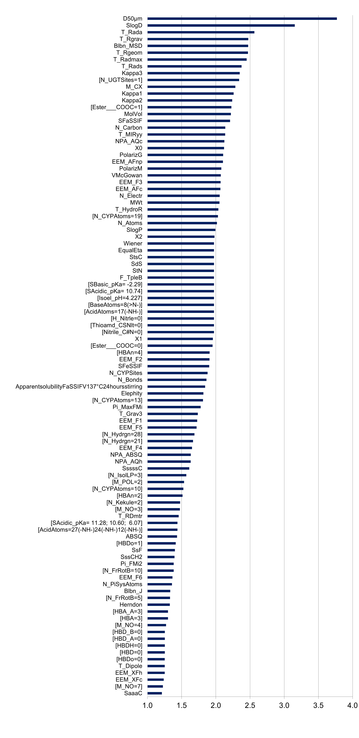

Figure S60: Variables of Importance in Projection plots for COMDR_{60min}

